KaizenRhino Solutions International Consultancy 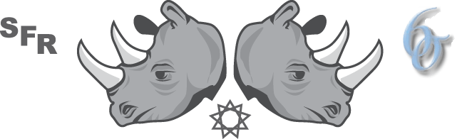

**“My** **GPIA”**

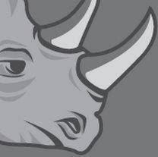

THIS IS MY GPIA There are many like it but this one is mine. My GPIA is my financial best friend.

My GPIA protects my economic life. I must master it as I must master my life. My GPIA, without me is useless. Without my GPIA I am financially dependent. I must manage my GPIA true. I must manage as accurately as I can. Poverty is seeking to destroy me. It won’t…..

My GPIA and myself know that what counts is not how much money I start with, what economic status was my birth or gender, nor my heritage. We know that consistent saving is what counts. We will save. We will become financially independent.

My GPIA has qualities, even as I, because it responds to how it is nurtured. Thus, I will learn it as myself. I will learn its weakness, its strength, its content, its holdings, its historical performance. I will ever guard against: lack of action, in-attention, overconfidence and hype. I will stay educated and current about laws, economic trends and my financial situation.

As I believe I commit to this creed. My GPIA and myself seek economic independence for my family, my state, nation and globe. We are financial saviors. So be it, until there is no Poverty!