|  |  |  |  |
| --- | --- | --- | --- |
| **Company Info** | | **Technical POC** | |
| Name: | HM InnoWiz, LLC | Name: | Dr. Mohit Jain |
| Address: | 22 Northfield Avenue  East Brunswick, NJ 08816 | Phone: | 732-309-0858 |
| Email: | mohit.jain@hminnowiz.com |
| **N2N System Description** | | | |
| Title: Automatic Nail-to-Nail Fingerprinting Device | | □Software Solution (uses conventional sensor)  X Hardware/SW Solution (custom hardware and software) | |

# 

# **IARPA Nail-to-Nail Challenge Registration**

## All Stage 1 Registrations need to be submitted to Challenge.gov by **March 17, 2017**

Abstract: We plan to construct a device that can acquire Nail-to-Nail fingerprint without any need of operator. The device allows a fast method to obtain the whole fingerprint with no inconvenience to the subject and does not pose any safety hazard. Additionally, it uses commercially available software or hardware component. The basic premise of the device is that the user put his/her finger in the center of the machine, and a camera mounted on a shaft will move around the finger, taking several pictures at various positions and a commercially available panoramic image stitching software will stitch these images to provide a nail-to-nail fingerprint.

System Diagram:

We propose an automated system for nail-to-nail fingerprinting, where only interaction the user will have is by inserting his/her finger in the machine. Figure 1 shows the perspective view of the machine. **1** is a camera with illumination light that is mounted on a shaft **2,** which is rotated by a stepper motor **3. 4** is support for the steeper motor and the cover **5.** Cover **5** keeps the camera protected and also prevents background details that camera might capture, hence taking the picture of only the finger**. 4** also support user support rod **6.** There will be a touch sensor in the support rod **6** to confirm that the user finger upper section is touching the support rod, ensuring that the finger is straight. There will be another touch sensor **7,** which user finger tip needs to touch allowing the machine to know that the finger is in right position. **8** is the electronic circuit box and **9** are USB connections to the computer to control the camera movement and image capture. **10** are indicator lights (standby, ready, done) and **11** is the machine base. Figure **2** shows the side view of the machine (without the cover **5** for clarity), indicating the position of the finger. All the operations in device are controlled by micro-controllers and computer. 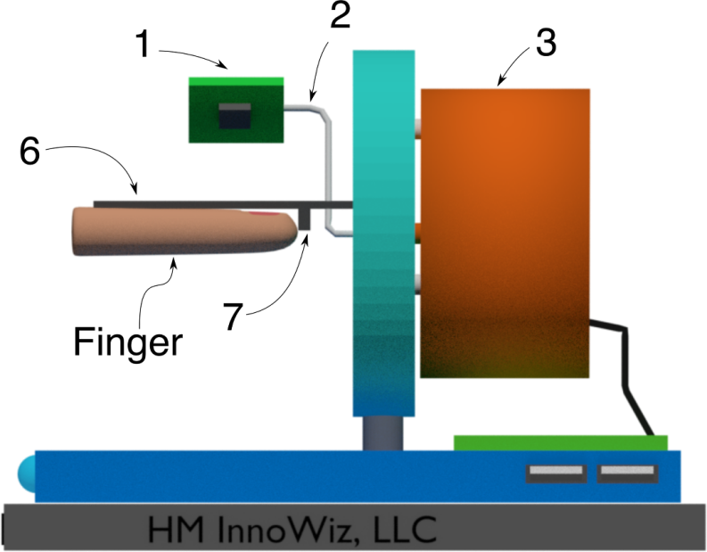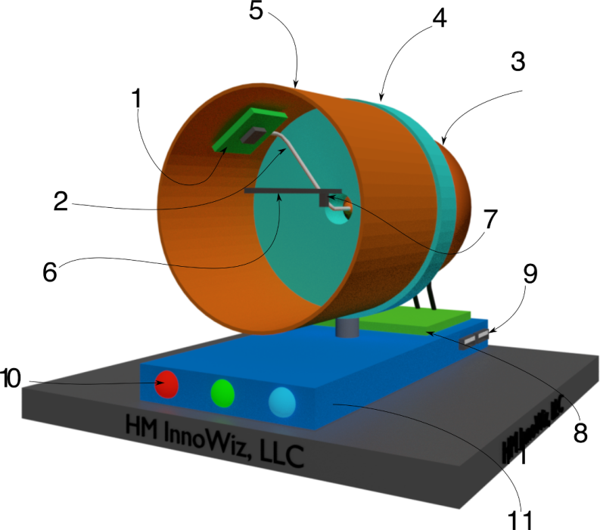

Concept of Operations: Figure 3 shows the operation of the proposed machine. The subject will insert his/her finger in the center so that the upper portion of the finger is touching the support rod 6, and tip of the finger is touching the touch sensor 7. Once both the sensors indicate that the finger is ready for imaging, green indicator light will come on and the camera will rotate around the finger, stopping and taking picture at various positions (shown in Figure 3 at three positions). The images will be transmitted to the computer and a commercially available panoramic image stitching software will stitch these images to provide a complete nail-to-nail image. Examples of some of the commercially available image stitching software are: PTGui, AutoPano Pro, and Microsoft ICE. The user will be instructed to position each finger by a speaker, connected to the computer, so that they know which finger to insert. We believe that if each finger imaging takes 10 seconds, a total imaging time will be 100 seconds for 10 fingers. Allowing an additional 100 seconds for instructions and switching fingers, we will have an additional 100 seconds left (out of 300 seconds) for the software to stitch the images, assuming we take 5 images for each finger scan and each image is 8 megapixels. These 100 seconds are more than sufficient for any computer with moderate hardware.

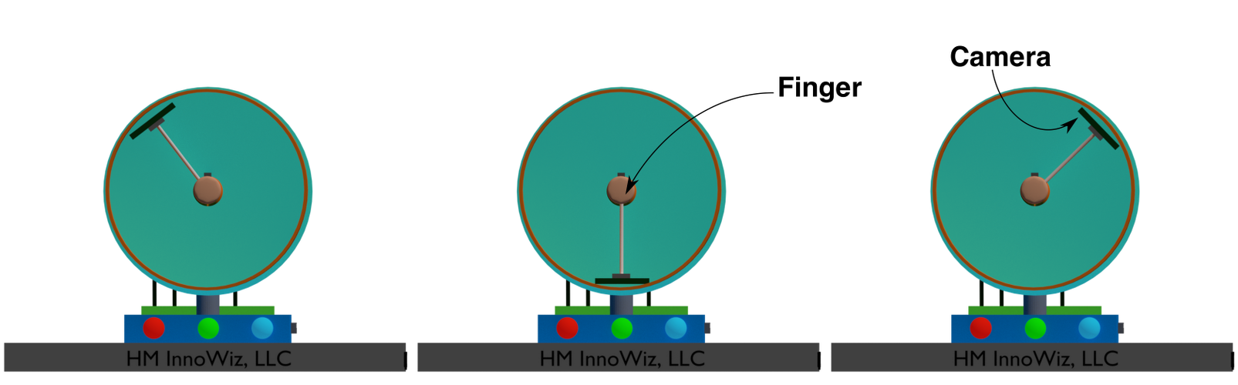



**Figure 3:** Position of camera at various positions during nail-to-nail imaging of the finger

Anticipated Equipment: We will use Windows PC as computing device as it not only provides software to take image and stitching the images but will also communicate with the microcontroller on the device. The microcontroller will control the stepper motor, which in turn control the position of the camera. Microcontroller will also control the indicator lights. Other components are stepper motor, passive electronic parts, and mechanical components described above.

Devices: *Creating New Device*

Matchers  
*A)Which Matcher will your team use for the* ***tenprint*** *to* ***tenprint*** *comparison? Please select one:*

*__X__ Government ___ Custom ____ Not Sure*

*B) Which Matcher will your team use for the* ***latent*** *to* ***tenprint*** *comparison? Please select one:*

*_X___ Government ___ Custom ____ Not Sure*

Safety Assessment: We don’t envision any safety concerns for the users, during the fingerprinting process.

Innovation: To the best of our knowledge, this is the first time a device with such a configuration has been proposed for fingerprinting. Accordingly, we will be filling a provisional patent to protect the intellectual property.