**Business Plan**

**I.AM.I LLC**

2511 Garrett Ave

Baltimore, MD 21218

Phone: 443-326-1779

Email: seconchancehousing04gmail.com

Owner: Jacqueline Bowser

Confidentiality Agreement

The undersigned reader acknowledges that the information provided by I.AM.I LLC in this business plan is confidential; therefore, the reader agrees not to disclose it without the express written permission of Jacqueline Bowser.

It is acknowledged by the reader that information to be furnished in this business plan is in all respects confidential in nature, other than information which is in the public domain through other means, and that any disclosure or use of same by the reader may cause serious harm or damage to I.AM.I LLC.

Upon request, this document is to be immediately returned to Jacqueline Bowser.

_Jacqueline Bowser__

Signature

_Jacqueline Bowser___

Name (Typed or Printed)

_5/18/17__________

Date

This is a business plan. It does not imply an offering of securities.

1.0 Executive Summary 4

Chart: Highlights 4

1.1 Company Summary 5

2.0 Products and Services 5

3.0 Market Analysis Summary 5

4.0 Strategy and Implementation Summary 6

4.1 Competitive Edge 6

4.2 Marketing Strategy 7

4.3 Sales Strategy 7

4.4 Milestones 8

Table: Milestones 8

Chart: Milestones 9

5.0 Management Summary 9

6.0 Financial Plan 10

Table: Financials 11

Chart: Profit Monthly 12

Chart: Profit Yearly 12

Chart: Sales Monthly 12

Chart: Sales by Year 13

6.1 Projected Cash Flow 13

Chart: Cash 13

Table: Financials 14

# 1.0 Executive Summary

I.AM.I LLC is an existing business located in Baltimore, Maryland. The company was established in 2009. I.AM.I is an acronym for “I Am Independent,” which reflects the goal of the company to help clients become independent members of society. The business was created with the idea of helping disadvantaged individuals find affordable housing and gain the skills necessary to be contributing members of the community. Specifically, the program was established for people who could not afford adequate housing and who were on the verge of becoming homeless.

I.AM.I LLC strives to help residents obtain financial literacy, life skills, and other supportive services necessary to be independent. The company provides housing and educational services for individuals who are facing homelessness or physical or mental disabilities. The company offers a variety of assistance options including transportation, help with meal preparation, budget counseling, and other support.

I.AM.I LLC currently operates two residential houses. The properties are in northeast Baltimore. The company has provided affordable housing and support services to over 75 people over the past seven years. The company plans to expand operations by purchasing two homes and two multi-family housing units.

I.AM.I LLC has worked hard to build a strong reputation for providing quality housing and excellent customer care. The company has developed solid relationships with current and former clients. The company takes pride in helping clients achieve independence and will continue to make this the number one priority.

Jacqueline Bowser is the sole owner of I.AM.I.LLC. Jacqueline has over 20 years of experience assisting people with minor physical and mental disabilities. She has a degree in human services and enjoys helping people learn the skills necessary to be independent members of our society. She will hire additional employees to staff the business as it expands operations.

I.AM.I LLC is requesting $654,700 in funding. The funds will provide the necessary capital to purchase and renovate the intended properties. The company will also use the funds to purchase a company vehicle, increase marketing efforts, and hire and train additional employees.

### Chart: Highlights

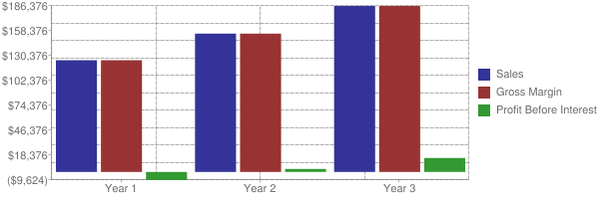

## 

## 1.1 Company Summary

I.AM.I LLC (IAI) is an existing business operating in Baltimore, MD. This S-corporation was established in 2011 as a real estate business. The company plans to provide housing options for individuals who are low income/homeless or have health challenges including mental and physical disabilities.

IAI will purchase two additional houses and two multi-family housing units. The company will expand in the upcoming year to accommodate an increased number of clients and to provide additional services.

IAI is an acronym for I Am Independent. The company is owned by Jacqueline Bowser. Jacqueline is a woman, and a member of an ethnic minority group.

# 

# 2.0 Products and Services

IAI provides temporary housing solutions for members of disadvantaged groups in the community. These disadvantaged groups include individuals who are physically and mentally disabled, homeless, victims of domestic abuse, and recovering substance abusers. These individuals may have lost their homes due to unforeseen circumstances, or have been unable to find affordable housing options. IAI will provide affordable housing for these people in their time of need.

IAI offers a variety of services geared to helping individuals become self-sufficient. The company helps direct clients to resources that can help them improve their credit scores, and receive other financial services. IAI provides supportive services to residents to help them learn vital skills such as budgeting, meal preparation, and homemaking skills. These resources can help residents feel more empowered to be successful contributors in their communities. IAI also provides transportation services and minor assistance with daily living needs.

# 

# 3.0 Market Analysis Summary

IAI offers affordable temporary or transitional housing in the area around Baltimore, MD. The company will offer rental terms below-market costs for disadvantaged individuals including those who are low-income, disabled, veterans, and recovering substance abusers.

The US transitional housing industry generates approximately $12 billion in annual revenue. This industry includes temporary housing, homeless shelters, and other options for low-income housing. Because this industry is a social-assistance industry, performance is often cyclical depending on a host of economic factors, but overall poverty and home vacancies are projected to increase, which will support demand for these critical housing services. Despite a decreasing homeless population, the sheltered homeless population has remained largely unchanged over the past five years. In the next five years, the economy is expected to slowly recover which will keep the demand high for affordable housing options.

The median sales price for a home in Baltimore for the first quarter of 2017 was $185,000, based on 1,073 home sales. The average price per square foot for homes in this market was $141, which is an increase of four percent compared to the same period in 2016. The median cost to rent an apartment in Baltimore is $1,350 per month. This cost is prohibitive to low-income and disadvantaged individuals.

IAI will continue to provide housing services to individuals in the Baltimore area. Baltimore is the largest city in the state of Maryland and the 29th most populous city in the US. The city has a population of nearly 650,000, with the Baltimore metropolitan area boasting a population of just under 2.8 million. Baltimore has been a major manufacturing center, but has recently shifted to a more service-oriented economy.

# 4.0 Strategy and Implementation Summary

IAI’s primary goal is to provide affordable housing to members of disadvantaged populations. These individuals often find themselves on waiting lists for low-income apartments or housing options. IAI will offer adults the opportunity to live independently by empowering them with helpful skills and resources. Independent living will provide clients with improved self-worth and will give them the ability to succeed in society.

IAI will strive to provide excellent customer service. The company employees will treat each resident with care and respect as they become more independent. IAI will grow a profitable business while helping to rebuild the community.

IAI will purchase additional properties to provide affordable housing to a greater number of individuals. The company has identified several potential properties for purchase and will work to negotiate the best possible price on each unit. IAI will complete renovations in a timely manner so the housing units can be offered for rent as quickly as possible.

The planned expansion is an important part of the company’s ability to continue serving the underserved populations in Baltimore. The following sections outline the company’s plans for sales, marketing, and growth.

## 4.1 Competitive Edge

IAI operates in the Baltimore area. Although there are approximately 150 businesses and community organizations which provide housing options in the area, there are few companies offering the same services. IAI will achieve a competitive edge as it provides affordable housing and a variety of supportive services to a broad population of disadvantaged individuals. These individuals come from a range of backgrounds and circumstances such as homelessness, physical and mental disabilities, and military veterans.

IAI operates on a small scale and can tailor programs to the clients so that each individual receives personalized assistance for the best possible outcome. This individualized focus allows the client to feel supported as he or she works to achieve independence within our society.

IAI has identified the following companies and organizations as competitors in the local market:

* Marian House is a community base housing facility. Marian House is a nonprofit organization located in the Waverly neighborhood of Baltimore. This organization offers temporary housing to women and their families. Marian House provides a safe and loving environment and encourages the women to learn to love and respect themselves as they confront emotional, social, and economical barriers. The organization provides support services such as counseling, addiction treatment, and employment and life skills, as the residents work to find permanent housing. There is significant demand for these services and there is a waiting list to get into the program.
* Catholic Charities of Baltimore provides a variety of assistance programs throughout Maryland. The programs are designed to support individuals who are struggling to make ends meet. The programs and assistance allow individuals to achieve self-sufficiency through a range of transitional housing services, meal programs, education, employment training and counseling services. Catholic Charities of Baltimore is not always able to meet the demands of the clients because they have limited staffing and limited funding.
* Booth House offers 30-day emergency shelter and 6-24 months for transitional housing. The organization addresses basic needs such as a safe place to sleep and warm meals. The organization is a nonprofit and depends on grants to meet financial obligations. Depending on available resources, Booth House offers assistance with mental health, GED classes, employment training, and life skills.

## 

## 4.2 Marketing Strategy

IAI will advertise available housing units and services through a combination of print, online, and personal methods. The company anticipates a budget of $10,000 for the first year of advertising. In time, the company will hire an additional employee to manage marketing efforts.

IAI will promote the available units in community service directories. IAI will print brochures, postcards, fliers, and business cards with company and service information. These publications will be distributed through community resource offices, mail, local businesses, and personal interactions.

IAI will develop and maintain a website to list available housing units, provide information about available services, and to link to other community resources. The company will also work with various community service organizations to be listed on those specific service directories.

IAI will also rely on positive word of mouth referrals from current clients and other community resource providers. The company will evaluate offering a referral program to reward clients with gift cards for connecting potential clients with the company. The community resource offices may include counseling centers, social service offices, veteran’s affairs offices, and hospitals.

## 

## 4.3 Sales Strategy

IAI offers affordable housing and supportive services to clients. Clients pay IAI directly for the services rendered. Many clients receive disability or other government assistance and can use a portion of those funds toward their living expenses. IAI accepts payment in the form of cash, personal check, or money order.

Clients interested in securing affordable housing through IAI will contact the company directly to complete an intake application. A company employee will explain the available services and will answer any questions the client may have. After the interview process, a contract will be drawn up to detail the lease and any additional terms. All contracts and other client information will be maintained through QuickBooks for management and accounting purposes.

Leases are offered to clients on a month-to-month basis. The cost per resident ranges from $400-$650 per month. The cost varies depending on the size of the room and amenities in the home. Clients can also arrange for transportation and other support services.

## 4.4 Milestones

IAI will work to achieve a set of milestones to successfully expand business operations. The company will purchase additional properties to provide temporary housing to clients. The company plans to purchase two multifamily units, and two four-bedroom homes. IAI will renovate and furnish the properties to make them functional and ensure the properties meet current code regulations.

IAI will secure and furnish office space. The office will allow the company to have a dedicated space to meet with clients and community resource providers, as well as effectively manage the business.

IAI will hire additional employees to staff the organization through this expansion and beyond. IAI will remain committed to providing outstanding customer service and assisting each client as a unique and valuable individual. The company will hire a bookkeeper, property manager, office staff, and maintenance personnel.

IAI will purchase a vehicle to use for business purposes. The vehicle will feature company information to promote the business while driving through the community. The vehicle will also be used to transport clients to various appointments and to check on to the various properties. IAI will also expand marketing efforts to grow the client base.

### Table: Milestones

|  |  |  |  |  |  |
| --- | --- | --- | --- | --- | --- |
| **Milestone** | **Start Date** | **End Date** | **Budget** | **Manager** | **Department** |
| Marketing | 08/15/2017 | 07/31/2018 | $10,000 | Bob/Jackie | Marketing |
| Purchase Multifamily Units | 08/15/2017 | 08/01/2018 | $135,000 | Jackie | Purchasing |
| Hire Office Staff | 08/20/2017 | 08/15/2018 | $25,000 | Rhonda | Human Resources |
| Purchase 4 BR Home | 09/01/2017 | 09/30/2017 | $89,000 | Jackie | Purchasing |
| Purchase 4 BR Home | 09/01/2017 | 10/01/2017 | $159,000 | Jackie | Purchasing |
| Purchase Multifamily Units | 09/01/2017 | 10/31/2017 | $80,000 | Jackie | Purchasing |
| Renovate Properties | 09/01/2017 | 11/30/2017 | $50,000 | Jackie | Purchasing |
| Hire Maintenance Personnel | 09/01/2017 | 07/31/2018 | $9,600 | Herman | Human Resources |
| Salary | 09/01/2017 | 08/30/2018 | $30,000 | Jackie | Human Resources |
| Hire Bookkeeper | 09/01/2017 | 08/30/2018 | $12,500 | Tish | Human Resources |
| Purchase Company Vehicle | 09/15/2017 | 09/30/2017 | $20,000 | Jackie | Purchasing |
| Hire Property Manager | 10/01/2017 | 09/30/2018 | $9,600 | Mike | Human Resources |
| Secure Office Space | 11/01/2017 | 02/28/2018 | $25,000 | Jackie | Operations |
| **Totals** |  |  | **$654,700** |  |  |

### 

### Chart: Milestones

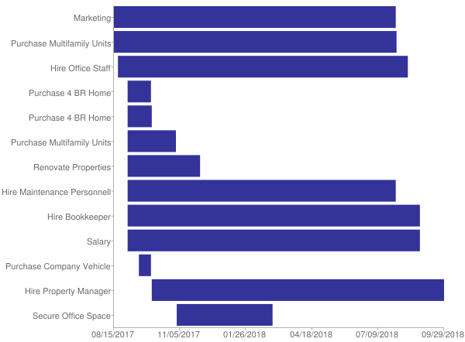

# 

# 5.0 Management Summary

IAI is wholly owned by Jacqueline Bowser. Jacqueline is a woman and a member of an ethnic minority group. She has over 20 years of experience working with people from various minority groups and will continue to use that experience to help disadvantaged individuals achieve the American dream of home ownership.

Jacqueline attended the Community College of Baltimore. She received an associate’s degree in human services. She has been an active volunteer within her community and has assisted in homeless shelters, shelters for abused women, and shelters for young teens. She has worked for a counseling service providing outreach assistance relating to a variety of issues including abuse, homelessness, substance abuse, mental health, and more. Jacqueline is responsible to collect rent, maintain the customer database, interview potential residents, complete background checks, and manage the properties.

Jacqueline manages the daily operations of the business and is assisted by family members as needed. Currently, her daughter assists with transporting clients, office management, and customer service. Jacqueline plans to hire additional employees to continue providing outstanding customer care through the planned expansion. Jacqueline anticipates hiring four employees by the end of 2018. These employees will be responsible for office and finance management, and property maintenance. The office manager will be responsible for customer service, office work, and other duties as necessary. The finance manager will be responsible for the accounts payable and receivable. The maintenance workers will manage all repairs and general upkeep of the properties.

# 

# 6.0 Financial Plan

IAI is requesting $654,700 to finance the planned expansion. The company will use the funds to purchase additional properties to offer as affordable housing. Specifically, IAI will purchase two multifamily units and two four-bedroom houses. The company will improve, renovate, and furnish the properties to make them comfortable and functional for the residents. The company will also ensure all properties are compliant with accessibility requirements and local building codes.

IAI will use the funds to purchase a company vehicle to transport residents to and from appointments. The company will implement marketing plans to attract new clientele to the new properties. The company will hire and train employees to help manage the office, properties, bookkeeping, and marketing.

IAI will rely on the requested funding to purchase the planned properties. By purchasing the properties outright with new investments, the company will be able to continue providing affordable housing to disadvantaged individuals. The funding will cover the initial investment. The company will cover operating costs with monthly rental income from clients. The following tables and charts detail the financial projections through the next three years.

### Table: Financials

|  |  |  |  |
| --- | --- | --- | --- |
|  | **Year 1** | **Year 2** | **Year 3** |
| Opening Balance Cash & Checking | $10,000 | $81,331 | $70,874 |
| New Investments | $654,700 | $0 | $0 |
| Sales | $132,000 | $163,400 | $196,080 |
| **Subtotal Money Received** | **$786,700** | **$163,400** | **$196,080** |
| Cost of Goods Sold | $0 | $0 | $0 |
| **Operating Expenses** |  |  |  |
| Advertising | $6,504 | $7,154 | $7,869 |
| Other Operating Expenses | $25,644 | $30,000 | $34,000 |
| Payroll | $86,676 | $95,343 | $104,877 |
| Purchase Of Assets | $562,300 | $0 | $0 |
| Rent Utilities | $22,800 | $27,360 | $32,832 |
| Taxes | $11,445 | $14,000 | $16,000 |
| **Subtotal Money Spent** | **$715,369** | **$173,857** | **$195,578** |
| Ending Balance Cash and Checking | $81,331 | $70,874 | $71,376 |
| **Profit Before Interest and Taxes** |  |  |  |
| Sales | $132,000 | $163,400 | $196,080 |
| Less Cost of Sales | $0 | $0 | $0 |
| Gross Margin | $132,000 | $163,400 | $196,080 |
| Less Operating Expenses | ($141,624) | ($159,857) | ($179,578) |
| Profit Before Interest and Taxes | ($9,624) | $3,543 | $16,502 |
| **Net Cash Flow** | **$71,331** | **($10,457)** | **$502** |

### Chart: Profit Monthly

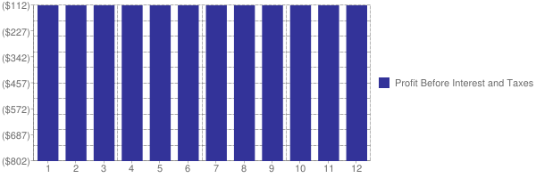

### 

### Chart: Profit Yearly

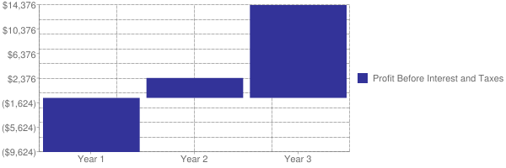

### 

### Chart: Sales Monthly

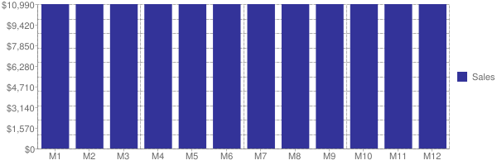

### Chart: Sales by Year

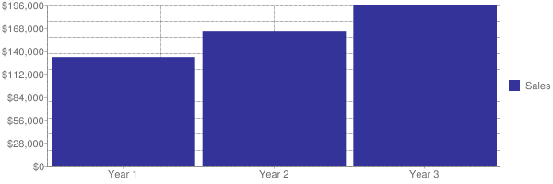

## 

## 6.1 Projected Cash Flow

IAI is currently operating and generating revenue. The company has no existing debt. The company has approximately $10,000 to invest in this expansion. The additional properties will allow the company to provide affordable housing to many additional clients, as well as substantially increase cash flow. The company expects it will take a few months for advertising to take effect and for each of the housing units to be filled with occupants.

Apart from the initial investment of purchasing and renovating the properties, the cost to provide services is relatively low compared to the revenue potential. Utilizing grant funding for the initial investments will allow IAI to avoid incurring prohibitive debt. IAI collects rent payments on a weekly and monthly basis, depending on the terms of the individual contract.

### 

### Chart: Cash

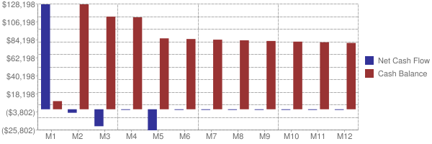

# Table: Financials

|  |  |  |  |  |  |  |  |  |  |  |  |  |
| --- | --- | --- | --- | --- | --- | --- | --- | --- | --- | --- | --- | --- |
|  | **Month 1** | **Month 2** | **Month 3** | **Month 4** | **Month 5** | **Month 6** | **Month 7** | **Month 8** | **Month 9** | **Month 10** | **Month 11** | **Month 12** |
| Opening Balance Cash & Checking | $10,000 | $138,653 | $134,351 | $113,549 | $112,747 | $86,945 | $86,143 | $85,341 | $84,539 | $83,737 | $82,935 | $82,133 |
| New Investments | $654,700 | $0 | $0 | $0 | $0 | $0 | $0 | $0 | $0 | $0 | $0 | $0 |
| Sales | $11,000 | $11,000 | $11,000 | $11,000 | $11,000 | $11,000 | $11,000 | $11,000 | $11,000 | $11,000 | $11,000 | $11,000 |
| **Subtotal Money Received** | $665,700 | $11,000 | $11,000 | $11,000 | $11,000 | $11,000 | $11,000 | $11,000 | $11,000 | $11,000 | $11,000 | $11,000 |
| Cost of Goods Sold | $0 | $0 | $0 | $0 | $0 | $0 | $0 | $0 | $0 | $0 | $0 | $0 |
| **Operating Expenses** |  |  |  |  |  |  |  |  |  |  |  |  |
| Advertising | $542 | $542 | $542 | $542 | $542 | $542 | $542 | $542 | $542 | $542 | $542 | $542 |
| Other Operating Expenses | $2,137 | $2,137 | $2,137 | $2,137 | $2,137 | $2,137 | $2,137 | $2,137 | $2,137 | $2,137 | $2,137 | $2,137 |
| Payroll | $7,223 | $7,223 | $7,223 | $7,223 | $7,223 | $7,223 | $7,223 | $7,223 | $7,223 | $7,223 | $7,223 | $7,223 |
| Purchase Of Assets | $513,800 | $3,500 | $20,000 | $0 | $25,000 | $0 | $0 | $0 | $0 | $0 | $0 | $0 |
| Rent Utilities | $1,900 | $1,900 | $1,900 | $1,900 | $1,900 | $1,900 | $1,900 | $1,900 | $1,900 | $1,900 | $1,900 | $1,900 |
| Taxes | $11,445 | $0 | $0 | $0 | $0 | $0 | $0 | $0 | $0 | $0 | $0 | $0 |
| **Subtotal Money Spent** | $537,047 | $15,302 | $31,802 | $11,802 | $36,802 | $11,802 | $11,802 | $11,802 | $11,802 | $11,802 | $11,802 | $11,802 |
| Ending Balance Cash and Checking | $138,653 | $134,351 | $113,549 | $112,747 | $86,945 | $86,143 | $85,341 | $84,539 | $83,737 | $82,935 | $82,133 | $81,331 |
| **Profit Before Interest and Taxes** |  |  |  |  |  |  |  |  |  |  |  |  |
| Sales | $11,000 | $11,000 | $11,000 | $11,000 | $11,000 | $11,000 | $11,000 | $11,000 | $11,000 | $11,000 | $11,000 | $11,000 |
| Less Cost of Sales | $0 | $0 | $0 | $0 | $0 | $0 | $0 | $0 | $0 | $0 | $0 | $0 |
| Gross Margin | $11,000 | $11,000 | $11,000 | $11,000 | $11,000 | $11,000 | $11,000 | $11,000 | $11,000 | $11,000 | $11,000 | $11,000 |
| Less Operating Expenses | ($11,802) | ($11,802) | ($11,802) | ($11,802) | ($11,802) | ($11,802) | ($11,802) | ($11,802) | ($11,802) | ($11,802) | ($11,802) | ($11,802) |
| Profit Before Interest and Taxes | ($802) | ($802) | ($802) | ($802) | ($802) | ($802) | ($802) | ($802) | ($802) | ($802) | ($802) | ($802) |
| **Net Cash Flow** | **$128,653** | **($4,302)** | **($20,802)** | **($802)** | **($25,802)** | **($802)** | **($802)** | **($802)** | **($802)** | **($802)** | **($802)** | **($802)** |