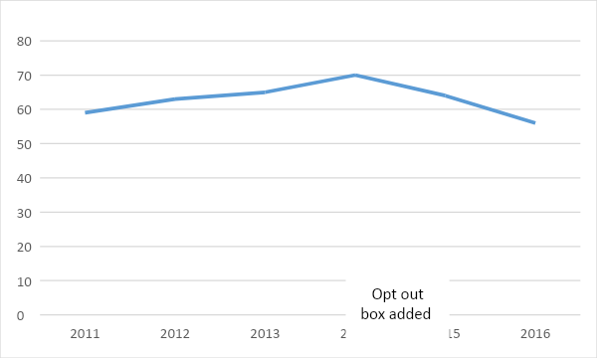

Example of what the data might look like as a result of adding an “opt out” option to a verification letter. *This is a sample and not based on real results.*