SaferStays, LLC

 Safety inspections for rentals



1. [**Executive Summary**](https://docs.google.com/document/d/18FVNATcwbXIl7RL0RCbbCNR-GLueWH_2demEixXL1_E/edit#heading=h.30j0zll)

[Highlights](https://docs.google.com/document/d/18FVNATcwbXIl7RL0RCbbCNR-GLueWH_2demEixXL1_E/edit#heading=h.1fob9te)

[Objectives](https://docs.google.com/document/d/18FVNATcwbXIl7RL0RCbbCNR-GLueWH_2demEixXL1_E/edit#heading=h.3znysh7)

[Mission Statement](https://docs.google.com/document/d/18FVNATcwbXIl7RL0RCbbCNR-GLueWH_2demEixXL1_E/edit#heading=h.2et92p0)

[Keys to Success](https://docs.google.com/document/d/18FVNATcwbXIl7RL0RCbbCNR-GLueWH_2demEixXL1_E/edit#heading=h.tyjcwt)

1. [**Description of Business**](https://docs.google.com/document/d/18FVNATcwbXIl7RL0RCbbCNR-GLueWH_2demEixXL1_E/edit#heading=h.3dy6vkm)

[Company Ownership/Legal Entity](https://docs.google.com/document/d/18FVNATcwbXIl7RL0RCbbCNR-GLueWH_2demEixXL1_E/edit#heading=h.1t3h5sf)

Products and Services

[Location](https://docs.google.com/document/d/18FVNATcwbXIl7RL0RCbbCNR-GLueWH_2demEixXL1_E/edit#heading=h.4d34og8)

[Hours of Operation](https://docs.google.com/document/d/18FVNATcwbXIl7RL0RCbbCNR-GLueWH_2demEixXL1_E/edit#heading=h.17dp8vu)

[Management](https://docs.google.com/document/d/18FVNATcwbXIl7RL0RCbbCNR-GLueWH_2demEixXL1_E/edit#heading=h.1ksv4uv)

[Financial Management](https://docs.google.com/document/d/18FVNATcwbXIl7RL0RCbbCNR-GLueWH_2demEixXL1_E/edit#heading=h.44sinio)

1. [**Marketing**](https://docs.google.com/document/d/18FVNATcwbXIl7RL0RCbbCNR-GLueWH_2demEixXL1_E/edit#heading=h.z337ya)

[Market Analysis](https://docs.google.com/document/d/18FVNATcwbXIl7RL0RCbbCNR-GLueWH_2demEixXL1_E/edit#heading=h.3j2qqm3)

[Competition](https://docs.google.com/document/d/18FVNATcwbXIl7RL0RCbbCNR-GLueWH_2demEixXL1_E/edit#heading=h.4i7ojhp)

[Pricing](https://docs.google.com/document/d/18FVNATcwbXIl7RL0RCbbCNR-GLueWH_2demEixXL1_E/edit#heading=h.2xcytpi)

Strategy and Implementation

Sales Forecast

1. [**Appendix**](https://docs.google.com/document/d/18FVNATcwbXIl7RL0RCbbCNR-GLueWH_2demEixXL1_E/edit#heading=h.1ci93xb)

[Start-Up Expenses](https://docs.google.com/document/d/18FVNATcwbXIl7RL0RCbbCNR-GLueWH_2demEixXL1_E/edit#heading=h.3whwml4)

[Cash Flow](https://docs.google.com/document/d/18FVNATcwbXIl7RL0RCbbCNR-GLueWH_2demEixXL1_E/edit#heading=h.qsh70q)

[Miscellaneous Documents](https://docs.google.com/document/d/18FVNATcwbXIl7RL0RCbbCNR-GLueWH_2demEixXL1_E/edit#heading=h.23ckvvd)

*Executive Summary*

SaferStays is changing the culture of renting with specialized, professional safety inspections for then renter. We are passionate about helping vulnerable target population, such as, families (single mothers) on public assisted housing, families renting privately, students, and the elderly, find safe places to live and stay.

SaferStays’ revolutionary, low cost safety inspection gives renters and their families the opportunity to take control of their safety and help prevent unforeseen hazards. A necessary tool that renters within our target market did not have the ability to access previously.

SaferStays’ is a women-owned and family run business located in Binghamton, NY.

Within our pilot program, run in Binghamton, NY, SaferStays targeted individuals living in county supplemented housing by creating an incentive program for landlords. We have partnered with local universities to promote our services to college students and their parents. We will continue to make crucial partnerships as we evolve to fit the needs of the rapidly growing rental market. We are the first in our industry, changing the rental process forever.

*Highlights*

SaferStays’ revolutionary safety inspection provides renters and their families with a necessary tool. Statistically, renting has increased across all age groups, making a safety inspection essential for families with children and the elderly.

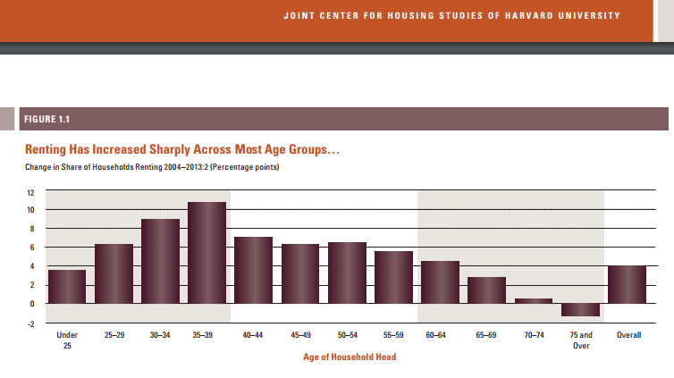

*Objectives*

* To complete the process of getting our Minority and Woman-Owned Business Enterprise (MWBE) certification in order to receive government contracts.
* To reach women and families, and the elderly living in public assisted housing.
* To reach the elderly living in private housing who are in need of safety inspections of their current living situations (i.e. the aging population and those just released from rehabilitation centers).
* To provide safety inspections for students (and their parents) who are living in off campus housing rentals
* To change the culture of renting by protecting and advocating for renters and their families.

*Mission Statement*

SaferStays’ safety inspection is a revolutionary tool that is crucial for our growing rental economy. We conduct safety inspections for students, families living in public assisted housing, single mothers (and fathers), and the elderly. We foster awareness and peace of mind for our customers through our detailed safety inspections and reports.

*Keys to Success*

SaferStays’ web-based inspection network concentrates on the renter, not the home owner. The rental economy has been growing tremendously over the past ten years, yet we have few services for renters that ensure they are living in a safe environment, especially for families living in public assisted housing and students. SaferStays will fill that gap by conducting safety inspections for these target groups.

*Description of Business*

Renters of both long-term and short-term properties predominately fail to secure safety and condition inspections which lead to increased risk of injuries and fatalities as well as property damage disputes. This is due to the complexity and hassle of securing an inspector, negotiating a rate, and completing the process. SaferStays removes the hurdles that are suppressing the amount of safety inspections being performed. In addition to tenants and homeowners receiving a direct benefit, landlords will also benefit by having rental properties inspected. We are among one of the first web based inspection networks that concentrates on renters as well as implementing our groundbreaking safety inspection. Not only do we concentrate on renters, but we are a one stop shop. We differ in that we not only find the home inspector, but we book the inspection, take the payment, provide the template, review the report, and send it out to the customer. We will be the flagship of a fledgling industry and will change the way people rent and travel forever.

* The rental economy is an evolving market with evolving needs. For example, The Joint Center for Housing Studies has estimated that the number of renters from 2013-2023 will increase by 4.7 million. SaferStays will create a necessary step in the rental process, ensuring that families, students, and the elderly are living in safe living conditions as the rental economy grows.
* Our safety inspection costs considerably less than a home inspection, at roughly one half to one fourth the cost, making it more affordable.

There have been too many preventable tragedies, such as the balcony collapse in Connecticut (see appendix for article) or more recently the London apartment fire see appendix for article). The Connecticut porch collapse was a result of old, rotting wood, which typically a safety inspection would have noted. The building involved in the London fire had outdated fire extinguishers dating back to 2009 that most certainly would have been identified in a safety inspection. Locally, we have witnessed and prevented numerous tragedies, including an elderly woman falling through the floor of her apartment (public assisted housing) or having to evacuate a fraternity house due to a carbon monoxide leak. Safety inspections have and will continue to lower the numbers significantly of preventable injuries and fatalities from poor housing conditions.

*Company Ownership and Legal Entity*

SaferStays is currently operating as an LLC. Clara Lawrence is the primary member. SaferStays is currently working toward obtaining their WMBE certification to secure state and government contracts. We are in the final phase of trademarking our name, which will be complete by June 30, 2017.

*Products and Services*

SaferStays specializes in safety inspections.  A safety inspection is a limited scope inspection that identifies potential risks and safety hazards that a licensed home inspector finds. A safety inspection does not include cosmetic issues or investment issues, such as how old a roof or furnace is, therefore the inspection takes less time to complete, allowing us to keep our inspection affordable for everyone. A safety inspection is meant to educate the renter, landlord, or organization that ordered the inspection about potential safety issues that could cause potential harm or damage to oneself or the property. A safety inspection is offered to a client as an extra level of protection or peace of mind about a property they own or are interested in renting.

SaferStays’ safety inspection is revolutionary in the home inspection field because we are offering an inspection that is unique, affordable, and different from other web-based inspection companies.

Our services will benefit three major target groups:

* Women (single mothers) and families living in public assisted housing. Often, people living in public assisted housing do not have much of a say in their housing and often end up in unsafe conditions. Safety inspections will eliminate many of the hazards and risks that are present in government assisted housing rentals.
* Students (and their parents) who live in off campus rentals. Student rentals are notorious for being unsafe and having inherent security risks. This provides parents with an option when finding private housing for their daughter or son off campus.
* The elderly who either live in public assisted housing or private housing. As our housing inventory continues to age, the elderly will continue to be affected by unsafe housing conditions. As more programs are created to help keep the elderly out of nursing homes, safety inspections will be a necessary tool for many organizations.

*Location*

SaferStays is a web-based company. Therefore, we can operate from any location, keeping our overhead extremely low. Because our inspectors are not our employees, and act as independent contractors, all work and contact with them can be done virtually. Once SaferStays grows to a level where outside employees are necessary, we will open a centrally located call center (i.e. central New York and New York City) to help handle the volume of phone calls we will receive. However, initially all work can be done virtually through home offices.

*Hours of Operation*

* Monday through Friday 9 A.M. to 7 P.M. and Saturday 10 A.M. to 2 P.M.
* As SaferStays grows, the call center will be open for extended hours
* Customers can book inspections online 24 hours a day, 7 days a week

*Inspectors*

SaferStays will rely on licensed and insured home inspectors to conduct our safety inspections. This will create more work and jobs for the inspection industry. By creating a condensed safety inspection, inspectors can complete numerous inspections in one day. An inspector is paid $199 per inspection, making it appealing to complete numerous inspections daily. We have eliminated the head ache of writing a time-consuming report afterwards by creating a pre-made template that the can complete at the time of the inspection, making the job appealing to home inspectors.

*Management*

SaferStays is currently run by an Adult Education major and a licensed and insured home inspector. As an Adult Educator, Clara identified a void in the rental process while working with college students. After reaching out to a home inspector for clarification, Clara realized that this gap existed for people living in low income housing and the elderly as well. Together, the safety inspection was created.

* Currently, SaferStays is owned and operated by Clara with the help and services of Fred Lawrence, licensed and certified home inspector.
* As an educator, Clara is able to assess and educate customers on the importance of safe housing as well as advocate to local and state governments on the needs and necessity of our safety inspection.
* Fred uses his knowledge in the inspection field to create templates and reach inspectors who are interested in joining our network.

As SaferStays expands, we will hire inspectors to train and act as liaisons to other inspectors and customers.

*Financial Management*

Our biggest expenses are website costs, such as updating and automating our system. Initially, our largest fee was building our site. Now that the site is built, our monthly overhead is extremely low. See our startup expense chart and cash flow chart for the past six months in the appendix. Currently, our monthly overhead is under $225. We charge $269 per inspection and pay the inspector $199. Therefore, we only need to conduct 4 inspections monthly in order to break even. See our sales forecast for further details regarding our financial plans.

*Marketing*

*Market Analysis*

Our target market includes mothers and families living in public assisted housing, students (and their parents) moving into off campus rentals, and the elderly.

* Rental numbers are skyrocketing nationwide. In Broome County, NY approximately 1/3 of the population rents. In larger cities, such as New York City, approximately ½ of the population rents. As numbers continue to rise, the need for regulations and safety inspections will also increase
* According to the JCHS, the numbers of families with children renting has more than tripled in the past ten years

As mentioned before, rental numbers have increased across all age groups, 18-65+

Fig. 1

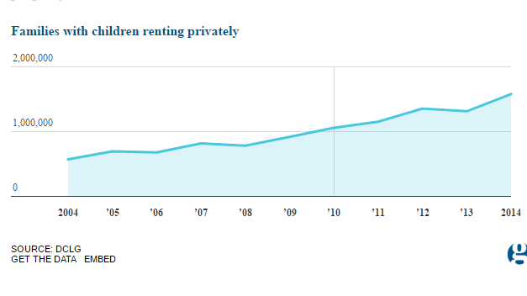

Fig. 2

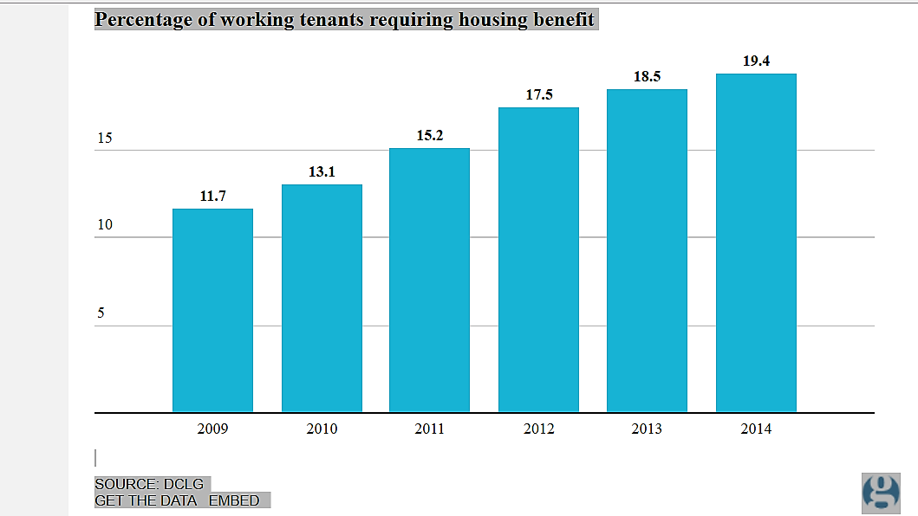

Traditionally within the industry, safety inspections are done for prospective home buyers and within the housing market. SaferStays targets and specializes in helping the renter rather than the home buyer. SaferStays’ inspections are tailored to meet the needs of the renter. Renters are not interested in the investment aspects or cosmetic issues, they want to make sure that the living space they are going to occupy is safe, free from dangers unknown to the untrained eye. Our varied target audience within the rental community helps to regulate the work flow, eliminating dead sales periods. It also provides us with a large and diverse customer base, giving us the opportunity to continuously expand and evolve.

*Competition*

There are numerous web-based inspection companies. However, we have different target markets. These companies concentrate on home buyers, and the more traditional general home inspection. We will use some of the same techniques, such as building our network and reaching inspectors. Virtually and locally copy cats will exist:

* Virtually, our indirect competitors (traditional home inspector sites) may try and pivot, going in the direction of renters.
* At the local level, individual home inspectors and companies may start adding safety inspections as a small service

To gain a competitive advantage, SaferStays plans to expand quickly and explosively. We will streamline the process as we go, making sure that it is always efficient and effective by:

* We will have Fred and other seasoned inspectors that we hire do test inspections from time to time in new and old markets alike to test both our computer systems and the actual inspection process
* Encouraging feedback from our inspectors and customers through surveys and mailings
* Inspectors will be required to watch sample safety inspection videos before performing their first inspection. SaferStays will provide the inspectors with an inspection template that they will be required to use. This will make our inspections uniform and easy to read. There will be sections for comments, allowing the inspector to make notes, because all properties are different.
* SaferStays will review all inspection reports before releasing them to the customer. We will check that all fields of the report are completed, that the inspector was thorough, and for grammar and spelling errors.
* Landlords that choose to have a safety inspection done will be given a list of items that our inspectors look for, to prep their property ahead of time for the inspection. This will save the inspectors’ time.

Eventually, SaferStays website will be completely automated, keeping us on the cutting edge and competitive. Our first upgrade will be making our site mobile friendly.

* + Follow-up emails will be sent to the customer automatically rather than manually
  + Initially, inspector reports will be provided through a link. The inspector will print the PDF, fill out the report, scan it, and upload it back to our site. Our next step will be to automate these reports. Inspectors will login in and access the reports virtually, fill them out with their tablet or smartphone and save them. They will automatically be uploaded to the site.
  + Each inspection will be given an ID number. We will manually include this number on our reports. As we begin automating the site, the ID numbers will automatically be carried over to the reports and emails which will help facilitate customer service and make our company auditable.
  + SaferStays will begin by manually matching the customer with an inspector in their area as we build our database of inspectors. As the database volume grows, we will automate the matching process. Eventually making the process completely automated, matching customers with an inspector, 24 hours a day 7 days a week.

*Pricing*

SaferStays.com charges $269 for a safety inspection. SaferStays keeps $70 of that and pays the inspector $199. We pay the inspector well as an incentive to work with SaferStays. We will offer discounted services to returning customers as well as promotional offers throughout the year. These include offering the customer their fifth safety inspection free, a family and friends discount code, and referral fees.  By keeping our inspection costs at roughly half the cost of a general home inspection, we make it more affordable and expand our target market.

Landlord pricing differs slightly so that we do not out price landlords. The inspection starts at $269 for a single unit plus $30 per unit. For example, the cost of a safety inspection for a duplex costs $299 or a 4-unit building costs $359. We pay the inspector the $199 plus $20 per unit. Again, this pricing technique puts us at almost half the amount a landlord would pay to have a traditional inspection done on his building while paying our inspector a decent fee.

*Advertising and Promotion*

* Currently, we are using grassroots marketing methods to get the word out to our customers.
  + Physically passing out flyers to local universities and their students, local business owners, landlords (particularly landlords who own student housing), insurance companies, and local inspectors.
  + Making connections with local legislatures such as our county executive, city council members, and Binghamton University personnel
  + Mail out packets that include flyers, door hangers, and letters explaining the agenda of SaferStays to both landlords and inspectors.
  + Physically visit inspectors and help to train them by doing a walk through
  + Send out surveys to our customers and include discounts as incentives for repeat business
  + Physically call customers, landlords, and inspectors to promote our product and get feedback
  + Create professional connections and networks to spread the word
* Advertising will consist of flyers and other marketing pieces such as large car magnets as well as light advertising in local newspapers. As we expand, we will begin to use marketing firms to promote our product and build on our image. We will use web and television advertising, and continue to use our grassroots marketing concepts.
* We will use our inspectors in each market to promote our service, as inspectors are our direct vein to the customer.

*Strategy and Implementation*

Our business is located in Binghamton, New York. This is our hometown; therefore, we have connections and a referral base. As our business grows, we will move into surrounding areas such as Syracuse, Albany, Rochester, and Buffalo, New York. Finally, we will move into Long Island and New York City. Once we have a market in all of New York State we will begin to expand nationally. Within three years, we plan to offer our services throughout all of New York State.

*Sales Forecast*

* Currently, we are building our database and inspection requests to the volume where we are able to efficiently match and complete a minimum of 40 inspections per week. The charge per inspection will be set at $269 per inspection. Of the $269, SaferStays keeps $70 and pays the inspector $199. Our gross profit will be $2,800 per week or $145,600 annually.
* Within the first two years we will complete at least 100 inspections per week resulting in a gross profit of $7,000 per week or $364,000 annually.
* Once SaferStays develops solid partnerships and expands into several markets, we will then look to perform 500 plus inspections per week, resulting in a gross profit of $35,000 per week or $1,820,000 annually.
* As SaferStays scales nationwide and within the first five years of operation, we will perform a minimum of 1,000 inspections per week, resulting in a gross profit of $70,000 per week or $3,640,000 annually.

*Appendix*

*Startup Expenses*

|  |  |
| --- | --- |
| Business Licenses | $25 |
| Incorporation Expenses | $250 |
| Trademarking | $1500.00 |
| Lawyer Fees | $2800.00 |
| Accountant | $300.00 |
|  |  |
| Equipment/Machinery Required: |  |
| Website | $21,000 |
| Office supplies | $200 |
| Item 3 |  |
| *Total Equipment/Machinery* | *$21,200* |
|  |  |
| Stationery/Business Cards | $35.00 |
| Brochures | $250.00 |
| Pre-Opening Advertising | $100.00 |
|  |  |
| Other (list): |  |
| Phone system | $26.00 |
| Amazon hosting certificate | $75.00 |
| **Total Startup Expenses** | **$26,561.00** |
|  |  |

https://ssl.gstatic.com/ui/v1/icons/mail/images/cleardot.gif

*Monthly expenses*

Our monthly overheard is extremely low, coming in under $225.00. As we grow, we expect this number to rise, however we will always be comparatively low due to the ability to work from home. Automating our website will further our ability to keep low overhead.

*Sales Forecast*

|  |  |  |  |
| --- | --- | --- | --- |
| *Years* | *# of Inspections/week* | *Gross Profit Per Week* | *Total Gross Profit*  *Per Year* |
| *1* | *40* | *$2,800* | *$145,600* |
| *2* | *100* | *$7,000* | *$364,000* |
| *3* | *500* | *$35,000* | *$1,820,000* |
| *5* | *1,000* | *$70,000* | *$3,640,000* |

*Our main marketing picture*

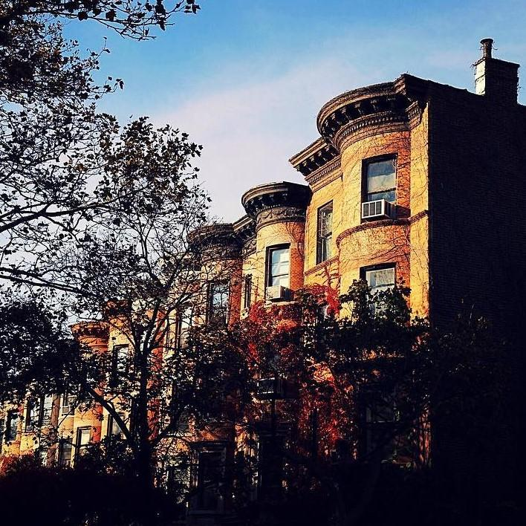

*SaferStays’ logo*



* Deck Collapse

<http://www.foxnews.com/us/2016/09/11/dozens-injured-after-decks-collapse-at-connecticut-house-party.html>

* London apartment fire

<https://www.nytimes.com/2017/06/14/world/europe/uk-london-fire-grenfell-tower.html?mcubz=1>