

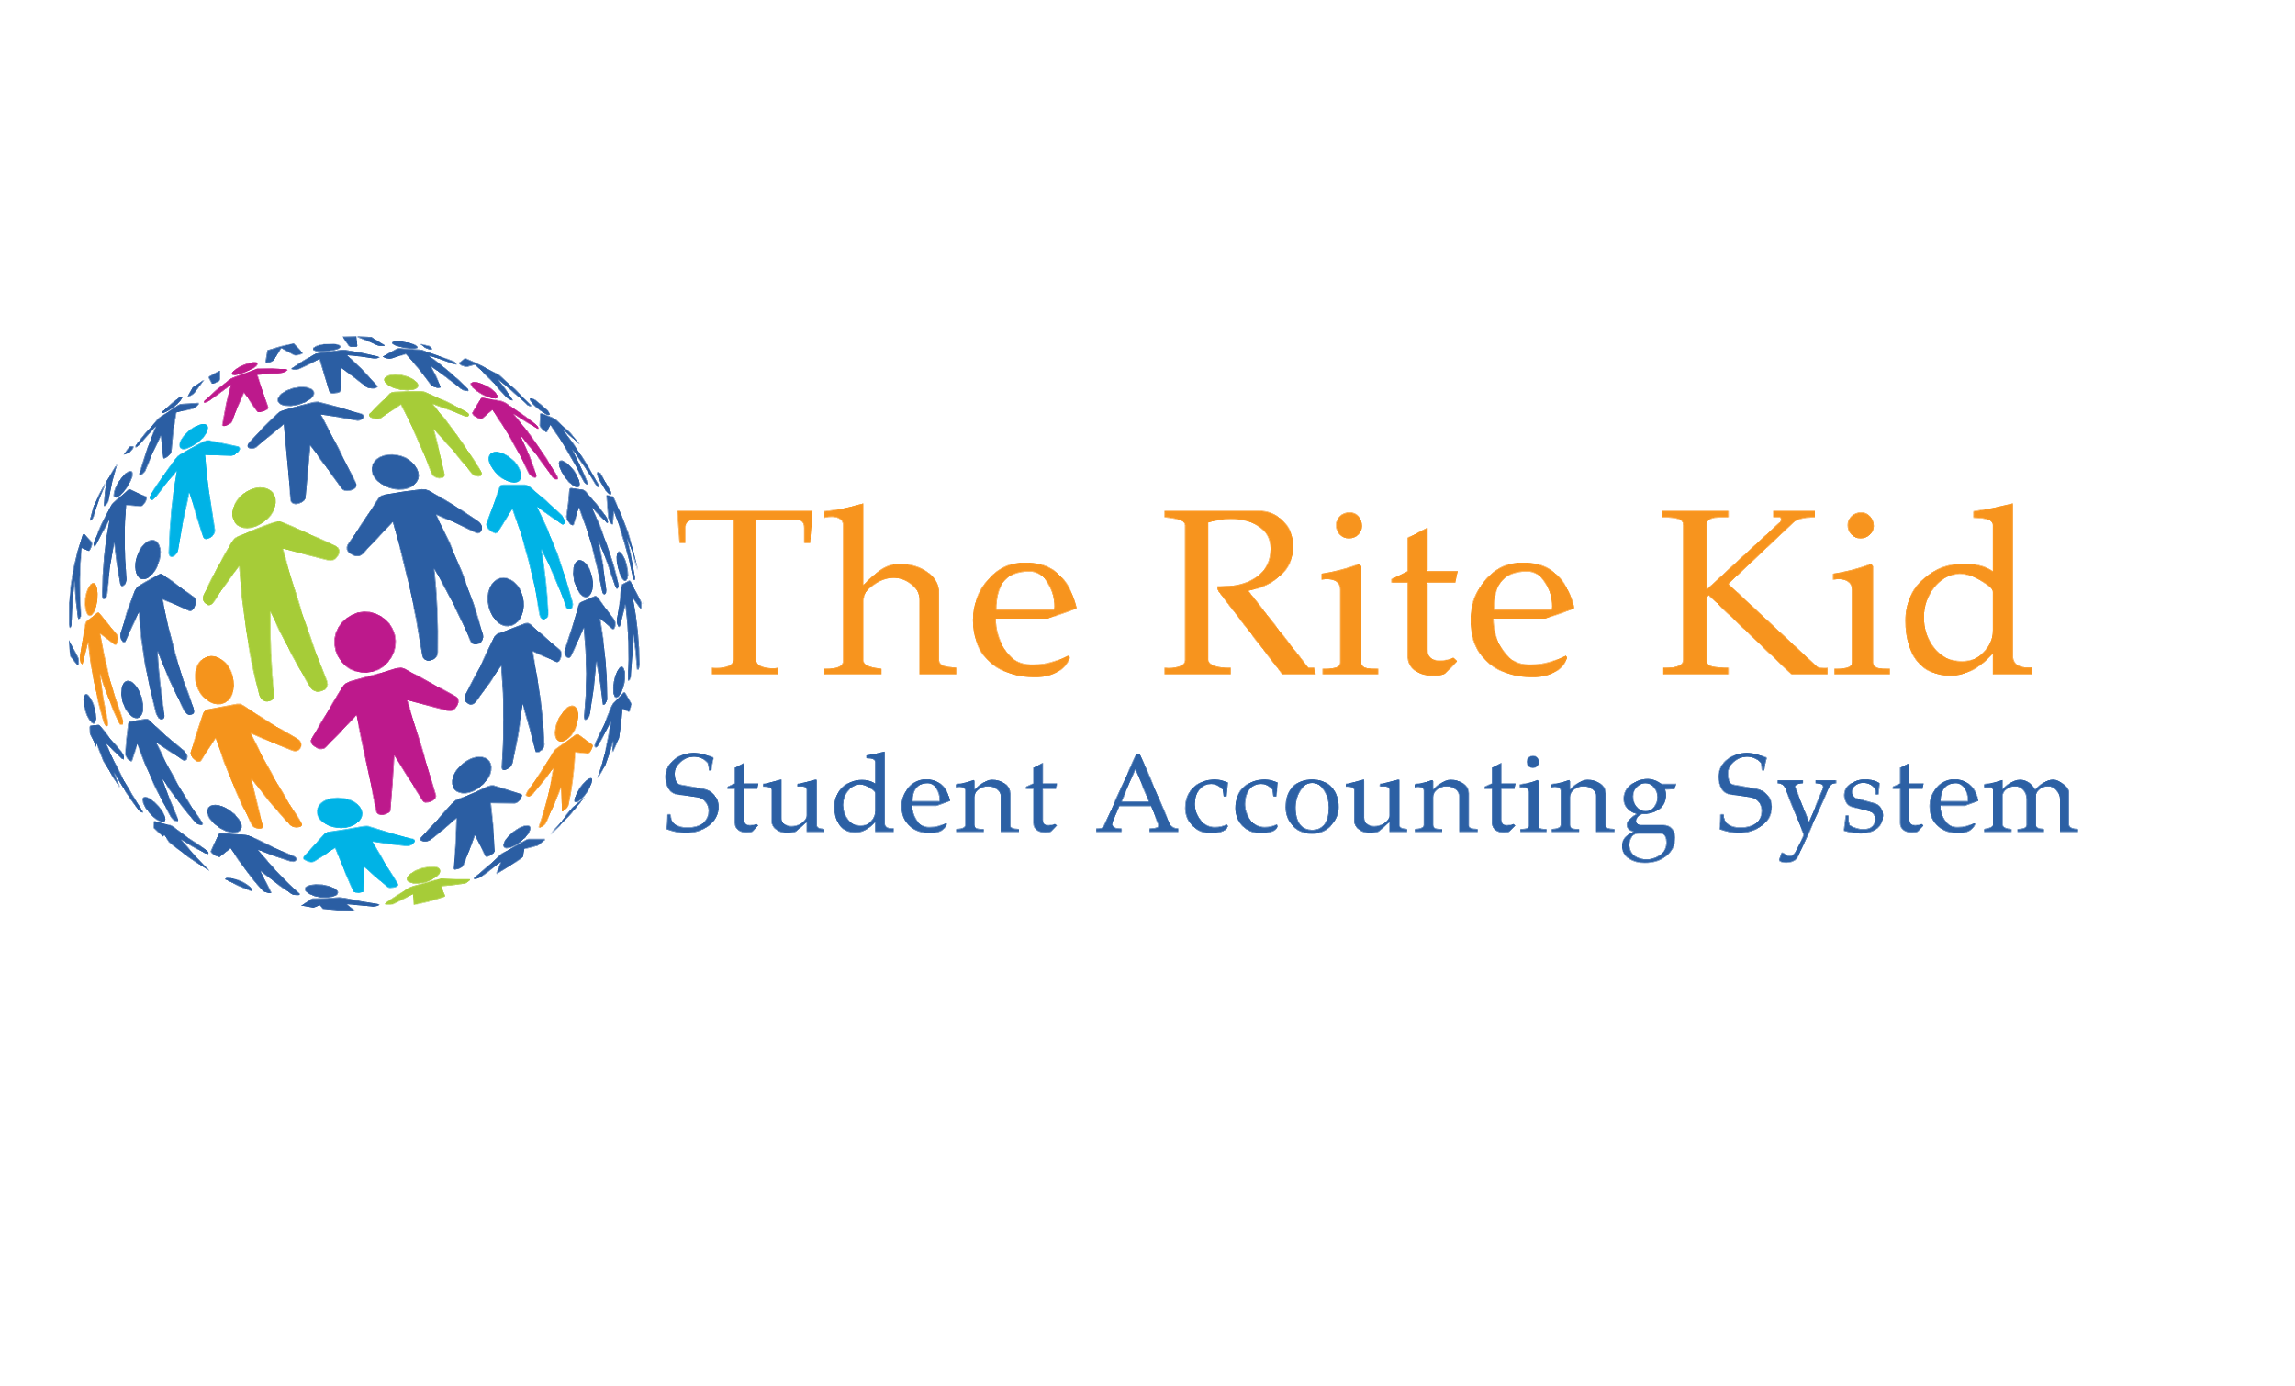



# Opportunity

## Problem & Solution

### Problem Worth Solving

Overall, the key problems The Rite Kid will solve are:

* Student release accountability
* The daily chaos of student release and pedestrian endangerment
* Governmental budget cuts and funding

The elementary school pickup process is complicated due to the increase in divorce rates, single parent homes, working mothers, and dual income families. Parents are forced to call on a myriad of caretakers to collect their children at the end of the school day. Delivery of those changes are received by various school staff members in lieu of notes, emails, text messages, phone calls, etc. - which leaves room for substantial error.

Through piloting the Rite Kid's dismissal solution, the install experience proved that on average each student has six to eight people on their approved pick up list. On average 446 students attend each elementary school across the nation. That generates roughly 3,200 approved pick up people per school! It is not possible to recognize 3,200 people, and accurately match them with the right child, without accessing real-time digital records.

According to the Department of Justice, 800,000 children go missing each year in the US – one every 40 seconds – it’s critically important to note that 76% of those missing children are abducted by 'people they know'.  A child’s willingness to get in the car with someone cannot be the metric to determine if it’s safe to release the child to that individual. The benefit of these digital records is the ability to account for each child’s dismissal, not only creating a culture of accountability, but also a reduction in significant liabilities faced by school officials.

Additional statistics include:

* 50% divorce rate which increases significantly for subsequent marriages
* 66% of families in the U.S. have parents that are both working
* 70% of working women care for children under 18 years old
* 57% of working age women participate in the labor force and 74% work full-time
* As of 2016, there are 12 million single parent homes in the U.S.
* Funding to K-12 education will cut $5.9 billion dollars in 2018

Furthermore, there is a hazard of children walking between cars during typical release procedures. This danger is amplified by the reality that most drivers waiting for children to come outside at release time are on their cell phones. Drivers using hand-held devices are four times more likely to get into crashes, as it delays a driver’s reaction as much as having a blood alcohol concentration level of .08 percent.

### Our Solution

To solve the problems, The Rite Kid will provide the following features and benefits:

* Student Accountability System
* An organized, safe, and efficient "car-line, van, walker, and bus" student release process
* Charitable donations of funds

The Rite Kid strives to improve safety and accountability throughout all aspects of the student dismissal process. It gives schools the proper verification tools needed, while tracking and recording all student dismissals. Parents have peace of mind about who is picking up their child because they are alerted as soon as the child gets leaves campus.

The Rite Kid will improve efficiency throughout the entire school day while increasing the amount of teaching time because dismissals are no longer a task for teachers.  The Rite Kid streamlines all communications and processes through the front office, providing faculty and parents with the tools they need to safely, efficiently and effectively dismiss hundreds of children in minutes at the end of each school day, with perfect accountability.

The Rite Kid’s release system increases pedestrian traffic safety by releasing children in the order cars are lined up outside, one lane at a time. Children no longer will have to walk through moving traffic.

With the reality of shrinking education budgets, The Rite Kid implements a tech philanthropy platform which provides a potential revenue stream. While demand for the safety and accountability continues to rise, schools are facing massive funding cuts. The Rite Kid’s goal is to deliver the critical safety and accountability that parents, teachers and administrators demand but also establish financial resources that deal with the unpredictable social demands on school safety.

*See the following diagram for a visual presentation of the process.

**Highly, confidential demo video available at:** <https://youtu.be/3iMHulYFNQM>

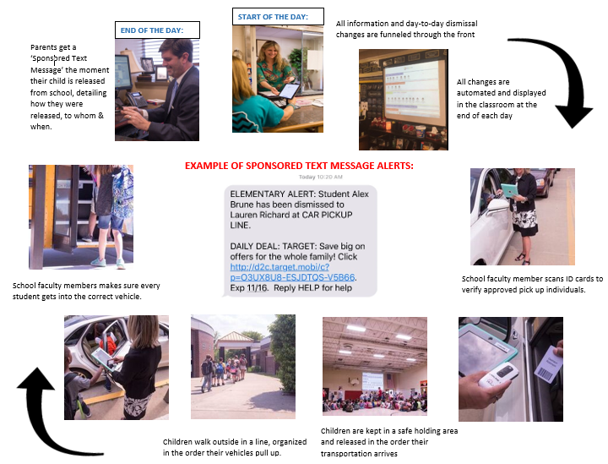

## Target Market

There are 86,386 elementary schools in the United States, with 55.6 million students currently enrolled at them.  The target market is separated into two segments consisting of administrators and parents/guardians. First, the administrators, who are responsible for decisions that affect student safety and accountability needs on campus. Second, the parents/guardians, who create an ongoing demand for advancements in school security. Not only does The Rite Kid’s comprehensive student safety/accountability solution meet the needs for elementary schools; it can help with any kind of activity that involves dropping off and picking up kids.  This process could potentially help at preschools, Sunday schools, after school programs, sports activities, camp environments, and more!

The Rite Kid's target market segments include:

* Administrators - As the primary target market, administrators face a significant challenge resulting from lack of accountability during daily dismissal procedures. The liability associated with this process is significant and stressful. The ability to account and track the safe dismissal of each student, relieves both stress and liability for the school.
* Parents/guardians - The secondary target market are parents/guardians of elementary students or kids involved with anything that includes drop off/pick-up duties. The intent is to use focused marketing efforts to generate urgency from parents/guardians to demand ongoing safety needs for their kids.

## Competition

### Current Alternatives

While several companies have worked for years trying to implement student dismissal systems, each competitor’s product lacks the comprehensive set of tools, security procedures, features and functionality required to successfully conquer the market. Competitors include PikMyKid, School Dismissal Manager, Car Rider Pro, tavtrac and School-Pass.

**PikMyKid** touts itself as being the ‘#1 Student Dismissal System’.  It employs a geo-fence that allows parents/guardians to log into an app on their phone to announce they’ve arrived on campus.  They ship clients a stop sign and a set of instructions on how to use the software and smartphone app.  However, their success has yet to truly gain national attention, due to where they fall short on personal verification security measures and an only 85% parent/guardian adaptation rate.  If you steal a phone, you can abduct a child.

**School Dismissal Manager** offers a web-based software platform with an extensive parent/guardian user interface.  The system allows parents to make changes to their child’s daily dismissal method via logging into the system from a remote home or office computer and/or smartphone. While the multiple features seem convenient to some parents, it is limited to those that speak English and are tech savvy, due to the complicated nature of the software.

**CarRiderPro** is a system that requires a school to install an expensive vehicle entryway, which registers cars as they drive through it and up to the school.  The technology works by utilizing long range readers that identify the order of the cars pulling, and match them with the children that they are assigned to pick up each day.  This technology is limited to the car line and does not account for Walkers, Bus Riders or vans that pick students up at the end of the day for after school programs/daycare.  While limited in its ability to account for ALL student dismissal types, it also has a high up-front cost and lacks human verification processes.  If you steal a car, you can abduct a child.

**Tavtrac** is a comprehensive solution to student dismissals.  It employs a great deal of data and uses the image of the child throughout software applications, which fails to meet FERPA (Federal Education Resource Protection Act) guidelines.  However, this company directly states that it only does business with ‘Independent Schools’, thus FERPA compliance is not applicable to them.  This product fails to meet the needs of public and/or low-income school districts that receive Federal funding.

**School-Pass** is another example of a robust system that deals with the daily changes to student dismissal schedules, which gives parents online tools and smartphone apps to log changes without having to send notes or call the school.  However, it’s also an example of employing too much technology in favor of efficiency, which loses effectiveness in terms of student safety.  It utilizes long-range readers and license plate recognition to automate the approved pick up verification process, lacking human contact required to effectively keep students safe.  If you steal a car, you can abduct a child.

In summary, while there are several competitors in the market, each falls short of The Rite Kid’s solution.  The parent/guardian technological interface is often difficult for end users to navigate. Therefore, taking too much of the student dismissal responsibility away from school officials, who ultimately are liable for the outcome.  In addition, they use technology with heavy up-front costs and eliminate staff needed for dismissals. However, saving time and money for staff, the competitor's systems lack the human verification truly required to execute a safe and accountable dismissal process. For example, the governmental protocol for boarding an airplane consists of personal ID verification by a TSA agent. Thus, scanning a license plate, RFID or a cellphone isn't adequate to verify an individual's identity. The Rite Kid employs a mix of technology and human touch, that's required to efficiently and effectively meet the needs of all stakeholders.

### Our Advantages

The vision of The Rite Kid is to meet the current safety and accountability demands of parents, teachers and administrators while providing funding for ongoing technology advancements to school security. In addition to offering features consistent with their competitors, The Rite Kid takes the student accounting and dismissal system to the next level by blending human verification with technological efficiencies.

This system sets itself apart by:

* Human verification
* web based/BYOD
* FERPA Compliance
* Offers technology and funding solutions to all schools

The significance of The Rite Kid's model is its entrepreneurial approach to school's technology needs by means of giving back. With their Tech-Philanthropy platform, The Rite Kid partners with schools to provide all kids, with the same level security and accountability they deserve.

# Execution

## Marketing & Sales

### Marketing Plan

The Rite Kid is entrepreneurial approach to bring technology solutions to schools through direct marketing, building relationships, and brand awareness. Their mission will focus on this key message:

**"The Rite Kid Assures That The Rite Kid Goes Home The Rite Way Every Day"**

The marketing strategy will focus on stimulating demand by presenting The Rite Kid solution to the parents of the school’s first. It will emphasize the fact that there is a safer and more efficient option than the current school dismissal process. This is a model designed to bring technology solutions to elementary schools that focus on the importance of safety, accountability, and peace of mind to parents.

Marketing activities and tools will include:

* Website
* Targeted social media campaigns (Facebook, Pinterest, Twitter, and Instagram)
* PTO meeting presentations
* Promotional materials and swag
* Trade shows
* Mobile marketing (People look at their mobile device 150 times a day)

A key part to the success of The Rite Kid is bringing the parents on board by creating 'word-of-mouth' advertising. This will partially be accomplished when parents naturally become brand ambassadors by telling their friends about the advantages of having The Rite Kid installed at their schools. However, the mobile marketing will also aid in providing an opportunity for families, schools, and communities to benefit from the offers they are receiving through the use of The Rite Kid.

### Sales Plan

The Rite Kid uses a grassroots approach to appeal the parents demand for a safe, accountable, and modern student dismissal service. This demand will influence the school board and administrators who make budgetary decisions. With the reality of shrinking education budgets, The Rite Kid implements a tech philanthropy platform which provides a potential revenue stream. There's a critical need to employ not only technologies but also establish financial resources that deal with the unpredictable social demands on school safety.

Interested users will be able to view an online demo and schedule a live online consultation through The Rite Kid website. There will be contact information like email and phone provided to request additional details regarding the service. Unlike similar products, The Rite Kid, sends representatives to your school to assist with software installation and the staff training required to use the system. The Rite Kid is not only a product but a service through collaborative partnership.

Prior to installation, there's a one time initial set -up fee with yearly, reoccurring subscription charges for the student dismissal system. Furthermore, The Rite Kid affords schools with the potential to finance the service by using mobile marketing. The daily student notification message supplies a link for discounts that parents can use at businesses in their local community. This a tech philanthropy platform that can provide schools with an additional revenue stream after covering the cost of installing the system.

The Rite Kid provides a peace of mind alert system that comes with promotions aimed to aid the growing number of working parents, while meeting the accountability and safety needs of schools.

## Operations

### Locations & Facilities

The Rite Kid does not have a set headquarters at the moment. We utilize the offices of The Rite Group in Jackson, Missouri, for team meetings. Client meetings are held at client locations and all employees can successfully continue to work for The Rite Kid and access shared documents while on the road. Employees also maintain home offices, with remote connectivity to our client database, email and servers. This works well for our corporate structure and our employees enjoy the flexibility.

### Technology

The Rite Kid employs a BYOD (bring your own device) system allowing schools to use the smart devices (computers, tablets, projectors, smartphones, etc.) they already have, at low up-front cost to implement new dismissal software and procedures.  The student dismissal system utilizes web based encrypted software, that can run on a school's WAN, LAN, WIFI or LTE network. The system provides an alternative if there is a campus-wide network failure, allowing teachers to use their smart phones to run the dismissal system, connecting to our server via the cellular network. When students are released from school using The Rite Kid, parents receive a real-time text message alert, detailing who picked their child up from school that day, or however they were released.

The front office utilizes a touch-screen hands-free device to log all sign-in/sign-out records, as well as visitors on campus.

Parents are provided with a smart-phone app to log into their child's dismissal account, to automate the process of executing daily changes to their child's standard dismissal schedule.  This takes pressure off the front office having to receive calls and log each child's changes, as well as removing the need to send hand-written notes or emails to school with children, to communicate changes to dismissal schedules.

Parents have the option to opt-in for text message alerts which includes a link to a daily sponsored promotion that parents can use at businesses in their local community. The Rite Kid is in compliance with the Federal Trade Commission (FTC) and Federal Communications Commission (FCC) which concerns the rules and regulations pertaining to messages sent to mobile devices.

# Company

## Overview

The Rite Kid is registered as a limited-liability company and is owned and operated by Lauren Anne Cole, President & CEO.

No outside investors are involved at this time, although there will be an opportunity for investment as the business grows.

## Team

### Management Team

The following key roles have been identified and filled:

* President & CEO, Vice President of Sales - Lauren Anne Cole

Lauren Anne Cole has 7 years’ experience and is currently working as a Technology Integrator and specializes in video surveillance, access control and telecom, with a strong focus on school security in the Cape Girardeau, Missouri area.   
Lauren holds an Honors BS Degree in the field of economics, with a minor in statistics from Rollins College, in Winter Park, Florida (Cum Laude / John R. Commons Award for Excellence in Research and Analysis). She was admitted into the MBA program and attended Daniels School of Business at the University of Denver.

* Vice President of Marketing- Allison Brune-Evans

Allison has a Bachelor of Arts degree in print journalism with an emphasis in public relations from the University of Mississippi. She has over 11 years of professional experience in advertising, multimedia marketing, public relations and development through Clear Channel Communications and the Cripps Howard Network.

* Software Engineer & Install Technician - Owen Sandler

Owen has worked in the technology industry under The Rite Group for over 10 years. He specializes in telecom, data networks, video surveillance, technology integration, access control and security. He has extensive experience working directly with Lauren implementing school security systems.

Other positions needed to correctly staff the operations of The Rite Kid:

* Commission based sales representatives
* Administrative assistant

### Personnel Table

|  |  |  |  |
| --- | --- | --- | --- |
|  | **FY2018** | **FY2019** | **FY2020** |
| Sales - Lauren Anne Cole | $72,000 | $114,000 | $125,000 |
| Commission Sales Reps |  | $118,808 | $208,320 |
| Additional Sales Reps |  |  | $312,480 |
| Marketing - Allison Brune-Evans | $42,000 | $84,000 | $100,000 |
| Software Developer & Techs | $99,000 | $174,000 | $200,000 |
| Administrative Assistant | $30,000 | $30,000 | $30,000 |
| **Total** | **$243,000** | **$520,808** | **$975,800** |

Additional positions that may be filled if a real need is deemed necessary:

* Co-Owner/Investor
* Chief Financial Officer
* Chief Operating Officer

### Advisors To ensure that all aspects of the proposed business concept are considered and reviewed the management team have identified a group of advisors:

* T. Robin Cole, III - President and Owner of The Rite Group, a 50-year old technology firm located in Cape Girardeau, Missouri
* Jeff Spray - Lawyer at Osburn, Hiane, & Yates, LLC
* Virgil Jones - Owner/President at ServiceMaster PCS
* Dr. Erin Fluegge - Professor of Management at Southeast Missouri State University, PhD in Business Administration
* Courtney Beattie & Kayla Ray - Small Business Technology & Development Center Business Consultants at the Cape Girardeau Center for Engagement
* Southeast Missouri State Market Research students

# Financial Plan

## Forecast

### Key Assumptions

These assumptions were generated with conservative figures, based on the pilot programs of 3 different elementary schools located in Missouri, and based on independent third-party research conducted by Southeast Missouri State University to show that the company can and will be sustainable.

**Revenue Assumptions**

The revenue structure for The Rite Kid is separated into two package options and an additional revenue stream generated by text advertising. The Rite Kid assumes that most sales will be made August through April and the slower sales months are May, June, and July because of the timing of the school year.

Software Only Package:

Cost - $2,500 per year

The software only package includes an interactive database application in the front office which communicates daily dismissal changes to each classroom and eliminates the need for handwritten notes and intercom announcements.  
Schools may only want the software due to difficult driveway and parking lot configurations where the car and bus lines are not conducive to systematic lane operations.

The Rite Kid has set achievable goals and believes that they can produce new sign-ups of the software only to 10 schools in the first year, 20 schools in the second year, and 30 schools in the third year. The software package is sold at a constant price of $2,500 per year for software licensing meaning this is an annual reoccurring fee. Considering that customers potentially may not continue with our services, a churn rate of 10% is included in the assumption. After including the 10% churn rate and adding the reoccurring sales carrying over from year to year, there will be revenue generated from 10 schools in the first year, 29 schools in the second year, and 57 schools in the third year.

Full Package - Software & ID Verification Dismissal Process

Cost - $6,000 per year, plus a $2,500 installment fee

The full package includes the software package plus 2 days of on-site installation of systematic lane operations and training for parents, teachers, and staff. Hardware is also provided and includes 2 ID cards per student for the individuals on the approved pick-up list and card scanners.

The Rite Kid has set additional goals and believes that they can produce new sign-ups of the full packaged product to 20 schools in the first year, 30 schools in the second year, and 40 schools in the third year. The full package is sold at a constant price of $6,000 per year for software licensing meaning this is an annual reoccurring fee. There is also an initial installment fee of $2,500. Considering that customers potentially may not continue with our services, a churn rate of 10% is included in the assumption. After including the 10% churn rate and adding the reoccurring sales carrying over from year to year, there will be revenue generated from 20 schools in the first year, 48 schools in the second year, and 80 schools in the third year.

SMS Advertising

Revenue is generated on a CPM (cost per impression) formula which is based on contemporary practices in the political fundraising arena regarding SMS text messaging. This model is increasingly becoming popular with such retailers as Target, Walmart, and food chains.

The advertising revenue for 1,000 CPM is $125. This number is conservative because it is estimated at $200 per 1,000 CPM in the political realm.

There is an average of 446 children per U.S. elementary school. Each child is assumed to require the delivery of two SMS text messages relaying the student’s dismissal status per day. There are 180 school days in the year. For an average school that equals 892 text messages sent out per day and 160,560 per school year. With a CPM priced per 1,000, this yields a multiplier of 160.56 at $125 and leads to a net income of $20,070 per school per year.

The demand for daily dismissal, targeted text message advertising is significant, because of the focused geographic location of the target audience and the fact that they all have children of the same age.

**Direct Costs Assumptions**

The direct cost of installing the software only is set at 10% of the revenue generated. This equals $250 and considers the cost of downloading student information from the school's SIS (Student Information System) and populating The Rite Kid database with the given school's enrollment information. Additionally, online training will be provided and kept up to date as the system evolves.

The direct cost of the full package is equal to 100% of the $2,500 generated from the initial install fee. Included in this direct cost is travel and hotel cost for the staff, training materials, ID scanners, 2 ID cards per student, and an iPad stand for the front office (for the student and visitor sign-in/sign-out tablet).

Lauren plans to take 50% of the revenue generated from the text advertising and give a charitable donation back to schools to cover the cost of The Rite Kid software and services. There is also a 5.7% direct cost of total text messaging fees taken out of the net revenue.

**Expense Assumptions**

The marketing expense is set at the general business average of 3% of net revenues and increases with the growth of the company. Additionally, education industry trade shows are vital to the market growth of The Rite Kid. Taking this into consideration, an additional 1.5% of net revenues is allocated to this important marketing opportunity. These trade shows take place locally, as well as nationally. There is about $12,000 assigned in the first year of operations, about $30,000 in the second year, and a little over $50,000 in the third year.

Other expenses included in the financial assumptions are training videos, cloud hosting services, cell phones & data, office supplies, general liability insurance, professional services (accounting & legal), and website fees.

The Rite Kid's expense assumptions also include a miscellaneous expense. This expense is set at 1% of overall revenue to account for any unexpected expenditures that could occur. These totals equal about $8,000 in the first year, about $20,000 in the second year, and about $35,000 in the third year.

**Asset Assumptions**

There is an estimated hardware cost associated with every new hire set at $2,200. This includes a computer and a multi-function printer that can print, copy, fax, and scan.

There will be an opportunity to have a headquarters in the future and this could be a potential asset of The Rite Kid, LLC.

### Net Profit (or Loss) by Year

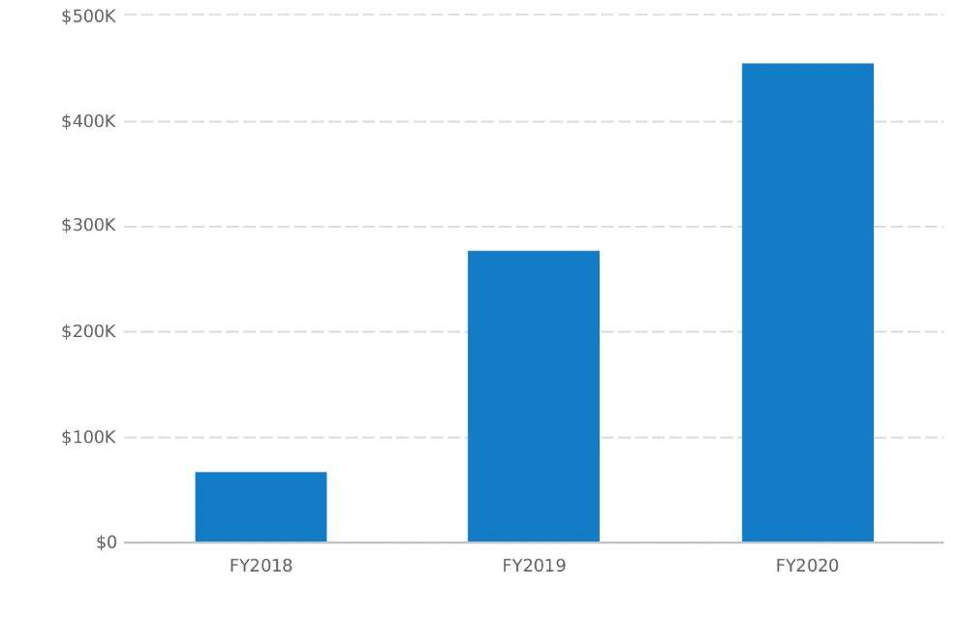

## Financing

### Use of Funds

Additional funding will help The Rite Kid expand the market reach of the company by traveling and promoting the product, service, and SMS text advertising platform to potential customers outside the Missouri region.

## Statements

### Projected Profit & Loss

|  |  |  |  |
| --- | --- | --- | --- |
|  | **FY2018** | **FY2019** | **FY2020** |
| **Revenue** | **$796,875** | **$1,980,125** | **$3,472,000** |
|  |  |  |  |
| **Direct Costs** | **$459,744** | **$1,175,414** | **$2,291,522** |
|  |  |  |  |
| Gross Margin | $337,131 | $804,711 | $1,180,479 |
| **Gross Margin %** | **42%** | **41%** | **34%** |
| **Operating Expenses** |  |  |  |
| Salary | $171,000 | $288,000 | $330,000 |
| Marketing | $23,906 | $59,404 | $104,160 |
| Trade Shows | $11,953 | $29,702 | $52,080 |
| Training Videos | $4,000 | $2,500 | $2,500 |
| Cloud Services | $7,200 | $21,600 | $36,000 |
| Miscellaneous | $7,969 | $19,801 | $34,720 |
| Cell Phones & Data | $6,000 | $6,000 | $6,000 |
| Office Supplies | $4,800 | $7,200 | $10,000 |
| General Liability Insurance | $9,600 | $13,800 | $20,000 |
| Professional Services | $2,400 | $4,200 | $7,500 |
| Website | $1,800 | $1,800 | $1,800 |
| **Total Operating Expenses** | **$250,628** | **$454,007** | **$604,760** |
|  |  |  |  |
| **Operating Income** | **$86,503** | **$350,704** | **$575,719** |
|  |  |  |  |
| Interest Incurred |  |  |  |
| Depreciation and Amortization | $2,200 | $3,667 | $5,866 |
| Income Taxes | $16,861 | $69,407 | $113,970 |
| **Total Expenses** | **$729,433** | **$1,702,495** | **$3,016,118** |
| **Net Profit** | **$67,442** | **$277,630** | **$455,882** |
| **Net Profit / Sales** | **8%** | **14%** | **13%** |

### Projected Balance Sheet

|  |  |  |  |
| --- | --- | --- | --- |
|  | **FY2018** | **FY2019** | **FY2020** |
| Cash | $51,491 | $321,260 | $884,208 |
| Accounts Receivable | $0 | $0 | $0 |
| Inventory |  |  |  |
| Other Current Assets |  |  |  |
| **Total Current Assets** | **$51,491** | **$321,260** | **$884,208** |
|  |  |  |  |
| Long-Term Assets | $6,600 | $11,000 | $17,600 |
| Accumulated Depreciation | ($2,200) | ($5,867) | ($11,733) |
| **Total Long-Term Assets** | **$4,400** | **$5,133** | **$5,867** |
|  |  |  |  |
| **Total Assets** | **$55,891** | **$326,393** | **$890,075** |
|  |  |  |  |
| Accounts Payable | $0 | $0 | $0 |
| Income Taxes Payable | ($12,321) | ($20,219) | $28,405 |
| Sales Taxes Payable | $770 | $1,540 | $60,716 |
| Short-Term Debt |  |  |  |
| Prepaid Revenue |  |  |  |
| **Total Current Liabilities** | **($11,551)** | **($18,679)** | **$89,121** |
| Long-Term Debt |  |  |  |
|  |  |  |  |
| **Total Liabilities** | **($11,551)** | **($18,679)** | **$89,121** |
|  |  |  |  |
| Paid-in Capital |  |  |  |
| Retained Earnings |  | $67,442 | $345,072 |
| Earnings | $67,442 | $277,631 | $455,882 |
| **Total Owner's Equity** | **$67,442** | **$345,072** | **$800,954** |
|  |  |  |  |
| **Total Liabilities & Equity** | **$55,891** | **$326,393** | **$890,075** |

**MAY, 2017; TANSCRIPT OF TESTIMONIALS TAKEN FROM PILOT SCHOOL STAKEHOLDERS**

Clippard Elementary School, Cape Girardeau, MO

**OPINIONS ABOUT STUDENT DISMISSAL PROCESSES BEFORE INSTALL:**

“In today’s society, in today’s world, unfortunately**, we have to be aware of the accountability and the safety of our students at all times**…We had the students come outside, and they would wait under the awning, and raise their hands when they saw their cars. This created a **problem for time**, because the students weren’t always paying attention when their cars were there. Sometimes they would have a different person pick them up so they wouldn’t recognize the car”

* Principal, Clippard Elementary School

“It was a little **chaotic** outside. Essentially we would send all the kids outside, they would try to **wave down their parents like they were in Times Square**, and we would send the kids out to try to catch their mom or dad, as they were pulling up through the driveway. **We’d have kids walking through cars and we’d have teachers just flailing and grabbing children by the hand and it was a little bit nuts**, but it was always the way it was, we never really thought there was another way of doing it, so that was just sort of what we dealt with.”

* Teacher, Dismissal Duty

“So, I’m Jeff Brune and I have a son at Clippard Elementary in Cape Girardeau. We’re a **dual income family**, so, my wife’s a Nurse, and I’m a Banker, and our hours are pretty hectic. I have a lot of social things that I have to go to after work, and, uh, so we have two nannies that pick the kids up, sometimes three, depending on who’s doing it. And, **beforehand, we knew who was scheduled to pick up, but we didn’t a lot of times know who actually ended up doing the pick up**, so after school, you know, we would have to text multiple people, saying, ‘hey, do you have the kids?”. And so**, it really was, inconvenient, didn’t feel very safe**, we trusted the girls of course, but, **it didn’t feel very safe** that they could be anywhere in town.”

* Banker, Dual-Income family, parent of a student at Clippard Elementary

“Before, they had a list that you signed of who was approved to get your child. And, that was really officially what you would go by, but that was more for if you went into the school and picked them up, because they had that information right there, at their computer screen. But **the teachers at the release times, they have no access to technology or anything, they can’t possibly remember 400 students approved pick up list, and know their vehicles**.”

* Mother (dual parent home) of a student at Clippard Elementary

**OPINIONS ABOUT STUDENT DISMISSAL PROCESSES AFTER INSTALL:**

**“It has given us that accountability piece to be able to print off those reports and be able to tell you where every student has gone and who has picked them up. And the safety factor, it is providing a piece of mind for the parents and for the teachers and administrators, and for the students themselves, that we are putting their safety first and are only allowing them to go with someone who has been approved by their parents.”**

* Principal, Clippard Elementary School

“We just moved here, not too long ago, from Texas. I see they have a **new system** to how they pick the children up in the afternoon, which **I think is great, because it makes me feel like it’s safe, it’s convenient, there’s no problems**…**I can have my son in and out pretty fast, within 10 minutes, because before they had this process it took 20 or 30 minutes**.”

* Single Mom, Nurse – Parent of a student at Clippard Elementary

“So **we don’t have to worry about someone else, friend of the family or whatever, that doesn’t have our permission, picking up the child**. And **the quickness of the procedure now is so much better** for some of us that have to pick up children at other schools after this. We were constantly late before, and now we’ve got plenty of time to pick up the other child.”

* Grandparent of a child at Clippard Elementary School

“I don’t care if I have to wait 20, 15, 30 minutes, but **safety, and not hitting a child in this parking lot is important**. And **it’s safety first, when it comes to our kids**, because you don’t want to wait until something happens, and THEN let’s have safety. Lets prevent it by doing this first. And then also, I like the new system because it gives me text messages when it’s time or when someone has come to pick up my son, because recently I just started a new job, just moving here from Texas, and when my girlfriend picks him up, it gives me text messages at work to let me know she’s picked him up, and **I think that’s a great system, because I know my son is safe**, she’s got him, and it’s all good.”

* Single Working Mom

“**Before**, ya know, it was structured, but only structured to the point that they thought they could structure it. **They didn’t know there was any other way**. And so, it ran seemingly smooth and they did what they did what they could with it. **But** **now, ya know, it’s a completely different** **way of thinking** about how you are going to be picking your kids up and how other people are going to be picking your kids up.

* Father of a child at Clippard Elementary

“I would just tell other teachers in other buildings that **there IS another way**. **The end of the day doesn’t have to end in chaos**. The end of the day can be as organized as any other part of the school day**. I would just assure them that it doesn’t have to be like this, there IS another way to do this.”**

* Teacher, Dismissal Duty

“So, **this is one of the biggest things I LOVE about this**, I’m sitting here responding to emails, and we had a change in who’s picking the kids up, and **I get a text message, a text alert, that tells me, that confirms who picked them up and when, and now that they’re out of school**.”

* Working Dad, Parent of a student at Clippard Elementary

“**The release of kids was SO chaotic**, they, first of all, are outside in the elements, they are under pavilion, but **you have 4 lines of traffic that kids are crossing in between, and parents aren’t all paying attention, half of them are on their phones anyway, so if they go, there might be a kid in front of them**, you just don’t know. You’re hoping that they’re paying attention, because they’re at a school, but they may not be.”

* Working Mom, Parent of a student at Clippard Elementary

“**Once we started it’s completely different**. We would actually bring all the kids to the gym holding area, the kids line up, nice and organized, and we get them into single file lines, and we know exactly where everyone is going, because their names come up on the screen, **we know exactly where these kids are going and who is picking them up** **at the end of the day so all that chaos I talked about was gone and it is a streamlined process and it was organized and it was just AWESOME**.”

* Teacher, Clippard Elementary School

“Fr**om what I’ve seen, I don’t think a school cannot afford it, they HAVE TO afford it**. You afford what you want, in this, in this space, and **when it comes to the safety of your students, you’ve GOT to do it.**”

* Father, Banker, Dual-Income Family