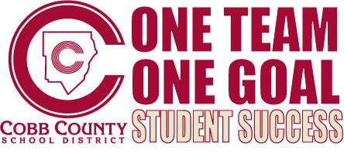

USDA School Meal Programs Verification Response Rate Challenge- Video Transcript

VERIFICATION SOLUTION: Organization and LOTS of follow up!

(Music: Christian Groves)

(Speaking: Heidi Groves, Regulations Supervisor, Cobb County School District)

As the second largest school district in the State of Georgia, Cobb County School District verifies hundreds of family meal applications each year. We hope you find our solution of organization and follow-up helpful.

1. We start by creating a file folder for each selected family. The folder should include the following:
   1. A verification worksheet (visible)
   2. Copy of the Application (visible)
   3. Household information from school database.
2. Next, send the federal Notification of Selection Letters to the family’s home address.

If no response is received:

1. Follow-up:
   1. Send the required Follow-up letter to the selected family’s home address and email.
2. Use phone scripts to make follow-up phone calls, have different phone scripts for: (visible)
   1. A phone script for leaving a message if no one answers.
   2. A phone script for when someone answers.
   3. A phone script for missing information.
   4. Each phone script should include a place for taking notes such as the date & time, who you spoke with, and details of the call. This way the most up-to-date information is being noted for each family selected for verification and you can stay on task and organized.
3. Another great idea for staying organized is to color code folders. During verification, place colored tabs on folders to help save on time, for example:
   1. Blue Tab – The verification process is complete. (visible)
   2. Yellow Tab – The family needs to send in additional information in order to complete verification. (visible)
   3. No Tab –Information has not been received from this family. Continue with follow-up procedures.
4. Continue reaching out to the families that have not responded by calling and emailing until the final deadline.

How do we measure this success? In the year we implemented our new strategy we increased our response rate dramatically. (Documents shown):

As you can see, in 2009 we were struggling to meet the required response rate so in 2010 we implemented our new strategy and received a vast improvement as our non-response rate improved to 9.3 %. Each year since, we have been able to meet the federal bench mark for the required Verification Response Rate.

Thank you for your time and we hope this has been helpful for your school system to successfully complete the federal verification requirements for the National School Meal Program.