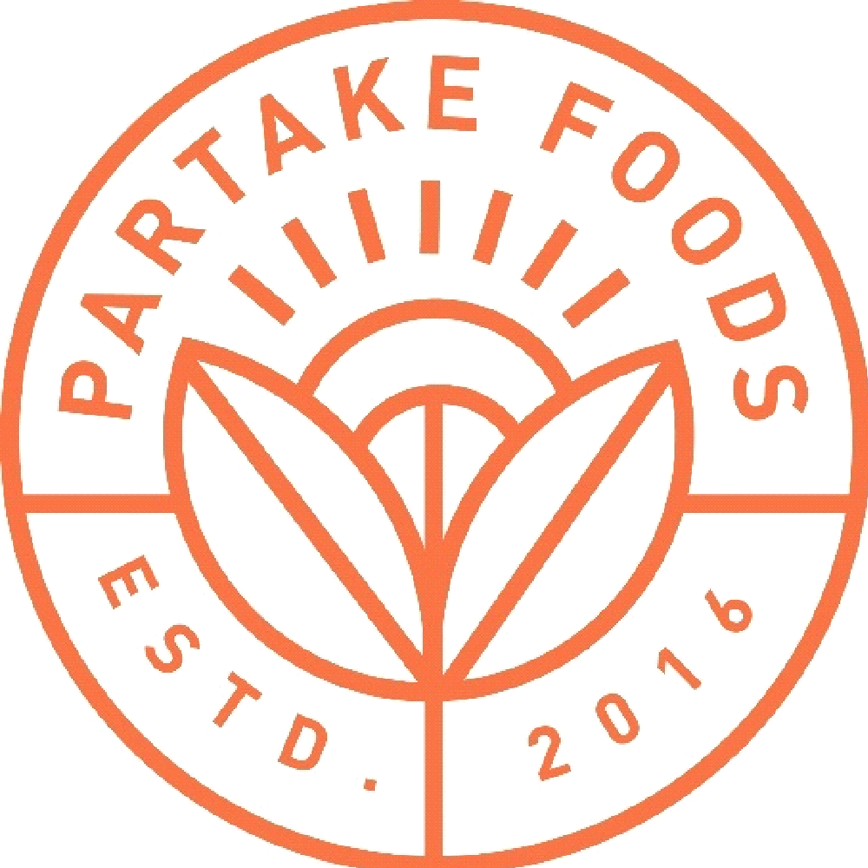

**Business Plan**

**June 2017**

**Denise Woodward, Owner**

**Vivi’s Life, LLC (dba Partake Foods)**

**Phone: 910-685-6859**

**E-mail:** [**denise@partakefoods.com**](mailto:denise@partakefoods.com)

**Website:** [**https://www.partakefoods.com/welcome**](https://www.partakefoods.com/welcome)

Table of Contents

1. Executive Summary
2. Business Background, History & Objectives
3. Management & Organization
4. Products & Operations
5. Competition
6. Marketing
7. Financial Information
8. Executive Summary

Introduction – Partake Foods is a line of allergy friendly kids food. Our first products are three flavors of mini cookies: Carrot Oat, Sweet Potato Millet, and Sprouted Grain Chocolate Chip that are packaged in a 5.5oz Box that retails for $4.99. All of our products are Free of the Top 12 Allergens, Non GMO Project Verified, OU Kosher, Gluten Free, Vegan, and made with simple, whole food ingredients. We will make them available for sale online, as well as in retail stores, and on premise outlets, such as schools and airports. Our brand vision is for Partake to be the leading, trusted allergy friendly food brand for families.

Company and Management – We have built a strong team of industry professionals to grow Partake. I am the CEO and have 12 years CPG experience, most recently as Director, National Sales in Coca-Cola’s Venturing & Emerging Brands division, which incubates entrepreneurial beverage brands that Coca-Cola has acquired. In addition, my daughter suffers from food allergies, so I understand the struggles and emotions that food allergy parents face. Our CFO was most recently a Vice President of Investment Banking at Goldman Sachs, with significant M&A experience. Our Product Developer led product development and innovation for Enjoy Life, the industry leader in allergy friendly foods.

Market Opportunity – One in 13 children in the US has a food allergy – that’s nearly 2 children in every classroom. That figure is up 50% since 1997 and is expected to continue to grow to 1 in 10 by 2020. Large CPG companies are hungry for allergy friendly food companies, with Mondelez acquiring Enjoy Life Foods, and Campbell’s investing in the Safe + Fair Food Company. General Mills and Kelloggs currently do not have allergy friendly food companies in their portfolio and are our acquisition targets.

Competitive Advantages – Our strong leadership team, authentic brand story, simple/whole food ingredients, and nutritional profile (more fiber and protein; less sugar than our primary competitors) are competitive advantages for Partake.

Financials – We have invested over $57,000 of our personal savings to start Partake. In addition, we ran a successful Kickstarter in October 2016 that raised $30,000. Our projections predict becoming profitable in January 2018, with a $18M revenue target in Year 5.

1. Business Background, History, & Objectives

Background:

I started Partake Foods in June 2016 because I was frustrated with the lack of convenient and healthy meal and snack options that existed in the market for my 2 year old daughter, Vivienne, who suffers from severe food allergies. The existing products either did not meet her food restrictions or were full of sugar and preservatives. I set out to create a platform for nutritious, convenient, allergy friendly meals and snacks in Partake Foods.

History:

* June 2016 – Vivi’s Life, LLC dba Partake Foods was incorporated as a Delaware LLC
* July 2016 – Won 1st Place in the 2016 Start Something Challenge, a small business pitch competition for NJ-based companies, sponsored by Rising Tide Capital, JP Morgan, and the Blackstone Charitable Foundation
* October/November 2016 – Launched and successfully completed a Kickstarter campaign that netted $30,260 in presales from over 200 backers (<https://www.kickstarter.com/projects/1406226232/partake-foods>); Campaign finished in the top 1% of all food Kickstarter campaigns
* February 2017 – Completed a trial production run of all 3 flavors of product at contract manufacturing location
* March – May 2017 – Obtained Gluten Free Certification, Vegan Certification, Minority Owned Business Certification (NMSDC), Kosher Certification, Non GMO Project Verification and B Corp Pending Certification
* June 2017 – Chosen as 1 of 5 food and beverage companies out of 150 to pitch at Project Nosh Pitch Slam; Chosen as a semi-finalist in the Miller Lite Tap the Future small business competition

Objectives:

* Short Term (1 to 6 Months)
* Increase brand awareness of Partake Foods with our target consumer, as evidenced by a 300% growth in social media followers on Instagram
* Launch Partake Foods’ products on Amazon, the Partake Foods website, and 100 local natural/specialty grocers in the New York City metro area
* Medium Term (6 to 12 Months)
* Continue to grow brand awareness of Partake Foods with our target consumer; Partner with likeminded brands and relevant influencers
* Expand Partake Foods’ distribution to at least 500 stores throughout the Northeast and gain placement in Whole Foods Market during their category review cycle
* Gain distribution in on-premise outlets such as airports, camps, and schools
* Expand product offering to include an additional cookie flavor and an on-the-go snack pack
* Long Term (12 Months +)
* Become the most trusted allergy friendly kids food brand on the market
* Announce next product line innovation by Expo East 2018
* Foster relationships with strategic partners – both likeminded brands and relevant influencers
* Seek a Series A round of funding to expand to national distribution into conventional grocery, mass merchandisers, and club stores

1. Management & Organization



CEO: Denise Woodard

* Responsible for leading all day to day operations; Strategy; Fundraising
* UNC-Chapel Hill, BA; Arizona State University, MBA
* 12 years Consumer Packaged Goods experience (Altria, Coca-Cola); Supply Chain experience (FedEx)
* Most recently served as Director, National Sales for Coca-Cola’s Venturing & Emerging Brands division, responsible for growing entrepreneurial beverage brands within national and global foodservice accounts

CFO: Jeremy Woodard

* Responsible for financial projections/reporting, accounting
* Florida A&M University, BA; University of Chicago, MBA
* Extensive Investment Banking background to include valuation and M&A
* Vice-President, Investment Banking, Goldman Sachs

COO: Bill Monaghan

* Responsible for QA and Operations
* 25 years operations experience at Wilton, Nestle
* Previously led QA for Enjoy Life, the market leader for allergy friendly food products

Product Innovation: Lindsey Herman

* Responsible for innovation pipeline and product development
* Harvard, BA; Northwestern University, MBA
* Significant product development and innovation experience – Sara Lee, Daymon Worldwide
* Previously led product development for Enjoy Life, the market leader for allergy friendly food products

Additional Functions:

* Social Media Manager – Our Social Media Manager, Kristie Lin, previously managed social media for Halo Top Creamery, an alternative dairy ice cream company with 442K followers on Instagram.
* Influencer Outreach –Justina Bui will lead influencer outreach, specifically targeting Millennial Mom bloggers, Food Allergy Moms, and Vegan moms. Justina previously managed influencer outreach at Halo Top.
* Accounting – Our quarterly accounting reconciliation will be outsourced to Relish Food Group, a firm that specializes in accounting for food startups.
* Public Relations – Jamie Warner PR, a boutique agency led by a former PR exec, will manage Partake’s public relations efforts.

1. Products/Operations

Products: Our first products are three flavors of crunchy, mini cookies – Carrot Oat, Sweet Potato Millet, and Sprouted Grain Chocolate Chip. They are packaged in a 5.5oz Box that retails for $4.99. Product attributes include: Free of the Top 12 Allergens, Non GMO Project Verified, Kosher, Certified Gluten Free, and Certified Vegan. All flavors are made with sprouted ancient grain flours, real fruits/vegetables, and simple, whole foods ingredients.

We believe Partake Foods is a brand platform that can be expanded to include other snacks, meal kits, and frozen products, all of which are Free of the Top 12 Allergens.

Operations: Our products are manufactured by a contract manufacturing facility that has a Top 8 Allergen Free baking room, SQF Level 2 (Food Safety) Certification, and the capability and capacity to grow as Partake expands distribution nationally. Each batch of product is tested for gluten, and random batches are tested for peanut, tree nut, egg, and milk contamination.

1. Competitors

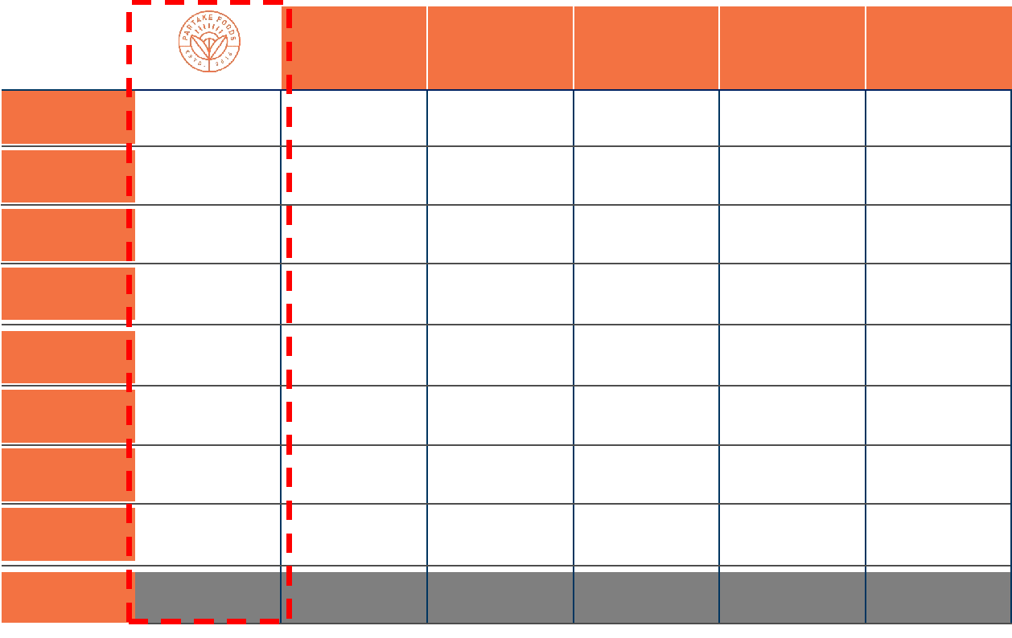

Primary Competitors

Enjoy Life - Enjoy Life, founded in 2001, is the category leader in allergy-friendly foods. The company was acquired by Mondelez for a reported $80M in 2015. Their product portfolio includes over 20 snack foods, such as cookies, trail mix, and lentil crackers,that are all Top 8 Allergen Free.

Cybele’s – Cybele’s is a line of Top 8 Allergen Free food, based in California, with primarily West Coast distribution. Their first products, released in 2012, were four flavors of cookies – Chocolate Chip, Oatmeal Raisin, Snickerdoodle, and Chocolate Brownie. They recently released a line of bean pastas.

Secondary Competitors

Annie’s Homegrown – Annie’s Homegrown was founded in 1989 and acquired by General Mills in September 2014 for $820M. Annie’s offers a wide range of products including snacks, condiments, frozen foods, and meal kits. Their products are organic, but do not cater to the food allergy population.

My SuperFoods Company – My SuperFoods Company was founded in 2014 by two moms in New Jersey and focuses on “better for you” snacks for kids, to include cookies, granola bars, and popcorn chips.

Brand Differentiation and Value Proposition

While there are other allergy friendly food brands that exist, we believe that Partake Foods is uniquely positioned to succeed for the following reasons:

* Founder’s Experience – I recently led National Sales for Coca-Cola’s Venturing & Emerging Brand (VEB) division, and prior to that, I worked on Coca-Cola trademark brands. I have extensive CPG knowledge, ranging from sales to supply chain, and running the gamut from smaller, entrepreneurial brands like Honest Tea to the most well-known brands in the world, in Coca-Cola and Marlboro. My experience with the VEB brands allowed me to learn all aspects of the business from manufacturing to marketing and sales.
* Simple, Whole Food Ingredients – Our competitors rely on the traditional ingredients used in gluten-free baking – rice, starches, and gums, all of which are nutritionally void and full of refined sugar. Partake uses whole food ingredients that provide nutritional value – Our cookies are higher in protein and fiber and lower in sugar than all of our primary and secondary competitors and do not include any rice, starches or gums.
* Authentic Story – Partake was started by a Millennial food allergy mom who realized a gap in the marketplace because of her own struggles, whereas our competitors are run by large corporations, like General Mills and Mondelez. Our consumers will resonate with the passion behind the Partake

brand, as well as our social commitments as a Certified B Corp that donates a portion of revenue to food allergy research.

1. Marketing

Marketing Strategy: Omni-channel marketing strategy comprised of multiple components: Social Media, Influencer Outreach, Public Relations, In-Market Sampling/Demos, and Email Marketing

Market Size: 1 in 13 children in the US has a food allergy – that’s nearly 2 children in every classroom. That figure is up 50% since 1997 and is expected to grow to 1 in 10 by 2020.[1] Because of the prevalence of food allergies in the US, many schools have adopted a nut-free policy. $25B is spent annually on caring for children with food allergy, including buying foods that meet dietary restrictions.[2] In addition, 17% of families in the US follow a gluten free diet, and .5% of families in the US are vegan.[3]

Target Consumer: Millennial Mom (25-34) with children aged 2-12 who have food allergies; Millennial Moms who are looking for “better for you” snack alternatives for their children; HHI > $70K

Geographic Area: In-market efforts will take place where a retail footprint exists for Partake (initially NY/NJ); digital tactics will be employed nationally.

Distribution: Product will be self-distributed to retailers in NY/NJ; Will also be sold nationally through Partake Foods’ website and Amazon

Price: $4.99 for a 5.5oz Box

Social Media: Build brand awareness and brand love for Partake Foods through social media by

posting relevant content regularly (3x/week), hosting giveaways with likeminded partner brands, and engaging with consumers. Posted content will include quotes, product photography, and lifestyle photography.

Influencer Outreach: Contact 5 relevant influencers on a weekly basis & provide them with sample product, which will encourage user-generated content about Partake; Continue to forge relationships with these influencers through regular engagement. Target influencers fall into the following categories: food allergy moms, vegans, gluten free, autism/special diet, Millennial moms.

Public Relations: A freelance public relations professional will manage Partake’s PR efforts. We feel we have a compelling story that will appeal to multiple media outlets. Various angles that will be pitched: African American female founder, first ex-Coke Venturing & Emerging Brands employee to start a CPG company, first generation college graduate, food allergy mom, bootstrapping/scrappy entrepreneur. Prior to bring a PR employee on board, we were able to secure placement in People magazine. Target outlets for placement are *O* Magazine, *Real Simple, Forbes, Entrepreneur, Inc, Parents, Food Allergy Living, People,* and the *New York Times.*

In-Market Sampling: In-market sampling will occur at events in the Northeast, such as the Gluten Free Allergen Free Expo, Autism Speaks events, Food Allergy Research Education walks, and local farmer markets. Demos will also take place in store, where permitted.

Email Marketing: Quarterly newsletter with seasonal features, recipes, parenting news, and food allergy news will be sent to subscribers.

1. Financial Information

Contributed Capital to Date

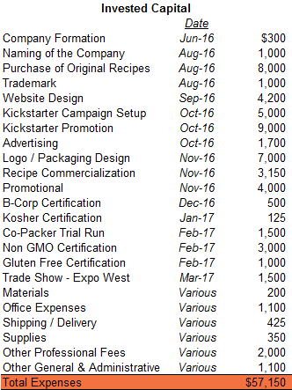

Year 1 Monthly Projection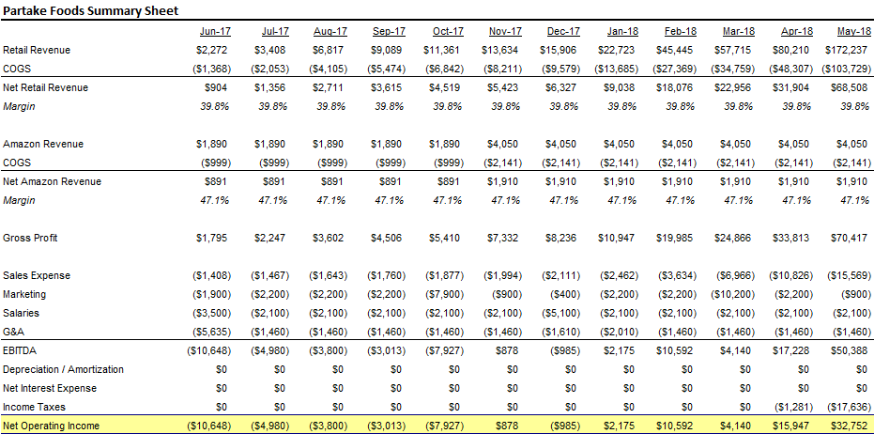

Annual Projections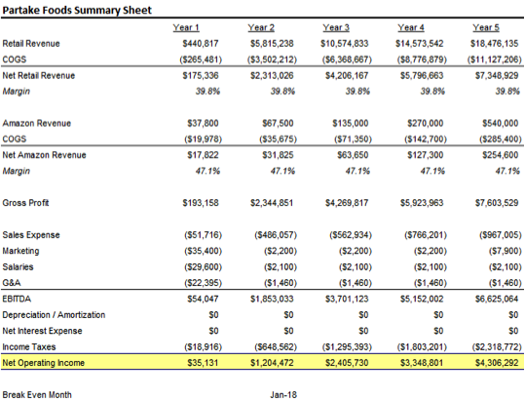

Revenue By Category

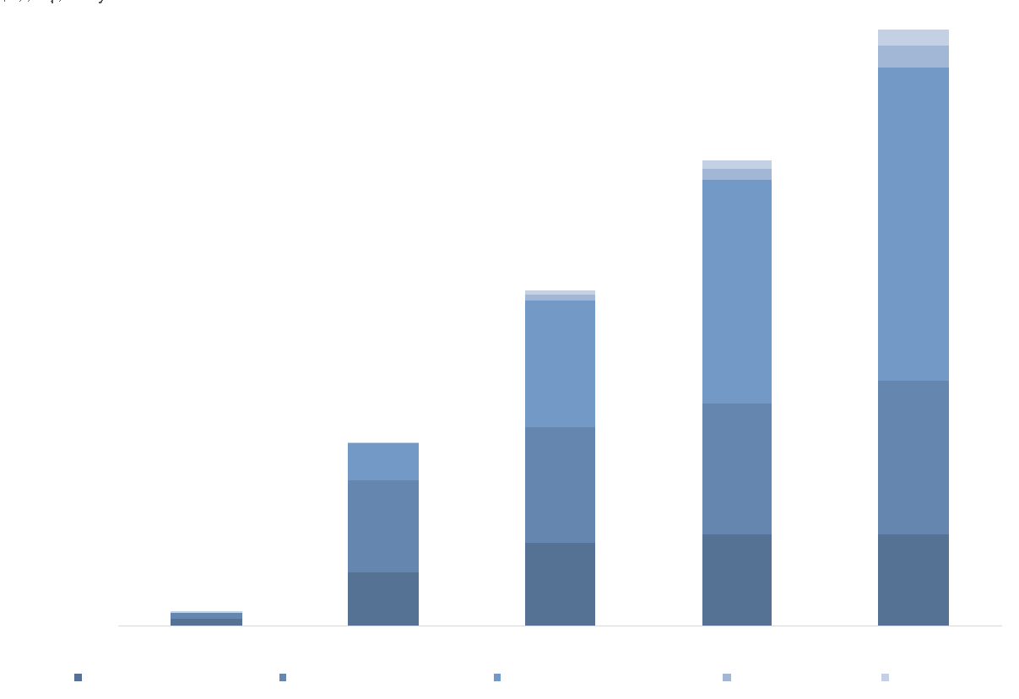

Store Count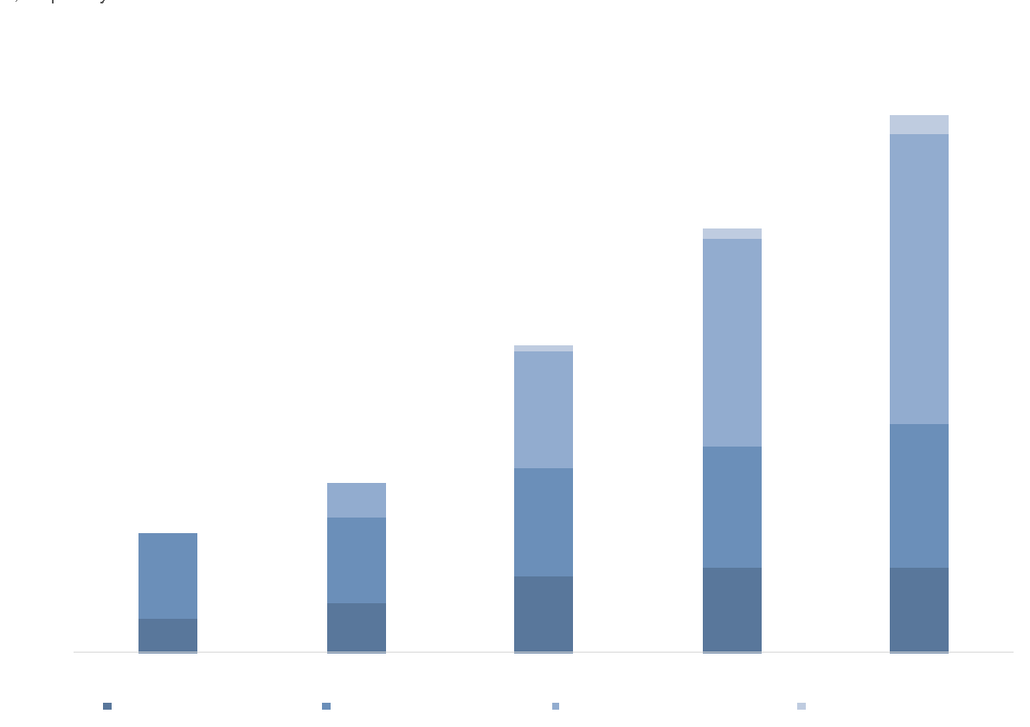

1. www.foodallergy.org/facts-and-stats
2. JAMA Pediatrics
3. Gallup Poll, July 2016