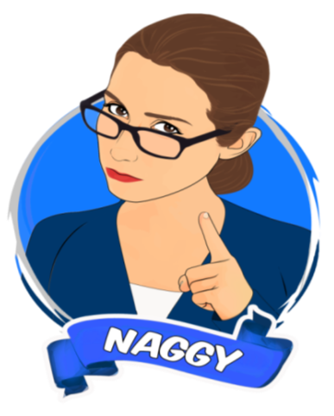



NAGGY APP

Business Plan

Rita Smith

Montclair, New Jersey

347-705-7774

naggyapp@gmail.com





**The Problem**

According to an article in the NY Times, 56% of working parents feel stressed, tired, and short on quality time with their children and have a hard time balancing their family/work life. Dubbed the “Chore Wars Battle”, PRNewswire.com reported that 50% of kids will do ANYTHING to avoid doing chores and 50% of parents say that they spend more time arguing with their kids about chores then they spend getting them to do them.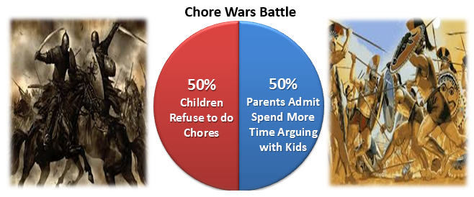

What’s the problem?

*Parents can’t get their kids to do their chores

*Kids are on their cell phone all the time

*Kids feel like their parents are constantly nagging

*Parents feel that there’s a lot of arguing, fighting & debating with kids

*There is a lot of stress and frustration in the home

*There’s a huge loss of quality family time (time you can't get back)

*This is a problem parents are having all over the world

**The Solution**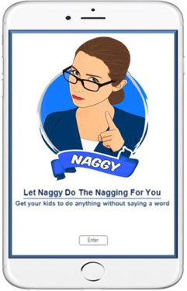

Is there a solution for this problem? You bet there is! Naggy is an app that will revolutionize the way parents interact with their kids, using technology to get them to complete their chores. One of the unique things about our app is a special feature to temporarily shut down the child’s phone if the chore is not completed. This app will save parents time and reduce stress by keeping them from fighting, debating, and reasoning with their kids, essentially keeping the peace in their homes promoting quality family time.

**Mission Statement & Goal**

The mission of our app is to help parents save time, and reduce stress, from fighting, debating, and reasoning with their kids. Essentially keeping the peace in their homes and promoting quality family time and happy memories!

**Business Description**

**Name of app:** Naggy app

**Creator of app:** Rita Smith, Army Veteran and mom

**Location:** Montclair, New Jersey

**Operations & space:** We are being given office space, donated by an organization that helps Veterans with their business.

**Team/Advisors:**

Rita Smith (App Creator) – an Army Veteran and Mom with passion to help solve problems for women, parents and families. Before starting this venture, Rita worked in Television for 20 years with some of America’s top networks like: ABC, CBS, NBC, FOX. When working for ABC, she had a rare opportunity to twice work on the Oscars. In 2014 she wrote, produced, and directed a commercial for the Doritos Super Bowl competition. Rita created Naggy app because she wanted to solve a huge problem with parents having to get their kids off the cell phone to do chores. Her hope is that through Naggy app, parents will save time, reducing stress and spending less time arguing, and debating. Meanwhile, creating positive memories and having quality family time. In 2016, Rita won the Farleigh Dickenson University Veterans Launching Ventures class.

Amanda Veinott (Advisor/Mentor) – is an expert in Military Talent Programs and Veterans Initiatives. Prior to founding Miligistix, Amanda launched Military Talent Program and Veterans Initiative across thirty companies. Amanda graduated from Christopher Newport University with a B.S. in Psychology, received her M.B.A., Summa Cum Laude, from Centenary College, and holds a CPC – Certification in Professional Coaching – from the Institute for Professional Excellence in Coaching.

**Product & Services**

**Name:** Naggy App

**Motto:** "Let Naggy do the nagging for you" "Get your kids to do anything without saying a word“.

**Product Description:** Naggy is an app that will revolutionize the way parents interact with their kids using technology to complete their chores. One of the unique things about Naggy app is a special feature to temporarily shut down the child’s phone if the chore is not completed. This app will save parents time and reduce stress keeping them from fighting, debating and reasoning with their kids, essentially keeping the peace in their homes and promoting quality family time.

**How the app works:** Parents can schedule a task for each child. Then set a timer for each assigned chore. Kids will receive a warning pop-up when timer is running out to complete their task. If the timer runs out, the child’s phone will temporarily shut down, however the parent can unlock the child’s phone once the chore is completed.

**Unique special features that set Naggy app apart:**

1. Child has a choice to call parent or send a picture when chore is completed.

2. When the phone is in shut down mode (no text, net or talking).

3. Parents will get an alert if child completes or doesn’t complete chore.

4. Parents can unlock child's phone with code from anywhere (when it’s shutdown).

5. We have a special reward system to motivate the kids where they accumulate coins and win prizes.

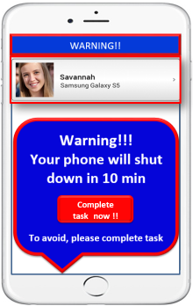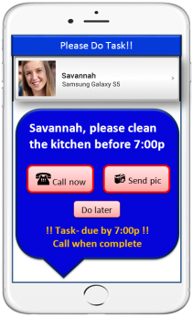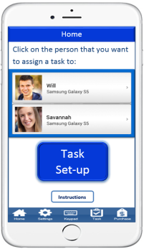

**Marketing Analysis**

**Customer & Target Market**

Our customers and target market are the consumers with the most influential buying power in the world, women and parents. Women drive 70-80% of all consumer purchasing and are multiple markets in one, because they are the main caregivers and make the buying decisions for their families. We aim to focus on mothers (including single moms) with kids between the ages of 7 to 17.

According to the Bureau of Labor Statistics, of the 148 million families in America, 34 million have children under the age of 18. Also, according to Emarketer.com, 73% of millennials (18-34), 69% of Gen X (35-44) and 62% of Baby boomer (45+) parents said they either had or intended to purchase an app for their children. We believe that these are promising statistics where parents today can see the value of Naggy app and will be willing to purchase it.

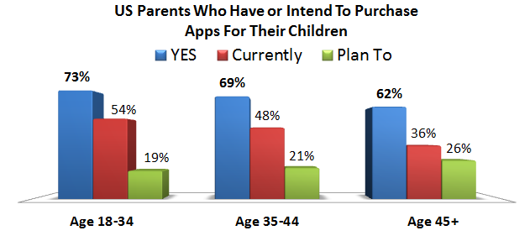

**Industry & Market Segment:** In 2016, the Mobile Industry size grossed $51 billion and is forecast to double to $101 billion within 4 years. 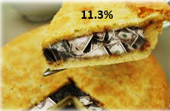

**Target Market Segment:** Naggy app falls under lifestyle & productivity which are **11.3%** of the app market; this translates to $5.7 billion dollars.

**Pricing Strategy**

Naggy app will cost $2.99 to download. We also have other ways to monetize by offering in-app purchases of our other apps, tokens, prizes, games, various alarm tones, colors, emojis and encouraging messages. Also, in the near future once we establish a certain amount of users, we will be able to further monetize by having companies purchase in-app ads.

**Competition & Competitive Advantage**

One of the things that I believe that gives us the unique advantage is that Naggy app is created by a Veteran mom. Even though there are other task apps, we only have one competitor, however Naggy app is far more superior. Our main competitor’s price point is way too high costing $5.99, Naggy is only $2.99. Also, they do not offer the unique special features that we offer to our customers. We believe that our competitive advantage lies in the quality, design, development, functionality and service, which our competitor fails to offer (pales in comparison). One critical flaw that we found is that our competitor has many complaints from customers about their app and we feel that we can fill this void by offering parents the value and service that they’re looking for to solve this long standing problem with getting their kids to get off their phones and get their chores done. Through our app parents will save time and reduce stress and get the peace in their homes and quality family time that they have been seeking. 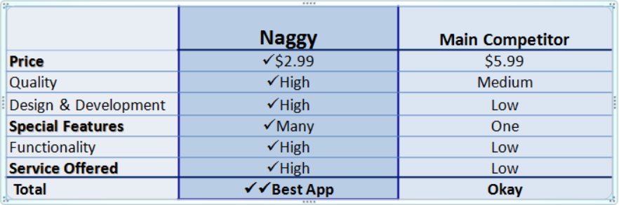

**Sales &Marketing Strategy**

**Marketing& Networking Strategy:**

FREE Advertisement –One of my greatest marketing & networking advantages is that I have worked in the Television Industry for over 20 years, which has allowed me to establish relationships with important people in the TV/News Industry like producers and reporters. This will help promote & market my app and give me the edge over my competitors because I can easily give various producers the story idea about my app for them to do the story and in-turn other networks & shows could pick up the story and it could spread quickly like wildfire. Another marketing advantage I have is that I have a couple of friends who are actors that can promote my app and give a testimonial. Some of my other marketing strategies are: App stores, Facebook, LinkedIn, online women’s groups, and school bulletins/PTA.

Sales Strategy

**Pricing Strategy:**

Naggy app will cost $2.99 to download. We also have other ways to monetize by offering in-app purchases of our other apps, virtual tokens, various alarm tones, colors, emojis and encouraging messages. Also, in the near future once we establish a certain amount of users, we will be able to further monetize by having companies purchase in-app ads.

**Channels of Distribution:**

We will offer our app in all of the channels of distribution for apps such as: Apple, Google, Amazon, Apptopia, Flippa and a Website.

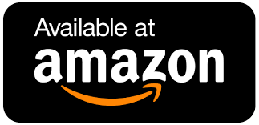

**Revenue Forecast:**

We expect to be profitable the first year making $498,000. We project a return of $1,794,000 in year two and $4,485,000 by year three.

|  |  |  |  |
| --- | --- | --- | --- |
|  | Year 1 | Year 2 | Year 3 |
|  |  |  |  |
| Percentage | 0.5% | 2% | 5% |
| Possible Customers  Out of 30 million | 150,000 | 600,000 | 1,500,000 |
| App cost | $2.99 | $2.99 | $2.99 |
| Revenue Forecast | **$498,000** | **$1,794,000** | **$4,485,000** |

**Financing Sought & Use of Funds**

I’ve completed Phase 1 of designing my app by investing my own money.

We seek $40,000 to complete phases 2-7:

Phase 2: User Interface Design

Phase 3: Development Coding

Phase 4: Build in-app purchases

Phase 5: Marketing

Phase 6: Downloads & Database Storage

Phase 7: Maintenance