**Development of human axon regeneration model using retinal organoids**

**ABSTRACT**

Glaucoma is the leading of irreversible blindness with an estimated 64 million affected worldwide in 2013 and projected 111 million by 2040. Glaucoma is a neuronal degenerative disease associated with retinal ganglion cell (RGC) apoptosis and optic nerve degeneration. Once RGCs are lost, they cannot regenerate or be replaced in humans or other mammals, and vision loss is irreversible. RGC regeneration and axon reconnection would be approaches to restore vision; however, little is known about which gene or signaling pathway participating in human RGC degeneration/regeneration, neurons’ interactions and axon reconnection. Although studies have been done by using other animals such as mouse or rat, are the same mechanisms working in humans? Many protocols have been reported for RGC generation from induced pluripotent stem cells (iPSCs) or embryonic stem cells (ESCs) (Gill et al., 2016; Tanaka et al., 2015), but two-dimension (2D) culture limits our understanding of neurons’ interactions in the retina. Unfortunately, 3D retinal organoids (RO) studies have largely ignored questions of RGC differentiation and survival. In this proposal, I aim to address both of these unmet needs by analyzing 3D ROs derived from hiPSCs with a specific application of our RGC cell biology expertise. **The goal of this project will be to differentiate more organized and retinal specific RO from hiPSCs, and then use this model to study human RGC degeneration after axon injury using laser axotomy technique, applying a variety of innovative imaging and molecular methods. Finally, I will study approaches to promote human RGC survival and regeneration in this organoid model, as a step towards translating molecular manipulations previously studied in rodents now into the human retinal model.**

**BACKGROUND**

Glaucoma is one of leading causes of blindness (Jonas et al., 2017) and along with other optic neuropathies is characterized by loss of retinal ganglion cells (RGCs) (Stowell et al., 2017). The current treatment for slowing the degeneration of RGCs by lowering intraocular pressure (IOP) fails to stop the loss of RGCs and progressive visual dysfunction in some patients. Unfortunately, vision loss and RGC loss are irreversible, leading to bilateral blindness in as many as 14% of all diagnosed patients (Blomdahl, Calissendorff, Tengroth, & Wallin, 1997). Therefore, the understanding of what molecular signals regulate RGC degeneration is still a great interest of study in the neuroscience fields. The mammalian retina is composed of many cell types including pigment epithelial cell, photoreceptors (rod and cone), glial cells (Müller glial cell, microglia, astrocyte), bipolar, horizontal, amacrine, and ganglion cells (Livesey & Cepko, 2001; Vecino, Rodriguez, Ruzafa, Pereiro, & Sharma, 2016). Understanding the molecular signals that regulate retinal cell fate is a common goal for researchers in the field of neuro-ophthalmology. In the past decades, many genes were described to promote neurogenesis. In eye, Sry-related high mobility box C transcription factors (SoxC TFs) are reported to be necessary and sufficient required for RGC differentiation (Chang et al., 2017; Jiang et al., 2013; Kuwajima, Soares, Sitko, Lefebvre, & Mason, 2017). Our current SoxC study further confirmed that overexpression of SoxC TFs promotes RGC differentiation from hiPSCs (Chang et al., 2017). In parallel in stem cell biology, Neurogenin2 (Ngn2) was introduced as an innovative, rapid, direct induced neuron (iN) protocol from hiPSCs (Zhang et al., 2013). Here I will take advantages of both findings to develop a novel induced retinal organoid (iRO) model.

Damage of mammalian central nervous system (CNS) axons is the common feature of several diseases, such as glaucoma, sclerosis and traumatic nerve degeneration. Axonal degeneration could start from the injury point bidirectionally, one is retrograde degeneration that is towards the proximal cell body, the other is orthograde (Wallerian) degeneration that is towards the distal axon terminal. In the studies of CNS injury, cell death of the soma and relative protection has committed a lot of effects, but even with maximum neuroprotection of soma, the axon still disconnected from its target. So, establishing a reproducible axonal degeneration model and understanding the mechanisms during injury is pivotal for development of new therapeutic treatment.

My sponsor’s lab is committed to solving these technical challenges including RGC isolation and transplantation, and to elucidating the molecular mechanisms underlying RGC development and fate specification (Venugopalan et al., 2016). In this paper, there was about 16% successful rate for primary RGC transplantation. To further address this challenge, I am devoted to developing a stem cell therapy as an alternative method. How stem cells differentiate into different cell types remains an important question. Many studies have shown that pluripotent stem cells such as ESCs and iPSCs differentiate to RGC-like cells (Chang et al., 2017; Ohlemacher et al., 2016; Teotia et al., 2017). However, two-dimensional (2D) stem cell culture limits our observation of cell-cell interactions such as RGC-amacrine cell and RGC-bipolar cell. Recently, many innovative protocols of 3D stem cell culture or so-called stem cell organoids, were developed leading to cerebral organoids (Bershteyn et al., 2017) or retinal organoids (ROs) (Kaewkhaw et al., 2015). These models enhance our understanding of the microenvironment of the brain and retina, which mimics at least some *in vivo* observations.

How to maximize the use of ROs to study RGC survival and regeneration? Here I propose to use H7-A81, an ESC line engineered in Dr. Donald Zack’s lab with CRISPR to express membrane mCherry under the Brn3b promoter (Sluch et al., 2015), which facilitates the detection of RGC-like cell differentiation. In addition, an innovative, rapid, and direct induced neuron (iN) protocol was established by overexpressing Ngn2 in my co-sponsor’s lab (Zhang et al., 2013). Here I will take advantage of both H7-A81 and iN protocols to develop a new system, named induced RO (iRO). **I will develop iRO protocol with incorporation of SoxC TFs and Ngn2 genes during retinal development. Then I will use laser to damage the mCherry-labeled axon to mimic the axonal damage caused by glaucoma or trauma. I will investigate Wallerian and retrograde degeneration of** **RGC axon, RGC apoptosis and astrocytic reaction. In addition, I will use this model to validate the therapeutic possibility using virus transduction in axonal reconnecting and preventing RGC degeneration in laser-treated RO.****Accordingly, I believe that the proposed work will bring significant additions to (1)** *development of novel iRO protocol,* **(2)** *our understating of human RGC gene change during laser-induced axon injury**and development of therapies for neural degeneration.* To this end I propose the following specific aims:

**Aim 1: Transduce the SoxC TFs and Ngn2 in RO development for investigating RGC differentiation, axonal organization and 3D assembly.** *I hypothesize that in vitro, lentiviral overexpression of Ngn2 shortens the time for RO formation and improves retinal lamination, and that overexpression of SoxC TFs promotes RGC differentiation in RO model.* To test this aim, I will utilize H7-A81 and **1a.** transduce cells with SoxC TFs and Ngn2 using lentiviruses following RO protocol. I will then **1b.** observe RGC differentiation and integration in RO. I expect to analyze RGC development and axon outgrowth by probing mCherry and other marker expression, and **1c.** measure neuronal function by electrophysiology.

**Aim 2: Design RGC and axonal degeneration model in RO and follow by analysis of transcriptome and physiological change. Then develop gene therapeutic strategy using virus transduction.** In this aim, I plan to establish an axonal damage model using intraretinal laser axotomy in RO. *I hypothesize that laser can selectively damage the differentiated and mCherry-labelled axons, such that I can observe the related RGC apoptosis and adjacent glial cells reaction in hiPSC-induced RO.* To test this hypothesis, I will **2a.** use two-photon imaging and focus ion beam– scanning electron microscopy to trace the progress of degeneration. *I then hypothesize that gene expression is changed in injury model, which corresponds to axonal pathogenic phenotype in RO.* To test this hypothesis, I will **2b.** observe RGC phenotype obtained from aim 2a and investigate gene variation using single-cell RNA sequencing. Followed by the finding from aim 2b, *I hypothesize that knock-in or knock-out of genes will recover laser-induced axon degeneration.* I will **2c.** transduce or delete genes in laser-treated RO and see whether gene therapies could rescue axonal defect during retinogenesis. Together, these experiments will advance our understanding of axonal degeneration and genetic variant in glaucoma, but more broadly, of the therapeutic possibility that may be worthy for clinical trial. This specific aim will be a pioneer study of human RGC regeneration in glaucoma.

**AIMS/TECHNOLOGIES/PROTOCOLS**

**AIM 1: Transduce the SoxC TFs and Ngn2 in RO development for investigating RGC differentiation, axonal organization and 3D assembly.**

*Rationale:* Ngn2 has been introduced in an innovative, rapid, and direct induced neuron (iN) protocol (Figure 1) from hiPSCs (Zhang et al., 2013). In this preliminary study, we were able to detect Brn3a+ cells started at day 5 of differentiation. This observation brings me a speculation that whether Ngn2 overexpression promotes RO development, especially in photoreceptors and ganglion cells. In addition, SoxC TFs (Sox4 and Sox11) were shown to be required for RGC differentiation (Chang et al., 2017; Jiang et al., 2013; Kuwajima et al., 2017). Recently, Sox11 was demonstrated to promote axon regeneration in optic nerve crush model (Norsworthy et al., 2017). More beneficially, H7-A81 was generated using CRISPR engineering that expresses membrane mCherry under the Brn3b promoter, which signal was detected at day 25 of differentiation (Sluch et al., 2015). We were also able to utilize this ESC line combined with Ngn2 and SoxC TFs to monitor RGC-like cell differentiation in 2D culture (Figure 2A) and found that Sox4 promotes iRGC differentiation (Figure 2B). This preliminary 2D culture protocol shows the **reproducibility** of neurons induction followed by iN protocol. Accordingly, application of those SoxC TFs in an innovative model for RO development will be studied in this proposal. I previous reported that hiPSC-differentiated Brn3+ RGC-like cells carry electrical activity (Chang et al., 2017). I therefore expect to measure electronic activity in RGC-like cells of iROs. 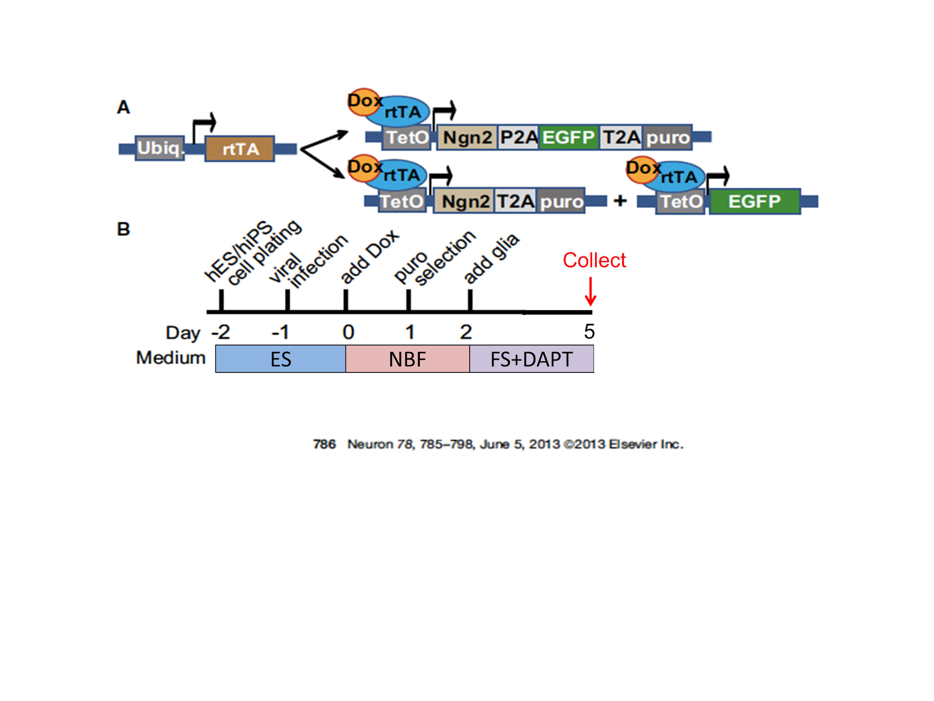

*Hypothesis: I hypothesize that intrinsic overexpression of Ngn2 and SoxC TFs promotes retina, specifically electrical active RGC, differentiation in iRO model.*

*Design:* All experiments will follow the rules of **rigor and transparency in research** including at least three replicates and appropriate statistical analyses. Here, I will start at culturing H7-A81 in a protocol from previous work (Kaewkhaw et al., 2015) and then develop a novel protocol (iRO) that transduces Ngn2 and SoxC TFs for RO development. ROs will be collected at different time point for imaging. RGCs and other retinal cell types will be identified with upstraight fluorescence microscopy for marker screening (such as Brn3a for RGC; Calb2 and Calb1 for horizontal and amacrine cells; PKC-α for bipolar; Glul for Müller glial cells) and with confocal microscopy for detail investigation. RGC could also be identified using mCherry marker that driven by Brn3b. I will check whether overexpression of Sox4 or Ngn2 reduces suppressive gene (Notchs and REST) expression during RO development. Once I observe mCherry signal, I will patch clam technique to probe specific cell for measuring electrical potential change. Stem cell culture and operating upstraight fluorescence microscopy is the routine for my current studies. For patch clamp, it is well established in my sponsor’s lab and I will collaborate with the expert in the lab.

*Expected and Alternative Results:* Functionally, I expect to find that overexpression of Ngn2 and/or Sox4 promote retinal development, and specifically in RGC fate. I expect to observe the RGC marker expression earlier than 37 days in incubation, which was previously reported (Kaewkhaw et al., 2015). This result would support my hypothesis that intrinsic overexpression of Ngn2 and SoxC TFs promotes RGC, differentiation in iRO model. This would be interesting to further observe other retinal cell types differentiation using iRO protocol although it is not our aim in this proposal. *Alternatively,* I may find no change of RGC marker expression with Ngn2 and SoxC TFs transduction incorporated in iRO protocol. Or more unexpected, I may find Ngn2 or SoxC TFs has an opposite effect, for example Ngn2 or SoxC TFs might decrease RGC fate in retina, which opposes my current data (Figure 2B). Any such results would be interesting because this could be the variation between 2D and 3D culture and will lead to a new direction to study why those genes cause different effects on 2D vs. 3D cultures. 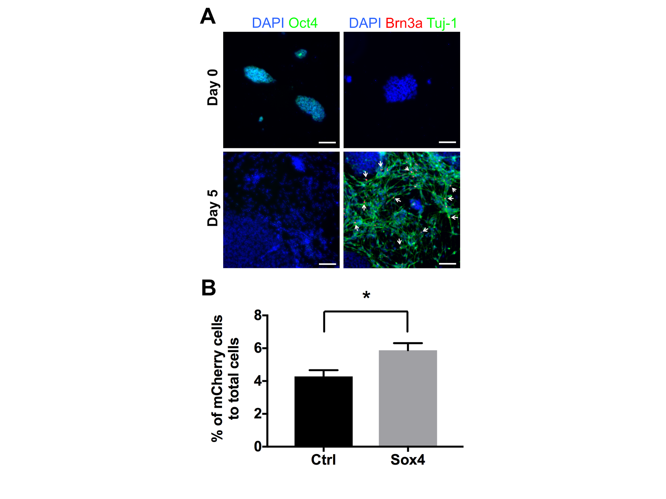

*Potential Pitfalls and Alternative Approaches:* I may find it difficult to clarify RGC and other cell types markers or SoxC TF (Sox4 and Sox11) in retina explant culture using Western blot due to non-specific binding. Alternatively, I will utilize qPCR to observe cell specific marker change in this experiment. I may also find that mCherry signal is weak to be detected in RO model. Alternatively, I will stain the RO with mCherry antibody to enhance signal. Most importantly, I may find that Ngn2 or SoxC TFs cause random differentiation or mis-transdifferentiation during RO development, which leads to disorientation of the cell growth. For electrophysiological assay, I may not find RGCs are not electrically active suggesting that RGCs from this protocol are still immature. Alternatively, I would transplant these iROs into rodent retina for maturation. I will then dissect retina explant and conduct patch calm on iRO to examine whether *in vivo* co-culture can drive iRO’s maturity.

**Aim 2: Design RGC and axonal degeneration model in RO and follow by analysis of genetic and physiological change. Then develop the gene therapeutic strategy using virus transduction technique.**

*Rationale:* A previous study showed that Brn3b is expressed in RO at day 37. I hypothesize that organoids derived from H7-A81 hiPSCs would express Brn3b-driven mCherry signal, which labeling RGCs and bundles of axons. Axons with mCherry signal are visible using two-photon imaging, so that I can selectively damage the axon and trace them by real-time imaging. The understanding of neuron and neutrophil functions is closely linked to the high technical microscope imaging. The combination of two-photon in vivo imaging with focus ion beam/scanning electron microscope (FIB/SEM) will allow the visualization of functional interactions within the retina and study the progress of axon degeneration (Blazquez-Llorca et al., 2015). Development of laser-initiated injury on selected RGCs axon of RO *in vitro* would mimics glaucoma disease caused by axonal damage. Understand the mechanism of neuronal degeneration induced by axonal injury (mechanism of glaucoma or optic nerve trauma) will provide a hope to reconnect the axon to target. In this study, I are going to use two-photon laser-mediated axotomy, which won’t perturb the adjacent tissue and expect to be no inflammatory response. This model will be beneficial for ophthalmologist and neuroscientist to study the mechanism of axonal or glial response and test any possible treatment using the human *ex vivo* tissue, which can exceed the limitation of using other animal studies. In addition, many studies such as PTEN deletion (Park et al., 2008) or Sox11 overexpression (Norsworthy et al., 2017) have demonstrated the capability of axon regeneration using gene therapy in an optic nerved crush (ONC) model. I will follow the same idea to test if these gene therapy approaches promote axon regeneration in human iRO models.

*Hypothesis: I hypothesize that I will induce a reliable and reproducible axonal injury model that can mimics glaucoma CNS disease using 3D ROs, and discover the gene/signaling changes following laser axotomy regarding the apoptosis of RGC and surrounding glial response. I then hypothesize that gene therapy development based on the discovery of gene/signaling change can promote axon regeneration.*

*Design:* To mimic glaucoma disease *in vitro*, I will use high-energy femtosecond lasers to establish the RO axon injury model and use two-photon imaging (Sharma, Williams, Palczewska, Palczewski, & Hunter, 2016) to trace the real-time reorganization of the injury axon at synaptic resolution, which is the limitation of other published results. I will equip the microscope with a tunable Coherent Ti:Sapphire laser with the help of Dr. Palanker (Stanford University). **This model will enable us to investigate the complex interactions and dynamic features that may happen in other mammals’ axonal degeneration diseases, such as glaucoma and optic nerve trauma.** The parameters of the excitation laser (laser power, wavelength, duration and depth of penetration) will be optimized to induce reproducible axonal lesions. Lesions will be conducted on the retinal nerve fiber layers (RNFL). Axons will be imaged at variable intervals before and after lesion. ROs will be collected at different time points after lesion, following by immunohistochemical analysis of the lesion site using with inflammatory markers such as TNF-α and IL-1β. Gene changes of the ROs before or after laser axotomy injury will be analyzed by RNA-sequence. Axon regrowth is an indicator for neuronal regeneration. I will assess the regrowth capacity and development pattern of the axon after injury. It has been known that astrocyte glial cells are involved in scar formation after injury (Anderson et al., 2016). I will detect astrocytic projections and processes by GFAP immunostaining after injury. I will use real-time confocal scanning laser ophthalmoscopy to image RGC apoptosis, intracellular signaling and intraretinal axonal degeneration as well as to assess the affects of microglia, astrocytes and the surrounding neutrophil with signaling pathway. To address the time course of axonal degeneration and regeneration, we will use noninvasive visualization of the dynamics of retrograde and Wallerian degeneration and regeneration after relative gene therapies.

Based on the data obtained from RNA-sequence, I will design a serial test of RGC-target specific virus selection and gene encoded construction generation. Although lentivirus is the most common tool to use *in vitro*, I will design the therapeutic gene in AAV because it could be further used *in vivo*. Viruses will be added after different times (1, 3 and 5 days) of post surgery to find the optimal timing for gene therapy.

*Expected and Alternative Results:* Since laser axotomy technique was well-established in previous study in mouse brain (Canty et al., 2013), I will expect to successfully apply this technique in OR model and be useful for analyzing the injury mechanism and testing neuron regeneration strategies by using human alive tissue. In this laser axotomy model, I expect to characterize the gene/signaling changes, cell apoptosis and glial response under axons injury condition, and compare to our lab’s data on similar transcriptome and other changes in rodent models. *Alternatively,* I may find that there is little physiological or genetic change after injury. This would be interesting because it could be due to the stronger viability in RO compared to primary RGC. In this case I could make sure to characterize the changes not being simply due to insufficient or too high of a laser power by titrating a number of different doses of laser.

Since AAV generation and application is a routine in my lab, I will expect to find that gene therapy protects cells from apoptosis and promote axon regeneration.

*Potential Pitfalls and Alternative Approaches:*I may injure the adjacent cells or tissues when doing the laser axotomy, but I will use two-photon microscope to identify and focus laser on mCherry-labelled axon and to avoid perturbing the adjacent cells or tissues. *Alternatively,* I will test the parameters of the excitation laser first to induce reproducibly localized axonal lesions. I may also find the laser-mediated axotomy cause glial-mediated inhibition. This would still be quite interesting as it could lead to discovery of extrinsic factors that affect RGC regeneration.

**INNOVATION**

In summary, this proposal will provide a **reproducible** and validated RO axonal injury model that is not only useful to characterize the intrinsic/extrinsic mechanisms of RGCs, but is also capable of justifying gene therapy as alternative neuron regeneration therapy for the treatment of human CNS diseases.

There is a burgeoning need to understand what intrinsic factors regulate neuronal regeneration. In retina, RGC regeneration has been a hot topic for curing glaucoma and related optic neuropathies. Application of stem cells such as human ESC or iPSC using 3D protocol provides a hope for understanding cell-cell interaction and integration in RO; however, the process of RO formation usually take couple months to become mature. As is evident from our preliminary data, we have demonstrated the progressive effects of Ngn2 and Sox4 in 2D culture of RGC differentiation from H7-A81, which warrants further study. Here, I propose a **technically and scientifically innovative project** to understand how Ngn2 and SoxC TFs influence RGC development in iRO model, and use this **interdisciplinary** model for investigating gene change in laser-induced injury. First, at a techniques level, this proposal incorporates gene transduction to shorten the time for RO development. This proposal also enahnces the physiological relevance of the results with high-resolution microscopy, and a novel incorporation of electrophysiological evaluation of iRO differentiation. Using innovative time-lapse imaging, immunostaining, and single-cell RNA sequencing, I propose to characterize and then enhance RGC integration in these retinas. Second, at a scientific approach level, this proposal will **(1)** develop an innovative stem cell differentiation protocol for ESC-to-iRO by introducing Ngn2 and SoxC TFs; **(2)** develop laser-induced injury on RGCs that carry mCherry signal in iRO model, and further identify the gene change with different degree of injury; and design gene specific therapy using AAV virus transduction techniques. **In summary, the proposal work will help to develop novel RO protocol and therapeutic relevance in RGC degeneration iRO model, which may provide promising therapeutic strategies cross disciplinary for RGC degenerative disease such as glaucoma**.

**TIMELINE**

Although I have proposed an ambitious set of experimental aims, I will cooperate with colleagues in the lab and experts on campus to generate the RO model and laser axotomy technique needed for these experiments. I have already begun establishing some of the experiments proposed. Aim 1 would commence immediately and take approximately 1 year. Aim 2 would be dependent on the time needed for optimizing laser axotomy technique, maybe about 1 year. However, the timeline could be overlapping for aim 1 and 2 during the waiting time for RO formation.

**References**

Anderson, M. A., Burda, J. E., Ren, Y., Ao, Y., O'Shea, T. M., Kawaguchi, R., . . . Sofroniew, M. V. (2016). Astrocyte scar formation aids central nervous system axon regeneration. *Nature, 532*(7598), 195-200. doi:10.1038/nature17623

Bershteyn, M., Nowakowski, T. J., Pollen, A. A., Di Lullo, E., Nene, A., Wynshaw-Boris, A., & Kriegstein, A. R. (2017). Human iPSC-Derived Cerebral Organoids Model Cellular Features of Lissencephaly and Reveal Prolonged Mitosis of Outer Radial Glia. *Cell Stem Cell, 20*(4), 435-449 e434. doi:10.1016/j.stem.2016.12.007

Blazquez-Llorca, L., Hummel, E., Zimmerman, H., Zou, C., Burgold, S., Rietdorf, J., & Herms, J. (2015). Correlation of two-photon in vivo imaging and FIB/SEM microscopy. *J Microsc, 259*(2), 129-136. doi:10.1111/jmi.12231

Blomdahl, S., Calissendorff, B. M., Tengroth, B., & Wallin, O. (1997). Blindness in glaucoma patients. *Acta Ophthalmol Scand, 75*(5), 589-591.

Canty, A. J., Huang, L., Jackson, J. S., Little, G. E., Knott, G., Maco, B., & De Paola, V. (2013). In-vivo single neuron axotomy triggers axon regeneration to restore synaptic density in specific cortical circuits. *Nat Commun, 4*, 2038. doi:10.1038/ncomms3038

Chang, K. C., Hertz, J., Zhang, X., Jin, X. L., Shaw, P., Derosa, B. A., . . . Goldberg, J. L. (2017). Novel Regulatory Mechanisms for the SoxC Transcriptional Network Required for Visual Pathway Development. *J Neurosci, 37*(19), 4967-4981. doi:10.1523/JNEUROSCI.3430-13.2017

Gill, K. P., Hung, S. S., Sharov, A., Lo, C. Y., Needham, K., Lidgerwood, G. E., . . . Wong, R. C. (2016). Enriched retinal ganglion cells derived from human embryonic stem cells. *Sci Rep, 6*, 30552. doi:10.1038/srep30552

Jiang, Y., Ding, Q., Xie, X., Libby, R. T., Lefebvre, V., & Gan, L. (2013). Transcription factors SOX4 and SOX11 function redundantly to regulate the development of mouse retinal ganglion cells. *J Biol Chem, 288*(25), 18429-18438. doi:10.1074/jbc.M113.478503

Jonas, J. B., Aung, T., Bourne, R. R., Bron, A. M., Ritch, R., & Panda-Jonas, S. (2017). Glaucoma. *Lancet*. doi:10.1016/S0140-6736(17)31469-1

Kaewkhaw, R., Kaya, K. D., Brooks, M., Homma, K., Zou, J., Chaitankar, V., . . . Swaroop, A. (2015). Transcriptome Dynamics of Developing Photoreceptors in Three-Dimensional Retina Cultures Recapitulates Temporal Sequence of Human Cone and Rod Differentiation Revealing Cell Surface Markers and Gene Networks. *Stem Cells, 33*(12), 3504-3518. doi:10.1002/stem.2122

Kuwajima, T., Soares, C. A., Sitko, A. A., Lefebvre, V., & Mason, C. (2017). SoxC Transcription Factors Promote Contralateral Retinal Ganglion Cell Differentiation and Axon Guidance in the Mouse Visual System. *Neuron, 93*(5), 1110-1125 e1115. doi:10.1016/j.neuron.2017.01.029

Livesey, F. J., & Cepko, C. L. (2001). Vertebrate neural cell-fate determination: lessons from the retina. *Nat Rev Neurosci, 2*(2), 109-118. doi:10.1038/35053522

Norsworthy, M. W., Bei, F., Kawaguchi, R., Wang, Q., Tran, N. M., Li, Y., . . . He, Z. (2017). Sox11 Expression Promotes Regeneration of Some Retinal Ganglion Cell Types but Kills Others. *Neuron, 94*(6), 1112-1120 e1114. doi:10.1016/j.neuron.2017.05.035

Ohlemacher, S. K., Sridhar, A., Xiao, Y., Hochstetler, A. E., Sarfarazi, M., Cummins, T. R., & Meyer, J. S. (2016). Stepwise Differentiation of Retinal Ganglion Cells from Human Pluripotent Stem Cells Enables Analysis of Glaucomatous Neurodegeneration. *Stem Cells, 34*(6), 1553-1562. doi:10.1002/stem.2356

Park, K. K., Liu, K., Hu, Y., Smith, P. D., Wang, C., Cai, B., . . . He, Z. (2008). Promoting axon regeneration in the adult CNS by modulation of the PTEN/mTOR pathway. *Science, 322*(5903), 963-966. doi:10.1126/science.1161566

Sharma, R., Williams, D. R., Palczewska, G., Palczewski, K., & Hunter, J. J. (2016). Two-Photon Autofluorescence Imaging Reveals Cellular Structures Throughout the Retina of the Living Primate Eye. *Invest Ophthalmol Vis Sci, 57*(2), 632-646. doi:10.1167/iovs.15-17961

Sluch, V. M., Davis, C. H., Ranganathan, V., Kerr, J. M., Krick, K., Martin, R., . . . Zack, D. J. (2015). Differentiation of human ESCs to retinal ganglion cells using a CRISPR engineered reporter cell line. *Sci Rep, 5*, 16595. doi:10.1038/srep16595

Stowell, C., Burgoyne, C. F., Tamm, E. R., Ethier, C. R., Lasker, I. I. o. A., & Glaucomatous Neurodegeneration, P. (2017). Biomechanical aspects of axonal damage in glaucoma: A brief review. *Exp Eye Res, 157*, 13-19. doi:10.1016/j.exer.2017.02.005

Tanaka, T., Yokoi, T., Tamalu, F., Watanabe, S., Nishina, S., & Azuma, N. (2015). Generation of retinal ganglion cells with functional axons from human induced pluripotent stem cells. *Sci Rep, 5*, 8344. doi:10.1038/srep08344

Teotia, P., Chopra, D. A., Dravid, S. M., Van Hook, M. J., Qiu, F., Morrison, J., . . . Ahmad, I. (2017). Generation of Functional Human Retinal Ganglion Cells with Target Specificity from Pluripotent Stem Cells by Chemically Defined Recapitulation of Developmental Mechanism. *Stem Cells, 35*(3), 572-585. doi:10.1002/stem.2513

Vecino, E., Rodriguez, F. D., Ruzafa, N., Pereiro, X., & Sharma, S. C. (2016). Glia-neuron interactions in the mammalian retina. *Prog Retin Eye Res, 51*, 1-40. doi:10.1016/j.preteyeres.2015.06.003

Venugopalan, P., Wang, Y., Nguyen, T., Huang, A., Muller, K. J., & Goldberg, J. L. (2016). Transplanted neurons integrate into adult retinas and respond to light. *Nat Commun, 7*, 10472. doi:10.1038/ncomms10472

Zhang, Y., Pak, C., Han, Y., Ahlenius, H., Zhang, Z., Chanda, S., . . . Sudhof, T. C. (2013). Rapid single-step induction of functional neurons from human pluripotent stem cells. *Neuron, 78*(5), 785-798. doi:10.1016/j.neuron.2013.05.029