

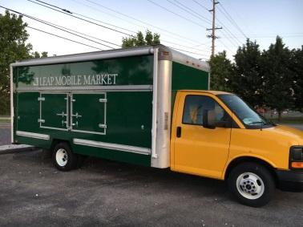

**New farmers market on wheels debuts Monday in Roanoke**

The Local Environmental Agriculture Project will bring its new farmers

market on wheels to the West End Station on Monday from 4 to 6 p.m.

 **Farmers market hits the road in Roanoke**

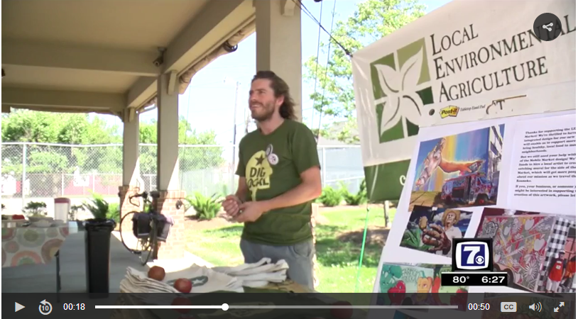 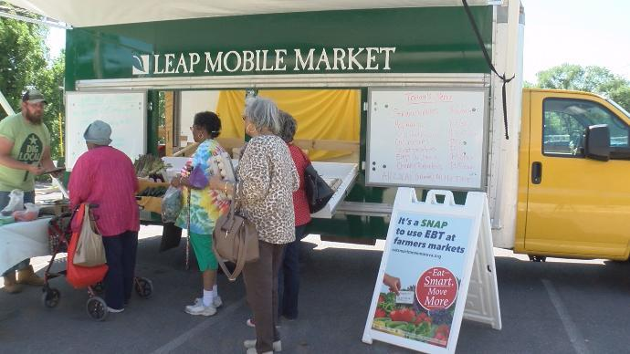

**VISTA Ned Savage at the LEAP Mobile Market**