**A scalable retinal differentiation system for the production of substantially mature mini retinas for modeling human retinal development and inherited retinal degenerations**

A solution to 3D ROC Challenge

**Team lead**

**Wei Liu, Ph.D.,**

Assistant Professor

Department of Ophthalmology and Visual Sciences, Department of Genetics, Albert Einstein College of Medicine, 1300 Morris Park Ave., Bronx, NY 10461

Expertise: retinal organoid cultures, stem cells, gene editing, retinal development

**Team members**

Albert Lowe, Ph.D. student, Department of Genetics, Albert Einstein College of Medicine

Expertise: retinal organoid cultures, stem cells, gene editing

Collaborators

1) Rui Chen, Ph.D., Associate Professor, Human Genome Sequencing Center, Department of Molecular and Human Genetics, Baylor College of Medicine

Expertise: RNAseq, single cell RNAseq, disease gene discovery of human LCA/RP through sequencing

2) Z. Jimmy Zhou, PhD, Marvin L. Sears Professor of Ophthalmology and Visual Science and Professor of Cellular and Molecular Physiology and Professor of Neuroscience; Vice Chairman and Director of Research, Ophthalmology and Visual Science, Yale School of Medicine

Expertise: electrophysiology of the retina

**Applicable to disease modeling or drug testing: Yes.**

**Trainee category: no.**

**Comprehensive Description of the Proposed Solution**

**A. Abstract—**Here we present our solution to the 3-D ROC Challenge. Retinal structures from hESCs or hiPSCs have been generated using a number of protocols, but the requirement of manual manipulation, low efficiency, immaturity and variability limit their applications. We have established a retinal differentiation protocol for generating and isolating large quantities of retinal organoids that produce stratified mini retinas from hESCs. We propose *innovative concepts* that the efficient generation and isolation of VSX2+ epithelium and the establishment and maintenance of proper apical junctions are critical for producing stratified mini retinas. *The novelties* in our solution are the ease of use, scalability, robustness, reproducibility, the maturity of photoreceptors, VSX2::EGFP reporter, and TJP1::EGFP reporter. *The advantages* of our protocol are the efficient generation of early retinal epithelium through Matrigel-induced cyst formation and scalable isolation of self-organized retinal organoids through Dispase-mediated cell detachment and subsequent floating culture. Our retinal organoids produce stratified neuroretinal tissues with all five neuronal retina cell types. Notably, outer segments of photoreceptors and outer limiting membrane are evidenced by immunostaining and electron microscopy. In RNAseq, our retinal organoids express 260 retinal disease genes and 15 outer segment genes in a pattern similar to human donor retinas, establishing the feasibility for modeling human retinal disease. The functions of our mini retinas are demonstrated by electrophysiological analysis. We are using the retinal organoids to model optic cup invagination and CRB1-associated retinal disease (Leber Congenital Amaurosis 8, LCA8). Our *CRB1*-null retinal organoids display the expected phenotypes and are being used for mechanistic studies, drug screening, and therapeutic development. We propose solutions to faithfully recapitulate the complexity of the retina through tissue engineering.

**B. Background—**Retinal structures from hESCs or hiPSCs have been generated using differentiation protocols (Boucherie et al., 2013; Lamba, Gust, & Reh, 2009; Meyer et al., 2011; Nakano et al., 2012; Reichman et al., 2014; Volkner et al., 2016; Wahlin et al., 2017; Zhong et al., 2014; Zhou et al., 2015; Zhu et al., 2013). Sasai group generates self-organizing optic cups in 3-D cultures of mouse embryonic stem cells (mESCs) and hESCs (Eiraku et al., 2011; Nakano et al., 2012), Gamm group generates optic vesicles through manual dissection or mechanical scraping of rosette structures in adherent cultures (Meyer et al., 2011; Meyer et al., 2009), Canto-Soler group generates 3-D retinal tissue through manual dissection of horse-shoe shape structures in adherent cultures (Zhong et al., 2014), and Goureau group generates RPE cells and self-forming neuroretina (NR)-like structures in confluent hiPSCs (Reichman et al., 2014). Nevertheless, the requirement of manual manipulation, low efficiency, immaturity, and variability exist.

**C. Solution—**We have established a method for generating and isolating large quantities of retinal organoids that produce stratified mini retinas with outer segments from hESCs (Lowe, Harris, Bhansali, Cvekl, & Liu, 2016). *Evaluation criteria* that have been met and solutions for unmetcriteria are as follow.

*Summary of our retinal differentiation protocol (Fig. 1)*—Briefly, small aggregates of hESCs (or hiPSCs) are suspended in ice-cold Matrigel. After gelling at 37 °Cfor 15-30 minutes, the hESC/Matrigel clump is gently dispersed in a N2B27 Medium for floating culture. Cysts with a single lumen form on day 1 and constitute over 90 percent of the cultures. On day 4 or 5, floating cysts are passaged to new 24-well plates at a density of around 20 cysts per well. The cysts spontaneously attach to the culture surface and spread, forming concentric zones of VSX2+ neural retinal progenitors and PAX6high RPE progenitors with apical junctions. On day 13-17, Dispase-mediated detachment and subsequent floating culture lead to self-formation of retinal organoids that are morphologically distinct and are found in over 85 percent of the floating aggregates. In long-term cultures, the retinal organoids autonomously generate stratified mini retinas that contain photoreceptors with the ultrastructure of outer segments.

*Innovation—*We propose *an innovative concept* that the generation and isolation of VSX2+ epithelium and the establishment and maintenance of proper apical junctions are critical in producing laminar mini retinas. The novelties are the efficient generation of retinal epithelium via Matrigel-induced cyst formation, scalable isolation of retinal organoids via Dispase-mediated cell detachment and subsequent floating culture, and VSX2::EGFP reporter hESCs generated in my lab using CRISPR/Cas9 technology.

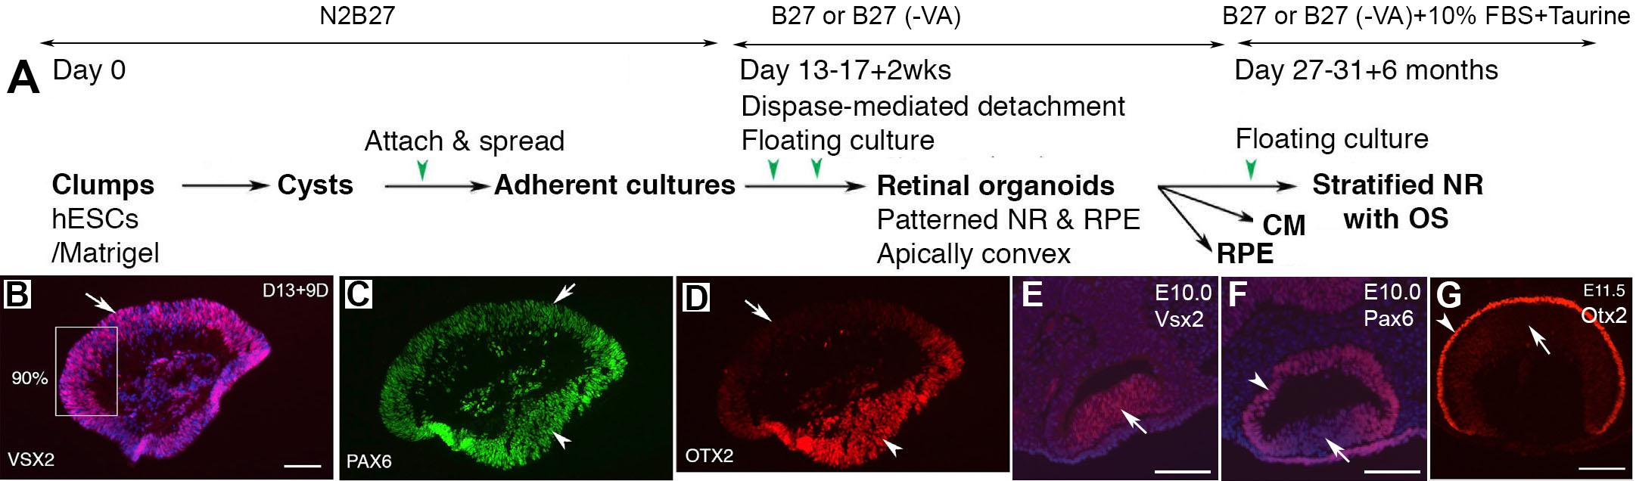

*Strengths and met criteria*

***1).*** *Efficient generation of early retinal epithelium though Matrigel-induced cyst formation*—Most of retinal differentiation protocols begin with the formation of embryonic bodies with or without adding diluted Matrigel (Lamba et al., 2009; Meyer et al., 2011; Meyer et al., 2009; Nakano et al., 2012; Volkner et al., 2016; Wahlin et al., 2017; Zhong et al., 2014). Embryonic bodies are amorphous solid cell masses that produce cells in all three germ layers. In our protocol, direct contact between Matrigel and small hESC aggregates provide a cue of extracelluar matrix similar to that in the blastocyst and the eye field, leading to efficient epithelialization of hESCs and subsequent retinal differentiation. The cysts are composed of coordinately polarized cells with their apical surface at the single lumens, and spontaneously and efficiently acquire the cell fates of anterior ectoderm/neural plate/early retinal progenitors following a neural default model (Lowe et al., 2016; Stern, 2006). The epithelial structure of the cysts confers cell survival in a manner similar to the polarization of acini accounting for resistance to apoptosis in breast cancer cell lines (Weigelt & Bissell, 2008). Inhibitors of ROCK or myosin are frequently used in differentiation protocols to suppress undesirable apoptosis (Nakano et al., 2012; Zhong et al., 2014), but the inhibition compromises cell epithelialization. In our system, ROCK inhibitor Y27632 is dispensable and disruptive in cyst formation. In contrast to the culture of a solidified Matrigel/hESCs layer on a surface (Zhu et al., 2013), our floating culture of Matrigel/hESCs clumps permit the cells to have better access to the medium. Importantly, at later stages, the floating clumps spontaneously attach to the culture surface and spread, forming concentric zones of VSX2+ progenitors and PAX6high RPE progenitors with apical junctions. *We conclude that direct contact between Matrigel and hESC aggregates and floating culture of Matrigel/hESCs clumps are advantageous over embryonic body formation in efficiently generating early retinal epithelium.*

***2).*** *Isolation of large quantities of 3-D retinal organoids containing patterned VSX2+ epithelium and PAX6high RPE epithelium without manual dissection*—Manual dissection of retinal structures is necessary in a number of retinal differentiation protocols (Meyer et al., 2011; Meyer et al., 2009; Nakano et al., 2012; Reichman et al., 2014; Volkner et al., 2016; Wahlin et al., 2017; Zhong et al., 2014). In our protocol, Dispase-mediated cell detachment of cyst-derived adherent cultures and subsequent floating culture lead to differential cell survival and self-organization of retinal organoids with distinct morphology, reducing manual manipulation. Our retinal organoids contain patterned VSX2+ epithelia and PAX6high RPE epithelia as single spheres or fused spheres, and both types produce stratified mini retinas in long-term cultures. Compared to previous protocols via a process of embryonic body formation, attachment, manual or mechanical lift-up for floating culture (Meyer et al., 2011; Meyer et al., 2009; Zhong et al., 2014), our protocol is unique in the following aspects: 1) our cysts are epithelia and acquire retinal cell fate efficiently, whereas embryonic bodies differentiate into cells in all three germ layers; 2) concentric zones of VSX2+ progenitors and PAX6high RPE progenitors with apical junctions forms in our adherent cultures, whereas no such pattern has been described in previous studies (Meyer et al., 2011; Meyer et al., 2009; Zhu et al., 2013); 3) Dispase-mediated cell detachment in our protocol is gentle and leads to self-formation of retinal organoids containing both VSX2+ neuroretinal epithelium and PAX6high RPE epithelium, whereas mechanical lift-up of adherent cultures is harsh for cells and generate optic vesicles only containing VSX2+ progenitors (Meyer et al., 2011; Meyer et al., 2009).

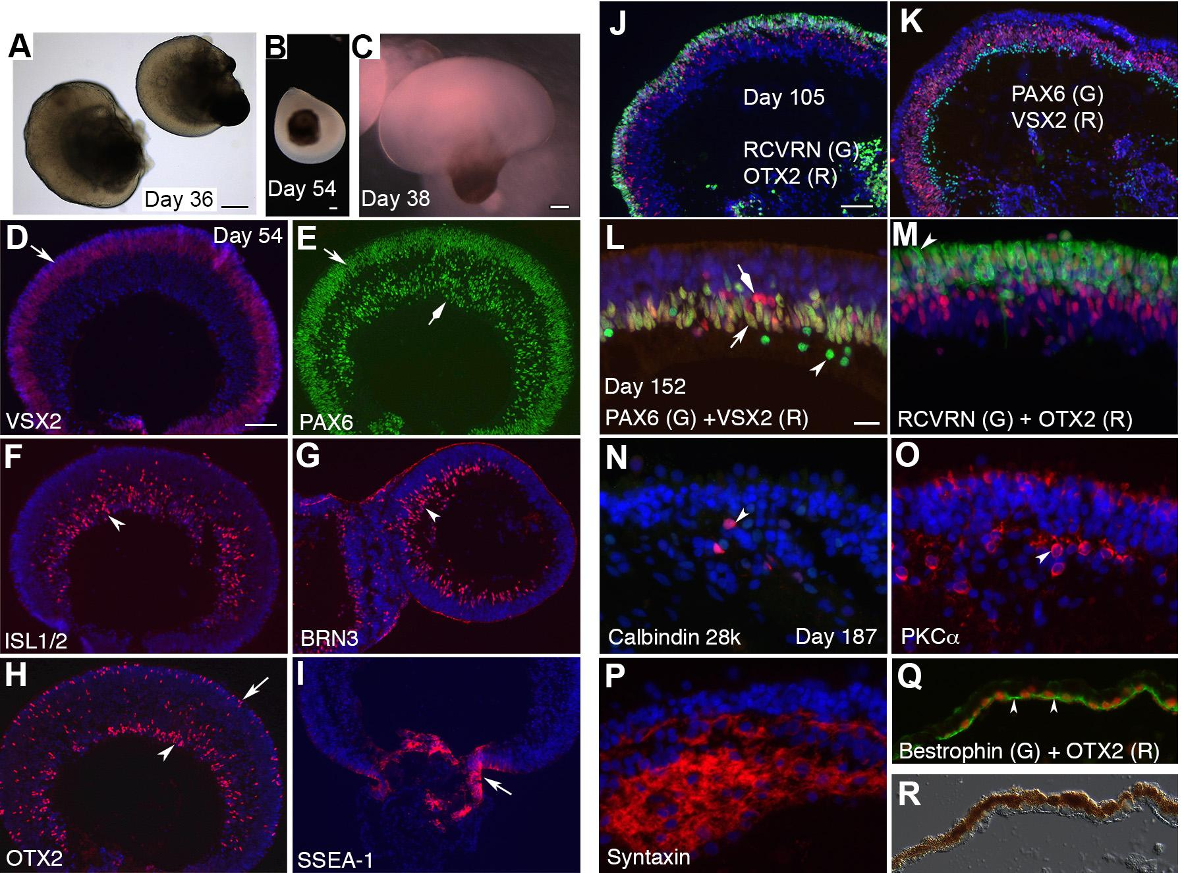

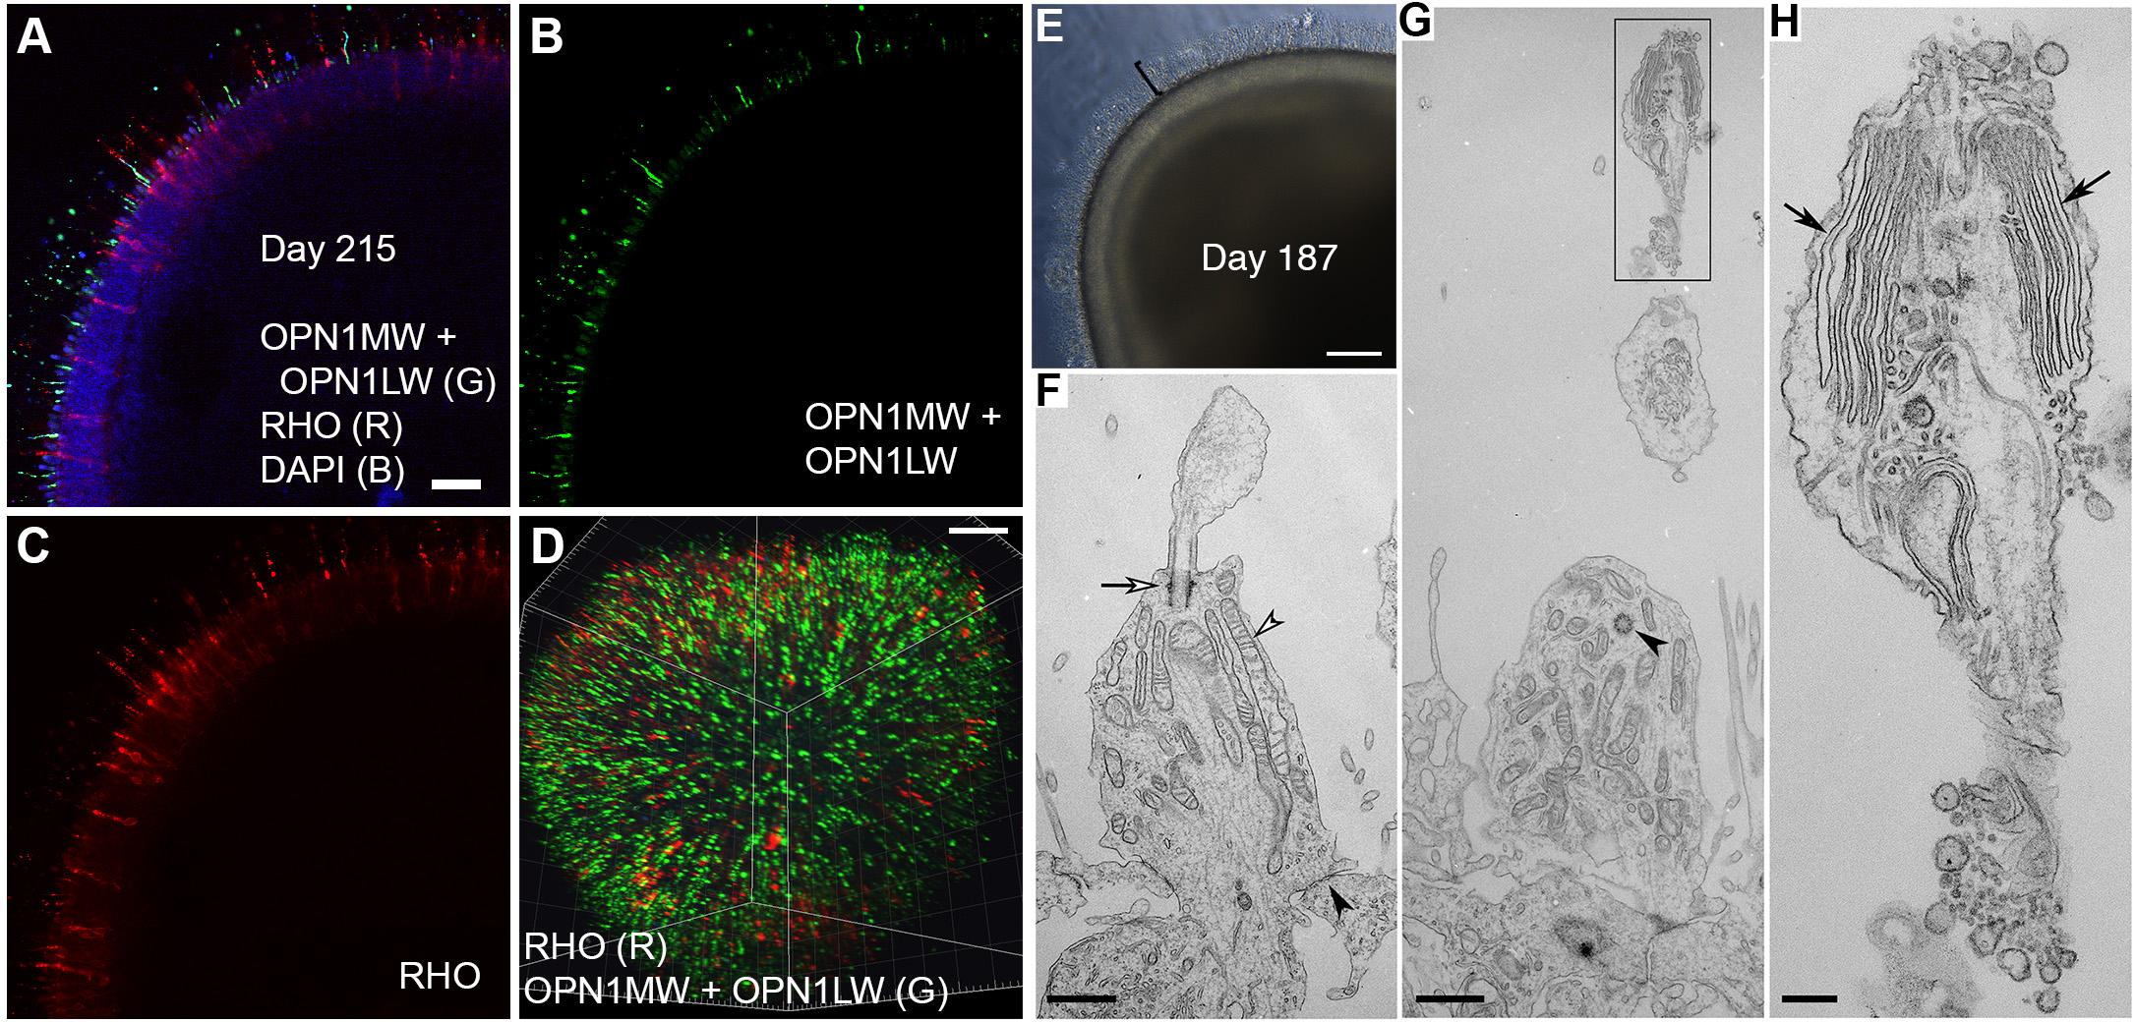

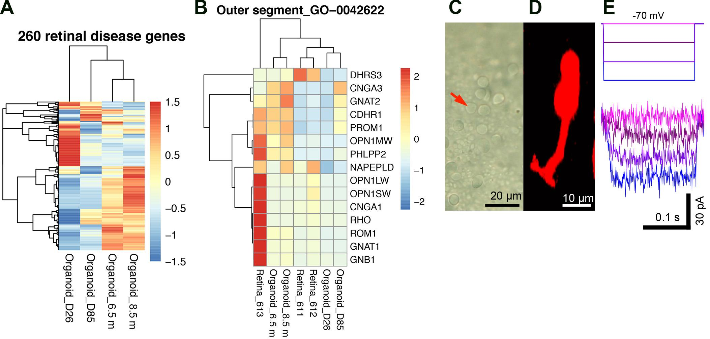

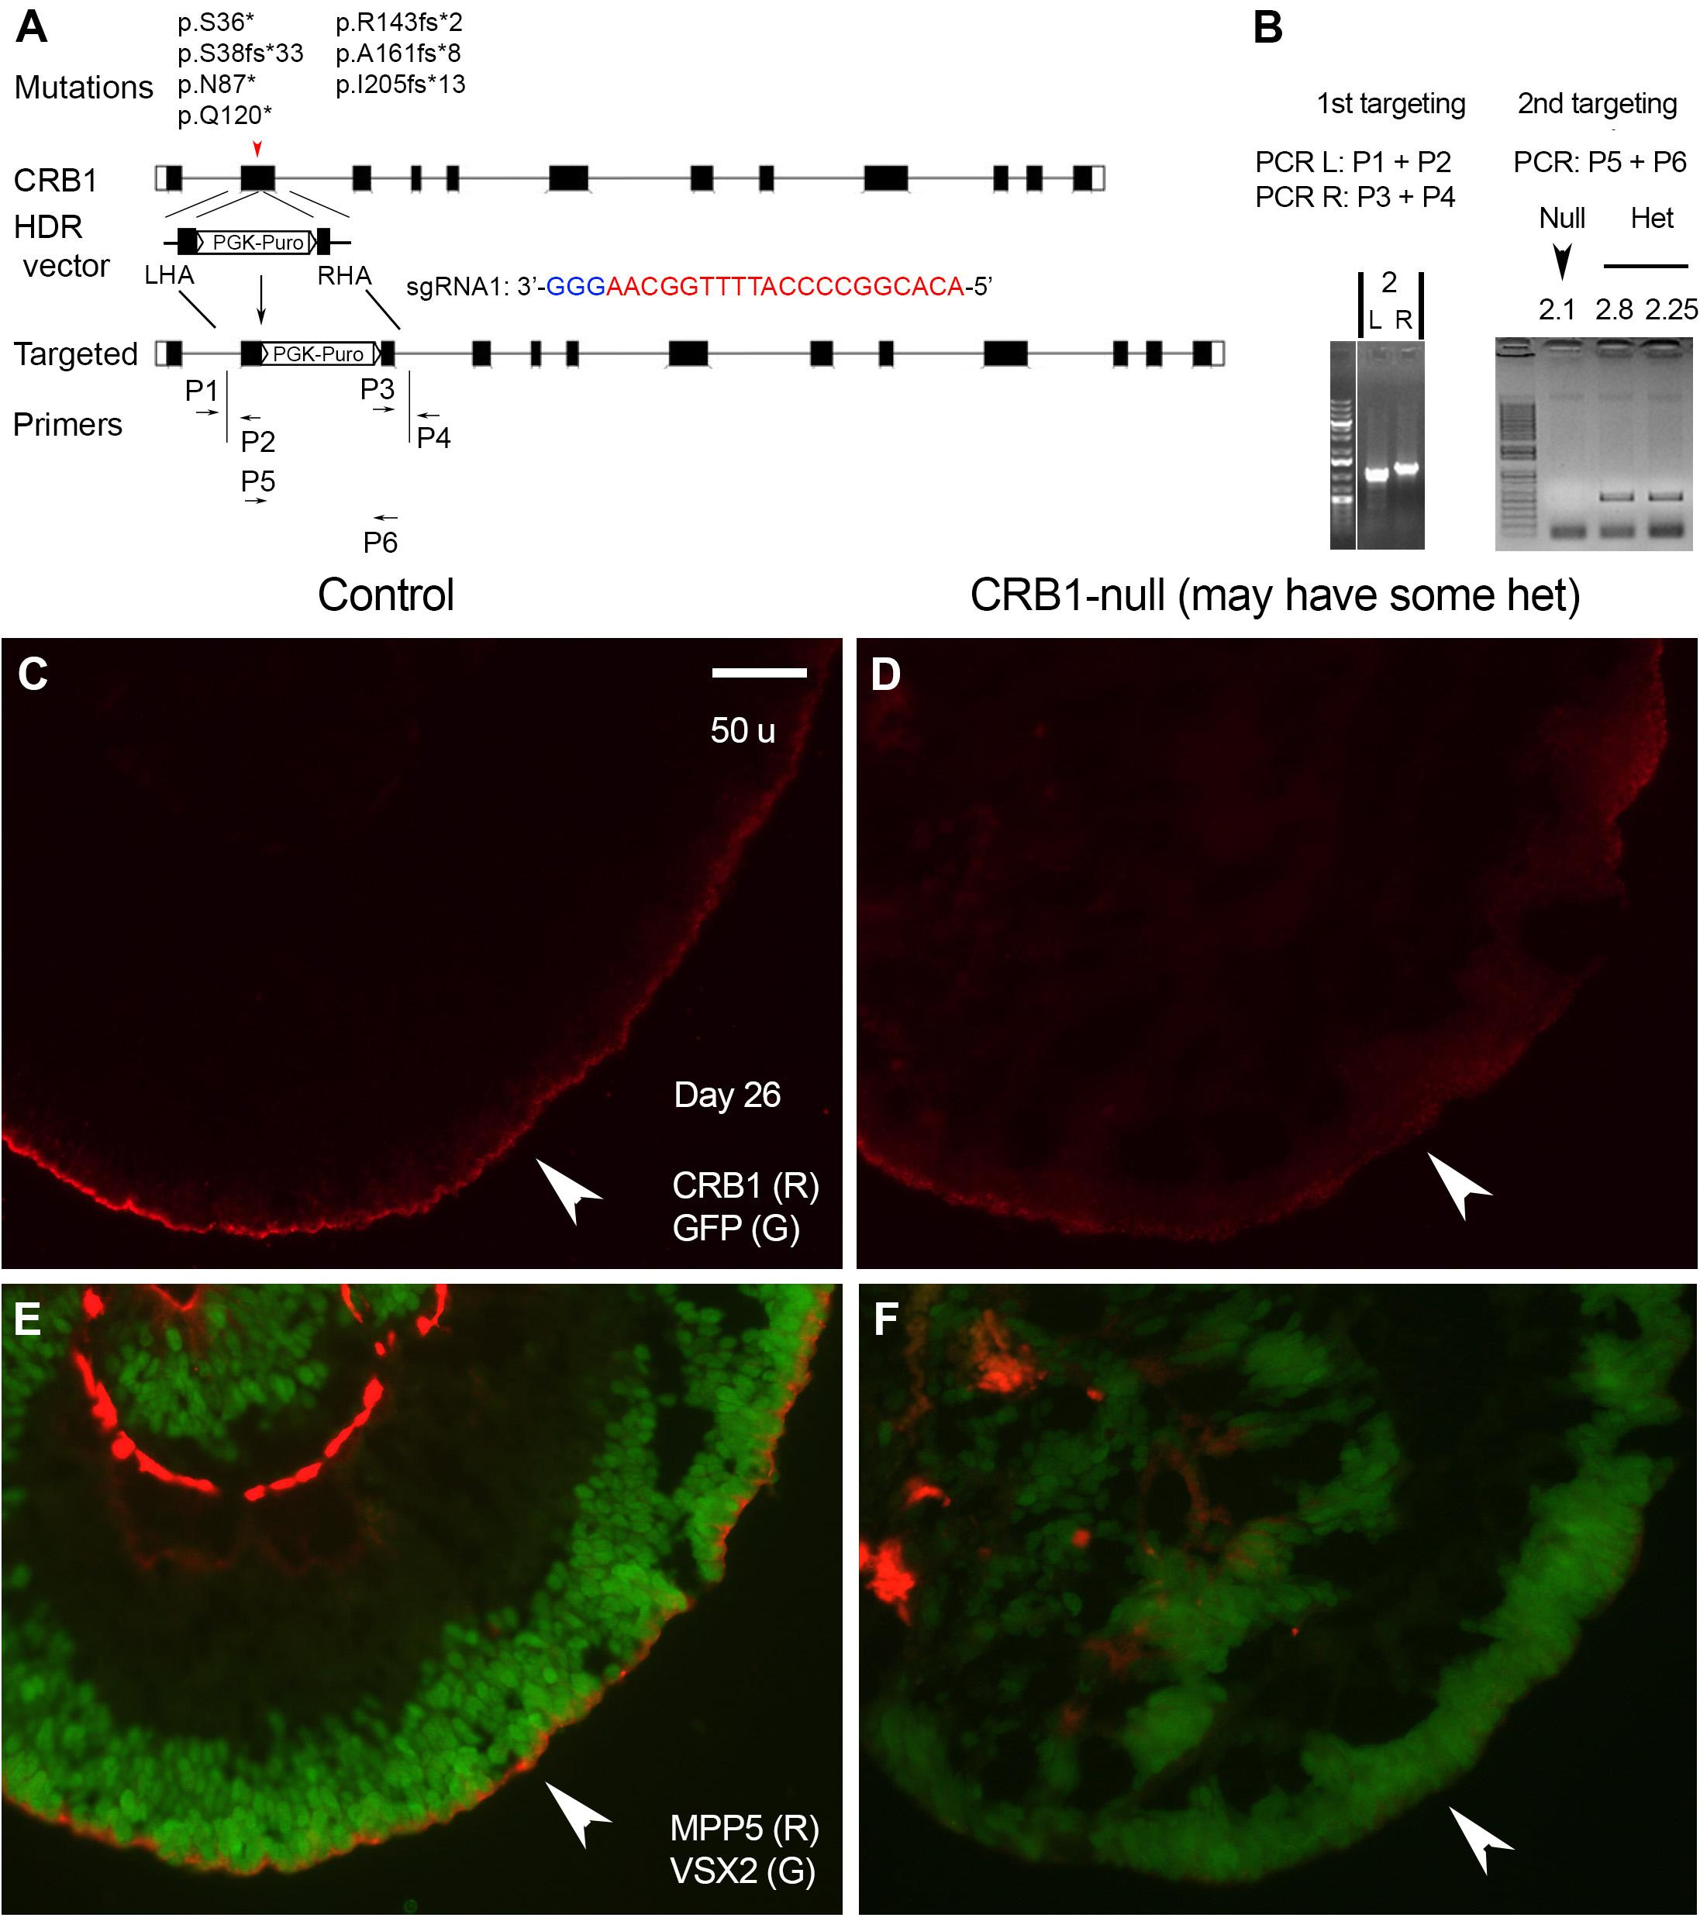

***3).*** *Cell types in our mini retinas*—Our retinal organoids produce stratified neuroretinal tissues with all five neuronal retina cell types, *i.e.,* photoreceptors, bipolar cells, ganglion cells, horizontal cells, and amacrine cells (Fig. 2, 3). Glul+ Muller glia and GFAP+ astrocytes are also present (data not shown). Notably, outer segments of photoreceptors and outer limiting membrane are evidenced by immunostaining and by the ultrastructure (Fig. 3) and are well maintained for at least several months.

**4).** *Structure of our retinal organoids—*Laminar structure is generated in our retinal organoids through self-organization and spatially restricted lineage commitment (Fig. 2, 3). Isolation of substantially pure VSX2+ epithelium and maintenance of proper apical junctions in our protocol ensure that 3-D organoids have layers recapitulating a laminated retina.

***5).*** *Viability—*In our protocol,culture plates containing retinal organoids are placed on an orbital shaker to increase viability and retinal differentiation. We propose to inject endothelial progenitors into retinal organoids to form blood vasculature to further increase cell viability.

***6).*** *Functional characterization of cell types*—In collaboration with Dr. Jimmy Zhou at Yale, we have identified electrophysiological functions of multiple cell types, including photoreceptors (Fig. 4C-E).

***7).*** *Robustness and Reproducibility* —Our protocol is highly reproducible. Cysts and retinal organoids are generated at percentages over 85% of the cultures with a low variation. Even in long-term cultures, 50 out of 67 retinal organoids display dense cilia after 5–6 months, and four out of four retinal organoids with dense cilia highly express cone opsin and rhodopsin (Fig.3). Our retinal differentiation protocol has been confirmed using VSX2::EGFP reporter and has been cited by other researchers shortly after publication.

***8).*** *Scientific applications: biology/disease modeling*—Our mini retinas express 260 retinal disease genes and 15 outer segment genes in a pattern similar to human donor retinas, establishing the feasibility for modeling human retinal development and disease (Fig. 4). Our retinal organoids are sufficiently mature for modeling early retinal phenotypes and photoreceptor phenotypes that are intrinsic to the neuroretina. We are using retinal organoids to model optic cup invagination and CRB1-associated retinal disease (Leber Congenital Amaurosis 8, LCA8). CRB1-null retinal organoids displayed the expected phenotypes (Fig. 5) and are being used for mechanistic studies, drug screening and therapeutic development.

***9).*** *High Content Screening—*We have generated VSX2::EGFP reporter (Fig. 7) that is a faithful readout of proper retinal differentiation and is suitable for high content screening setup (Fig. 7-9). Our protocol reduces manual manipulation and thus is scalable for mass-production for high content screening.We also have TJP1::EGFP reporter that is used for tracking apical junctions and the outer limiting membrane.

***10).*** *Validation scheme—*Morphology, histology, immunostaining, light microscopy, electron microscopy, electrophysiology, VSX2::EGFP reporter, and RNAseq are used.

*Unmet criteria and solutions: recapitulate the complexity of the retina through tissue engineering*

Rationale: Our retinal organoids contain VSX2+ epithelium and PAX6high RPE epithelium, but do not contain other components of the retina. We will combine our retinal organoids with the missing retinal tissues, *i.e.,* progenitors for optic nerve head and stalk, endothelial progenitors and RPE cells, in order to faithfully recapitulate the complexity of the retina and improve retinal organoids.

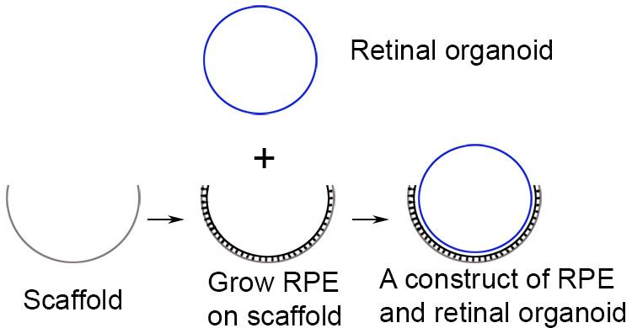

Exp. 1. Make a construct of optic nerve head/stalk and retinal organoids. VSX2::EGFP retinal organoids will be injected with red fluorescence-labeled progenitors for optic nerve head and optic stalk either from mouse embryos or derived from hESCs, and then be examined using imaging and immunostaining.

Exp. 2. Make a construct of endothelial cells and retinal organoids. VSX2::EGFP retinal organoids will be injected with red fluorescence-labeled endothelial progenitors and then be analyzed using live imaging and immunostaining.

Exp. 3. Make a construct of juxtaposed RPE and retinal organoids. We will first grow RPE cells on curved scaffolds. The scaffolds will be made via bioprinting, and its dimension and Young's modulus will be adjusted to meet the mechanics of RPE cell growth. Then, VSX2::EGFP retinal organoids will be placed onto the RPE cells. Live imaging and histological analysis will be performed to evaluate cell interactions.

*Pitfall and alternative plans—*Reconstruction of the complexity of the retina via tissue engineering is exploratory and requires extensive experimentation. As an alternative to microinjection, bioprinting will be used to couple different types of cells for co-cultures.

BIOGRAPHICAL SKETCH

NAME: Wei Liu

eRA COMMONS USER NAME (credential, e.g., agency login): weiliu

POSITION TITLE: Assistant Professor

EDUCATION/TRAINING

|  |  |  |  |
| --- | --- | --- | --- |
| INSTITUTION AND LOCATION | DEGREE  *(if applicable)* | Completion Date | FIELD OF STUDY |
| Nankai University, P. R. China | B.S. | 06/1990 | Bioengineering |
| Institute of Biophysics, Chinese Academy of Sciences, P. R. China | M.Sc. | 06/1993 | Molecular Biology |
| Institute of Biophysics, Chinese Academy of Sciences, P. R. China | Ph.D. | 06/1999 | Molecular Biology |
| St Jude Children’s Research Hospital, TN | Postdoctoral | 2002-2008 | Developmental Biology |

**A. Personal Statement**

I have the expertise in 1) modeling human retinal development and disease using 3-dimensional (3-D) retinal organoid cultures and 2) mechanistic studies of retinal development using engineered mice. I have made major contributions to elucidate the roles of homeobox gene *Six3* in retinal development, lens development, and forebrain development. For stem cell projects, my laboratory has recently published a scalable method for isolating large quantities of 3-D retinal organoids that generate stratified mini-retinas with the ultrastructure of outer segments, and the outer segments of photoreceptors are highly reproducible in our retinal organoids. Notably, we have generated VSX2::EGFP reporter hESCs that are powerful for further improvement of retinal differentiation protocol. Collectively, my laboratory has the necessary expertise in modeling human retinal development and disease using 3-D retinal organoid cultures.

**B. Positions and Honors**

Positions and Employment:

2009-2010 Staff Scientist, Department of Genetics and Tumor Cell Biology, St Jude Children’s Research Hospital, Memphis, TN

2010-2012 Instructor, Department of Ophthalmology and Visual Sciences, Albert Einstein College of Medicine, Bronx, NY

2012- Assistant Professor, Departments of Ophthalmology and Visual Sciences and Genetics, Albert Einstein College of Medicine, Bronx, NY

Other Experience and Professional Memberships:

2013- Journal Reviewer for

BBA-Molecular Basis of Disease, Biomechanics and Modeling in Mechanobiology, Translational Research, Molecular Vision

2013 Peer reviewer, MRC UKRMP II Systems, UK

2016 Peer reviewer, MRC Biomedical Catalyst grant, DPFS, UK

2015 Ad Hoc reviewer, Special Emphasis Panel, ZRG1 BDCN-R (02) M

2015 Ad Hoc reviewer, Special Emphasis Panel, ZRG1 BDCN-R (90)

2016 Ad Hoc reviewer, Special Emphasis Panel, ZRG1 BDCN-W (04)

2016 Reviewer, Scientific Peer Review Panel, Maryland Stem Cell Research Fund

2017 Reviewer, Scientific Peer Review Panel, Maryland Stem Cell Research Fund

**C. Contribution to Science**

1. Lowe A, Harris R, Bhansali P, Cvekl A, Liu W (2016) Intercellular adhesion-dependent cell survival and ROCK-regulated actomyosin-driven forces mediate self-formation of a retinal organoid. **Stem Cell Reports**. (2016) 6:743-56. doi: 10.1016/j.stemcr.2016.03.011. PubMed PMID: 27132890.
2. Liu W¶, Cvekl A (2017) Six3 in a small population of progenitors at E8.5 is required for neuroretinal specification via regulating cell signaling and survival in mice. **Developmental Biology**. <http://dx.doi.org/10.1016/j.ydbio.2017.05.026>.

¶ Corresponding author.

1. Liu W, Lagutin O, Swindell E, Jamrich M, Oliver G (2010) Neuroretina specification in mouse embryos requires Six3-mediated suppression of Wnt8b in the anterior neural plate. **J Clin Invest** 120: 3568-3577. PMID: 20890044.
2. Liu W (2012) Focus on molecules: Wnt8b: a suppressor of early eye and retinal progenitor formation. **Exp Eye Res** 101: 113-114. PMID: 21219900.
3. Liu W, Lagutin OV, Mende M, Streit A, Oliver G (2006) Six3 activation of Pax6 expression is essential for mammalian lens induction and specification. **EMBO J** 25: 5383-5395. PMID: 17066077.
4. Xie Q, McGreal R, Harris R, Gao CY, Liu W, Reneker LW, Musil LS, Cvekl A. Regulation of c-Maf and αA-Crystallin in Ocular Lens by Fibroblast Growth Factor Signaling. **J Biol Chem.** (2016) 291:3947-58. doi: 10.1074/jbc.M115.705103. PMID: 26719333.
5. He S, Limi S, McGreal RS, Xie Q, Brennan LA, Kantorow WL, Kokavec J, Majumdar R, Hou H Jr, Edelmann W, Liu W, Ashery-Padan R, Zavadil J, Kantorow M, Skoultchi AI, Stopka T, Cvekl A. Chromatin remodeling enzyme Snf2h regulates embryonic lens differentiation and denucleation. **Development**. (2016) 143:1937-47. doi: 10.1242/dev.135285. PMID: 27246713.
6. Geng X, Speirs C, Lagutin O, Inbal A, Liu W, Solnica-Krezel L, Jeong Y, Epstein DJ, Oliver G (2008) Haploinsufficiency of Six3 fails to activate Sonic hedgehog expression in the ventral forebrain and causes holoprosencephaly. **Dev Cell** 15: 236-247. PMID: 18694563.

**Complete List of Published Work in MyBibliography:**

<https://www.ncbi.nlm.nih.gov/sites/myncbi/1N1Salrpoft/bibliography/40153666/public/?sort=date&direction=ascending>

**D. Research Support**

Ongoing Research Support

1R01EY022645-01A1 Wei Liu (PI) 5/1/2013 – 04/30/2018

Funding agency: National Eye Institute, NIH

Title: *Gene regulation of retinal cell differentiation*

This project aims to elucidate the molecular mechanisms that control retinal cell differentiation.

Completed Research Support

M2012044 Wei Liu (PI) 7/1/2012 – 6/30/2014

Funding agency: American Health Assistance Foundation (AHAF) Macular Degeneration Program

Title: *Efficient differentiation of retinal pigment epithelial cells from human embryonic stem cells*

This project aims at the efficient generation of RPE cells in the cultures of hESCs.

**E. Collaborators**

1) Dr. Rui Chen, Associate Professor, Dept. of Mol. and Human Gen., Baylor College of Medicine

<http://www.ncbi.nlm.nih.gov/sites/myncbi/rui.chen.1/bibliography/41160789/public/?sort=date&direction=ascending>

2) Dr. Z. Jimmy Zhou, Professor, Dept. of Ophthal. & Vis. Sci., Yale University, School of Medicine

<http://www.ncbi.nlm.nih.gov/sites/myncbi/z.zhou.2/bibliography/40876336/public/?sort=date&direction=ascending>

**Feasibility Assessment**

***1.*** *VSX2::EGFP Reporter and TJP1::EGFP reporter for monitoring proper retinal differentiation*

Rationale: In our human retinal differentiation system, newly specified VSX2+ RPCs self-organize into apically convex epithelium, and substantially pure VSX2+ epithelium has an intrinsic propensity to differentiate into stratified NR (Lowe et al., 2016). Accordingly, the generation and isolation of VSX2+ epithelium is the critical step in retinal differentiation in vitro, and the VSX2::EGFP reporter cell line generated in our preliminary studies is a powerful tool for modeling human retinal development and disease. In addition, our data also indicates that the establishment and maintenance of proper apical junctions are critical for generating laminar mini retina. Now we utilize a TJP1::EGFP reporter to track apical junctions and outer limiting membrane in modeling human retinal development and disease.

*We have generated VSX2::EGFP H1 hESCs using CRISPR/Cas9 technology*. 2A-EGFP cassette was inserted into VSX2 locus immediately before the stop codon (Fig. 7). VSX2::EGFP H1 hESCs were successfully used for generating retinal organoids using our retinal differentiation procedure (Lowe et al., 2016). EGFP and VSX2 are co-localized in retinal organoids (Fig. 7), indicating that EGFP faithfully recapitulates VSX2 expression. Live imaging of floating aggregates show that VSX2::EGFP+ cells self-organize into retinal organoids (Fig. 7), confirming our previous findings (Lowe et al., 2016). We performed live imaging of VSX2::EGFP retinal organoids using wide-field (Fig. 7-9) and multiphoton microscopy (Fig. 10) and demonstrated the utility of VSX2::EGFP reporter in retinal differentiation. Importantly, the VSX2::EGFP reporter is amenable to a high content screening setup (Fig. 9). *Thus, we have generated a VSX2::EGFP reporter cell line that is a powerful tool for tracking VSX2+ epithelial retinal progenitors in high content screening and tissue engineering.*

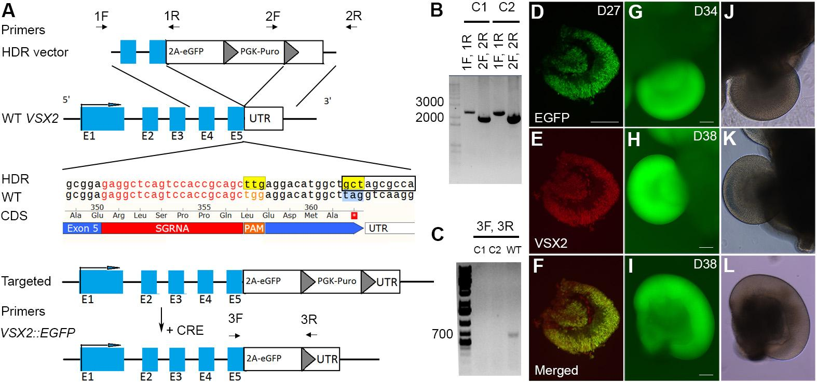

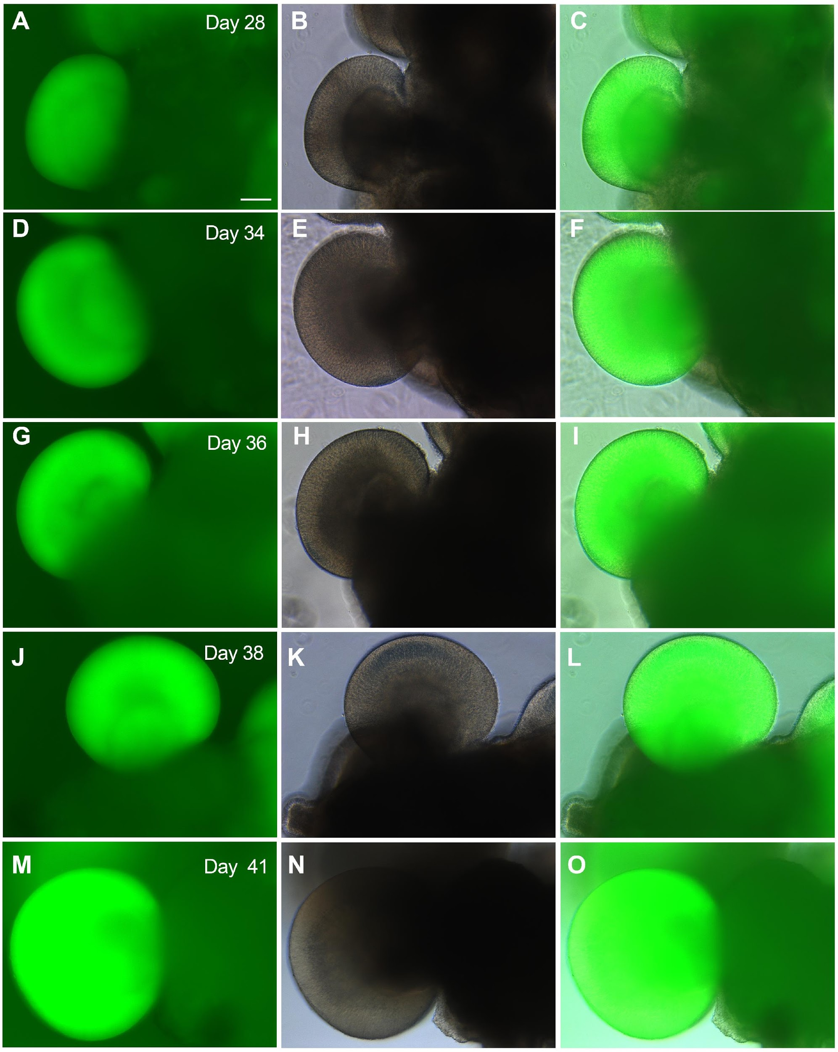



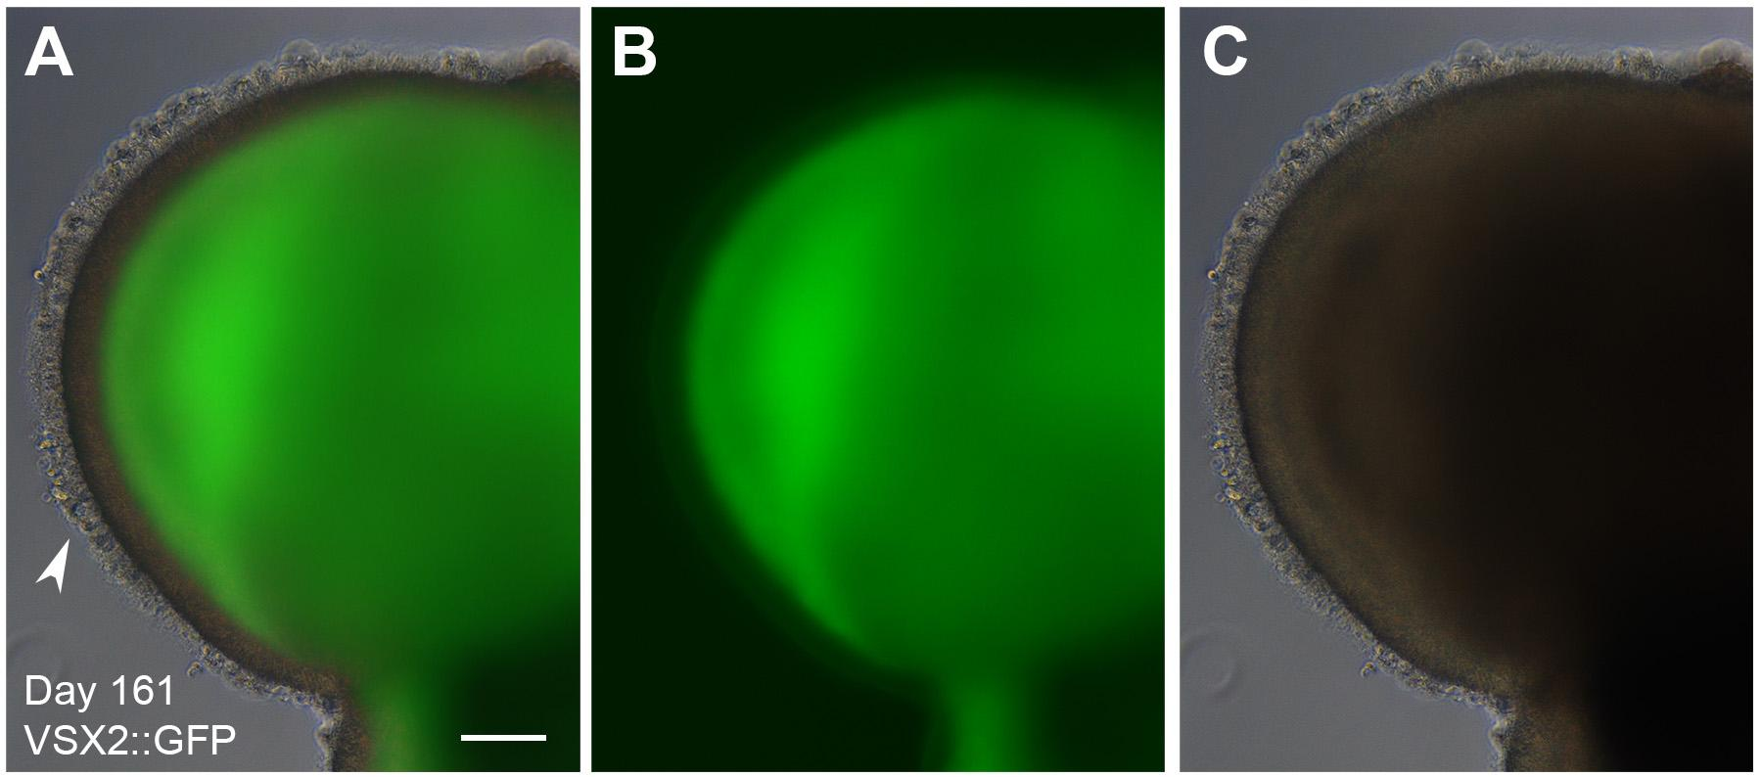

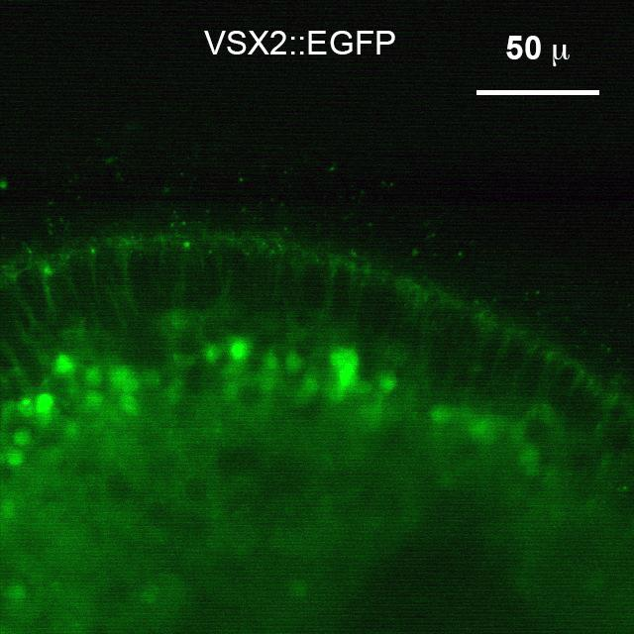

***2.*** *Source of cells for tissue engineering*

We will supplement the missing cells from embryonic mouse tissues or hESC-derived progenitors for tissue engineering in an effort to faithfully recapitulate the complexity of the retina.

***3.*** *Deliver the missing cells to retinal organoids for tissue engineering*

Microinjection will be used to combine the missing progenitors to our retinal organoids for co-cultures. Alternatively, bioprinting will be used to couple the cells of different types for co-culture. We will use bioprinting to make semi-sphere scaffolds for cell cultures.

***4.*** *Missing resource*

Micro injector setup and Bioprinting setup.

***5.*** *Estimated timeframe*

Five years.

**References**

Boucherie, C., Mukherjee, S., Henckaerts, E., Thrasher, A. J., Sowden, J. C., & Ali, R. R. (2013). Brief report: self-organizing neuroepithelium from human pluripotent stem cells facilitates derivation of photoreceptors. *Stem Cells, 31*(2), 408-414. doi:10.1002/stem.1268

Eiraku, M., Takata, N., Ishibashi, H., Kawada, M., Sakakura, E., Okuda, S., . . . Sasai, Y. (2011). Self-organizing optic-cup morphogenesis in three-dimensional culture. *Nature, 472*(7341), 51-56. doi:10.1038/nature09941

Lamba, D. A., Gust, J., & Reh, T. A. (2009). Transplantation of human embryonic stem cell-derived photoreceptors restores some visual function in Crx-deficient mice. *Cell Stem Cell, 4*(1), 73-79. doi:10.1016/j.stem.2008.10.015

Lowe, A., Harris, R., Bhansali, P., Cvekl, A., & Liu, W. (2016). Intercellular Adhesion-Dependent Cell Survival and ROCK-Regulated Actomyosin-Driven Forces Mediate Self-Formation of a Retinal Organoid. *Stem Cell Reports, 6*(5), 743-756. doi:10.1016/j.stemcr.2016.03.011

Meyer, J. S., Howden, S. E., Wallace, K. A., Verhoeven, A. D., Wright, L. S., Capowski, E. E., . . . Gamm, D. M. (2011). Optic vesicle-like structures derived from human pluripotent stem cells facilitate a customized approach to retinal disease treatment. *Stem Cells, 29*(8), 1206-1218. doi:10.1002/stem.674

Meyer, J. S., Shearer, R. L., Capowski, E. E., Wright, L. S., Wallace, K. A., McMillan, E. L., . . . Gamm, D. M. (2009). Modeling early retinal development with human embryonic and induced pluripotent stem cells. *Proc Natl Acad Sci U S A, 106*(39), 16698-16703. doi:0905245106 [pii]

10.1073/pnas.0905245106

Nakano, T., Ando, S., Takata, N., Kawada, M., Muguruma, K., Sekiguchi, K., . . . Sasai, Y. (2012). Self-formation of optic cups and storable stratified neural retina from human ESCs. *Cell Stem Cell, 10*(6), 771-785. doi:10.1016/j.stem.2012.05.009

Reichman, S., Terray, A., Slembrouck, A., Nanteau, C., Orieux, G., Habeler, W., . . . Goureau, O. (2014). From confluent human iPS cells to self-forming neural retina and retinal pigmented epithelium. *Proc Natl Acad Sci U S A, 111*(23), 8518-8523. doi:10.1073/pnas.1324212111

Stern, C. D. (2006). Neural induction: 10 years on since the 'default model'. *Curr Opin Cell Biol, 18*(6), 692-697. doi:10.1016/j.ceb.2006.09.002

Volkner, M., Zschatzsch, M., Rostovskaya, M., Overall, R. W., Busskamp, V., Anastassiadis, K., & Karl, M. O. (2016). Retinal Organoids from Pluripotent Stem Cells Efficiently Recapitulate Retinogenesis. *Stem Cell Reports, 6*(4), 525-538. doi:10.1016/j.stemcr.2016.03.001

Wahlin, K. J., Maruotti, J. A., Sripathi, S. R., Ball, J., Angueyra, J. M., Kim, C., . . . Zack, D. J. (2017). Photoreceptor Outer Segment-like Structures in Long-Term 3D Retinas from Human Pluripotent Stem Cells. *Sci Rep, 7*(1), 766. doi:10.1038/s41598-017-00774-9

Weigelt, B., & Bissell, M. J. (2008). Unraveling the microenvironmental influences on the normal mammary gland and breast cancer. *Semin Cancer Biol, 18*(5), 311-321. doi:10.1016/j.semcancer.2008.03.013

Zhong, X., Gutierrez, C., Xue, T., Hampton, C., Vergara, M. N., Cao, L. H., . . . Canto-Soler, M. V. (2014). Generation of three-dimensional retinal tissue with functional photoreceptors from human iPSCs. *Nat Commun, 5*, 4047. doi:10.1038/ncomms5047

Zhou, S., Flamier, A., Abdouh, M., Tetreault, N., Barabino, A., Wadhwa, S., & Bernier, G. (2015). Differentiation of human embryonic stem cells into cone photoreceptors through simultaneous inhibition of BMP, TGFbeta and Wnt signaling. *Development, 142*(19), 3294-3306. doi:10.1242/dev.125385

Zhu, Y., Carido, M., Meinhardt, A., Kurth, T., Karl, M. O., Ader, M., & Tanaka, E. M. (2013). Three-dimensional neuroepithelial culture from human embryonic stem cells and its use for quantitative conversion to retinal pigment epithelium. *PLoS One, 8*(1), e54552. doi:10.1371/journal.pone.0054552