Abstract (257 words; 300 words limit)

Yoshiki Sasai and his team pioneered the development of stem cells derived optic cup, also called 3-dimentional retinal organoid (RO) that is a major scientific advancement of potential understanding the development and interaction of retinal cells in healthy and disease retina *in vitro*. However, the inconsistent yield of RO, photoreceptors (PR) and retinal ganglion cells (RGC) are limited that hinder the application of human stem cells derived RO for studying the pathogenesis of retinal degenerative diseases or drug screening. In fact, photoreceptors and retinal ganglion cells are major retinal cell types associated with vision impairment diseases such as age-related macular degeneration and glaucoma.

To address the challenge of reproducibility of generating RO, our team has established a novel biomaterial platform to generate human iPSC-derived RO. Our data showed that a scaffold of polybenzyl glutamate (PBG), could significantly increase the yield of RO. In addition, the yield of photoreceptors and retinal ganglion cells are significantly increased. It suggests that the presence of PBG could significantly increase the context of retinogenesis and the maturation of retinal neurons. Interestingly, we also observe a robust neurite outgrowth from RGC-like cell in the innermost layer of RO although no optic nerve is formed. Overall, the PBG shows a great potential to generate RO in a reproducible fashion for the purposes of investigation the pathogenesis of retinal degenerative diseases and drug screening. In this study, we propose 2 Aims; **Aim 1**: Examine the Temporal Gene Expression of RO with or without PBG Scaffold, and **Aim 2**: Analysis the Birthday of Retinal Neurons.

Background

Cell replacement strategies using cell derivatives of pluripotent stem cells are promising approaches to rescue the degenerated retina. There are several studies using stepwise differentiation protocols to mimic retinal differentiation and to successfully generate RPE cells, RGCs, and photoreceptors from human embryonic stem cells (hESC) and induced pluripotent stem cells (hiPSC) (Kim, Greber, et al., 2009; Kim, Sebastiano, et al., 2009; Mellough, Sernagor, Moreno-Gimeno, Steel, & Lako, 2012; Meyer et al., 2009). Recent innovative process demonstrated that ESC or hiPSC could efficiently form 3D retinal structures, starting from embryoid bodies [15-18] or simply from confluent hiPSC cultures (Reichman et al., 2014; Singh et al., 2015). Recently, there are also some studies focusing on the establishment of a defined and completely xeno-free culture system following current Good Manufacturing Practice (GMP) guidelines for the generation of transplantable retinal cell types derived from hESC or hiPSC for future clinical applications. The use of feeder-free system with chemically defined media is now well described for hESC and hiPSC culture (Cho, Kim, Park, & Park, 2011), as well as for the generation of RPE cells (Plaza Reyes et al., 2016; Singh et al., 2015) including from hESC in clinical conditions (Schwartz, Tan, Hosseini, & Nagiel, 2016).

In this proposal, we propose to use a novel biomaterial scaffold called polybenzyl glutamate (PBG) to generate 3D retinal organoid (RO). Our preliminary result showed that PBG could promote the maturation of various retinal neurons from progenitors in RO and induce robust neurite outgrowth of retinal ganglion cells (RGC).

Description of the technologies and protocols to develop the model systems.

Although accumulating studies demonstrated the capability of generating 3-dimentional retinal organoid (RO) from human stem cells (Eiraku et al., 2011; Parfitt et al., 2016), there are limitations on the yield of RO and retinal neurons such as photoreceptors and retinal ganglion cells (RGC). It hinders the potential of RO for investigation of retinogenesis, pathogenesis of retinal diseases and drug screening. Thus, we propose to a novel system for generation of RO derived from human iPSC using biomaterial.

Our previous publication in IOVS showed that glutamate analogue induced the expression of progenitor program in Muller cells and also promotes the differentiation into various retinal neurons (Takeda et al., 2008). This observation prompts us to hypothesize that glutamate-induced activity may be a critical signal to Muller cells for turning on the progenitor program, promote its differentiation and maturation to various retinal neurons. We hypothesize that glutamate is critical to promote the maturation of progenitor cells into various retinal neurons in RO. Thus, we come up an idea and design a glutamate-containing scaffold called polybenzyl glutamate (PBG). It is synthesized using electrospinning method with 1-2 um diameter fibers. The PBG scaffold is a controlled biodegradable material and its pH value is maintained around 7 in *in vitro* environment. In addition, to evaluate any toxicity of PBG *in vivo*, we transplanted a small piece of PBG scaffold into the vitreous of adult C57BL/6 mice for 8 weeks. No toxicity was detected on retinal neurons such as retinal ganglion cells (RGC) comparing to the control. In addition, no sign of inflammation was detected in the retina/eyeball. Taken together, PBG is a safe material for using in cell or tissue culture. In our preliminary data generating RO with PBG, we detected a significant increase of gene expression specific to various retinal neurons such as RGC and photoreceptors, in the RO differentiating with PBG. In addition, robust neurite outgrowth from the RO is detected. Our preliminary data supports our hypothesis that PBG promote the maturation of progenitors into various retinal neurons.

To validate the reproducibility, birthdays of various retinal cell types (all 5 types) and temporal gene expression of RO will be examined. Briefly, the culture condition is adopted from a modified protocol published by Sasai’s group (Eiraku et al., 2011). At Day 27, we will transfer the EB to the non-aligned PBG scaffold for generation and maturation of RO. The stepwise protocol is straightforward and could be easily replicated by other laboratories. To promote the popularity of our biomaterial system, we could collaborate with other stem cell laboratories by providing the PBG scaffold. In the present study, we propose 2 Aims to establish the model system using a novel scaffold PBG.

Aim 1: Examine the Temporal Gene Expression of RO with or without PBG Scaffold.

To demonstrate the role of PBG scaffold in promoting the maturation of retinal progenitors in the RO, we will perform a temporal gene expression of individual RO (Day 9, 13, 17, 21, 27 and 30) with or without PBG by RNASeq. It will provide molecular evidence supporting the robust changes of RO during development in culture. We anticipate that PBG will induce a robust maturation process from progenitors to mature retinal neurons in RO comparing.

Aim 2: Analysis the Birthday of Retinal Neurons.

To show if PBG promote the RO formation by recapitulation of developmental process of human retina and the reproducibility of RO formation, a pulse of EdU will be applied to the cultures at various time points (Day 12, 15, 18, 21, 24 and 27) for 2 hours. Immunolableing of EdU and various retinal neuronal markers for all retinal neuron types will be performed after 2 days and then the newly generated retinal neurons (EdU+ and specific retinal marker+) will be quantified. We anticipate that higher proportion of progenitor cells in the RO will commit the differentiation and maturation process to become various types of retinal neurons.

We do not anticipate any technique difficulties to carry out the proposed experiments. The core facility in Harvard Public Health will perform the analysis the RNASeq. To attempt generating optic nerve-like structure, we will induce the formation of RO on an aligned form of PBG scaffold. We hope it could direct most neurite outgrowth from RO into a uni-direction.

Potential to achieve a model system

In our previous study, we showed glutamate analogue could induce expression of progenitor program in Muller cells and in addition, some of these cells will migrate out the inner nuclear layer and express markers of various retinal neurons in the correct layer of retina (Takeda et al., 2008). For example, we detected Muller cells migrating to outer nuclear layer and ganglion cell layer and express photoreceptor marker recoverin and ganglion cell marker beta-III tubulin, respectively. We hypothesize that glutamate-containing scaffold called polybenzyl glutamate (PBG) scaffold promotes the differentiation of progenitors and maturation into various retinal neurons in RO. Our preliminary data showed that in the presence of PBG, the RO has a higher expression level of specific markers for various retinal neurons and also exhibits robust neurite outgrowth from RO. It suggests that this novel scaffold induce RO formation with higher yield of matured retinal neurons that is more similar to a mature retina in human. We anticipate that our novel scaffold system could be used as a model system for generating RO. Thus, the PBG would be a simple and convenient platform to generate RO for studying the mechanisms of retinal degenerative diseases and for drug screening especially of photoreceptor or RGC degenerative diseases.

Disease model

We propose to use the PBG scaffold to generate RO to mimic a disease model of glaucoma. Although glaucoma is attributed to multiple factors, elevation of intraocular pressure is a well-accepted key risk factor (Agarwal, Gupta, Agarwal, Saxena, & Agrawal, 2009) and mutations in trabecular meshwork have been associated to different forms of glaucoma (Jacobson et al., 2001). So far, human RO has only a 3D structure mimicking retina but missing other structures such as trabecular meshwork and optic nerve. Therefore, RO would be more suitable to mimic the retina of glaucoma patient carrying mutations in retinal ganglion cells (RGC). In fact, genetic susceptible factors in RGC have already been found to be associated with glaucoma such as optineurin (OPN) (Minegishi, Nakayama, Iejima, Kawase, & Iwata, 2016; Shim et al., 2016). OPN has been suggested to be associated with different types of glaucoma such as primary open angle glaucoma and normal tension glaucoma. The prevailing view of mutated OPN such as E50K could mediate degeneration of RGC (Shim et al., 2016). The detailed mechanism of how the mutated OPN (mutations other than E50K in OPN have been found) contribute to the degeneration of RGC in glaucoma remains unclear. Note different mutations other than E50K have been identified. Thus, we propose to generate human iPSC from glaucoma patients carrying gene mutation in RGC such as OPN and hence generate RO with PBG scaffold. Control RO will be generated from iPSC from healthy subject. Then we will compare the morphology, electrophysiology of RGC, course of degeneration of soma and neurite formation of iPSC-derived RO from glaucoma patients and healthy subject. We anticipate that using RO as a glaucoma model would lead us understanding interaction between RGC and other retinal neurons and also the mechanisms of RGC degeneration. A long-term goal will be used the model to screen neuroprotective molecules to protect RGC degeneration.

Innovation statement

We propose a novel scaffold called polybenzyl glutamate (PBG) to generate iPSC-derived RO. Our preliminary data suggests that this innovative system could generate RO and yield more mature retinal neurons such as photoreceptors and RGC. It suggests that PBG could promote the differentiation and maturation process of progenitor cells into various retinal cell types. This model has a potential to be used as a disease model of glaucoma for studying the mechanism of RGC degeneration under stress. Instead of using experimental animals or purified RGC culture, iPSC derived RO from glaucoma patients is a superior system to mimic retina in vitro and used as a reproducible platform for high throughput drug screeningBiographical Sketches

**1.** **Dr. Kin-Sang Cho, PhD**. Instructor, Schepens Eye Reserach Institute, Massachusetts Eye and Ear, Harvard Medical School. Email: kinsang_cho@meei.harvard.edu

Dr. Cho earned his PhD degree in The University of Hong Kong and then received post-doctoral training in Schepens Eye Reserach Institute. He is the first to report a long distance optic nerve regeneration from the eye to the brain in postnatal mice with genetically modification. Then he developed another line of research in glaucoma and retinal stem cells. The long term goal is to develop novel therapeutic strategies to apply stem cells to treat retinal degenerative diseases such as glaucoma.

**Related Publications:**

1. Cho KS, Yang L, Lu B, Feng Ma H, Huang X, Pekny M, Chen DF. [Re-establishing the regenerative potential of central nervous system axons in postnatal mice.](https://www.ncbi.nlm.nih.gov/pubmed/15731004) ***J Cell Sci.*** 2005 Mar 1;118(Pt 5):863-72. PubMed PMID: 15731004.
2. Takeda M, Takamiya A, Jiao JW, Cho KS, Trevino SG, Matsuda T, Chen DF. [alpha-Aminoadipate induces progenitor cell properties of Müller glia in adult mice.](https://www.ncbi.nlm.nih.gov/pubmed/18326742) ***Invest Ophthalmol Vis Sci.*** 2008 Mar;49(3):1142-50. doi: 10.1167/iovs.07-0434. PubMed PMID: 18326742.
3. Yang Q, Cho KS, Chen H, Yu D, Wang WH, Luo G, Pang IH, Guo W, Chen DF. [Microbead-induced ocular hypertensive mouse model for screening and testing of aqueous production suppressants for glaucoma.](https://www.ncbi.nlm.nih.gov/pubmed/22599582) ***Invest Ophthalmol Vis Sci***. 2012 Jun 20;53(7):3733-41. doi: 10.1167/iovs.12-9814. PubMed PMID: 22599582.
4. Fang Y, Cho KS, Tchedre K, Lee SW, Guo C, Kinouchi H, Fried S, Sun X, Chen DF. [Ephrin-A3 suppresses Wnt signaling to control retinal stem cell potency.](https://www.ncbi.nlm.nih.gov/pubmed/23165658) ***Stem Cells***. 2013 Feb;31(2):349-59. doi: 10.1002/stem.1283. PubMed PMID: 23165658.
5. Wu N, Wang Y, Yang L, Cho KS. [Signaling Networks of Retinal Ganglion Cell Formation and the Potential Application of Stem Cell-Based Therapy in Retinal Degenerative Diseases.](https://www.ncbi.nlm.nih.gov/pubmed/27466076) ***Hum Gene Ther***. 2016 Aug;27(8):609-20. PubMed PMID: 27466076.

**2.** **Dr. Dong Feng Chen, MD, PhD**. Associate Professor, Schepens Eye Reserach Institute, Massachusetts Eye and Ear, Harvard Medical School. Email: dongfeng_chen@meei.harvard.edu

Dr. Chen is a graduate of Beijing University Medical Center, and was then trained in the laboratory of a Nobel laurel Dr. Susumu Tonegawa at the Massachusetts Institute of Technology. She was awarded with RPB Sybil B. Harrington Scholar and Outstanding Scientific Achievement Award from RP International and also received Visiting Professorship at the New York Eye and Ear Infirmary in 2008. Her research focuses on the molecular mechanisms that regulate the regenerative potential of neural stem cells and nerve injury and repair in the central nervous system (CNS) of adult mammals. My lab was the first to discover that the failure of optic nerve regeneration in adult mammals is a genetic event of neurons. Following identification of key genes regulating optic nerve regrowth, my laboratory achieved a landmark breakthrough by applying mouse genetic technology to induce full-length optic nerve regeneration from the eye all the way into the brain in postnatal mice. In another line of research, we studied the potential of a stem cell-based approach for promoting neuroregeneration and reported that Müller cells of adult mice possess retinal progenitor cell properties that can activated by small molecule to generate new retinal neurons.

**Related Publications**

1. Chen DF, Schneider GE, Martinou JC, Tonegawa S. Bcl-2 promotes regeneration of severed axons in mammalian CNS. ***Nature.*** 1997 Jan 30;385(6615):434-9. PubMed PMID: 9009190.
2. Kinouchi R, Takeda M, Yang L, Wilhelmsson U, Lundkvist A, Pekny M, Chen DF. Robust neural integration from retinal transplants in mice deficient in GFAP and vimentin. ***Nat Neurosci.*** 2003 Aug;6(8):863-8. PubMed PMID: 12845328.
3. Jiao J, Chen DF. Induction of neurogenesis in nonconventional neurogenic regions of the adult central nervous system by niche astrocyte-produced signals. ***Stem Cells.*** 2008 May;26(5):1221-30. PubMed PMID: 18323412; PubMed Central PMCID: PMC2683670.
4. Fang Y, Cho KS, Tchedre K, Lee SW, Guo C, Kinouchi H, Fried S, Sun X, Chen DF. Ephrin-A3 suppresses Wnt signaling to control retinal stem cell potency. ***Stem Cells.*** 2013 Feb;31(2):349-59. PubMed PMID: 23165658; PubMed Central PMCID: PMC3572266

**3. Professor Wei-Fang Su, PhD.** Distinguished Professor, Department of Materials Science and Engineering, National Taiwan University, Taipei, Taiwan, email:suwf@ntu.edu.tw

Professor Su is specialized in polymeric materials and nanomaterials for medical applications and electronic device/solar applications. She obtained her Ph.D. from University of Massachusetts (Amherst, MA, USA) and did postdoctoral research in Northwestern University (Evanston, IL, USA). She has published 200 SCI papers, 2 text books for polymer (2013 Springer) and solar cell (2012 Wiley) respectively, 30 US patents and 34 Taiwan patents.

**Related Publications**

1. **Wei-Fang Su**, Chun-Chih Ho, Tzu-Hsiang Shih, Chen-Hua Wang, Chun-Hao Yeh,“Exceptional Biocompatibility of 3D Fibrous Scaffold for Cardiac Tissue Engineering Fabricated from Biodegradable Polyurethane Blended with Cellulose,” *International Journal of Polymeric Materials and Polymeric Biomaterials*, 2016, 65(14), 703-711
2. Po-Hsuen Chen, Hsueh-Chung Liao, Sheng-Hao Hsu, Rung-Shu Chen, Ming-Chung Wu, Yi-Fan Yang, Chau-Chung Wu, Min-Huey Chen and **Wei-Fang Su**, “A Novel Polyurethane/cellulose Fibrous Scaffold for Cardiac Tissue Engineering,” *RSC Advances,* 2015*,* 5, 6932-6939
3. Chun-Chih Ho, Shang-Jung Wu, Shih-Hsiang Lin, Seth B. Darling, **Wei-Fang Su**,“Kinetically Enhanced Approach for Rapid and Tunable Self-Assembly of Rod–Coil Block Copolymers,” 2015, *Macromolecular Rapid Communications 36,* 1329-1335.

**4. Dr. Ta-Ching Chen, MD, PhD.** Assistant Professor, Department of Ophthalmology, National Taiwan University & Affiliated Hospital, Taipei, Taiwan. Email: tachingchen@ntuh.gov.tw

Dr. Chen is specialized in medical and surgical treatments of retina and optic nerve diseases. He obtained his Doctor of Medicine and master degree from NTU and completed his residency, retina fellowship and neuro-ophthalmology fellowship in NTUH (Taipei, Taiwan). After several years of clinical practice, he further did postdoctoral fellowship in Johns Hopkins University (Baltimore, MD, USA) and Harvard University (Boston, MA, USA) for visual neuroscience and stem cell biology. Apart from clinical research, his interest in basic research is studying a defined protocol for generating retinal organoid for clinical application. In recent 5 years, he published more than 10 peer-reviewed papers and has been invited for more than 20 speeches in academic conference.

Feasibility Assessment (3 pages max)

We propose to establish a system of generating RO using biomaterials. The proposal will be carried out by our team members Drs Dong Feng Chen and Kin-Sang Cho (Schepens Eye Research Institute, Massachusetts Eye and Ear), and Drs Wei-Fang Su and Taching Chen (National Taiwan University). We have formed a team for solving the problems of optic nerve and retinal tissue regeneration using biomaterials since 2014. In a previous publication in IOVS published by Dr. DF Chen’s group, glutamate or its analogue (sub-lethal dose) could induce Muller cells to proliferate and differentiate into although in this publication, we reported Muller cells migrating to the outer nuclear layer and some expressed a mature photoreceptor marker recoverin, we also observed a minor population of Muller cells migrating to the ganglion cell layer and expressing retinal ganglion cell marker. The potential role of glutamate of inducing neurogenesis from Muller cells is consistent with other studies. We hypothesize that glutamate may be a critical molecule to signaling the cells to differentiate and even maturation process. The mechanism is under investigation. Then we collaborate with Drs. Su in National Taiwan University who is a well-known expert in Biomaterials, to build a scaffold containing glutamate; called polybenzyl glutamate.

Drs Chen and Cho at Schepens Eye Research Institute have a strong track record of studying pathogenesis of glaucoma using microbead-induced model and DBA/2J mice, and retinal or optic nerve regeneration. In a glutamate analogue study on the neurogenic potential of Muller cells, we used BrdU to trace the fate of proliferating cells. A similar technique using EdU will be used in the proposed study. Recently, we have developed a new area of studying the role of epigenetic player Ezh2 and G9a on retinal development that involved RNA sequencing that were reported in Annual Meeting of ARVO (B0144: G9a and Ezh2 are important for RGC cell fate determination during development). Our preliminary data showed that PBG scaffold significantly promote neurite outgrowth of human ESC-derived retinal ganglion cell progenitors. It supports our hypothesis that glutamate promote the maturation of neuronal cells. All these techniques proposed in the present study are equipped in our laboratories.

Dr Taching Chen is a clinical scientist. His laboratory has generated human eye cup or retinal organoid from human iPSC. By combination the PBG scaffold, his preliminary data showed higher expression level of specific markers for various retinal neurons such as RGC in the RO with PBG. In addition, a robust neurite outgrowth from RGC of RO with PBG that supports our observation of human ESC-derived retinal ganglion cell progenitors on PBG scaffold. His group shows the ability to culture iPSC and generate RO with PBG.

Regarding the proposed study, we proposed a timeline.

0-9 month: Aim 1

6-18 month: Aim 2

18-24 month: Prepare a manuscript.

Overall, our team has the resources and expertise in various scientific areas that is required for accomplishing the proposed study. We will transfer the techniques and resources are needed. In fact, our team has filed jointly a patent that covers the usage of PBG scaffold to generate RO and application for retina/optic nerve regeneration.

For collecting and using of human cells, we have IRB approval and in addition, will follow strictly the requirements by the corresponding Institutes and the Government in Taiwan and the USA. All investigators handling human cells will receive vaccination of Hepatitis B for personal protection. In both Institutions, we have standard laboratory for human cell culture. In fact, our team has filed jointly a patent that covers the usage of PBG scaffold to generate RO and application for retina/optic nerve regeneration.

References

Agarwal, R., Gupta, S. K., Agarwal, P., Saxena, R., & Agrawal, S. S. (2009). Current concepts in the pathophysiology of glaucoma. *Indian J Ophthalmol, 57*(4), 257-266. doi: 10.4103/0301-4738.53049

Cho, K. J., Kim, J. H., Park, H. Y., & Park, C. K. (2011). Glial cell response and iNOS expression in the optic nerve head and retina of the rat following acute high IOP ischemia-reperfusion. *Brain Res, 1403*, 67-77. doi: 10.1016/j.brainres.2011.06.005

Eiraku, M., Takata, N., Ishibashi, H., Kawada, M., Sakakura, E., Okuda, S., . . . Sasai, Y. (2011). Self-organizing optic-cup morphogenesis in three-dimensional culture. *Nature, 472*(7341), 51-56. doi: 10.1038/nature09941

Jacobson, N., Andrews, M., Shepard, A. R., Nishimura, D., Searby, C., Fingert, J. H., . . . Sheffield, V. C. (2001). Non-secretion of mutant proteins of the glaucoma gene myocilin in cultured trabecular meshwork cells and in aqueous humor. *Hum Mol Genet, 10*(2), 117-125.

Kim, J. B., Greber, B., Arauzo-Bravo, M. J., Meyer, J., Park, K. I., Zaehres, H., & Scholer, H. R. (2009). Direct reprogramming of human neural stem cells by OCT4. *Nature, 461*(7264), 649-643. doi: 10.1038/nature08436

Kim, J. B., Sebastiano, V., Wu, G., Arauzo-Bravo, M. J., Sasse, P., Gentile, L., . . . Scholer, H. R. (2009). Oct4-induced pluripotency in adult neural stem cells. *Cell, 136*(3), 411-419. doi: 10.1016/j.cell.2009.01.023

Mellough, C. B., Sernagor, E., Moreno-Gimeno, I., Steel, D. H., & Lako, M. (2012). Efficient stage-specific differentiation of human pluripotent stem cells toward retinal photoreceptor cells. *Stem Cells, 30*(4), 673-686. doi: 10.1002/stem.1037

Meyer, J. S., Shearer, R. L., Capowski, E. E., Wright, L. S., Wallace, K. A., McMillan, E. L., . . . Gamm, D. M. (2009). Modeling early retinal development with human embryonic and induced pluripotent stem cells. *Proc Natl Acad Sci U S A, 106*(39), 16698-16703. doi: 10.1073/pnas.0905245106

Minegishi, Y., Nakayama, M., Iejima, D., Kawase, K., & Iwata, T. (2016). Significance of optineurin mutations in glaucoma and other diseases. *Prog Retin Eye Res, 55*, 149-181. doi: 10.1016/j.preteyeres.2016.08.002

Parfitt, D. A., Lane, A., Ramsden, C. M., Carr, A. J., Munro, P. M., Jovanovic, K., . . . Cheetham, M. E. (2016). Identification and Correction of Mechanisms Underlying Inherited Blindness in Human iPSC-Derived Optic Cups. *Cell Stem Cell, 18*(6), 769-781. doi: 10.1016/j.stem.2016.03.021

Plaza Reyes, A., Petrus-Reurer, S., Antonsson, L., Stenfelt, S., Bartuma, H., Panula, S., . . . Kvanta, A. (2016). Xeno-Free and Defined Human Embryonic Stem Cell-Derived Retinal Pigment Epithelial Cells Functionally Integrate in a Large-Eyed Preclinical Model. *Stem Cell Reports, 6*(1), 9-17. doi: 10.1016/j.stemcr.2015.11.008

Reichman, S., Terray, A., Slembrouck, A., Nanteau, C., Orieux, G., Habeler, W., . . . Goureau, O. (2014). From confluent human iPS cells to self-forming neural retina and retinal pigmented epithelium. *Proc Natl Acad Sci U S A, 111*(23), 8518-8523. doi: 10.1073/pnas.1324212111

Schwartz, S. D., Tan, G., Hosseini, H., & Nagiel, A. (2016). Subretinal Transplantation of Embryonic Stem Cell-Derived Retinal Pigment Epithelium for the Treatment of Macular Degeneration: An Assessment at 4 Years. *Invest Ophthalmol Vis Sci, 57*(5), ORSFc1-9. doi: 10.1167/iovs.15-18681

Shim, M. S., Takihara, Y., Kim, K. Y., Iwata, T., Yue, B. Y., Inatani, M., . . . Ju, W. K. (2016). Mitochondrial pathogenic mechanism and degradation in optineurin E50K mutation-mediated retinal ganglion cell degeneration. *Sci Rep, 6*, 33830. doi: 10.1038/srep33830

Singh, R. K., Mallela, R. K., Cornuet, P. K., Reifler, A. N., Chervenak, A. P., West, M. D., . . . Nasonkin, I. O. (2015). Characterization of Three-Dimensional Retinal Tissue Derived from Human Embryonic Stem Cells in Adherent Monolayer Cultures. *Stem Cells Dev, 24*(23), 2778-2795. doi: 10.1089/scd.2015.0144

Takeda, M., Takamiya, A., Jiao, J. W., Cho, K. S., Trevino, S. G., Matsuda, T., & Chen, D. F. (2008). alpha-Aminoadipate induces progenitor cell properties of Muller glia in adult mice. *Invest Ophthalmol Vis Sci, 49*(3), 1142-1150. doi: 10.1167/iovs.07-0434

Optional Appendix Section

In this Section, we provid our unpublished or proprietary data to support our proposed hypothesis that polybenzyl glutamate (PBG) scaffold is critical to promote the maturation of progenitor cells into various retinal neurons in RO.

We designed and synthetized PBG using electospinning method to generate non-aligned or aligned fiber with 1 -2 um diameter (**Fig. 1**). In addition, we showed a slow degradation of PBG scaffold and the changes of pH in phosphate buffered saline at 37oC in vitro (**Fig. 2**).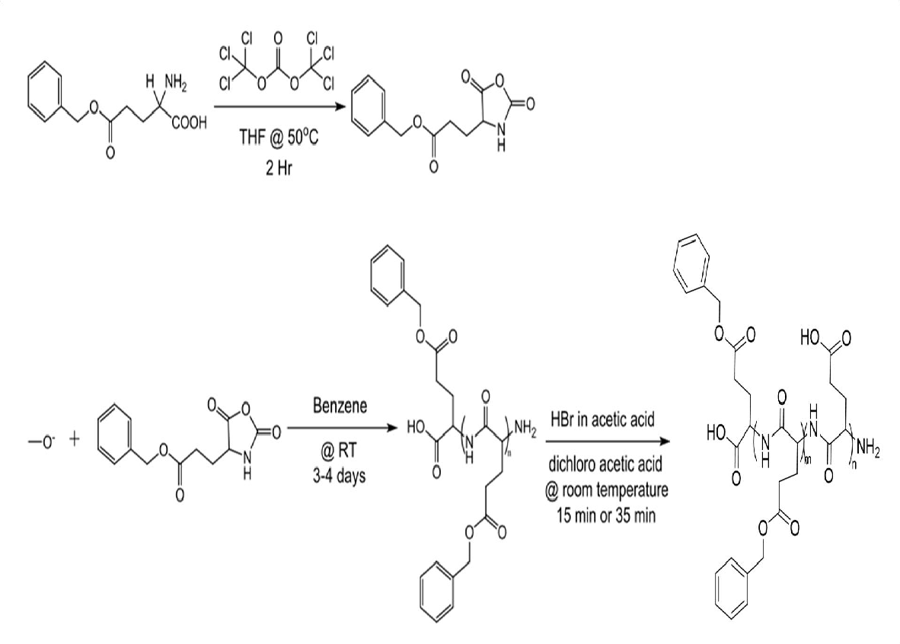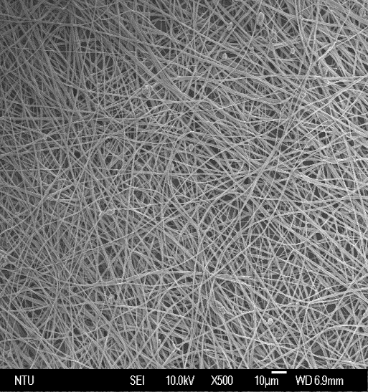

**Fig. 1 Structure and Appearance of polybenzyl glutamate (PBG)**. Schematic diagram of chemical synthesis of polybenzyl glutamate PBG in (**a**) and an image of scanning electromicroscopy isotrophic or non-aligned PBG fibers (**b**) were shown. The diameter of PBG fiber is 1 - 2 um.

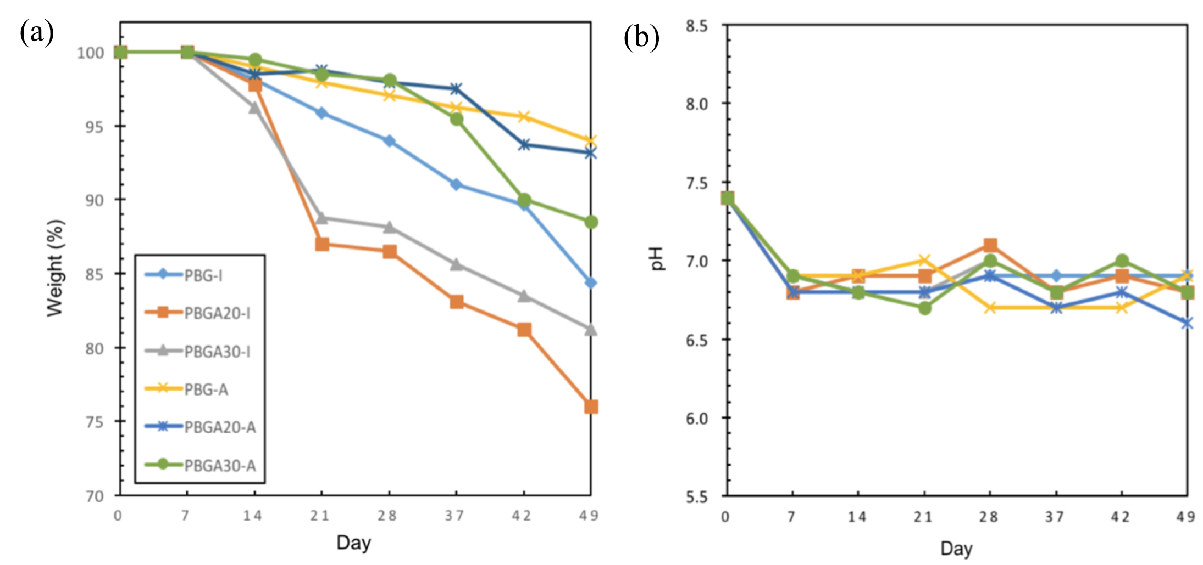

**Fig. 2 Showing the rate of biodegradability of PBG (a) and the changes of pH in PBS at 37oC (b).** PBG-I and PBG-A represents PBG-Isotrophic and PBG-Aligned, respectively.

We adopted the protocol from Sasai's group (Eiraku et al., 2011) to generate retinal organoid (RO) from human iPSC with minor modifications. At Day 27, embryoid bodies were collected and transferred to PBG scaffold for additional 3 to 7 days.(**Fig. 3**) Then the RO were collected for immunolableing for various markers of retinal neurons. (Fig. 4) In fact, the intensity and the extend of neurite outgrowth from RO is significant increased in the presence of PBG.

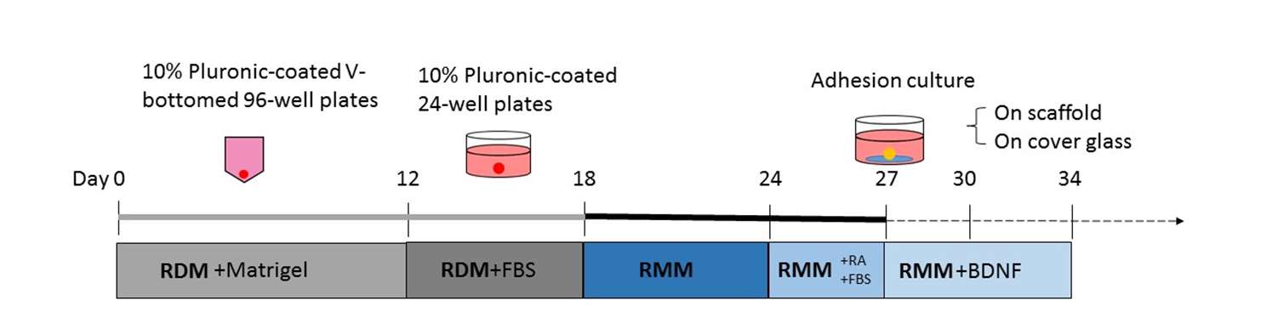

**Fig. 3 Schematic time line showing a protocol of generation of retinal organoid from human iPSC.** Note embryoid bodies were transferred to new culture well and culture on PBG scaffold or cover glass at Day 27.

Finally, to further demonstrate the RO expressing RGC markers, we collected the RO with or without PBG at D30 and examine their gene expression. We found that in the presence of PBG, the RGC marker is significantly increased while the progenitor gene such as ISL1, is significantly decreased comparing to the control RO culturing on a cover glass. On the contrary, RO on the cover glass with lower signal of RGC and photoreceptor markers. (**Fig. 5**) It supports the hypothesis that PBG is critical to promote the maturation of progenitor cells into various retinal neurons such as RGC, in RO.

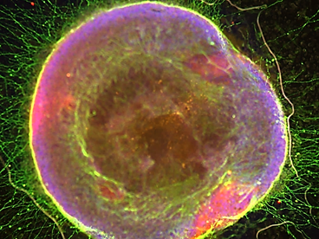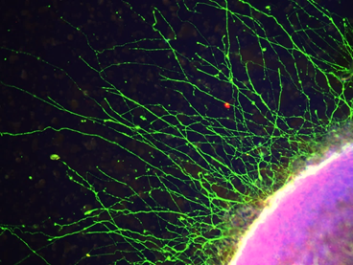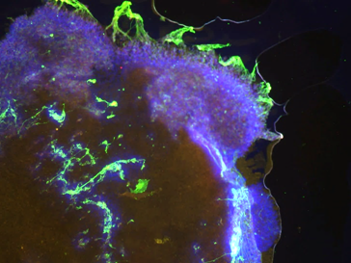

**Fig. 4. Showing the retinal organoid at D30 on PBG scaffold or cover glass**. A low magnification image of RO on PBG that showed strong signal of rhodopsin (purple; rod photoreceptor marker) and βIII-tubulin (green; retinal ganglion cell marker) (**a**) and a higher magnification image of RO on PBG was shown (**b**). Note a strong signal of βIII-tubulin (green) signal and rhodopsin (purple) were confined in the inner and outer layer of the RO, respectively. In addition, a robust neurite outgrowth from the RO was detected. In the control, the expression of βIII-tubulin (green, RGC marker) and rhodopsin (purple, rod photoreceptor), and a very limited neurite outgrowth from RO were detected (**c**).

Taken together, our preliminary data demonstrates the potential of generating iPSC-derived RO with PBG scaffold that will have higher yield of matured retinal neurons in a more organized fashion. We anticipate that the PBG scaffold will be a convenient and reliable tool to generate RO in a reproducible fashion.

|  |  |
| --- | --- |
| Material or Regaent | Supplier |
| V bottom 96 well plate, 24 well plate | Corning |
| RDM: |  |
| -Neurobasal | ThermoFisher |
| -NEAA Solution | Sigma |
| -L-glutamine | ThermoScientific |
| -Nicotinamide | Stemcell Technologies |
| -KOSR | Stemcell Technologies |
| RMM: |  |
| -DMEM/F12/Glutamax | Sigma |
| -N2 | ThermoFisher |
| -penicillin/straptomycin | Sigma |
| Matrigel | BD Biosciences |
| FBS | Sigma |
| Retinoid acid | Stemcell Technologies |
| BDNF | Peprotech |