**Feasibility Assessment**

*Describe the ability to execute the proposed solution and address the Evaluation Criteria. Include estimated timeframe, supporting precedents, and any special resources that are needed. If proposal requires expertise in divergent areas of research, the ability of the team to execute solution will be considered. If applicable, address protections for human subjects, compliance with policies related to use of human stem cells, biosafety issues, and use of technologies covered by patents or other intellectual property protection.*

**Estimated Time frame**

The estimated time frame for this project is 1 year. In the first 3 months, components will be differentiated separately from H9 hESCs, then combined step-by-step.

Retina organoids will be differentiated for 30-60 days (at least) before combining them with the other tissues.

**Supporting precedents**

Dr. Seiler’s lab has shown that sheets dissected from retina organoids transplanted to retinal degenerate rat models develop all major retinal cell types *in vivo* (**Fig. 8**).

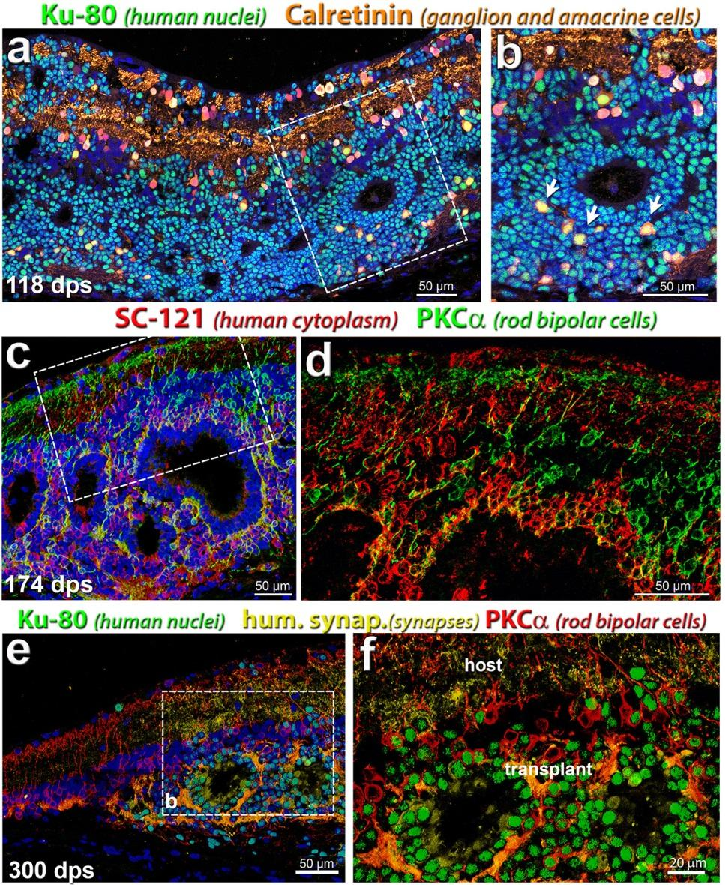



**Special resources**

There are no special resources required. Each lab (Dr. Seiler, Dr. Thomas, Dr. Lee) has access to a special tissue culture room with biosafety cabinets, incubators, inverted and stereo microscopes, and technicians with expertise in cell culture.

**Team expertise in divergent areas of research**

Dr. Seiler is expert in retinal transplantation, development, and microdissection. Her lab has developed expertise in differentiating retina organoids from hESCs.

Dr. Thomas is expert in studying retinal degenerative diseases and conducting transplantation experiments in rodent models. His laboratory developed the technique to transplant RPE cultured as a polarized monolayer on ultrathin substrates.

Dr. Lee is expert in microfluidic technologies for 3D cell cultures. Collaborating with a vascular biologist, he has developed a microfluidic platform for perfused vascularized tissue that are connected with microchannels intravascularly. He has developed a wide range of technologies for cell sorting, single cell analysis, molecular detection, and therapeutic particles.

**Protections for human subjects**: n/a

**Human stem cells:**

Dr. Seiler’s studies are covered by hSCRO protocol 2006-5316, last approval date 7-21-17 (expiration date 7-20-18).

Dr. Thomas’ SCRO protocol approval is pending

Dr. Lee’s hSCRO protocol is pending.

**Biosafety issues:**

Dr. Seiler’s biosafety protocol is last approved 10/25/2016 through 10/24/2019, with annual report requirements.

Dr. Thomas’ biosafety protocol is approved July 27, 2017 through July 26 2020

Dr. Lee’s biosafety protocol is last approved 05/12/2016 through 05/11/2019, with annual report requirements.

**Use of technologies covered by patents or other intellectual property protection**

Microfluidity patents:

* A HIGH-THROUGHPUT PLATFORM TO INVESTIGATE ANGIOGENESIS IN PERFUSED HUMAN CAPILLARIES, US Filing date 10/05/2011, US Serial #13/253,820
* MICROFLUIDIC PRESSURE REGULATOR FOR ROBUST HYDROGEL LOADING WITHOUT BURSTING, US Filing date 10/24/2016, US Serial #15/333,183

The implantation instrument is covered by patents # 5,941,250, # 6,159,218, # 6,156,042, and # 8,057,483.