**Trainee Category Submission**

**Team Lead: Julia Oswald, PhD**

**Position: Postdoctoral Researcher**

at the laboratory of Petr Baranov, MD PhD

**Institution: Schepens Eye Research Institute,**

**Massachusetts Eye and Ear,**

an affiliate of Harvard Medical School

**Innovation statement**

This proposal combines the use of biologically relevant matrixes and bioprinting to achieve the de-novo assembly of a fully structured 3-dimensional, multilayered retinal spheroid from previously matured retinal cell types. By generating a hydrogel encapsulated organoid with all neuronal retinal cell types represented this solution to the 3D-ROC challenge aims to provide a layout towards the high-throughput production of retinal organoids suitable for drug screening.

**Abstract**

To date full recapitulation of in-vivo retinal development and structure within hiPSC derived 3- dimensional organoids is limited with respect to both, synchrony of retinal maturation across cell types as well as the characteristic retinal layering. Furthermore, retinal organoids derived from current culture protocols are extremely sensitive to high-throughput handling and require labor-intensive selection procedures to achieve reproducible yields of differentiation, as batch variations in differentiation and maturation remain high.

In order to improve the handling of hiPSC derived retinal organoids on a high-throughput scale this proposal envisions the encapsulation of retinal organoids in stiffness tunable hydrogel to enhance resistance to sheer stress during manual/automatic handling. Furthermore, to bridge the discrepancy between cell type specific maturation and lamination observed within current culture systems, it proposes the generation of 3-dimensional organoids from **3D-printed, multilayered spheroids**, using differentially aged retinal cell populations.

While all neuronal cell types of the retina will be differentiated from hiPSC according to already existing protocols, the here proposed protocol envisions the isolation of each cell type from those “native” organoids, followed by the **reassembly into 3D-printed, multilayered spheroids** to achieve the characteristic laminar structure of the retina. To enhance cell viability and to mimic in-vivo extracellular matrix conditions each layer of the proposed spheroid will be derived from a **stiffness tunable hydrogel matrix**, adjusted for each individual cell type. In conclusion, by disentangling the process of cellular differentiation and neuronal network formation, this proposal aims to provide an organoid system that can be generated and maintained within high-throughput setups and provides the ability to simultaneously maintain all neuronal cell types of the retina within an in-vivo representative laminar scaffold.

**Background**

Following the ability to generate induced pluripotent stem cells and the quest to differentiate various native cell types in-vitro as well as to recapitulate in-vivo development, 3-dimensional organoids have become a new research frontier. While 3-dimensional organoids recapitulate development with respect to cellular differentiation for many systems, including the brain and eye, and are able to reproduce some of the structural features observed within the native organs, their overall ability to be truly representative of the in-vivo organ remains limited. Due to either immature structural maturation or the absence of proper functional interaction between the different cell types, 3-dimensional organoids to date have not been able to limit/replace the use of animal models in disease modeling and drug discovery/toxicity studies.

For the retina, several research groups have been able to generate 3-dimensional organoids from hiPSC by using slightly variant protocols, which result in robust, though somewhat batch variable, induction of optic cups and differentiation of all major retinal cell types within (Wahlin et al., 2017; Ohlemacher et al., 2015; Zhong et al., 2014; Nakano et al., 2012; Eiraku et al., 2011). While all groups are able to generate retinal ganglion, horizontal, amacrine and bipolar cells as well as photoreceptors, over the course of several months within a single organoid, earlier cell phenotypes are often lost before full maturation of the later born cells. Hence, once the photoreceptors are matured, the majority of retinal ganglion cells has been lost. Consequently, when aiming to obtain a fully laminated retinal structure, the premature loss of those early cell fates impedes proper synaptic connectivity as well as the formation of a fully laminated tissue, as developmentally cellular interaction between different cell types is required for this process.

In contrast to those current protocols that aim to achieve both, cellular maturation and synaptic connectivity (layering) within a single, continuously grown organoid structure (which for the purpose of this proposal will be termed “native organoids”), **the aim of this proposal is to disentangle the process of cellular maturation and the synaptic, laminar assembly of the underlying neuronal network.** For the proposed solution all retinal cell types will be grown and differentiated within a native organoid initially (Figure 1), followed by the isolation of each cell type to then reassemble a properly laminated retina within a 3D-printed, multilayered spheroid, based on a stiffness tunable hydrogel matrix (Figure 2). In detail, this process can be broken down into four major steps which will be optimized separately, as discussed in the following sections:

- **Retinal differentiation** according to current protocols

- **Cell type specific isolation** based on cell surface markers using magnetic microbeads

- **Reassembly into 3D-printed, multilayered spheroids** using Biogelx matrix scaffolds

**- Quality control**

**Step 1 Retinal differentiation**

Given the demonstrated success of existing protocols with respect to cell type specific retinal differentiation in 3D-organoids, this proposal does not generally aim to change the overall protocol setup used to initiate cell type specific differentiation. Since the delay between earlier and later cell fates will be bridged by isolation of each cell type within a defined (see next section) time window from distinct native organoid populations, the availability of each cell type can be ensured by time shifted cultures to match isolation windows for each cell layer. It should be mentioned though that this approach opens the possibility to work on biasing organoid differentiation towards generating early and late fated organoids. So rather than trying to synchronize the occurrence of early and late cell fates and to improve the time they can survive in-situ, this approach opens the possibility to strongly favor early vs. late fates in one of the differentiation batches and vice versa. This could be achieved by modulating cellular exposure to growth factors, Notch signaling and Retinoic Acid signaling and ultimately may ensure both an increase in cell yield as well as a shortened time window for the generation of each single cell fate within the fate biased organoids. In general though the addition of fate modulating chemicals and factors should be limited to avoid carried on effects towards the study of other drugs within the system. For the use of growth factors the PODSTM design would reduce this problem, as the polyhedrin crystals can be immobilized in the matrix coating of the culture vessel and therefore would not carry over once the organoid is removed to a new well.

Fate biased or not, to allow those native organoids to be usable within a high-throughput setup it is necessary to improve their resistance to sheer stress during handling and suspension culture. Currently, within the field of cortical organoids Matrigel encapsulation is used for a similar purpose as well as to improve cellular lamination due to the added structural support (Lancaster et al., 2017; Lancaster & Knoblich, 2014). Since for the purpose of this proposal Matrigel should be eliminated as it is not a chemically defined compound (Hunt et al., 2017), the goal is to encapsulate single organoids (spheroid bodies) within a stiffness tunable hydrogel matrix (Biogelx) at the onset of differentiation. Biogelx is a biocompatible, non-animal derived, tunable, and chemically defined hydrogel which eliminates the inherent variability of Matrigel as a reagent and will provide sufficient structural support to enhance the overall resistance of the organoids to mechanical stress during handling. 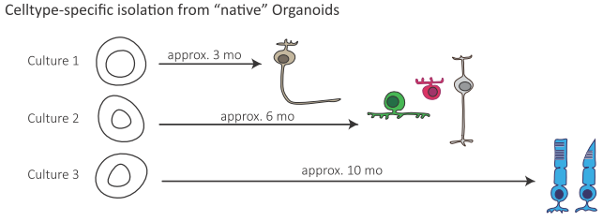

*Figure 1. Generation of retinal cell types for VisionSpheres*

*Each cell type will be derived from an independent set of native organoids, at a defined time point, relating to cell maturity and ability to form synaptic connections, according to prior 2D screening.*

**Step 2 Cell type specific isolation**

Following the differentiation of all retinal cell types within the native organoids, the retinal cell populations will be isolated in three distinct fractions. Comparable to the native retina where only retinal ganglion cells and the photoreceptors are forming unique cellular layers by themselves, also within the envisioned multilayered spheroid, bipolar, amacrine and horizontal cells will be treated as one fraction. The isolation of each fraction will be performed using magnetic-associated cell sorting (MACS) targeting CD90 for the isolation of retinal ganglion cells and CD73 for photoreceptors. For bipolar/amacrine and horizontal cells the negative fraction from both CD90 and CD73 selection will be used. Even though this procedure only yields enriched rather than fully purified cell populations compared to fluorescence activated cell sorting, cell viability is enhanced, which has been deemed more important to the overall goal of the setup, which aims to generate high cellular yields.

The point of isolation will be determined to ensure highest subtype specific viability and ability to connect and terminally mature. In analogy to in-vivo development it can be suggested that the ideal window for isolation is probably slightly prior to full-differentiation of each respective cell type in culture. So while transcription of cell type specific genes has just been stabilized but prior to the state of full maturation, marked by the expression of certain subclass specific genes within each cell population.

To test the ideal time window for isolation of each cell type, cells will be transferred to a multi well 2D-culture system (Figure 2, C) and grown on stiffness tunable Biogelx, the same matrix which will later be used for the assembly of the 3-dimensional spheroid. Aside from adjusting the mechanical properties of the Biogelx matrix it is also possible to chemically tune its properties by the incorporation of RGD (fibronectin) and laminin mimetic peptide sequences, which provides additional options to modulate the proposed matrix scaffold. Given the effects of extracellular matrixes on differentiation and axon outgrowth (Li et al., 2017; Alakpa et al., 2016), the Biogelx scaffold is expected to enhance and stabilize cellular fates within the spheroids as well as to improve neuronal network formation.

The transfer of the isolated retinal cell populations into multi well 2D-culture for the initial testing of the system has several advantages. First of all, the optimal time window for isolation can be determined for each cell type, which can be assessed by straightforward, high throughout viability assays. Secondly, the ideal matrix conditions for cell maturation and axon outgrowth can be determined in a similar fashion and last but not least, cellular function can be assessed in away amendable to multi-electrode array setups. Consequently, those initial steps of optimization not only aid to define the properties of the final multilayered spheroid but at the same time can serve as quality control measures within the final product cycle, which each of them being amendable to semi-automation.

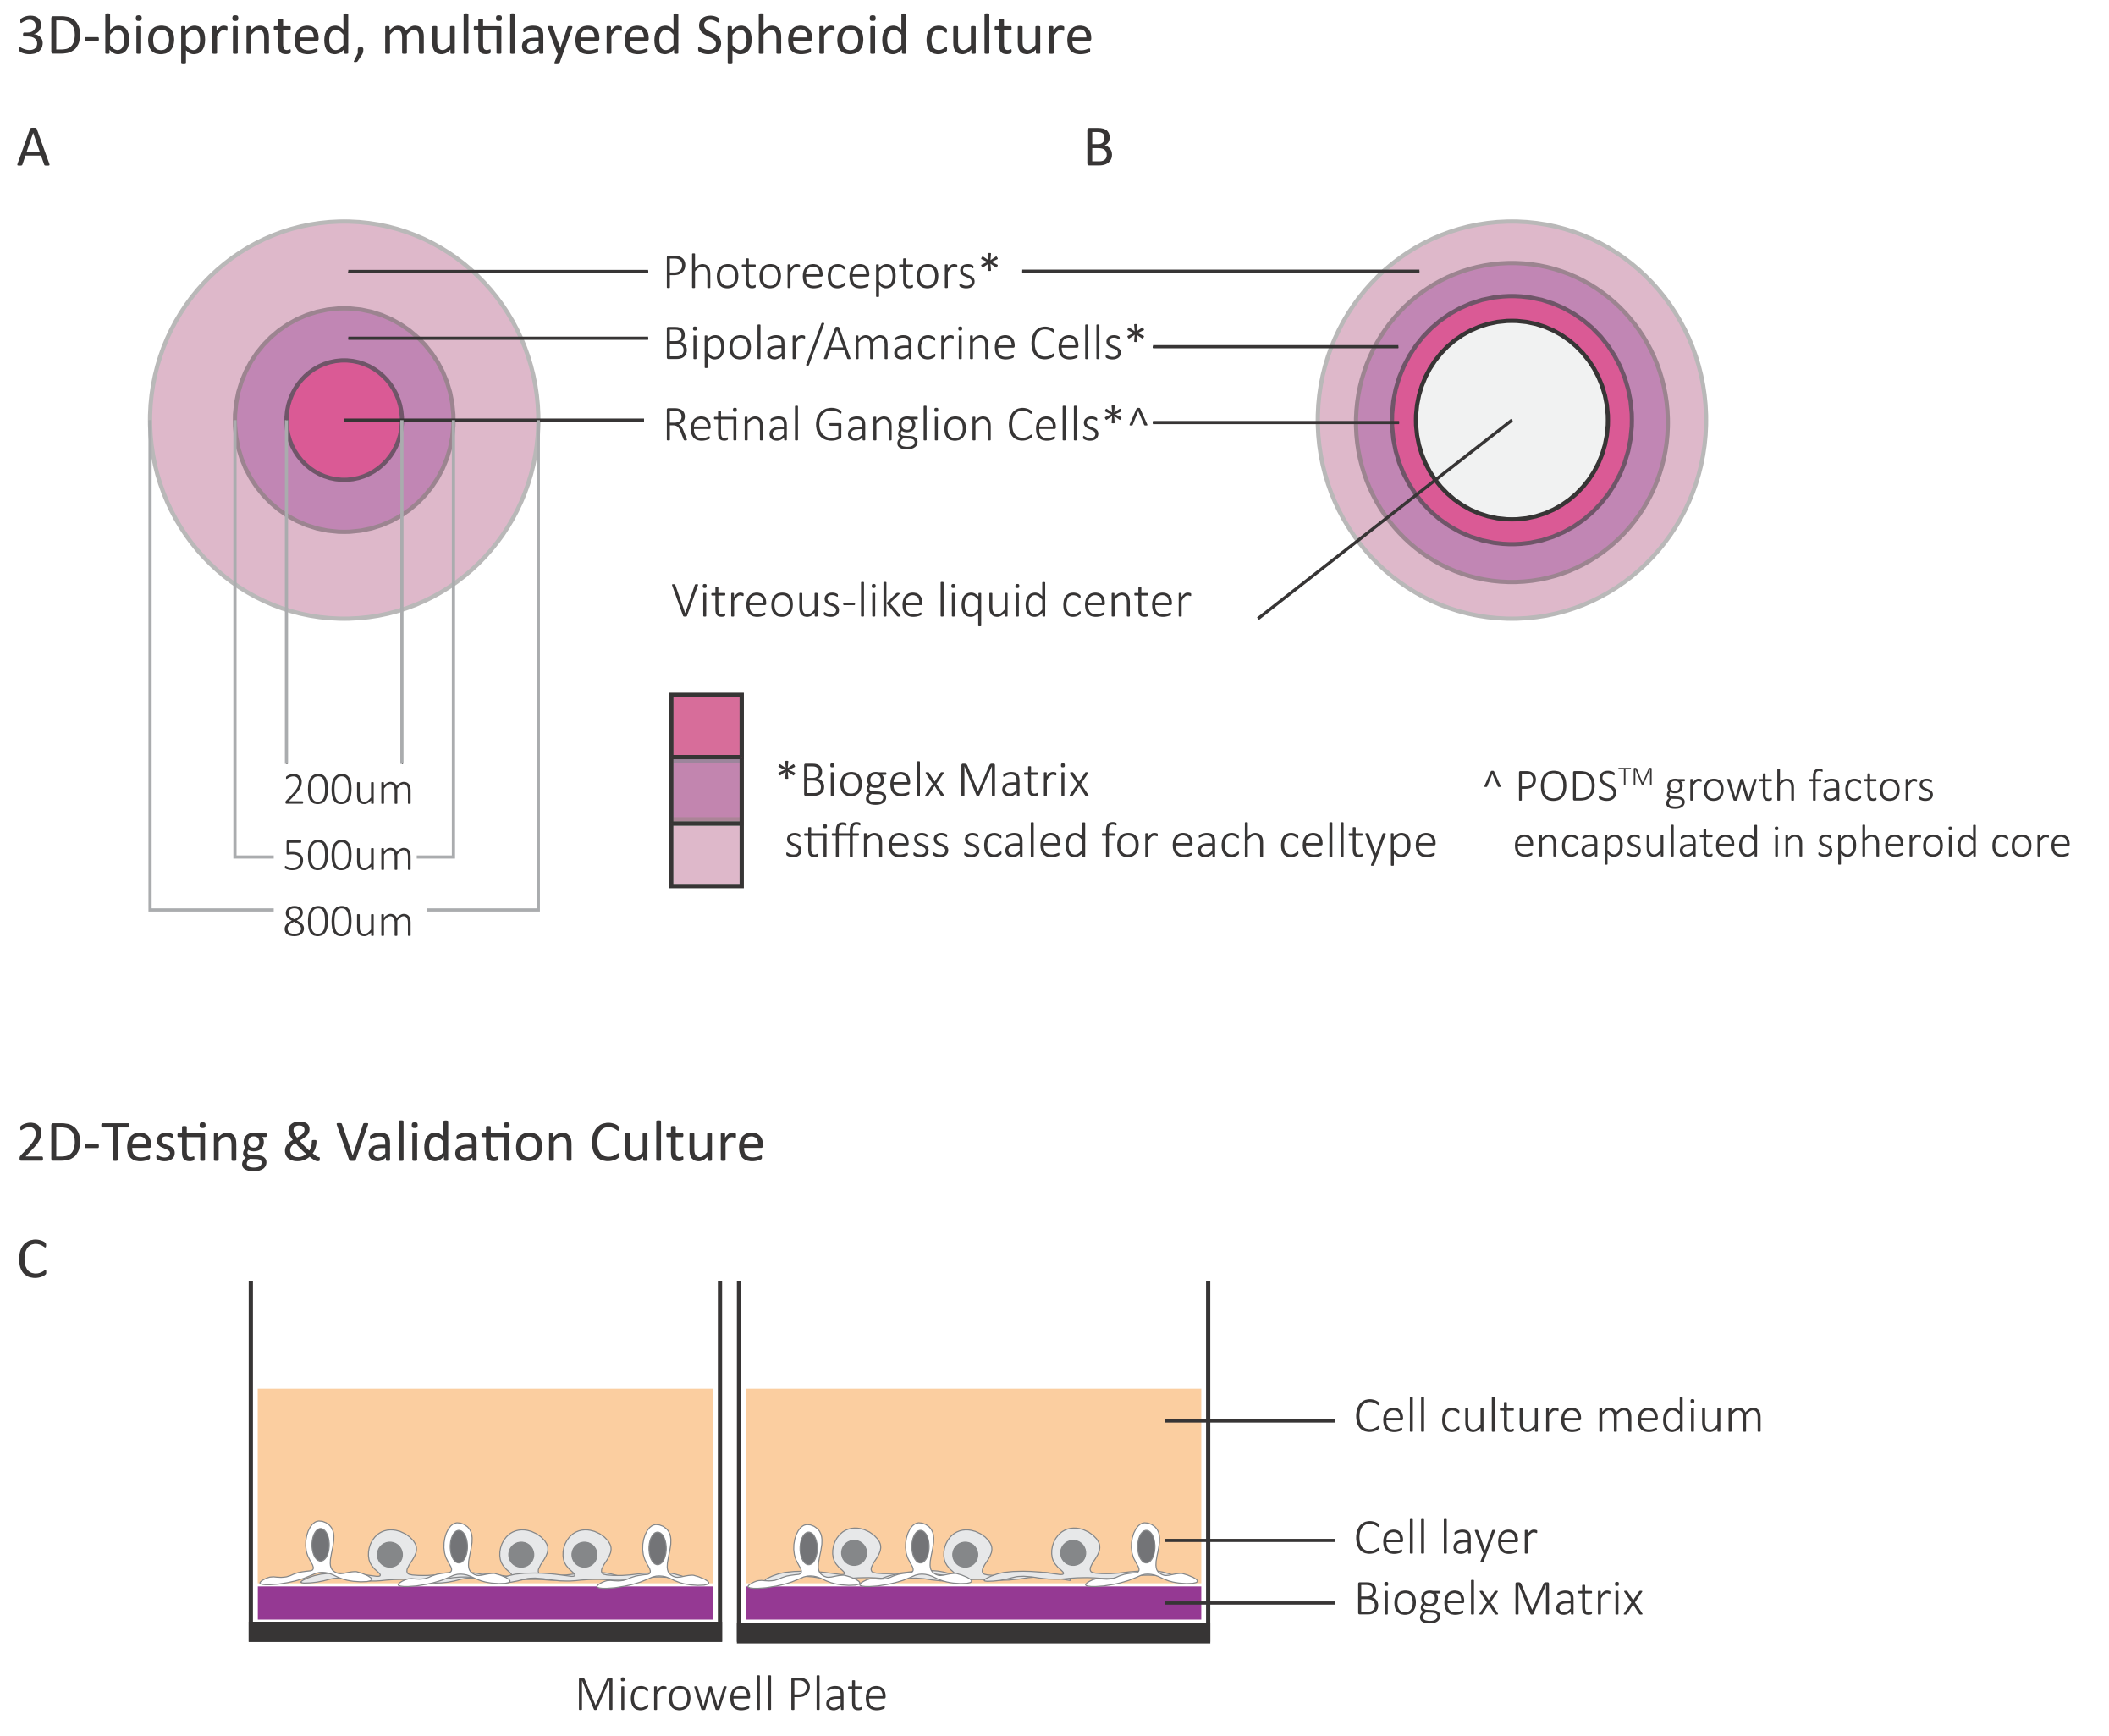

*Figure 2. (****A****) 3D-printed, multilayered spheroid culture comprised of three layers, including photoreceptors and retinal ganglion cells as purified cell layers and one layer including amacrine, horizontal and bipolar cells. Each cell layer will be generated from Biogelx matrix that has been tuned to the needs of each specific cell type. Core embedding of PODS growth factors CNTF, BDNF and GDNF is intended to improve cell viability and synaptic rewiring within the spheroids. Overall spheroids sizes have been limited to account for oxygen diffusion in suspension culture.*

*(****B****) Following the establishment of version (****A****) of a multilayered spheroid it is proposed to expand the retinal organoids to a layout that includes a fluid core comparable to the vitreous, allowing for the delivery of drugs by injection rather than media bathing.*

*(****C****) 2D-Testing and Validation cell culture allowing for the assessment of cell viability, function and maturation in a high-throughput multi well setup.*

**Step 3 Reassembly into 3D-printed, multilayered spheroids**

Once all three cellular fractions have been isolated, the cells will be mixed with a biodegradable, tunable hydrogel matrix, the specific stiffness of each being set for each cell layer separately. While it would then be possible on the lab scale to generate the proposed multilayered spheroids by repeated dipping of the spheres (Figure 2, A), a high-throughput approach involving bioprinting will be tested. Using the **CELLINK Bio X bioprinter system**, which is compatible with the Biogelx matrix, it is already possible to generate precisely sized spheroids with diameters from 1 mm down to a few hundred micrometers. A co-axial nozzle apparatus will be utilized to facilitate the multi-coating of the droplets within the bioprinter system for these studies, but could be adapted to a microfluidics setup for droplet enclosure for high-throughput applications. Overall the size of those 3D-multilayered spheroids is thought to be limited to below 1mm, in order to allow for optimal oxygen diffusion within the organoids when maintained in suspension culture. This furthermore eliminates the need for the addition of vasculature to the proposed setup.

To enhance cell survival and synapse formation within the newly assembled organoids the center spheroid, aside from retinal ganglion cells will contain **PODS™ Growth Factors** (Figure 2, A). PODS™ are a newly developed technology allowing for the capturing of proteins within a polyhedrin crystal lattice which protects the respective protein against physical and chemical damage. Once applied within culture, the polyhedrin crystal slowly releases its cargo protein, thereby generating a long-lasting (in the order of weeks to months), sustained release of growth factors to the organoid. As candidates CNTF will be tested to improve cells survival and GDNF and BDNF to promote cell maturation and synapse formation. Once assembled the 3D-multilayered spheroids can be grown in culture medium within either small well plates for high-throughput drug screen purposes or within suspension culture, making them amendable for automated maintenance due to the robustness of the hydrogel matrix that will allow for automated organoid transfer and media exchange. Furthermore, the sustained-release aspect of the PODS™ Growth Factors reduces the need for persistent media changes to subsidize cultures with those factors.

Ultimately, once the first layout of 3D-printed, multilayered retinal spheroids has been established this system could be advanced to a second stage in which the core of the spheroid will be formed by a fluid-filled cavity, representative of the vitreous of the eye (Figure 2, B). This would allow to deliver drugs for screening into the middle of the organoid rather than performing a bath exposure, which can alter the dynamics of drug effects observed. It would probably also be more representative for testing drugs for intra-vitreous delivery as only then retinal ganglion cells would be exposed first, as compared to the photoreceptors as within bath exposure approaches. In addition, the insertion of a fluid filled space could aid the structural integrity of the outer layers by modulating hydrostatic pressure across the spheroid.

**Step 4 Quality control**

As already alluded to earlier, the step of cellular isolation from the native organoids prior to the reassembly into the 3D-printed, multilayered retinal spheroids is an ideal opportunity for quality control to ensure batch reproducibility. At this point both, cell viability and functional assays can be performed for each distinct cell population to control for cellular health and maturation. Furthermore, the functionality of the assembled spheroids can be tested by assessing responses to light by patch clamping and Calcium Imaging. The system is also adjustable to allow for immunohistochemistry and other histological approaches to assess structural integrity, cell maturation and lamination.

**Feasibility Assessment**

**Timeframe**

The main limiting factor for the timeframe of the project is the initial setup and culture of the respective retinal cell types within the native organoids. As documented by other research groups, photoreceptor maturation in particular requires up to 10 months in culture, whereas retinal ganglion cells will be mature within a two to three month time frame already. Given that the proposal aims for a reassembly approach for the final organoid the first cell type specific test results for adjusting the Biogelx matrix can be obtained as early as 4 months into the project as the system can be tested for each cell type individually, allowing a staggered testing approach. Meanwhile the overall concept of generating a multilayered spheroid can be tested in cell free conditions, allowing the opportunity to solve the bioengineering challenges separate and prior to the introduction of the cells into the system. Furthermore, the targeted 2D approach for functional validation and matrix adjustment will streamline the overall assessment time across various testing conditions. Following those considerations, the overall cell-free spheroid setup should be obtainable within six months of the start of the project, followed by the establishment of the retinal ganglion cell containing growth factor core within nine months of setup. Likewise, after the first six months, the middle layer comprised of amacrine, horizontal and bipolar cells can be optimized and tested, which guided by the first results from the retinal ganglion cell layer should be established quicker. The availability of both cell fractions at this point will then also help to assess first interaction studies between cells within a two--layered spheroid. Overall, assuming favorable differentiation within the native organoids the first final spheroids could be obtained within a 15 month time frame, assuming a start without pre-differentiated native organoids.

**Resources for Materials and Technologies**

All materials and technologies mentioned within this proposal that are needed to fulfill the initial testing on the proposed 3D-printed, multilayered spheroid in a (cell-free) setup will be provided from industry collaborators (see Appendix). Access to a bioprinting facility at the Mass Innovation Lab in Cambridge, MA will be made available by CELLINK within the next four months.

**Cell culture resources**

A human induced pluripotent stem cell line as well as the required biosafety measures are provided by the laboratory of Petr Baranov at the Schepens Eye Research Institute. General setups for multi well and suspension culture are already established within the lab for miPSC and will be available for the transition to hiPSC.

**References**

Alakpa, E. V., Jayawarna, V., Lampel, A., Burgess, K. V., West, C. C., Bakker, S. C. J., … Dalby, M. J. (2016). Tunable Supramolecular Hydrogels for Selection of Lineage-Guiding Metabolites in Stem Cell Cultures. Chem, 1(2), 298–319.

Eiraku, M., Takata, N., Ishibashi, H., Kawada, M., Sakakura, E., Okuda, S., … Sasai, Y. (2011). Self-organizing optic-cup morphogenesis in three-dimensional culture. Nature, 472(7341), 51–56.

Hunt, N. C., Hallam, D., Karimi, A., Mellough, C. B., Chen, J., Steel, D. H. W., & Lako, M. (2017). 3D culture of human pluripotent stem cells in RGD-alginate hydrogel improves retinal tissue development. Acta Biomaterialia, 49, 329–343.

Lancaster, M. A., Corsini, N. S., Wolfinger, S., Gustafson, E. H., Phillips, A. W., Burkard, T. R., … Knoblich, J. A. (2017). Guided self-organization and cortical plate formation in human brain organoids. Nat Biotech, 35(7), 659–666.

Lancaster, M. A., & Knoblich, J. A. (2014). Generation of cerebral organoids from human pluripotent stem cells. Nat. Protocols, 9(10), 2329–2340.

Li, K., Zhong, X., Yang, S., Luo, Z., Li, K., Liu, Y., … Ge, J. (2017). HiPSC-derived retinal ganglion cells grow dendritic arbors and functional axons on a tissue-engineered scaffold. Acta Biomaterialia, 54, 117–127.

Nakano, T., Ando, S., Takata, N., Kawada, M., Muguruma, K., Sekiguchi, K., … Sasai, Y. (2012). Self-Formation of Optic Cups and Storable Stratified Neural Retina from Human ESCs. Cell Stem Cell, 10(6), 771–785.

Ohlemacher, S. K., Iglesias, C. L., Sridhar, A., Gamm, D. M., & Meyer, J. S. (2015). Generation of Highly Enriched Populations of Optic Vesicle-Like Retinal Cells from Human Pluripotent Stem Cells. Current Protocols in Stem Cell Biology, 32, 1H.8.1–1H.8.20.

Wahlin, K. J., Maruotti, J. A., Sripathi, S. R., Ball, J., Angueyra, J. M., Kim, C., … Zack, D. J. (2017). Photoreceptor Outer Segment-like Structures in Long-Term 3D Retinas from Human Pluripotent Stem Cells. Scientific Reports, 7(1), 766–.

Zhong, X., Gutierrez, C., Xue, T., Hampton, C., Vergara, M. N., Cao, L.-H., … Canto-Soler, M. V. (2014). Generation of three dimensional retinal tissue with functional photoreceptors from human iPSCs. Nature Communications, 5, 4047–4047.

**Biographical Sketch**

**Previous Experience**

|  |  |  |  |
| --- | --- | --- | --- |
| **Institution** | **Degree** | **Completion Date** | **Area of**  **Study** |
| Jacobs University Bremen, Bremen, Germany | BSc | 06/2011 | Biochemistry & Cell Biology |
| University of Cambridge, Cambridge, Cambridgeshire, United Kingdom | MPhil | 09/2012 | Developmental Biology, Neuroscience, |
| University of Cambridge, Cambridge, Cambridgeshire, United Kingdom | PhD | 03/2017 | Retinal Development, Notch Signaling |
| The Schepens Eye Research Institute, Massachusetts Eye and Ear, Boston, MA, USA | Postdoctoral Fellow | to date | Retinal Regeneration, RGC Replacement |

# Personal Statement

In continuation of my previous work as a student, which has been mainly focused around the neurodevelopmental aspects of CNS formation, I have decided to focus my postdoctoral career on the translation of this knowledge into the generation of novel therapies targeting CNS degeneration and disease. In order to achieve this goal, I aim to combine my experience in the area of developmental cell fate assignment in the CNS with the expertise of the Baranov laboratory in the field of iPSC differentiation and transplantation, to come up with novel therapies for degenerative eye diseases. The first results of which have already been presented at this year’s ARVO and ISSCR conference. Aside from my knowledge in the area of cell fate assignment, my previous experience with iPS cell differentiation as well as the physiological characterization of neuronal networks *in-vitro* will aid me in the pursuit to develop a new type of bioengineered retinal spheroids.

**Publications**

MacDonald R.B., Randlett O., **Oswald J.**, Yoshimatsu T., Franze K., Harris W.A.,(2015). Müller glia provide tensile strength to the developing retina. Journal of Cell Biology, 210(7):1075.

Dauth S., Sirbulescu R.F., Jordans S., Rehders M., Avena L., **Oswald J.**, Lerchl A., Saftig P., Brix K., (2011). Cathepsin K deficiency in mice induces structural and metabolic changes in the central nervous system that are associated with learning and memory deficits. BMC Neuroscience, 12(1):74.

**Appendix Section**

The following industry collaborators have agreed to provide expertise and materials for the testing of the proposed system:

Biogelx Matrix BIOGELX INC. Harlem Biospace,

423 West 127th Street, New York, NY 10027, USA

Contact: Elia Lopez Bernardo, PhD – Business Development

(elia.lopezbernardo@biogelx.com)

Bioprinting CELLINK LLC

675 West Kendall Street, Cambridge, MA 02142

Contact: Patrick Thayer – Bioink Officer

(pt@cellink.com)

PODS™ Growth Factors Cell Guidance Systems

Moneta Building, Babraham Research Campus,

Cambridge CB22 3AT, United Kingdom

Contact: Christian Pernstich, PhD - Research Director

(chris.pernstich@cellgs.com)