Multi-sensor cloud-enabled decision making system for nutrient reduction water shed protection

**A. Nutrient Issue:**

**1. Background of nutrient issues.**

The degradation of our nations’ water quality associated with excess levels of nitrogen and phosphorus has been studied and documented extensively[1]. Nutrients, such as Nitrate, Phosphate and Ammonia, impact water quality through eutrophication and siltation. However continuous monitoring as nitrogen and phosphate is not currently required by regulation or EPA. Excess use of nutrients over the last several decades has caused significant water quality and health issues on a global scale. In the U.S., the impact of nutrient pollution has been identified as one of the most widespread, costly, and challenging environmental problems in the 21st century[2].

It is commonly understood that excessive levels of nutrient can cause excess algae growth over large bodies of water, which has a significant impact on the environment, human health, and the economy. Algal blooms consume significant amounts of oxygen and thus deprive fish, shellfish, and other aquatic organisms of the oxygen needed to survive. In addition, algae can have a negative impact on human health by emitting toxins that can cause stomachaches, rashes, and more serious health issues. It is estimated that the U.S. tourism industry loses approximately $1 billion annually because of algae-related decreases in fishing and recreational activities. There are about 14,000 nutrient-related impairment listings across 49 states that include 2.5 million acres of lakes and reservoirs and 80,000 miles of rivers and streams. Reports have estimated 50% of the nation’s streams contain medium to high levels of nitrogen and phosphorus, 80% of the assessed U.S. coastal waterways are currently experiencing eutrophication. Excess nutrients in bodies of water are primarily caused by fertilizer runoff, animal manure, sewage treatment plant discharges, storm water runoff, and the combustion of fossil fuels. In the Mississippi River Basin, agriculture is the leading contributor of excess nutrients. About two-thirds of nitrogen loadings and about one-half of phosphorus loadings are contributed from crop agriculture, which is not regulated under the Clean Water Act.

Thermo Fisher Scientific has been developing sensors and analyzers for water analysis to make the world healthier, cleaner and safer for more than 50 years. Thermo Fisher Scientific has different techniques for nitrogen and phosphorus analysis and has done work on reducing nitrite and nitrate in drinking water[3]. Thermo Fisher Ionplus® Nitrate Electrode can read nitrate directly. Also the Orion 2295 phosphate analyzer and the Orion 2210AM ammonia analyzer, phosphate and ammonia levels in the water can be continuous monitored and the data collected can be saved in the analyzers for up to 2 years. With the continuous monitoring and data collecting, people can summarize the nutrient pollution at different locations, different seasons or different times of day. To resolve this environmental challenge Thermo Fisher Scientific has a plan to develop a network of sensors integrated with the data cloud. The data will be processed thru algorithms and mapped in geospatial coordinates for decision making to reduce the impact of harmful levels of nutrients on watersheds through the United States.

2. **Data from continuous sensors will be incorporated into Thermo Fisher Cloud as monitoring operations.**

Thermo Fisher Scientific multi-sensor continuous monitoring system is cloud ready. Continuous data is automatically uploaded to our cloud account from cloud-enabled instruments.

* Judging and monitoring teams can stay connected to cloud-enabled instruments and devices anytime, anywhere, and from any mobile device to see availability, run progress, and view plots and filter by test locations or target in real time.
* Perform primary and secondary analysis across all continuous data and projects with a robust toolkit of fast and powerful analysis software.
* Use group permissions and custom sharing options to invite colleagues and collaborators to review results and perform new analyses.

3. **Nutrient sensors will enable improved decision-making for nutrient reduction.**

As the sensor continuous monitoring system is cloud ready and data could be shared with different groups of experts and the public, it is a great tool to bring awareness to nutrient issues that affect water quality and to make decisions to improve it.

**B. Team**:

* Identify the team that will be working on the challenge.

Thermo Fisher scientific at Chelmsford will work with University of Massachusetts Amherst together to build the continuous monitoring system.

* **Lead:**

Gang Wang

Senior R&D Chemist

Water and Lab Products

Thermo Fisher Scientific

22 Alpha Rd | Chelmsford, MA 01824

Tel: +1 (978) 232-6059 | Fax: 978-232-6038

gang.wang1@thermofisher.com | www.thermoscientific.com/water

* **Members:**

**Thermo Fisher Scientific**

Gang Wang, R&D Chemist (Water quality monitoring)

Rick Gomes, Sensor Engineer (Data Management / Information technology)

Maritza Diaz, IT leader at Thermo Fisher Cloud team (Data Management / Information technology)

**University of Massachusetts**

David Reckhow, Professor of Civil & Environmental Engineering

Patrick Wittbold, Research Engineer and WINSSS QC Manager (Data Analytics)

**C. Current Monitoring**:

The team at Thermo Fisher Scientific has been working on Nitrogen & Phosphorus Analysis for many years. The details of the nutrient issue research and reducing nitrite and nitrate in drinking water research could be found at the following website

[**https://www.thermoFisher .com/us/en/home/industrial/environmental/environmental-learning-center/contaminant-analysis-information/anion-analysis/total-nitrogen-phosphorus-analysis.html**](https://www.thermofisher.com/us/en/home/industrial/environmental/environmental-learning-center/contaminant-analysis-information/anion-analysis/total-nitrogen-phosphorus-analysis.html)

**Technical Application notes on nitrate in drinking water**

[https://tools.thermoFisher .com/content/sfs/brochures/nitrate-in-drinking-water.pdf](https://tools.thermofisher.com/content/sfs/brochures/nitrate-in-drinking-water.pdf)

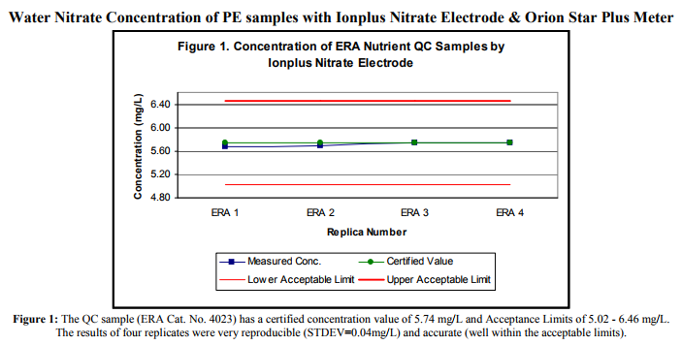

**Nitrate in Surface Water and Wastewater by Colorimetry**

[https://tools.thermoFisher .com/content/sfs/brochures/Log-83-Nitrate-in-Surface-and-Wastewater-by-Colorimetry-AC2007.pdf](https://tools.thermofisher.com/content/sfs/brochures/Log-83-Nitrate-in-Surface-and-Wastewater-by-Colorimetry-AC2007.pdf)

The team at University of Massachusetts Amherst has decades of experience on General Drinking Water and Wastewater Research. Details of Professor Reckhow’s research group can be found below:

<http://www.ecs.umass.edu/cee/reckhow/?_ga=2.131240207.1895666930.1505417835-780320541.1505417835>

**Highlights of Professor Reckhow’s research group:**

* Disinfection Byproducts

Human exposure to disinfection byproducts (DBPs) in tap water has been associated with elevated incidence of cancer and adverse reproductive outcomes. Reducing this exposure is a major challenge to the drinking water industry.

* [Targeted Studies on DBP Chemistry & Toxicology](http://www.ecs.umass.edu/eve/research/DBP%20Misc/DBP%20Chemistry.html), several sponsors, on-going
* [Fate of Non-Regulated DBPs in Distribution systems](http://www.ecs.umass.edu/eve/research/rf_unreg/),(with Chul Park) Water Resarch Foundation, 5/1/2010-10/31/2012
* [Impacts of Chlorine addition to NYC's Catskill Aqueduct](http://www.ecs.umass.edu/eve/research/NYCcataq/), NYC DEP, Hazen & Sawyer Engineering, 10/3/2012 - 3/31/2014
* [Assessment of Unregulated Disinfection Byproducts in Philadelphia’s Water](http://www.ecs.umass.edu/eve/research/Philly/), PWD, 10/21/2012-6/30/2015
* [DBPs in Domestic Hot Water Systems](http://www.ecs.umass.edu/eve/research/DBP%20Misc/Water%20Heaters.html), ongoing
* Risk Based Prioritization of Disinfection Byproducts (with Richard Bull & Vince Rotello) Water Research Foundation
* [Characterization of TOX Produced During Disinfection Processes](http://www.ecs.umass.edu/eve/research/rf_tox/)[,](http://www.ecs.umass.edu/cee/reckhow/EVE/projects/index.htm)Water Research Foundation
* New Analytical Methods for DBPs, unsponsored, ongoing
* [Control of Manganese, Natural Organic Matter and Disinfection By-Products for Mystic, CT](http://www.ecs.umass.edu/eve/research/manganese_control.html)(John Tobiason, PI) Aquarion Water Company, 4/06-05/08.
* [Chloramination Feasibility Study for NYC](http://www.ecs.umass.edu/eve/research/nyc_chloramines/), (with John E. Tobiason) Hazen & Sawyer Engineering, City of New York, 8/22/2006-8/21/2009
* Pharmaceuticals & Personal Care Products

Over the past 10 years, Professor Reckhow’s research group has begun to recognize the extent to which PPCPs and endocrine disrupting compounds (EDCs) are found in the aquatic environment.

* [EDC/PPCP Benchmarking and Monitoring for Drinking Water Utilities](http://www.ecs.umass.edu/eve/research/rf_4260/)*, (with Mi-Hyun Park & Michael Lavine) Water Research Foundation, 9/1/2010-12/1/2013*
* [Onsite Septic Systems for the Removal of Selected Micro-Constituents and Contaminants of Emerging Concern](http://www.ecs.umass.edu/eve/research/MASSTC/)*, Barnstable County Dept of Health, 6/2010-6/2015*
* [*Establishing Guidelines for the use of Ozone-GAC for Control of Endocrine Disruptors and Related Compounds in Water*](http://www.ecs.umass.edu/eve/research/rf_edc/)*(with Kathleen Arcaro) Water Research Foundation, 7/15/2008-12/30/2011*
* Advanced and Innovative Oxidants

Oxidation processes are critical for destruction of organic and reduced inorganic pollutants.

* [Use of Ferrate in Small Drinking Water Treatment Systems](http://www.ecs.umass.edu/eve/research/epa_ferrate/),
* [Assessment of Ozonation Impacts on Taste and Odor Compounds](http://www.ecs.umass.edu/eve/research/dcr/index.html#Ozone),
* [Strategies for Minimizing Adverse Impacts of an Oil Spill in Wachusett Reservoir](http://www.ecs.umass.edu/eve/research/MWRA15/MWRA15.html),
* Natural Organic Matter

All surface and groundwater have dissolved natural organic matter (NOM) derived from aquatic and terrestrial plants.

* [On-line NOM Characterization: Advanced Techniques for Controlling DBPs and Monitoring for Changes in NOM Under Future Climate Change Scenarios](http://www.ecs.umass.edu/eve/research/rf_4422/), Water Research Foundation, NYC DEP and Hazen & Sawyer, 9/1/2012-12/31/2013
* [NOM Monitoring on the Mill River](http://www.ecs.umass.edu/eve/facilities/MRMF.html), several sponsors, on-going
* [Climate Change and Water Quality - Impacts and Adaptation Strategies for NYS Utilities](http://www.ecs.umass.edu/eve/research/NYSERDA/), NYSERDA and Hazen & Sawyer, 1/1/2013-12/31/2014
* [Evaluation of NOM and DBP Precursors in SWSC West Parish Raw Water Sources](http://www.ecs.umass.edu/eve/research/SWSC04/)**,**(with John Tobiason) Springfield Water and Sewer Commission
* [Water Quality in Massachusetts Reservoirs](http://www.ecs.umass.edu/eve/research/dcr/), (David P. Ahlfeld, John E. Tobaison, Mi-Hyun Park & David A. Reckhow) Massachusetts Department of Conservation and Recreation
* [Watershed Sources and Long-term Variability of BDOC and NOM as Precursors](http://www.ecs.umass.edu/eve/research/rf_watersheds/) Water Research Foundation

**D. Sensors and monitoring:**

Please provide plans for sensor deployment that includes placement of sensors, power considerations, sensor maintenance, telemetry, calibration, sampling regime etc.

|  |  |  |  |  |
| --- | --- | --- | --- | --- |
|  | **Nitrate** | **Phosphates** | **Ammonia** | **TRO** |
| **Sensors** | **Ionplus® Nitrate Electrode (Orion 9707BNWP)** | **Orion 2295 Phosphate Analyzer** | **Orion 2210AM Ammonia Analyzer** | **Orion 1700 TRO Analyzer** |
| **Compliance** | The ion-selective electrode method is an EPA-compliant test procedure to directly read nitrate. | EPA-compliant test procedure | EPA-compliant test procedure | The ion-selective electrode method is an EPA-compliant test procedure |
| **Measuring Range** | 0.1 ppm to 14,000 ppm nitrate as N | 0.03-50ppm | 0.03-2 up to 500 ppm | 0.03 to 15 ppm as chlorine or other specified oxidant |
| **Accuracy** | ±10% of reading or 0.04 mg/L (ppm) whichever is greater | Less than 5% of reading or ±0.05 ppm | Less than 5% of reading or ±0.05 ppm, whichever is greater from 0 to10 ppm | ±10% of reading or 0.04 mg/L (ppm) whichever is greater |
| **Repeatability** | ± 2% | Less than ±2% of reading or ±0.05 ppm | Less than ±2% of reading or ±0.05 ppm, whichever is greater from 0 - 50ppm | 10% in 180 days or 0.04 mg/L (ppm) whichever is greater |
| **Limit of Detection** | 0.1ppm | 0.03 ppm | 0.03 ppm | 0.03 ppm as chlorine or other specified oxidant |
| **Reagent Consumption** | None | 1 pack of reagents every 45 days with 15 min cycle | 1 pack of reagents every 45 days with 2 hour cycle time up to 50 ppm | 30 ml/hr or 160 hours continuous operation |
| **calibration** | Weekly | weekly and programmable auto calibration | weekly and programmable auto calibration | weekly and programmable |
| **Method** | ion selective electrode | Vanadate- molybdate colorimetric | Salicylate colorimetric method | ion selective electrode |
| **Sample Flow** |  | 50 to 1000 mL/min | 50 to 1000 mL/min |  |
| **Sample Pressure** |  | 5 psig max | 5 psig max | 3-90PSi |
| **Enclosure Dimensions** | N/A, working with Aquapro meter | 27.5" x 16" x 6.4" (698 mm x 406 mm x 162 mm) | 27.5" x 16" x 6.4" (698 mm x 406 mm x 162 mm) | 610 x 824 x 339 mm (24 x 32.4 x 13.3 inches) |
| **Power Requirements** | 100-240 V AC, 50/60 Hz | 100-240 V AC, 110 W, 50/60 Hz | 100-240V AC, 110 W, 50/60 Hz | 100 to 240 VAC 50/60 Hz- nominal |
| **Current Loops** | 4-20mA | Two 0/4-20 mA – Direct or Reverse Acting (Isolated). Maximum 900 ohm load. | Two 0/4-20 mA – Direct or Reverse Acting (Isolated). Maximum 900 ohm load. | 4-20mA |
| **Digital Comms** | USB | RS232 ASCII protocol for data reporting | RS232 ASCII protocol for data reporting | USB |
| **Communication** | Thermo Fisher Cloud | Thermo Fisher Cloud | Thermo Fisher Cloud | Thermo Fisher Cloud |

**E. Data:**

**1. Solution Architecture:**

Diagram illustrates the overall configuration of the proposed data solution as below:

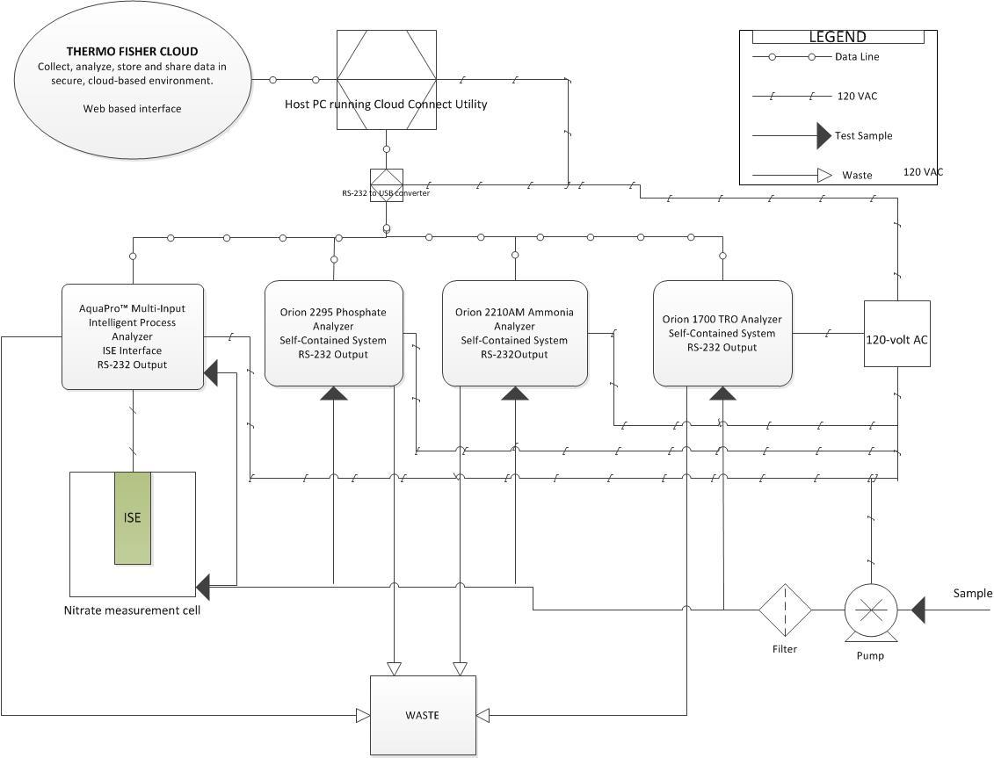

**2. QA/QC**:

All Thermo Fisher sensors and analyzers used for continuous nutrient monitoring have automatic calibration and automatic validation functions. The interval between automatic calibration and automatic validation is programmable. Users can set the interval between automatic calibration and automatic validation as short as hours or as long as weekly. With automatic calibration we can check the calibration against the last calibration to verify the analyzer is in good condition. With automatic validation we can check the validation against our standard inside the analyzer to make sure the analyzer is functioning properly.

**3. Data Sharing**:

As described earlier in PartA2, team will upload data to thermo Fisher cloud with Open Geospatial Consortium data standards.

* **Metadata**:

Teams are expected to provide metadata that will explain the data content. We are going to use NWQMC Water Quality Data Elements as the guideline for our metadata.

**F. Analytics and Interpretation:**

* The team at University of Massachusetts Amherst will provide algorithms and models.
* Thermo Fisher cloud will perform primary and secondary analysis across all continuous data and projects with a robust toolkit of fast and powerful analysis software.

**G. Communication and Use:**

* Thermo Fisher cloud will enable user group permissions and custom sharing options to invite colleagues and collaborators to review results and perform new analyses.
* The team at University of Massachusetts Amherst will publish the results in international journal to help reduce nutrient issues.

1. <https://www.epa.gov/sites/production/files/documents/memo_nitrogen_framework.pdf>
2. Brian M. De Borba, Richard F. Jack, Jeffrey S. Rohrer, Joan Wirt, DongmeiWang. Simultaneous determination of total nitrogen and total phosphorus in environmental waters using alkaline persulfate digestion and ion chromatography. Journal of Chromatography A, Volume 1369, 21 November 2014, Pages 131-137
3. [https://tools.thermoFisher .com/content/sfs/brochures/nitrate-in-drinking-water.pdf](https://tools.thermofisher.com/content/sfs/brochures/nitrate-in-drinking-water.pdf)