**Research idea**

The last twenty years of studies in genetic epidemiology have shown persuasively that large cohorts are required to investigate human addictive behaviors. Dr. Joel Gelernter’s lab at the Yale University School of Medicine has been one of the pioneers in the application of molecular genetics to investigate substance use disorders (SUDs) in human subjects. To date, Dr. Gelernter and his colleagues recruited more 14,500 US subjects assessed with the Semi-Structured Assessment for Drug Dependence and Alcoholism (SSADDA). This diagnostic instrument was developed for studies of the genetics of substance use and associated disorders and provides more detailed coverage of specific SUDs than most other psychiatric diagnostic instruments. More than 250 peer-reviewed articles regarding the results of genetic studies of SUDs conducted by Dr. Gelernter and his colleagues have been published in peer-reviewed international journals, based on the analyses performed on this cohort. These previous studies uncovered risk loci for wide range of traits related to SUDs and identified numerous molecular mechanisms by which substance use affects human brain function. Although previous genetic studies successfully contributed to our understanding the neurobiology of SUDs, SUD research is still inadequate (and is funded inadequately, especially considering private funding) when compared with other psychiatric disorders. Indeed, in contrast to other major psychiatric traits, such autism spectrum disorder, schizophrenia, and bipolar disorder, genetic research in substance dependences is not well supported by any major philanthropy. Thus, most progress in this field by US investigators is attributable to funding from National Institutes of Health.

Improving the understanding of the general public regarding substance use and abuse and inviting people to know more about their own status may help to create more participation in addiction research. In particular, we would like to boost citizen science in addiction. To do that, we plan to open the SSADDA to everyone interested in knowing more about addiction and addiction research. We plan to develop an online survey, called TestYourAddictions, based on more than 15 years of SSADDA research. People will be able to learn about their status regarding exposure, abuse, and dependence related to various substances, including Alcohol, Nicotine, Marijuana, Cocaine, Opioids, and to non-substance addictive behaviors, including Gambling, Internet Use, and Eating. Based on the results, we will provide a series of links to treatment programs and helplines available in their area and information regarding research studies that may be interested in reading about, or participating in. Among them, we will describe the addiction genetic studies conducted by the Gelernter lab at Yale and clinical projects ongoing at Yale, informing users how they can participate to the ongoing investigations. Most current addiction research focuses on groups that present multiple risk factors, such as low socio-economic status and high prevalence of traumatic experience. The TestYourAddictions start-up will reach a different population group who are able to function in society at a higher level, because individuals participating in online surveys about their health status do not usually present low socio-economic status.

**Technical Competence**

The founders of this start-up are Joel Gelernter and Yaira Nunez. An additional member of the research team is Renato Polimanti. Informatics support will be provided by the Yale Information Technology Services, Division of Application Development.

Joel Gelernter, MD is Foundations Fund Professor of Psychiatry, Professor of Genetics and Neuroscience, and Director of the Division of Human Genetics in Psychiatry at the Yale University School of Medicine. He is a world-leading expert in addiction genetics and a leading scientist for addiction research in large collaborative efforts, such as the Psychiatric Genomics Consortium and the Million Veteran Program.

Yari Nunez, BS is the Research Coordinator in Gelernter Lab. She has 16 years of experiences in training and supervising more than 25 research assistants in the standardized administration of the SSADDA at Yale University and the University of Pennsylvania, and other universities in Thailand, Taiwan and China. She is also a web designer and social media manager, and on the board of Remarkable STEAM, the organization that produces Maker Faire Westport, Connecticut's largest event focused on creativity and innovation.

Renato Polimanti, PhD is Assistant Professor in the Division of Human Genetics of the Yale Department of Psychiatry and an experienced researcher in computational biology, psychiatry, and human genetics. Dr. Polimanti is interested in citizen science. For instance, he is currently collaborating with uBiome, a biotechnology company interested in citizen science for personal microbiome analysis, to analyze the oral microbiome analysis of individuals affected by nicotine and alcohol use disorders.

**Product description**

The product is an online survey questionnaire called TestYourAddictions (Figure 1). 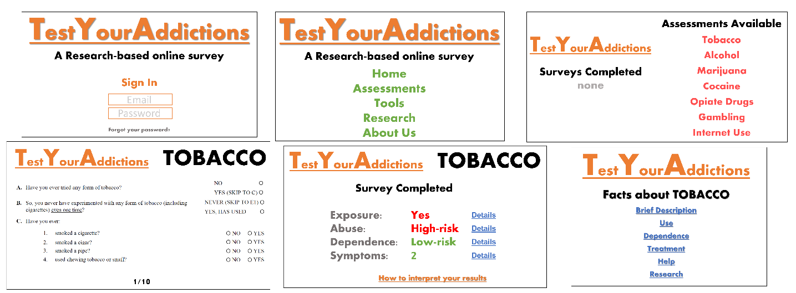

Users will begin by creating an account so that they may keep track of previous survey results and responses. Creating an account will also involve collection of credit card payment information. The cost to the user will be $10.00.

Once a user has logged in, he or she will be given a menu of questionnaires that are available to complete. These will include: Alcohol, Nicotine, Marijuana, Cocaine, Opioids, Gambling, Internet Use, and Eating. The user will respond to selected questions from the SSADDA. These questions are mostly in the ‘yes-no’ format and take less than 20 minutes to complete for each section. The users will have the opportunity to save the answers and complete one or multiple sections during different times.

Once the survey is submitted, the user will be given feedback based on their responses. The symptoms endorsed will be displayed. The user will also receive a score depending on the number of symptoms endorsed as well as feedback, which will let the user know if they are at risk of developing a disorder. If the user is not at risk, he or she will be reminded that the use of certain substances is not safe. Users will have the ability to share their results with others via text or email, and share that they have taken the survey on social media. All survey questions will be displayed in easy to read, user-friendly text and graphics. It will also contain details about how we keep their personal information confidential and protected.

All respondents will be given links to the NIDA webpage of the corresponding survey section together with other links for treatment programs and helplines available in their area. We will also provide information regarding ongoing research studies that they may be interested in reading about or participating in. In particular, we will introduce our team and our work. We will motivate users to participate in our ongoing studies. We would like to give users the opportunity to submit a saliva sample for genetic analysis. In doing so the user will receive a $5.00 discount. Additionally, the fee is waived if the user chooses to upload their third party personal genetics data from companies such as ancestry.com and 23&Me. Furthermore, the website will include an “About Us” page which will provide more information regarding our previous studies and initiatives. We will also develop a complimentary mobile app for the website which includes the same features but with the convenience of completing surveys on the go. A further development permitted by the app will be to provide the users an instrument to longitudinally assess their status. We will offer users the opportunity to track a specific addictive behavior, which will permit them to monitor the changes in their habits.

**Audience Attraction**

Currently consumers are paying to learn more about their health. Beyond DNA test kits, consumers are paying to learn more about their microbiome, sleep patterns, menstrual cycle, posture, emotions, moods, bowel movements and alcohol intake. Few substance dependence screening questionnaires are available online, and none of them is as comprehensive as the proposed TestYourAddictions set; and they do not provide evidence based research and information from the NIDA.gov website. Currently there are only two addiction survey apps on the itunes app store, however, both are limited to alcohol dependence. A search on google trends illustrates that individuals are searching for self-help resources have sharply increased in the past 10 years. For example, Americans are as interested in learning more about meditation as they are about addiction (Figure 2).

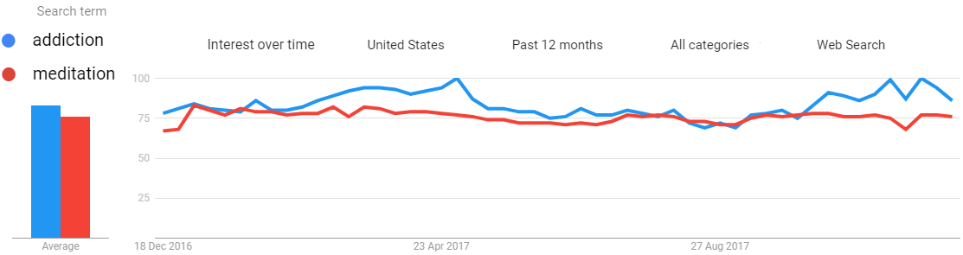

**Figure 2**: Google web search trend for “addiction” and “mediation” in the past 12 months. Numbers represent search interest relative to the highest point on the chart for the given region and time. A value of 100 is the peak popularity for the term. A value of 50 means that the term is half as popular. Likewise, a score of 0 means the term was less than 1% as popular as the peak.

Recently, the iTunes store named its top app of 2017 - the Calm app. This app focuses on wellness and mental health by teaching users how to relax using meditation, mindfulness, breathing exercises and other tools to improve sleep and mood. It has been downloaded over 14 million times since 2012 and proves that Americans are interested in having control over their mental health to a greater extent now than ever before. On the basis of google trend results, we believe that the TestYourAddictions website and app will have a similar success in the general public. Indeed, with the advent of the opioid crisis, Americans are turning to the internet to learn more about the signs of addiction for themselves and for their loved ones. The TestYourAddictions website will be a way for users to identify problematic behaviors that they may have not realized is interfering with their daily lives, leading the user to useful information about treatment and support resources.

Another objective of our website is to introduce people to citizen science. We will emphasize how the user’s participation will be instrumental to increase our knowledge of SUDs. We want users to know that their contribution is part of something bigger and will be beneficial to our society. TestYourAddictions will be an optimal way to involve the general public in addiction citizen science. People will have the opportunity to be involved in addiction research, understanding how they can participate to ongoing research projects. In particular, it will be easy to participate to our ongoing research efforts, via the submission of their saliva samples or the uploading of their genetic information. Each participant will be updated about the final results of the studies to which she or he contributed: we will share with them links to article publications and public media releases related to them.