# 4D eF (4 D exit finder)

**VR 1 version AiGA**.

When walls are crashing around you, disbalance and lost of direction covered with panic leads anyone to personal disaster.

Exit from disaster zone must be guided TROUGH safe pathway and health positive surrounding’s .

Our VR software called AiGA( Artificial Intelligent Guiding Avatar) with simple recognizable follow me directions no other languages or terminologies are used , no age restriction .

Extra features are color navigation to life safe exit and time safe pathfinder , “help me SOS “ on map discovery .

Two main mode are “self-help” and “save the others”

“self-help”

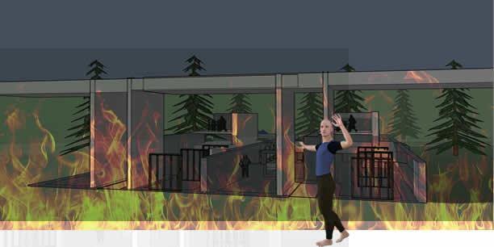

“save the others”

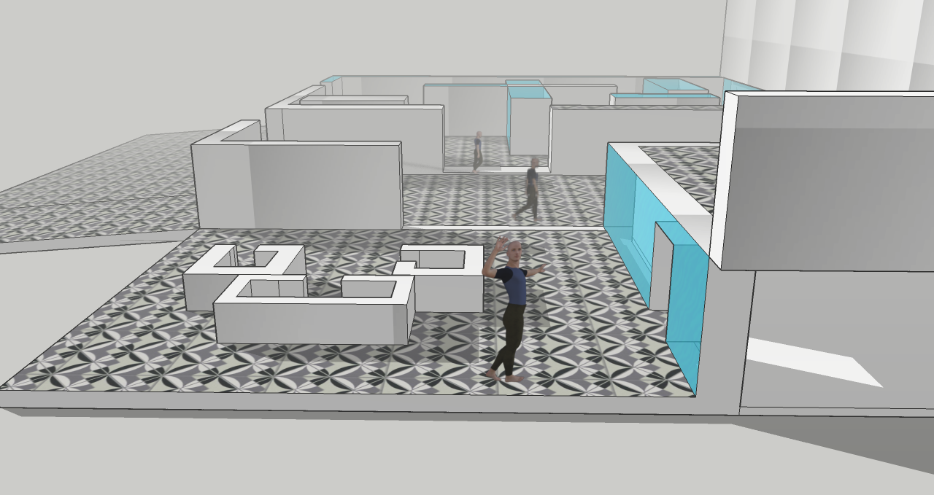

*“Quote”*

"Aut inveniam viam aut faciam" :- I will either find a way, or make one.