## A Gasoline Powered Tandem Helicopter UAS

By

Endure Air Inc.

A Delaware C Corp.

www.endureair.com

3052 San Jose Vineyard Ct #4

San Jose CA 95136

1/21/2018

|  |  |  |
| --- | --- | --- |
| Role | Name | Contact Info |
| Head of Business, 107 FAA certified | Yamin Durrani | [yamin@endureair.com](mailto:yamin@endureair.com)  +14086935499 |
| Systems Expert | Sagar Setu | [sagar@endureair.com](mailto:sagar@endureair.com) |
| Hardware Expert | Ankur Duhoon | ankur@endureair.com |
| Software Expert | Nidhish Raj | [nraj@iitk.ac.in](mailto:nraj@iitk.ac.in) |
| Vehicle Design | Dr. Abhishek | abhish@iitk.ac.in |



# Abstract

## Introduction

This concept paper is the basis for the collaborative effort between Endure Air Inc. and the Aerospace Department, Indian Institute of Technology, (IIT) Kanpur, India. Endure Air is a technology company that is focused on VTOL, endurance, scalability and intelligence for UAVs. The goal of the company is to make best in class Unmanned Aerial Vehicles with VTOL and high endurance capabilities. We have developed and tested “The Endure 800” helicopter (single main rotor + tail rotor) having a 1740mm rotor diameter powered by a single 29cc internal combustion engine with an onboard IMU and flight management unit for autonomous flight. It is one of the most reliable and durable unmanned helicopter available for a multitude of monitoring tasks.

Our solution for this challenge will be a gasoline powered unmanned tandem helicopter with two main rotors (as shown in figure 1) capable of high endurance and heavy payload handling capacity. We picked a helicopter over quadrotor because of two main reasons. First being efficiency of a helicopter is a factor of 1.4X that of a quadcopter, secondly, we wanted to use gasoline due to its high-energy density, a gas-powered quadcopter is more complex, more expensive and less reliable than a gas-powered helicopter.

For the challenge of keeping the UAS and its payload airborne for the longest period possible to support first responders’ we are going to design a UAS which will be capable of flying both autonomously and manually based on helicopter’s tandem configuration, powered by 2 IC engines running on gasoline as fuel. To achieve this, we will be utilizing the existing “Endure 800” platform that has proven track record.

Helicopters in tandem configuration have many advantages over conventional helicopter (single main rotor + tail rotor) as in tandem configuration both the main rotors produce lift and cancels out the torque of each other’s and therefore all the power is used for lift production and none is wasted in countering the torque. Our approach of using a helicopter in tandem configuration coupled with gasoline as an energy source will provide maximum lift as well as long endurance required to meet the challenge.

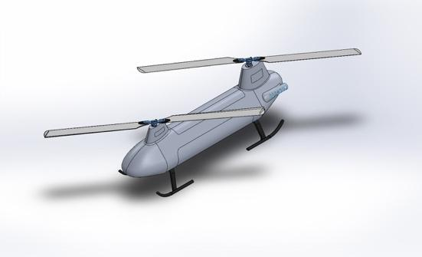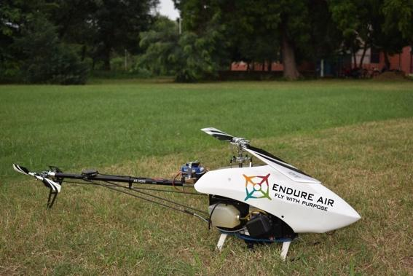

Figure 1: Helicopter tandem configuration Figure 2: Endure 800 Helicopter

## Endurance Vs Payload

We will construct the airframe with aeronautical grade aluminum and carbon fiber, and the 2-stroke engines will be small and efficient. Our UAS will have a Maximum take-off weight of 48 lb. that includes the vehicle, fuel and useful payload. We target the following endurance

|  |  |  |
| --- | --- | --- |
| Useful payload | Condition | Time (min) |
| 10 lb. | 100% Hover | 90 |
| 15 lb. | 100% Hover | 60 |
| 20 lb. | 100% Hover | 45 |
| 10 lb. | 50% Hover, 50% Forward flight | 120 |
| 15 lb. | 50% Hover, 50% Forward flight | 90 |
| 20 lb. | 50% Hover, 50% Forward flight | 60 |

# Project Objectives

## About Endure Air and IIT Kanpur Aerospace Department

The team working at Endure Air and Aerospace Department of Indian Institute of Technology Kanpur lead by Dr. Abhishek (Assistant Professor, Aerospace Engineering) has been involved in design, development and testing of Unmanned Aerial Vehicles for more than 15 years. Together the team has five patents and authored more than 20 technical papers in various journals and conferences on the design and development of novel unmanned aerial vehicles. The team has been instrumental in design and development of autonomous IC engine (gasoline fuel) powered conventional helicopter type drones which can fly for over 50 mins with 500ml of gasoline and cover a range of over 5 miles.

The UAVs developed by Endure Air are regularly operated for research purpose and over last 1 year have clocked a flight time of more than 150 hours. Apart from this the team is involved in design and development of hybrid VTOL UAVs aimed towards solving the challenge of delivering payload over long distances in the most economical and safe manner. For, this a quadrotor convertiplane is under development which is a unique vehicle that takes-off and hovers like a quadrotor and then transitions to fixed wing mode in order to fly efficiently at high speeds. After reaching the destination it would again transition back to quadrotor mode to hover at one place for delivering the payload. This concept has the possibility of being a game changer for payload delivery. It should be noted that being an educational institute, the experience of IIT Kanpur is more geared towards design and development of innovative cutting-edge UAVs and not towards operations. With partnership with Endure Air, we are looking to develop technology from IIT Kanpur into a product for solving real world problems.

Our UAVs jointly developed by Endure Air and IIT Kanpur were used to conduct aerial survey of agricultural land for monitoring the health of crop. This was performed using battery powered quadrotor drone in April 2016. In this operation, the drone was programmed to fly in way point navigation mode to click images of farm land with crops to cover an area of 1 sq. mile in every flight. The flight was continued to click aerial images of over 5 sq. miles in a pilot effort to see the effectiveness of the drone for aerial surveying. This exercise was deemed successful as all the test parameters were satisfactorily met. This work was carried out for an Agricultural consultancy company Weather Risk Pvt. Ltd.

## Gasoline powered helicopter

Recent years have witnessed a tremendous growth in Unmanned Aerial Systems (UASs), which are being used for wide range of military as well as civilian applications ranging from surveillance, precision agriculture, field inspections, terrain mapping, transmission line monitoring, payload delivery etc. to name a few. Several of these applications require the UAS to have hovering and vertical flight capabilities. Currently various configurations of UAS such as fixed wing, VTOL fixed wing, tilt rotor, multirotor (quadcopter, hexacopter and octa copter), flapping wing and helicopter (single rotor, coaxial, tandem) have been developed or under the development. Each of these configurations has its own advantages and limitations over others.

Among these the most successful configuration which caught the eyes of researchers and amateurs alike in the early 2000s is the quadrotor configuration. Since then, the quadrotor unmanned aerial vehicle configuration with four rotors has been extensively studied and several researchers have studied its design, dynamics, stabilization and control. The commercial success for this configuration can be gauged from the fact that, quadrotors with all up weights ranging from 0.5 lb. to 50 lb. can be bought off-the-shelf and can be used for a variety of missions discussed above.

With all its success, the conventional quadrotor configuration which has four rotors each driven by its own electric motor and controlled by varying the RPM of the motors, still suffers from the limitations of energy density of LiPo (~300 wh/kg) batteries available due to which endurance is limited to 15-30 minutes for vehicles designed to lift optimum payload. Similarly, conventional fixed wing UAS has the limitation of unable to hover at one place which reduces their flight envelope. Tilt rotor UAS are capable of hovering but they face huge difficulties while transitioning from hover to forward flight or vice versa. Whereas conventional Helicopter (single main rotor + tail rotor) is capable of a stable hover and forward flight and is well understood and developed, but suffer from loss of power in producing counter torque from tail rotor. There are many off-the-shelf UAS readily available for all these configurations and in operation throughout the world. However, a gasoline powered tandem configuration of helicopter composed of two main rotors and no tail rotor, is unique to the UAS ecosystem and will meet the requirements of payload and endurance required for this challenge.

Helicopters in tandem configuration have many advantages over helicopter in conventional configuration (single main rotor + tail rotor). A single main rotor produces an equal amount of torque (which has been provided by an engine to rotor) in opposite direction to the helicopter fuselage and thereby sending the helicopter body in uncommanded yaw. To overcome this problem single main rotor’s torque is countered by a small tail rotor. The small tail rotor consumes useful energy which could have been used for producing lift and reduces the efficiency of single main rotor configuration by 15-20%. But in tandem configuration both the main rotors produce lift and cancels out the torque of each other’s and therefore all the helicopter’s engine power is used for lift production and none is wasted in countering the torque. Tandem helicopters have lower disk loading and uses less power in hover and low speed flight. Lower disk loading means more efficient rotor system. This configuration has more freedom over single rotor configuration in positioning the payload between two rotors as it has good longitudinal stability.

For assisting in a search and rescue mission an UAS must be powered from a fuel which is easily available and transferable in urban as well as in remote locations. LiPo batteries are the most commonly used fuel source for UASs but these batteries have very low energy density due to which they get drained very fast and takes long time (as compared to mission time) to recharge back. Gasoline with higher energy density and readily available can serve as a better fuel for the mission where UAS must remain airborne for long time. Therefore, we are going to develop a UAS which is powered by gasoline as a fuel to address the problem of low endurance.

There are some UAS Quadcopters that are available off-the-shelf, powered by liquid fuel such as gasoline or nitro fuel. Such a hybrid system provides electrical energy to a battery (Hybrid approach) through a generator but those quadcopters are small and won’t be able to integrate a useful payload required by this challenge. Moreover, the use of battery/generator is an added dead weight. Another approach for gasoline powered quadcopter is to directly connect the rotors with the IC engine via a power transmission system with fixed RPM utilizing variable pitch control. Such a quadcopter running on gasoline and powered by IC engine faces the problem of low engine responsiveness because of the response frequency of the gasoline powered motor which is significantly low as compared to Brushless DC motors (400 Hz) and therefore while operating at constant RPM in the sweet zone of IC engine when subjected to sudden gust load the engine RPM decreases suddenly thereby reducing the lift generated by rotors. The other challenge such a design faces is added transmission complexity, increased weight of gears, and increased cost of bill of material.

However, there are many proven and tested UAS Helicopters available which runs on gasoline and powered by IC engine and are scalable up to the desired payload size. Gas powered helicopters have bigger blades as compared to a quadcopter of same lift generating capacity. Bigger blades have more inertia and momentum and therefore whenever there is a need of doing aggressive maneuvers and countering gust, an on-board PID controller adjust blade pitch and engine throttle of helicopters to do that. Gas engines in helicopters also suffers from sudden loading and reduction in engine RPM but more inertia of blades helps in overcoming that. Multirotor also need a parachute to manage landing during malfunctions, in the case of helicopters we can deploy autorotation to help the UAS achieve safe landing.

So, to address the challenge of keeping the UAS and its payload airborne for the longest time possible to support first responders’ we are going to design a UAS which will be able to fly autonomously in hovering or forward flight condition based on helicopter’s tandem (two main rotors) configuration and powered by IC engines running on gasoline as fuel. The major competitive advantage of gas powered helicopter over a battery powered quadrotor is better endurance, autonomy, range and resistance to adverse weather conditions. The Endure Air’s helicopter will outlast, fly further, perform better in rougher weather conditions, and refuel faster than any UAS currently available in the market within the same weight class.

## Technical specifications of proposed UAS

The UAS we are proposing will have the following technical specifications once it gets completed.

|  |  |
| --- | --- |
| Configuration | Tandem Helicopter |
| Empty weight with fuel tank full | 28 lb. |
| Payload weight | 20 lb. |
| Max. take-off weight | 48 lb. |
| Power required to hover @MTOW | 2.6kw |
| Powerplant | 2 x Zenoah G290RC IC engine, 2kW each |
| Fuel | Gasoline |
| Max. fuel capacity 1 gallon | 6.3 lb. |
| Front rotor diameter | 1.740 m |
| Rear rotor diameter | 1.740 m |
| Total disk area | 4.75 m2 |
| Disk loading | 10.1 lb./m2 |
| Endurance @AUW in 50% hover and 50% cruise | 60 minutes |
| speed |  |
| Cruise speed | 90 kmph |

## UAS airframe sketch

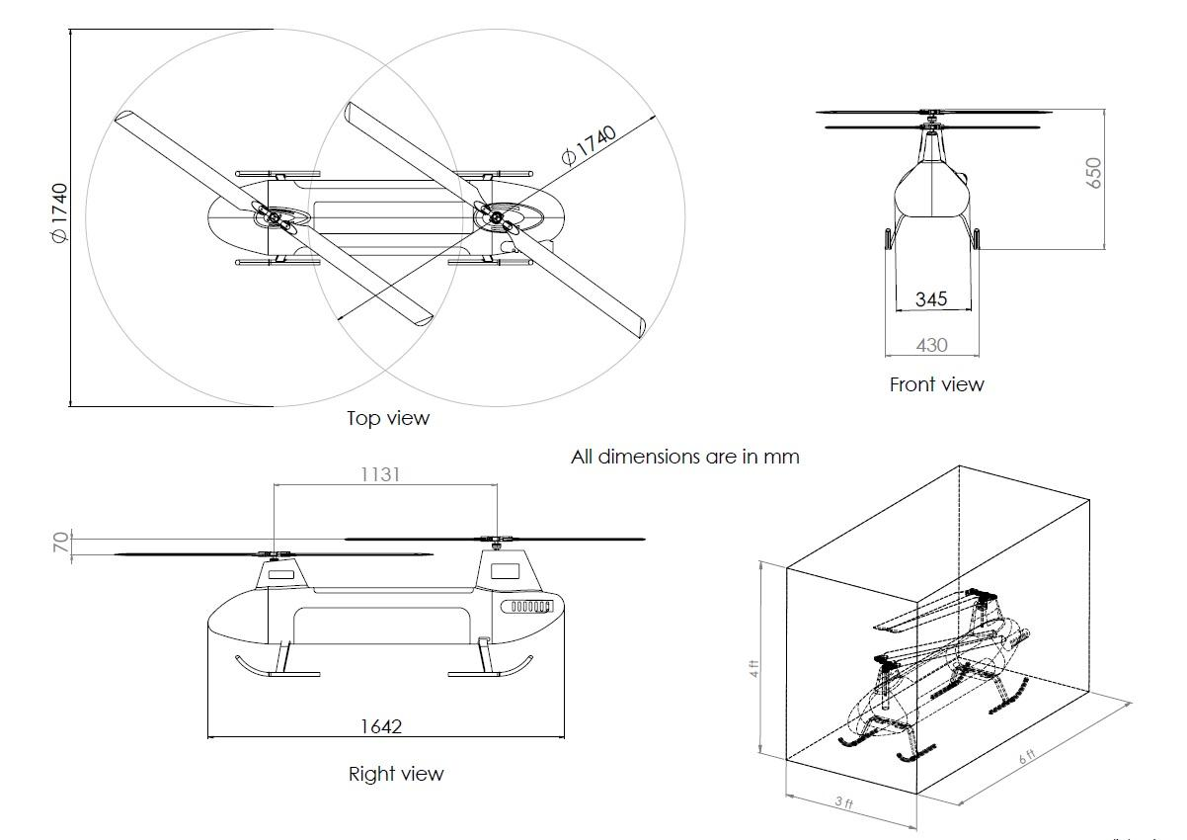

## Performance Metric

Our high-level goal is to design and develop a UAS which will be able to fly autonomously in hovering or forward flight condition based on tandem rotors configuration and powered by an IC engine running on gasoline as fuel. Our UAS will showcase the following endurance

|  |  |  |
| --- | --- | --- |
| Useful payload | Condition | Time (min) |
| 10 lb. | 100% Hover | 90 |
| 15 lb. | 100% Hover | 60 |
| 20 lb. | 100% Hover | 45 |
| 10 lb. | 50% Hover, 50% Forward flight | 120 |
| 15 lb. | 50% Hover, 50% Forward flight | 90 |
| 20 lb. | 50% Hover, 50% Forward flight | 60 |

We currently have developed a UAS helicopter called “Endure 800” and has done over 150 hours of flight testing (a demo reel can be seen on www.endureair.com) with a single 29 cc 2 stroke engine, 500 ml gas tank, 1740 mm main rotor diameter and an auto pilot system that can do way point navigation and capable of autonomous hover. This UAS can hover for 50 min with a payload of 11 lb. and the total all up weight of 27 lb. Our current design of UAS utilizes a wireless connection between the controller/flight computer and the aircraft. We use a Dragon Link © telemetry and radio communication 12 channel micro receiver that has radio based on FHSS (Frequency Hopping Spread Spectrum) to provide immunity from interference. Our current UAS prototype works on an off the shelf auto pilot board from Pixhawk. For this challenge, we are going to accomplish the following goals in stages:

Intermediate goal 1: Design of a new airframe to accommodate the following changes

* Remove the tail rotor subsystem and add another main rotor.
* Replace the existing engine of 29 cc with two engines of 29cc each.
* Integrate a larger fuel tank of 1 gallon fuel capacity.
* Integrate the payload adapter that allows for the different weight payloads to be interchangeable for test flights.

Time required to accomplish this goal is 10 weeks.

Intermediate goal 2: To the autopilot software we want to add auto take-off and landing. Time required to accomplish this goal is 8 weeks. We already have a very robust and reliable auto pilot software capable of autonomous hovering, way point navigation and forward flight, we will be building this software further to add auto take-off and landing module.

Intermediate goal 3: Implement a kill switch, as well as long range telemetry to cover beyond visual line of sight flights of more than 10 miles. The UAS system will include an independent kill switch (KS) that can be remotely activated from the ground by pressing an “emergency stop button”. When remotely activated, the KS will shut down the IC engine. Time required to accomplish this goal is 3 weeks.

Intermediate goal 4: Autorotation mode trigger for safe landing when the kill switch is on or when the vehicle malfunctions. Time required to accomplish this goal is 10 weeks. We will be utilizing machine learning techniques and train the controller to accomplish autorotation.

End goal to be reached: An unmanned helicopter having 120 min flight time with 50% hover and 50% forward flight at an AUW of 48lb and should be capable of fully autonomous take-off, hover, landing, waypoint navigation, autorotation glide along with an integrated kill switch mode and 10 miles’ telemetry range. Product should be ready in 14 weeks from start including testing time for the solution.

# Skills Required

For developing a UAS the team must include members with expertise in aircraft designing, controls and navigation, vehicle dynamics, electronics, manufacturing, remote UAV pilot and project management. Below are some key skills required in making this project a success.

## Vehicle Design

One of the key aspects of this challenge is the ability to make a design of the vehicle within the specified volumetric and weight limitations. This requires an excellent understanding of rotary wing aerodynamics and vehicle design experience. Dr Abhishek Assistant Professor at Indian Institute of Technology brings this expertise and experience. Abhishek has a Ph.D., Aerospace Engineering (Rotorcraft Dynamics) and M.S. Aerospace Engineering, University of Maryland, B.Tech., Aerospace Engineering, IIT Kharagpur. India

## Electronics for flight control

The vehicle will require an onboard computer, battery management system, servo motors and sensors for various inertial measurements. All these signals must be clean and fed back into the computer for the flight controller to provide autonomous flight control. Sagar Setu, an aspiring PhD scholar from IIT Kanpur, Aerospace department, M. Tech and B. Tech Aerospace Department IIT Kanpur and CTO of Endure Air Inc. Previous work experience in robotics and IOT product development is an expert in electronics and computer systems when it comes to UAV’s. He will be responsible for the electronics and the computer hardware.

## Firmware for flight control

We are aiming for a vehicle that is unmanned and can do autonomous flight. This requires attitude control, autonomous hover, altitude control, way point navigation and autonomous take-off and landing. For these features to be implemented deep understanding of control systems and firmware design is required. Nidhish is one of the key contributors to the NAVIK autonomous flight controller and will be responsible for implementing the same for this project. Nidhish will also be the chief pilot in command for the helicopter during real time flights and demos. He has over 100 hours of flight experience with unmanned helicopters. Nidhish Raj is currently pursuing PhD in Aerospace Engineering at IIT Kanpur (India). He received his Bachelor's degree in Mechanical Engineering in 2013 from NIT Warangal, India. He has worked on the development of NAAVIK autopilot for rotary-wing and fixed-wing aircraft. His research interest includes Geometric and Nonlinear Control of mechanical and aerospace systems.

## Hardware

The UAV must be build, manufactured and maintained keeping weight and reliability into mind, for this excellent understanding of materials science is required. Moreover, for our vehicle we also need to have deep understanding of IC engine and its maintenance. CAD tools for developing any custom part, an ability to assemble the entire vehicle, and perform maintenance post flight is an important skill set to have on the team. Ankur is a research scholar with Masters in Aerospace engineering from IIT Kanpur and will be responsible for hardware assembly, design for manufacturing of the vehicle.

## 107 FAA Remote Pilot Certification, Business, manufacturing, procurement and project management

Business leadership will be under Yamin Durrani. he will be responsible for procurement of parts, keeping design, manufacturing, and components cost under control. Yamin will also be despicable for project management and making sure that project time lines are met and deliverables are up to the desired standards. Yamin has an MBA from Santa Clara University, MS from Texas A&M and Bachelors from IIT Kharagpur. He is also the CEO of Endure Air Inc. Yamin has over 12 years of managing and growing business in Silicon Valley, in his last role he was responsible for sales of excess of $100M/year for Fairchild semiconductor’s consumer electronic division. Yamin is a 107 FAA certified remote pilot and will supervise the demonstration.

Please find attached one page resumes of the key people listed above.

**Abhishek**

Department of Aerospace Engineering IIT Kanpur, Kanpur, UP, India 208016 +91-8765069138, 0512-259-7515, [abhish@iitk.ac.in](mailto:abhish@iitk.ac.in)

**Educational Qualification**

B. Tech., Aerospace Engineering, Indian Institute of Technology Kharagpur, India, 2002

M.S., Aerospace Engineering, University of Maryland, College Park, 2005

Ph.D., Aerospace Engineering (Rotorcraft), University of Maryland, College Park, 2010

**Professional Experience**

|  |  |  |
| --- | --- | --- |
| Assistant Professor, Indian Institute of Technology Kanpur | Research, teaching and supervising students | 2011 – Till date |
| Asst. Research Scientist, University of Maryland, College Park, USA | Research and supervising students | 2010 – 2011 |

**Specialization and Expertise**

Rotary wing aeromechanics, hover capable autonomous Unmanned Air Vehicles, multi-body dynamics, inverse flight dynamics, helicopter and innovative VTOL air vehicle design, wind turbines

**Selected Publications**

1. Jain, P., and Abhishek, “Modeling and Simulation of Virtual Camber in Cycloidal Rotors,” AIAA Journal, Vol. 55, No. 4, 2017, pp. 1465-1468.
2. Rahul, R., and Abhishek, “Performance Optimization of a Variable Speed and Variable Geometry Rotor Concept”, Journal of Aircraft early edition 2016.
3. Jain, P., and Abhishek, “Performance Prediction and Fundamental Understanding of Small Scale Vertical Axis Wind Turbine with Variable Amplitude Blade Pitching,” Renewable Energy, Vol. 97, November 2016, pp. 97–113.
4. Abhishek, and Prasad, R., “Helicopter Unsteady Maneuver Analysis Using Inverse Flight Dynamics Simulation and Comprehensive Analysis,” Journal of Aircraft Vol. 53, No. 6 , Nov-Dec 2016, pp. 1614-1625.

**Selected Patents**

1. Abhishek, Jain, P., and Bhatnagar, K., “High Efficiency Variable-pitch Vertical Axis Wind Turbine (VAWT),” Patent Application No.904/DEL/2015 Dated: 31/03/2015
2. Abhishek, Kothari, M., Ramdas, Raj, N., “High Endurance Quadrotor Unmanned Aerial Vehicle,” Patent Application No. 4184/DEL/2015 Dated: 19/12/2015
3. Abhishek, Kothari, M., Gupta, N., Chipade, V., Gupta, N., Chaudhari, R., and Singh, R. V., “A VTOL Unmanned Aerial Vehicle,” Application No.: 201611015384, Dated: 03/05/2016
4. Rahul R. and Abhishek, "Coaxial Rotor System with Asymmetric Rotor Arrangement and Method Thereof", Patent Application No. 201711013049, Dated: 11/04/2017

**Selected Technology Developed / Transferred**

1. Onboard autopilot developed for autonomous control and navigation of 10 kg class rotary winged unmanned aerial vehicle (RUAV) developed and transferred to HAL RWR&DC Bangalore.
2. General purpose cross platform / vehicle autopilot NAAVIK (Navigation for Autonomous Aerial Vehicles by IIT Kanpur) for autonomous control and navigation of fixed and rotary wing UAVs: demonstrated on several types and class of UAVs.
3. Designed and developed IC engine powered variable pitch quadrotor Unmanned Air Vehicle, for high endurance.
4. Designed and developed high efficiency novel vertical axis wind turbine for household applications.

**Sagar Setu**

Ph: +91-9532832241 • +91-8172823773 [sagarsetubks@gmail.com](mailto:sagarsetubks@gmail.com)

**Education**

Ph.D. in Aerospace Engineering 2013–Ongoing

Indian Institute of Technology Kanpur, India CPI - 8.5 /10

* Developed a real-time simulation framework for testing and tuning of autopilot
* Present focus on autonomous landing of helicopter post engine failure

B.Tech. - M.Tech. Dual Degree in Aerospace Engineering 2008–2013

Indian Institute of Technology Kanpur, India

CPI : PG - 9.3/10, UG - 6.3/10

* Developed a computationally light algorithm for obstacle avoidance from 3-D images

**Experience**

Co-founder and CTO, Endure Air Inc. Feb 2017 – present

* Start-up in the field of aerial logistics
* Developed the first prototype of the delivery vehicle

Co-founder and Director, Kritsnam Technologies Private Limited Nov 2015 – Nov 2017

* Start-up in the field of IoT with focus on data-driven water resources management
* Developed hydrological monitoring instruments based on the proprietary FAN stack

Assistant Research Scientist, Infinium Robotics, Singapore May 2015 – July 2015

* Worked on development of localization system Using Ultra-Wide Band modules
* Built a visual cue based indoor navigation system for small aerial vehicles

**Main Publications and Conference Presentations**

* Setu, S., and Abhishek, “Framework for Attitude Controller Development Using Physics Based Flight Dynamics and Hardware-in-the-loop Simulation for Rotary Wing UAVs,” presented at AHS Forum 73, 9 – 11 May, 2017
* Abhishek, and Sagar Setu. "Development of a Coaxial MAV with Real-Time Obstacle Avoidance Capability." Journal of Instrumentation, Automation and Systems 1.1 (2014): 18-30.
* Aishwarya, P., Setu, S., Singh, P., and Abhishek, “Design and Development of an Autonomous Coaxial Rotor Micro Air Vehicle,” presented at 9th International Conference on Intelligent Unmanned Systems, Jaipur, 25 – 27 September, 2013

**Technical Skills**

* Programming: C, C++, Python, Java, Shell scripting, Android
* Scientific: MATLAB, LABVIEW, CATIA, SciPy, NumPy, OpenCV
* Hardware: NI PXI, Arduino, BeagleBoard, Odroid-X, PixHawk, Navstik
* Autopilots: PX4, Pandapilot
* Sensors: Accelerometer, Gyroscope, Magnetometer, Barometer, GPS, RGB and Depth Camera, VICON, RTOS: ChibiOS, NuttX, TI-RTOS

**Achievements**

* Awarded the National Talent Search Examination Scholarship by NCERT, India
* Recipient of Boeing-IITK scholarship (January, 2010 – December 2011)

Yamin Durrani

3052 San Jose Vineyard Ct #4 San Jose CA 95136 [yamin@endureair.com](mailto:yamin@endureair.com) +140806935499

**EDUCATION**

Santa Clara University Leavey School Of Business, United States 2011

Master of Business Administration – GPA 3.9/4.0

Texas A&M University, United States 2005

Master of Science in Electrical Engineering GPA 4.0/4.0

Indian Institute of Technology (IIT) Kharagpur, India 2002

Bachelors in Technology (Honors) in Energy Engineering CGPA 8.5/10.0

107 FAA certified remote pilot in command 2016

**PROFESSIONAL EXPERIENCE**

Endure Air Inc 2016 – Present  
Co-Founder and Chief Executive Officer

* Defined the strategy and build a team to accomplish the vision of the company.

Fairchild Semiconductor Inc 2012 – 2016  
Director of sales for Apple Account

* Grew sales revenue from $10M to $100M+ in 4 years.

Maazu Commerce Pvt Ltd, India 2011 – 2012  
Co-Founder and Chief Executive Officer

* Responsible for growing business from concept to revenue stage.

National Semiconductor Corporation, United States 2006 - 2011

* Joined as Product Marketing Manager, charted an impressive growth curve through exceptional performance to merit promotion to Institutional Sales Manager for Apple Account.

Toshiba International Corporation, United States 2005 - 2006

Research and Development Engineer

* Took the initiative for proposing new display for the latest products and successfully implemented the first prototype.

Tata Energy Research Institute, India 2002 - 2003

* Research Associate

|  |  |
| --- | --- |
| **Nidhish Raj**  Department of Aerospace Engineering, IIT Kanpur +91 8090758802  nidhishraj1614@gmail.com | |
| **Research Interest** | Aerospace Guidance and Control, Geometric Mechanics, Geometric Control. |
| **Education** | Indian Institute of Technology Kanpur, Kanpur / PhD  June 2014 - Present, UP, India  PhD, Aerospace Engineering  Thesis: Trajectory generation and Geometric Control of Aerobatic helicopters  National Institute of Technology Warangal, Warangal / B. Tech  June 2009 - April 2013  B.Tech, Mechanical Engineering |
| **Research Experience** | Research Assistant  Department of Aerospace Engineering, IIT Kanpur  May 2013 - June 2014  Supervisor: Dr. Abhishek  Project: NAAVIK (Navigation for Autonomous Aerial Vehicles by IIT Kanpur)  Summary: Lead developer of the NAAVIK autopilot. Focused primarily on developing drivers, control and guidance algorithm for various platforms. NAAVIK is cross platform / vehicle autopilot project meant for UAV/MAV applications |
| **Patent** | 1. Abhishek, Kothari, M., Ramdas, Raj, N., ”High Endurance Quadrotor Unmanned Aerial Vehicle”, Patent Application No. 4184/DEL/2015 Dated: 19/12/2015 |
| **Conference Proceedings** | 1. Raj, N., Banavar, R.N. and Kothari, M.,. Attitude Tracking Control for  Aerobatic Helicopters: A Geometric Approach. 56th IEEE CDC 2017, Melbourne.  2. Bhowmik, J., Raj, N., Das, D., Abhishek, A. (2014). Measurement and  analysis of aerodynamic forces of an Ornithopter in free flight. In Proceedings of International Conference on Intelligent Unmanned Systems (Vol. 10).  3. Verma, A., Raj, N., Srivastava, S., and Abhishek, ”Design of Control System for Gust Resistant Micro Air Vehicle,” Proceedings of 8th International Conference on Intelligent Unmanned Systems, Singapore, 22 24 October, 2012. |
| **Programming skills** | C, C++, Python, OpenCV, Matlab, Maple, UNIX shell scripting, GNU make |

Ankur Duhoon

Ph: +91-9532095119 • +91-7987399020 [ankur@endureair.com](mailto:ankur@endureair.com)

Education

B.Tech. - M.Tech. Dual Degree in Aerospace Engineering 2009–2015

Indian Institute of Technology Kanpur, India

CPI : PG – 6.9/10, UG - 6.2/10

* Carbon nanotubes/epoxy nanocomposites were developed and characterized for their mechanical properties
* Fabricated small size wings of intricate shape and structure.
* Performed modal analysis of developed nanocomposite flapping wings to obtain natural frequencies and mode shapes
* Computational FEM analysis of fabricated wings was performed and compared with experimental results

Field of Interest

Design and Development of UAVs, Transmission Design, Composite Development, Material Manufacturing, Bio mimicking, Structural Dynamic Testing and CAD Modelling

Experience

Hardware Engineer, Endure Air Inc. Feb 2017 – present

* Designed and manufactured a novel payload delivery mechanism for UAS
* Carried out efficieny analysis of an IC engine and integrated that on a UAS platform

Project Engineer, MAV Laboratory, Dept of Aerospace Engineering IIT Kanpur Feb 2016 – Jan 2017

* Developed IC engine powered variable pitch quadrotor
* Designed transmission system and CAD models of the variable pitch quadrotor

Conference Presentation

* Gadekar, R., Duhoon, A., Abhishek, Kothari, M., Kadukar, S., Rane, L. and Suryavanshi, G. "Design, Development, and Closed-loop Flight-Testing of a Single Power Plant Variable Pitch Quadrotor Unmanned Air Vehicle", presented at 73rd American Helicopter Society Annual Forum, Fort Worth, Texas, USA, May 9-11, 2017.

Technical Skills

* Material Testing: Dynamic Mechanical Analyzer (DMA), Universal Testing Machine (UTM)
* Design and Simulation Tools: SolidWorks, Autodesk 3ds Max, AutoCAD-CATIA and ANSYS
* Programming: C, C++, Python, Matlab and LabVIEW