|  |  |  |  |  |  |  |  |
| --- | --- | --- | --- | --- | --- | --- | --- |
| Michael Bergmann Email icon Michael_bergmann@live.com Telephone icon 516-658-6220  |  | | --- | |  | | Objective Line graphic  Advance to round 2 and 3 of the UAS Challenge | | Skills Line graphic  Jack of all trades to say the least.  UAV Pilot, 3D Builder, Mechanic, Investigator, Tech Junkie, AEMT. | | |  | | --- | | ExperienceDrone Operator from 2016 to Present(Yuneec Typhoon H)3D Builder from 2016 to Present(Makerbot Duel Clone)Over 60hrs Flight time Single Engine landMechanic from 1998 to Present(auto / Marine) | |  | | Plan of attackDRAGONFLY I learned of this competition and immediately began to design a prototype. Within 8 hours I had designed and built a miniature prototype on my 3d Printer. After the print was made I named the prototype with my daughter and we called it the Dragonfly. Since my first draft I have come up with multiple improvements. My design borrows many features from both fixed wing aircraft and drone. Most noticeably dual sets of wings off set with motors on each wing. The first question would be why does a drone need wings?  This is not just any drone, this is the Dragonfly it will be capable of traditional fixed wing flight along with drone operations thanks to it rotatable motors similar to a V-22 Osprey. The front wings will have 2 puller motors the rear wings will have 2 pusher motors along with a motor at the tail. The payload will be housed in an internal compartment. The design features I listed above along with others I will go into detail about later will create a multi-use platform capable of many different operations along with extended range and flight time. The hybrid gas electric (gas engine connected to generator powering 5 motors) flight system should bring over 2 hours of flight time with the maximum payload of 25 Lbs. | |

Project Description

Time line for Dragonfly build.

Day one ordering of materials Ex. (Carbon Fiber sheets, epoxy, Motors, Rotors, R/C gas engine, water cooled electric motor, heat sink, avionics, etc.).

Day 2 – 20. Construction of Aluminum skeleton and wooden shells that will later be used to form carbon fiber parts.

Day 21 – 28. Carbon Fiber construction of main body parts.

Day 29 – 45. Assembly of main parts and electronics.

Day 46 – 56. Electronics land based tests.

Day 57 – 80. Flight tests

Day 81 – Live test. Fine tuning of electronics and flight time.

Concept of the Dragonfly.

Todays world needs more then just a Drone with extended flight time, we need a truly multipurpose unmanned aerial vehicle. This is where the Dragonfly will conquer all other drones. The Dragonfly is not just a conventional drone it can also be a fixed wing aircraft or a combination of the 2. The Dragonfly will have 3 different sets of wings and 2 sets of tails. All forward wings will contain batteries while the aft wings will hold fuel cells.

Body

The main body will consist of an aluminum frame and carbon fiber shell made into case halves. The center of gravity will be between the forward and aft wings. The payload will be housed internally in the forward section of the hull. Avionics and electronics will be hosed in the nose of the aircraft along with a fish eye camera. The gas motor will be placed at the aft of the hull connected to a converted water cooled electric motor housed inside the tail section of the aircraft (generator). The lower portion of the tail will contain the heat sinks for the electric “generator”. All “lift” motors will be electric run; the system will be a true gas electric hybrid with the gas motor / generator providing electric to the main batteries.

Wings

Wing set 1. Dedicated drone wings. These wings will be fixed mounted with the motors in a traditional drone position. These wings will not need to produce lift, so they will save on weight by not taking a full traditional wing design.

Wing set 2. Dedicated fixed wing aircraft, these wings will be locked in a forward-facing position with a traditional Symmetrical wing design to produce lift and achieve forward flight.

Wing set 3. Mixed flight, the forward wings will rotate from the forward position to an upward position to switch between forward flight and drone operations. The rear wings will be locked with rotating motors on the wingtips. The rotating motors will have magnet locks to remove pressure from the motors that will rotate the wings or motors.

Tails

Tail set 1. Fixed motor, this tail will be the fixed motor tail. The tails position can be fixed in the drone or pusher prop configuration

Tail set 2. Multi flight tail, will rotate on a gear driven by an electric motor with magnet locks to hold position.

Tail sections will contain the converted electric motor (generator), head sinks, a drive motor and a small motor and prop internally housed to act as a “tail rotor”.

Construction

All main parts will be built with aluminum frame and carbon fiber skin, they will also be made into case halves to provide easy access to the internal components sealed with silicone to protect from the elements. Both the forward flight and mixed flight variations will not contain ailerons to save on weight, to 4 independent motors will provide the functions of the aileron in a conventional aircraft. The “tail rotor” will replace the vertical stabilizer of a fixed wing aircraft. Motors the 5 motors will produce approximately 30,000 g of thrust while only needing about 23,920 g. With these specifications the drone should be able to lose a motor and maintain vertical flight in a “safe mode” to protect the drone, persons and property. The nose section will house most of the electronics except for the antenna’s (GPS and control). The remote control will incorporate a Ipad for advanced control and features.

Dragonfly’s purpose.

The Dragonfly will be a multipurpose vehicle with extended flight time perfect for law enforcement and first responders. The multi configuration will allow a department to choose what options they need and save money on the items they don’t need. The enclosed payload bay will offer a wide range of options from a portable Defibrillator to High Definition cameras and everything in between. The ability to convert from a convention aircraft to a drone would allow search and rescue teams to locate a lost person fast, drop a payload including but not limited to a radio, blanket and flashlight then maintain visual above the person until the SaR teams can get to the location.

The standard problems with drones is the limited flight time they offer, however with a true hybrid configuration the only limitation is the amount of fuel it can hold. With later versions of the Dragonfly I hope to incorporate a mid-air refueling system for drone to drone refueling operations. However, until then the standard flight time with a normal payload should be around 2 hours, with lighter payloads the drone can supplement auxiliary fuel cells as well.

The Dragonfly will be the drone of the future. Though I may not seem like an innovator on paper if given the chance I will make an amazing aircraft. I’m the backyard builder that will destroy the big dogs in all areas of the competition. So far I’m up to version 5 of the Dragonfly with each 3d build I refine a little more. Version one had 6 motors in a traditional drone configuration, since then I’ve made many improvements to break out from the traditional drone style thus making an amazing multi-purpose platform. All I need is a chance to show the world what I can do, and I promise not to let you down.

Resume

Michael Bergmann

Sound Beach, NY

[mbergma2@jcp.com](mailto:mbergma2@jcp.com)

5166586220

Authorized to work in the US for any employer

Work Experience

Multi Unit Asset Protection Manager

JC Penney - Lake Grove, NY June 2017 to Present Multi Unit Asset protection managers are responsible for preventing financial loss from theft and fraud along with running the safety program within a company. Companies that require merchandise to be protected rely on these managers to provide security and handle theft situations in line with company policy. Enhancing, tracking, and reporting on key performance-indicating metrics, allowing for performance improvements so that the desired outcomes are achieved to plan and in a timely manner. The Asset Protection Manager co-ordinates a staff of Asset Protection Supervisors and associates to meet the needs of the business. Effectively addressing security incidents, including potential and actual work place violence incidents per policy, as well as conducting testing of the incident response plans

Fire Fighter / Advanced EMT

Sound Beach Fire Dept. - Sound Beach, NY

January 2017 to Present

The Volunteer Firefighter/Emergency Medical Technician serves the community by responding to a wide variety of situations, ranging from emergencies that immediately threaten life or property to routine citizen requests for information or assistance. Serving as department’s liaison and security subject matter expert

Asset Protection Manager

Home Depot - Shirley, NY

November 2015 to June 2017

The Asset Protection Manager is responsible for the AP Department in the location to that they are assigned. They are responsible to protect the merchandise, employees, guests and other assets in partnership with the store management team. They are responsible for many aspects of the stores operations. They ensure their team concentrates on guest satisfaction and directly impact sales. They must identify, report, and resolve any issues that would cause a loss to the company, along with maintaining a safe working environment. Assisting with investigations of internal and external theft or fraud and conducting interviews when appropriate and Recruiting, hiring, developing and retaining candidates who raise the performance bar of the security services organization when needed.

Range Safety Officer

U.S. Army - Fort Benning, GA

July 2012 to November 2015

The Range Safety Officer is responsible for the safety of all customers and staff both Military and civilian. His primary duty is to organize, conduct and supervise safe shooting activities and range operations for all shooters at all times. The Range Safety Officer will provide Range orientation for new members and Day shooters. Results oriented leader that possesses strong influencing skill and is comfortable working in a fast-paced ambiguous environment while prioritizing and managing multiple responsibilities.

AEMT CARE AMBULANCE –

Phenix City, AL

August 2014 to August 2015

An Advanced Emergency Medical Technician (AEMT) functions as a primary care provider in the pre-hospital setting and is responsible for all aspects of care provided to the sick and injured. The EMT provides basic life support, including patient assessment, airway management, and use of the automatic defibrillator.

Asset Protection Supervisor

Home Depot –

Selden, NY

September 2006 to August 2012

The Asset Protection Supervisor is responsible for the AP Department in the location to that they are assigned. They are responsible to protect the merchandise, employees, guests and other assets in partnership with the store management team. They are responsible for many aspects of the stores operations. They ensure their team concentrates on guest satisfaction and directly impact sales. They must identify, report, and resolve any issues that would cause a loss to the company, along with maintaining a safe working environment. Loss Prevention Specialist

AAFES –

Fort Hamilton, NY

February 2009 to February 2011

Loss Prevention Investigators are responsible for reducing incidents such as theft, shoplifting, fire, and burglary. These professionals apprehending shoplifters, observing both customers and employees, using surveillance equipment, checking CCTV footage, patrolling premises, and calling law enforcement officers.

Education

Advanced Emergency Medical Technician in Emergency Medicine CVCC - Phenix City, AL September 2015 to June 2016 Criminal Justice Gibbs Melville - Melville, NY August 2003 to May 2005 Aviation Suny - Farmingdale, NY September 2001 to June 2003 High school or equivalent in General

Miller Place High School - Miller Place, NY September 1996 to June 2000

Skills

Interviewing (10+ years), Law Enforcement (10+ years), Security (10+ years), Investigations (10+ years), CCTV (10+ years), Management (10+ years), Human Resources (6 years), Wicklander Zulawski Certification (10+ years)

Certifications/Licenses Wicklander-Zulawski WZ Interviewing NYS Security Guard State Licence for Security Guard Advanced EMT Nationally Registered AEMT CPR/First Aid First Aid/CPR

Slide

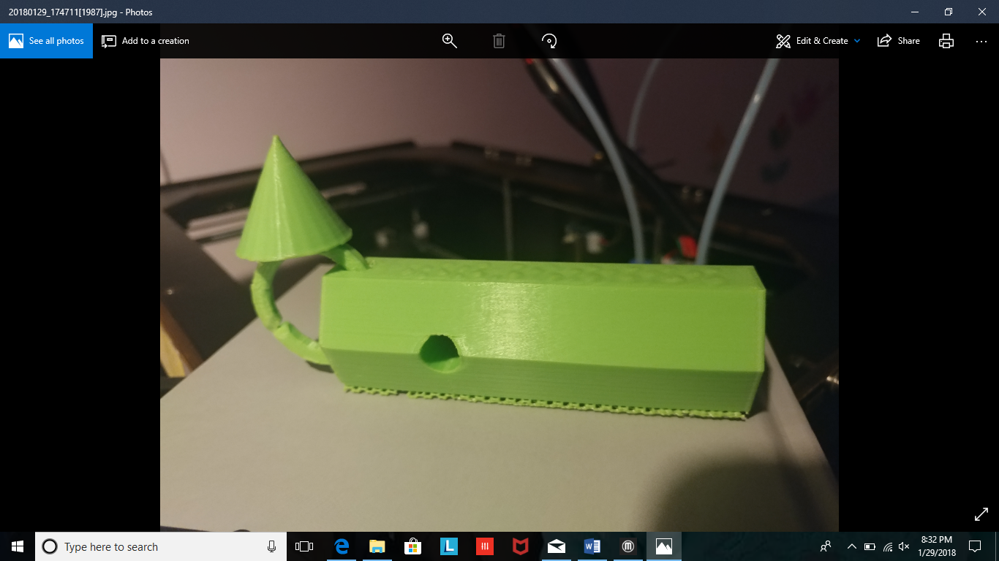Tail section with rotating motor. 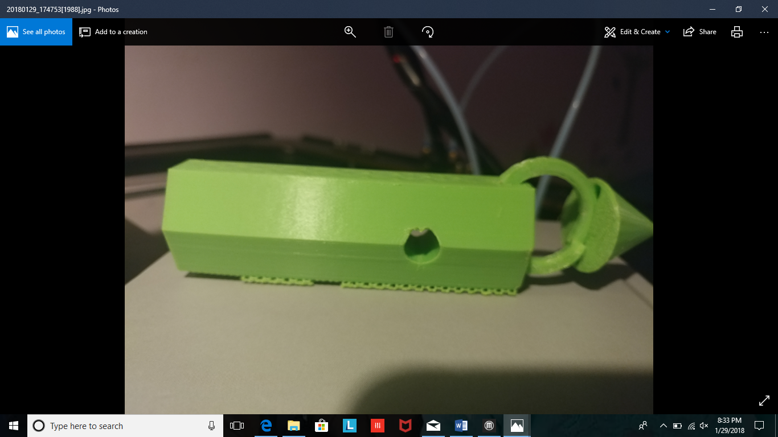

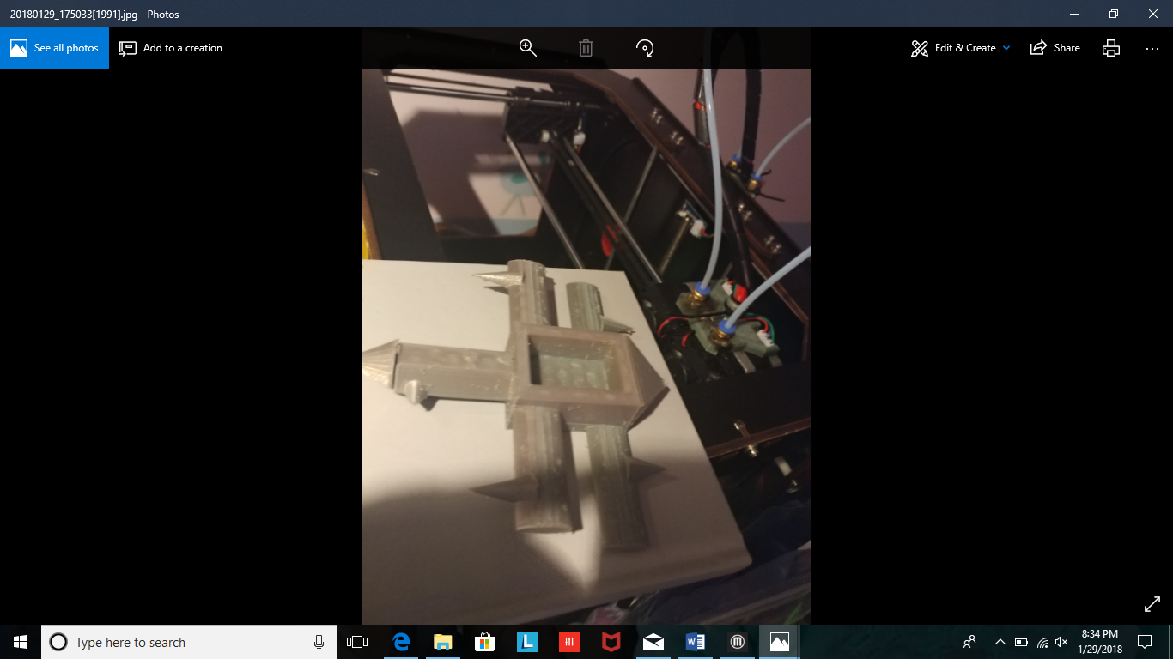Bottom of Dragonfly (cones = Thrust direction) 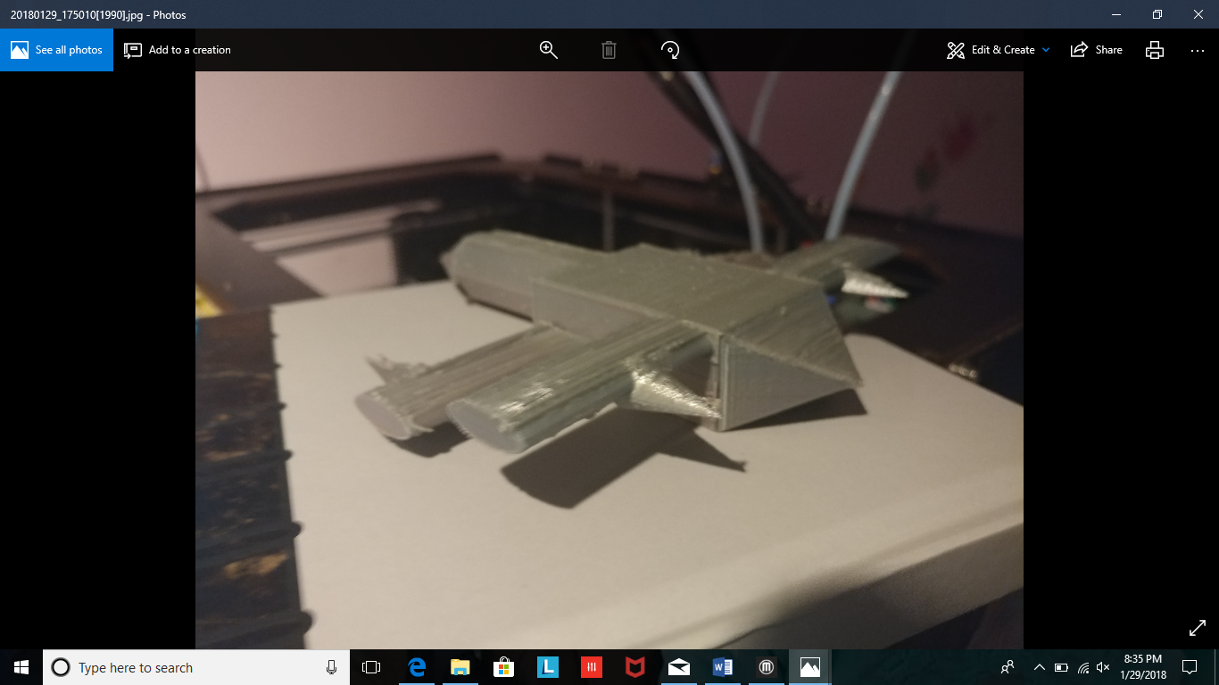

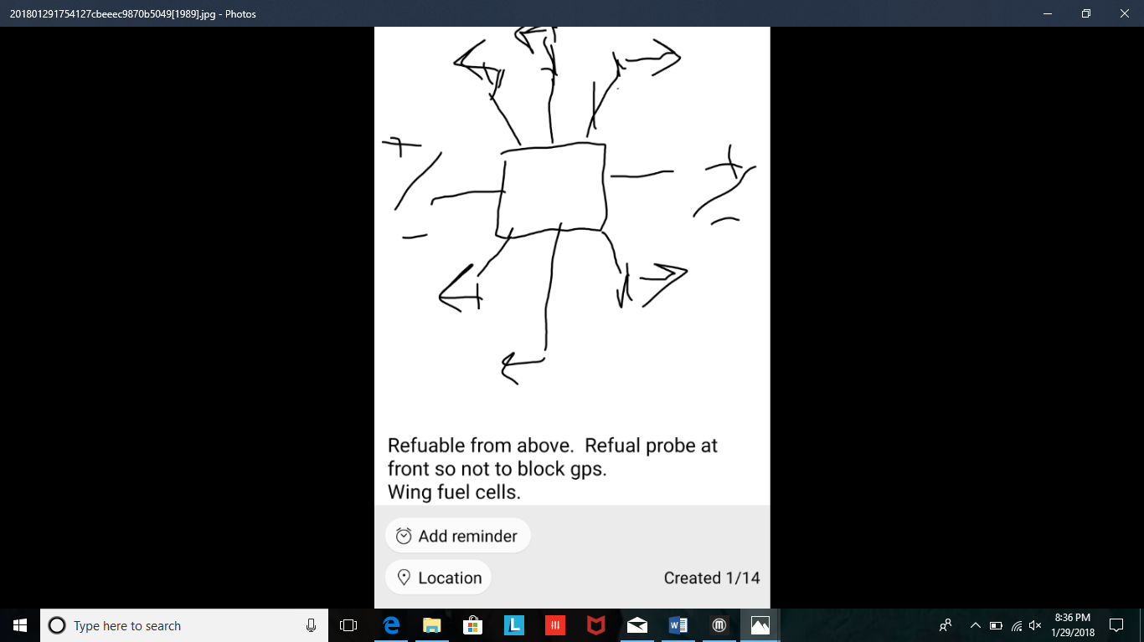Dragonfly V1