**First Responder Competition: Firefighter**

**Design Solution Proposed By:**

**Enhance-VR, LLC**

Enhance-VR, LLC is a young startup in Binghamton, New York, that pursues the development of VR, MR, and AR peripherals and systems. Our team (comprised of 4 undergraduate students from Binghamton University), is excited to take on the challenge of creating an AR prototype in a VR simulation to help firefighters. Leading up to the competition, we’ve met with our local Fire Department to work out the best and most effective solution that meets the requirements of the competition and the needs of the firefighters. We plan to blend actual physical components with the VR equipment (HTC Vive) to produce a simulation that is as close as possible to a real world solution. Our team take pride in the skills we’ve developed over the years through our own person projects and larger scale projects involving: VR motion platforms, haptic vest, and different VR applications. We fully believe that we have the right connections, resources, and knowledge to create a functional prototype that could win this competition and, if made into a real world device, save lives.

**Contact Information:**

**Mailing Address:**

Enhance-VR, LLC

Koffman Southern Tier Incubator

120 Hawley Street

Binghamton, NY 13901

**Team:**

Matt Gill: Electrical Engineer, Senior, CEO of Enhance-VR, LLC

Dylan Domenico: Computer Engineer, Senior

John Null: Computer Science, Senior

Amit Bachar: Mechanical Engineer, Senior

**Email:**

enhancevrteam@gmail.com

**Phone:**

607-426-8205

**Skills of Team:**

We are Enhance-VR, LLC. We are a newly founded company in Binghamton New York that works towards making peripherals and systems that can truly enhance a VR, AR or MR experience. Our origin is from creating a virtual reality skiing simulator with simple components as a concept project. From there we’ve expanded to making multiple prototypes from scratch such as: three motion simulator platforms, a haptic feedback vest, VR and AR mobile apps through Unity and multiple mini simulations developed for the Oculus DK1, HTC Vive, and the HDK2. Our work hasn’t gone unnoticed over the last three years. We’ve been featured in multiple newspapers and news stations, given a TEDx talk on VR to 1,200 guest, a University talk alongside directors (also university Alumni) from Intel and Qualcomm’s AR/VR departments, and guest lecture at Ithaca College in New York. We’re all excited to work on the project and create a prototype that can really help people. The team member’s resumes are attached with this document to highlight their own personal skills and achievements.

**Project Description:**

We’ve been fortunate to create a great relationship with our local fire department to help us leading up to the submission of this contest. Two of our team members worked in person with the department to learn about the struggles, challenges, and desires of our local firefighters. We gathered as much data as we could from information on their equipment, to even running through putting it all on ourselves and moving around how they would to get first can experience on what our design should possess. Given the requirements of what was to be displayed on the HUD and how the UI should work, this is what we found from our firefighters:

* Speaking, and hearing is hard in a fire, so voice commands wouldn’t work for a UI.
* Their gloves get worn out and beat up, having “conductive” fingertip gloves wouldn’t work for a UI.
* They need “landscapes” to feel for distinct features on their equipment to know what their touching. Thus we knew we needed to use these with our design.
* Any button they had on electronics were large enough to press through the gloves.
* Between standing, half kneeling and crawling, the one part of their body they could always touch was their face mask. It was also took little extra energy to reach.
* The mask “defogging” works like a car’s windshield, so most likely the only “clear area” or clearest line of sight, would be around the nose.
* Less items to press, select, and/or interact with the better. Too much information could be a distraction.

**Physical Features:**

Based on the information gathered, for our design, the physical interface of the HUD will include 6 buttons. It will also include several on-screen features to display both required atmospheric data as well as map/floor plan/locational data.

The mask will constantly display a thin bar across the top that contains temperature, oxygen levels of the SCBA, and a flash sensor. Based on reports from a few volunteer firefighters at the Johnson City Fire Department that their masks usually fog the least at the bottom, we chose to put this bar at the top so that in low visibility situations they will still be able to see their environment through the bottom of the mask. Most of the bar will be taken up by a sub-bar containing the amount of O2 left in the breathing apparatus. The temperature will be displayed next to this in either Fahrenheit or Celsius based on the users preference. The flash sensor will take into account oxygen levels of the room as well as rising temperatures and begin to blink if there are significant warning signs of flashing in the area. It will remain absent if there is no significant warning signs of the room flashing. Although the sensor blinking does not necessarily mean that the room will flash, it will give the user the ability to know when the atmospheric conditions point to it happening.

The user’s screen will be constantly displaying a map in the lower left side of the mask, much like several other gaming scenarios. This small, but detailed map will contain partner location and victim location as well as best route to them and the exits. There will be several map “modes.” The default is to have to map in the lower left corner. Pressing the appropriate button cycles through different views such as: enlarged this map to view the general floor plan of the user’s current floor. Next will be this enlarged map along with a 3 dimensional view of the building in order to distinguish between multiple floor routes. Lastly, there will be a “no map” mode.

Four of the six buttons will be on either side of the user’s head right past their temples, two per side. On each side there will be a plastic divider separating the buttons so that the user can distinguish between the front and back buttons. The mask will also have two large buttons on both of the user’s lower cheeks. The competitive advantage section explains how we determined this design. The buttons will operate as follows:

* Mode Switch Button (Upper Right Front Button) - This button will allow the user to switch between different modes, the three modes are Victim Location, Partner Location, and Exit Location. The processes involved in each of these modes will be discussed later in this paper.
* Arrow Toggle (Upper Right Back Button) - For all modes an arrow will be present in the middle of the screen right above the exhalation valve leading the user to either a victim, their partner, or the nearest exit. This button will be used to turn that arrow on and off.
* Bread Crumb Marker Drop (Upper Left Front Button) - Part of the user’s suit will include GPS point markers for breadcrumbs. This will allow the user to document their trail during victim location and be able to use the information as a best exit determinant.
* Hazard Marker Drop (Upper Left Back Button) - Part of the user’s suit will include GPS point markers for hazards. This will allow the user to document hazards during victim location and be able to use the information to avoid these hazards upon exit of the building.
* Select Toggle (Right Cheek Button) - When the exit navigation is generated, it will give an option to accept the path. The Map Toggle will be the “deny” option in this situation and the HUD will bring up the next best option to select or deny.
* Map Toggle (Left Cheek Button) - This button will toggle the different map modes and will allow the user to continuously choose which map will help them best in each scenario.

The attachments show a realistic physically layout of the buttons. For the HTC Vive, we’ll mount the buttons close to where they would be on an actual device.

There will also be a bone conduction headband worn underneath the HUD. Before the firefighter puts on their gear, they would already be wearing a bluetooth headband that both reduces sweat to the eyes but holds the transducers for the bone conduction. These will help the firefighters in multiple ways: They can hear radio commands clearly and/ or individually while still having an open ear to hear sounds around them (unlike typical headphones that “tune out” the world). If the local noise is too loud and the user cannot hear his/her fellow partner next to them, they can talk via the bone conduction to hear each other. Since it’s wireless, there’s no need for extra wires to link when preparing to leave the firehouse in an emergency

**Adjustable User Interface Set-Up:**

Prior to beginning a scenario the user will have the ability to adjust certain onscreen preferences. We came to this decision after gaining some insight from the firemen at the JC Fire Department. During a mission, their main focus is locating victims and exiting, everything about their equipment is set to their liking prior to going into the scenario. Therefore, we thought it would be best to allow the users to choose their preferences for on-screen font size and color.

A menu will appear in the beginning of the simulation allowing the users to change and define these settings. The default color of the font and features on the screen will be a shade of light blue. Users will have the ability to change this, as well as increase and decrease the size of the features to their liking. They will do this using the HTC controller. While underway, just like how phone screens can adjust to room brightness, a “photodiode” on the HUD will keep adjusting the brightness of the displays for optimal vision.

**Navigation:**

To assist the firefighter in navigating a “virtual” emergency, we have designed specific buttons and visuals to accomplish the desired situations such as breadcrumbs, hazards, finding victim, finding partner, finding exit. To note, we assume that we will be provided with simulation information of “GPS” coordinates like in a video game – unlike in the real work where GPS won’t work in a building and thus advanced Lidar or special Ultrasonic sensors would be needed but are beyond the scope of a virtual reality simulation. As mentioned earlier, breadcrumbs and Hazard markers are pressed by their according buttons and will include information on location temperature and oxygen at the time of press for later calculation of exiting. The location data from both will be “uploaded” to the locations GIS data so all floor plans and maps and HUD’s are up-to-date with all the hazardous locations and exit paths.

Additionally as mentioned earlier, there would be a directional arrow located in the middle of the headset in screen zone 2 (see diagram). This arrow will direct the user in the direction of their present objective (find victim, find partner, or exit the building). It will also display a distance in yards the user is away for the total path (not magnitude to objective).

When exiting the building or location the HUD will do all the calculations of best path to exit and fill screen zone 2 with a risk factor number between one and ten (one being almost no risk and ten being life threatening to the user). If the risk factor is over five, the HUD will display in the same screen zone 2 the greatest risk in little word count (i.e. “possible flash”, “Hot Space”, “Exiting through Window”, etc.) and speak it to the user. The calculations to determine risk factor and the best exit path take into account the hazard data, breadcrumbs, and all possible exits and compare that to the time to get out of the building. We believe that giving all of the options at once is too much data to sort through for a firefighter, therefore only the best option will be displayed unless denied.

Also while the area is being cleared, as a user moves through an area, a two yard radius around the user is mapped out and stored to note where they have been and not. This information could be found useful if the victim location isn’t known. On a realism note, the data of “searched” areas can be sent to a tablet to a Captain outside the location and help speed up the searching process.

**Movement:**

To move around in the Unreal Environment, unless predetermined by NIST, will be done by swinging the controllers. The swinging motion looks exactly how someone would swing their arms while running or walking. As you swing faster you can increase speed. This feature has proven to help reduce motion sickness (feels natural) versus a joystick controlled movement which can induce sickness.

**Biggest Challenge:**

Two of our biggest challenges is going to be learning Unreal Engine and the navigation feature. While our team has plenty of experience with Unity, we would have a week or two learning curve to transition to Unreal. We are all proficient with the programming languages that both game development softwares use, it’s just the UI’s we’d have to adjust to.

For the navigation, the challenge is the fine tuning process of what data should be valued higher than others (i.e. hazard versus time). To solve this problem, we plan to meet with the local fire department and have them test the environments and scenarios. If they find the risk factors are off and why they think so, we can adjust our parameters.

**Performance**:

Testing the performance of the mask will include testing amongst the team as well as testing with local firefighters in order to get their insight on the improved mask. We will also make it possible to test the scenario without the upgraded features so that we can compare and see just how helpful the features are. Data for testing will include survival of the user’s victim and partner as well as the completion time of a certain scenario. These tests will take place amongst multiple participants and be consistent for the case of a normal mask and the case of an upgraded mask.

**Competitive Advantage:**

We believe we have multiple competitive advantages. To start, we worked with our local fire department, put all of their gear on and work with them to determine our design. To have them as a resource to get professional opinions will help tremendously. Our team’s ability to rapid prototype is going to move the physical features along quickly. We’ve built motion simulators from scratch in under 24 hour hacking contests as well as a VR haptic vest. Skills our team has grown through the company, through personal project and through our education gives a tremendous advantage to complete the project.

**Costs:**

To build the physical components, the combined electronics (circuits and buttons) and 3D printed housings will cost us under $100 US. We already have an HTC Vive but having a secondary computer and Vive to speed up developing will help.

**Letter from Johnson City Fire Department:**

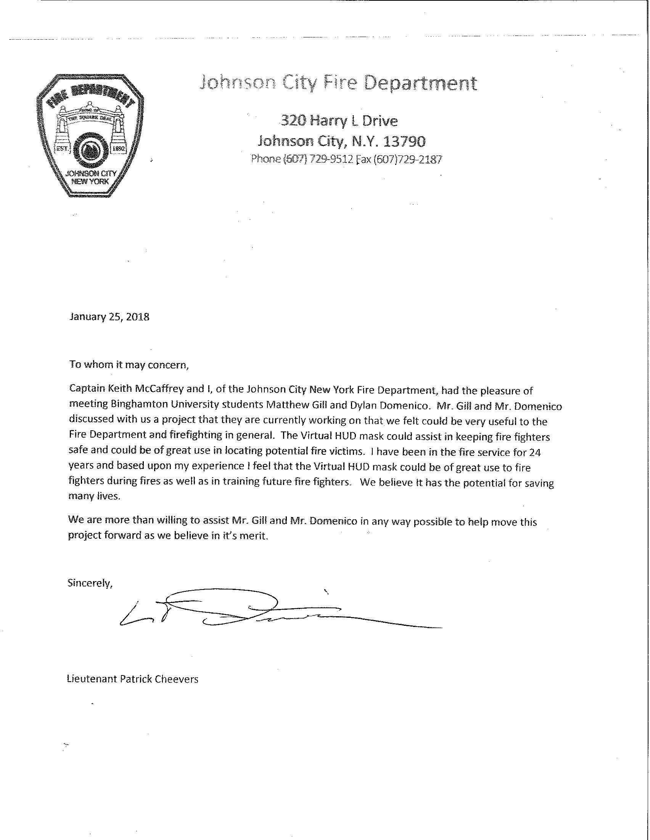

**Resumes:**

