MaxPran

Jim Faunce, Matt Koestner and Ben Faunce

Long Endurance C2 X8

Solution to

The Unmanned Aerial Systems Flight and Payload Challenge

Technical Point of Contact Business Point of Contact

James B. Faunce, P.E. James B. Faunce, P.E.

Cell: 609-977-2626 Cell: 609-977-2626

Email: [Engineer@IEEE.org](mailto:Engineer@IEEE.org) Email: [Engineer@IEEE.org](mailto:Engineer@IEEE.org)

Borrowing from the design of our existing 26 lb electric quadrotor, MaxPran will build a larger frame to allow integration of a gas generator and installation of 2 coaxial rotors on each of the 4 arms. Our original quadrotor was designed for long range, long endurance aerial surveillance using 28 inch carbon fiber propellers and lithium polymer (LiPo) batteries. We increased flight time 80% with the use of 30 inch props and Lithium Ion (Li-Ion) batteries. The higher energy density of gasoline will provide much more flight time, and propulsion system (ESC, motor and propeller) improvements will provide still more flight time.

Lithium Ion batteries provide a maximum specific energy of 265 Watt Hour/kg. The energy density of gasoline is around 13,200 Watt Hour/kg. The efficiency of an internal combustion engine is at best 50%, and more often 30 to 35%. Operating at 30% efficiency, a gas engine could provide yields the equivalent of approximately 4000 Watt Hour/kg for the fuel (not including weight of engine).

Our goal is to modify our existing design, improving, assembling and testing while varying the coaxial propeller geometry to yield the best performance possible.

Target Flight Times

20 lb payload flight time is 1.75 H

15 lb payload flight time is 3.61 H

10 lb payload flight time is 5.47 H

**Project Description**

MaxPran is a team comprised of Jim Faunce, Matt Koestner, and Ben Faunce. We have worked together designing and building large quadrotors for 3 years. Our venture started when Jim was working as a consultant for Vance Kershner, Owner and CEO of Labware. Vance owns a large game farm (Safari Park) in South Africa. To prevent rhino and elephant poaching we purchased a foreign made UAV (quadrotor) from a distributer in New Hampshire. Matt was the distributer’s technical guru. The big quadrotor was shipped to New Hampshire for us to integrate our payload consisting of a thermal Imager, 4k video, and long range control and communications (C2). However the foreign quadrotor had problems with mismatched power train components. The motor stator poles saturated from too large current, causing problems from loss of commutation to magnet wire epoxy melting. It was not always Crash and Burn, sometimes burn and crash. What started as a plan to buy an off the shelf UAS turned into a new UAS design and development project.

Starting with a maximum weight 55 lb (24.9 kg), 8 Motors could provide 6.88 lb required thrust per rotor (3.12 kg). Using technical data published by KDE Direct for their KDE8218XF-120 motor with a 30.5 x 9.7 prop

<https://www.kdedirect.com/collections/uas-multi-rotor-brushless-motors/products/kde8218xf-120>

Running on 12S (46.2V) the rotor consumes 143 Watts producing 2,220 grams thrust, and 337 W for 4100 g thrust. Although the data is not linear, simple interpolation gives approximately 192 W for 3,120 g of thrust. KDE’s data for the same motor and prop running on 6S (23.1 V) gives 217 W for 3130 g thrust. Two things to note:

1. The 192 W estimate is probably low due to linear interpolation and

2. The throttle required for 12S is only 30% whereas on 6S voltage the throttle is 62%.

ESCs tend to be more efficient at higher throttle than at lower throttle, but the difference is not as much as the efficiency difference between propeller RPM variations. Based on 217 Watts for each motor yields 1740 watts for average continuous power requirement. Taking into account the power for electronics and rounding up we will use 1800 Watts for the power requirement.

The Desert Aircraft DA-50 gas engine <https://www.desertaircraft.com/collections/da-engines> is large enough to drive a BLDC motor to run as a generator. The DA-50 weighs 2.94 lb.

Our current quadrotor using KDE motors weighs 26.4 lb with 10.6 lb of batteries. The UAS without batteries weighs 15.8 lb. The new X8 frame with larger diameter carbon fiber tubing and 4 additional motors will weigh approximately 23.7 lb without batteries. If we allow 1000 g (2.2 lb) for one 9,000 mAH LiPo battery, with 30 C discharge capacity (minimum for short flight time and current burst to motors for safe landing) then the total weight before adding a gas generator is 25.9 lb with battery.

With a maximum weight of 55 lb and allowing for a 20 lb payload, this leaves 9.1 lb for a gas generator and fuel. The DA-50 with a BLDC motor, fuel tank, electronics and mounting hardware is estimated to weigh 5 lb. This leaves us 4.1 lb (1.9 kg) for fuel. As noted earlier, the gas fuel could provide a net 4000 WH/kg, so 1.9 kg will provide 7,600 WH of energy. However this is too optimistic, and for a better estimate we will use the specifications for the NOVA-2000 an existing “Commercial Off The Shelf” (COTS) gas generator from Foxtech <https://www.foxtechfpv.com/foxtech-nova-2000-generator.html>

Generator output: 1.8 kw (continuous), 2 kw (max) with Fuel consumption: 1.5 L/H (Max)

Converting using the volumetric density of gasoline (0.748 kg/L) x 1.5 L/H = 1.22 kg/H fuel consumption

1.9 kg of fuel/1.22 kg/H fuel consumption = 1.58 hours for a 20 lb payload using all the gas fuel.

The UAS can hover for 1.58 hours before it starts to drain the battery. The battery would provide another 9 Amp hours x 48 V = 432 Watt Hours of energy, but landing with 20% we have 346 WH which would give us .17 hours or 10 minutes. Total for 20 lb payload is 1.75 hours.

Each additional 5 lbs (2.27 kg) of fuel provides 2.27 kg/1.22 kg/H = 1.86 hours of flight.

20 lb payload flight time is 1.75H; 15 lb payload flight time is 3.61 H, and 10 lb payload time is 5.47 H.

These are theoretical maximum target flight times. Actual performance will vary. For instance the 8 motors will not equally share the load under most conditions, even hover. Example: Wind will cause the UAS to lean into the wind and/or yaw, which will leave some motors powering more than others, with some props spinning higher RPMs. The net result will always sum higher than average as the RPM/thrust curve is nonlinear “in the wrong way”. We have even experienced 2 motors carrying most of the load on a quadrotor that was very symmetrical with the load concentrated near center. It was as if the center of gravity was hanging on an axis between two motors on a diagonal, and the other two diagonal motors served as a balance beam to keep the UAS level. Since two motors were operating near full throttle with the props spinning near max RPM, efficiency suffered.

Coaxial propeller efficiency is less than the efficiency of two same size propellers distanced from each other. However the size and weight of an octorotor with 8 arms and 8 motors is a bigger problem. The team debated several design configurations including folding arms to fit a large hexrotor or octorotor. We considered a quadrotor with larger props, but too large and the props spin so slow it can lead to control and stability problems.

**Summary Plan Schedule**

|  |  |  |  |
| --- | --- | --- | --- |
| **Task**  # | **Start** Date | **Task Description** | **End** Date |
| 1 | 2/9 | Procurement of Carbon Fiber Tube | 2/16 |
| 2 | 2/9 | Procurement of Motors and ESCs | 2/12 |
| 3 | 2/9 | Procurement of Radios and Flight Electronics | 2/12 |
| 4 | 2/9 | Procurement of Test Propellers | 2/14 |
| 5 | 2/9 | Procurement of Gas Engine and Electrical Generator parts | 2/16 |
| 6 | 2/9 | Machining of Aluminum Frame Parts | 2/15 |
| 7 | 2/16 | Assemble and Epoxy Frame | 2/17 |
| 8 | 2/14 | Propeller Testing – Singular Prop Testing | 2/15 |
| 9 | 2/15 | Propeller Testing – Coaxial Prop Combinations | 2/19 |
| 10 | 2/19 | Assemble Gas-Electric Generator | 2/21 |
| 11 | 2/20 | Assemble UAS Frame, motors, ESC, Electronics and batteries | 2/22 |
| 12 | 2/22 | Gas-Electric Generator Bench Testing | 2/26 |
| 13 | 2/26 | UAS Ground Testing including initial PID tuning | 2/27 |
| 14 | 2/28 | Initial Flight Testing and aerial PID Tuning (Batteries only) | 3/10 |
| 15 | 3/12 | Gas Generator installation in UAS | 3/13 |
| 16 | 3/14 | UAS Full System Ground Testing | 3/16 |
| 17 | 3/17 | UAS Full System Flight Testing | 3/31 |
| 18 | 4/2 | Data Review and System Optimization | 4/9 |
| 19 | 4/10 | UAS Full System Flight Test Repeat | 4/13 |
| 20 | 4/14 | Endurance Testing | 4/21 |
| 21 | 4/23 | Review and Stage 3 Prep | 5/14 |

Some task durations will be shorter, some longer. We can skip ahead to future tasks should a problem arise with an early scheduled task. There is time at the end of the schedule for contingencies.

Some videos of our work:

<https://www.youtube.com/watch?v=qkezlAWXyWE>

<https://www.youtube.com/watch?v=WVwHH1aPEVE>

<https://www.youtube.com/watch?v=SbmDuTMqV1o&index=20&list=PLWa5My2t4Tbk75LzPGXBNparkfDlKRwTm>

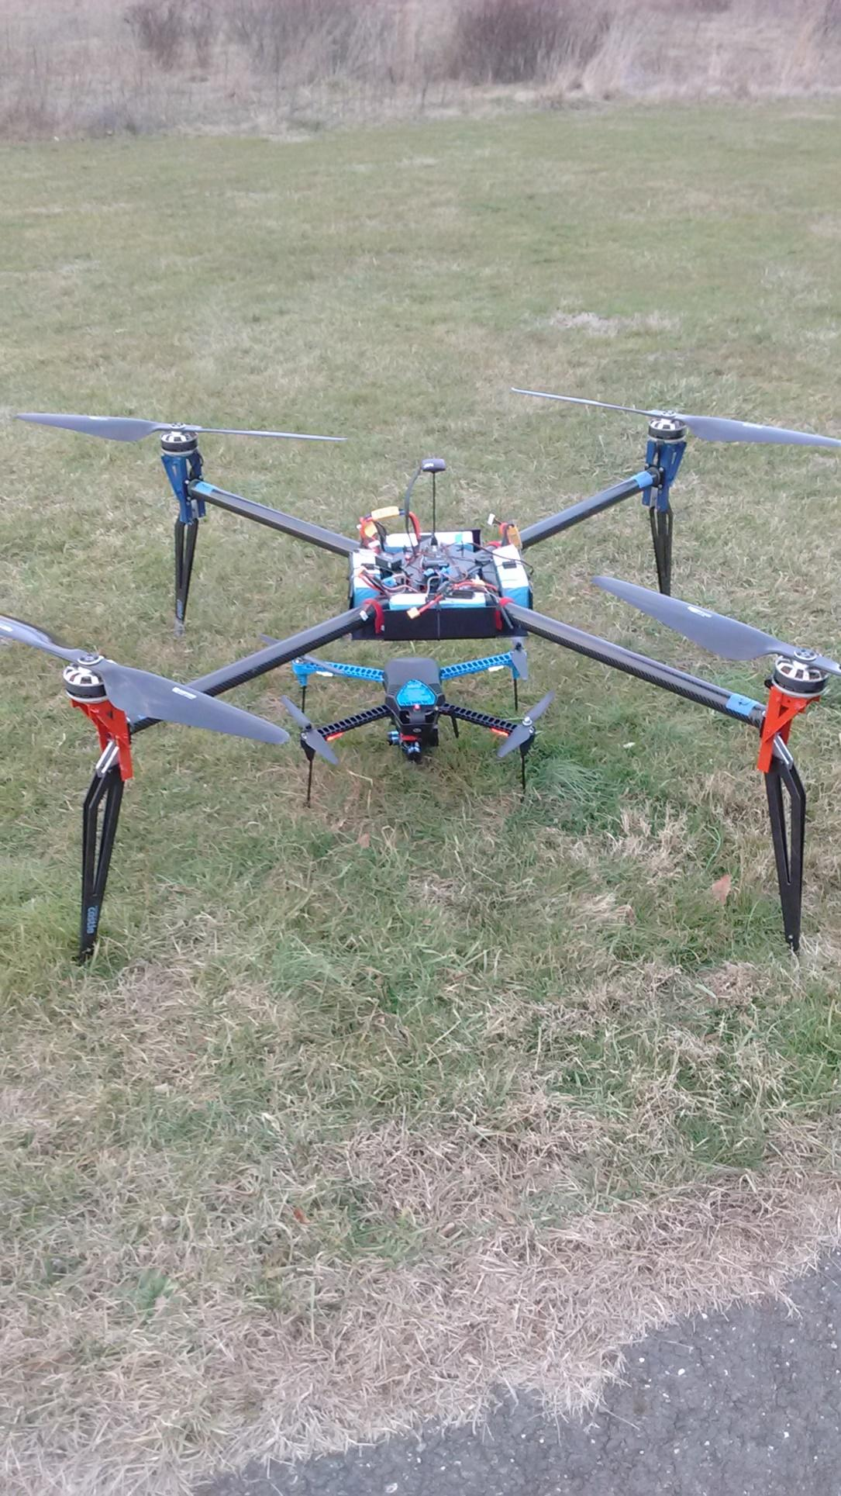

Our 26 lb quadrotor along with a 3DR Iris+

Key Team Members

**James Faunce** P.E. Jim’s Current projects include design and development of an Unmanned Aerial System (UAS) for antipoaching (rhinos) in South Africa; to be extended for wildlife surveying. Jim also served as a Systems Engineering and Technical Assistance (SETA) contractor to U.S. Army, SBIR program for Phacil Inc., Fort Monmouth, NJ and Aberdeen Proving Ground (APG), MD where he provided technical assistance to small businesses and Army researchers in the C4ISR region for the Army SBIR program. Transitioned and integrated SBIR technology into Army programs of record.

Ref: <https://www.armysbir.army.mil/docs/pdf/newsletter/2009_SBIR_Oct_Newsletter.pdf>

As a project engineer at BreezeEastern Jim directed multifunctional teams simultaneously on different programs in military, civil and commercial markets, with foreign and domestic customers. Jim provided customer interface from concept through design, build, test and installation. Projects included: Parafoil control winches for NASA X38 Crew Return Vehicle; Hoist/Winch Test Stand for Israeli Air Force; and CH47 Heavy Lift Hoist System for Boeing and US Army. Jim also worked as a Project Engineer for the Princeton Plasma Physics Laboratory as Chief Operations Engineer for S1 Spheromak and designed diagnostics (Neutron, Optical, X-ray and Magnetic) for the Tokamak Fusion Test Reactor (TFTR).

Jim earned his BSME and BSEE from the University of Delaware. Jim is Registered Professional Engineer in Delaware # 14992 and New Jersey # 24GEO3064900. He obtained a Secret Clearance (inactive) and had Army Acquisition Training.

**Matt Koestner** has 20+ years’ experience with electronic integration, radio control, and amateur radio experience. Matt is a Part 107 FAA UAS pilot. He was the Chief Technical Officer at UAV America, a New Hampshire small business providing custom UASs. He is current focus is on imaging systems and onboard computing, along with UAV propulsion system ESC/BLDC/propeller testing and hybrid (tailsitter) rotary/fixed wing UA development.

Matt earned his BSEE at University of Central Florida in 2005.

**Ben Faunce** is a certified welder and technician working at Marshal Industrial Technologies.