# Hand gestures and Arm HUD in VR

Team Name: Team REI

Team Members: Prashanth Vijayaraghavan (pvijayaraghavan@reisystems.com)

Brinda Somasundaram (brinda.somasundaram@reisystems.com)

Point of Contact: Brinda Somasundaram ([brinda.somasundaram@reisystems.com](mailto:brinda.somasundaram@reisystems.com))

Concept group: Concept for Firefighters

Abstract:

Virtual Reality(VR) and Augmented Reality (AR) are technologies for letting you create virtual worlds –in whole, in part or laid over reality. This lets you create lifelike experiences, where any type of situation can be simulated. VR technology is especially useful when it comes to training first responders for hazardous situations.

For the purposes of this challenge, the following discussion will only apply to VR technology. In this concept paper, we will discuss various input mechanisms and head up display concepts.

Traditional VR systems consists of controllers or tracking devices to interact with virtual world. While this works, we could go one step closer to real world by using bare hands and fingers to interact with objects within VR environment. In this concept, Leap Motion VR technology will be used to utilize hand/finger gestures to control sample Heads Up Display(HUD) instead of traditional VR tracking device/controller. No special gloves or controllers are needed.

*Impact*: Training scenarios will be more effective with bare hands and fingers than using controllers which are popular with current VR systems.

Traditional Head Up Displays consume lot of real estate in virtual environment and blocks the field of view. Using Leap motion VR technology, we would like to propose a display around the arm to display information related to environment and vitals of the fire fighter.

*Impact*: Use of arm HUD in VR environment will free up visibility when training fire fighters than using traditional Heads up Display on the virtual environment.

## Project Description

**Problem**:

In traditional VR systems, controllers lets users wirelessly interact with the virtual world. While this works well for gaming scenarios, it may not suit well for training first responders. It would be best for the first responders to use arms, hands and fingers to interact with virtual world because it simulates the real world in which first responders will be holding other objects/instruments to perform work in the field.

Also, Heads Up Display(HUD) in VR environment usually clutter up limited real estate that’s available in the current generation VR Headsets, we could address this by creating a Heads up Display wrapped around the arms.

**Proposed Solution:**

We will utilize Leap Motion VR technology, developed by Leap Motion Inc to address the problem above. Leap Motion VR Platform is a combination of hardware and software designed for existing VR/AR headsets. For consumers/developers, Leap Motion Developer Kit can mount the leap motion sensor to an existing VR device like HTC Vive. For production scenarios, Orginal Equipment Manufactures(OEM's) like HTC, Oculus can work with Leap Motion to directly integrate this sensor within the VR device. See image below for an example. This device also requires software installation called "Orion" to integrate hand tracking with the VR environment.

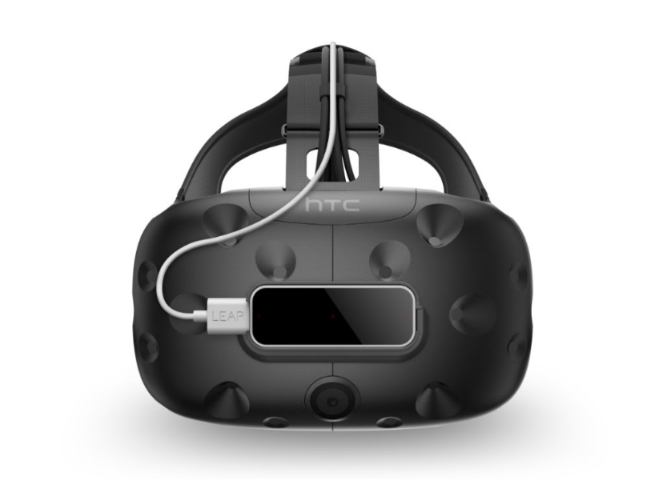

**Image 1: Leap Motion VR sensor attachment to HTC Vive**

With the sensor attachment, users can pinch, grab objects of variety of shapes and textures and perform other physical interactions within the virtual environment.

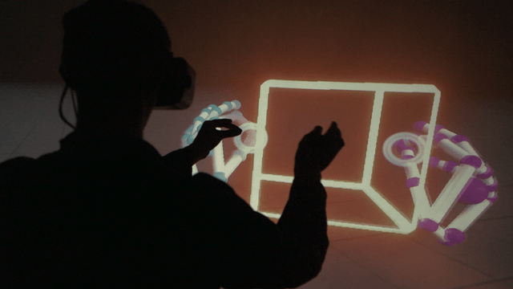

I**mage 2: User interacting with pinch action with objects inside VR environment.**

We could also develop compelling user experience like floating buttons, sliders etc that are easy for users using "interface builder" framework provided by Leap Motion, Inc. We could even create wearable menu that can be locked to your hand/wrist or arm. Head up display created around arm(Arm HUD) inside VR space can serve as a useful UI element for locating information and controls without cluttering up limited real estate inside VR environment. Arm HUD (Heads up display) can change functionality based on orientation of the arm. There is a sample widget available which can be customized to fire-fighting scenario. See images below for Arm HUD concept.

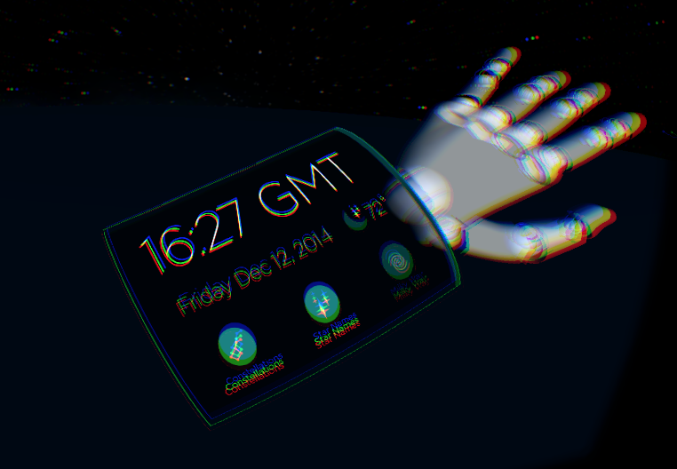

**Image 3: Sample Arm HUD Concept to display information around arm inside VR environment**

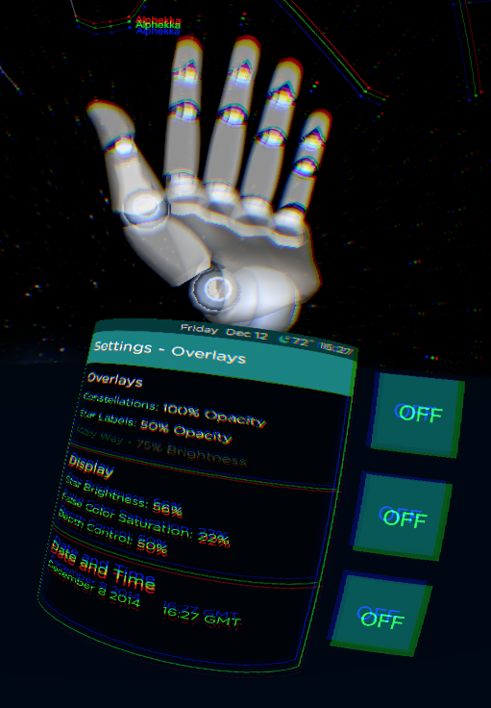

**Image 4: Arm HUD display changes when the orientation of the arm changes.**

**Potential Use Cases:**

* Display external temperature, oxygen levels on the Arm HUD.
* Display health vitals such as rate, pulse, breathing rate etc as per arm orientation.
* Use gestures/hand input to dismiss any on-screen warnings like low oxygen levels or dangerous vitals.

**Produced Artifacts:**

At the end of this project, we will demonstrate Arm HUD prototype based on firefighting scenario. The prototype will display sample data like external temperature, oxygen levels and health vitals such as heart rate, pulse, breathing rate etc that are relevant to a fire fighting scenario.