**Cover Page**

NIST - The Unmanned Aerial Systems Flight and Payload Challenge

**Title: Sliding Rotor UAV for Higher Endurance and Maneuverability**

Suvro Datta, PhD

Robodub Inc.

suvro@robodub.com

Phone: 206-724-8496

**Description:**

Currently, in the operation of Unmanned Aerial Systems (UAS/UAV) that carries a payload for any application, great care is taken to position the payload such that its center of mass aligns with the center of the vehicle. This is an artificial constraint that we must overcome for using UAVs in future days when the vehicle is expected to carry payloads of any arbitrary form, shape, and weight distribution. In the current design of the UAVs, any payload that is heavier on one side than the other, causes the rotors on the heavier side to work significantly harder than those on the other side. This situation forces uneven distribution of power, and severely affects endurance of the vehicle as well as its maneuverability.

We have an innovative and patent-pending design, that will efficiently correct the situation described above, and increase the flight time of the vehicle. Currently the frame design of standard multirotor UAVs are of fixed geometry and does not allow any change in configuration during the flight. In our innovative design, the rotors of the UAV will not be fixed in place but would have the freedom of sliding along the arms of the vehicle. We plan to create a closed loop system where the load imbalance is sensed in real-time during the flight, and consequently the rotors are moved to appropriate locations on their respective arms in order to balance the load evenly among all the rotors.

This proposed design, besides addressing the endurance issue which is of prime importance, also carries the promise of solving two other issues related to such multirotor UAVs. One of them is agility, which is also of great importance in adverse weather condition as well as for avoiding obstacles. Our design will enhance the agility of the UAV by augmenting the standard maneuver mechanism with continuous repositioning of the thrust generators. The second issue is of dynamic payload that shifts its weight distribution during the flight; for example, a sling load, slushing load, or a robotic arm attached to the UAV which cause the center of mass to move around. Our system would be able to re-adjust the center of thrust continuously and efficiently to adjust for that variation. Overall, we strongly think that this new system would change the way the UAVs are built today, and would solve multiple problems related to carrying an arbitrary payload.

**Project Description**

Robodub is a Seattle based startup, developing a new generation of drones. This technology, which we call Morphing, allows the vehicle to change its physical configuration in a number of ways in order to achieve higher endurance and superior maneuverability over conventional multirotor UAVs.

In this section we will first briefly describe the standard design and controls of a quadrotor UAV, followed by the description of the proposed mechanism that was outlined in the previous page, i.e. how by changing the location of the rotors on the arms of the UAV can increase the endurance and performance of the vehicle carrying an arbitrary payload.

Figure 1 illustrates how different types of maneuvers are achieved for a standard X-type quadrotor, whose four rotors are marked as 1, 2, 3 and 4. The rotors 1 and 3 spin clockwise, and the rotors 2 and 4 spin counter-clockwise. At a steady hover state, all the four propellers move at equal speed, causing the quadrotor to float steadily without any forward, backward, or sideways motion. Also, the reaction torque from clockwise rotating rotors 1 and 3 perfectly balances the reaction torque from counter-clockwise rotating rotors 2 and 4, causing no net yaw motion.

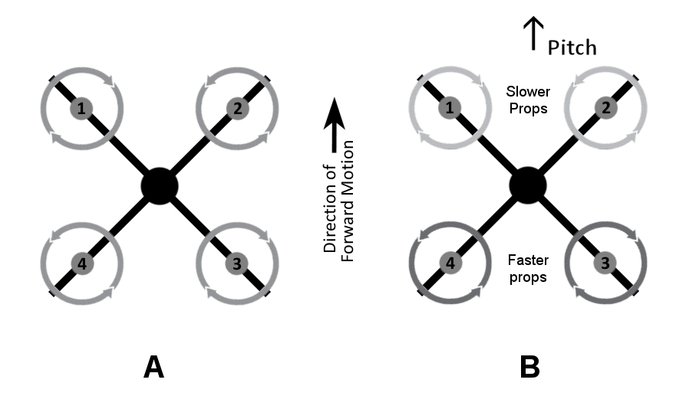

Fig. 1

If rotor 1 and 2 slow down and the opposite rotors 3 and 4 start going faster at the same time, then front side will tip down, and the quadrotor will have a pitch motion and will move forward, as shown in Fig. 1B. Inversely, if rotor 1 and 2 speed up and rotors 3 and 4 slow down, then the craft will move backward.

Similarly, if rotors 1 and 4 slow down and rotors 2 and 3 go faster, the left side will tip down causing the craft to roll towards left. If rotors 2 and 3 slows down and rotors 1 and 4 speed up, then the craft will roll towards right.

If the opposite rotors 1 and 3 (both rotating clockwise) slow down simultaneously while 2 and 4 (both rotating counter-clockwise) speed up, then the reaction torque from rotors 1 and 3 will not balance that from rotors 2 and 4. There will be an excess reaction torque in clockwise direction, which will make the craft turn clockwise. This is how a quadrotor goes into yaw motion.

All the above maneuvers occurs through the flight control software installed in the flight control board, which controls the speed of the four individual rotors. The flight controller acts on the operator’s inputs received through a transmitter-receiver system and the signals received from the on-board sensors.

**How Morphing Would Enhance the Load-balancing Capability of the UAV to Increase Endurance**

For a UAV carrying a lopsided load (indicated by L in Fig. 2), it must still maintain its ability to hover by staying level, as well as its ability of to perform pitch and roll maneuvers by tilting in appropriate direction. For a standard quadcopter, this is done by speeding up and slowing down the rotors, as described in the previous section using Fig. 1.

For our morphing quadcopter, this standard procedure can be further enhanced significantly by changing the rotor positions appropriately. This will be illustrated using Fig. 2.

Fig. 2A shows the UAV in its standard X configuration, with a lopsided payload L. To maintain a hover, the rotors 3 and 4 must spin up while rotors 1 and 2 slow down in order to balance the lopsided load. This kind of uneven distribution of power over the four rotors causes serious inefficiency because of the non-linear relation between input power and output thrust. Also, these is a limit of how fast a rotor can go; and when it is forced to operate near its limit because of the lopsided payload, it has no extra power available to speed up further that a required pitch or roll maneuver demands. Thus, both endurance and maneuverability of the vehicle is negatively affected.

At this moment there exists no elegant solution to this issue, except for using stronger motors and speed controllers, which also makes the craft heavier and negatively affects the endurance.

The solution we offer is innovative is elegant, as shown in Fig. 2B. In order to balance the lopsided payload, we would move rotors 1 and 2 inwards, and rotors 3 and 4 outwards along the respective arms as shown in Fig. 2B. This reduces the extra load on rotors 3 and 4. It also reduces wastage of power due to inefficiency, while maintaining the same maneuverability.

This technique can be extended further for dynamically changing payloads as well. Fig. 2C illustrates the situation when the load L is not stationary and moves to a new location in the course of time, we would simultaneously move rotors 2 and 3 inwards, and rotors 1 and 4 outwards along the respective arms as shown in Fig. 2C. This makes the vehicle perfectly balanced again. Essentially, morphing works as a mechanism to balance a lopsided load, which may be either stationary or dynamic in nature.

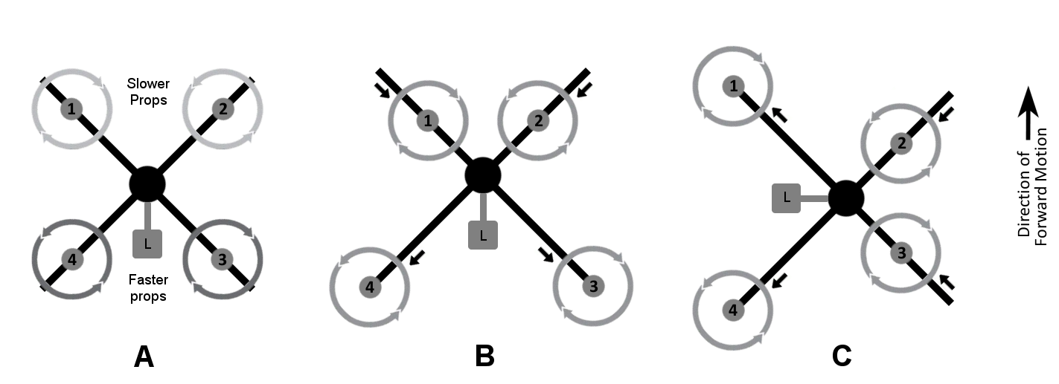

Fig. 2

**Hardware: The Sliding Rotor Vehicle**

The vehicle we are proposing to build will have four arms in a symmetric X configuration, with one rotor fitted to each arm, like a standard quadcopter. But in our design the rotors will be movable along the length of the respective arms, as illustrated in Fig. 3. Each rotor will be mounted on a carriage that can slide along the arm it is on. In this figure, the carriage is shown to move from one position (A) to another (B) along the arm.

The linear sliding motion of the carriages on the four arms can be achieved by a number of mechanical arrangements. We are planning to use either a rack-and-pinion gear arrangement or a belt-and-pulley arrangement, along with an encoder that can sense the location of the carriage on the arm. The net result will be the same on the dynamics of the vehicle.

For the mechanical design mentioned above, the actuation can also be done in a number of ways using various electro-mechanical devices, including continuous servo motors, stepper motors, or standard DC motors. We are planning to use high grade smart servo motors with built-in optical encoder for the actuation.

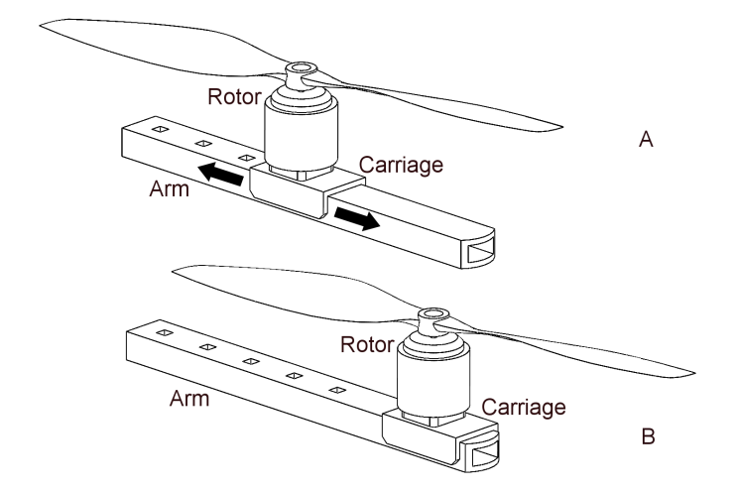

Fig. 3

**Software: Control System and Actuation**

The control software, which is a major part of the innovation, would control both the flight of the vehicle as well as the change of rotor position of the arms. The software sits in the controller board and its companion computer on-board of the vehicle.

We will briefly describe the control system, using Fig.  4. For a standard quadrotor (Fig. 4A) the flight controller receives input from the user through the radio receiver, and receives data from the on-board sensors like gyro and accelerometer. Using those two things, the controller sends signals to the ESC (electronic speed controller) of the four motors in order to perform various maneuvers like pitch, roll, yaw, upward and downward movement.

The control system of our UAV (Fig. 4B), in addition to the system described above, will have an onboard companion computer controlling a set of four servo actuators. The computer will determine the optimal position of the four rotors in real time from the data of the on-board sensors, and will drive the actuators to move the rotors to their desired positions. The whole operation will be on a closed-loop feedback system to maintain the best stability of the vehicle. Robodub will develop the necessary algorithms for the system operation.

In future work, we also plan to include artificial intelligence (AI) and implement advanced algorithms such as deep neural net to determine the drone actuations based on its dynamic environments.

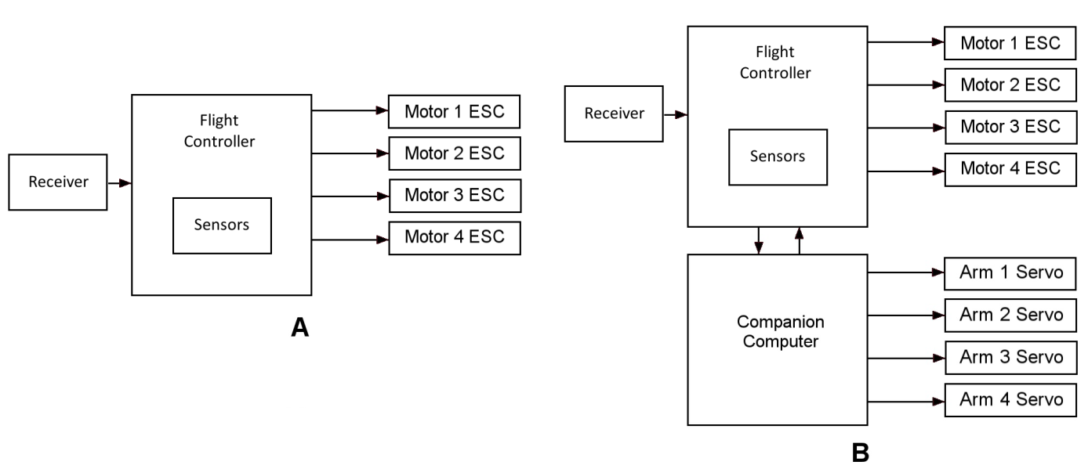

Fig. 4

**Evaluation:** The effectiveness of the system will be tested by attaching various payloads and monitoring the power consumption in hover position at different lopsided configurations of the payload. We will create a matrix including the asymmetry of the payload with respect to the UAV frame, and the power needed to keep the vehicle in hover position with and without our morphing mechanism activated. We expect as much as 50% increase of flight time using our technology.

Team: Our core team comprises of skilled and experienced engineers who are able to solve challenging technical problems with their expertise. The roles and responsibilities of the members of the team are given below, followed by the resume of individual members.

Table 1 below outlines the role and responsibilities of our core team for this project:

|  |  |  |
| --- | --- | --- |
| Name | Role | Activity |
| Suvro Datta, Ph.D. | Robodub CTO,  Mechanical Engineer | Principal Investigator  Mechanical Design  System Integration |
| Parminder Devsi | Robodub CEO  Electrical Engineer | Project Manager  Electro-mechanical and electronics design |
| Natat Pico Premvuti | Robotics Engineer | Firmware, Electronics and system integration |

Table 1

