**Nutrient Sensor Action Challenge** 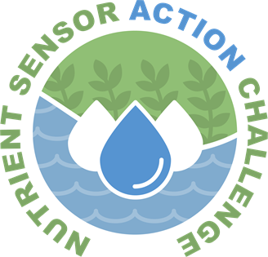

**Registration**

Upload the completed form to challenge.gov by clicking on the

“**Submit Solution**” tab on the [Nutrient Sensor Action Challenge](http://www.challenge.gov/nutrient-sensor-action-challenge-stage-II) page.

**General Information**

**Project Lead:**

|  |  |  |  |  |  |  |  |
| --- | --- | --- | --- | --- | --- | --- | --- |
| First name: | | |  | | Last name: | |  |
| Organization: | | | |  | | | |
| Title: |  | | | | | | |
| Phone: | |  | | | Email: |  | |

**Contact for matters of communication and media:**

|  |  |  |  |  |  |  |  |
| --- | --- | --- | --- | --- | --- | --- | --- |
| First name: | | |  | | Last name: | |  |
| Organization: | | | |  | | | |
| Title: |  | | | | | | |
| Phone: | |  | | | Email: |  | |

Do you agree to allow EPA to share project information with journalists for potential coverage of the project?

☐ Yes

☐ No

Are there others who should be notified via email about webinars and other updates? (provide as many as needed)

|  |  |  |  |  |  |  |  |
| --- | --- | --- | --- | --- | --- | --- | --- |
| First name: | | |  | | Last name: | |  |
| Organization: | | | |  | | | |
| Title: |  | | | | | | |
| Phone: | |  | | | Email: |  | |

Is there is any information about the project that should be treated as confidential?

☐ Yes

☐ No

If yes, please explain:

|  |
| --- |
|  |

**Project Description and Potential for Impact [limit 250 words]**

Describe the specific nutrient issue that the project will address.

|  |
| --- |
|  |

How will the addition of data and information from nutrient sensors inform and improve specific decisions and actions pertaining to nutrient management?

|  |
| --- |
|  |

What are the potential impacts and benefits of the project?

|  |
| --- |
|  |

**Sensors**

Provide the following information for each type of sensor that will be used in the project.

|  |  |
| --- | --- |
| Manufacturer/Model |  |
| Parameter being measured |  |
| Sensor Price |  |
| Maintenance Requirements |  |
| Accuracy |  |
| Precision |  |
| Range |  |

**Monitoring [limit 250 words]**

What is the general schedule for the project? Include: sensor deployment, maintenance and calibration, data analysis, and approximate date that data will be available to the Challenge Administrator.

|  |
| --- |
|  |

Describe location (provide map or link to a map) and monitoring frequency for each sensor.

|  |
| --- |
|  |

If applicable, describe any existing monitoring data being collected in the area and whether these data will be integrated:

|  |
| --- |
|  |

**Data Architecture [limit 250 words]** [Web service endpoint and authentication information are due to Challenge Administrator by November 1, 2018.]

Describe the plan for sensor data collection and management. Please provide any information about plans to meet data and web interface standards. Also identify any software products you intend to use that support the use of the standards.

|  |
| --- |
|  |