HIAS and Us Together, Inc.- Columbus Office (UST) are honored to nominate Refugee AmeriCorps Member, Eleni Connors, for the award of “Most Impactful Member Service.” Eleni is nominated by Christine Garcia, Director of Programs-Columbus Office who can be contacted via email at cgarcia@ustogether.us. Throughout her service at UST, Eleni has exemplified the true spirit of this award and the AmeriCorps Program through her dedication to assist refugees and her community.

In the past 6 months, Eleni has worked with 62 refugees who face significant health challenges upon arrival in the United States. Whether advocating on behalf of a refugee in need of hearing aids or a liver transplant, Eleni has demonstrated perseverance and patience in her pursuit to give our clients nothing but the specialized attention that they deserve. 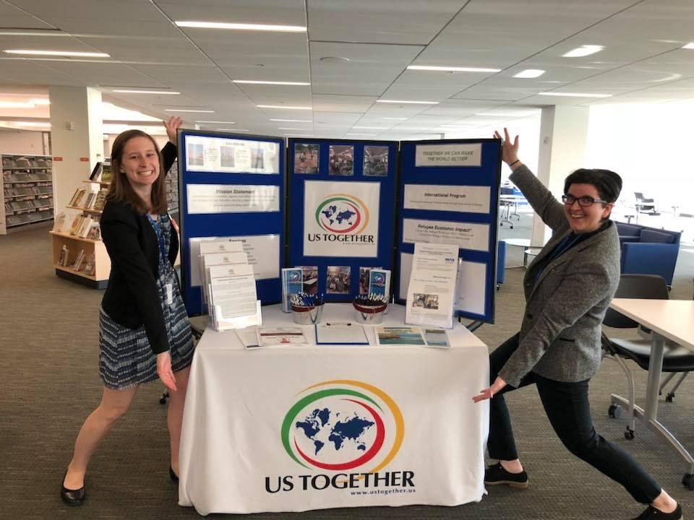

Prior to Eleni’s start, our agency’s cultural orientation program for refugees was limited in scope, without staff or volunteers to support it. Eleni was instrumental in organizing agency staff and volunteers to breathe life into the program. Eleni has been committed to supporting our refugees by recruiting family mentors and conversation partners for them. Due to Eleni’s dedication, she has successfully helped to recruit six mentors, six conversation partners, two interns, and one volunteer who works directly with refugees with severe medical conditions. Volunteers associated with this initiative have donated an estimated 386 hours since October, 2017 through April, 2018.

Eleni was also instrumental in helping to create the agency’s first Adopt-a-Refugee program for the holiday, where we paired the community with families who benefited from directed donations. She was able to pair sixteen families and one church congregation with eighteen refugee families who needed support—not just toys for children, but also grocery store gift cards, household items, and clothing among other items. Our agency could have easily compiled a list of suggested items to donate, but Eleni approached each family and made a personalized list of their needs and requests to give to the donors. The project was a resounding success; the average family donation was $575.00, and the maximum donation was $2,000, giving an estimated grand total of $10,937. Eleni’s talent continues to be a crucial component to not only our programs at UST, but also among the various partnerships with diverse communities in Columbus, and with our volunteers. Eleni’s creativity and constant dedication to volunteerism has proved to be a great benefit for the vulnerable refugees that our agency serves. Thank you for considering Eleni Connors as a recipient for your distinguished award. 