Sencommunications’ objective is to demonstrate an independent, secure, wireless communication system, capable of detecting muzzle blast and shockwave data by a wireless mesh radio, smart phone, including a shoulder worn pocket size device. The Sencommunications technology focus is categorized for this challenge as Soldier Lethality along with Network with hardware, software, and infrastructure.

Sencommunications realizes this device and its capabilities by combining two subsystems to form a wireless sensor network (WSN) :MEMs and Wireless Mesh Network (WMN). Each technology is independent of the other but interconnect by using the smart phone.

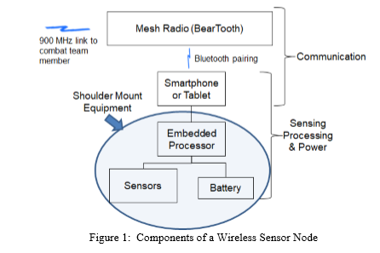

MEMs shoulder worn sensors have up to four microphones. Each sensor node consists of four blocks; sensing, processing, power and communication unit. MEMs sensor nodes consolidated with WMN address quick capabilities, location, and secure unit communication. MEMs sensor allows accurate shot detection with TOA/DOA simultaneously notifying others in the unit the same information. The WSN reduces cables as a Wireless Personal Area Network (WPAN) reducing size, weight, power, and decreases human error.

Far field communication based on WMN is independent of cell service or Wi-Fi, demonstrated with BearTooth and smart phones. Sencommunications’ early stage prototype uses NFMI (Near Field Magnetic Induction) for communication of sensors to smart phone. This creates a personal bubble of approximately 5 foot radius around a warrior. Using NFMI is less vulnerable to eavesdropping or jamming due to the short range of communication. The sensor phone interface can be connected by Bluetooth or USB as well.

Alongside NFMI, LoRa Modulation based -wireless radio was chosen due to the level of difficulty to detect on any RF or electromagnetic signatures using CSS (chirp spread spectrum). LoRa capabilities include: reduced interference, efficient processing and the ability to operate in negative ranges due to SNR.

Sencommunications brings the extensive experience required for technology evaluation, implementation and application along with precise program management and execution for tactical edge products. Our team is comprised of electronic engineers and software development specialists. Key team members possess extensive Prime Contracting experience with organizations including Harris and GE. Multiple team members hold electrical and software patents, have published work and have led the DoD proposal process. Ongoing R&D has been performed at our facility. Sencommunications possesses enhanced technical capabilities through our onsite depot for the repair of communication equipment. Our qualified technicians enable us to specialize tactical/DoD type devices in addition to the enterprise business, including rapid prototyping and development of ruggedized communication equipment. Utilizing electronic experience and knowledge with the understanding of DoD markets, Sencommunications is positioned for future steps for devices/technology in this Army Challenge.

Sencommunications’ device improves soldier protection equipment, both as a unit and independently. As a unit, the multiple sensors allow for more accurate detection of direct and indirect fire, location and time. Pairing of sensors with smart phone is achievable thanks to DARPA Transformative Apps Program (built around the idea that in addition to security, emphasis is also on usability and visualization.) The Sencommunications solution is different from other shooter localizations because the base system is replaced with a distributed model. Due to low bandwidth single message per node- when a shot is fired with sporadic status it updates for tracking the position of team members- due to low practical bound on the numbers of nodes within audible range of trajectory we can implement a simple robust model. All detection events with time, orientation and position information are broadcasted to the other nodes. Each node independently calculates its own solution; with identical results, unless message is lost. The unit is able to securely communicate and strategize in any terrain. The elimination of wires allows for easy mobility, ability to fit into tight areas without hassle, lessening error- actually enhancing and optimizing soldier’s abilities. Prominent for close combat when a soldier has less chances of getting snagged on wires when operating weapons or in intense situations needing fast response times. Decrease of wires improves timing of entering/exiting combat vehicles-linking remotely- no need to configure plug in/out.

The Improved situational awareness is demonstrated with known threats and untraceable communication making further explorations in high risk areas attainable. Using multiple soldiers in a distributed array solves challenging location issues in all environments. It improves the probability of correctly identifying the location of indirect fires. The smart phone communicates to the sensor array which provides information of the muzzle blast and shockwave as received at the shoulder worn sensors. Four microphones per soldier in a unit triangulate the source of the shot. MEMs and WMN prove to be more than a threat detection system. Applications provide line-of-sight and beyond-line-of-sight communication, remote sensing/switching, target tagging, tactical command and control of ground forces, and general improvements in situational awareness. The WMN operates at 900 MHz and provides LPD/LPI communications independent of cell service or Wi-Fi. This radio operates at 1Watt transmitted power providing voice communication up to two miles and text ability up to five miles.

Improved Communication in any combat vehicle, air, land, sea, it is believed to withstand all terrains and locations of each soldier and his unit securely at all times with this device. Communication without Bluetooth, Wi-Fi or cell service allows soldiers to succeed on the battlefield with knowledge of threat locations. The phone and radio act as a node, which can be placed in a combat vehicle, allowing cable free communication while underway. When placed in a vehicle, it also has the option of being coupled with an Invisio V60 communication hub (size of a deck of cards); capability to connect to almost any device (smart phones, vehicle intercom systems for land, sea, air) and multiple net radios (Falcon radio, PRC 117G, etc.) The BearTooth mesh system allows expanded operation demonstrated by search and rescue tactical units during Hurricane Harvey in Texas.

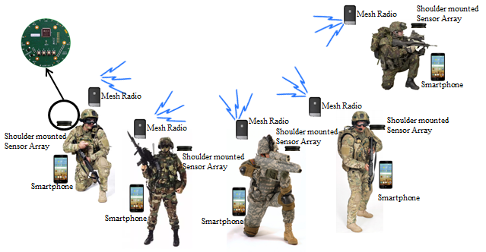

Sencommunications’ new technology is targeted to the Army, additional military branches, tactical units/agencies and first responders. SWaP at a low cost with benefits to soldiers’ mobility and security are of value to Sencommunications- a company ready to deliver an integrated solution for multiple needs.