*Ultra-polymeric Engineered Technology - UET, LLC.*

Army Expeditionary Technology Search (xTechSearch) Competition

**CONCEPT PAPER 7-11-2018**

Technology Focus Area:

**Next Generation Combat Vehicles**

Design / Advanced Materials / Vehicle Protection Against Advanced Threats

**Advanced Polymeric Solutions for High-Load, High-Wear, Impact, Shock, and Explosive Applications**

**Prepared By:**

Joshua Medling

UET, LLC.

101 Industrial Park Dr.

Sullivan, MO 63080

P. 877-741-2111

F. 844-965-9594

[jmedling@bleedingedge.us.com](mailto:jmedling@bleedingedge.us.com)

**Privacy and Confidentiality Notice:**

This document contains privileged and confidential information in relation to the technology. If you are not an intended recipient, you must not copy, forward, distribute or take any action in reliance on it. If you have received this electronic document in error, please notify the sender immediately.

**Advanced high-wear polymers can replace rubber components in many applications that experience high-load, abrasion, impact, shock, high-heat and explosive environments.**

UET (sister company to Bleeding Edge) was founded to develop advanced polymers for commercial/military applications, replacing rubber and reducing maintenance costs/intervals.

UET has created a set of urethanes and polymers specifically for high-demand rugged situations including Polymer Transparent Armor, Polymer Explosive Shielding, High-Temperature Mounting, High-Wear Trackpads/ Bushings, and Shock-Absorbing Polymers/Foams. Unique variations of these can significantly decrease maintenance while improving safety and operations of the warfighter. In-house testing, accredited third-party and university testing has proven the long life and incredible wear resistance of these materials.

**Explosive Blast / Ballistic Armored Panels**

This unique composite of advanced materials successfully stopped a simulated M-19 anti-tank mine.

To provide a baseline, “Aluminum Armor” was used with the simulated M-19 mine explosion 18” from a 1” aluminum armor plate mounted on a Humvee under frame. The under frame was built copying the Humvee 4” box frame construction on 16” centers. The result was a 16”x24” hole blown through the armor and the 4’x4’ plate was destroyed as was the Humvee frame.

The advanced UET polymer composite armor adds a 2” thick Blast Deflector, weighing only 18lbs per square foot. The same simulated M-19 anti-tank mine explosive test showed no penetration, no spalling, no other lethal damage. The slight deflection of the assembly would allow complete vehicle operation with no detrimental effects. Further, the addition of ballistic resistance level NATO 7.62 AP was incorporated into the panel and successfully stopped 3 shots in close proximity after the explosion. The blast+ballistic panel weighs 23lbs per square foot and is 2¼” thick.

A screenshot of a cell phone

Description generated with high confidence

**Advanced Transparent Armors**

A revolutionary highly transparent, liquid-cast polymer that is rigid and impact-resistant. The material can be made any shape/size, maintains clarity after impact and isn’t subject to cracking/spalling like glass/acrylic/polycarbonate. The unique chemistry is shock-absorbing and can customized for specific threats/applications from safety/intruder-resistant windows, to ballistic/high-caliber threats, to tornado/hurricane-resistance and construction such as floors, walls, railings, etc.

A screenshot of a social media post

Description generated with very high confidence

In its “neat” polymer-only state it passes the EF5 tornado test procedure by the National Wind Institute. The FEMA 320/361/ICC500 test propels a 15lb wooden 2”x4” at 100mph simulating a 250mph groundspeed EF5 tornado. The window sample was 1¼” thick x 20”x24” with 2” bite of frame. The projectile bounced off the window without damage.

These neat panels are ballistic certified for UL752-Level2/NIJ2(.357mag) at 1” thick at 5.23lbs/sqft, UL752-Level3/NIJ3A(.44mag) at 1½” thick at 8.65lbs/sqft. Tests show no penetration, no cracking, and no spalling, with maintained visibility. The polymer does not fracture around the impact and closes-up behind the bullet. The polymer can be cut/drilled in the field without cracking or chipping.

A series of glass-clad polymer composites were constructed/tested to high caliber ballistics and passed in various thicknesses in-house leading us to continue R&D on perfecting the stack-ups and reducing the thickness. Glass-clad panels have stopped the .223/7.62, .308/5.56, .30-06, .30-06 AP, .50 cal with no spalling on the impact or witness side. A proprietary liquid interlayer holds the glass together and allows increased multi-shot resistance. The interlayer has proven to bond more securely than traditional PVB interlayers and resist delamination over other transparent armors. More R&D work and funding is needed to continue development of high-caliber solutions.

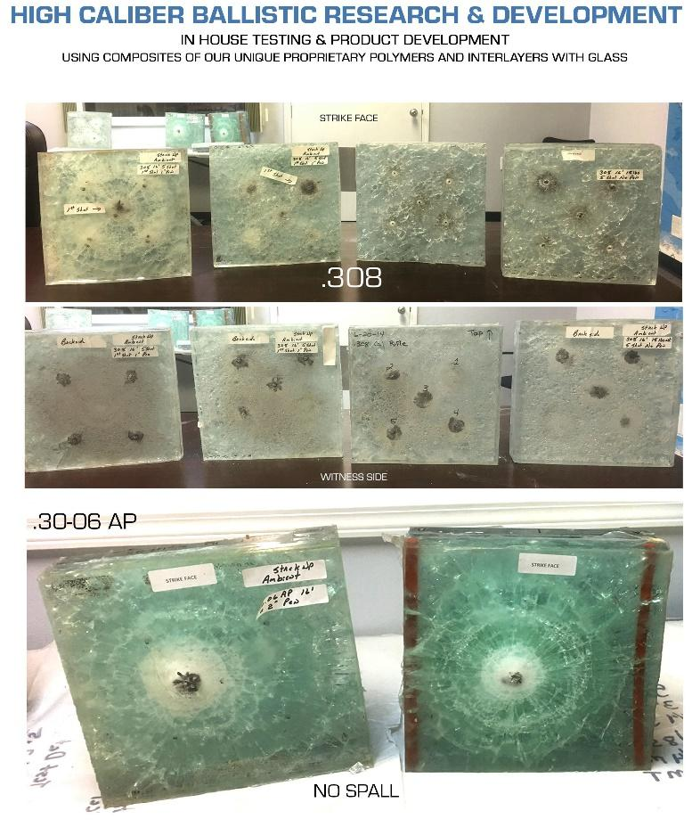

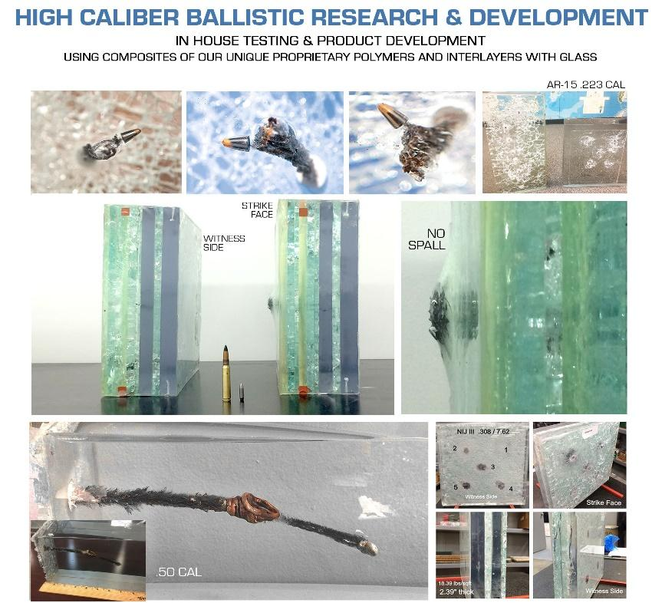

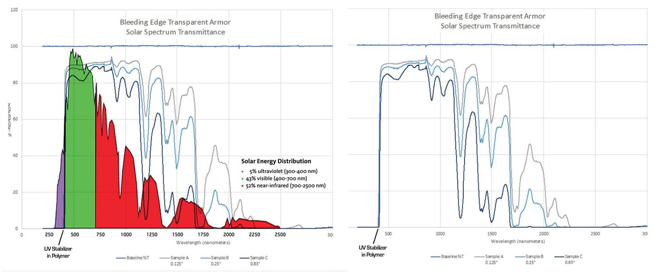

The transparent polymer accepts films/coatings such as abrasion-resistant hard-coatings, security/anti-graffiti/tinting films, and has a high-resistance to chemicals including acetone. More testing must be done to verify the numerous chemical resistances experienced in-house. The polymer is flame retardant, self-extinguishing and has a UV stabilizer to resist harmful UV rays/degradation, while allowing most of the color spectrum to pass through showing potential for solar applications and IR communications.

This unique polymer lends itself to frameless, load-bearing designs, curved windows and optics, and unique custom shapes that would otherwise be difficult to achieve with traditional glass/plastics and maintain the ballistic qualities.

A screenshot of a cell phone screen with text

Description generated with high confidence

**High Performance Tank Trackpads and Track Pin Bushings**

UET has customized its unique blend of polymers for the high-abrasion and heavy-load/wear applications of military battle tanks. The tank trackpads have been tested on an Abrams M1 against rubber pads in a real world simulated environment and proven to last 4-5 times longer than standard rubber track pads. Track pad testing was completed by Michigan Technological University’s Keweenaw Research Center (KRC), a TARDEC approved testing facility. These tests showed a five-fold increase in track pad wear resistance with comparable or superior performance to rubber pads. The abrasion-resistance was three times greater and puncture resistance was five times greater. Underwriters Laboratory test procedures show that polymer pads do not burn, which is a significant material and combat advantage over rubber pads.

Cost reduction based on longer maintenance intervals is estimated at reduced purchase price by 40% and more than $2 million per battalion, and reduced labor costs of 75% and more than 3.6 man-years per battalion. Labor savings estimates are based on 48 man-hours per tank, 44 tanks in a battalion and 1740 hours in a man-year.

A screenshot of a cell phone

Description generated with high confidence

A picture containing text, map

Description generated with very high confidence

**Core Team Members & Primary Experience**

* **George Sturmon**, Inventor/Owner/Engineer, founder of ATRO, a leading manufacturer of high-performance polymers for high-wear, high-heat, shock/vibration-mitigation. Work in proprietary chemistry for anti-blast/ballistic polymers and composites. Published works in thermodynamic management/gaseous fuels, worked on Gemini reentry issues, has 50+ global patents.
* **Susan Schmidt**, Vice President/Manufacturing/Purchasing, vast knowledge of purchasing/sourcing manufacturing processes, taking product R&D to market/starting new companies.
* **Mark O’Hare**, Business and Technical Advisor, 18-year CEO experience and retired USN CAPTAIN (PEO) with numerous successful government/commercial production and product deployments in hardware, software, IT and Cyber Security products, has run multi-million/billion-dollar businesses, is technically astute with 300+ global patents granted or applied for.
* **Joshua Medling**, Creative Director/R&D, research/product dev and strategic marketing, won 1st Place Award for the AMS submission to NASA/SAE Tech Briefs Create the Future Design Contest 2017.
* **Glenn Harris**, Plant & Quality Manager, uses ISO9000/Mil-Spec procedures for quality-control, extensive manufacturing/machining/automation/inspection knowledge.A picture containing indoor, table, wall

  Description generated with very high confidence