

**Company:** SURVICE Engineering Company, 4695 Millennium Dr., Belcamp, MD 21017

**Technical POC:** Robert Baltrusch, 410-273-7722 (p), [rob.baltrusch@survice.com](mailto:rob.baltrusch@survice.com)

**Admin. POC:** Mark Butkiewicz, 410-273-7722 (p), [mark.butkiewicz@survice.com](mailto:mark.butkiewicz@survice.com)

**Pitch Location:** Adelphi, MD

**Topic Area:** Soldier Lethality - Advanced Lethality and Projection

**Introduction**

Our proposal is to develop a Smart Grenade able to be thrown by a soldier hundreds of meters while also precisely hitting an intended target. We achieve this by combining the latest in racing drone technology with neural networks to intelligently identify and track pre-defined targets of interest.

Many Unmanned Aerial Systems (UASs) exist and employ autonomous capabilities, but these systems generally require significant training and are cumbersome for small units to employ. In addition, some of these systems remove a soldier from the fight by forcing them to concentrate solely on operating the system when in use. The Smart Grenade is a throw and forget platform that can dramatically extend the reach of a soldier (see Figure 1).

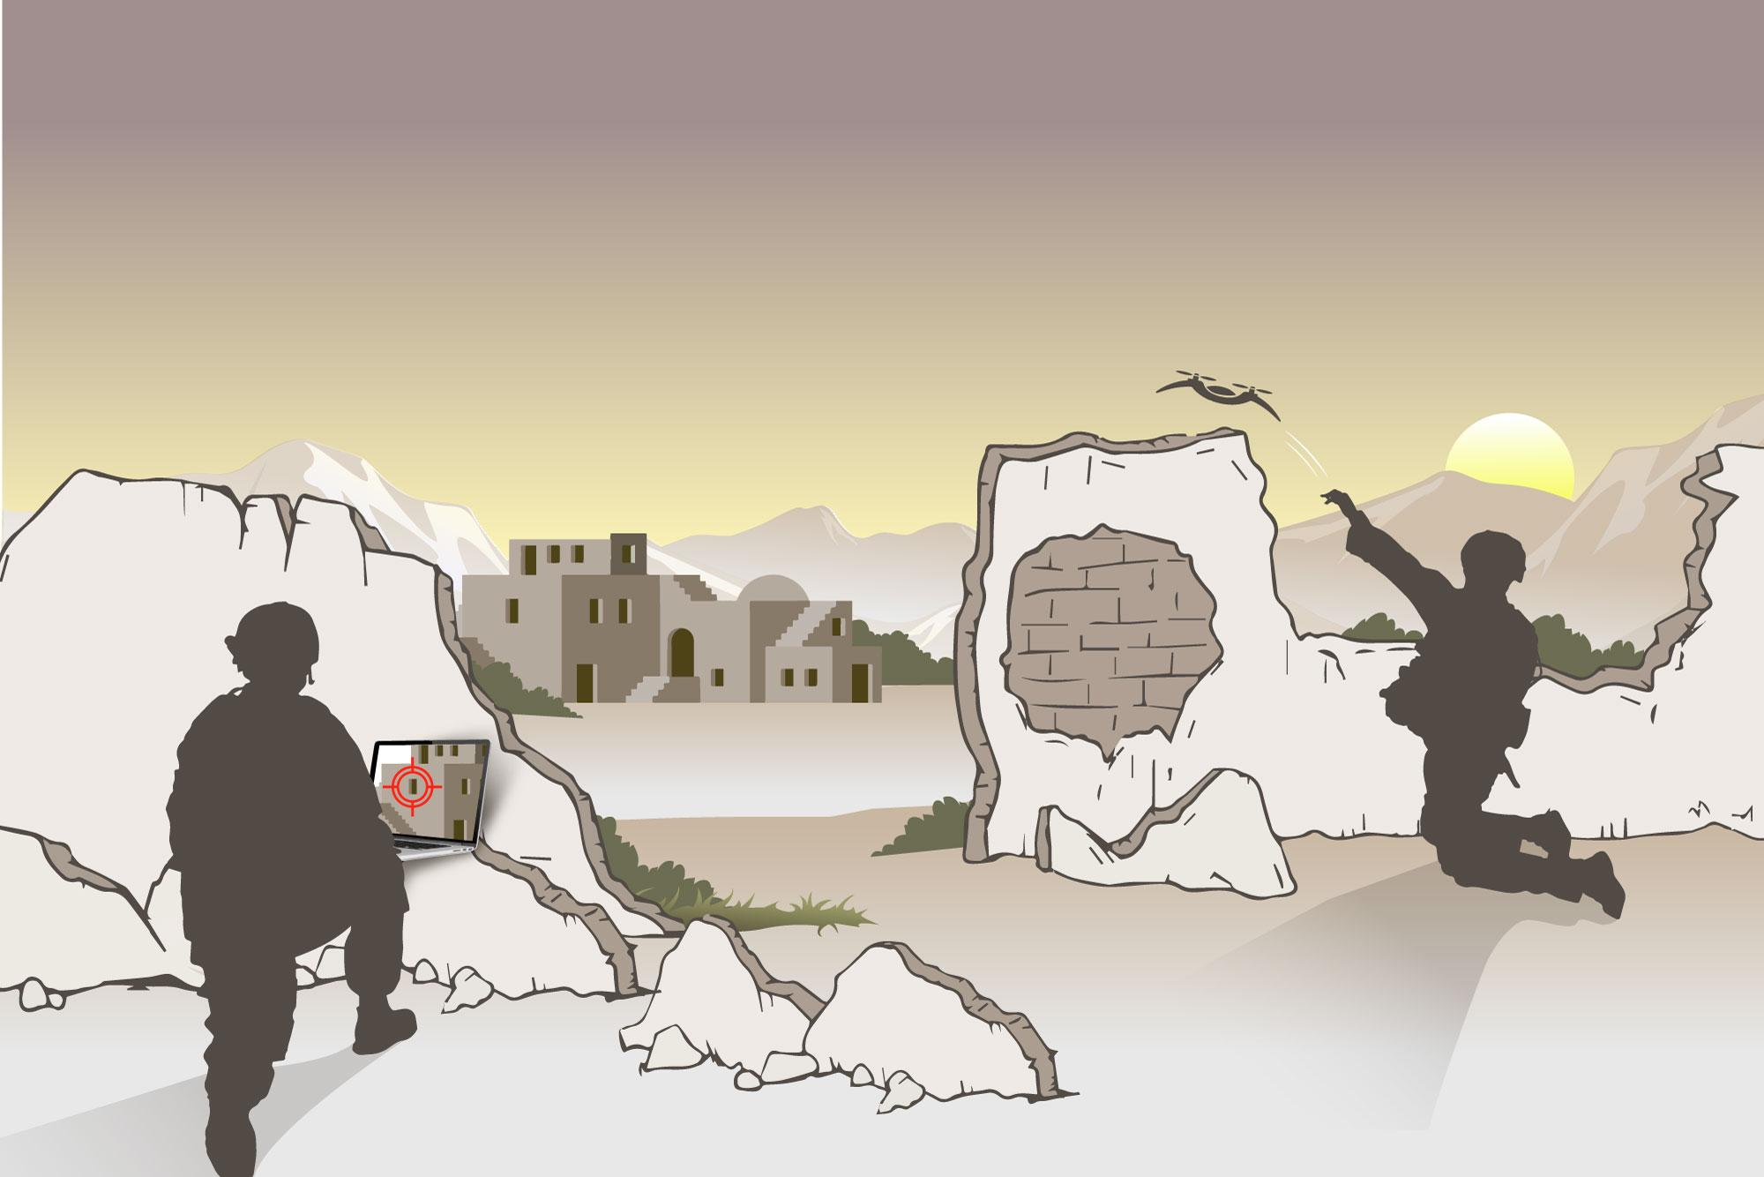

**FIGURE 1. Smart Grenade with Embedded AI**

Depicted here, a solider throws a Smart Grenade towards an intended target. In the simplest use case, it can impact/detonate at a pre-set user-defined distance. Optionally, a specific target can be identified and uploaded via field laptop/ tablet to provide precision munitions capability.

**Approach**

Our proposed approach is to leverage our in-house expertise in the field of drone technology and visual-based autonomy to create a small, cost-effective drone platform specifically designed for tactical applications. With push-button ease (or perhaps even initiated with the pull of a pin to more closely mimic the use of a grenade), our platform uses:

1. Simple Deployment: extend the straight-line reach of small explosive ordinance based on the direction the platform is thrown.
2. AI Targeting: autonomously identify and track pre-defined targets of interest using advances in artificial intelligence (i.e., neural networks and deep learning) and mobile GPU computing.

We have already developed a prototype of the proposed system with a single push-button interface (see Figure 2). This interface makes the platform a “throw and forget” system, requiring minimal training while keeping soldiers engaged on other tasks at hand. The system uses low-cost COTS hardware with custom SURVICE-developed computer vision software. The platform only weighs 1lb. and is 9” diagonally with no additional supporting hardware needed, making its footprint extremely small. This, combined with a top speed of 70mph, make this an extremely difficult asset to detect or intercept.

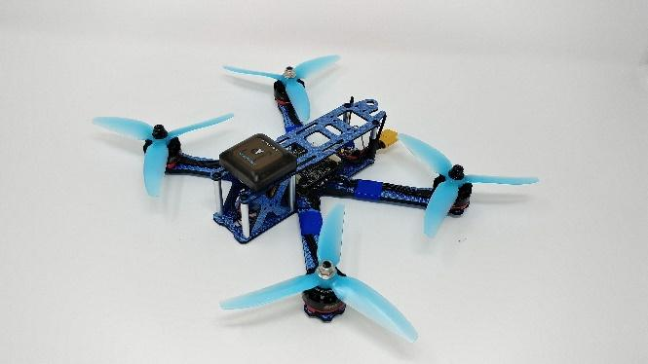 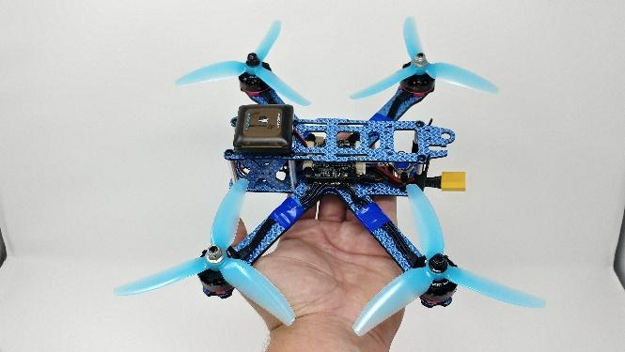

**FIGURE 2. Smart Grenade Prototype**

This Smart Grenade prototype is built upon COTS racing drone hardware, but enhanced with an onboard processor, camera, GPS, and custom SURVICE-developed software for tactical applications.

This prototype has already demonstrated the ability to be used as a “throw and forget” system (i.e., activated upon toss). With a payload capacity of approximately 5lbs, such a system is intuitive and can dramatically extend the reach of already fielded explosive payloads.

Adding the AI targeting capability provides the ability to identify and track adversarial drones, structural features, vehicles, or other pre-defined objects of interest in the direction the Smart Grenade is thrown. The Smart Grenade can also be employed non-lethally, dropping tear gas, circling a target of interest, or otherwise intimidating adversaries. The asymmetric advantages and potential uses available to the warfighter with such a platform are nearly limitless and have uses in a myriad of tactical situations.

**Street Creds**

SURVICE is the only small business serving the Department of Defense to have earned accreditation as an NVIDIA GPU Research Center, highlighting our computer vision expertise and our ability to program neural networks optimized for NVIDIA GPUs. SURVICE is also the systems integrator for the US-Army Joint Tactical Aerial Resupply Vehicle (JTARV) program, demonstrating our team’s unique and qualified position to deliver innovative multi-rotor drone technologies. Here are some of the world-class staff that would be working this effort:

MARK BUTKIEWCZ (Top Secret): Overseeing the Applied Technology Operation (ATO) with more than 30 years of experience in design, analysis, and systems engineering, and has captured and led dozens of successful DoD research grants.

ROBERT BALTRUSCH (Top Secret): Senior Design Engineer at SURVICE and Team Lead for ATO’s Industrial Design and Robotics Group, Rob oversees the development of innovative hardware/software solutions for both DoD and commercial customers and is currently integrating new technologies into the JTARV family of UAS platforms. Rob is an expert and nationally ranked FPV racing drone enthusiast.

SHAWN RECKER, Ph.D. (Secret): Research Scientist in SURVICE Engineering’s ATO, Shawn is an expert in computer vision, neural networks and deep learning, and numeric optimization. Shawn has been working on integrating computer vision technology onto drones leveraging NVIDIA mobile GPU’s.

RYAN WALTER (Secret): Roboticist and member of the Industrial Design Group within ATO, Ryan brings expertise in the fields of mechanical and electrical design and usability and has designed many in-use JTARV peripheral devices, including the Common Control Module and electro-magnetic drop kit.