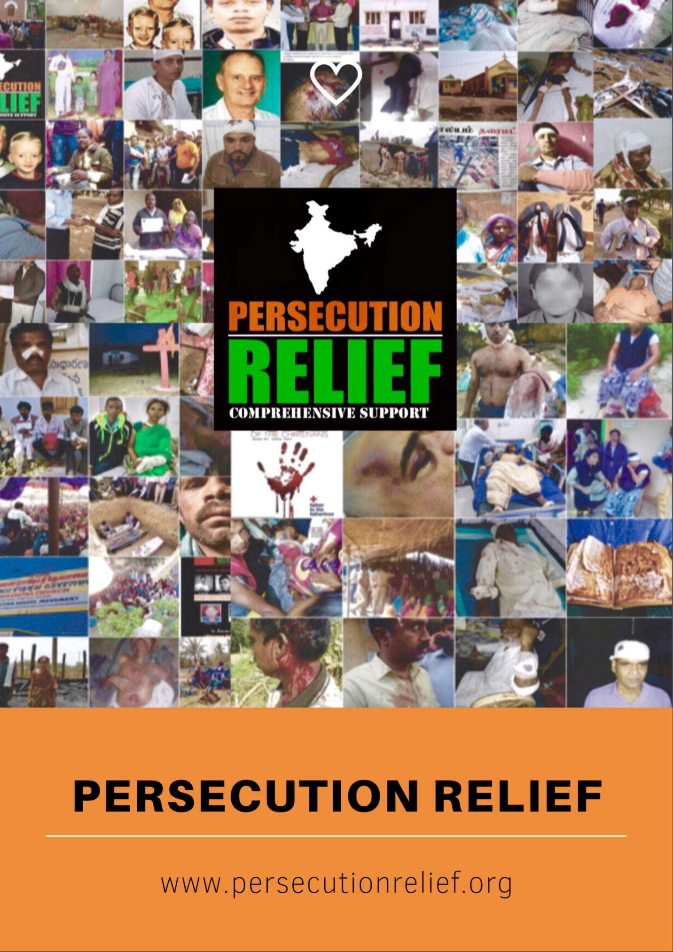

1. **Name of organization submitting partnership**

Persecution Relief   
Founder & President: Shibu Thomas

Mobile:

India: +91-98260 25747

USA: +1-214-558-8408

Email: [founder@persecutionrelief.org](mailto:founder@persecutionrelief.org)

Website: [www.persecutionrelief.org](http://www.persecutionrelief.org)

facebook.com/persecutionrelief

1. **Full address and postal code**

**India Office:**

Persecution Relief

P.O. Box: 1, Misrod Post office

Bhopal – 462026, Madhya Pradesh

INDIA

**USA Office:**

10111, Clark Street

Philadelphia, PA 19116

United States of America

1. **For-profit or not-for-profit status:**

Persecution Relief is a non-profit corporation, registered under 501 (C) (3), tax exempt organisation.

1. **Industry affiliation (e.g., health care, aviation, energy)**

Social Responsibility

1. **Links to biographies of the participants or LinkedIn profiles (preferable) that will be shared with the other participants**

Biodata and LinkedIn Profile enclosed.

1. **Has your organization ever partnered with the U.S. government? Describe.**

Mr. Shibu Thomas, Founder & President, Persecution Relief, the only organisation representing India, was invited by the Secretary of State of the United States of America, to attend the First-ever ‘Ministerial to Advance Religious Freedom’, which was held from July 24th to 26th 2018, at Washington D.C.

1. **What stage is your partnership business plan (new idea, existing program going to scale)?**

Persecution Relief is an organisation, working for the religious freedom of Christians, across the 29 States and 7 Union Territories of India, since July 2015.

Religious persecution is a global problem. While Persecution Relief is registered in India and the United States, our vision is to expand the same model, initially in the neighbouring Countries like Nepal, Pakistan and Bangladesh and then across Asia.

1. **Signed commitment statement to participate in the full three-day accelerator program in or around Washington, D.C.**

Yes, I commit to participate, engage and contribute in the full three-day accelerator program in or around Washington, D.C.

**Proposal Information:**

1. **Problem Statement (250 words max): Describe the problem you are trying to solve and any relevant background information. Address the impact and innovation potential of your idea given the status quo.**

Religious Freedom of India, the 2nd largest democracy in the world, is under imminent threat.

The present ruling political party, Bharatiya Janata Party (BJP), formed the Federal Government in 2014. Out of 29 States, 22 States are governed by BJP. RSS (Rashtriya Sevak Sangh) is the parent organisation of BJP, who’s ideology is to establish the hegemony of Hindus and make India a Hindu Nation.

Challenges

* Under Hindutva banner and ideology, intolerance has risen and minorities are constantly attacked & unsafe. Hindu militant organisations like Vishwa Hindu Parishad (VHP), Bajrang Dal (BD) etc. have taken the law into their hands, and are instrumental for most attacks against minorities.
* “Anti-Conversion Bill’ law has been passed by 8 States, criminalizing religious conversion; efforts are being made to make it a national law.
* CIA has classified VHP & BD as militant religious outfits in the World Factbook
* 41% increase in communal violence (NCBR – an Indian Govt. Agency)
* India is number 11 on the 2017 World Watch List
* USCIRF has placed India in Tier 2

Our View Point:

* Abolishment of anti-conversion law in existing 8 States and to enforce no other state pass the law in future
* Religious Freedom to be ensured by the Federal & State Governments under Article 25 – 28
* Atrocities against minorities and lack of Religious Freedom in India, to be highlighted through various forms of media, to create international awareness

1. **Idea (250 words max): What is the core concept for the partnership; what would it look like?  How will working in a partnership obtain the outcome that is required?  How does this advance religious freedom in a way that aligns with U.S. interests?**

Freedom of Religion in India is guaranteed by Article 25-28 of the Constitution of India which states that every citizen has the opportunity to practice and spread their religion peacefully.

However, incidents of religious intolerance have reached alarming proportions, with the current BJP Government in power, violating individual’s right to freedom of religion. Persecution Relief has recorded over 1200 incidents over the last 2 years, the worst since Indian Independence. More than 10 men and women were martyred for their faith, women molested and children beaten up during Sunday worship service.

The atrocities committed against Minorities are not known to the world. While it is the duty of the Government to curb these incidents and take strict actions against it, efforts are negligible, essentially providing immunity and impunity to religious fundamentalists and their organisations, which are flourishing.

Our responsibility is to raise awareness, by placing the facts about the rising restrictions on fundamental Religious Freedom in India.

The Office of International Religious Freedom must include India under Tier 1 Countries of Particular Concern category, and subject it to economic sanctions - so as to help advocate and ensure that the Central Indian Government will press the States with anti-conversion laws, to repeal them, and to conform with advancing Religious Freedom in India; outlaw the religious right-wing organisations that severely persecute on the basis of religious beliefs, assist Religious and Human Rights NGO’s in promoting religious freedom, with commitment to advocating democracy in India.

1. **Resource Requirements (250 words max): Describe what is needed to implement your idea (resources, stakeholder buy-in, legal requirements, etc.) Address the feasibility of your idea.**

Indian Government continues to turn a blind eye, to religious freedom violations, providing immunity and impunity to religious fundamentalists and their organisations. This crisis of religious freedom in India must be proclaimed to the world.

To consolidate our reach across 29 States of India and to help meet needs of victims, we need to set up State and Regional offices across India, with professional manpower.

**Resources needed:**

* Judicial help required to ensure religious freedom in India, by challenging the Anti-Conversion Laws in Courts
* Judicial help needed to acquit from prisons, 100’s of men and women, falsely implicated, while exercising rights of religious freedom.
* To conduct Seminars & Conferences, educate both at local and international levels, to highlight the prejudice to Religious Freedom
* To create awareness programs across the 29 states, educating the minorities about their Religious Freedom rights in India
* To develop a Mobile Software Program, made exclusively for the persecuted minorities in India, to help track them at the point of attack/distress
* To create awareness of religious freedom through on-line petitions
* To provide medical assistance to persecuted, to acquit those serving long-term jail sentences and support the families who had been Martyred for exercising their religious faith
* To provide Refuge Centre as a local asylum, where excommunicated Christians can find shelter
* To visit the Martyred and Persecuted victims across India, which is widespread, to take stock and to collect the facts.

**4. Best Potential Partners (250 words max): Describe ideal partners (from 2-10) or types of partners that would make for a successful partnership.**

We seek likeminded Partners, who share our goal and vision, and can identify our strengths to optimize it.

**Partners in Government:**

We need to work closely with leaders of the First-ever Ministerial for Advance on Religious Freedom and other Religious Freedom Organisations, to ensure religious freedom in India, which is at an all time low since Indian Independence.

**Partners in Research:**

To enhance our existing reports, we need scholars to further conduct research and produce resources on issues related to religious liberty, religious literacy and fundamental rights, which would be helpful for the citizens, as ready reference.

**Partners for Advocacy:**

We need Judicial Partners who can help in Legal Matters pertaining to religious freedom; advocacy to help abolish the Anti-Conversion Bill in various states of India which is a great obstacle against religious freedom; immediate assistance to release people who have been falsely implicated and languishing in prisons for long terms

**Partners for Events:**

We need to host multiple public events, seminars, conferences about religious freedom. We need speakers who are experts in their field from religious and civil liberty groups

**Partners for Education:**

As India has a large population of Youth, we need to collaborate with educational institutions, academic universities, to educate through publications, public events, educational programs so that they are equipped and educated on Religious Freedom

**Partners for expansion:**

We solicit Donors, Philanthropists, NGOs, to help mobilize and secure funds for further expansion, with respect to Infrastructure (Refuge Centre for the ex-communicated), Offices, Media, IT, Publications etc.

1. **Ideal End State (150 words max): Describe what success will look like with the implementation of your idea. Address the impact of your idea and its innovation potential**

As the 2nd largest democracy in the world, it is difficult to totally abolish religious freedom violations in India. We envision a brighter future that would be more enlightened, educated, free-thinking, tolerant and informed community, upholding Religious Freedom.

This intervention will certainly impose constraints on authorities, holding them accountable, if ably empowered and supported by stringent Laws and monitored by the International Religious Freedom Organisations.

Eradicating religion based racial and caste discrimination, subjugation, ostracization, cultural boycott, including violence against woman, children and Backward classes belonging to religious minorities, will be the ‘Utopian’ state.

We would like to conclude in the words of Neil Armstrong, who after completing his challenging journey, stepped onto the Moon saying these words:

**“One small step for a man, one giant leap for mankind”.**

This is our humble effort to make the World a free and secure place to live in for all minorities.