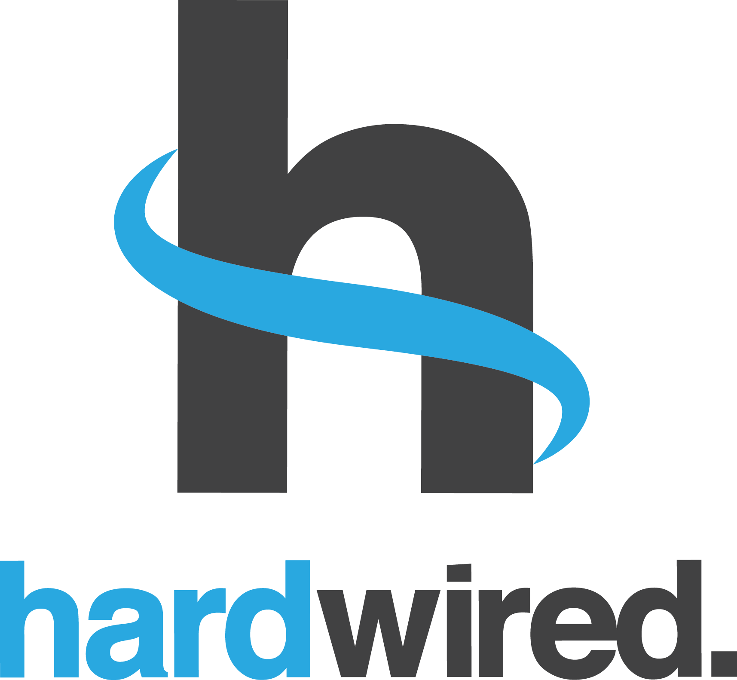

August 23, 2018

To Whom It May Concern,

I am writing to submit a proposal for the Boldline Religious Freedom Challenge on behalf of Hardwired, a 501(c)3 non-profit organization that works to promote the freedom of thought, conscience, religion or belief for all people without distinction in countries where it is most at risk. Hardwired is registered as an educational organization and does not have any religious or political affiliation.

Hardwired

P.O. Box 14743

Richmond, VA 23221

Information about Hardwired’s founder, Tina Ramirez can be found on our website at [www.hardwiredglobal.org/founder](http://www.hardwiredglobal.org/founder).

Hardwired has not partnered with the U.S. Government in the past. The proposal contained herein presents a plan for scaling a program that has been piloted with success in three countries in the Middle East and North Africa. In short, the proposal presents an innovative strategy to partner with the Kurdistan Regional Government’s Ministries of Education and Religious Affairs to implement a new religious education curriculum by developing a teacher-training program that equips teachers to develop and implement lessons that promote the rights and freedoms of people of different religions and beliefs. In addition, the program would establish after-school programs to support the production of a play focused on these values that would help to build local ownership of the program and values being taught. The current proposal is poised to begin in Iraqi Kurdistan following the development of a partnership with other stakeholders.

By submitting this proposal, Hardwired ensures its commitment to participate in the full three-day accelerator program in or around Washington, D.C.

**Thank you,**

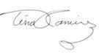

**Tina Ramirez**

**President, CEO**

**Addendum: Proposal to Follow**

**Program Title:** Promoting Peaceful Coexistence and Inclusion Through Religious Freedom Education

**Problem Statement**(250 words max): *Describe the problem you are trying to solve and any relevant background information. Address the impact and innovation potential of your idea given the status quo.*

Iraq’s children have been particularly affected by the recent conflict. Many were traumatized by the attacks against their community and forcibly displaced, others were radicalized in areas under extremist control or indirectly influenced by the ideas of hate and intolerance spread by extremists. Schools are the one place where children with these different experiences come together, but teachers are unequipped to respond and are eager for tools to help children on the frontline. From 2015-18, Hardwired conducted the first teacher-trainer program equipping teachers to respond to the serious challenges they face in the region (radicalization, physical violence, retribution, intolerance, fear and hostility toward people of different beliefs, and acting out scenes of beheadings and other extremist acts) using a rights-based educational program. The program provided substantial evidence of the organization’s ability to shift the mindset of schoolchildren toward greater acceptance of people of different religions and beliefs and contribute to an environment of peaceful coexistence and pluralism in schools most severely affected by the recent conflict.

The Kurdistan Regional Government’s Ministries of Education and Religious Affairs have invited Hardwired to scale the teacher-training program and develop a sustainable educational model that promotes respect for the rights and freedoms of people of diverse religions or beliefs with 100,000 teachers that will impact nearly 2.4 million schoolchildren over the next four years. By teaching children to value religious freedom, we will increase the immediate protection of persecuted minority faith communities and help break the recurrent cycle of violence against them.

**Idea**(250 words max): *What is the core concept for the partnership; what would it look like?  How will working in a partnership obtain the outcome that is required?*  *How does this advance religious freedom in a way that aligns with U.S. interests?*

The core concept for this partnership is to develop a sustainable model for religious freedom education in Iraq that can be scaled regionally to build resiliency against the ideas of hate and intolerance that have destabilized the region and support the long-term protection of minority faiths. The partnership will build upon an innovative rights-based teacher-training program piloted in Iraq, which utilizes lessons and simulations that draw upon best practices in play therapy for the victims of extremism and trauma to teach children to overcome their hostility toward one another and develop a genuine respect for the dignity and rights of people of different religions, beliefs and ethnicities. The program will equip teacher-trainers to establish after-school programs in their schools that will take a core group of children through lessons on the freedom of religion or belief, and then work with the students to produce a play based on the lessons for the school and community. The play would increase the engagement of other students and their communities in advancing religious freedom for all.

The partnership will meet the interests of stakeholders, such as corporations with investments in the country seeking greater long-term peace and stability, or foundations and other countries seeking effective educational models in tolerance and pluralism that help children become resilient to extremist thinking. The use of after-school programs and a play provides an innovative vehicle for diverse stakeholders such as artists, educators, child therapists, and cultural and religious communities to participate and effect change within the broader school culture and community.

**Resource Requirements**(250 words max): *Describe what is needed to implement your idea (resources, stakeholder buy-in, legal requirements, etc.). Address the feasibility of your idea.*

Hardwired estimates that it will cost an estimated $6-8 million dollars to provide a teacher-training program for 100,000 teachers and to conduct afterschool programs in each school in northern Iraq over the next three years. Given the government’s request for the program, there is built-in support for the teacher-trainers to implement the lessons they develop on religious freedom, conduct after-school programs, and produce a play to encourage broader support for the program and promote local ownership of the project in each school. Teachers have limited resources and will need financial support to conduct the afterschool programs and play productions. While the current program is focused on the Kurdistan Region; our success will create additional buy in from the national Ministry of Education to expand the program in Iraq and other countries in the region.

Given Hardwired’s previous experience piloting the program with teachers in Morocco, Lebanon and Iraq, the program is poised to be scaled with teachers and schools across northern Iraq and then the region more broadly. There is a need for financial and other resources to support the following areas:

* facilities to conduct the teacher-training program and production,
* local trainers, evaluators, and other experts to conduct the training,
* artists to coordinate the script, set design, and costumes,
* materials for the play production,
* media to build broader local support for the production,
* incentives and competitions for children from stakeholders and businesses, and
* participation from organizations representing minority communities in Iraq, teacher-training programs in colleges, and various youth organizations.

**Best Potential Partners**(250 words max): *Describe ideal partners (from 2-10) or types of partners that would make for a successful partnership.*

To ensure the success of this program, ideal partners include corporations, other countries, foundations, artists, and local stakeholders. Corporations include those interested in seeking greater long-term peace and stability to operate and protect their investments in the country. For example, companies involved in energy, trade, security, tourism, general hospitality or food industries, and technology. Since Iraqi youth and advocates frequently utilize social media for communicating, particularly on human rights issues, companies like Google, Twitter, and Facebook would be ideal partners. Other potential partners include industry leaders such as Exxon Mobil, Marriott Hotels, and various food chains interested in educational models for peaceful co-existence that can be scaled more broadly in other countries in the region. In addition, foundations focused on effective educational models in tolerance and pluralism would also be ideal partners, such as the Bill Gates Foundation or the Aga Khan.

Hardwired has already piloted the program in the region with great success and interest from other countries working to reform their educational systems, such as the Kingdoms of Morocco and Jordan. By scaling it in the Kurdish region, we will be able to provide an educational model they can utilize to counter the radicalization of youth and instill the values of respect for people of different beliefs.

Additionally, we are interested in partnering with actors and artists to support the production and inspire local ownership of the project in each school. Finally, Iraqi partners would include the Hammurabi Human Rights Organization and the Alliance of Iraqi Minorities.

**Ideal End State**(150 words max): *Describe what success will look like with the implementation of your idea. Address the impact of your idea and its innovation potential*

Hardwired will provide a sustainable model for religious freedom education in Iraq that can be scaled in other countries in the region. The impact of the program will extend beyond the core group of educators trained or students producing the play; hundreds of students will be reached in each school and community, and thousands of youth will receive lessons and materials designed to reinforce the values shared through the play and promote reconciliation and inclusion in their communities. Students who are participating in the play will emerge as leaders who can help other youth through the process of reconciliation and contribute to a culture of respect for the rights of others urgently needed in Iraq. Moreover, the program will increase discussion about the values shared in the play across each community, which we anticipate will support the efforts of religious and ethnic leadership or associations engaging in reconciliation efforts.