Data Center Consolidation Initiative
Baseline Asset Inventory Data Center Collection

Data Center Consolidation Initiative - Four Key Impact Areas

There are four distinct areas affecting data center optimization that need to be considered in parallel (typically by different teams - Building Facilities, IT Facilities, IT Operations, IT Development):
- IT Software Asset & Utilization (SW Asset inventory and utilization metrics - i.e. prioritize by application usage/mission requirements)
- IT Hardware Assets & Utilization (HW Asset inventory and utilization - i.e. prioritize consolidation based on age/refresh schedule)
- IT Facilities & Energy Usage (Consider alternatives for retrofitting existing space, upgrading power/cooling options)
- Geographic Location and Real Estate (Assess disaster/cost risk)

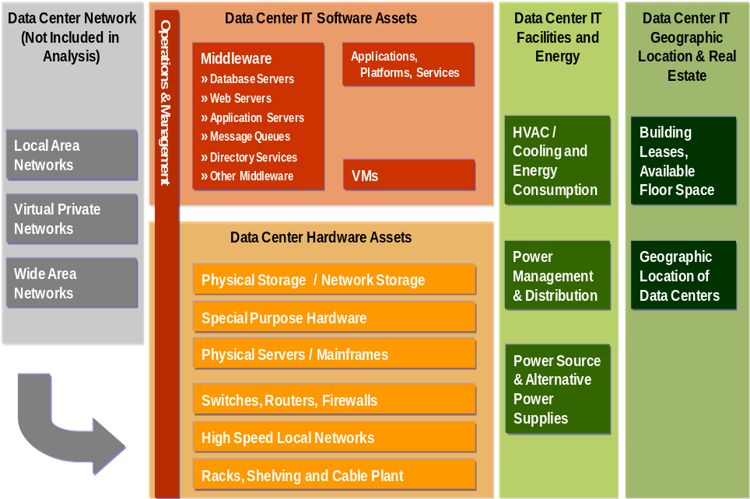

IT Asset Inventory Baseline

Within the first phase of the data consolidation initiative agencies will perform metrics gathering across the four key areas in order to derive a baseline state of their current data center environment. Several metrics will be gathered to measure the overall baseline of the agencies’ current data center environments. Agencies will identify and document an inventory of their data center assets across the four areas described above. The diagram below illustrates the four areas of focus and the associated data center metric components:

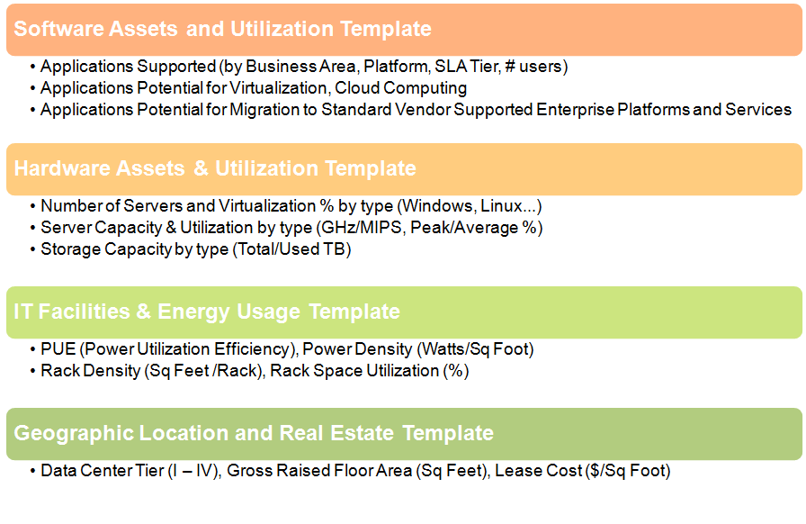
After the initial baseline data collection for all four templates is completed, agencies will conduct ongoing periodic annual data updates for all four templates and will use them as the foundation for completing the annual agency-level consolidation reporting.

IT Software Assets and Utilization Template

The purpose of the Software Assets Template is to document all Major and Non-Major Investments which are Systems (as defined in OMB Circular A-11, Sections 53 and 300) hosted in a data center, their key elements (e.g. platform, server, etc.) and to evaluate the feasibility of their consolidation via one of the four common approaches - Decommission, Consolidation, Virtualization or Cloud Computing. Here is the IT Software template:

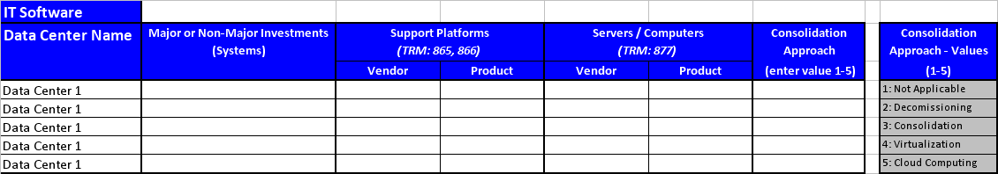

For consistency with ongoing OMB reporting, the Software Assets Template classification follows the Federal Enterprise Architecture (FEA) specifications of the Technical Reference Model (TRM) to map all Major Systems hosted within a data center to the TRM Service Standards, as defined in the FEA Consolidated Reference Model Document Version 2.3.

The specific Technical Reference Model Service Area used in this mapping is ‘Service Platform and Infrastructure’, with the following two TRM Service Categories:

- Support Platforms (TRM: 864-866) - e.g. Linux/J2EE, Windows Server 2008 / .Net etc.;
- Servers / Computers (TRM: 877) - e.g. Enterprise Server Type, Mainframe, etc.

In addition, the following Consolidation Options for each Major System are considered:

- Not Applicable - consolidation is not feasible;
- Decommissioning - the system is no longer in use or it is redundant and will be decommissioned;
- Consolidation - the system will be consolidated onto a shared infrastructure with other similar systems;
- Virtualization - the system will be migrated to a virtual machine environment;
- Cloud Computing - the system will be migrated to or replaced by cloud computing services.

The Proposed Consolidation Approach, based on the Consolidation Options listed above would become the leading driver for decommissioning, consolidating, virtualizing or migrating to cloud computing of major systems (applications), thereby facilitating the reduction in server hardware as captured by the IT Hardware Asset & Utilization Template described in the next section.

IT Hardware Assets and Utilization Template

The purpose of the IT Hardware Assets and Utilization Template is to document all physical servers and mainframes hosted in a data center, their count, CPU and power capacity and utilization, the available/used storage and finally the degree to which server utilization has been implemented within a data center. The degree of virtualization is measured by two calculated metrics (from the data submitted by Agencies in the IT Hardware template shown below):

- Virtualization (%) = Total Virtual Host Count / Total Physical Server Count (%) – this number is calculated from the total count of virtual hosts divided by the total count of physical servers (in % - per server type);
- Average Number of VM OS per Virtual Host (#) = Total Virtual OS Count / Total Virtual Host Count (#) – this number is calculated from the total count of VM OS instances divided by the total count of virtual host servers (# per server type).

Here is the IT Hardware template:

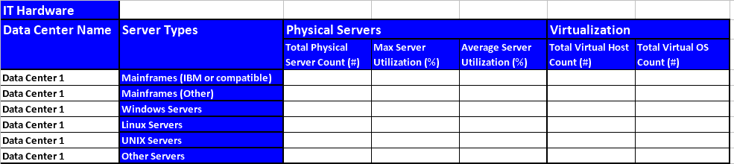

The specific server utilization metrics collected by the IT Hardware Template include (all values are collected by server type):

- Total Physical Server Count (#) – i.e. the total number of physical servers per server type;
- Maximum Server Utilization (%) – i.e. server utilization during peak usage periods – e.g. tax season, pay day, etc.;
- Average Server Utilization (%) – i.e. average server utilization over extended periods of time – e.g. month, quarter, year;
- Total Virtual Host Count (#) – i.e. total count of physical servers used as virtual hosts;
- Total Virtual OS Count (#) – i.e. total count of virtual machine OS instances.

In order to allow Agencies to leverage their previous work within the IT Infrastructure Line of Business (ITI LoB) as well as any similar on-going data collection work, the classification of server/mainframe types and breakdown of utilization metrics aligns well with the classification used by the ITI LoB. The data collected by the IT Hardware Asset and Utilization Template is only a limited subset of the ITI LoB collected data and its objectives are more narrowly focused on server utilization and virtualization levels, while targeting overall energy usage reduction.

The specific server/mainframe categories used are:
- Mainframes (IBM or compatible)
- Mainframes (Other)
- Windows Servers
- Linux Servers
- UNIX Servers
- Other Servers

IT Facilities, Energy and Storage Template

The purpose of the IT Facilities, Energy and Storage Template is to document electricity usage and cost, power capacity, rack count & utilization and total Centralized Network Storage capacity and utilization within a data center. The template is designed to enable consistent IT Facilities data collection across data centers and across Agencies. It also aims to leverage only a few key foundational data elements (e.g. Total Data Center IT Power Capacity and Power Usage, Rack Count and Rack Utilization) in order to calculate automatically more informative data center utilization metrics, such as:

- Average Power Capacity per Rack (kW)
- Rack Floor Utilization (%)
- Power Density Capacity and Usage Equivalents (W/sq.ft.)

Here is the IT Facilities, Energy and Storage template:

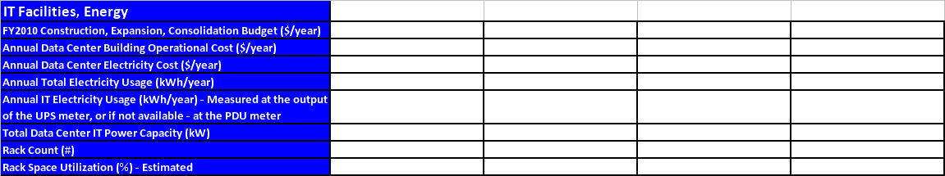

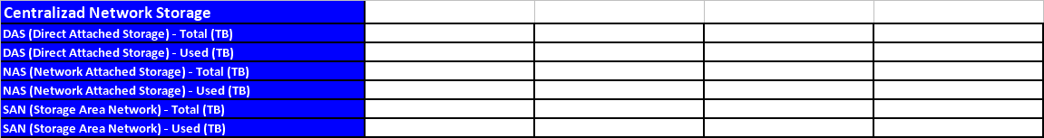

The specific IT Facilities utilization metrics collected by this template include:

- FY2010 Construction, Expansion, Consolidation Budget ($/year) – i.e. the annual budget for data center building construction, expansion, consolidation;
- Annual Data Center Building Operational Cost ($/year) – i.e. annual spent for data center building operations;
- Annual Data Center Electricity Cost ($/year) – i.e. annual electric bill for data center IT and Facilities equipment;
- Annual Total Electricity Usage (kWh/year) – i.e. annual electricity usage for data center IT and Facilities equipment;
- Annual IT Electricity Usage (kWh/year) - i.e. annual electricity usage for data center IT equipment only (measured at the output of the UPS meter, or if not available - at the PDU meter);
- Total Data Center IT Power Capacity (kW) – i.e. the total IT equipment power capacity for which the data center was designed;
- Rack Count (#) – i.e. the total number of usable racks for IT equipment;
- Rack Space Utilization (%) - Estimated – i.e. the average % of rack space utilization, typically provided by Facilities Management Systems, or estimated by the IT Facilities team.

The specific Centralized Network Storage utilization metrics collected by this template include:

- DAS (Direct Attached Storage) - Total (TB)
- DAS (Direct Attached Storage) - Used (TB)
- NAS (Network Attached Storage) - Total (TB)
- NAS (Network Attached Storage) - Used (TB)
- SAN (Storage Area Network) - Total (TB)
- SAN (Storage Area Network) - Used (TB)

Agencies can leverage their work on related initiatives such as Green IT since the selected metrics align well with leading industry research in this area by government agencies (EPA and DOE), non-profit organizations (The Green Grid), leading analyst firms (Gartner, Forrester, McKinsey) and by industry leaders in the Server, Power Equipment and Facilities Management space.

Regarding IT Power metering, the EPA recommendations from the November 12, 2009, Web Conference are as follows:

- Measurements of IT Power should be made at the output of the UPS meter;
- If a data center does not have a UPS meter, then IT Power should be measured at the PDU meter or at a location closer to the racks;
- If a data center has more than 10% non-IT load on a UPS meter it should measure IT Power at the PDU meter or a location closer to the racks, or it can sub-meter the non-IT load;
- If a data center prefers to measure IT Power at the PDU meter, EPA allows tracking of IT Power at both the UPS and PDU meters, but reporting preference is given to the UPS data.

As IT Power metering technology evolves and reaches wider adoption over time, measurements at the rack or even at the server level will become more feasible and routine, offering the best visibility into IT power usage patterns and savings opportunities.

Geographic Location and Real Estate Template

The purpose of the Geographic Location and Real Estate Template is to characterize the geographic location and the type of real estate – by data center tier, ownership model, gross floor area and cost. Here is the Geographic Location and Real Estate template:

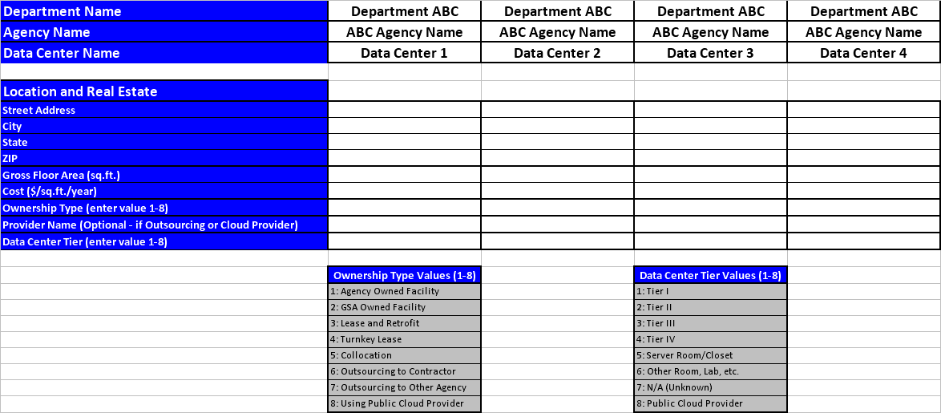

The following data center ownership options are included:
- Agency Owned Facility
- GSA Owned Facility
- Lease and Retrofit
- Turnkey Lease
- Collocation
- Outsourcing to Contractor
- Outsourcing to Other Agency
- Using Public Cloud Provider

The following data center tier options are included:
- Tier I
- Tier II
- Tier III
- Tier IV
- Server Room/Closet
- Other Room, Lab, etc.
- N/A (Unknown)
- Public Cloud Provider

Agencies with the support of OMB and the FDCCI PMO can readily align their work on complying with Executive Orders 13514 and 13423 with their Data Center Consolidation planning, while targeting the following data center specific objectives:

- Reducing risk of disasters (natural or man-made);
- Considering energy source type by location and the indirect greenhouse gas emissions factor (EPA eGRID);
- Evaluating proximity of energy and cooling sources and corresponding costs;
- Considering moderate climate zones (avoiding climate extremes for better cooling/heating efficiency);
- Looking for lower population density centers, leading to lower real estate & operational costs (availability of highly skilled work force - trained IT staff in the area is essential in order to avoid potential relocation costs).

