# Usability Test Report for [Product Name]

Date of Report: [Month Day, Year]

Date of Test: [Month Day, Year]

Location of Test: [City, State]

Prepared for: [First Name, Last Name]

Phone Number: [XXX-XXX-XXXX]

Email: [[name@address.gov](mailto:name@address.gov)]

Prepared by: [First Name, Last Name]

Phone Number: [XXX-XXX-XXXX]

Email: [[name@address.gov](mailto:name@address.gov)]

## Table of Contents

Executive Summary 3

Methodology 3

What happened during the usability test 3

Who we tested 3

What participants did 4

What data we collected 4

Where we tested 4

Introductory Questions & Tasks 5

Findings & Recommendations 6

Home Page Issues 7

Scenario #1 8

Exit Questions/User Impressions 9

Appendices 10

## Executive Summary

*NOTE: Include high-level summary of findings here, including:*

* *Overall task performance*
* *User difficulties and frustrations with the site*
* *Significant usability findings (may include positive as well as negative findings)*

## Methodology

### What happened during the usability test

The usability evaluation of the [product name] was conducted by [usability team or contractor] in [city, state] on [month day, year].

During the usability evaluation, [eight] participants, matching the user profile(s), were asked to spend one hour with the site. During this hour, participants:

* Completed a user background questionnaire
* Answered questions about initial site impressions
* Performed real-world tasks on the site while thinking aloud
* Answered questions about their overall satisfaction

### Who we tested

[Eight] participants, having the following profile characteristics, evaluated [product name].

*NOTE: Add or delete main categories as needed. Refer to screener for main demographic information.*

|  |  |  |  |  |  |  |  |  |  |  |  |  |  |  |  |  |  |
| --- | --- | --- | --- | --- | --- | --- | --- | --- | --- | --- | --- | --- | --- | --- | --- | --- | --- |
| **Audience Type**   |  |  | | --- | --- | | User Profile 1 | 2 | | User Profile 2 | 4 | | User Profile 3 | 2 | | **TOTAL (participants)** | **8** | | **Computer Usage**   |  |  | | --- | --- | | 0 to 10 hrs. wk. | 2 | | 11 to 25 hrs. wk. | 4 | | 26+ hrs. wk. | 2 | | **TOTAL (participants)** | **8** | |
| **Age**   |  |  | | --- | --- | | 18-25 | 2 | | 26-39 | 2 | | 40-59 | 2 | | 60-74 | 2 | | **TOTAL (participants)** | **8** | | **Gender**   |  |  | | --- | --- | | Women | 4 | | Men | 4 | | **TOTAL (participants)** | **8** | |

Participants, matching the [product name] user profile, were recruited prior to testing with the assistance of a market research firm. Participants were compensated [$75] for their time.

### What participants did

During the usability evaluation, participants were asked to complete [ten (10)] scenarios or “real-life” tasks on the site. The tasks were presented in [random order] and [participants were instructed not to search].

The following tasks were identified from user data collection efforts and assistance from the [project team].

| **#** | **Task** |
| --- | --- |
| 1 | [Task statement] |
| 2 | [Task statement] |
| 3 | [Task statement] |
| 4 | [Task statement] |
| 5 | [Task statement] |
| 6 | [Task statement] |
| 7 | [Task statement] |
| 8 | [Task statement] |
| 9 | [Task statement] |
| 10 | [Task statement] |

### What data we collected

*NOTE: This section should describe:*

* *Performance metrics captured and a description / definition of each metric*
* *Preference metrics captured and a description / definition of each metric*

### Where we tested

Following is a summary of the participants’ computing environment:

|  |  |
| --- | --- |
| URL of tested website: | [<http://www.sitename.gov>] |
| Computer platforms: | [Dell Pentium IV with an 18” display] |
| Browser tested: | [Internet Explorer 6.0] |
| Screen resolution: | [1024 X 768] |
| Operating system: | [Windows XP] |
| Connection speed: | [Shared T1] |

*NOTE: This section should also describe:*

* *Information about usability logging tools*
* *Video/audio recording equipment*
* *Set-up of the testing and observation rooms, etc.*

## Introductory Questions & Tasks

At the beginning of each session, we asked participants [four] questions, including:

* Have you heard of [site]?
* Just from looking at this site, what kinds of information do you think you could get from this site? Please be specific.
* Who do you think this site is designed for? Why?
* Who manages this site?

*[Include summary of participants’ comments]*

## Findings & Recommendations

*NOTE: This section should include:*

* *Usability findings observed in usability testing*
* *Evidence to support the finding, including performance and preference data*
* *Video clips to illustrate the finding (optional)*
* *Screenshots with callouts to illustrate the finding (optional)*
* *Severity ratings (optional)*
* *Research-based recommendations*

*The detailed findings may be organized in one of two ways, either:*

* *By scenario*
* *By type of issue*

*If organized by type of issue, the findings may coincide with the organization of the* Research-Based Web Design & Usability Guidelines*:*

* *Homepage*
* *Presentation, Layout and Visual Design*
* *Navigation, Links and Terminology*
* *Content*
* *Forms*
* *Search*
* *Accessibility*
* *Hardware and Software*

*Please note that we are including two different formats for the findings and recommendations section of the report. Please select the format that works best for you.*

### Home Page Issues

Finding [#1]: [Finding Statement***]***

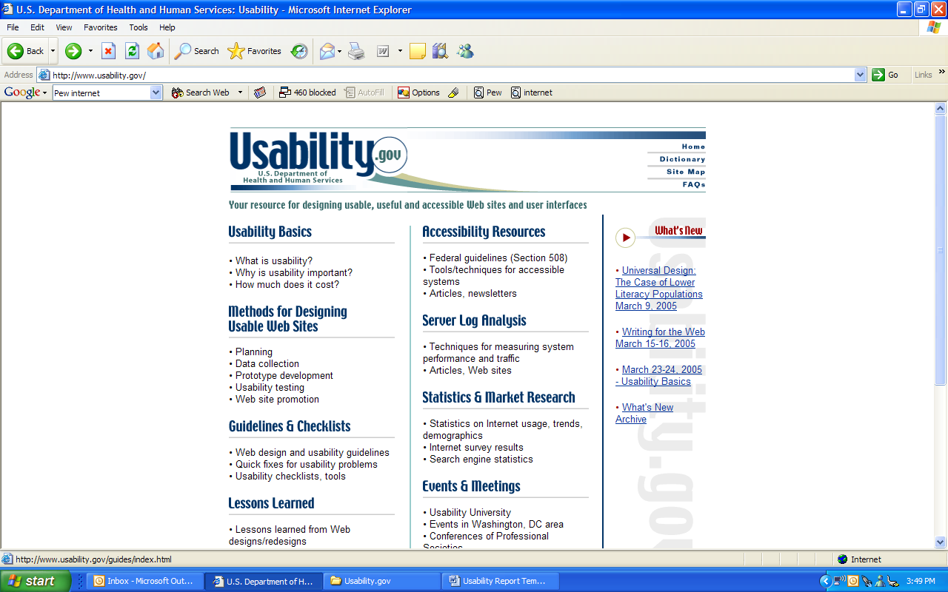

Participants performed better and preferred a plain background to the patterned background.

Figure

| **Supporting Evidence** | **Recommendations/Comments** |
| --- | --- |
| *[Statements of supporting evidence.]* | *[Statements of recommendations.]* |

### Scenario #1

Scenario [#1]

|  |  |
| --- | --- |
| Number of participants | [8] |
| % successful | [100%] |



Participants performed better and preferred a plain background to the patterned background.

| **Supporting Evidence** | **Recommendations/Comments** |
| --- | --- |
| *[Statements of supporting evidence.]* | *[Statements of recommendations.]* |

### Exit Questions/User Impressions

At the end of each session, we asked participants [nine] questions:

* What is your overall impression to [site]?
* What is your impression of the search capability?
* Do you feel this site is current? Why?
* What did you like best about the site?
* What did you like least about the site?
* If you were the website developer, what would be the first thing you would do to improve the website?
* Is there anything that you feel is missing on this site? (Probe: content or site features/functions)
* If you were to describe this site to a colleague in a sentence or two, what would you say?
* Do you have any other final comments or questions?

*[Include summary of participants’ comments]*

## Appendices

*NOTE: This section should include:*

* *Detailed information about the usability test that was not included in the report*
* *Copies of all guides, instructions, forms, and questionnaires used in the usability test so that the test can easily be recreated*