 | 

Guide to OSCAL-Based FedRAMP® System Security Plans
(SSP) – Rev5
User Implementation Guide
Fedramp2.0.0-oscal1.0.x
June 30, 2023

 |  | Controlled Unclassified Information info@fedramp.gov  fedramp.gov

TEMPLATE REVISION HISTORY
Date | Version | Pages | Description | Author
06/30/2023 | Fedramp2.0.0-oscal1.0.x | All | Initial release for FedRAMP rev 5 baselines SSP template. | FedRAMP PMO

How to contact us
For questions about FedRAMP, or for questions about this document, including how to use it, contact info@FedRAMP.gov.
For more information about FedRAMP, see www.FedRAMP.gov.

TABLE OF CONTENTS
1. Overview 1
1.1. Who Should Use This Document? 1
1.2. Related Documents 1
1.3. Basic Terminology 1
2. FedRAMP Extensions and Allowed Values 3
3. Working with OSCAL Files 4
3.1. XML and JSON Formats 4
3.2. SSP File Concepts 5
3.2.1. Resolved Profile Catalogs 7
3.3. OSCAL-based FedRAMP SSP Template 7
3.4. OSCAL’s Minimum File Requirements 8
3.5. Importing the FedRAMP Baseline 9
3.6. Resolution Resource Prop 11
4. SSP Template to OSCAL Mapping 12
4.1. System Information 14
4.1.1. Cloud Service Provider (CSP) Name 14
4.1.2. System Name, Abbreviation, and FedRAMP Unique Identifier 15
4.1.3. Service Model 16
4.1.4. Deployment Model 17
4.1.5. Digital Identity Level (DIL) Determination 18
4.1.6. System Sensitivity Level 19
4.1.7. System Status 20
4.1.8. System Functionality 21
4.2. Information System Owner 22
4.3. Federal Authorizing Officials 23
4.4. Assignment of Security Responsibilities 25
4.5. Leveraged FedRAMP-authorized Services 26
4.6. External Systems and Services Not Having FedRAMP Authorization 28
4.7 External System and Services (Queries) 29
4.8 Illustrated Architecture and Narratives 30
4.8.1 Authorization Boundary 30
4.8.2 Network Architecture 31
4.8.3 Data Flow 32
4.9 Ports, Protocols and Services 33
4.10 Cryptographic Modules Implemented for Data-in-Transit (DIT) 34
4.11 Cryptographic Modules Implemented for Data-at-Rest (DAR) 35
5 Attachments 36
5.7 Attachments 38
5.8 System Inventory Approach 39
5.8.1 Flat File Approach 40
5.8.2 Component-based Approach 41
5.8.3 Inventory Data Locations and XPath Queries 42
6 Security Controls 48
6.1 Control Definitions 49
6.2 Responsible Roles and Parameter Assignments 50
6.3 Implementation Status 52
6.4 Control Implementation Descriptions 56
6.4.1 Organization: Policy and Procedure Statements 56
6.4.2 Organization: Multi-Part Statements: 56
6.4.3 Organization: Single Statement 57
6.4.4 Response: Overview 57
6.4.5 Response: Example 59
6.4.6 Response: “This System” Component 60
6.4.7 Linking to Artifacts 61
6.4.8 Response: Identifying Inheritable Controls and Customer Responsibilities 62
6.4.9 Leveraged Authorization Response: Inheriting Controls, Satisfying Responsibilities 64
6.4.10 XPath Queries for Control Implementation Descriptions 66
7 Generated Content 67
7.1 Generating the Control Information Summary (CIS) 67
7.2 Generating the Customer Responsibility Matrix (CRM) 67
7.3 Working with Components 68
7.3.1 Minimum Required Components 68
7.3.2 Common Additional Components 69
7.3.3 Components as a Basis for System Inventory 70
7.4 Converting a Legacy SSP to OSCAL 71

Overview

Who Should Use This Document?
This document is intended for technical staff and tool developers implementing solutions
for importing, exporting, and manipulating Open Security Controls Assessment Language (OSCAL)-based FedRAMP System Security Plan (SSP) content.
It provides guidance and examples intended to guide an organization in the production and
use of OSCAL-based FedRAMP-compliant SSP files. Our goal is to enable your organization to develop tools that will seamlessly ensure these standards are met so your security practitioners can focus on SSP content and accuracy rather than formatting and presentation.

Related Documents
This document does not stand alone. It provides information specific to developing tools to create and manage OSCAL-based, FedRAMP-compliant SSPs.
Refer to the Guide to OSCAL-based FedRAMP Content for foundational information and
core concepts.
The Guide to OSCAL-based FedRAMP Content contains foundational information and core concepts, which apply
to |all OSCAL-based FedRAMP guides. This document contains several references to that content guide.

Basic Terminology
XML and JSON use different terminology. Instead of repeatedly clarifying format-specific terminology, this document uses the following format-agnostic terminology through
the document.
Term | XML Equivalent | JSON Equivalent
Field | A single element or node that  can hold a value or an attribute | A single object that can  hold a value or property
Flag | Attribute | Property
Assembly | A collection of elements or nodes. Typically, a parent node with  one or more child nodes. | A collection of objects.  Typically, a parent object with  one or more child objects.

These terms are used by National Institute of Standards and Technology (NIST) in the creation of OSCAL syntax.
Throughout this document, the following words are used to differentiate between requirements, recommendations, and options.
Term | Meaning
must | Indicates a required action.
should | Indicates a recommended action but not necessarily required.
may | Indicates an optional action.

FedRAMP Extensions and Allowed Values
NIST designed the core OSCAL syntax to model
cybersecurity information that is common to most organization and compliance frameworks; however, NIST also recognized the need to provide flexibility or organizations with unique information needs.
A summary of the FedRAMP extensions
and allowed values appears in the FedRAMP OSCAL Registry.
Instead of trying to provide a language that meets each organization's unique needs, NIST designed OSCAL with
the ability to be extended.
As a result, FedRAMP-compliant OSCAL files are a combination of the core OSCAL syntax and extensions defined by FedRAMP. The Guide to OSCAL-Based FedRAMP Content describes the concepts behind FedRAMP extensions and allowed values. The extensions related to the System Security Plan (SSP) are cited in this document in context of their use.
These concepts are described in the Guide
to OSCAL-based FedRAMP Content.

FedRAMP extensions and allowed values are cited in relevant portions of this document and summarized in the FedRAMP OSCAL Registry.
Revised FedRAMP Registry Approach
The FedRAMP OSCAL Registry was originally provided as a spreadsheet. It now uses the draft OSCAL Extensions syntax and is offered in XML and JSON formats, with a human-readable HTML representation.
- XML Version
- JSON Version
- HTML Version

Working with OSCAL Files
This section provides a summary of several important concepts and details that apply to OSCAL-based FedRAMP SSP files.
The Guide to OSCAL-based FedRAMP Content provides important concepts necessary for working with any OSCAL-based FedRAMP file. Familiarization with those concepts is important to understanding this guide.

XML and JSON Formats
The examples provided here are in XML; however, FedRAMP accepts XML or JSON formatted OSCAL-based SSP files. NIST offers a utility that provides lossless conversion of OSCAL-compliant files between XML and JSON in either direction.
You may submit your SSP to FedRAMP using either format. If necessary, FedRAMP tools will convert the files for processing.

SSP File Concepts
Unlike the traditional MS Word-based SSP, SAP, and Security Assessment Report (SAR),
the OSCAL-based versions of these files are designed to make information available through linkages, rather than duplicating information. In OSCAL, these linkages are established through import commands.

Each OSCAL file imports information from the one to the left

For example, the NIST control definitions and FedRAMP baseline content that normally appears in the SSP are defined in the FedRAMP profile and simply referenced by the SSP.

Baseline Information is referenced instead of duplicated.
For this reason, an OSCAL-based SSP points to the appropriate OSCAL-based FedRAMP baseline as determined by the system's FIPS-199 impact level. Instead of duplicating control details, the OSCAL-based SSP simply points to the baseline content for information such as control definition statements, FedRAMP-added guidance, parameters, and FedRAMP-required parameter constraints.

Resolved Profile Catalogs
The resolved profile catalog for each FedRAMP baseline is a pre-processing of the profile and catalog to produce the resulting data. This reduces overhead for tools by eliminating the need
to open and follow references from the profile to the catalog. It also includes only the catalog information relevant to the baseline, reducing the overhead of opening a larger catalog.
Where available, tool developers have the option of following the links from the profile
to the catalog as described above or using the resolved profile catalog.
Developers should be aware that at this time, catalogs and profiles remain relatively static.
As OSCAL gains wider adoption, there is a risk that profiles and catalogs will become more dynamic, and a resolved profile catalog becomes more likely to be out of date. Early adopters may wish to start with the resolved profile catalog now, and plan to add functionality later for
the separate profile and catalog handling later in their product roadmap.
The Resolved Profile Catalog for each FedRAMP Baseline reduces tool processing.
For more information about resolved profile catalogs, see the Guide to OSCAL-based FedRAMP Content Appendix C, Profile Resolution.

OSCAL-based FedRAMP SSP Template
FedRAMP offers an OSCAL-based SSP shell file in both XML and JSON formats. This shell contains many of the FedRAMP required standards to help get you started. This document
is intended to work in concert with that shell file. The OSCAL-based FedRAMP SSP Template
is available in XML and JSON formats here:
- OSCAL-based FedRAMP SSP Template (JSON Format):
https://github.com/GSA/fedramp-automation/raw/master/dist/rev5/content/rev5/templates/ssp/json/FedRAMP-SSP-OSCAL-Template.json
- OSCAL-based FedRAMP SSP Template (XML Format):
https://github.com/GSA/fedramp-automation/raw/master/dist/content/rev5/templates/ssp/xml/FedRAMP-SSP-OSCAL-Template.xml

OSCAL’s Minimum File Requirements
Every OSCAL-based FedRAMP SSP file must have a minimum set of required fields/assemblies and must follow the OSCAL SSP core syntax found here:
https://pages.nist.gov/OSCAL/documentation/schema/implementation-layer/ssp

Importing the FedRAMP Baseline
OSCAL is designed for traceability. Because of this, the SSP is designed to be linked to the FedRAMP baseline. Rather than duplicating content from the baseline, the SSP is intended to reference the baseline content itself.
Use the import-profile field to specify an existing OSCAL-based SSP. The href flag may include any valid uniform resource identifier (URI), including a relative path, absolute path, or URI fragment.
SSP Import Representation
<import-profile href="path/to/profile.xml" />

- OR -

<import-profile href="#[uuid-value]" />

XPath Queries
(SSP) URI to Baseline:
/*/import-profile/@href

If the value is a URI fragment, such as #96445439-6ce1-4e22-beae-aa72cfe173d0, the value to the right of the hashtag (#) is the universally unique identifier (UUID) value of a resource in the SSP file's back-matter. Refer to the Guide to OSCAL-based FedRAMP Content, Section 2.6, Citations, Attachments and Embedded Content in OSCAL Files for guidance on handling.
SSP Back Matter Representation
<back-matter>
<resource uuid="96445439-6ce1-4e22-beae-aa72cfe173d0">
<title>FedRAMP Moderate Baseline</title>
<prop name="type" value="baseline" />
<!-- Specify the XML or JSON file location. Only one required. -->
<rlink media-type="application/xml" href="./profile.xml" />
<rlink media-type="application/json" href="./profile.json" />
</resource>
</back-matter>

XPath Queries
(SSP) Referenced OSCAL-based FedRAMP Baseline
XML:
/*/back-matter/resource[@uuid='96445439-6ce1-4e22-beae-aa72cfe173d0'] /rlink[@media-type='application/xml']/@href
OR JSON:
/*/back-matter/resource[@uuid='96445439-6ce1-4e22-beae-aa72cfe173d0'] /rlink[@media-type='application/json']/@href

Note: Cloud Service Providers must import FedRAMP profiles or resolved profile catalogs.

Resolution Resource Prop
FedRAMP will be implementing a separate set of automated SSP validation rules for the
rev 5 OSCAL templates. To ensure FedRAMP initiates the appropriate validation rules
when processing OSCAL SSPs, SSP authors should add a new prop called “resolution-resource” in the metadata section and include an associated back-matter resource
as shown below:
SSP Resolution Resource
<system-security-plan>
<metadata>
<title>FedRAMP System Security Plan (SSP)</title>
<!-- cut -->
<version>fedramp2.0.0-oscal1.0.4</version>
<oscal-version>1.0.4</oscal-version>
<revisions>
<revision>
<!-- cut -->
</revisions>
<!-- New rev 5 prop -->
<prop ns="https://fedramp.gov/ns/oscal" name="resolution-resource"
value="ace2963d-ecb4-4be5-bdd0-1f6fd7610f41" />
</metadata>
<!-- cut -->
<back-matter>
<resource uuid="ace2963d-ecb4-4be5-bdd0-1f6fd7610f41">
<title>Resolution Resource</title>
<prop name="dataset" class="collection" value="Special Publication"/>
<prop name="dataset" class="name" value="800-53"/>
<prop name="dataset" class="version" value="5.0.2"/>
<prop name="dataset" class="organization" value="gov.nist.csrc"/>
<remarks>
<p>This "resolution resource" is used by FedRAMP as a local, authoritative indicator of what version SSP (rev 4 or rev 5) this OSCAL document is for.</p>
</remarks>
</resource>
</back-matter>
</system-security-plan>
XPath Queries
(SSP) UUID of “resolution-resource”:
/*/metadata/prop[@name=”resolution-resource”]/@value
(SSP)Target baseline version:
/*/back-matter/resource[@uuid=”uuid-of-resolution-resource”]/prop[@name=”dataset” and @class=”version”]/@value
If the “resolution-resource” prop is not specified in the metadata section of the SSP, FedRAMP will assume the SSP should be validated using the rev 5 validation rules. If the “resolution-resource” prop is present, FedRAMP will use the validation rules that correspond with the version specified in the back-matter resource.

SSP Template to OSCAL Mapping
For SSP-specific content, each main section of the SSP is represented in this section, along with OSCAL code snippets for representing the information in OSCAL syntax. There is also XPath syntax for querying the code in an OSCAL-based FedRAMP SSP represented in XML format.
Content that is common across OSCAL file types is described in the Guide to OSCAL-based FedRAMP Content. This includes the following:
Topic | Location
Title Page | Guide to OSCAL-based FedRAMP Content, Section 4.1
Prepared By/For | Guide to OSCAL-based FedRAMP Content, Section 4.2 - 4.4
Record of Template Changes | Not Applicable. Instead follow Guide to OSCAL-based FedRAMP Content, Section 2.3.2, OSCAL Syntax Version
Revision History | Guide to OSCAL-based FedRAMP Content, Section 4.5
How to Contact Us | Guide to OSCAL-based FedRAMP Content, Section 4.6
Document Approvers | Guide to OSCAL-based FedRAMP Content, Section 4.7
Acronyms and Glossary | Guide to OSCAL-based FedRAMP Content, Section 4.8
Laws, Regulations, Standards and Guidance | Guide to OSCAL-based FedRAMP Content, Section 4.9
Attachments and Citations | Guide to OSCAL-based FedRAMP Content, Section 4.10
It is not necessary to represent the following sections of the SSP template in OSCAL; however, tools should present users with this content where it is appropriate:
- Any blue-text instructions found in the SSP template where the instructions are related
to the content itself
- Table of Contents
- Introductory and instructive content in section 1, such as references to the NIST
SP 800-60 Guide to Mapping Types and the definitions from FIPS Pub 199.
- The control origination definitions are in appendix A of the SSP template; however, please note hybrid and shared are represented in OSCAL by specifying more than
one control origination.
The OSCAL syntax in this guide may be used to represent the High, Moderate, and Low FedRAMP SSP Templates. Simply ensure the correct FedRAMP baseline is referenced
using the import-profile statement.
NOTE: The FedRAMP SSP template screenshots in the sections that follow vary slightly from the most current version of the FedRAMP rev 5 SSP template.
The following pages are intended to be printed landscape on tabloid (11" x 17") paper.

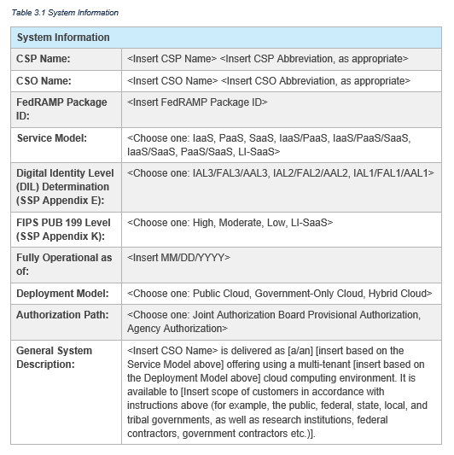
System Information

Cloud Service Provider (CSP) Name

The cloud service provider (CSP) must be provided as one of the party assemblies within the metadata.
<system-security-plan>
<metadata>
<!-- CSP Name -->
<party uuid=”uuid-of-csp” type=”organization”>
<name>Cloud Service Provider (CSP) Name</name>
</party>
</metadata>
</system-security-plan>

XPath Queries
Cloud Service Provider (CSP) Name:
/*/metadata/party[@uuid='uuid-of-csp']/name

System Name, Abbreviation, and FedRAMP Unique Identifier
The remainder of the system information is provided in the system-characteristics assembly.
The FedRAMP-assigned application number is the unique ID for a FedRAMP system. OSCAL supports several system identifiers, which may be assigned by different organizations.
For this reason, OSCAL requires the identifier-type flag be present and have a value that uniquely identifies the issuing organization. FedRAMP requires its value to be “https://fedramp.gov” for all FedRAMP-issued application numbers.
Representation
<system-security-plan>
<metadata>
<!-- CSP Name -->
<party uuid="uuid-of-csp" type="organization">
<name>Cloud Service Provider (CSP) Name</name>
</party>
</metadata>
<system-characteristics>
<!-- System Name & Abbreviation -->
<system-name>System's Full Name</system-name>
<system-name-short>System's Short Name or Acronym</system-name-short>
<!-- FedRAMP Unique Identifier -->
<system-id identifier-type="http://fedramp.gov">F00000000</system-id>
<!-- cut -->
</system-characteristics>
FedRAMP Allowed Value
Required Identifier Type:
- identifier-type="https://fedramp.gov"
<!-- cut -->
</system-security-plan>

XPath Queries
Information System Name:
/*/system-characteristics/system-name
Information System Abbreviation:
/*/system-characteristics/system-name-short
FedRAMP Unique Identifier:
/*/system-characteristics/system-id[@identifier-type="https://fedramp.gov"]

Service Model
The core-OSCAL system-characteristics assembly has a property for the cloud service model.
Representation
<system-security-plan>
<metadata>
<!-- CSP Name -->
<party uuid="uuid-of-csp" type="organization">
<name>Cloud Service Provider (CSP) Name</name>
</party>
</metadata>
<system-characteristics>
<!-- System Name & Abbreviation -->
<system-name>System's Full Name</system-name>
<system-name-short>System's Short Name or Acronym</system-name-short>
<!-- FedRAMP Unique Identifier -->
<system-id identifier-type="http://fedramp.gov">F00000000</system-id>
<!-- Service Model -->
<prop name="cloud-service-model" value="saas">
<remarks>
<p>Remarks are required if service model is "other". Optional otherwise.</p>
</remarks>
</prop>
<!-- cut -->
</system-characteristics>
<!-- cut -->
</system-security-plan>
NIST Allowed Values
Valid Service Model values:
- saas
- paas
- iaas
- other

XPath Queries
Service Model:
/*/system-characteristics/prop[@name="cloud-service-model"]/@value
Remarks on System's Service Model:
/*/system-characteristics/prop[@name="cloud-service-model"]/remarks/node()

The remarks field is Markup multiline, which enables the text to be formatted. This requires special handling. See Section 2.6 Handling OSCAL Data Types in the Guide to OSCAL-based FedRAMP Content, or visit: https://pages.nist.gov/OSCAL/documentation/schema/model-concepts/datatypes/#markup-multiline
NOTE:
- A cloud service provider may define two or more cloud service models for the cloud service offering defined in the system security plan if applicable for customer use (IaaS and PaaS; IaaS and PaaS and SaaS; PaaS and SaaS). Cloud service providers may use a “cloud-service-model” prop for each applicable cloud service model.
- If the service model is “other”, the remarks field is required. Otherwise, it is optional.

Deployment Model
The core-OSCAL system-characteristics assembly has a property for the cloud deployment model.
FedRAMP Accepted Values
- name="cloud-deployment-model"
Valid: public-cloud, private-cloud, government-only-cloud, hybrid-cloud, other
The remarks field is Markup multiline, which enables the text to be formatted. This requires special handling. See Section 2.6 Handling OSCAL Data Types in the Guide to OSCAL-based FedRAMP Content, or visit:https://pages.nist.gov/OSCAL/documentation/schema/model-concepts/datatypes/#markup-multiline
Representation
<system-security-plan>
<metadata>
<!-- CSP Name -->
<party uuid="uuid-of-csp" type="organization">
<name>Cloud Service Provider (CSP) Name</name>
</party>
</metadata>
<system-characteristics>
<!-- System Name & Abbreviation -->
<system-name>System's Full Name</system-name>
<system-name-short>System's Short Name or Acronym</system-name-short>
<!-- FedRAMP Unique Identifier -->
<system-id identifier-type="http://fedramp.gov">F00000000</system-id>
<!-- Service Model -->
<prop name="cloud-service-model" value="saas">
<remarks>
<p>Remarks are required if service model is "other". Optional otherwise.</p>
</remarks>
</prop>
<!-- Deployment Model -->
<prop name="cloud-deployment-model" value="public-cloud">
<remarks>
<p>Remarks are required if deployment model is "hybrid". Optional otherwise.</p>
</remarks>
</prop>
<!-- cut -->
</system-characteristics>
<!-- cut -->
</system-security-plan>

XPath Queries
Deployment Model:
/*/system-characteristics/prop[@name="cloud-deployment-model"]/@value
Remarks on System's Deployment Model:
/*/system-characteristics/prop[@name="cloud-deployment-model"]/remarks/node()

NOTE:
- A cloud service provider may define one and only one cloud deployment model in the system security plan for a cloud service offering.
- OSCAL 1.0.0 permits a cloud-deployment-model of value community-cloud, but FedRAMP does not permit such a deployment model for cloud service offerings and is not permitted for a FedRAMP OSCAL-based system security plan.
- If the deployment model is "hybrid", the remarks field is required. Otherwise, it is optional.

Digital Identity Level (DIL) Determination
The digital identity level identified in Table 1.0 is the same as the level in Attachment 3. It is expressed through
the following core OSCAL properties.
Representation
<system-security-plan>
<metadata>
<!-- cut CSP Name -->
</metadata>
<system-characteristics>
<!-- System Name & Abbreviation -->
<system-name>System's Full Name</system-name>
<system-name-short>System's Short Name or Acronym</system-name-short>
<!-- FedRAMP Unique Identifier -->
<system-id identifier-type="http://fedramp.gov">F00000000</system-id>
<!-- cut Service Model -->
<!-- cut Deployment Model -->
<!-- DIL Determination -->
<prop name="identity-assurance-level" value="1"/>
<prop name="authenticator-assurance-level" value="1"/>
<prop name="federation-assurance-level" value="1"/>
NIST Allowed Values
Valid IAL, AAL, and FAL values (as defined by NIST 800-63):
- 1
- 2
- 3
<!-- cut -->
</system-characteristics>
<!-- cut -->
</system-security-plan>

XPath Queries
Identity Assurance Level:
/*/system-characteristics/prop[@name="identity-assurance-level"]/@value
Authenticator Assurance Level:
/*/system-characteristics/prop[@name="authenticator-assurance-level"]/@value
Federation Assurance Level:
/*/system-characteristics/prop[@name="federation-assurance-level"]/@value

System Sensitivity Level
The privacy system designation in Table 1.0 is the same as in Attachment 4. It is expressed through
the following core OSCAL property.
Representation
<system-security-plan>
<metadata>
<!-- cut CSP Name -->
</metadata>
<system-characteristics>
<!-- System Name & Abbreviation -->
<system-name>System's Full Name</system-name>
<system-name-short>System's Short Name or Acronym</system-name-short>
<!-- FedRAMP Unique Identifier -->
<system-id identifier-type="http://fedramp.gov">F00000000</system-id>
<!-- cut Service Model -->
<!-- cut Deployment Model -->
<!-- cut DIL Determination -->
<!-- FIPS PUB 199 Level (SSP Attachment 10) -->
<security-sensitivity-level>fips-199-moderate</security-sensitivity-level>
<!-- cut -->
</system-characteristics>
<!-- cut -->
</system-security-plan>
OSCAL Allowed Values
Valid values for
security-sensitivity-level:
- fips-199-low
- fips-199-moderate
- fips-199-high

XPath Queries
System Sensitivity Level:
/*/system-characteristics/security-sensitivity-level

NOTES:
- The identified System Sensitivity Level governs which FedRAMP baseline applies. See Appendix A for more information about importing the appropriate FedRAMP baseline.

System Status
Representation
<system-security-plan>
<metadata>
<!-- cut CSP Name -->
</metadata>
<system-characteristics>
<!-- System Name & Abbreviation -->
<system-name>System's Full Name</system-name>
<system-name-short>System's Short Name or Acronym</system-name-short>
<!-- FedRAMP Unique Identifier -->
<system-id identifier-type=“http://fedramp.gov/ns/oscal”>F00000000</system-id>
<!-- cut Service Model -->
<!-- cut Deployment Model -->
<!-- cut DIL Determination -->
<!-- FIPS PUB 199 Level (SSP Attachment 10) -->
<security-sensitivity-level>fips-199-moderate</security-sensitivity-level>
<!-- Fully Operational as of -->
<status state="operational">
<remarks>
<p>Remarks are optional if status/state is "operational".</p>
<p>Remarks are required otherwise.</p>
</remarks>
</status>
<prop ns="https://fedramp.gov/ns/oscal" name="fully-operational-date"
value="mm/dd/yyyy"/>
NIST Allowed Values
FedRAMP only accepts those in bold:
- operational
- under-development
- under-major-modification
- disposition
- other
<!-- cut -->
</system-characteristics>
<!-- cut -->
</system-security-plan>

XPath Queries
System's Operational Status:
/*/system-characteristics/status/@state
Remarks on System's Operational Status:
/*/system-characteristics/status/remarks/node()
Fully Operational As Of Date:
/*/system-characteristics/prop[@name="fully-operational-date"][@ns="https://fedramp.gov/ns/oscal"]/@value

NOTE:
- If the status is “other”, the remarks field is required. Otherwise, it is optional.
- While under-development, and disposition are valid OSCAL values, systems with either of these operational status values are not eligible for a FedRAMP Authorization.

System Functionality

Representation
<system-security-plan>
<metadata>
<!-- cut CSP Name -->
</metadata>
<system-characteristics>
<!-- System Name & Abbreviation -->
<system-name>System's Full Name</system-name>
<system-name-short>System's Short Name or Acronym</system-name-short>
<!-- FedRAMP Unique Identifier -->
<system-id identifier-type=“http://fedramp.gov/ns/oscal”>F00000000</system-id>
<!-- cut Service Model -->
<!-- cut Deployment Model -->
<!-- cut DIL Determination -->
<!-- FIPS PUB 199 Level (SSP Attachment 10) -->
<security-sensitivity-level>fips-199-moderate</security-sensitivity-level>
<!-- cut Fully Operational as of -->
<!-- system functionality -->
<description>
<p>Describe the purpose and functions of this system here.</p>
<!-- list of services/features in scope -->
<!-– (use paragraph, list item, or table) -->
</description>
</system-characteristics>
<!-- cut -->
</system-security-plan>

XPath Queries
System Function or Purpose: First paragraph in description
/*/system-characteristics/description/node()

The description field is Markup multiline, which enables the text to be formatted. This requires special handling. See Section 2.6 Handling OSCAL Data Types in the Guide to OSCAL-based FedRAMP Content, or visit:https://pages.nist.gov/OSCAL/reference/datatypes/#markup-data-types

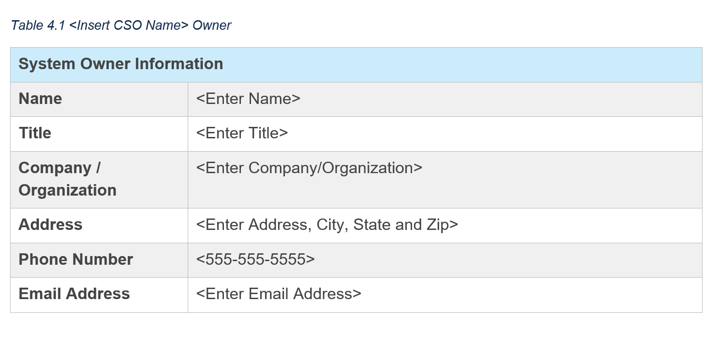
Information System Owner
A role with an ID value of "system-owner" is required. Use the responsible-party assembly
to associate this role with the party assembly containing the System Owner's information.
NOTES ON ADDRESSES
Preferred Approach: When multiple parties share the same address, such as multiple staff members at a company HQ, define the location once as a location assembly, then use the location-uuid field within each party assembly to identify the location of that individual or team.
Alternate Approach: If the address is unique to this individual, it may be included in the party assembly itself.
Hybrid Approach: It is possible to include both a location-uuid and an address assembly within a party assembly. This may be used where multiple staff are in the same building but have different office numbers or mail stops. Use the location-uuid to identify the shared building, and only include a single addr-line field within the party's address assembly.
A tool developer may elect to always create a location assembly, even when only used once; however, tools must recognize and handle all of the approaches above when processing OSCAL files.
Representation
<metadata>
<!-- cut -->
<role id="system-owner"><!-- cut --></role>
<location uuid="uuid-of-hq-location">
<title>CSP HQ</title>
<address type="work">
<addr-line>1234 Some Street</addr-line>
<city>Haven</city>
<state>ME</state>
<postal-code>00000</postal-code>
</address>
</location>
<party uuid="uuid-of-csp" type="organization">
<name>Cloud Service Provider (CSP) Name</name>
</party>
<party uuid="uuid-of-person-1" type="person">
<name>[SAMPLE]Person Name 1</name>
<prop name="job-title" value="Individual's Title"/>
<prop name="mail-stop" value="A-1"/>
<email-address>name@example.com</email-address>
<telephone-number>202-000-0000</telephone-number>
<location-uuid>uuid-of-hq-location</location-uuid>
<member-of-organization>uuid-of-csp</member-of-organization>
</party>
<responsible-party role-id="system-owner">
<party-uuid>uuid-of-person-1</party-uuid>
</responsible-party>
</metadata>
NIST Allowed Value
Required role ID:
- system-owner
XPath Queries
System Owner's Name:
/*/metadata/party[@uuid=[/*/metadata/responsible-party[@role-id="system-owner"]/‌party-uuid]]/name
NOTE: Replace "name" with "email-address" or "telephone-number" above as needed.
System Owner’s Address:
/*/metadata/location[@uuid=/*/metadata/party[@uuid=[/*/metadata/responsible-party [@role-id="system-owner"]/party-uuid]]/location-uuid]/address/addr-line
NOTE: Replace "addr-line" with "city", "state", or "postal-code" above as needed.
System Owner's Title:
/*/metadata/party[@uuid=[/*/metadata/responsible-party[@role-id="system-owner"]/‌party-uuid]]/prop[@name='job-title']/@value
Company/Organization:
/*/metadata/party[@uuid=/*/metadata/party[@uuid=[/*/metadata/responsible-party‌[@role-id="system-owner"]/party-uuid]]/member-of-organization]/name
NOTE:
If no country is provided, FedRAMP tools will assume a US address.

Federal Authorizing Officials
FedRAMP JAB P-ATO Authorization Representation
<metadata>
<!-- cut -->
<role id="authorizing-official">
<title>Authorizing Official</title>
<desc>The government executive(s) who authorize this system.</desc>
</role>
<!-- cut -->
<party uuid="uuid-of-fedramp-jab" type="organization">
<name>FedRAMP: Joint Authorization Board</name>
<short-name>FedRAMP JAB</short-name>
</party>
<!-- cut -->
<responsible-party role-id="authorizing-official">
<party-uuid>uuid-of-fedramp-jab</party-uuid>
</responsible-party>
</metadata>
<!-- import -->
<system-characteristics>
<!-- description -->
<prop name="authorization-type"
ns="https://fedramp.gov/ns/oscal">fedramp-jab</prop>
<!-- prop -->
</system-characteristics>
JAB XPath Queries
Authorizing Official’s Name:
//metadata/party[@uuid=[//metadata/responsible-party[@role-id="authorizing-official"]/party-uuid]]/name

A role with an ID value of “authorizing-official” is required. Use the responsible-party
assembly to associate this role with the party assembly containing the Authorizing Official's information.
NIST Allowed Value
Required Role ID:
- authorizing-official
FedRAMP Extension:
prop (ns="https://fedramp.gov/ns/oscal")
- name="authorization-type"

FedRAMP Allowed Values
- fedramp-jab
- fedramp-agency
- fedramp-li-saas
FedRAMP Agency Authorization Representation
<metadata>
<role id="authorizing-official">
<title>Authorizing Official</title>
</role>
<party uuid="uuid-of-agency" type="organization">
<name>Agency Name</name>
</party>
<party uuid="uuid-of-person-6" type="person">
<name>[SAMPLE]Person Name 6</name>
<prop name="job-title" value="Individual's Title"/>
<email-address>name@example.com</email-address>
<telephone-number>202-000-0000</telephone-number>
<member-of-organization>uuid-of-agency</member-of-organization>
</party>
<responsible-party role-id="authorizing-official">
<party-uuid>uuid-of-person-6</party-uuid>
</responsible-party>
</metadata>
<!-- import -->
<system-characteristics>
<!-- description -->
<prop name="authorization-type"
ns="https://fedramp.gov/ns/oscal"
value="fedramp-agency" />
<!-- prop -->
</system-characteristics>
Authorization Type XPath Query
FedRAMP Authorization Type:
/*/system-characteristics/prop[@name="authorization-type"]‌[@ns="https://fedramp.gov/ns/oscal"]/@value
FedRAMP Agency and LI-SaaS XPath Queries
Authorizing Official’s Name:
/*/metadata/party[@uuid=[/*/metadata/responsible-party [@role-id="authorizing-official"]/party-uuid]]/name
NOTE: Replace "name" with "email-address" or "telephone-number" above as needed.
Authorizing Official’s Title:
/*/metadata/party[@uuid=[/*/metadata/responsible-party [@role-id="authorizing-official"]/party-uuid]]/prop[@name='job-title']
Authorizing Official's Agency:
/*/metadata/party[@uuid=/*/metadata/party[@uuid=[/*/metadata/responsible-party [@role-id="authorizing-official"]/party-uuid]]/member-of-organization]/name
NOTE:
If the authorization-type field is “fedramp-jab”, the responsible-party/party-uuid field must
be the uuid value for the FedRAMP JAB.
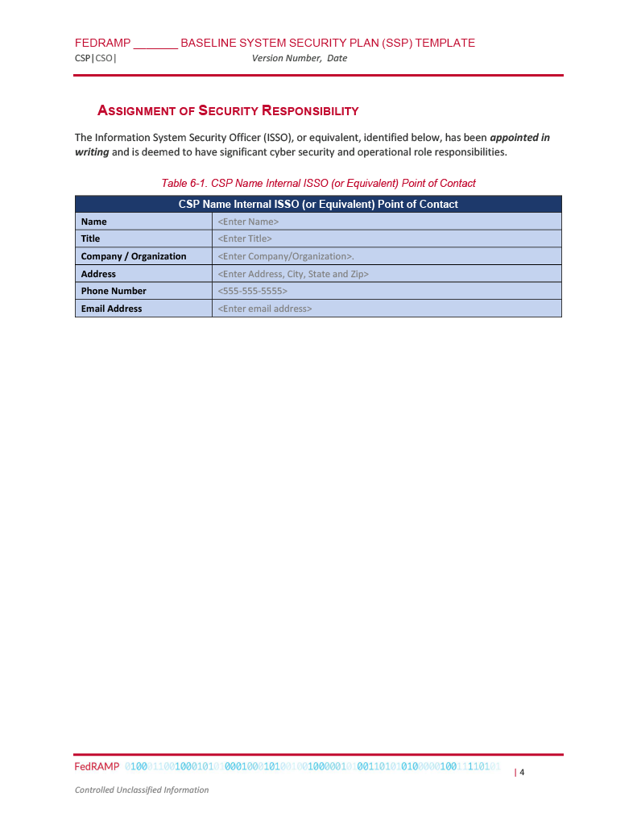
FedRAMP JAB P-ATO Authorization Representation
<metadata>
<!-- cut -->
<role id="authorizing-official">
<title>Authorizing Official</title>
<desc>The government executive(s) who authorize this system.</desc>
</role>
<!-- cut -->
<party uuid="uuid-of-fedramp-jab" type="organization">
<name>FedRAMP: Joint Authorization Board</name>
<short-name>FedRAMP JAB</short-name>
</party>
<!-- cut -->
<responsible-party role-id="authorizing-official">
<party-uuid>uuid-of-fedramp-jab</party-uuid>
</responsible-party>
</metadata>
<!-- import -->
<system-characteristics>
<!-- description -->
<prop name="authorization-type"
ns="https://fedramp.gov/ns/oscal">fedramp-jab</prop>
<!-- prop -->
</system-characteristics>
JAB XPath Queries
Authorizing Official’s Name:
//metadata/party[@uuid=[//metadata/responsible-party[@role-id="authorizing-official"]/party-uuid]]/name

NIST Allowed Value
Required Role ID:
- authorizing-official

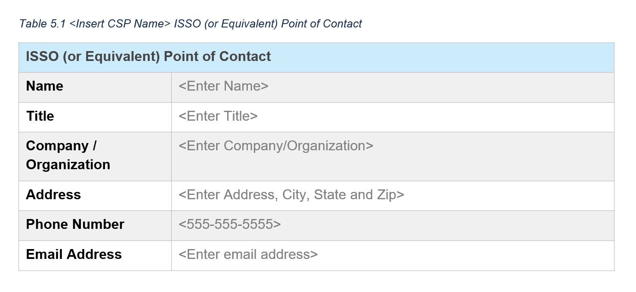
Assignment of Security Responsibilities
A role with an ID value of “information-system-security-officer” is required. Use the
responsible-party assembly to associate this role with the party assembly containing the Information
System Security Officer's information.
NOTES ON ADDRESSES
Preferred Approach: When multiple parties share the same address, such as multiple staff members at a company HQ, define the location once as a location assembly, then use the location-uuid field within each party assembly to identify the location of that individual or team.
Alternate Approach: If the address is unique to this individual, it may be included in the party assembly itself.
Hybrid Approach: It is possible to include both a location-uuid and an address assembly within a party assembly. This may be used where multiple staff are in the same building but have different office numbers or mail stops. Use the location-uuid to identify the shared building, and only include a single addr-line field within the party's address assembly.
A tool developer may elect to always create a location assembly, even when only used once; however, tools must recognize and handle all of the approaches above when processing OSCAL files.
Table 6-1 Representation
<metadata>
<!-- cut -->
<role id="information-system-security-officer"><!-- cut -->
<title>System Information System Security Officer (or Equivalent)</title>
</role>
<location uuid="uuid-of-hq-location">
<title>CSP HQ</title>
<address type="work">
<addr-line>1234 Some Street</addr-line>
<city>Haven</city>
<state>ME</state>
<postal-code>00000</postal-code>
</address>
</location>
<party uuid="uuid-of-csp" type="organization">
<name>Cloud Service Provider (CSP) Name</name>
</party>
<party uuid="uuid-of-person-10" type="person">
<name>[SAMPLE]Person Name 10</name>
<prop name="job-title" value="Individual's Title"/>
<email-address>name@org.domain</email-address>
<telephone-number>202-000-0000</telephone-number>
<location-uuid>uuid-of-hq-location</location-uuid>
<member-of-organization>uuid-of-csp</member-of-organization>
</party>
<!-- repeat party assembly for each person -->
<responsible-party role-id="system-poc-technical">
<party-uuid>uuid-of-person-7</party-uuid>
</responsible-party>
</metadata>
NIST Allowed Value
Required Role ID:
- information-system-security-officer
XPath Queries
ISSO POC Name:
/*/metadata/party[@uuid=[/*/metadata/responsible-party[@role-id="information-system-security-officer"]/‌party-uuid]]/name
NOTE: Replace "name" with "email-address" or "telephone-number" above as needed.
ISSO POC’s Address:
/*/metadata/location[@uuid=/*/metadata/party[@uuid=[/*/metadata/responsible-party [@role-id="information-system-security-officer"]/party-uuid]]/location-uuid]/address/addr-line
NOTE: Replace "addr-line" with "city", "state", or "postal-code" above as needed.
ISSO POC's Title:
/*/metadata/party[@uuid=[/*/metadata/responsible-party[@role-id="information-system-security-officer"]/‌party-uuid]]/prop[@name='job-title']
Company/Organization:
/*/metadata/party[@uuid=/*/metadata/party[@uuid=[/*/metadata/responsible-party‌[@role-id="information-system-security-officer"]/party-uuid]]/member-of-organization]/name

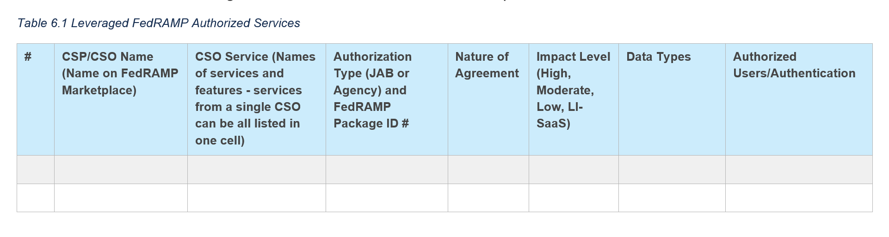
Leveraged FedRAMP-authorized Services
If this system is leveraging the authorization of one or more systems, such as a SaaS running on an IaaS, each leveraged system must be represented within the system-implementation assembly. There must be one leveraged-authorization assembly and one matching component assembly for each leveraged authorization.
The leveraged-authorization assembly includes the leveraged system's name, point of contact (POC), and authorization date. The component assembly must be linked to the leveraged-authorization assembly using a property (prop) field with the name leveraged-authorization-uuid and the UUID value of its associated leveraged-authorization assembly. The component assembly enables controls to reference it with the by-component responses described in Section 5.4, Control Implementation Descriptions. The implementation-point property value must be set to “external”.
IMPORTANT FOR LEVERAGED SYSTEMS:
While a leveraged system has no need to represent content here, its SSP must include special inheritance and responsibility information in the individual controls. See Section 5.4.8, Response: Identifying Inheritable Controls and Customer Responsibilities for more information.
If the leveraged system owner provides a UUID for their system, such as in an OSCAL-based Inheritance and Responsibility document (similar to a CRM), it should be provided as the inherited-uuid property value.
The description and remarks fields are Markup multiline, which enables the text to be formatted. This requires special handling. See Section 2.6 Handling OSCAL Data Types in the Guide to OSCAL-based FedRAMP Content, or visit:
https://pages.nist.gov/OSCAL/documentation/schema/model-concepts/datatypes/#markup-multiline
The date-authorized field is string type date, which requires a four-digit year, a dash, a two-digit month, a dash, a two-digit day, and an optional time zone offset. (yyyy-mm-dd or yyyy-mm-dd-05:00)
For more information, visit:
https://pages.nist.gov/OSCAL/documentation/schema/model-concepts/datatypes/#date
The title field must match an existing FedRAMP authorized Cloud_Service_Provider_Package property value.

A leveraged-system-identifier property must be provided within each leveraged-authorization field. The value of this property must be from the same Cloud Service Provider as identified in the title field.
Additional information is required within each control. See Section 5.4.9, Leveraged Authorization Response: Inheriting Controls, Satisfying Responsibilities for more information.
Representation
<metadata>
<!—CSP name -->
<party uuid="uuid-value">
<name>Example IaaS Provider</name>
<short-name>E.I.P.</short-name>
</party>
</metadata>
<!-- cut import-profile, system-characteristics -->
<system-implementation>
<leveraged-authorization uuid="uuid-value" >
<title>Name of Underlying System</title>
<!—FedRAMP Package ID -->
<prop name="leveraged-system-identifier"
ns="https://fedramp.gov/ns/oscal"
value="Package_ID value" />
<prop ns="https://fedramp.gov/ns/oscal" name="authorization-type"
value="fedramp-agency"/>
<prop ns="https://fedramp.gov/ns/oscal" name="impact-level" value="moderate"/>
<link href="//path/to/leveraged_system_legacy_crm.xslt" />
<link href="//path/to/leveraged_system_responsibility_and_inheritance.xml" />
<party-uuid>uuid-of-leveraged-system-poc</party-uuid>
<date-authorized>2015-01-01</date-authorized>
</leveraged-authorization>
<!-- CSO name & service description -->
<component uuid="uuid-of-leveraged-system" type="leveraged-system">
<title>Name of Leveraged System</title>
<description>
<p>Briefly describe leveraged system.</p>
</description>
<prop name="leveraged-authorization-uuid"
value="5a9c98ab-8e5e-433d-a7bd-515c07cd1497" />
<prop name="inherited-uuid" value="11111111-0000-4000-9001-000000000001" />
<prop name="implementation-point" value="external"/>
<!—FedRAMP prop extensions for table 6.1 columns -->
<status state="operational"/>
</component>
</system-implementation>

IMPORTANT FOR LEVERAGED SYSTEMS:
While a leveraged system has no need to represent content here, its SSP must include special inheritance and responsibility information in the individual controls. See Section 5.4.8, Response: Identifying Inheritable Controls and Customer Responsibilities for more information.
The description and remarks fields are Markup multiline, which enables the text to be formatted. This requires special handling. See Section 2.6 Handling OSCAL Data Types in the Guide to OSCAL-based FedRAMP Content, or visit:
https://pages.nist.gov/OSCAL/documentation/schema/model-concepts/datatypes/#markup-multiline
XPath Queries
Name of first leveraged system:
/*/system-implementation/leveraged-authorization[1]/title
Replace "[1]" with "[2]", "[3]", etc.
Name of first leveraged system CSO service (component):
(//*/component/prop[@name="leveraged-authorization-uuid" and @value="uuid-of-leveraged-system"]/parent::component/title)[1]
Description of first leveraged system CSO service (component):
(//*/component/prop[@name="leveraged-authorization-uuid" and @value="uuid-of-leveraged-system"]/parent::component/description)[1]
Authorization type of first leveraged system:
/system-security-plan/system-implementation[1]/leveraged-authorization[1]/prop[@ns="https://fedramp.gov/ns/oscal" and @name="authorization-type"]/@value
FedRAMP package ID# of the first leveraged system:
/system-security-plan/system-implementation[1]/leveraged-authorization[1]/prop[@ns="https://fedramp.gov/ns/oscal" and @name="leveraged-system-identifier"]/@value
Nature of Agreement for first leveraged system:
(//*/component/prop[@name="leveraged-authorization-uuid" and @value="uuid-of-leveraged-system"]/parent::component/prop[@ns="https://fedramp.gov/ns/oscal" and @name="nature-of-agreement"]/@value)[1]
FedRAMP impact level of the first leveraged system:
/system-security-plan/system-implementation[1]/leveraged-authorization[1]/prop[@ns="https://fedramp.gov/ns/oscal" and @name="impact-level"]/@value
Data Types transmitted to, stored or processed by the first leveraged system CSO:
(//*/component/prop[@name="leveraged-authorization-uuid" and @value="uuid-of-leveraged-system"]/parent::component/prop[@ns="https://fedramp.gov/ns/oscal" and @name="interconnection-data-type"]/@value)
Authorized Users of the first leveraged system CSO:
//system-security-plan/system-implementation/user[@uuid="uuid-of-user"]
Corresponding Access Level:
//system-security-plan/system-implementation/user[@uuid="uuid-of-user"]/prop @name="privilege-level"]/@value
Corresponding Authentication method:
//system-security-plan/system-implementation/user[@uuid="uuid-of-user"]/prop[@ns="https://fedramp.gov/ns/oscal" and @name="authentication-method"]/@value

Additional information is required within each control. See Section 5.4.9, Leveraged Authorization Response: Inheriting Controls, Satisfying Responsibilities for more information.

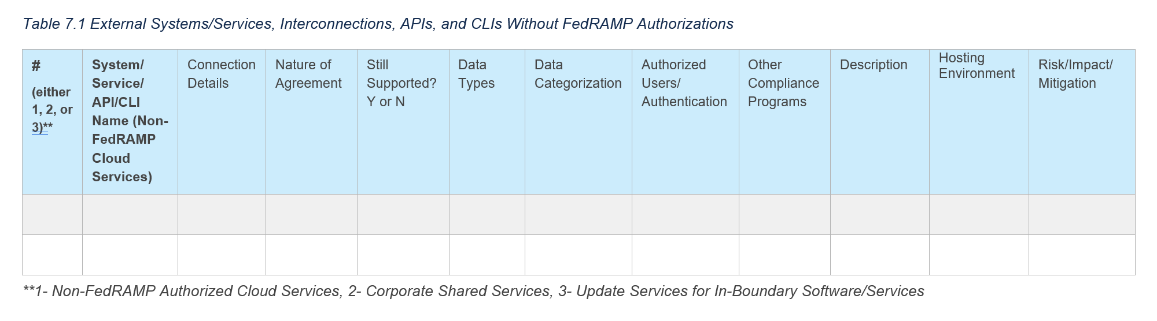
External Systems and Services Not Having FedRAMP Authorization
The remarks fields are Markup multiline, which enables the text to be formatted. This requires
special handling. See Section 2.5.3 Markup-line and Markup-multiline Fields in OSCAL, or visit: https://pages.nist.gov/OSCAL/documentation/schema/datatypes/#markup-multiline
FedRAMP Extensions & Allowed Values
prop
(ns="https://fedramp.gov/ns/oscal"):
- name="service-processor"
- name="information
- name="port"
- name="circuit"

prop
(ns="https://fedramp.gov/ns/oscal"):
- name="connection-security"
  - Valid: ipsec, vpn, ssl, certificate, secure-file-transfer, other
NIST Allowed Values
Required ICA Role IDs:
- isa-poc-remote
- isa-poc-local
- isa-authorizing-official-remote
- isa-authorizing-official-local
Representation
<!-- list any external connections as components in the system-characteristics -->
<component uuid="uuid-value" type="interconnection">
<title>[EXAMPLE]External System / Service Name</title>
<description>
<p>Briefly describe the interconnection details.</p>
</description>
<!—Props for table 7.1 columns -->
<prop ns="https://fedramp.gov/ns/oscal" name="service-processor"
value="[SAMPLE] Telco Name"/>
<prop ns="https://fedramp.gov/ns/oscal" name="interconnection-type" value="1" />
<prop name="direction" value="incoming"/>
<prop name="direction" value="outgoing"/>
<prop ns="https://fedramp.gov/ns/oscal" name="nature-of-agreement"
value="contract" />
<prop ns="https://fedramp.gov/ns/oscal" name="still-supported" value="yes" />
<prop ns="https://fedramp.gov/ns/oscal" class="fedramp"
name="interconnection-data-type" value="C.3.5.1" />
<prop ns="https://fedramp.gov/ns/oscal" class="fedramp"
name="interconnection-data-type" value="C.3.5.8" />
<prop ns="https://fedramp.gov/ns/oscal" class="C.3.5.1"
name="interconnection-data-categorization" value="low" />
<prop ns="https://fedramp.gov/ns/oscal" class="C.3.5.8"
name="interconnection-data-categorization" value="moderate" />
<prop ns="https://fedramp.gov/ns/oscal" name="authorized-users"
value="SecOps engineers" />
<prop ns="https://fedramp.gov/ns/oscal" class="fedramp"
name="interconnection-compliance" value="PCI SOC 2" />
<prop ns="https://fedramp.gov/ns/oscal" class="fedramp"
name="interconnection-compliance" value="ISO/IEC 27001" />
<prop ns="https://fedramp.gov/ns/oscal" name="interconnection-hosting-environment"
value="PaaS" />
<prop ns="https://fedramp.gov/ns/oscal" name="interconnection-risk" value="None" />
<prop name="isa-title" value="system interconnection agreement"/>
<prop name="isa-date" value="2023-01-01T00:00:00Z"/>
<prop name="ipv4-address" class="local" value="10.1.1.1"/>
<prop name="ipv4-address" class="remote" value="10.2.2.2"/>
<prop name="ipv6-address" value="::ffff:10.2.2.2"/>
<prop ns="https://fedramp.gov/ns/oscal" name="information"
value="Describe the information being transmitted."/>
<prop ns="https://fedramp.gov/ns/oscal" name="port" class="remote" value="80"/>
<prop ns="https://fedramp.gov/ns/oscal" name="interconnection-security"
value="ipsec">
<!-- cut ports, protocols -->
<link href="#uuid-of-ICA-resource-in-back-matter" rel="isa-agreement" />
<!-- cut repeat responsible-party assembly for each required ICA role id -->
</component>
<!-- cut …. -->
<back-matter>
<resource uuid="uuid-value">
<title>[SAMPLE]Interconnection Security Agreement Title</title>
<prop name="version" value="Document Version"/>
<rlink href="./documents/ISAs/ISA-1.docx"/>
<citation><!-- cut --></citation>
</resource>
<!-- repeat citation assembly for each ICA -->
</back-matter>

External System and Services (Queries)
The remarks fields are Markup multiline, which enables the text to be formatted. This requires special handling. See Section 2.5.3 Markup-line and Markup-multiline Fields in OSCAL, or visit: https://pages.nist.gov/OSCAL/documentation/schema/model-concepts/datatypes/#markup-multiline
Queries are for the Interconnection Security Agreement (ISA)'s remote POC and authorizing official (AO) information. To obtain the ISA's local POC and AO information:
Replace "isa-poc-remote" with "isa-poc-local"
Replace "[isa-authorizing-official-remote" with "isa-authorizing-official-local"
XPath Queries
Replace "[1]" with "[2]", "[3]", etc.
Interconnection # for first external system:
/*/system-implementation/component[@type='interconnection'][1]/ prop[@ns="https://fedramp.gov/ns/oscal" and @name="interconnection-type"]/@value
System/Service/API/CLI Name:
/*/system-implementation/component[@type='interconnection']/title
Connection Details:
/*/system-implementation/component[@type='interconnection'][1]/prop[@name="direction"]/@value
Nature of Agreement for first external system:
/*/system-implementation/component[@type='interconnection'][1]/ prop[@ns="https://fedramp.gov/ns/oscal" and @name="nature-of-agreement"]/@value
Still Supported (Y/N):
/*/system-implementation/component[@type='interconnection'][1]/ prop[@ns="https://fedramp.gov/ns/oscal" and @name="still-supported"]/@value
Data Types:
/*/system-implementation/component[@type='interconnection'][1]/prop[@ns="https://fedramp.gov/ns/oscal" and @name="interconnection-data-type"]/@value
Data Categorization:
/*/system-implementation/component[@type='interconnection'][1]/prop[@ns="https://fedramp.gov/ns/oscal" and @name="interconnection-data-categorization"]/@value
Authorized Users:
//system-security-plan/system-implementation/user[@uuid="uuid-of-user"]
Corresponding Access Level:
//system-security-plan/system-implementation/user[@uuid="uuid-of-user"]/prop @name="privilege-level"]/@value
Other Compliance Programs:
/*/system-implementation/component[@type='interconnection'][1]/prop[@ns="https://fedramp.gov/ns/oscal" and @name="interconnection-compliance"]/@value
Description:
/*/system-implementation/component[@type='interconnection'][1]/description
Hosting Environment:
/*/system-implementation/component[@type='interconnection'][1]/prop[@ns="https://fedramp.gov/ns/oscal" and @name="interconnection-hosting-environment"]/@value
Risk/Impact/Mitigation:
/*/system-implementation/component[@type='interconnection'][1]/prop[@ns="https://fedramp.gov/ns/oscal" and @name="interconnection-risk"]/@value

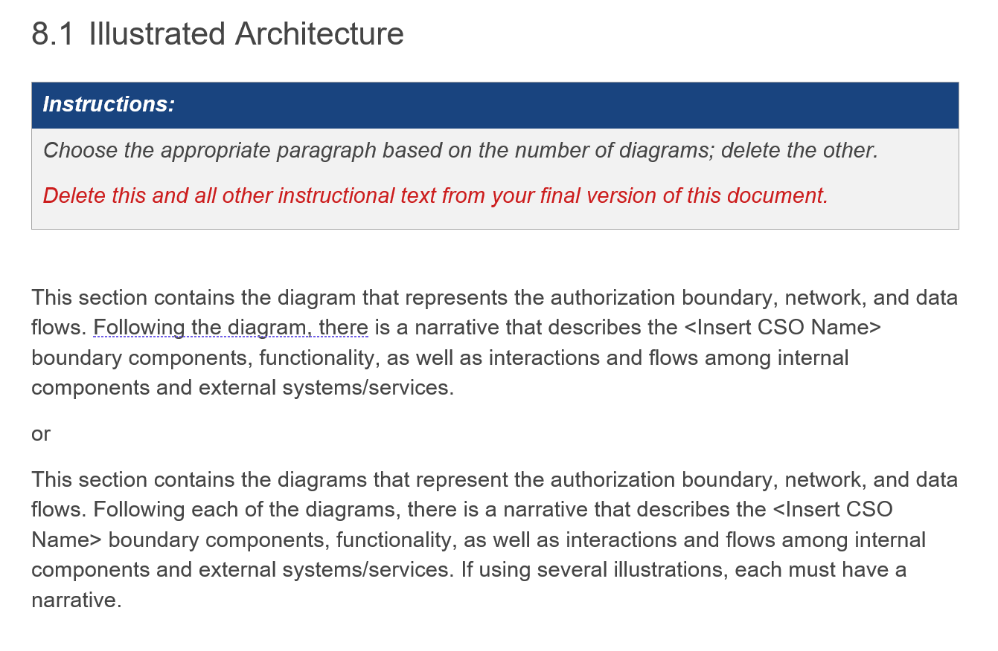
Illustrated Architecture and Narratives

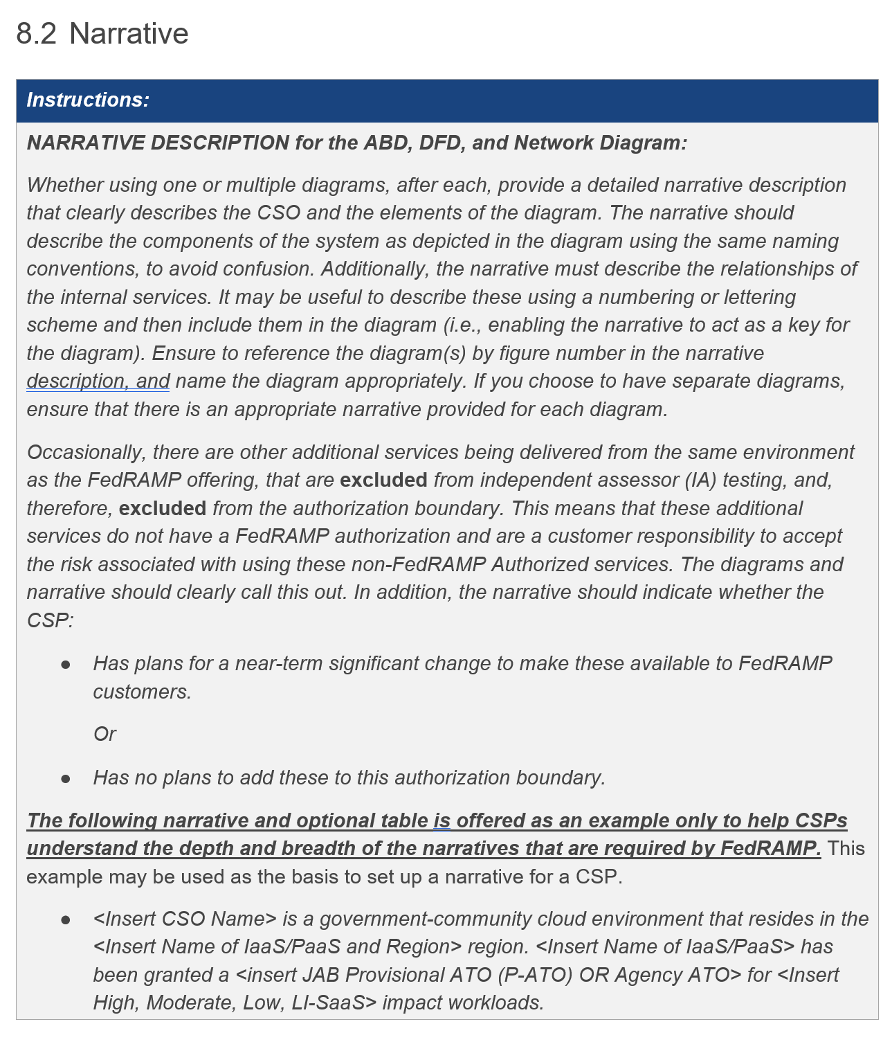
Authorization Boundary
The OSCAL approach to this type of diagram is to treat the image data as either a linked or base64-encoded resource in the back-matter section of the OSCAL file, then reference the diagram using the link field.
FedRAMP has not yet established image format standards for the authorization boundary, network, and dataflow diagrams. Please use a format that will render natively in most modern browsers, and ensure the image quality is high enough to read all text when zoomed in.
The description fields are Markup multiline and the caption field is Markup-line.
These enable the text to be formatted, which requires special handling. See Section 2.5.3 Markup-line and Markup-multiline Fields in OSCAL, or visit: https://pages.nist.gov/OSCAL/documentation/schema/model-concepts/datatypes/#markup-multiline
In OSCAL, the link field's href flag may be any URI that points to the actual diagram image file; however, FedRAMP requires the authorization boundary, network, and data flow diagrams to be embedded or attached via back-matter/resource assemblies. This means the href flag should always be a URI fragment (#diagram-id). FedRAMP tools must recognize the fragment, and locate the appropriate resource using the diagram ID. (/*/back-matter/resource[@id='diagram-id'])
Representation
<system-characteristics>
<!-- leveraged-authorization -->
<authorization-boundary>
<!-- 8.2 Narrative (Boundary) -->
<description>
<p>A holistic, top-level explanation of the FedRAMP authorization boundary.</p>
</description>
<!-- 8.1 Illustrated Architecture (Boundary) -->
<diagram uuid="uuid-value">
<description><p>A diagram-specific explanation.</p></description>
<link href="#uuid-of-boundary-diagram-1" rel="diagram" />
<caption>Authorization Boundary Diagram</caption>
</diagram>
<!-- repeat diagram assembly for each additional boundary diagram -->
</authorization-boundary>
<!-- network-architecture -->
</system-characteristics>
<!-- cut -->
<back-matter>
<resource uuid="uuid-of-boundary-diagram-1">
<description><p>The primary authorization boundary diagram.</p></description>
<base64 filename="architecture-main.png" media-type="image/png">00000000</base64>
</resource>
</back-matter>
XPath Queries
Overall Description:
/*/system-characteristics/authorization-boundary/description/node()
Count the Number of Diagrams (There should be at least 1):
count(/*/system-characteristics/authorization-boundary/diagram)
Link to First Diagram:
/*/system-characteristics/authorization-boundary/diagram[1]/link/@href
Replace "[1]" with "[2]", "[3]", etc.

If the diagram link points to a resource within the OSCAL file:
/*/back-matter/resource[@uuid="uuid-of-boundary-diagram"]/base64
OR:
/*/back-matter/resource[@uuid="uuid-of-boundary-diagram-1"]/rlink/@href
Diagram-specific Description:
/*/system-characteristics/authorization-boundary/diagram[1]/description/node()

Network Architecture
In OSCAL, the link field's href flag may be any URI that points to the actual diagram image file; however, FedRAMP requires the authorization boundary, network, and data flow diagrams to be embedded or attached via back-matter\resource assemblies. This means the href flag should always be a URI fragment (#diagram-id). FedRAMP tools must recognize the fragment, and locate the appropriate resource using the diagram ID. (/*/</resource[@id='diagram-id'])
FedRAMP has not yet established image format standards for the authorization boundary, network, and dataflow diagrams. Please use a format that will render natively in most modern browsers, and ensure the image quality is high enough to read all text when zoomed in.
The description fields are Markup multiline and the caption field is Markup-line. These enable the text to be formatted, which requires special handling. See Section 2.5.3 Markup-line and Markup-multiline Fields in OSCAL, or visit: https://pages.nist.gov/OSCAL/documentation/schema/model-concepts/datatypes/#markup-multiline
Representation
<system-characteristics>
<!-- authorization-boundary -->
<network-architecture>
<!-- 8.2 Narrative (Network) -->
<description>
<p>A holistic, top-level explanation of the system's network.</p>
</description>
<!-- 8.1 Illustrated Architecture (Network) -->
<diagram uuid="uuid-value">
<description><p>A diagram-specific explanation.</p></description>
<link href="#uuid-of-network-diagram-1" rel="diagram" />
<caption>Network Diagram</caption>
</diagram>
<!-- repeat diagram assembly for each additional network diagram -->
</network-architecture>
<!-- data-flow -->
</system-characteristics>
<!-- cut -->
<back-matter>
<!-- citation -->
<resource uuid=" uuid-of-network-diagram-1">
<description><p>The primary network architecture diagram.</p></description>
<rlink href="./diagrams/network.png" media-type="image/png"/>
</resource>
</back-matter>
XPath Queries
Overall Description:
/*/system-characteristics/network-architecture/description/node()
Count the Number of Diagrams (There should be at least 1):
count(/*/system-characteristics/network-architecture/diagram)
Link to First Diagram:
/*/system-characteristics/network-architecture/diagram[1]/link/@href
Replace "[1]" with "[2]", "[3]", etc.

If the diagram link points to a resource within the OSCAL file:
/*/back-matter/resource[@uuid="uuid-of-network-diagram-1"]/base64
OR:
/*/back-matter/resource[@uuid="uuid-of-network-diagram-1"]/rlink/@href
First Diagram Description:
/*/system-characteristics/network-architecture/diagram[1]/description/node()

Data Flow
In OSCAL, the link field's href flag may be any URI that points to the actual diagram image file; however, FedRAMP requires the authorization boundary, network, and data flow diagrams to be embedded or attached via back-matter\resource assemblies. This means the href flag should always be a URI fragment (#diagram-id). FedRAMP tools must recognize the fragment, and locate the appropriate resource using the diagram ID. (/*/back-matter/resource[@id='diagram-id'])
The description fields are Markup multiline and the caption field is Markup-line. These enable
the text to be formatted, which requires special handling. See Section 2.5.3 Markup-line and Markup-multiline Fields in OSCAL, or visit: https://pages.nist.gov/OSCAL/documentation/schema/model-concepts/datatypes/#markup-multiline
FedRAMP has not yet established image format standards for the authorization boundary, network, and dataflow diagrams. Please use a format that will render natively in most modern browsers, and ensure the image quality is high enough to read all text when zoomed in.
Representation
<system-characteristics>
<!-- data-flow -->
<data-flow>
<!-- 8.2 Narrative (Data Flow) -->
<description>
<p>A holistic, top-level explanation of the system's data flows.</p>
</description>
<!-- 8.1 Illustrated Architecture (Data Flow) -->
<diagram uuid="uuid-value">
<description><p>A diagram-specific explanation.</p></description>
<link href="#uuid-of-dataflow-diagram-1" rel="diagram" />
<caption>Data Flow Diagram</caption>
</diagram>
<!-- repeat diagram assembly for each additional data flow diagram -->
</data-flow>
<!-- network-architecture -->
</system-characteristics>
<!-- cut -->
<back-matter>
<!-- citation -->
<resource uuid="uuid-of-dataflow-diagram-1">
<description><p>The primary data flow diagram.</p></description>
<base64 filename="data-flow-1.png" media-type="image/png">
0000<!-- base64 cut -->0000
</base64>
</resource>
</back-matter>
XPath Queries
Overall Description:
/*/system-characteristics/data-flow/description/node()
Count the Number of Diagrams (There should be at least 1):
count(/*/system-characteristics/data-flow/diagram)
Link to First Diagram:
/*/system-characteristics/data-flow/diagram[1]/link/@href
Replace "[1]" with "[2]", "[3]", etc.

If the diagram link points to a resource within the OSCAL file:
/*/back-matter/resource[@uuid="uuid-of-dataflow-diagram-1"]/base64
OR:
/*/back-matter/resource[@uuid="uuid-of-dataflow-diagram-1"]/rlink/@href
First Diagram Description:
/*/system-characteristics/data-flow/diagram[1]/description/node()

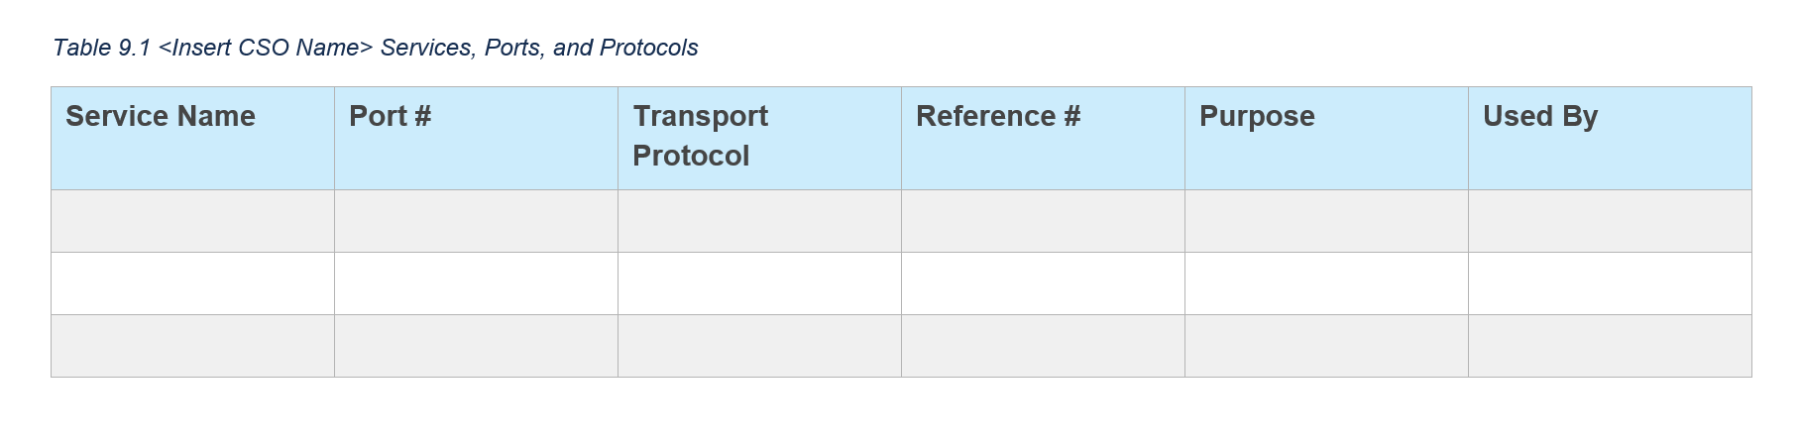
Ports, Protocols and Services
Entries in the ports, protocols, and services table are represented as component assemblies, with the component-type flag set to “service”. Use a protocol assembly for each protocol associated with the service. For a single port, set the port-range start flag and end flag to the same value.
NIST has consolidated OSCAL syntax and is now handling ports, protocols, and services
as components. This is a change from the SSP Syntax in Milestone Release 2.
The description fields are Markup multiline and the purpose field is Markup-line.
These enable the text to be formatted, which requires special handling. See Section 2.5.3
Markup-line and Markup-multiline Fields in OSCAL, or visit: https://pages.nist.gov/OSCAL/documentation/schema/model-concepts/datatypes/#markup-multiline
Representation
<system-implementation>
<!-- user -->
<component uuid="uuid-of-service" type="service">
<title>[SAMPLE]Service Name</title>
<description><p>Describe the service</p></description>
<purpose>Describe the purpose the service is needed.</purpose>
<link href="uuid-of-component-used-by" rel="used-by" />
<link href=" uuid-of-component-provided-by" rel="provided-by" />
<status state="operational" />
<protocol name="http">
<port-range start="80" end="80" transport="TCP"/>
</protocol>
<protocol name="https">
<port-range start="443" end="443" transport="TCP"/>
</protocol>
</component>
<!-- Repeat the component assembly for each row in Table 9.1 -->
<!-- system-inventory -->
</system-implementation>
Replace "[1]" with "[2]", "[3]", etc.
XPath Queries
Service (1st service):
/*/system-implementation/component[@type='service'][1]/title
Ports: Start (1st service, 1st protocol, 1st port range):
/*/system-implementation/component[@type='service'][1]/protocol[1]/port-range[1]/@start
Ports: End (1st service, 1st protocol, 1st port range):
/*/system-implementation/component[@type='service'][1]/protocol[1]/port-range[1]/@end
Ports: Transport (1st service, 1st protocol, 1st port range):
/*/system-implementation/component[@type='service'][1]/protocol[1]/port-range[1]/@transport
Protocol (1st service, 1st protocol):
/*/system-implementation/component[@type='service'][1]/protocol[1]/@name
Purpose (1st service):
/*/system-implementation/component[@type='service'][1]/purpose
Used By (1st service):
/*/system-implementation/component[@uuid='uuid-of-component-used-by']/title

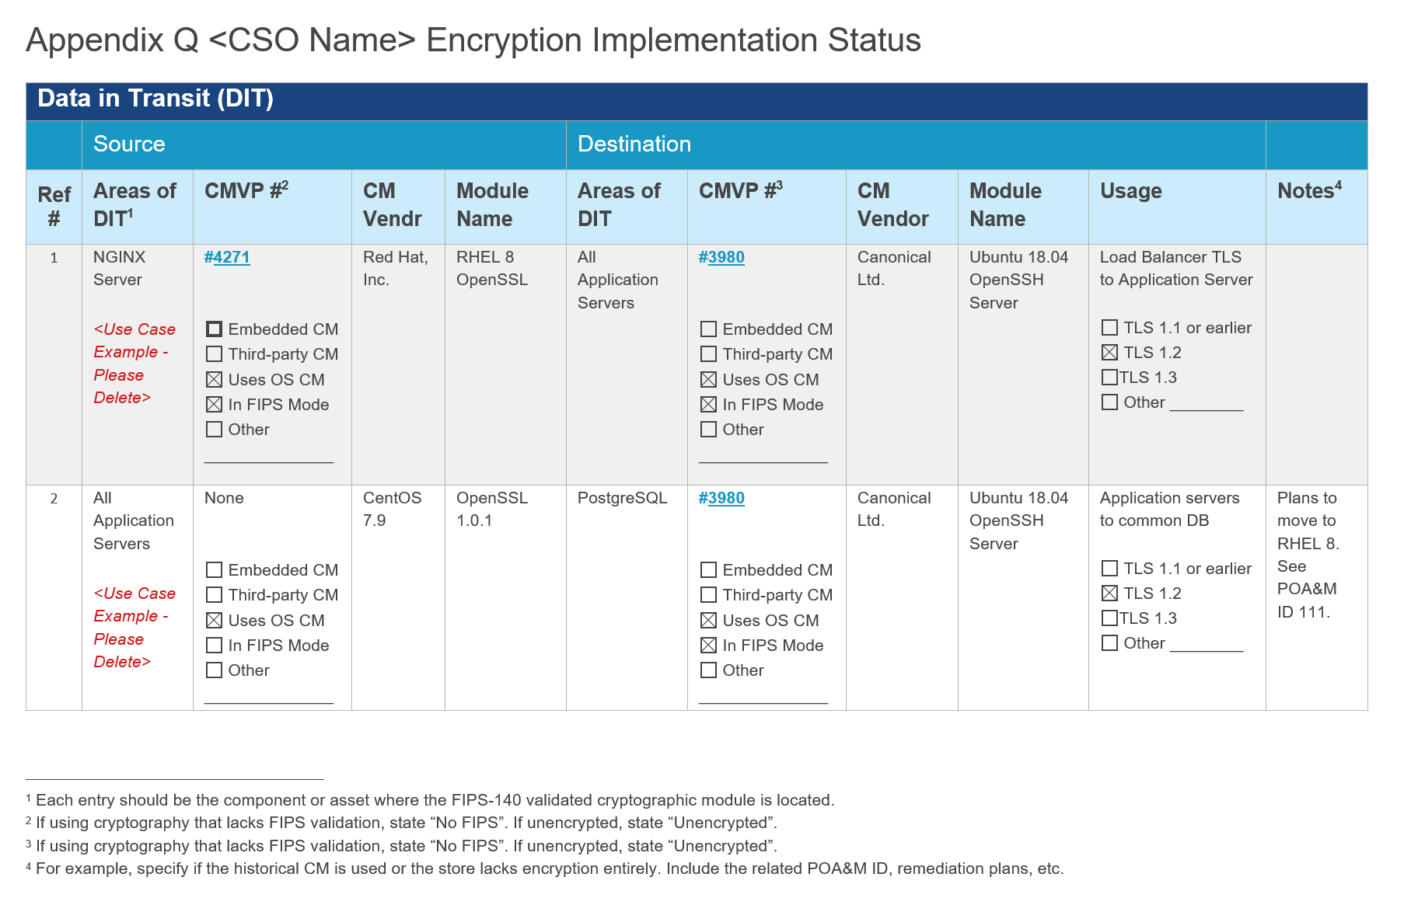
Cryptographic Modules Implemented for Data-in-Transit (DIT)
NIST's component model treats independent validation of products and services as if that validation were a separate component. This means when using components with FIPS 140 validated cryptographic modules, there must be two component assemblies:
- The Validation Definition: A component definition that provides details about the validation.
- The Product Definition: A component definition that describes the hardware or software product.
The validation definition is a component definition that provides details about the independent validation. Its type must have a value of “validation”. In the case of FIPS 140 validation, this must include a link field with a rel value set to “validation-details”. This link must point to the cryptographic module's entry in the NIST Computer Security Resource Center (CSRC) Cryptographic Module Validation Program Database.
The product definition is a product with a cryptographic module. It must contain all of the typical component information suitable for reference by inventory-items and control statements. It must also include a link field with a rel value set to “validation” and an href value containing a URI fragment. The Fragment must start with a hashtag (#) and include the UUID value of the validation component. This links the two together.
The link with rel=”used-by” is used to identify the component that is using the cryptographic module (e.g., Areas of DIT).
Component Representation: Example Product with FIPS 140-2 Validation
<!-- system-characteristics -->
<system-implementation>
<!-- user -->
<!-- Minimum Required Components -->
<!-- FIPS 140-2 Validation Certificate Information -->
<!-- Include a separate component for each relevant certificate -->
<component uuid="uuid-value" type="validation">
<title>Module Name</title>
<description><p>FIPS 140-2 Validated Module</p></description>
<prop ns="https://fedramp.gov/ns/oscal" name="asset-type"
value="cryptographic-module" />
<prop ns="https://fedramp.gov/ns/oscal" name="vendor-name"
value="CM Vendor"/>
<prop ns="https://fedramp.gov/ns/oscal" name="cryptographic-module-usage"
value="data-at-rest"/>
<prop name="validation-type" value="fips-140-2"/>
<prop name="validation-reference" value="0000"/>
<link href="https://csrc.nist.gov/projects/cryptographic-module-validation-program/Certificate/0000" rel="validation-details" />
<status state="operational" />
</component>
<!-- FIPS 140-2 Validated Product -->
<component uuid="uuid-value" type="software" >
<title>Product Name</title>
<description><p>A product with a cryptographic module.</p></description>
<link href="#uuid-of-validation-component" rel="validation" />
<status state="operational" />
</component>
<!-- service -->
</system-implementation>
<!-- control-implementation -->

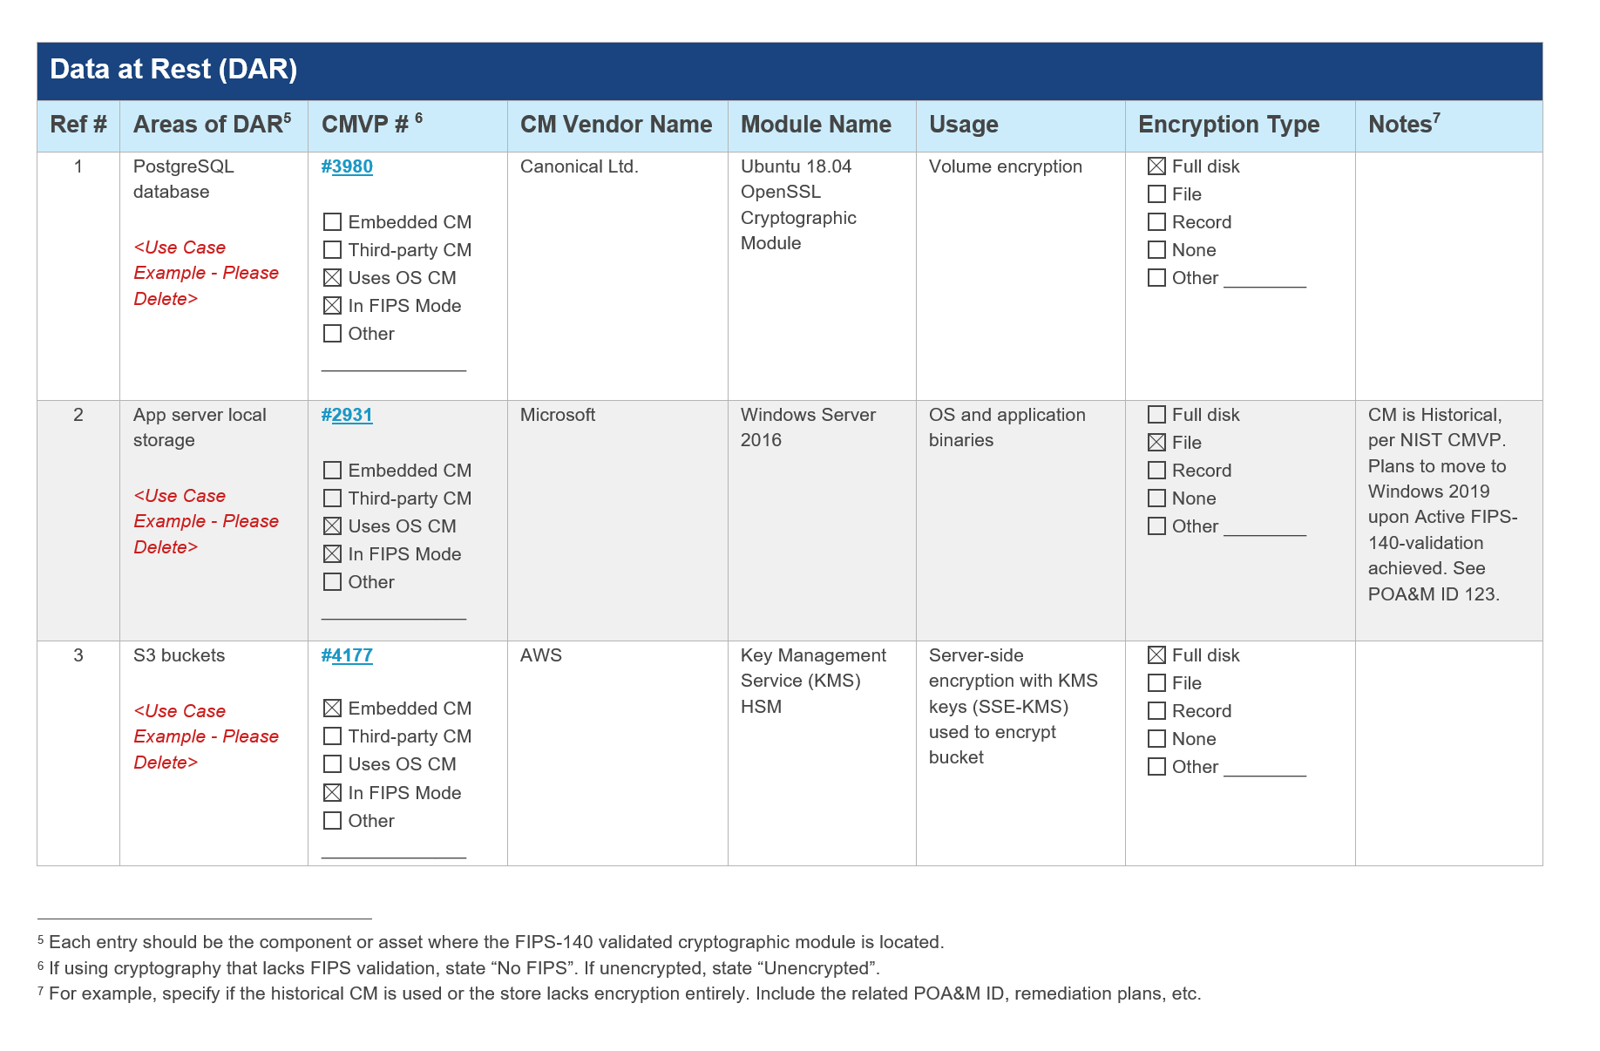
Cryptographic Modules Implemented for Data-at-Rest (DAR)
The approach is the same as in section 4.14 (cryptographic module data-in-transit).
The link with rel=”used-by” is used to identify the component that is using the cryptographic module (e.g., Areas of DAR).
Component Representation: Example Product with FIPS 140-2 Validation
<!-- system-characteristics -->
<system-implementation>
<!-- user -->
<!-- Minimum Required Components -->
<!-- FIPS 140-2 Validation Certificate Information -->
<!-- Include a separate component for each relevant certificate -->
<component uuid="uuid-value" type="validation">
<title>Module Name</title>
<description><p>FIPS 140-3 Validated Module</p></description>
<prop ns="https://fedramp.gov/ns/oscal" name="asset-type"
value="cryptographic-module" />
<prop ns="https://fedramp.gov/ns/oscal" name="vendor-name"
value="CM Vendor"/>
<prop ns="https://fedramp.gov/ns/oscal" name="cryptographic-module-usage"
value="data-in-transit"/>
<prop name="validation-type" value="fips-140-3"/>
<prop name="validation-reference" value="0000"/>
<link href="https://csrc.nist.gov/projects/cryptographic-module-validation-program/Certificate/0000" rel="validation-details" />
<status state="operational" />
</component>
<!-- FIPS 140-2 Validated Product -->
<component uuid="uuid-value" type="software" >
<title>Product Name</title>
<description><p>A product with a cryptographic module.</p></description>
<link href="#uuid-of-validation-component" rel="validation" />
<status state="operational" />
</component>
<!-- service -->
</system-implementation>
<!-- control-implementation -->

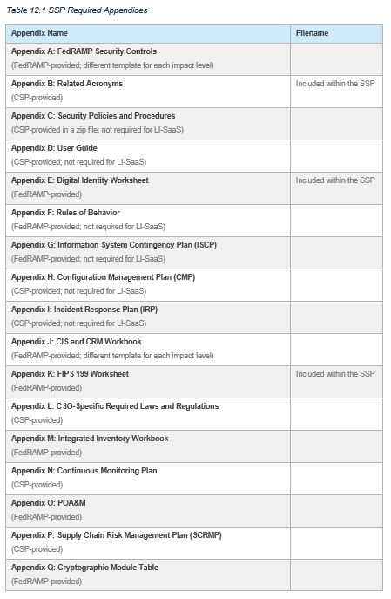
Attachments
Classic FedRAMP attachments include a mix of items. Some lend well to machine-readable format, while others do not. Machine-readable content is typically addressed within the OSCAL-based FedRAMP SSP syntax, while policies, procedures, plans, guidance, and the rules of behavior documents are all treated as classic attachments, as described in the Citations, Attachments, and Embedded Content in OSCAL Files Section. The resource’s title and description must be used to provide a human-readable indicator of what attachment is being referenced, however, OSCAL extensions must also be provided when applicable for machine readability. The following table describes how each attachment is handled:
Appendix Name | Machine Readable | How to Handle in OSCAL
Appendix A: FedRAMP Security Controls | Yes | This can be generated from the content in the Security Controls section and does not need to be maintained separately or attached.
Appendix B: Related Acronyms | No | Attach using the back-matter, resource syntax.  For Acronyms, resource must include a prop with @ns="https://fedramp.gov/ns/oscal", @name="type", and @value="fedramp-acronyms".
Appendix C: Security Policies and Procedures | No | Attach using the back-matter, resource syntax.  For Policies, resource must include a prop with @name=”type”, @value=”policy”, and @class=”control-family”.  For Procedures, resource must include a prop with @name=”type”, @value=”procedure”, and @class=”control-family”.
Appendix D: User Guide | No | Attach using the back-matter, resource syntax.  For User Guides, resource must include a prop with @name=”type” and @value=”users-guide”.
Appendix E: Digital Identity Worksheet | Yes | Incorporated above. See the Digital Identity Determination Section.
Appendix F: Rules of Behavior | No | Attach using the back-matter, resource syntax.  For Rules of Behavior, resource must include a prop with @name=”type” and @value="rules-of-behavior".
Appendix G: Information System Contingency Plan (ISCP) | No | Attach using the back-matter, resource syntax.  For ISCP, resource must include a prop with @name=”type”, @value="plan", and @class="information-system-contingency-plan".
Appendix H: Configuration Management Plan (CMP) | No | Attach using the back-matter, resource syntax.  For CMP, resource must include a prop with @name=”type”, @value="plan", and @class="configuration-management-plan".
Appendix I: Incident Response Plan (IRP) | No | Attach using the back-matter, resource syntax.  For IRP, resource must include a prop with @name=”type”, @value="plan", and @class="incident-response-plan".
Appendix J: CIS and CRM Workbook | Yes | This can be generated from the content in the Security Controls section and does not need to be maintained separately or attached.
Appendix K: FIPS 199 Worksheet | Yes | Incorporated above. See the Security Objectives Categorization (FIPS-199) Section.
Appendix L: CSO-Specific Required Laws and Regulations | No | Attach using the back-matter, resource syntax.  For User Guides, resource must include a prop with @name=”type” and @value=”law”.
Appendix M: Integrated Inventory Workbook | Yes | See the System Inventory Section.
Appendix N: Continuous Monitoring Plan | No | Attach using the back-matter, resource syntax.  For ConMon, resource must include a prop with @name=”type”, @value="plan", and @class="incident-response-plan".
Appendix O: POA&M | Yes | This is maintained separately in an OSCAL POA&M but can be attached using the back-matter, resource syntax.  For POA&M, resource must include a prop with @name=”type”, @value="plan", and @class="poam".
Appendix P: Supply Chain Risk Management Plan (SCRMP) | No | Attach using the back-matter, resource syntax.  For SCRMP, resource must include a prop with @name=”type”, @value="plan", and @class="scrmp".
Appendix Q: Cryptographic Module Table | Yes | See the Cryptographic Modules Section dealing with components.

Attachments
Classic FedRAMP attachments include a mix of items. Some lend well to machine-readable format, while others do not. Machine-readable content is typically addressed within the OSCAL-based FedRAMP SSP syntax, while policies, procedures, plans, guidance, and the rules of behavior documents are all treated as classic attachments, as described in the Citations, Attachments, and Embedded Content in OSCAL Files Section. The following table describes how each attachment is handled:

Attachment Representation
<!-- cut -->
<back-matter>
<resource uuid="uuid-value">
<title>Document Title</title>
<desc>Policy document</desc>
<prop name="type" ns="https://fedramp.gov/ns/oscal" value="policy"/>
<prop name="publication" ns="https://fedramp.gov/ns/oscal" value="2021-01-01Z"/>
<prop name="version" ns="https://fedramp.gov/ns/oscal" value="1.2"/>
<!-- Add rlink with relative path or embed with base64 encoding -->
<base64>00000000</base64>
</resource>
<resource uuid="uuid-value" />
<!-- cut: policies 3 - 13 -->
<resource uuid="uuid-value" />
<resource uuid="uuid-value" />
<!-- cut: procedure 2 - 13 -->
</back-matter>
FedRAMP Extensions & Accepted Values
prop (ns="https://fedramp.gov/ns/oscal"):
- name="type"
- name="title"
- name="publication"
- name="version"

XPath Queries
The Number of Policies Attached:
count(/*/back-matter/resource/prop[@name="type"]‌[@ns="https://fedramp.gov/ns/oscal"][string(./@value)="policy"])
Attachment (Embedded Base64 encoded):
/*/back-matter/resource[@id="att-policy-1"]/base64
OR (Relative Link):
/*/back-matter/resource[@id="att-policy-1"]/rlink/@href
Replace "policy" with "plan", "rob", etc. for each attachment type.
Title of First Policy Document:
/*/back-matter/resource/prop[@name="type"][@ns="https://fedramp.gov/ns/oscal"]‌[string(.)="policy"][1]/../prop[@name="title"][@ns="https://fedramp.gov/ns/oscal"]

System Inventory Approach
NOTE: OSCAL also uses components to represent content that does not typically appear in the system inventory. When rendering a presentation of system inventory, tools should offer users the option to exclude components such as:
Interconnections, services, policies, procedures, the system (as a whole), leveraged systems (as a whole), and FIPS 140 validation details.
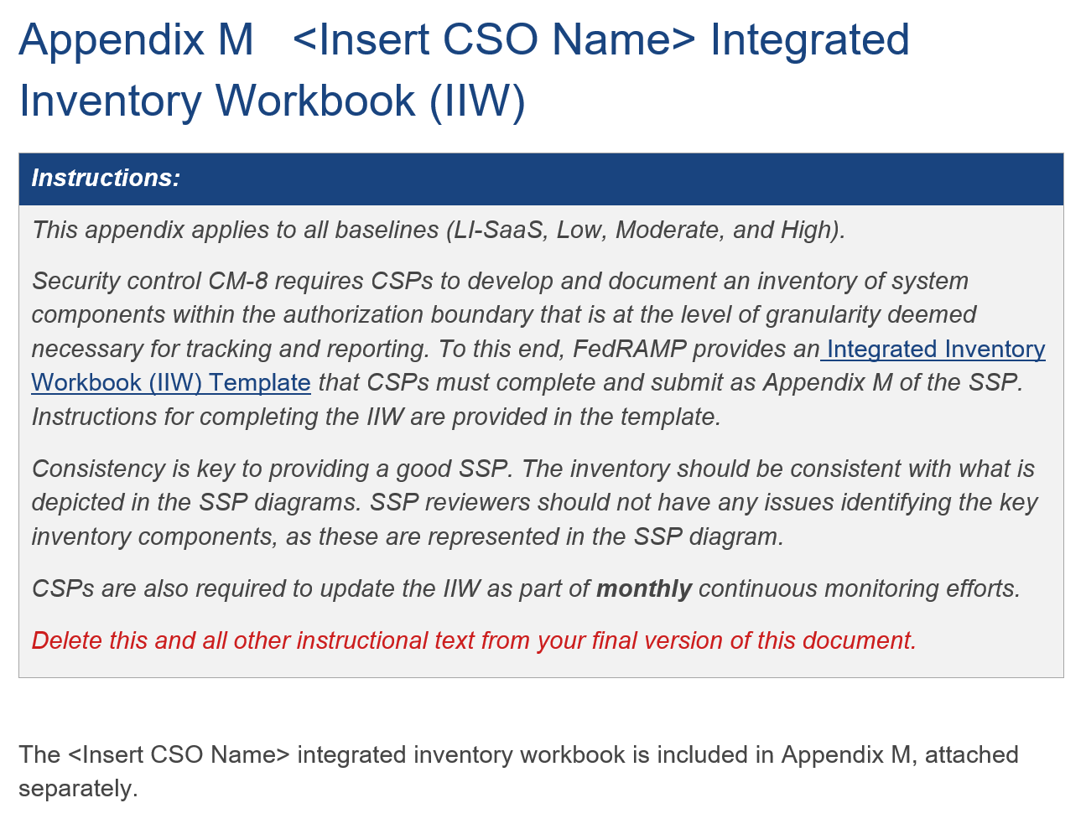
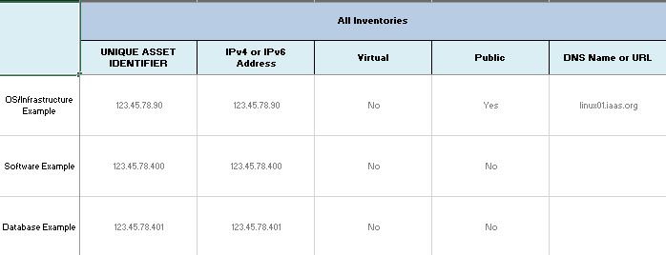
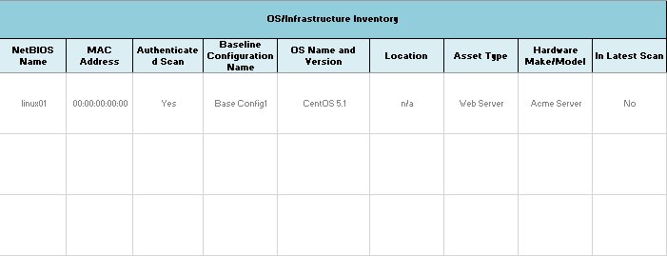
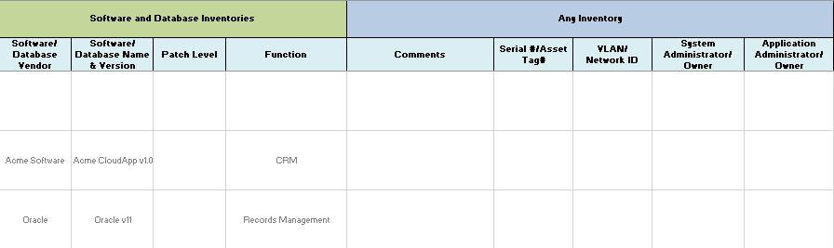
OSCAL makes two approaches available for depicting the system inventory:
- Flat-File Approach: Similar to today's FedRAMP Integrated inventory workbook where all of the information on a spreadsheet row is captured in a single assembly.
- Component-Based Approach: A component is defined once with as much known detail as possible,
and inventory-items point to components for common information.
FedRAMP prefers the component-based approach but accepts the flat-file approach to aid CSPs who are converting their existing MS-Excel based FedRAMP Integrated Inventory Workbook to OSCAL. FedRAMP SSP tools must support both approaches.
With the flat-file approach, all content on a spreadsheet row appears in
a single OSCAL inventory-item assembly. This results in a great deal of redundant information but is a simple transition from the current spreadsheet approach.
Flat-File Inventory Approach
With the component-based approach, common information is captured once in a component assembly. Each instance of that component has its own inventory-item assembly, which cites the relevant component and only includes information unique to that instance.
For example, if the same Linux operating system is used as the platform for all database and web servers, most of the details about the Linux operating system can be captured once as a component. This includes information such as vendor name, version number, and patch level. If four Linux instances are used, each instance is an inventory item with a unique IP address and MAC address. Only those unique pieces are captured at the inventory level. All four inventory-items point back to the component for vendor name, version number, and patch level.
Component-based Inventory Approach

Flat File Approach
NIST Allowed Values
prop
- name="virtual"
  - Valid: yes, no
- name="public"
  - Valid: yes, no
prop
- name="allows-authenticated-scan"
  - Valid: yes, no
- name="is-scanned"
  - Valid: yes, no
The description and remarks fields are Markup multiline, which enables the text to be formatted. This requires special handling. See Section 2.6 Handling OSCAL Data Types in the Guide to OSCAL-based FedRAMP Content, or visit:
https://pages.nist.gov/OSCAL/documentation/schema/model-concepts/datatypes/#markup-multiline
FedRAMP Allowed Values
prop
- name="asset-type"
  - Valid: operating-system, database, web-server, dns-server, email-server, directory-server, pbx, firewall, router, switch, storage-array
Other values are allowed for now.
FedRAMP Extensions & Allowed Values
prop (ns="https://fedramp.gov/ns/oscal"):
- name="vendor-name"
- name="scan-type"
  - Valid: infrastructure, web, database, container
Flat-File Representation
<!-- cut -->
<system-implementation>
<!-- interconnection -->
<system-inventory>
<inventory-item uuid="uuid-value" asset-id="unique-asset-id">
<description><p>Flat-File Example (No implemented-component).</p></description>
<prop name="ipv4-address" value="0.0.0.0"/>
<prop name="ipv6-address" value="0000:0000:0000:0000"/>
<prop name="virtual" value="no"/>
<prop name="public" value="no"/>
<prop name="fqdn" value="example.com"/>
<prop name="uri" value="https://example/query?key=value#anchor"/>
<prop name="netbios-name" value="netbios-name"/>
<prop name="mac-address" value="00:00:00:00:00:00"/>
<prop name="software-name" value="software-name"/>
<prop name="version" value="V 0.0.0"/>
<prop name="asset-type" value="os"/>
<prop name="vendor-name" value="Vendor Name"/>
<prop name="model" value="Model Number"/>
<prop name="patch-level" value="Patch-Level"/>
<prop name="serial-number" value="Serial #"/>
<prop name="asset-tag" value="Asset Tag"/>
<prop name="vlan-id" value="VLAN Identifier"/>
<prop name="network-id" value="Network Identifier"/>
<prop name="scan-type" ns="https://fedramp.gov/ns/oscal" value="infrastructure"/>
<prop name="allows-authenticated-scan" value="no">
<remarks><p>If no, explain why. If yes, omit remarks field.</p></remarks>
</prop>
<prop name="baseline-configuration-name" value="Baseline Config. Name" />
<prop name="physical-location" value="Physical location of Asset" />
<prop name="is-scanned" value="yes"/>
<prop name="function" value="Required brief, text-based description."/>
<link rel="validation" href="#uuid-of-validation-component" />
<status state="operational"/>
<responsible-party role-id="asset-owner">
<party-id>person-7</party-id>
</responsible-party>
<responsible-party role-id="asset-administrator">
<party-id>it-dept</party-id>
</responsible-party>
<implemented-component component-uuid="component-uuid-value " />
<remarks><p>COMMENTS: Additional information about this item.</p></remarks>
</inventory-item>
<!-- Repeat the inventory-item assembly for each item in the inventory -->
</system-inventory>
<!-- system-implementation remarks -->
</system-implementation>
NIST-Defined Identifier
Required Role ID may be one of the following:
- asset-owner
- asset-administrator
- security-operations
- network-operations
- incident-response
- helpdesk
- configuration-management
- maintainer
- provider

Other values are allowed.
XPath Queries
See Section 6.5.3, Inventory Data Locations and XPath Queries
Notes:
The value of asset-type determines whether the identified asset-administrator is managing a system or an application. Currently, any FedRAMP-defined asset-type implies the management of a system, and therefore,
is to be scanned as infrastructure.

Component-based Approach
The description and remarks fields are Markup multiline, which enables the text to be formatted. This requires special handling. See Section 2.6 Handling OSCAL Data Types in the Guide to OSCAL-based FedRAMP Content, or visit:
https://pages.nist.gov/OSCAL/documentation/schema/model-concepts/datatypes/#markup-multiline
FedRAMP Allowed Values
prop
- name="asset-type"
  - Valid: os, database, web-server, dns-server, email-server, directory-server, pbx, firewall, router, switch, storage-array
Other values are allowed for now.
FedRAMP Extensions & Allowed Values
prop (ns="https://fedramp.gov/ns/oscal"):
- name=““vendor-name”“
- name="scan-type"
  - Valid: infrastructure, web, database, container
Component-based Representation
<!-- cut -->
<system-implementation>
<component uuid="uuid-value" type="software">
<prop name="virtual" value="no"/>
<prop name="software-name" value="software-name"/>
<prop name="version" value="V 0.0.0"/>
<prop name="asset-type" value="operating-system"/>
<prop name="vendor-name" value="Vendor Name"/>
<prop name="model" value="Model Number"/>
<prop name="patch-level" value="Patch-Level"/>
<prop name="scan-type" ns="https://fedramp.gov/ns/oscal" value="infrastructure"/>
<prop name="allows-authenticated-scan" value="no">
<remarks><p>If no, explain why. If yes, omit remarks field.</p></remarks>
</prop>
<prop name="baseline-configuration-name" value="Baseline Config. Name" />
<prop name="function" value="Required brief, text-based description.">
<remarks><p>Optional, longer, formatted description.</p></remarks>
</prop>
<link rel="validation" href="#uuid-of-validation-component" />
<status state="operational"/>
<responsible-party role-id="asset-owner">
<party-id>person-7</party-id>
</responsible-party>
<responsible-party role-id="asset-administrator">
<party-id>it-dept</party-id>
</responsible-party>
</component>
<!-- service, interconnection -->
<system-inventory>
<inventory-item uuid="uuid-value" asset-id="unique-asset-id">
<description><p>If needed, describe this instance.</p></description>
<prop name="ipv4-address" value="0.0.0.0"/>
<prop name="public" value="no"/>
<prop name="fqdn" value="example.com"/>
<prop name="uri" value="https://example/query?key=value#anchor"/>
<prop name="mac-address" value=">00:00:00:00:00:00"/>
<prop name="serial-number" value="Serial #"/>
<prop name="vlan-id" value="VLAN Identifier"/>
<prop name="network-id" value="Network Identifier"/>
<prop name="is-scanned" value="yes" />
<implemented-component component-uuid="component-uuid-value " />
<remarks><p>COMMENTS: Additional information about this item.</p></remarks>
</inventory-item>
<!-- Repeat the inventory-item assembly for each use of the above component -->
</system-inventory>
<!-- system-implementation remarks -->
</system-implementation>
NIST-Defined Identifier
Required Role ID may be one of the following:
- asset-owner
- asset-administrator
- security-operations
- network-operations
- incident-response
- helpdesk
- configuration-management
- maintainer
- provider

Other values are allowed.
XPath Queries
See Section 6.5.3, Inventory Data Locations and XPath Queries
Notes:
- If component-sample is an image of a Linux virtual machine (VM), and 10 instances of that VM are in use, there would be one (1) component assembly and ten (10) inventory-item assemblies, all referencing the same component.

Inventory Data Locations and XPath Queries
The following queries are intended to show where to find each piece of information within the system
inventory template.
 |  | Guidance | Valid Values | Requirement | Component | Inventory-Item | OSCAL Cardinality | Data Location: XPath Notation (CASE SENSITIVE) | NOTES
All Inventories | UNIQUE ASSET IDENTIFIER | Unique Identifier associated with the asset. This Identifier should be used consistently across all documents, 3PAOs artifacts, and any vulnerability scanning tools. For OS/Infrastructure and Web Application Software, this is typically an IP address or URL/DNS name. For a database, it is typically an IP address, URL, or database name. A CSP's own naming scheme is also acceptable as long as it has unique identifiers. | Must be unique. | Mandatory for all inventory records. |  | X | 1 | /*/system-implementation/system-inventory/inventory-item/prop[@asset-id="___"]/@value  OR  /*/system-implementation/component/prop[@name="asset-id"]/@value | The system-specific “Unique Asset Identifier” must be set as the asset-id flag on the inventory-item field.
All Inventories | IPv4 or IPv6  Address | If available, state the IPv4 or IPv6 address of the inventory item. This can be left blank if one does not exist, or if it is a dynamic field. If the IP address is used as the Unique Asset Identifier, then this field will duplicate the contents of the Unique Asset Identifier column.  If a device has multiple IP addresses, then include one row in this inventory for each IP address. |  | Optional, unless used as Identifier in vulnerability scans or security assessments. |  | X | 0 - ꚙ | /*/system-implementation/system-inventory/inventory-item/‌prop[@name="ipv4-address"]/@value  /*/system-implementation/system-inventory/inventory-item/‌prop[@name="ipv6-address"]/@value | One prop field per  IP address, if more  than one.
All Inventories | Virtual | Is this asset virtual? | Yes or No. | Mandatory for OS/Infrastructure. Software, and Database. | X | X | 1 | /*/system-implementation/component/prop[@name="virtual"]/@value  /*/system-implementation/system-inventory/inventory-item/‌prop[@name="virtual"]/@value | Must have “Virtual” at  the inventory item-level either explicitly, or via  a linked component.  May define it at component level  and propagate to inventory-item.
All Inventories | Public | Is this asset a public facing device? That is, is it outside the boundary? If so, it is an entry point. | Yes or No. | Mandatory for OS/Infrastructure. Software, and Database. |  | X | 1 | /*/system-implementation/system-inventory/inventory-item/‌prop[@name="public"]/@value
All Inventories | DNS Name  or URL | If available, state the DNS name or URL of the inventory item. This can be left blank if one does not exist, or it is a dynamic field. | Valid DNS name or URL. | Optional, unless used as Identifier in vulnerability scans or security assessments. |  | X | 0 - ꚙ | /*/system-implementation/system-inventory/inventory-item/prop[@name="fqdn"]/@value  /*/system-implementation/system-inventory/inventory-item/prop[@name="uri"]/@value | May use either DNS name, URL, or both.  Use a separate prop field for each DNS name and/or URL.

 |  | Guidance | Valid Values | Requirement | Component | Inventory-Item | OSCAL Cardinality | Data Location: XPath Notation (CASE SENSITIVE) | NOTES
OS/Infrastructure Inventory | NetBIOS Name | If available, state the NetBIOS name. May be left blank if one does not exist, or dynamic. | Valid NetBIOS name. | Optional, unless used as Identifier in scans or security assessments. |  | X | 0 - ꚙ | /*/system-implementation/system-inventory/inventory-item/‌prop[@name="netbios-name"]/@value | One prop field per NetBIOS name, if more than one.
OS/Infrastructure Inventory | MAC Address | If available, state the MAC Address. May be left blank if one does not exist, or dynamic. | Valid MAC Address. | Optional, unless used as Identifier in scans or security assessments. |  | X | 0 - ꚙ | /*/system-implementation/system-inventory/inventory-item/‌prop[@name="mac-address"]/@value | One prop field per MAC address, if more than one.
OS/Infrastructure Inventory | Authenticated Scan | Is the asset is planned for an authenticated scan? | Yes or No. | Mandatory for OS/Infrastructure. Leave blank for Software and Database. | X | X | 1 | /*/system-implementation/component/prop[@name="allows-authenticated-scan"]/@value  /*/system-implementation/system-inventory/inventory-item/prop[@name="allows-authenticated-scan"]/@value | Must have “Authenticated-Scan” at the inventory-item level either explicitly or via a linked component.  May define it at component level and propagate to inventory-item.
OS/Infrastructure Inventory | Baseline Configuration Name | If available, provide the name of the configuration template used within the CSP configuration management. | . | Mandatory for OS/Infrastructure. Leave blank for Software and Database. | X | X | 0 or 1 | /*/system-implementation/component/prop[@name="baseline-configuration-name"]/@value  /*/system-implementation/system-inventory/inventory-item/prop[@name="baseline-configuration-name"]/@value | Must have “Baseline Configuration Name” at the inventory-item level either explicitly or via a linked component.  May define it at component level and propagate to inventory-item.
OS/Infrastructure Inventory | OS Name and Version | Operating System Name and Version running on the asset. |  | Optional for OS/Infrastructure. Leave blank for Software and Database. |  | X | 0 or 1 | /*/system-implementation/component/prop[@name="software-name"]‌ [@ns="https://fedramp.gov/ns/oscal"]/@value  /*/system-implementation/component/prop[@name="version"]/@value  /*/system-implementation/system-inventory/inventory-item/‌prop[@name="software-name"]/@value  /*/system-implementation/system-inventory/inventory-item/‌prop[@name="software-version"]/@value | Use software name and version and set asset-type of “os”.  Required for operating systems.  Must have “OS Name and Version” at the inventory-item level either explicitly or via a linked component. May define it at the component level and propagate to inventory item.
OS/Infrastructure Inventory | Location | Physical location of hardware. Could include Data Center ID, Cage#, Rack# or other meaningful location identifiers. | Valid locations for CSP infrastructure. | Optional for OS/Infrastructure. Leave blank for Software and Database. |  | X | 0 or 1 | /*/system-implementation/system-inventory/inventory-item/prop[@name="physical-location"]/@value
OS/Infrastructure Inventory | Asset Type | Simple description of the asset's function (e.g., Router, Storage Array, DNS Server, etc.) |  | Mandatory for OS/Infrastructure. Leave blank for Software and Database. | X | X | 1 | /*/system-implementation/component/prop[@name="asset-type"]/@value  /*/system-implementation/system-inventory/inventory-item‌ [@name="asset-type"]/@value | Must use an Accepted Value (see Registry) if an applicable one exists.  Must have “Asset Type” at the inventory-item level, either explicitly or via a linked component. May define it at component level and propagate to inventory-item.
OS/Infrastructure Inventory | Hardware Make/Model | Name of the hardware product and model. |  | Mandatory for OS/Infrastructure. Leave blank for Software and Database. | X | X | 0 or 1 | /*/system-implementation/component/prop[@name="vendor-name"]/@value  /*/system-implementation/component/prop[@name="model"]/@value  /*/system-implementation/system-inventory/inventory-item/prop[@name="vendor-name"]‌[@ns="https://fedramp.gov/ns/oscal"]/@value  /*/system-implementation/system-inventory/inventory-item/‌prop[@name="hardware-model"]/@value | Must have “Hardware Vendor” and “Hardware Model” at the inventory item-level either explicitly, or via a linked component. May define it at component level and propagate to inventory-item.  NOTE: @name=“model” at component level, but @name=“hardware-model” at inventory level.
OS/Infrastructure Inventory | In Latest Scan | Should the asset appear in the network scans, and can it be probed by the scans creating the current POA&M? | Yes or No. | Mandatory for OS/Infrastructure. Leave blank for Software and Database. |  | X | 1 | /*/system-implementation/system-inventory/inventory-item/prop[@name="is-scanned"]/@value

 |  | Guidance | Valid Values | Requirement | Component | Inventory-Item | OSCAL Cardinality | Data Location: XPath Notation (CASE SENSITIVE) | NOTES
Software and Database Inventories | Software/ Database Vendor | Name of Software or Database vendor. | If open source (e.g., there is no "vendor), enter "Open Source" as the vendor name. | Mandatory for Software and Database. Leave blank for OS/Infrastructure. | X | X | 0 or 1 | /*/system-implementation/component/prop[@name="vendor-name"]‌ [@ns="https://fedramp.gov/ns/oscal"]/@value  /*/system-implementation/system-inventory/inventory-item/‌prop[@name="vendor-name"][@ns="https://fedramp.gov/ns/oscal"]/@value | Must have “Software/Database Vendor” at the inventory-item level either explicitly or via a linked component.  May define it at component level and propagate to inventory-item.
Software and Database Inventories | Software/ Database Name & Version | Name of Software or Database product and version number. |  | Mandatory for Software or Database. Leave blank for OS/Infrastructure. | X | X | 0 or 1 | /*/system-implementation/component/prop[@name="software-name"]‌ [@ns="https://fedramp.gov/ns/oscal"]/@value  /*/system-implementation/component/prop[@name="version"]/@value  /*/system-implementation/system-inventory/inventory-item/‌prop[@name="software-name"]/@value  /*/system-implementation/system-inventory/inventory-item/‌prop[@name="software-version"]/@value | Required for software or database. Omit for OS/Infrastructure
Software and Database Inventories | Patch Level | If applicable. |  | Optional if applicable. Otherwise, leave blank. | X | X | 0 or 1 | /*/system-implementation/component/prop[@name="patch-level"]/@value  /*/system-implementation/system-inventory/inventory-item/‌prop[@name="software-patch-level"]/@value | The “Patch Level” may be specified at the component or inventory-item level.
Software and Database Inventories | Function | For Software or Database, the function provided by the Software or Database for the system. |  | Mandatory for Software or Database. Leave blank for OS/Infrastructure. | X | X | 0 or 1 | /*/system-implementation/component/prop[@name="function"]/@value  /*/system-implementation/component/prop[@name="function"]/remarks  /*/system-implementation/system-inventory/inventory-item/‌prop[@name="function"]/@value  /*/system-implementation/system-inventory/inventory-item/‌prop[@name="function"]/remarks | Must have a brief, text-base “function” description in the value flag at the inventory item-level.  May define it at component level and propagate to inventory-item.  May have a separate “function” at the component level.  May have an expanded, formatted function description in the remarks.
.
 |  | Guidance | Valid Values | Requirement | Component | Inventory-Item | OSCAL Cardinality | Data Location: XPath Notation (CASE SENSITIVE) | NOTES
Any Inventory | Comments | Any additional information that could be useful to the reviewer. |  | Optional for OS/Infrastructure, Software and Database. | X | X | 0 or 1 | /*/system-implementation/component/remarks  /*/system-implementation/system-inventory/inventory-item/remarks | May have comments in either the component level, inventory-item level, or both.
Any Inventory | Serial #/Asset Tag# | Product serial number or internal asset tag #. |  | Optional for OS/Infrastructure, Software, and Database. |  | X | 0 or 1 | /*/system-implementation/system-inventory/inventory-item/‌prop[@name="serial-number"]/@value  /*/system-implementation/system-inventory/inventory-item/‌prop[@name="asset-tag"]/@value
Any Inventory | VLAN/  Network ID | Virtual LAN or Network ID. |  | Optional for OS/Infrastructure, Software, and Database. |  | X | 0 - ꚙ | /*/system-implementation/system-inventory/inventory-item/prop[@name="vlan-id"]/@value  /*/system-implementation/system-inventory/inventory-item/‌prop[@name="network-id"]/@value
Any Inventory | System Administrator/ Owner | Name of the system administrator or owner. |  | Mandatory for HIGH impact systems. Optional for Low and Moderate impact systems. | X | X | 0 - ꚙ | COMPONENT OWNER (Person):  /*/metadata/party[@uuid=/*/system-implementation/component/responsible-role‌ [@role-id="asset-owner"]/party-uuid]/name  COMPONENT ADMINISTRATOR (Org):  /*/metadata/party[@uuid=/*/system-implementation/component/responsible-role‌ [@role-id="asset-administrator"]/party-uuid]/name  INVENTORY ITEM OWNER (Person):  /*/metadata/party[@uuid=/*/system-implementation/system-inventory/inventory-item/responsible-party[@role-id="asset-owner"]/party-uuid]/name  INVENTORY ITEM ADMINISTRATOR (Org):  /*/metadata/party[@uuid=/*/system-implementation/system-inventory/inventory-item/responsible-party[@role-id="asset-administrator"]/party-uuid]/name | Must have “System Owner/Administrator” at the inventory item-level.  May define it at component level and propagate to inventory-item.  May have a separate “system owner/administrator” at the component level.
Any Inventory | Application Administrator/ Owner | Name of the application administrator or owner. |  | Optional for OS/Infrastructure, Software, and Database. | X | X | 0 - ꚙ | COMPONENT OWNER:  /*/metadata/party[@uuid=/*/system-implementation/component/responsible-role[@role-id="asset-owner"]/party-uuid]/name  CMPONENT ADMINISTRATOR:  /*/metadata/party[@uuid=/*/system-implementation/component/responsible-role[@role-id="asset-administrator"]/party-uuid]/name  INVENTORY ITEM OWNER:  /*/metadata/party[@id=/*/system-implementation/system-inventory/inventory-item/responsible-party[@role-id="asset-owner"]/party-id]/person/person-name  INVENTORY ITEM ADMINISTRATOR:  /*/metadata/party[@uuid=/*/system-implementation/system-inventory/inventory-item/responsible-party[@role-id="asset-administrator"]/party-uuid]/name | Must have “Application Owner/Administrator” at the inventory item-level.  May define it at component level and propagate to inventory-item.  May have a separate “system owner/administrator” at the component level.
ADDITIONAL | Scan Type | Indicate which scan type(s) the item is subjected to. | infrastructure, database,  web | Mandatory | X | X | 1 - ꚙ | /*/system-implementation/component/prop[@name="scan-type"]‌ [@ns="https://fedramp.gov/ns/oscal"]/@value  /*/system-implementation/system-inventory/inventory-item/‌prop[@name="scan-type"][@ns="https://fedramp.gov/ns/oscal"]/@value | Valid values: infrastructure, web, database.  If more than one type is applicable, use one field per type.
ADDITIONAL | FIPS 140-2 Validation | Indicate the certificate information for an inventory item with a FIPS 140-2 validated cryptographic module. | component-id | Mandatory for any item involving cryptography. Omit otherwise. | X | X | 1w - ꚙ | /*/system-implementation/component/prop[@name="validation"]‌ [@ns="https://fedramp.gov/ns/oscal"]/@value  /*/system-implementation/system-inventory/inventory-item/‌prop[@name="validation"][@ns="https://fedramp.gov/ns/oscal"]/@value | If an item has more than one cryptographic module, use one entry per validation certificate.  May define “FIPS 140-2 validation” at the component level and propagate to the inventory-item level.

XPath Queries
Number of Inventory Items:
count(/*/system-implementation/system-inventory/inventory-item)
Number of Hardware Components:
count(/*/system-implementation/component[@type="hardware"])
Number of Software Components:
count(/*/system-implementation/component[@type="software"])
In Latest Scan?:
/*/system-implementation/system-inventory/inventory-item[1]/prop[@name=‌"is-scanned"]/@value
Replace "[1]" with "[2]", "[3]", etc.

List Inventory Items Not Scanned:
/*/system-implementation/system-inventory/inventory-item/prop[@name="is-scanned"][@value='no']/../prop[@name='ipv4-address']
List of Reasons Inventory Items Were Not Scanned:
/*/system-implementation/system-inventory/inventory-item/prop[@name="is-scanned"][@value='no']/remarks/node()

The remarks field is Markup multiline, which enables the text to be formatted. This requires special handling.
See Section 2.6 Handling OSCAL Data Types in the Guide to OSCAL-based FedRAMP Content, or visit:
https://pages.nist.gov/OSCAL/reference/datatypes/
Unlike most XPath 2.0 queries in this document, the following queries cannot be easily converted to XPath 1.0. If working with XPath 1.0, it may be necessary to perform each search with two separate queries. These queries will list all the IPv4 addresses for each scan type (infrastructure, web, and database), whether using the flat-file inventory approach or the component-based approach.
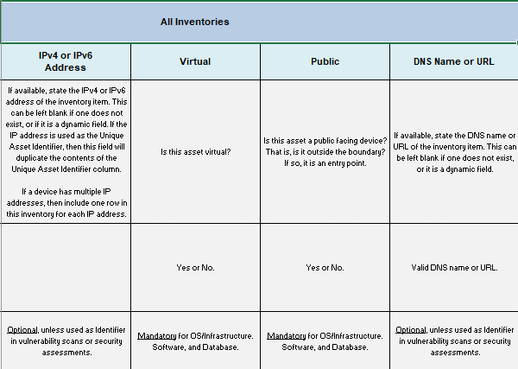
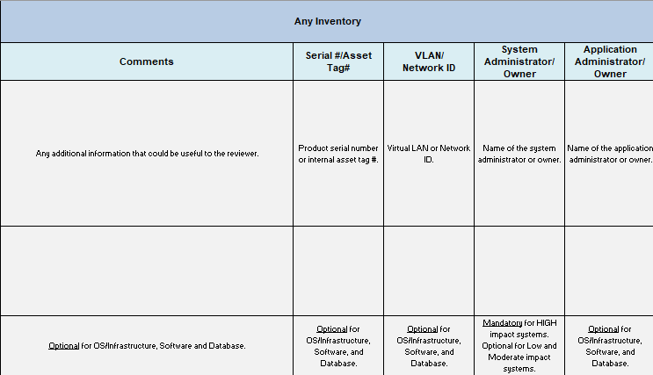
XPath 2.0 Queries
IPv4 Address of All Inventory Items Identified for Infrastructure Scanning:
distinct-values( (let $key:=/*/system-implementation/component[prop [@name='scan-type'] [@ns='https://fedramp.gov/ns/oscal']='infrastructure']/@uuid return /*/system-implementation/‌system-inventory/inventory-item [implemented-component/@component-uuid=$key]/ ‌prop[@name='ipv4-address']) | (/*/system-implementation/system-inventory/inventory-item/‌prop[@name='ipv4-address'][../prop[@name='scan-type'][@ns='https://fedramp.gov/ns/oscal'] ‌ [string(.)='infrastructure']]) )
IPv4 Address of All Inventory Items Identified for Web Scanning:
distinct-values( (let $key:=/*/system-implementation/component[prop[@name='scan-type']‌[@ns='https://fedramp.gov/ns/oscal']='web']/@uuid return /*/system-implementation/system-inventory/inventory-item [implemented-component/@component-uuid=$key]/prop[@name='ipv4-address']) | (/*/system-implementation/system-inventory/inventory-item/prop[@name='ipv4-address'][../prop[@name='scan-type'][@ns='https://fedramp.gov/ns/oscal'][string(.)='web']]))
IPv4 Address of All Inventory Items Identified for Database Scanning:
distinct-values( (let $key:=/*/system-implementation/component[prop [@name='scan-type'] [@ns='https://fedramp.gov/ns/oscal']='database']/@uuid return /*/system-implementation/‌system-inventory/inventory-item [implemented-component/@component-uuid=$key]/‌prop[@name='ipv4-address']) | (/*/system-implementation/system-inventory/inventory-item/‌prop[@name='ipv4-address'][../prop[@name='scan-type'][@ns='https://fedramp.gov/ns/oscal']‌[string(.)='database']]))
IPv4 Address of All Items Where an Authenticated Scan is Possible:
distinct-values( (/*/system-implementation/system-inventory/inventory-item/prop [@name='ipv4-address'][../prop[@name="allows-authenticated-scan"][@value='yes']] ) | (let $key:=/*/system-implementation/component[prop [@name='allows-authenticated-scan'][@value='yes']]/@uuid return /*/system-implementation/system-inventory/inventory-item [implemented-component/@component-uuid=$key]/prop[@name='ipv4-address']))
IPv4 Address of All Items Where an Authenticated Scan is Not Possible:
distinct-values( (/*/system-implementation/system-inventory/inventory-item/‌prop[@name='ipv4-address'][../prop[@name="allows-authenticated-scan"][@value='no']] ) | ( let $key:=/*/system-implementation/component[prop [@name='allows-authenticated-scan'][@value='no']]/@uuid return /*/system-implementation/system-inventory/inventory-item [implemented-component/@component-uuid=$key]/prop[@name='ipv4-address']) )
Authenticated Scan Justification (if Authenticate Scan is "no"):
/*/system-implementation/system-inventory/inventory-item/prop[@name=‌"allows-authenticated-scan"][@value="no"]/remarks/node()
OR
/*/system-implementation/component/prop[@name="allows-authenticated-scan"]‌ [@value="no"]/remarks/node()

The remarks field is Markup multiline, which enables the text to be formatted. This requires special handling. See Section 2.6 Handling OSCAL Data Types in the Guide to OSCAL-based FedRAMP Content, or visit:
https://pages.nist.gov/OSCAL/reference/datatypes/

Security Controls
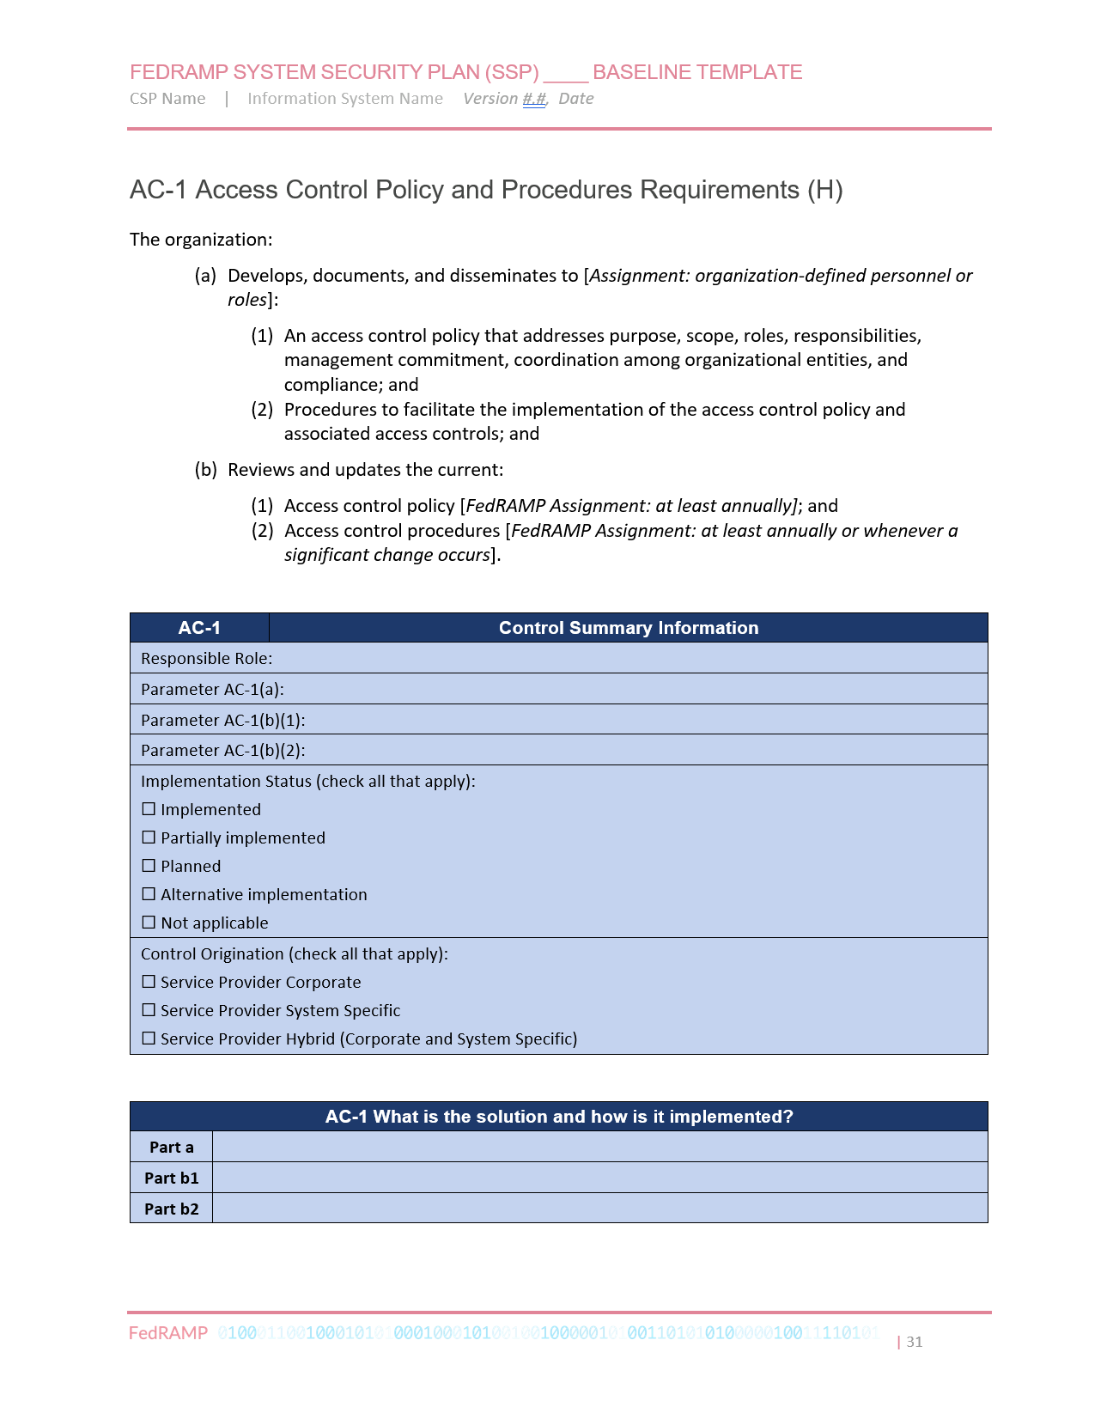
Control Implementation Descriptions
FIPS 140 Validation References, Cited Document References
Inheritance, Customer Responsibilities, Inheriting Description
Control Definitions
NIST control requirement statements
FedRAMP additional requirement statements
NIST parameter labels
FedRAMP parameter constraints
This section describes the modeling of security control information in an OSCAL-based FedRAMP SSP. To ensure consistent processing, FedRAMP imposes specific requirements on the use of OSCAL for control implementation information.
The modeling of controls is addressed in the following sections as follows:
- Section 5.1, Control Definitions
- Section 5.2, Responsible Roles Responsible Roles and Parameter Assignments
- Section 5.3, Implementation Status
- Section 5.3.1.1, Control Origination
- Section 5.4, Control Implementation Descriptions
  - Organization
    - Policy and Procedure Statements
Responsible Roles
    - Multi-Part Statements
    - Single Statements
  - Response
Parameter Assignments
    - Overview
    - Example
Implementation Status
    - “This System”
    - Inheriting from a Leveraged Authorization
    - Identifying Customer Responsibilities
    - Providing Inheritance
Control Origination

This section provides the preferred approach to representing controls in OSCAL. For system owners converting their MS Word-based SSP to OSCAL, see Appendix B, Converting a Legacy SSP to OSCAL for an alternative OSCAL control representation, which aligns better with legacy SSP content.

Control Definitions
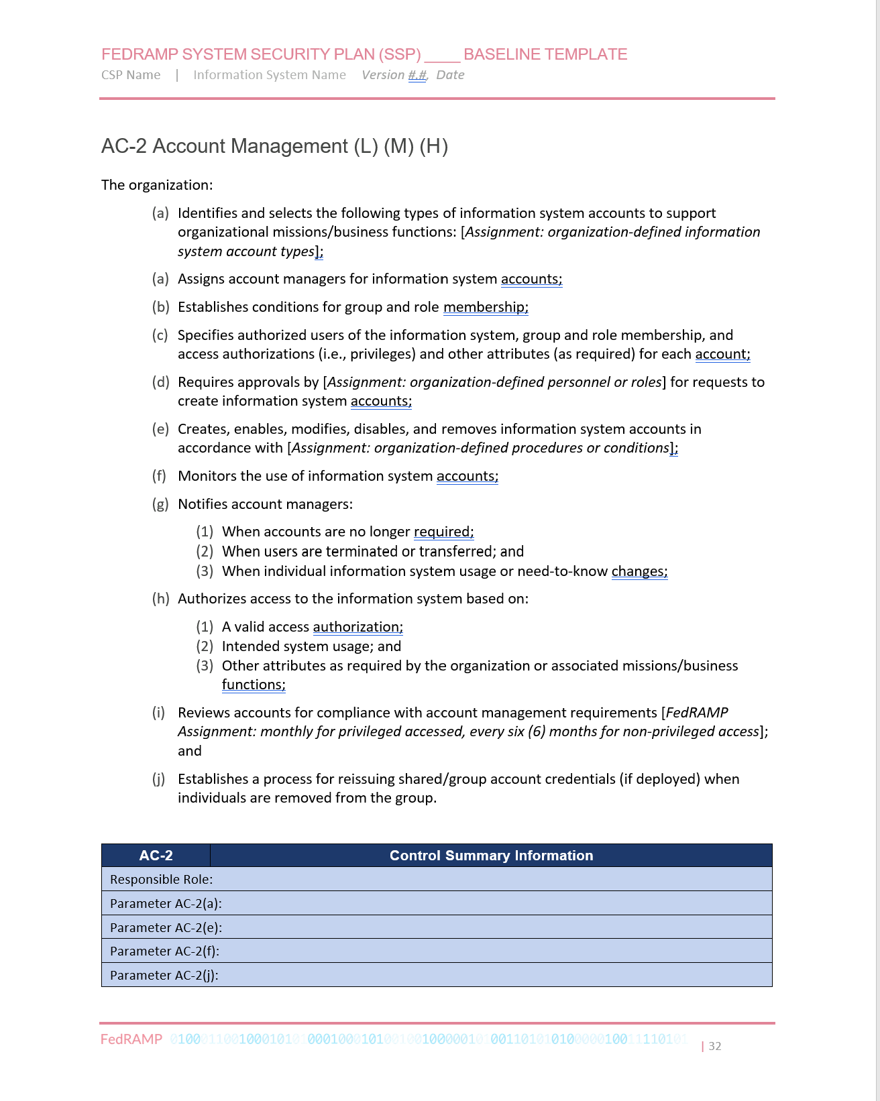
All control definition information is imported from the appropriate FedRAMP baseline (OSCAL profile).
This includes the original NIST control definition and parameter labels as well as any FedRAMP control
guidance and parameter constraints.
Interpreting and presenting profile content is beyond the scope of this document. Please refer to the
NIST OSCAL Profile and Catalog schema references for more information:
- Profile Model
- Catalog Reference
Only the control implementation information is present within an OSCAL-based SSP. Each control in the FedRAMP baseline must have a corresponding implemented-requirement assembly in the control-implementation assembly.
Replace "ac-1" with target control ID.
Representation
<!-- metadata -->
<import-profile href="https://path/to/xml/FedRAMP_MODERATE-baseline_profile.xml"/>
<!-- system-characteristics -->
<!-- system-implementation -->
<control-implementation>
<description>
<p>This field required by OSCAL, but may be left blank.</p>
<p>FedRAMP requires no specific content here.</p>
</description>
<!-- one implemented-requirement assembly for each required control -->
<implemented-requirement uuid="uuid-value" control-id="ac-1">
<!-- Control content cut - See next pages for detail -->
</implemented-requirement>
<implemented-requirement uuid="uuid-value" control-id="ac-2">
<!-- Control content cut - See next pages for detail -->
</implemented-requirement>
<implemented-requirement uuid="uuid-value" control-id="ac-2.1">
<!-- Control content cut - See next pages for detail -->
</implemented-requirement>
</control-implementation>
<!-- back-matter -->
XPath Queries
URI to Profile:
/*/import-profile/@href
CSP's Control Implementation Information
/*/control-implementation/implemented-requirement[@control-id="ac-1"]
NOTE: FedRAMP tools check to ensure there is one implemented-requirement assembly for each control identified in the applicable FedRAMP baseline.

Responsible Roles and Parameter Assignments
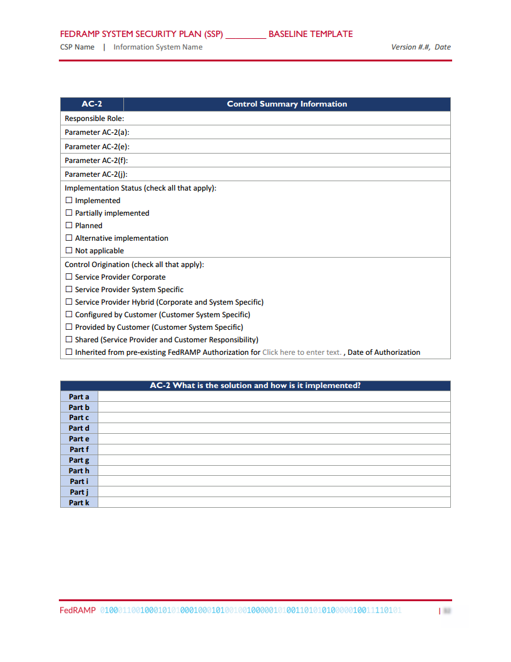
Every applicable control must have at least one responsible-role defined. There must be a separate responsible-role assembly for each responsible role. OSCAL requires the specified role-id to be valid in the defined list of roles in the metadata. Controls with a FedRAMP implementation-status property value of non-applicable (see section 5.3) do not require a responsible-role. FedRAMP further requires the specified role-id must also have been referenced in the system-implementation/user assembly. This equates to the FedRAMP requirement of all responsible roles appearing in the Personnel Roles and Privileges table.

With the implemented-requirement assembly, there must be one set-parameter statement for each of the control's parameters, as specified in the FedRAMP baseline and illustrated in the example representation below. The only exception to this is with nested parameters. Some select parameters contain an assignment parameter within a selection parameter, such as appears in AC-7 (b). In these instances, only the final selected value must be provided. The nested assignment parameter may be ignored.
OSCAL also supports parameter setting at the component level, within a by-component assembly.
Representation
<metadata>
<role id="admin-unix">
<title>Unix Administrator</title>
</role>
</metadata>
<!-- Fragment: -->
<system-implementation>
<user uuid="uuid-value">
<role-id>admin-unix</role-id>
</user>
</system-implementation >
<!-- system-implementation -->
<control-implementation>
<implemented-requirement uuid="uuid-value" control-id="ac-2">
<!-- cut -->
<responsible-role role-id="admin-unix" />
<set-parameter param-id="ac-2_prm_1">
<value>System Manager, System Architect, ISSO</value>
</set-parameter >
<!-- cut -->
</implemented-requirement>
</control-implementation>
<!-- back-matter -->
XPath Queries
Replace "ac-2" with target control ID.
Number of specified Responsible Roles:
count(/*/control-implementation/implemented-requirement[@control-id="ac-2"]/‌responsible-role)
Replace "[1]" with "[2]", "[3]", etc.
Responsible Role:
/*/metadata/role[@id=/*/control-implementation/implemented-requirement‌[@control-id="ac-2"]/responsible-role[1]/@role-id]/title
Check for existence in Personnel Roles and Privileges (Should return a number > 0)
count(/*/system-implementation/user/role-id[string(.)=/*/control-implementation/‌implemented-requirement[@control-id="ac-2"]/responsible-role/@role-id])
Parameter Value:
/*/control-implementation/implemented-requirement[@control-id="ac-2"]/set-parameter ‌[@param-id="ac-2_prm_1"]/value
Replace "ac-2_prm_1" with target parameter ID.

Implementation Status
FedRAMP only accepts only one of five values for implementation-status: implemented, partial, planned, alternative, and not-applicable. A control may be marked “partial” and “planned” (using two separate implementation-status fields). All other choices are mutually exclusive.
If the implementation-status is partial, the gap must be explained in the remarks field.
See Previous Page
If the implementation-status is planned, a brief description of the plan to address the gap, including major milestones must be explained in the remarks field. There must also be a prop (name="planned-completion-date" ns="https://fedramp.gov/ns/oscal") field containing the intended completion date. With XML, prop fields must appear before prop fields, even though that sequence is counter-intuitive in this situation.
If the implementation-status is alternative, the alternative implementation must be summarized in the remarks field.

If the implementation-status is not-applicable, the N/A justification must be provided in the remarks field.
See Next Pages
The remarks fields are Markup multiline, which enables the text to be formatted. This requires special handling. See Section 2.5.3 Markup-line and Markup-multiline Fields in OSCAL, https://pages.nist.gov/OSCAL/documentation/schema/model-concepts/datatypes/#markup-multiline
FedRAMP Extensions and Accepted Values
prop (ns="https://fedramp.gov/ns/oscal"):
- name="planned-completion-date"
prop (ns="https://fedramp.gov/ns/oscal"):
- name="implementation-status"
Valid: implemented, partial, planned, alternative, not-applicable
Implementation Status Representation
<!-- system-implementation -->
<control-implementation>
<implemented-requirement uuid="uuid-value" control-id="ac-1">
<prop name="planned-completion-date"
ns="https://fedramp.gov/ns/oscal" value="2021-01-01Z"/>
<prop name="implementation-status"
ns="https://fedramp.gov/ns/oscal" value="implemented" />
<prop name="implementation-status"
ns="https://fedramp.gov/ns/oscal" value="partial" />
<prop name="implementation-status"
ns="https://fedramp.gov/ns/oscal" value="planned" />
<prop name="implementation-status"
ns="https://fedramp.gov/ns/oscal" value="not-applicable"/>
<!-- responsible-role, statement, by-component -->
</implemented-requirement>
</control-implementation>
<!-- back-matter -->
Implementation Status XPath Queries
Replace "ac-1" with target control-id.
Implementation Status (may return more than 1 result for a given control):
/*/control-implementation/implemented-requirement[@control-id="ac-1"] /prop[@name="implementation-status"]/@value
Gap Description (If implementation-status="partial"):
/*/control-implementation/implemented-requirement/prop[@name='implementation-status'][@value="partial"][@ns="https://fedramp.gov/ns/oscal"]/remarks/node()
Planned Completion Date (If implementation-status="planned"):
/*/control-implementation/implemented-requirement[@control-id="ac-1"]/‌prop[@name="planned-completion-date"][@ns="https://fedramp.gov/ns/oscal"]/@value
Plan for Completion (If implementation-status="planned"):
/*/control-implementation/implemented-requirement/prop[@name='implementation-status'][@value="planned"][@ns="https://fedramp.gov/ns/oscal"]/remarks/node()
Not Applicable (N/A) Justification (If implementation-status="na"):
/*/control-implementation/implemented-requirement/prop[@name='implementation-status'][@value="not-applicable"][@ns="https://fedramp.gov/ns/oscal"]/remarks/node()
The FedRAMP implementation-status property at the control’s implemented-requirement level is a summary of all statement and/or component level core OSCAL implementation-status designations. It must be set to the appropriately based on the least value of child statement or component level implementation-status designations. When a statement and/or component level implementation-status designation is not specified, the FedRAMP implementation-status value is assumed. Individual statements and/or components may override implementation-status locally.

Control Origination
FedRAMP accepts only one of five values for control-origination: sp-corporate, sp-system, customer-configured, customer-provided, and inherited. Hybrid choices are now expressed by identifying more than one control-origination, each in a separate prop field.
For controls with a control-id ending in "-1", FedRAMP only accepts sp-corporate, and sp-system.
If the control origination is inherited, there must also be a FedRAMP extension (prop name="leveraged-authorization-uuid" ns="https://fedramp.gov/ns/oscal") field containing the UUID of the leveraged authorization as it appears in the /*/system-implementation/leveraged-authorization assembly.
Replace "[1]" with "[2]", "[3]", etc.
FedRAMP Extensions and Accepted Values
prop (ns="https://fedramp.gov/ns/oscal"):
- name="control-origination"
Valid: sp-corporate, sp-system, customer-configured, customer-provided, inherited
Instead of hybrid, identify multiple control-origination types, each in its own prop assembly.
See Next Pages
See Previous Pages

Control Origination Representation
<system-implementation>
<!-- status -->
<leveraged-authorization uuid="uuid-of-leveraged-authorization">
<!-- details cut - see Leveraged Authorizations Section -->
</leveraged-authorization>
</system-implmentation>
<control-implementation>
<implemented-requirement uuid="uuid-value" control-id="ac-2">
<prop name="leveraged-authorization-uuid"
value="uuid-of-leveraged-authorization"/>
<prop ns="https://fedramp.gov/ns/oscal" name="control-origination"
value="sp-corporate" />
<prop ns="https://fedramp.gov/ns/oscal" name="control-origination"
value="sp-system" />
<prop ns="https://fedramp.gov/ns/oscal" name="control-origination"
value="customer-configured" />
<prop ns="https://fedramp.gov/ns/oscal" name="control-origination"
value="inherited" />
<!-- responsible-role -->
</implemented-requirement>
</control-implementation>
<!-- back-matter -->
XPath Queries
Number of Control Originations:
count(/*/control-implementation/implemented-requirement[@control-id="ac-2"]/‌prop[@name="control-origination"][@ns="https://fedramp.gov/ns/oscal"])
Control Origination(could return more than 1 result):
/*/control-implementation/implemented-requirement[@control-id="ac-2"]/prop‌[@name="control-origination"][@ns="https://fedramp.gov/ns/oscal"][1]/@value
Inherited From: System Name (If control-origination="inherited"):
/*/system-implementation/leveraged-authorization[@uuid=/*/control-implementation/‌implemented-requirement[@control-id="ac-2"]/prop[@name="leveraged-authorization-uuid"]]/title
Inherited From: Authorization Date (If control-origination="inherited"):
/*/system-implementation/leveraged-authorization[@uuid=/*/control-implementation/‌implemented-requirement[@control-id="ac-2"]/prop[@name="leveraged-authorization-uuid"]]/date-authorized

The remarks fields are Markup multiline, which enables the text to be formatted.
This requires special handling. See Section 2.5.3 Markup-line and Markup-multiline
Fields in OSCAL, or visit: https://pages.nist.gov/OSCAL/documentation/schema/model-concepts/datatypes/#markup-multiline

Control Implementation Descriptions
Policy and Procedure Statements
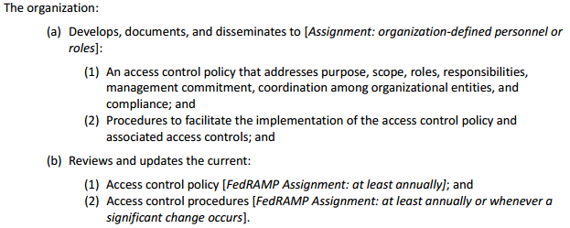
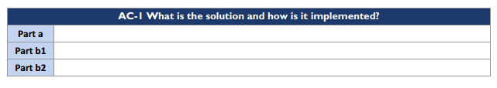
Multi-Part Statements
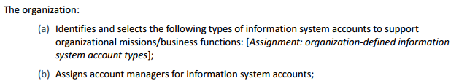
cut c, d, e, f, g, h, i
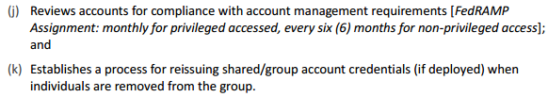
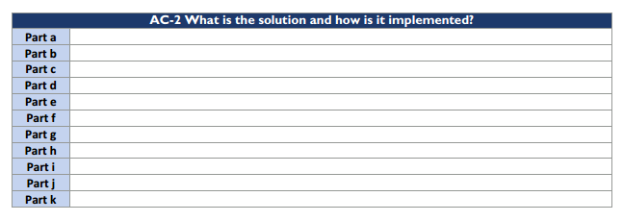
Single Statement

Within the OSCAL-based FedRAMP baselines, control statements and control objectives are tagged with a response-point FedRAMP Extension. Every control statement designated as a response-point in the baseline must have a statement with the control's implemented-requirement assembly. Please note control objective response points are used for the SAP and SAR.
When using a FedRAMP Resolved Profile Catalog, the following query will identify the response points for a given control.
Replace "ac-1" with other control IDs as required.
XPath Query
Response Points for AC-1:
//control[@id='ac-1']/part[@name='statement']//prop[@name='response-point'][@ns='https://fedramp.gov/ns/oscal']/../@id

Organization: Policy and Procedure Statements
For each of the -1 controls, such as AC-1, there must be exactly four statement assemblies: Part (a)(1), Part (a)(2), Part (b)(1), and Part (b)(2).
Policy and Procedure Representation
<!-- system-implementation -->
<control-implementation>
<!-- cut -->
<implemented-requirement uuid="uuid-value" control-id="ac-1">
<statement statement-id="ac-1_smt.a.1"><!-- cut --></statement>
<statement statement-id="ac-1_smt.a.2"><!-- cut --></statement>
<statement statement-id="ac-1_smt.b.1"><!-- cut --></statement>
<statement statement-id="ac-1_smt.b.2"><!-- cut --></statement>
</implemented-requirement>
</control-implementation>

Organization: Multi-Part Statements:
There must be one statement assembly for each lettered part, such as with AC-2, parts a, b, c, etc.
Multi-Part Statement Representation
<!-- system-implementation -->
<control-implementation>
<!-- cut -->
<implemented-requirement uuid="uuid-value" control-id="ac-2">
<statement statement-id="ac-2_smt.a"><!-- cut --></statement>
<!-- repeat for b, c, d, e, f, g, h, i, j -->
<statement statement-id="ac-2_smt.k"><!-- cut --></statement>
</implemented-requirement>
</control-implementation>

Organization: Single Statement
See Previous Pages
If there are no lettered parts in the control definition, such as with AC-2 (1), there must be exactly one statement assembly.
Single-Statement Representation
<!-- system-implementation -->
<control-implementation>
<!-- cut -->
<implemented-requirement control-id="ac-2.1">
<statement statement-id="ac-2.1_smt"><!-- cut --></statement>
</implemented-requirement>
</control-implementation>

Response: Overview
Within each statement assembly, all responses must be provided within one or more by-component assemblies. There must always be a component defined in the system-implementation representing the system as a whole (“THIS SYSTEM”), even if individual components are defined that comprise the system.
See Appendix A, Working with Components for more information.
An OSCAL-based FedRAMP SSP should define individual components of the system. Components are not just hardware and software. Policies, processes, FIPS 140 validation information, interconnections, services, and underlying systems (leveraged authorizations) are all components.
With OSCAL, the content in the cell next to Part a must be broken down into its individual components and responded to separately.

COMPONENT APPROACH: AC-2 What is the solution and how is it implemented?
Part a
  Component | Description
  THIS SYSTEM | Describes how part a is satisfied holistically, or where the description does not fit with a defined component.
  Platform | Describes how part a is satisfied by the platform.
  Web-server | Describes how part a is satisfied by the web server
  Process | Describes how part a is satisfied by an identified process within this organization.
  Inherited | Describes what is inherited from the underlying Infrastructure as a Service (IaaS) provider to satisfy part a.
Part b
  Component | Description
  THIS SYSTEM | Describes how part b is satisfied holistically, or where the description does not fit with a defined component.
  Platform | Describes how part b is satisfied by the platform.
  Web-server | Describes how part b is satisfied by the web server
  Process | Describes how part b is satisfied by an identified process within this organization.
  Inherited | Describes what is inherited from the underlying Infrastructure as a Service (IaaS) provider to satisfy part b.
The following pages provide examples.

Converting Legacy SSPs to OSCAL
For CSPs converting their existing MS Word-based SSP to OSCAL, FedRAMP allows the entire part response to initially be associated with the “THIS SYSTEM” component. Once converted, the CSP is encouraged to begin defining individual components and move content from the general “THIS SYSTEM” description to the component-specific description.
See Appendix B, Converting a Legacy SSP to OSCAL for an alternative OSCAL control representation, which aligns better with legacy SSP content.

Response: Example
See Previous Pages
Within each of the statement assemblies, all responses appear in one or more by-component assemblies.
Each by-component assembly references a component defined in the system-implementation assembly.
The description fields are Markup multiline, which enables the text to be formatted.
This requires special handling. See Section 2.6 Handling OSCAL Data Types in the
Guide to OSCAL-based FedRAMP Content, or visit:
https://pages.nist.gov/OSCAL/documentation/schema/model-concepts/datatypes/#markup-multiline
Representation
<system-implementation>
<!-- leveraged-authorization, user -->
<component uuid="uuid-value" type="software">
<title>Component Title</title>
<description>
<p>Description of the component.</p>
</description>
<status state="operational"/>
</component>
<component uuid="uuid-value" type="process">
<title>Process Title</title>
<description>
<p>Description of the component.</p>
</description>
<status state="operational"/>
<responsible-role role-id="admin-unix">
<party-uuid>3360e343-9860-4bda-9dfc-ff427c3dfab6</party-uuid>
</responsible-role>
</component>
</system-implementation>
<control-implementation>
<!-- cut -->
<implemented-requirement uuid="uuid-value" control-id="ac-2">
<statement uuid="uuid-value" statement-id="ac-2_smt.a">
<by-component uuid="uuid-value" component-uuid="uuid-of-software-component">
<description>
<p>Describe how is the software component satisfying the control.</p>
</description>
</by-component>
<by-component uuid="uuid-value" component-uuid="uuid-of-process-component">
<description>
<p>Describe how is the process satisfies the control.</p>
</description>
</by-component>
<!-- repeat by-component assembly for each component related to part a. -->
</statement>
<!-- repeat statement assembly for statement part (b, c, etc.) as needed. -->
</implemented-requirement>
</control-implementation>
<!-- back-matter -->

XPath Queries
See Section 6.4.10, XPath Queries for Control Implementation Descriptions
NOTES:
- All statement-id values must be cited as they appear in the NIST SP 800-53, Revision 4 or Revision 5 OSCAL catalogs:
https://github.com/usnistgov/oscal-content/tree/master/nist.gov/SP800-53

Response: “This System” Component
When converting a legacy SSP to OSCAL, the legacy content can be associated with the “This System” component until the SSP author is able to provide more granular content.
There must always be a “This System” component in the SSP. This is used in several ways:
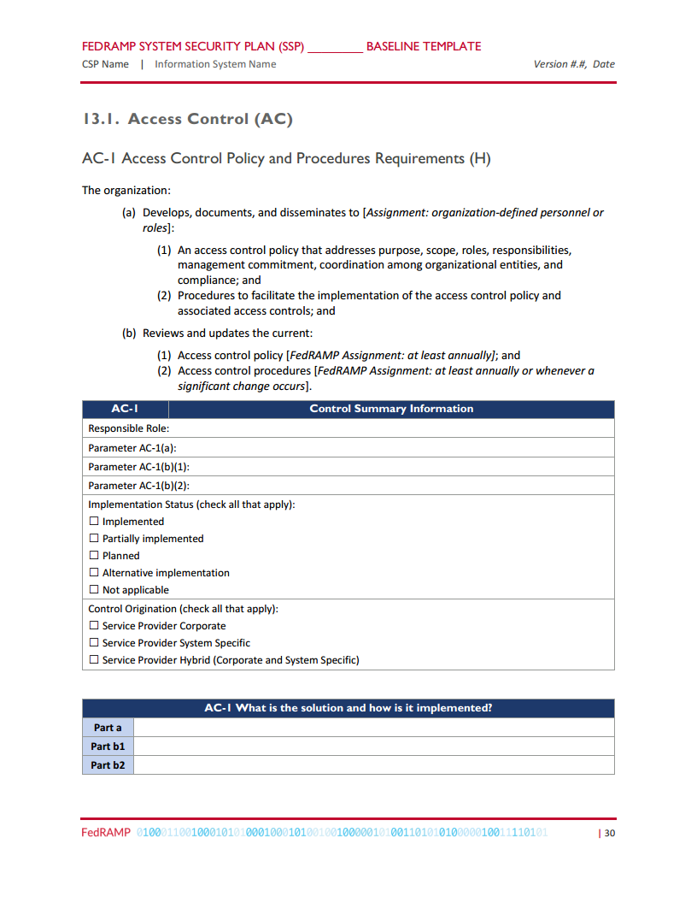
- Holistic Overview: If the SSP author wishes to provide a more holistic overview of how several components work together, even if details are provided individually in other by-component assemblies.
- Catch-all: Any control response that does not cleanly align with another system component may be described in the “This System” component.
- Legacy SSP Conversion: When converting a legacy SSP to OSCAL, the legacy control response statements may initially be associated with the “This System” component until the SSP author is able
to provide responses for individual components.
Representation
<system-implementation>
<!-- leveraged-authorization, user -->
<component uuid="uuid-value" type="this-system">
<title>This System</title>
<description>
<p>Description of the component.</p>
</description>
<status state="operational"/>
</component>
</system-implementation>
<control-implementation>
<!-- cut -->
<implemented-requirement uuid="uuid-value" control-id="ac-2">
<statement uuid="uuid-value" statement-id="ac-2_smt.a">
<by-component uuid="uuid-value" component-uuid="uuid-of-this-system-component">
<description>
<p>Describe how individual components are working together.</p>
<p>Describe how the system - as a whole - is satisfying this statement.</p>
<p>This can include policy, procedures, hardware, software, etc.</p>
</description>
</by-component>
</statement>
<!-- repeat statement assembly for statement part (b, c, etc.) as needed. -->
</implemented-requirement>
</control-implementation>
<!-- back-matter -->
XPath Queries
See Section 5.4.10, XPath Queries for Control Implementation Descriptions
NOTES:
- Although the name of the component is “This System”, non-technical solutions may also be discussed here, such as policies and procedures.

Linking to Artifacts
Any time policies, procedures, plans, and similar documentation are cited in a control response, they must
be linked.
For the legacy approach, when responding within the by-component assembly for “this system”, the link must
be within the same by-component assembly where the artifact is cited.
Representation: Legacy Approach Example - No Policy Component
<control-implementation>
<implemented-requirement uuid="uuid-value" control-id="ac-1">
<statement uuid="uuid-value" statement-id="ac-1_smt.a">
<by-component component-uuid="uuid-of-this-system" uuid="uuid-value">
<description>
<p>Describe how Part a is satisfied within the system.</p>
</description>
<link href="#uuid-of-policy-resource-in-back-matter" rel="policy" />
</by-component>
</statement>
</implemented-requirement>
</control-implementation>
<!-- back-matter -->
For the component approach, use the component representing the policy. The link should be in the component, but may be added directly to the by-component as well.
Representation: Component Approach Example
<system-implementation>
<!-- leveraged-authorization, user -->
<component uuid="uuid-value" type="policy">
<title>Access Control and Identity Management Policy</title>
<description>
<p>An example component representing a policy.</p>
</description>
<link href="#uuid-of-policy-resource-in-back-matter" rel="policy" />
<status state="operational"/>
</component>
</system-implementation>
<control-implementation>
<implemented-requirement uuid="uuid-value" control-id="ac-1">
<statement uuid="uuid-value" statement-id="ac-1_smt.a">
<by-component component-uuid="uuid-of-policy-component" uuid="uuid-value">
<description>
<p>Describe how this policy satisfies Part a.</p>
</description>
</by-component>
</statement>
</implemented-requirement>
</control-implementation>
<!-- back-matter -->
For either example above, the policy must be present as a resource in back-matter.

In Back Matter
<back-matter>
<resource uuid="uuid-value">
<title>Access Control and Identity Management Policy</title>
<rlink media-type="application/pdf" href="./documents/policies/sample_policy.pdf" />
<base64 filename="sample_policy.pdf" media-type="application/pdf">00000000</base64>
</resource>
</back-matter>

Response: Identifying Inheritable Controls and Customer Responsibilities
The description fields are Markup multiline, which enables the text to be formatted. This requires special handling. See Section 2.5.3 Markup-line and Markup-multiline Fields in OSCAL, or visit: https://pages.nist.gov/OSCAL/documentation/schema/model-concepts/datatypes/#markup-multiline
For systems that may be leveraged, OSCAL enables a robust mechanism for providing both inheritance details as well as customer responsibilities (referred to as consumer responsibilities by NIST). OSCAL is designed to enable leveraged and leveraging system SSP details to be linked by tools for validation.
Within the appropriate by-component assembly, include an export assembly. Use provided to identify
a capability that may be inherited by a leveraging system. Use responsibility to identify a customer responsibility. If a responsibility must be satisfied to achieve inheritance, add the provided-uuid flag
to the responsibility field.
The description and remarks fields are Markup multiline, which enables the text to be formatted. This requires special handling. See Section 2.5.3 Markup-line and Markup-multiline Fields in OSCAL, or visit: https://pages.nist.gov/OSCAL/reference/datatypes/
When a responsibility is linked to a provided assembly it indicates to a leveraging system that if inheritance is desired, the customer responsibility must be satisfied. If the leveraging system elects to ignore inheritance and implement their own solution, the linked responsibility may be ignored.
If a responsibility is always required, add it to the by-component assembly representing “this system” and do not link it to a provided assembly.
A role and associated party should be identified in the leveraged system's metadata identifying who leveraging customers should contact regarding inherited capabilities. The role should be supplied in the responsible-role field of the provided assembly.
A role with an id="customer" must be defined in the metadata, and referenced by the responsible-role field of the responsibility assembly.
Representation
<!-- system-implementation -->
<control-implementation><!-- cut -->
<implemented-requirement uuid="uuid-value" control-id="ac-2">
<statement uuid="uuid-value" statement-id="ac-2_smt.a">
<by-component uuid="uuid-value" component-uuid="uuid-of-this-system-component">
<description>
<p>Describe how the system - as a whole - is satisfying this statement.</p>
</description>
<export>
<responsibility uuid="uuid-value">
<description>
<p>Leveraging system's responsibilities in satisfaction of AC-2.</p>
<p>Not linked to inheritance, so this is always required.</p>
</description>
<responsible-role role-id="customer" />
</responsibility>
</export>
</by-component>
<by-component uuid="uuid-value" component-uuid="uuid-of-software-component">
<description>
<p>Describe how the software is satisfying this statement.</p>
</description>
<export>
<provided uuid="uuid-value">
<description>
<p>Customer appropriate description of what may be inherited.</p>
</description>
<responsible-role role-id="poc-for-customers" />
</provided>
<responsibility uuid="uuid-value" provided-uuid="uuid-of-provided">
<description>
<p>Customer responsibilities if inheriting this capability.</p>
</description>
<responsible-role role-id="customer" />
</responsibility>
</export>
</by-component>
</statement>
</implemented-requirement>
</control-implementation>
See Section 5.4.10, XPath Queries for Control Implementation Descriptions
See the NIST OSCAL Leveraged Authorization Presentation for more information.

Leveraged Authorization Response: Inheriting Controls, Satisfying Responsibilities

The description fields are Markup multiline, which enables the text to be formatted. This requires special handling. See Section 2.5.3 Markup-line and Markup-multiline Fields in OSCAL, or visit: https://pages.nist.gov/OSCAL/documentation/schema/model-concepts/datatypes/#markup-multiline
When the current system is inheriting a control from or meeting customer responsibilities defined by an underlying authorization, the leveraged system must first be defined as described in Section 4.15, Leveraged Authorizations before it may be referenced in a control response. The by-component assembly references these components.
IMPORTANT: The leveraged system may provide a single component representing the entire leveraged system
or may provide individual system components as well. In either case, the inherited-uuid property in the component when defined in the leveraging system's SSP.
The provided-uuid flag in inherited links to the provided statement in the leveraged
system's SSP.
The responsibility-uuid flag in satisfied links to the responsibility statement
in the leveraged system's SSP.
Both may be exposed to the leveraging system via the OSCAL Inheritance and Responsibility model when the leveraging system owner is not entitled to see the leveraged system's SSP
as is typical with FedRAMP-authorized systems. This model replaces the CRM.
The description fields are Markup multiline, which enables the text to be formatted.
This requires special handling. See Section 2.5.3 Markup-line and Markup-multiline Fields
in OSCAL, or visit: https://pages.nist.gov/OSCAL/documentation/schema/model-concepts/datatypes/#markup-multiline
Representation
<system-implementation>
<component uuid="uuid-value" type="this-system"><!-- cut --></component>
<component uuid="uuid-value" type="leveraged-system">
<title><b>LEVERAGED SYSTEM as a whole (IaaS)</b></title>
<prop name="leveraged-authorization-uuid" value="uuid-of-LA-in-this-SSP" />
<prop name="inherited-uuid" value="uuid-of-component-in-leveraged-SSP" />
</component>
<component uuid="uuid-value" type="service">
<title>Service Provided by Leveraged System</title>
<prop name="leveraged-authorization-uuid" value="uuid-of-LA-in-this-SSP" />
<prop name="inherited-uuid" value="uuid-of-component-in-leveraged-SSP" />
</component>
</system-implementation>
<control-implementation>
<implemented-requirement uuid="uuid-value" control-id="ac-2">
<statement uuid="uuid-value" statement-id="ac-2_smt.a">
<by-component uuid="uuid-value" component-uuid="uuid-of-this-system-component">
<description><p>Describe what is satisfied by this system.</p></description>
</by-component>
<by-component uuid="uuid-value" component-uuid="uuid-leveraged-system-component">
<description>
<p>Describe what is inherited from the leveraged system in satisfaction
of this control statement.</p>
</description>
<inherited provided-uuid="uuid-of-provided" uuid="uuid-value">
<description>
<p>Optional: Information provided by leveraged system.</p>
</description>
</inherited>
<satisfied responsibility-uuid="uuid-of-responsibility" uuid="uuid-value" >
<description>
<p>Description of how the responsibility was satisfied.</p>
</description>
</satisfied>
</by-component>
</statement>
<!-- repeat statement assembly for statement part (b, c, etc.) as needed. -->
</implemented-requirement>
</control-implementation>
<!-- back-matter -->
See Section 5.4.10, XPath Queries for Control Implementation Descriptions
The description fields are Markup multiline, which enables the text to be formatted.
This requires special handling. See Section 2.5.3 Markup-line and Markup-multiline Fields
in OSCAL, or visit: https://pages.nist.gov/OSCAL/documentation/schema/model-concepts/datatypes/#markup-multiline
See the NIST OSCAL Leveraged Authorization Presentation for more information.

XPath Queries for Control Implementation Descriptions
See Previous Pages
Use the following XPath queries to retrieve basic control response information. For any given control response part, tools should list the name of each component cited by a by-component assembly, as well as the description.
XPath Queries
Number of cited components for AC-2, part a (Integer):
count(/*/control-implementation/implemented-requirement[@control-id="ac-2"]/statement[@statement-id="ac-2_smt.a"]/by-component)
Name of first component related to AC-2, part a:
/*/system-implementation/component[@uuid=/*/control-implementation/implemented-requirement[@control-id="ac-2"]/statement[@statement-id="ac-2_smt.a"]/by-component[1]/@component-uuid]/title
"What is the solution and how is it implemented?" for AC-2, Part (a), first component:
/*/control-implementation/implemented-requirement[@control-id="ac-2"]/statement[@statement-id="ac-2_smt.a"]/by-component[1]/description/node()
Is there a customer responsibility for the first component in AC-2, part a? (true/false):
boolean(/*/control-implementation/implemented-requirement[@control-id="ac-2"]/statement[@statement-id="ac-2_smt.a"]/by-component[1] /prop[@name='responsibility'][@value='customer'])
Customer responsibility statement for the first component in AC-2, part a:
/*/control-implementation/implemented-requirement[@control-id="ac-2"]/statement[@statement-id="ac-2_smt.a"]/by-component[1]/prop[@name='responsibility'][@value='customer']/remarks/node()

NOTES:
- Replace “ac-2” with target control-id.
- Replace “ac-2_smt.a” with target control statement-id.
- Replace "”1]” with “[2]”, “[3]”, etc. as needed to reference is by-component statement.

Generated Content
The following artifacts are historically generated by hand to summarize content found in other portions of the FedRAMP SSP. When using OSCAL, these artifacts can be generated from content found elsewhere in this document. This includes the:
- Control Information Summary (CIS)
- Customer Responsibility Matrix (CRM)
If delivering SSP content in OSCAL, CSPs are no longer required to manually generate
and maintain these artifacts, provided the content in their OSCAL-based FedRAMP SSP remains accurate.
Tool developers are encouraged to develop their own solutions to generating
this content.

Generating the Control Information Summary (CIS)
There are many ways a tool developer can generate the CIS. FedRAMP is developing
an Extensible Stylesheet Language Transformation (XSLT) file to generate the FedRAMP
CIS. When ready, FedRAMP will make this freely available to the public here:
https://github.com/GSA/fedramp-automation/tree/master/dist/content/rev5/resources

Generating the Customer Responsibility Matrix (CRM)
There are many ways a tool developer can generate the CRM. FedRAMP is developing
an XSLT file to generate the FedRAMP CRM. When ready, FedRAMP will make this freely available to the public here:
https://github.com/GSA/fedramp-automation/tree/master/dist/content/resources
Useful CRM XPath Queries
Flat-File CRM Query:
//control-implementation/implemented-requirement/prop[@name=‌"control-origination"][@ns="https://fedramp.gov/ns/oscal"]‌[@value="customer-configured" or @value="customer-provided"]/remarks/node()
Component-based CRM Query:
//control-implementation/implemented-requirement/statement/by-component‌[@component-id="customer"]/description

Working with Components
NIST designed OSCAL such that a system architect can express all aspects of the system as components. A component is anything that can satisfy a control requirement. This includes hardware, software, services, and underlying service providers, as well as policies, plans, and procedures. There are several ways to use components in an OSCAL-based SSP. The following defines FedRAMP's minimum initial use.
Anything that can satisfy a control requirement is a component, including hardware, software, services, policies, plans, and procedures.
This section will likely be updated as NIST continues to evolve its approach to components
in OSCAL, and as FedRAMP receives feedback from stakeholders.
FedRAMP-defined component identifiers are cited in relevant portions of this document and summarized in the FedRAMP OSCAL Registry.

Minimum Required Components
There must be a component that represents the entire system itself. It should be the only component with the component-type set to “system”.
The following is an example of defined components.
Minimum Required Component Representation
<!-- system-characteristics -->
<system-implementation>
<!-- user -->
<!-- This System -->
<component uuid="uuid-value" type="this-system" >
<title>This System</title>
<description><p>
The entire system as depicted in the system authorization boundary.
</p></description>
<status state="operational" />
</component>
</system-implementation>
NIST has clarified the approach to leveraged authorizations and the CRM. Leveraged authorizations and customer responsibility content are no longer handled as components.
These scenarios require special handling as described in Section6, Security Controls.

Common Additional Components
For each FIPS 140 validated module, there must be a component that represents the validation certificate itself. For more information about this, see the FIPS 140 Validated Components Section.
Common Additional Component Representation
<!-- system-characteristics -->
<system-implementation>
<!-- user -->
<!-- System Component -->
<!-- Ports, Protocols and Services Entry -->
<component uuid="uuid-of-service" type="service">
<title>[SAMPLE]Service Name</title>
<description><p>Describe the service</p></description>
<purpose>Describe the purpose the service is needed.</purpose>
<prop name="used-by" value="What uses this service?"/>
<status state="operational" />
<protocol name="http">
<port-range start="80" end="80" transport="TCP"/>
</protocol>
<protocol name="https">
<port-range start="443" end="443" transport="TCP"/>
</protocol>
</component>
<!-- FIPS 140 Validation Certificate Information -->
<!-- Include a separate component for each relevant certificate -->
<component uuid="uuid-value" type="validation">
<title>Module Name</title>
<description><p>FIPS 140 Validated Module</p></description>
<prop name="validation-type" value="fips-140-2"/>
<prop name="validation-reference" value="0000"/>
<link href="https://csrc.nist.gov/projects/cryptographic-module-validation-program/Certificate/0000" />
<status state="operational" />
</component>
<!-- service -->
</system-implementation>
<!-- control-implementation -->
NIST has clarified the approach to leveraged authorizations and the CRM. Leveraged authorizations and customer responsibility content are no longer handled as components.
These scenarios require special handling as described in Section 6, Security Controls.
The component-type “service” is now used for information typically found in the Ports,
Protocols, and Services table, as described in Section 4.9, Ports, Protocols and Services.

Components as a Basis for System Inventory
NIST's approach to component-based system modeling is to reduce redundancy of information and increase flexibility. NIST accomplishes this with separate component and inventory item modeling.
This is a one-to-many relationship. One component to many inventory item instances.
For example, if an open-source operating system (OS) is used in many places throughout the system, it is defined once as a component. All information about the product, vendor, and support are modeled within the component detail. If the OS is used four times within the system, each use is an inventory item, with details about that specific information, such as IP address.
Relationship of Components and Inventory Items
FedRAMP requires a component assembly for each model of infrastructure device used, and each version of software and database used within the system. FedRAMP is not asking for more detail than provided in the legacy inventory workbook. Only that the information is organized differently.
As NIST continues to evolve its component approach, FedRAMP will re-evaluate its approach to system inventory representation.

Converting a Legacy SSP to OSCAL
NIST designed OSCAL such that a system architect can express all aspects of the system
as components. A component is anything that can satisfy a control requirement. This includes hardware, software, services, and underlying service providers, as well as policies, plans,
and procedures.
OSCAL is also designed to support legacy conversion of SSPs without individual components defined and enables an SSP author to migrate to the component approach gradually over time. In this instance, only a single component is initially required, representing the system as
a whole and designated with the special component type, “this-system”. The following provides an example of FedRAMP's minimum required component approach:
Anything that can satisfy a control requirement is a component, including hardware, software, services, policies, plans, and procedures.
Example control for legacy SSP conversion
<!-- system-characteristics -->
<system-implementation>
<!-- Include a separate component for each relevant certificate -->
<component uuid="uuid-value" type="this-system">
<title>System Name</title>
<description>
<p>Component representing the entire system.</p>
</description>
</component>
</system-implementation>
<control-implementation>
<description><p>FedRAMP SSP Template Section 13</p></description>
<implemented-requirement control-id="ac-1" uuid="uuid-value">
<statement statement-id="ac-1_stmt.a" uuid="uuid-value">
<by-component component-uuid="Component-uuid-value" uuid="uuid-value">
<description>
<p>Describe how Part a is satisfied within the system.</p>
</description>
</by-component>
</statement>
<statement statement-id="ac-1_stmt.b.1" uuid="uuid-value">
<by-component component-uuid="Component-uuid-value" uuid="uuid-value">
<description>
<p>Describe how Part b 1 is satisfied within the system.</p>
</description>
</by-component>
</statement>
<statement statement-id="ac-1_stmt.b.2" uuid="uuid-value">
<by-component component-uuid="Component-uuid-value" uuid="uuid-value">
<description>
<p>Describe how Part b 2 is satisfied within the system.</p>
</description>
</by-component>
</statement>
</implemented-requirement>
</control-implementation>

