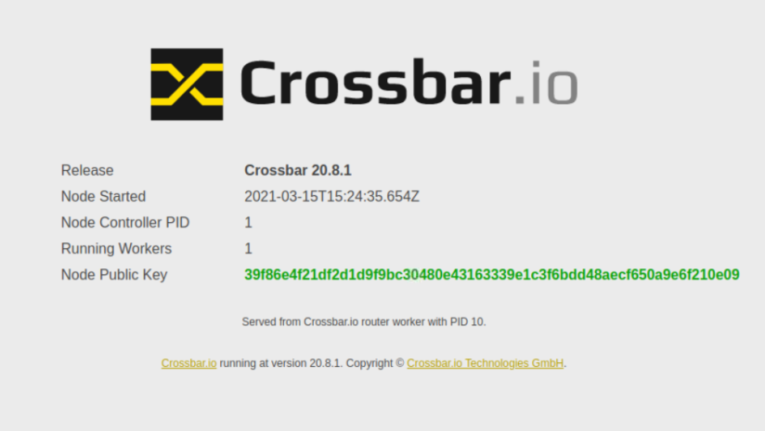  
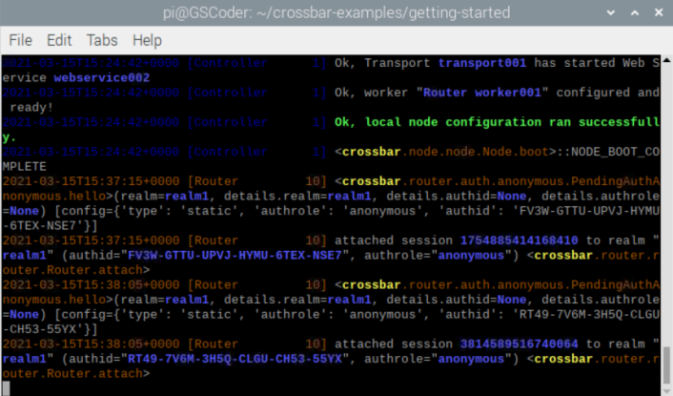

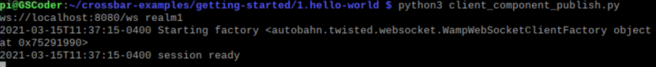

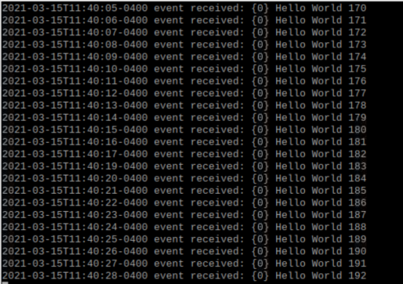

Mosquitto subscribing on one terminal and publishing to another. This one publishes to SYS, a common terminal, so there are other data from other users showing

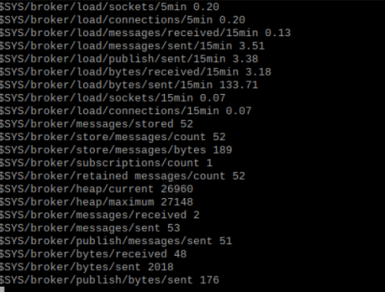

Something something, mqtt server

Writing this on terminal 1: mosquitto_sub -h localhost -v -t test/topic &

*runs in background*

And then writing this on terminal 2: mosquitto_pub -h localhost -t test/topic -m "Hello"

Yields in terminal 1:



Paho stuff:

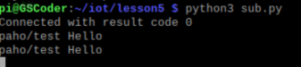

Python3 pub.py in 2nd terminal allows Hello message to get through on sub.py.

Cat into file to look at code

Same with this:

