Performance Evaluation of
the White Rabbit switch
(RFC 2889 Benchmarking)

Enkhbold Ochirsuren

GSI, TOS

15.11.2023

Table of Contents
1. Overview 3
1 WR switch 4
4 layers of the WR switch 5
1.1. Full Mesh Results 6
Forwarding test 7
Throughput test 9
1.2. Partial 1:N Mesh Results 10
Forwarding test 11
Throughput test 13
1.3. Partial N:N Mesh Results 14
Forwarding test 15
Throughput test 17
1.4. Congestion Control Results 18
1.5. Forward Pressure Results 19
1.6. Maximum Forwarding Rate Results 20
1.7. Address Caching Capacity and Learning Rate Results 21
1.8. Errored Frames Filtering Results 23
1.9. Broadcast Forwarding Results 24
2.1. Full Mesh Results, 4 layers 26
Forwarding test 27
Throughput test 29
2.2. Partial 1:N Mesh Results, 4 layers 30
Forwarding test 31
Throughput test 33
2.3. Partial N:N Mesh Results, 4 layers 34
Forwarding test 35
Throughput test 37
2.4. Congestion Control Results 38
2.5. Forward Pressure Results 39
2.6. Maximum Forwarding Rate Results 40
2.7. Address Caching Capacity and Learning Rate Results 41
2.8. Errored Frames Filtering Results 42
2.9. Broadcast Forwarding Results 43

1. Overview

The performance of the White Rabbit switch is evaluated by the methods defined in RFC 2889. This RFC deals with networking devices at the Medium Access Control (MAC) layer and provides a methodology for checking the capabilities given below:
- frame forwarding performance (forwarding rate and throughput)
- congestion control
- forward pressure and maximum forwarding rate
- broadcast forwarding and latency
- address handling

The testbed includes:
- chassis: XenaBay (140.181.139.228)
- software: Valkyrie2889 v1.40, MS Windows 8.1 Enterprise Evaluation (VirtualBox guest)
- configuration: https://github.com/GSI-CS-CO/network_testing
- wr_RFC_2889/xena_cfg/RFC_2889_1_switch_Xena.v2889
- wr_RFC_2889/xena_cfg/RFC_2889_4_switches_Xena.v2889

As a device under test the WR switch from Creotech (model WRS-3/18) with the HW version v3.4 and SW version v6.1 is chosen.

In general, 2 test setups are built for benchmarking:
- single WR switch and
- 4 layers of the WR switch

Some sub-tests have been failed because of not optimal configuration and repeated again with suitable parameters. All test results are recorded into following files:
- xena2889-report-20230928-222005.pdf (initial test, 1 switch, todo: repeat the throughput, address caching and learning tests with suitable setups)
- xena2889-report-20231023-194401.pdf (1 switch, address caching capacity test, aging time = 350 seconds)
- xena2889-report-20231023-195822.pdf (1 switch, address caching capacity test, switch test ports)
- xena2889-report-20231107-222240.pdf (1 switch, complete test)
- xena2889-report-20231108-191929.pdf (initial test, 4 switches, todo: repeat 1:N & N:N tests with different topologies)
- xena2889-report-20231113-173928.pdf (4 switches, N:N mesh)
- xena2889-report-20231114-122401.pdf (4 switches, 1:N mesh)
- xena2889-report-20231114-201104.pdf (4 switches, tests except 1:N and N:N meshes)

Similar to the previous test, which was done in 2016, the test results are color coded to indicate if the WR switch passes or fails each test. The results that cannot be concluded are in green.

Moreover, test results are compared with the results of previous test and comparison results are coded as follows: better than v4.2 (+), worse than v4.2 (-) and not much different than v4.2 (=).

For test report of 2016 refer to: https://www-acc.gsi.de/wiki/pub/Timing/TimingSystemDocumentsReportsAndMeasurements/WR_Switch_RFC_2889.pdf

1 WR switch

Test results in ‘xena2889-report-20231107-222240.pdf’ are evaluated.

- Traffic test: for all predefined frame lengths (64-1518 bytes) and bandwidths (10-100%, 100M-1Gb/s) there are frame losses. RX rates never achieve corresponding TX rates. Throughput cannot be determined for all frame lengths by a single test.
  - full mesh (-): maximum total throughput are around 4,5Mb/s and 4,9Mb/s and can be determined only for the frame sizes of 128 and 1280 bytes. For a single port they correspond to 253 and 273Kb/s data rate.
  - partial 1:N mesh (=): maximum total throughput reached to 90,9Mb/s for the frame size of 256 bytes and 46,36Mb/s for the frame size of 512 bytes.
  - partial N:N mesh (-): maximum total throughput are 13,43Mb/s and 1,57Mb/s for the frame sizes 256 and 1280 bytes.
- Congestion control (=): no congestion control. Neither ‘head of line blocking’ (for uncongested port) nor back pressure (for congested port) is detected. Test for the frame size of 1518 bytes is passed when the test is repeated.
- Forward pressure (=): no ‘forward pressure’ is detected and switch can guarantee the interfame gap (IFG) of 96-bits.
- Maximum forwarding rate (=): maximum TX rate is achieved with frame loss. For shorter frame sizes (64 and 128 bytes) the loss rates are higher (4,54% and 2,63%). The frame loss decreases when frame size gets larger (1,43% to 0,25%).
- Address caching capacity and learning rate (=): switch has inherently the slow address learning capability (< 1ms). Therefore, at the relative low frame rate (20f/s) the switch can learn up to 1500 MAC addresses. The minimum address count is 769 for frame size of 1518 bytes. There is a problem in MAC aging: switch keeps MAC addresses beyond the aging time. This means that if ‘aging time’ (or ‘toggling sync state’) is selected for address reset condition, then test is failed. This behavior is observed in all software versions including v4.2, v5.0.1, v6.0 and v6.1. Hence, address aging must be checked.
- Errored frames filtering (=): oversized and undersized frames cannot be filtered, but invalid FCS frames. Ignore lost frames at the highest data rate (refer to maximum forwarding rate test).
- Broadcast forwarding (=): better broadcasting performance (over 90%, 900 Mb/s) for frames equal or larger than 512 bytes. The lowest forwarding rate is 66% (660 Mb/s) for 64 bytes frame length.

4 layers of the WR switch

Test results in following files are evaluated:
- xena2889-report-20231113-173928.pdf (4 switches, N:N mesh)
- xena2889-report-20231114-122401.pdf (4 switches, 1:N mesh)
- xena2889-report-20231114-201104.pdf (4 switches, tests except 1:N and N:N meshes)

Next sections present the performed test results in graphs.

1.1. Full Mesh Results
XenaBay
(Valkyrie
2889 v1.40)
WRS
(nwt0297,
FW v6.1)
all 18 ports in TX and RX

Forwarding test

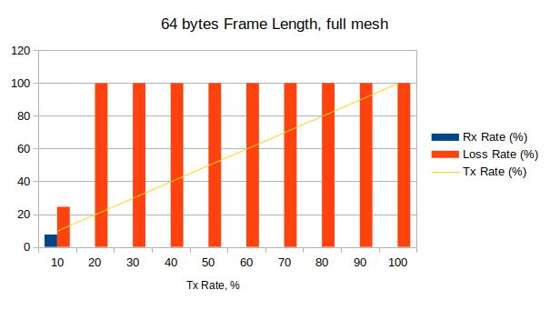

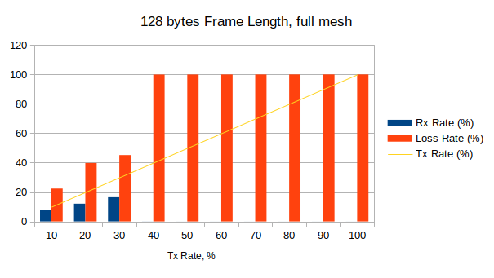

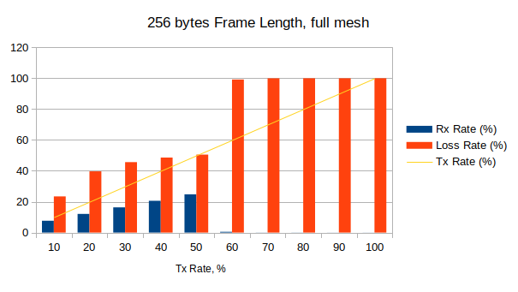

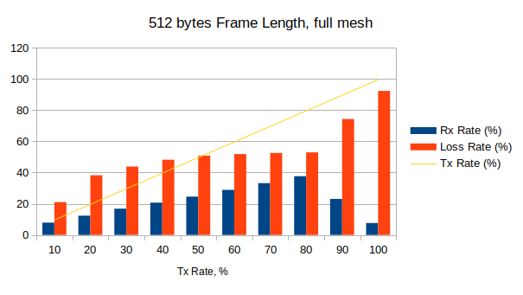

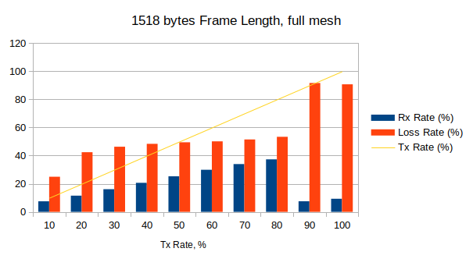

Frame Length | 64 bytes |  | 128 bytes |  | 256 bytes |  | 512 bytes |  | 1024 bytes |  | 1518 bytes
Tx Rate, % | Rx Rate, % | Loss Rate, % | Rx Rate, % | Loss Rate, % | Rx Rate, % | Loss Rate, % | Rx Rate, % | Loss Rate, % | Rx Rate, % | Loss Rate, % | Rx Rate, % | Loss Rate, %
10 | 7,56 | 24,43 | 7,76 | 22,36 | 7,66 | 23,42 | 7,9 | 21,03 | 8,08 | 19,22 | 7,5 | 24,96
20 | 0,2 | 99 | 11,96 | 40,22 | 12,19 | 39,04 | 11,92 | 40,4 | 12,1 | 39,48 | 12,25 | 38,76
30 | 0,02 | 99,94 | 16,8 | 44 | 16,49 | 45,04 | 16,01 | 46,62 | 16,39 | 45,36 | 16,74 | 44,2
40 | 0,01 | 99,97 | 0,03 | 99,92 | 20,75 | 48,14 | 20,32 | 49,19 | 20,87 | 47,83 | 20,6 | 48,5
50 | 0,01 | 99,98 | 0,03 | 99,95 | 24,96 | 50,08 | 24,54 | 50,91 | 25,23 | 49,53 | 24,52 | 50,96
60 | 0,01 | 99,99 | 0,02 | 99,96 | 0,17 | 99,71 | 28,96 | 51,74 | 29,8 | 50,33 | 29,03 | 51,62
70 | 0,01 | 99,99 | 0,02 | 99,97 | 0,02 | 99,97 | 33,26 | 52,49 | 34,25 | 51,08 | 33,79 | 51,73
80 | 0,01 | 99,99 | 0,02 | 99,98 | 0,05 | 99,94 | 37,7 | 52,87 | 38,91 | 51,36 | 37,54 | 53,08
90 | 0,01 | 99,99 | 0,01 | 99,99 | 0,04 | 99,96 | 15,69 | 82,56 | 22,59 | 74,9 | 22,61 | 74,88
100 | 0 | 100 | 0,01 | 99,99 | 0,03 | 99,97 | 7,66 | 92,34 | 45,46 | 54,54 | 6,24 | 93,76

Throughput test

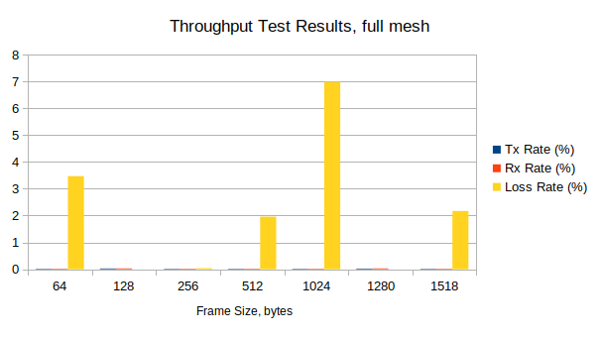

Frame Size, bytes | Tx Rate, % | Tx Rate, b/s | Tx Rate, f/s | Rx Rate, % | Loss Rate, % (frames) | Result
64 | 0,018 | 3,19M | 4743 | 0,02 | 3,47 (4938) | Fail
128 | 0,027 | 4,93M | 4162 | 0,03 | 0 (0) | Pass
256 | 0,018 | 3,18M | 1438 | 0,02 | 0,04 (18) | Fail
512 | 0,018 | 3,17M | 745 | 0,02 | 1,96 (438) | Fail
1024 | 0,018 | 3,15M | 377 | 0,02 | 6,99 (791) | Fail
1280 | 0,025 | 4,56M | 439 | 0,03 | 0 (0) | Pass
1518 | 0,018 | 3,14M | 255 | 0,02 | 2,17 (166) | Fail

1.2. Partial 1:N Mesh Results

XenaBay
(Valkyrie
2889 v1.40)
WRS
(nwt0297,
FW v6.1)
TX-to-RX: 1-to-17 or 17-to-1

Forwarding test

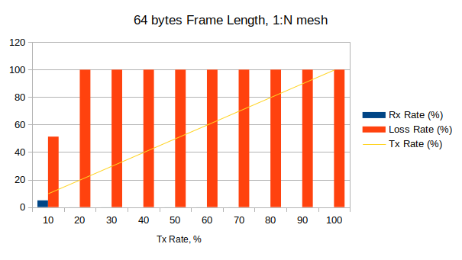

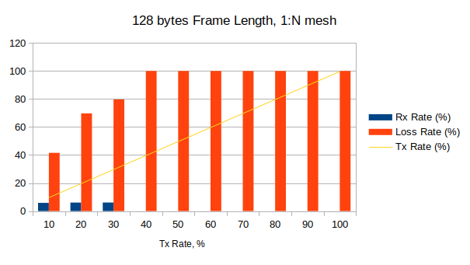

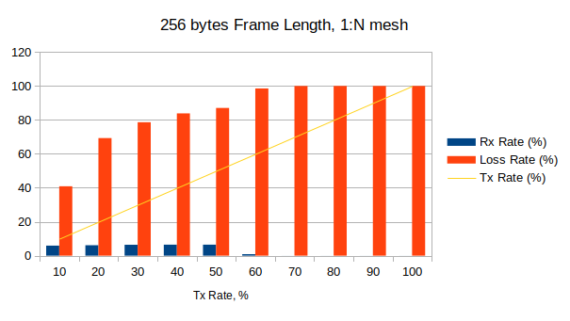

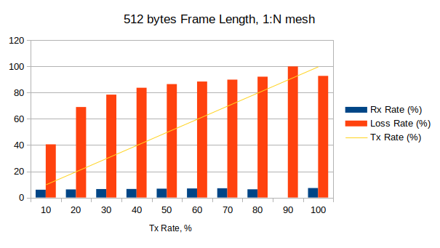

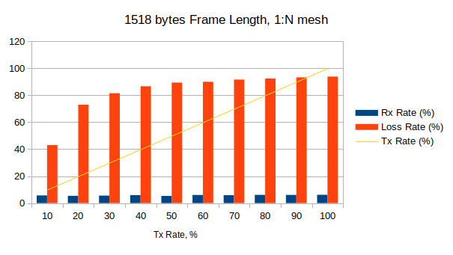

Frame Length | 64 bytes |  | 128 bytes |  | 256 bytes |  | 512 bytes |  | 1024 bytes |  | 1518 bytes
Tx Rate, % | Rx Rate, % | Loss Rate, % | Rx Rate, % | Loss Rate, % | Rx Rate, % | Loss Rate, % | Rx Rate, % | Loss Rate, % | Rx Rate, % | Loss Rate, % | Rx Rate, % | Loss Rate, %
10 | 4,87 | 51,25 | 5,85 | 41,54 | 5,91 | 40,87 | 5,94 | 40,55 | 4,92 | 50,77 | 5,7 | 43
20 | 0,02 | 99,92 | 6,06 | 69,7 | 6,14 | 69,29 | 6,19 | 69,03 | 6,2 | 68,98 | 5,4 | 72,98
30 | 0,01 | 99,96 | 6,1 | 79,66 | 6,41 | 78,63 | 6,46 | 78,47 | 6,45 | 78,51 | 5,56 | 81,46
40 | 0 | 99,99 | 0,02 | 99,96 | 6,47 | 83,83 | 6,51 | 83,72 | 6,76 | 83,11 | 5,92 | 86,64
50 | 0,01 | 99,99 | 0,01 | 99,99 | 6,48 | 87,04 | 6,74 | 86,52 | 6,87 | 86,25 | 5,31 | 89,37
60 | 0,01 | 99,99 | 0,01 | 99,98 | 0,88 | 98,53 | 6,92 | 88,47 | 6,58 | 89,04 | 6,03 | 89,96
70 | 0,01 | 99,99 | 0 | 99,99 | 0,02 | 99,97 | 7,06 | 89,92 | 6,95 | 90,07 | 5,88 | 91,61
80 | 0 | 100 | 0 | 100 | 0,01 | 99,99 | 6,26 | 92,17 | 6,94 | 91,33 | 6,1 | 92,37
90 | 0 | 100 | 0,01 | 99,99 | 0,02 | 99,98 | 0 | 100 | 6,48 | 92,8 | 6,05 | 93,28
100 | 0 | 100 | 0,01 | 99,99 | 0,01 | 99,99 | 7,23 | 92,77 | 0 | 100 | 6,15 | 93,85

Throughput test

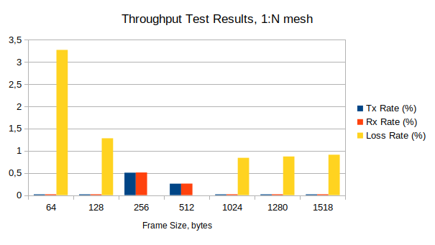

Frame Size, bytes | Tx Rate, % | Tx Rate, b/s | Tx Rate, f/s | Rx Rate, % | Loss Rate, % (frames) | Result
64 | 0,018 | 3,19M | 4750 | 0,02 | 3,24 (4620) | Fail
128 | 0,018 | 3,19M | 2696 | 0,02 | 1,28 (1036) | Fail
256 | 0,505 | 90,9M | 41168 | 0,51 | 0 (0) | Pass
512 | 0,258 | 46,36M | 10892 | 0,26 | 0 (0) | Pass
1024 | 0,018 | 3,19M | 382 | 0,02 | 0,84 (96) | Fail
1280 | 0,018 | 3,19M | 307 | 0,03 | 0,87 (80) | Fail
1518 | 0,018 | 3,19M | 259 | 0,02 | 0,91 (71) | Fail

1.3. Partial N:N Mesh Results
XenaBay
(Valkyrie
2889 v1.40)
WRS
(nwt0297,
FW v6.1)
TX-to-RX: 9-to-9

Forwarding test

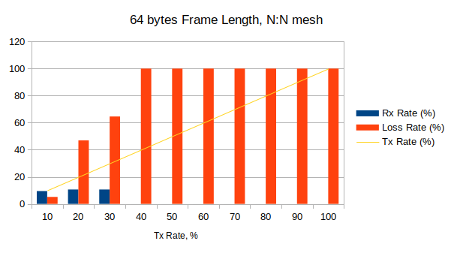

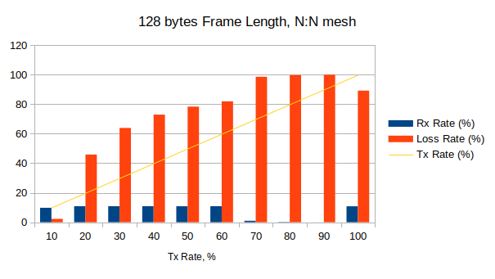

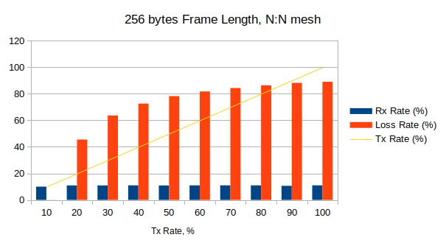

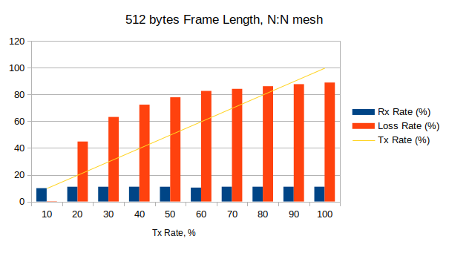

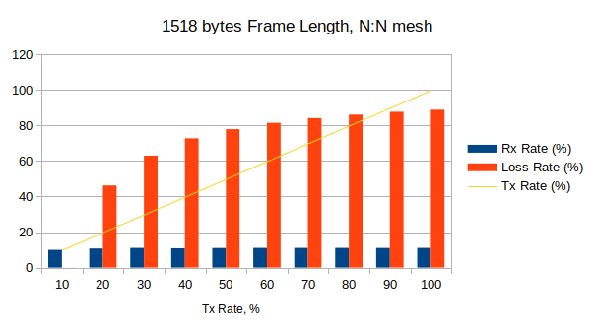

 | Frame Length, bytes
 | 64 |  | 128 |  | 256 |  | 512 |  | 1024 |  | 1518
Tx Rate, % | Rx Rate, % | Loss Rate, % | Rx Rate, % | Loss Rate, % | Rx Rate, % | Loss Rate, % | Rx Rate, % | Loss Rate, % | Rx Rate, % | Loss Rate, % | Rx Rate, % | Loss Rate, %
10 | 9,48 | 5,15 | 9,77 | 2,26 | 9,99 | 0,08 | 9,98 | 0,22 | 9,74 | 2,59 | 10 | 0,03
20 | 10,62 | 46,92 | 10,83 | 45,86 | 10,91 | 45,46 | 11,03 | 44,84 | 11,02 | 44,92 | 10,73 | 46,22
30 | 10,62 | 64,59 | 10,83 | 63,92 | 10,91 | 63,64 | 11,03 | 63,22 | 10,85 | 63,85 | 11,09 | 63,04
40 | 0,02 | 99,96 | 10,83 | 72,93 | 10,96 | 72,6 | 11,04 | 72,41 | 11,08 | 72,31 | 10,89 | 72,79
50 | 0,01 | 99,97 | 10,82 | 78,35 | 10,88 | 78,25 | 11,03 | 77,93 | 10,79 | 78,42 | 11,05 | 77,93
60 | 0,01 | 99,98 | 10,83 | 81,96 | 10,96 | 81,73 | 10,39 | 82,68 | 10,96 | 81,74 | 11,06 | 81,52
70 | 0,01 | 99,99 | 0,97 | 98,61 | 10,96 | 84,34 | 11,04 | 84,23 | 11,08 | 84,17 | 11,09 | 84,15
80 | 0,01 | 99,99 | 0,19 | 99,76 | 10,96 | 86,31 | 11,04 | 86,2 | 11,05 | 86,19 | 11,09 | 86,13
90 | 0,01 | 99,99 | 0,02 | 99,98 | 10,62 | 88,2 | 11,04 | 87,74 | 11,08 | 87,69 | 11,07 | 87,73
100 | 0,01 | 99,99 | 10,8 | 89,2 | 10,96 | 89,04 | 11,05 | 88,95 | 11,07 | 88,93 | 11,09 | 88,91

Throughput test

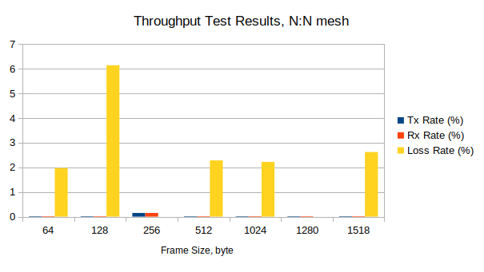

Frame Size, bytes | Tx Rate, % | Tx Rate, b/s | Tx Rate, f/s | Rx Rate, % | Loss Rate, % (frames) | Result
64 | 0,018 | 1,59M | 2373 | 0,02 | 1,97 (1404) | Fail
128 | 0,018 | 1,6M | 1347 | 0,02 | 6,14 (2482) | Fail
256 | 0,149 | 13,43M | 6080 | 0,15 | 0 (0) | Pass
512 | 0,018 | 1,59M | 373 | 0,02 | 2,28 (255) | Fail
1024 | 0,018 | 1,58M | 189 | 0,02 | 2,22 (126) | Fail
1280 | 0,018 | 1,57M | 151 | 0,02 | 0 (0) | Pass
1518 | 0,018 | 1,59M | 130 | 0,02 | 2,62 (102) | Fail

1.4. Congestion Control Results
2 ports in TX, 2 ports in RX

XenaBay
(Valkyrie
2889 v1.40)
WRS
(nwt0297,
FW v6.1)

Frame Size | Tx Rate, % | Tx Frames | UC-Port:  Tx | UC-Port:  Rx | UC-Port:  Loss, % | C-Port:  Tx | C-Port:  Rx | C-Port:  Loss, % | Result
64 | 100 | 89285714 | 22321429 | 22321429 | 0 | 66964285 | 42621994 | 36,35 | Pass
128 | 100 | 50675676 | 12668919 | 12668919 | 0 | 38006757 | 24672462 | 35,08 | Pass
256 | 100 | 27173914 | 6793479 | 6793479 | 0 | 20380435 | 13394063 | 34,28 | Pass
512 | 100 | 14097746 | 3524437 | 3524437 | 0 | 10573309 | 6996705 | 33,83 | Pass
1024 | 100 | 7183909 | 1795978 | 1795978 | 0 | 5387932 | 3578495 | 33,58 | Pass
1280 | 100 | 5769232 | 1442308 | 1442308 | 0 | 4326924 | 2875980 | 33,53 | Pass
1518 | 100 | 4876464 | 1219116 | 1194263 | 0 | 3657348 | 2432097 | 33,50 | Fail

C-Port: Congested Port
UC-Port: Uncongested Port

1.5. Forward Pressure Results

XenaBay
(Valkyrie
2889 v1.40)
WRS
(nwt0297,
FW v6.1)
1 TX port, 1 RX port

Frame Size,  bytes | Tx Frames | Tx max. util.,  % | Rx Frames | Rx max. util.,  % | Loss, % | Result
64 | 45180722 | 101,205 | 42613671 | 95,45 | 5,68 | Pass
128 | 25510204 | 100,68 | 24671105 | 97,368 | 3,29 | Pass
256 | 13636363 | 100,364 | 13392910 | 98,571 | 1,79 | Pass
512 | 7062146 | 100,188 | 6996323 | 99,254 | 0,93 | Pass
1024 | 3595397 | 100,096 | 3578303 | 99,618 | 0,48 | Pass
1280 | 2886836 | 100,077 | 2875826 | 99,693 | 0,38 | Pass
1518 | 2439817 | 100,065 | 2431964 | 99,74 | 0,32 | Pass

1.6. Maximum Forwarding Rate Results
XenaBay
(Valkyrie
2889 v1.40)
WRS
(nwt0297,
FW v6.1)
1 port in TX, 1 port in RX

Frame Size, bytes | Tx Rate, % | Tx Rate, f/s | Tx Frames | Rx Frames | Loss, % (calculated) | Result
64 | 100 | 1488,1K | 44642857 | 42613750 | 4,54 | Pass
128 | 100 | 844,6K | 25337837 | 24671132 | 2,63 | Pass
256 | 100 | 452,9K | 13586956 | 13392932 | 1,43 | Pass
512 | 100 | 234,9K | 7048872 | 6996338 | 0,75 | Pass
1024 | 100 | 119,7K | 3591954 | 3578310 | 0,38 | Pass
1280 | 100 | 96,1K | 2884615 | 2875831 | 0,304 | Pass
1518 | 100 | 81,3K | 2438231 | 2431968 | 0,25 | Pass

1.7. Address Caching Capacity and Learning Rate Results

XenaBay
(Valkyrie
2889 v1.40)
WRS
(nwt0297,
FW v6.1)
3 ports (test, learning, monitor)

Address Caching Capacity (Learning Rate=20 Frames/s)

Frame Size, bytes | Address Count | Test Port  Tx Frames | Learn Port  Rx Frames | Monitor Port  Rx Frames | Result
64 | 1500 | 1500 | 1500 | 0 | Pass
128 | 1500 | 1500 | 1500 | 0 | Pass
256 | 1469 | 1469 | 1469 | 0 | Pass
512 | 982 | 982 | 982 | 0 | Pass
1024 | 1225 | 1225 | 1225 | 0 | Pass
1280 | 1469 | 1469 | 1469 | 0 | Pass
1518 | 769 | 769 | 769 | 0 | Pass

Address Learning Rate, frame/s

Frame size, byte  Address count | 64 | 128 | 256 | 512 | 1024 | 1280 | 1518
100 | 80 | 80 | 80 | 80 | 80 | 40 | 80
612 | 80 | 80 | 80 | 40 | 40 | 40 | 40
1124 | 40 | 80 | 20 |  | 20 | 20
1500 | 80 | 40
1469 |  |  | 20 |  |  | 20
982 |  |  |  | 20
1225 |  |  |  |  | 20
769 |  |  |  |  |  |  | 20

Issue (23.10.2023): RTU routing table keeps the part of dynamic entries (check output of ‘rtu_stat’). Many of them have even aging value of ‘0’. Attempts to remove them manually with ‘rtu_stat remove all <port> 1’ fails. It looks like that there is a problem with MAC aging.

Considering the MAC aging issue, another option is selected for address learning reset (switching test and learning port roles between iterations) and the test is repeated with following settings:
- frame size: 512 bytes
- learning rate: 20 frame/s
In this setup, test is passed learning up to 1439 addresses: switch forwards the test packets (100, 1074, #1561, 1317, 1439) properly in all iterations except those with critical/high number of packets (1561). For test report refer to xena2889-report-20231023-195822.pdf.

If the aging time of 350 seconds (300 seconds for WR switches by default) is chosen for the reset condition, then test is failed again. Here, switch starts to forward test packets (100, 1074) properly, no flooding. At iteration with the critical number of packets (1561) it floods, and then it remains to flood in all further iterations with decreasing number of the test packets (1317, 1195, …, 1075, 1074). The test is failed because the switch floods even with the same number of packets (1074), with which no flooding was happened in previous iteration. For test details refer to xena2889-report-20231023-194401.pdf.

1.8. Errored Frames Filtering Results

XenaBay
(Valkyrie
2889 v1.40)
WRS
(nwt0297,
FW v6.1)
1 port in TX, 1 port in RX

Tx Rate, % | Tx Frames | Rx Frames | Tx Valid | Rx Valid | Tx Over  size | Rx Over  size | Tx Under  size | Rx Under  size | Tx FCS Error | Rx FCS Error | Result
10 | 1741375 | 1741290 | 154130 | 154130 | 81221 | 81221 | 1506024 | 1505939 | 58 | 0 | Fail
20 | 3482752 | 3482617 | 308261 | 308261 | 162443 | 162443 | 3012048 | 3011913 | 58 | 0 | Fail
30 | 5224128 | 5223881 | 462392 | 462392 | 243664 | 243664 | 4518072 | 4517825 | 58 | 0 | Fail
40 | 6965430 | 6965089 | 616522 | 616522 | 324812 | 324812 | 6024096 | 6023755 | 58 | 0 | Fail
50 | 8706880 | 8706482 | 770653 | 770653 | 406107 | 406107 | 7530120 | 7529722 | 58 | 0 | Fail
60 | 10448257 | 10447811 | 924784 | 924784 | 487329 | 487329 | 9036144 | 9035698 | 58 | 0 | Fail
70 | 12188912 | 12187983 | 1078864 | 1078864 | 568530 | 568530 | 10541518 | 10540589 | 58 | 0 | Fail
80 | 13931001 | 13929961 | 1233045 | 1233045 | 649764 | 649764 | 12048192 | 12047152 | 58 | 0 | Fail
90 | 15672386 | 15671187 | 1387176 | 1387176 | 730994 | 730994 | 13554216 | 13553017 | 58 | 0 | Fail
100 | 17413762 | 13740596 | 1541307 | 1477904 | 812215 | 632575 | 15060240 | 11630117 | 58 | 0 | Fail

1.9. Broadcast Forwarding Results
XenaBay
(Valkyrie
2889 v1.40)
WRS
(nwt0297,
FW v6.1)
1 port in TX and rest in RX

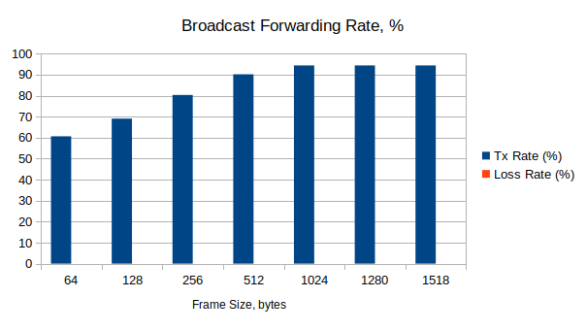

Frame Size, bytes | Tx Rate, % | Loss Rate, % | Loss Frames | Result
64 | 60,62 | 0 | 0 | Pass
128 | 69,06 | 0 | 0 | Pass
256 | 80,31 | 0 | 0 | Pass
512 | 90,15 | 0 | 0 | Pass
1024 | 94,37 | 0 | 0 | Pass
1280 | 94,37 | 0 | 0 | Pass
1518 | 94,37 | 0 | 0 | Pass

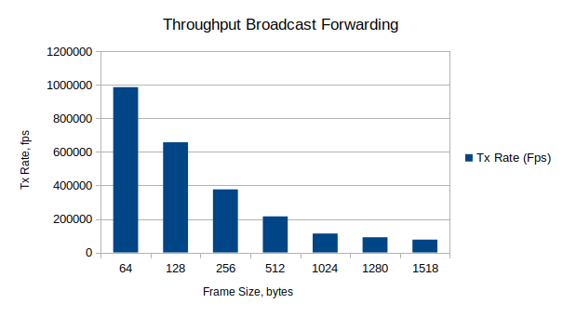

Frame Size, bytes | Tx Rate (Fps)
64 | 986377
128 | 657530
256 | 376472
512 | 215137
1024 | 112997
1280 | 90725
1518 | 76703

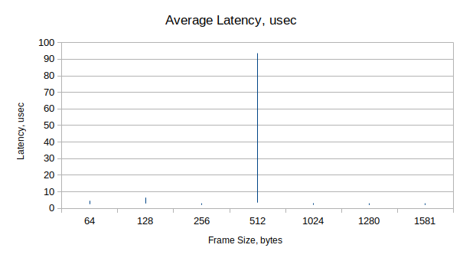

Frame Size,  bytes | Latency, usec |  |  | Jitter, usec
Frame Size,  bytes | Average | Min | Max | Average | Min | Max
64 | 2,48-4,52 | 1,29-2,28 | 6,84-11,29 | 0,003-0,011 | 0 | 2,23-2,74
128 | 2,88-6,41 | 1,78-2,75 | 6,93-12,07 | 0,002 | 0 | 2,02-2,35
256 | 2,03-2,97 | 1,77-2,74 | 4,32-6,54 | 0,008-0,01 | 0 | 2,11-2,52
512 | 3,41-93,63 | 1,78-2,96 | 8,06-216,34 | 0,002 | 0 | 2,06-2,33
1024 | 2,07-3,03 | 1,82-2,76 | 4,41-5,36 | 0,003-0,004 | 0 | 2,21-2,5
1280 | 1,99-2,97 | 1,78-2,75 | 4,21-5,37 | 0,004-0,006 | 0 | 2,14-2,57
1518 | 1,99-2,97 | 1,78-2,73 | 4,12-5,33 | 0,002-0,003 | 0 | 2,14-2,5

2.1. Full Mesh Results, 4 layers

XenaBay
(Valkyrie
2889 v1.40)
WRS
(nwt0010,
FW v6.1)
all 18 ports in TX and RX
WRS
(nwt0016,
FW v6.1)
WRS
(nwt0296,
FW v6.1)
WRS
(nwt0297,
FW v6.1)

Forwarding test

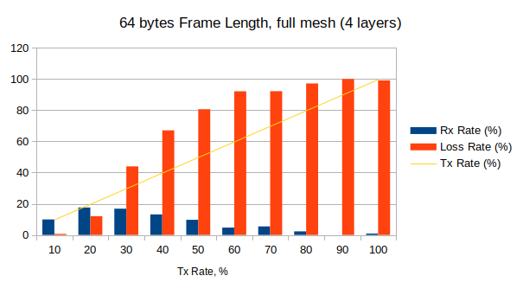

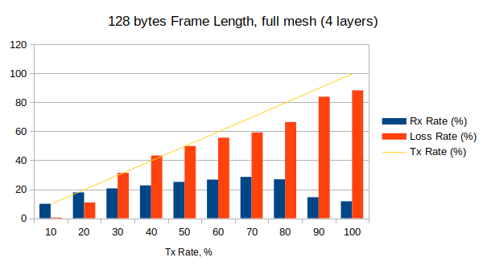

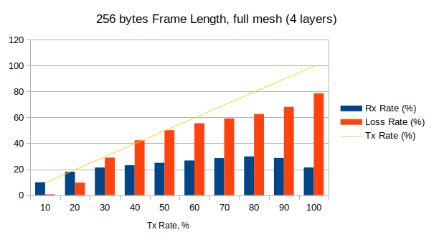

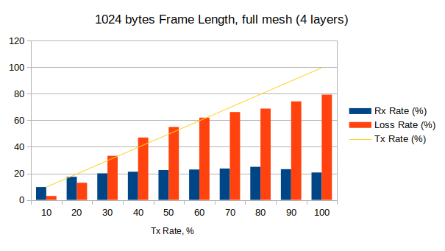

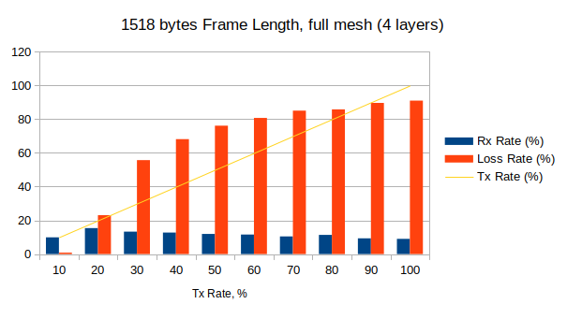

Frame Length | 64 bytes |  | 128 bytes |  | 256 bytes |  | 512 bytes |  | 1024 bytes |  | 1518 bytes
Tx Rate, % | Rx Rate, % | Loss Rate, % | Rx Rate, % | Loss Rate, % | Rx Rate, % | Loss Rate, % | Rx Rate, % | Loss Rate, % | Rx Rate, % | Loss Rate, % | Rx Rate, % | Loss Rate, %
10 | 9,93 | 0,69 | 9,95 | 0,48 | 9,93 | 0,67 | 9,88 | 1,21 | 9,7 | 2,96 | 9,91 | 0,86
20 | 17,59 | 12,03 | 17,83 | 10,87 | 18,08 | 9,62 | 18,03 | 9,86 | 17,42 | 12,91 | 15,39 | 23,05
30 | 16,82 | 43,95 | 20,6 | 31,35 | 21,31 | 28,98 | 20,97 | 30,09 | 20,03 | 33,23 | 13,3 | 55,68
40 | 13,17 | 67,08 | 22,68 | 43,29 | 23,08 | 42,31 | 23,16 | 42,1 | 21,23 | 47 | 12,74 | 68,15
50 | 9,7 | 80,61 | 25,06 | 49,88 | 24,94 | 50,12 | 24,89 | 50,22 | 22,53 | 54,95 | 11,94 | 76,13
60 | 4,72 | 92,13 | 26,66 | 55,57 | 26,73 | 55,45 | 26,17 | 56,39 | 22,91 | 62 | 11,57 | 80,72
70 | 5,47 | 92,18 | 28,54 | 59,23 | 28,57 | 59,19 | 28,9 | 58,71 | 23,65 | 66,22 | 10,47 | 85,05
80 | 2,29 | 97,14 | 26,87 | 66,42 | 29,9 | 62,62 | 30,06 | 62,42 | 24,95 | 68,82 | 11,37 | 85,78
90 | 0,01 | 99,98 | 14,52 | 83,87 | 28,67 | 68,14 | 23,4 | 74 | 23,16 | 74,26 | 9,33 | 89,63
100 | 0,89 | 99,11 | 11,7 | 88,3 | 21,35 | 78,65 | 28,11 | 71,89 | 20,66 | 79,34 | 9,01 | 90,99

Throughput test

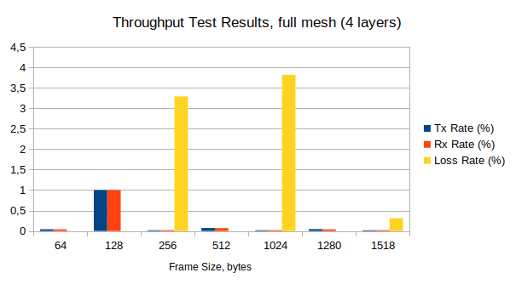

Frame Size, bytes | Tx Rate, % | Tx Rate, b/s | Tx Rate, f/s | Rx Rate, % | Loss Rate, % (frames) | Result
64 | 0,041 | 3,19M | 4743 | 0,04 | 0 (0) | Pass
128 | 1 | 1,31G | 1,1M | 1 | 0 (0) | Pass
256 | 0,018 | 90,9M | 41K | 0,02 | 3,29 (1420) | Fail
512 | 0,073 | 91,21M | 21K | 0,07 | 0 (0) | Pass
1024 | 0,018 | 3,15M | 377 | 0,02 | 3,82 (432) | Fail
1280 | 0,045 | 3,18M | 306 | 0,04 | 0 (0) | Pass
1518 | 0,018 | 3,14M | 255 | 0,02 | 0,31 (24) | Fail

2.2. Partial 1:N Mesh Results, 4 layers

XenaBay
(Valkyrie
2889 v1.40)
WRS
(nwt0010,
FW v6.1)
TX-to-RX: 1-to-17 or 17-to-1
WRS
(nwt0016,
FW v6.1)
WRS
(nwt0296,
FW v6.1)
WRS
(nwt0297,
FW v6.1)

Forwarding test

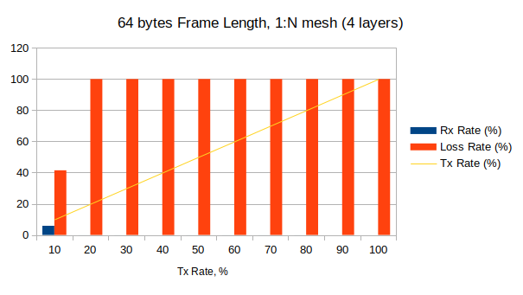

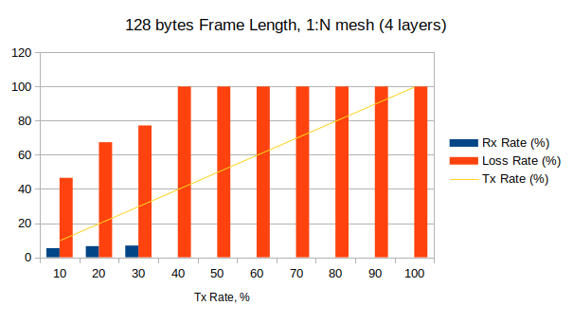

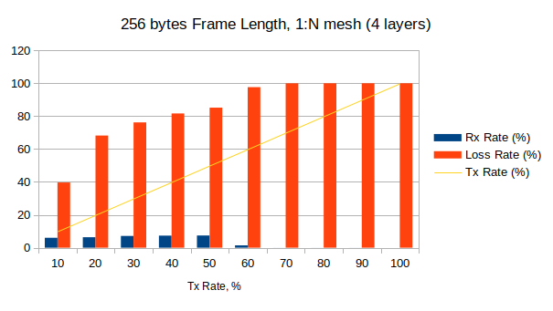

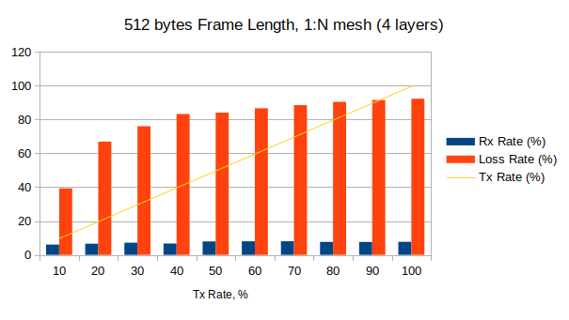

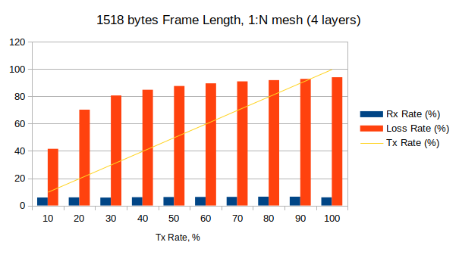

Frame Length | 64 bytes |  | 128 bytes |  | 256 bytes |  | 512 bytes |  | 1024 bytes |  | 1518 bytes
Tx Rate, % | Rx Rate, % | Loss Rate, % | Rx Rate, % | Loss Rate, % | Rx Rate, % | Loss Rate, % | Rx Rate, % | Loss Rate, % | Rx Rate, % | Loss Rate, % | Rx Rate, % | Loss Rate, %
10 | 5,83 | 41,67 | 5,94 | 40,64 | 6,02 | 39,82 | 6,03 | 39,65 | 6,06 | 39,37 | 5,85 | 41,49
20 | 6,27 | 68,66 | 6,35 | 68,25 | 6,38 | 68,11 | 6,46 | 67,7 | 5,83 | 70,84 | 5,87 | 70,66
30 | 6,5 | 78,32 | 5,25 | 82,49 | 6,76 | 77,48 | 6,31 | 78,96 | 6,21 | 79,31 | 5,41 | 81,97
40 | 6,57 | 83,57 | 6,91 | 82,73 | 6,97 | 82,56 | 7,02 | 82,44 | 7,02 | 82,45 | 5,83 | 85,41
50 | 0,01 | 99,99 | 7,09 | 85,81 | 7,37 | 85,27 | 7,3 | 85,41 | 7,3 | 85,4 | 5,9 | 88,2
60 | 0,01 | 99,98 | 6,64 | 88,93 | 7,08 | 88,21 | 7,58 | 87,36 | 7,63 | 87,28 | 5,79 | 90,17
70 | 0,01 | 99,99 | 7,65 | 89,07 | 7,8 | 88,86 | 7,83 | 88,81 | 7,26 | 89,63 | 5,79 | 91,73
80 | 0,02 | 99,98 | 7,82 | 90,23 | 7,96 | 90,05 | 8,09 | 89,88 | 7,73 | 90,34 | 5,79 | 92,76
90 | 0,01 | 99,99 | 0,01 | 99,98 | 7,71 | 91,44 | 7,94 | 91,18 | 8,21 | 90,88 | 5,74 | 93,62
100 | 0,01 | 99,99 | 0 | 100 | 7,86 | 92,14 | 8,06 | 91,94 | 8,37 | 91,63 | 5,64 | 94,36

Throughput test

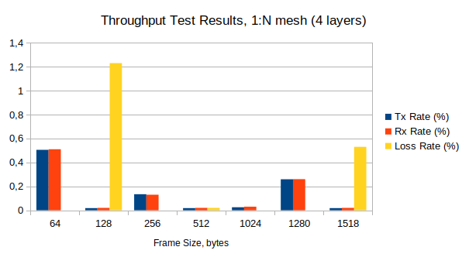

Frame Size, bytes | Tx Rate, % | Tx Rate, b/s | Tx Rate, f/s | Rx Rate, % | Loss Rate, % (frames) | Result
64 | 0,505 | 90,9M | 135K | 0,51 | 0 (0) | Pass
128 | 0,018 | 3,19M | 2696 | 0,02 | 1,23 (991) | Fail
256 | 0,134 | 24,07M | 11K | 0,13 | 0 (0) | Pass
512 | 0,018 | 3,19M | 750 | 0,02 | 0,02 (5) | Fail
1024 | 0,025 | 4,58M | 548 | 0,03 | 0 (0) | Pass
1280 | 0,259 | 46,69M | 4490 | 0,26 | 0 (0) | Pass
1518 | 0,018 | 3,19M | 259 | 0,02 | 0,53 (41) | Fail

2.3. Partial N:N Mesh Results, 4 layers

XenaBay
(Valkyrie
2889 v1.40)
WRS
(nwt0010,
FW v6.1)
TX-to-RX: 9-to-9
WRS
(nwt0016,
FW v6.1)
WRS
(nwt0296,
FW v6.1)
WRS
(nwt0297,
FW v6.1)

Forwarding test

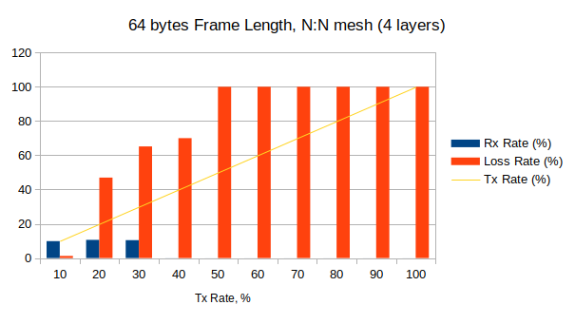

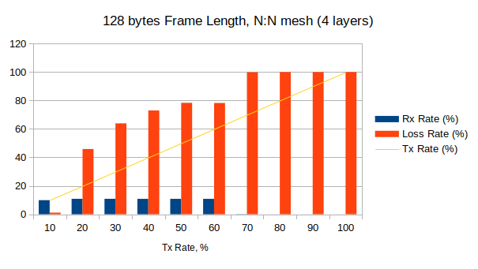

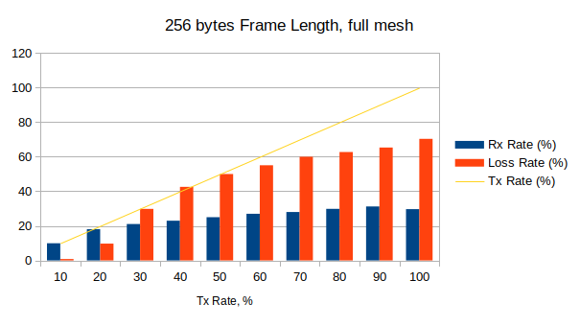

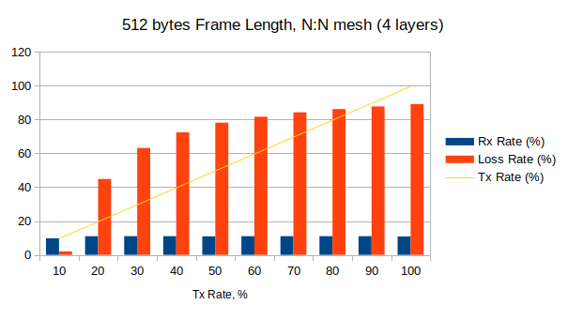

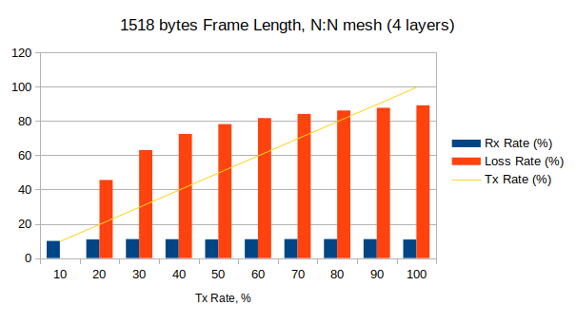

 | Frame Length, bytes
 | 64 |  | 128 |  | 256 |  | 512 |  | 1024 |  | 1518
Tx Rate, % | Rx Rate, % | Loss Rate, % | Rx Rate, % | Loss Rate, % | Rx Rate, % | Loss Rate, % | Rx Rate, % | Loss Rate, % | Rx Rate, % | Loss Rate, % | Rx Rate, % | Loss Rate, %
10 | 9,88 | 1,22 | 9,89 | 1,14 | 9,99 | 0,07 | 9,79 | 2,07 | 9,97 | 0,29 | 10 | 0
20 | 10,61 | 46,95 | 10,83 | 45,87 | 10,96 | 45,22 | 11,03 | 44,83 | 10,88 | 45,59 | 10,88 | 45,58
30 | 10,45 | 65,17 | 10,83 | 63,91 | 10,96 | 63,46 | 11,04 | 63,21 | 11,08 | 63,08 | 11,06 | 63,05
40 | 0,03 | 69,99 | 10,81 | 72,98 | 10,96 | 72,6 | 11,04 | 72,41 | 11,08 | 72,31 | 11,01 | 72,48
50 | 0,01 | 99,97 | 10,82 | 78,36 | 10,92 | 78,17 | 10,94 | 78,12 | 11,08 | 77,85 | 10,9 | 78,19
60 | 0,01 | 99,98 | 10,82 | 78,25 | 10,96 | 81,73 | 11,02 | 81,64 | 11,08 | 81,54 | 10,98 | 81,71
70 | 0,01 | 99,99 | 0,11 | 99,85 | 10,96 | 84,34 | 11,03 | 84,24 | 10,99 | 84,3 | 11,09 | 84,15
80 | 0,01 | 99,99 | 0,01 | 99,98 | 10,83 | 86,46 | 11,04 | 86,2 | 11,08 | 86,15 | 11,09 | 86,14
90 | 0,01 | 99,99 | 0,01 | 99,99 | 10,84 | 87,96 | 11,03 | 87,74 | 10,84 | 87,95 | 11,05 | 87,72
100 | 0,01 | 99,99 | 0,01 | 99,99 | 10,96 | 89,04 | 10,87 | 89,13 | 11,08 | 88,92 | 10,83 | 89,17

Throughput test

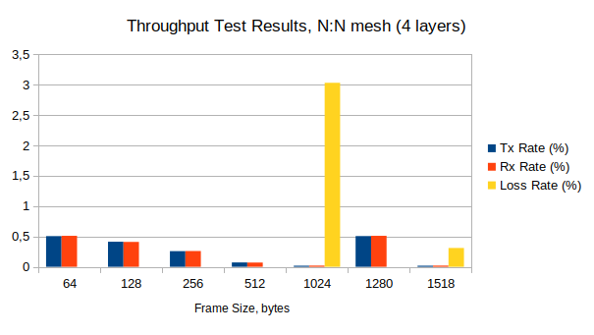

Frame Size, bytes | Tx Rate, % | Tx Rate, b/s | Tx Rate, f/s | Rx Rate, % | Loss Rate, % (frames) | Result
64 | 0,505 | 45,45M | 67,6K | 0,51 | 0 (0) | Pass
128 | 0,413 | 37,14M | 31,4K | 0,41 | 0 (0) | Pass
256 | 0,258 | 23,2M | 10,5K | 0,26 | 0 (0) | Pass
512 | 0,072 | 6,47M | 1520 | 0,07 | 0 (0) | Pass
1024 | 0,018 | 1,58M | 189 | 0,02 | 3,03 (172) | Fail
1280 | 0,506 | 45,52M | 4377 | 0,51 | 0 (0) | Pass
1518 | 0,018 | 1,59M | 130 | 0,02 | 0,31 (12) | Fail

2.4. Congestion Control Results, 4 layers

XenaBay
(Valkyrie
2889 v1.40)
WRS
(nwt0010,
FW v6.1)
RX: 1/1 congested/uncongested
WRS
(nwt0016,
FW v6.1)
WRS
(nwt0296,
FW v6.1)
WRS
(nwt0297,
FW v6.1)

Frame Size | Tx Rate, % | Tx Frames | UC-Port:  Tx | UC-Port:  Rx | UC-Port:  Loss, % | C-Port:  Tx | C-Port:  Rx | C-Port:  Loss, % | Result
64 | 100 | 89285715 | 22321429 | 13529892 | 39,38 | 66964286 | 29088136 | 56,56 | Fail
128 | 100 | 50675676 | 12668919 | 3792798 | 70,06 | 38006757 | 20880846 | 45,06 | Fail
256 | 100 | 27173914 | 6793479 | 1918984 | 71,75 | 20380435 | 11475425 | 43,69 | Fail
512 | 100 | 14097746 | 3524437 | 3313398 | 5,99 | 10573309 | 3683671 | 65,16 | Fail
1024 | 100 | 7183908 | 1795977 | 1346084 | 25,05 | 5387931 | 2232593 | 58,56 | Fail
1280 | 100 | 5769232 | 1442308 | 1362413 | 5,54 | 4326924 | 1513763 | 65,02 | Fail
1518 | 100 | 4876464 | 1219116 | 551574 | 54,76 | 3657348 | 1880644 | 48,58 | Fail

C-Port: Congested Port
UC-Port: Uncongested Port

2.5. Forward Pressure Results, 4 layers

XenaBay
(Valkyrie
2889 v1.40)
WRS
(nwt0010,
FW v6.1)
1 TX port, 1 RX port
WRS
(nwt0016,
FW v6.1)
WRS
(nwt0296,
FW v6.1)
WRS
(nwt0297,
FW v6.1)

Frame Size,  bytes | Tx Frames | Tx max. util.,  % | Rx Frames | Rx max. util.,  % | Loss, % | Result
64 | 45180722 | 101,205 | 42613551 | 95,45 | 5,68 | Pass
128 | 25510204 | 100,68 | 24671032 | 97,368 | 3,29 | Pass
256 | 13636363 | 100,364 | 13392872 | 98,571 | 1,79 | Pass
512 | 7062146 | 100,188 | 6996305 | 99,253 | 0,93 | Pass
1024 | 3595397 | 100,096 | 3578293 | 99,618 | 0,48 | Pass
1280 | 2886048 | 100,05 | 2875032 | 99,693 | 0,38 | Pass
1518 | 2439817 | 100,065 | 2431956 | 99,74 | 0,32 | Pass

2.6. Maximum Forwarding Rate Results, 4 layers

XenaBay
(Valkyrie
2889 v1.40)
WRS
(nwt0010,
FW v6.1)
1 TX port, 1 RX port
WRS
(nwt0016,
FW v6.1)
WRS
(nwt0296,
FW v6.1)
WRS
(nwt0297,
FW v6.1)

Frame Size, bytes | Tx Rate, % | Tx Rate, f/s | Tx Frames | Rx Frames | Loss, % (calculated) | Result
64 | 90,04 | 1339,9K | 40196901 | 40050411 | 0,4 | Pass
128 | 100 | 844,5K | 25337837 | 24671036 | 2,6 | Pass
256 | 100 | 452,9K | 13586956 | 13392868 | 1,4 | Pass
512 | 100 | 234,9K | 7048872 | 6996303 | 0,7 | Pass
1024 | 100 | 119,7K | 3591954 | 3578293 | 0,4 | Pass
1280 | 100 | 96,1K | 2884615 | 2875818 | 0,3 | Pass
1518 | 80 | 65K | 1950585 | 1950585 | 0 | Pass

2.7. Address Caching Capacity and Learning Rate Results, 4 layers

XenaBay
(Valkyrie
2889 v1.40)
WRS
(nwt0010,
FW v6.1)
Test port
WRS
(nwt0016,
FW v6.1)
WRS
(nwt0296,
FW v6.1)
WRS
(nwt0297,
FW v6.1)
Learning port
Monitor port

Address Caching Capacity (Learning Rate=20 frames/s)

Frame Size, bytes | Address Count | Test Port  Tx Frames | Learn Port  Rx Frames | Monitor Port  Rx Frames | Result
64 | 1074 | 1074 | 1073 | 0 | Fail
128 | 404 | 404 | 404 | 0 | Pass
256 | 160 | 160 | 160 | 0 | Pass
512 | 160 | 160 | 160 | 0 | Pass
1024 | 160 | 160 | 160 | 0 | Pass
1280 | 160 | 160 | 160 | 0 | Pass
1518 | 160 | 160 | 160 | 0 | Pass

Address Learning Rate, frame/s (Base Learning Rate=100 frames/s)

Frame size, byte  Address count | 64 | 128 | 256 | 512 | 1024 | 1280 | 1518
100 | 80 | 80 | 80 | 80 | 80 | 40 | 80
612 | 20
1124 | 20
1636 | 20
2048 | 20
404 |  | 20
160 |  |  | 80 | 80 | 80 | 80 | 80

2.8. Errored Frames Filtering Results, 4 layers

XenaBay
(Valkyrie
2889 v1.40)
WRS
(nwt0010,
FW v6.1)
1 TX port, 1 RX port
WRS
(nwt0016,
FW v6.1)
WRS
(nwt0296,
FW v6.1)
WRS
(nwt0297,
FW v6.1)

Tx Rate, % | Tx Frames | Rx Frames | Tx Valid | Rx Valid | Tx Over  size | Rx Over  size | Tx Under  size | Rx Under  size | Tx FCS Error | Rx FCS Error | Result
10 | 1741343 | 1740465 | 154130 | 154130 | 81214 | 81214 | 1505999 | 1505121 | 58 | 0 | Fail
20 | 3482752 | 3480930 | 308261 | 308261 | 162443 | 162443 | 3012048 | 3010226 | 58 | 0 | Fail
30 | 5224128 | 5221495 | 462392 | 462392 | 243664 | 243664 | 4518072 | 4515439 | 58 | 0 | Fail
40 | 6965419 | 6961801 | 616522 | 616522 | 324801 | 324801 | 6024096 | 6020478 | 58 | 0 | Fail
50 | 8706880 | 8702374 | 770653 | 770653 | 406107 | 406107 | 7530120 | 7525614 | 58 | 0 | Fail
60 | 10448257 | 10442887 | 924784 | 924784 | 487329 | 487329 | 9036144 | 9030774 | 58 | 0 | Fail
70 | 12189633 | 12183437 | 1078914 | 1078914 | 568551 | 568551 | 10542168 | 10535972 | 58 | 0 | Fail
80 | 13931009 | 13923924 | 1233045 | 1233045 | 649772 | 649772 | 12048192 | 12041107 | 58 | 0 | Fail
90 | 15672386 | 15663306 | 1387176 | 1387176 | 730994 | 730994 | 13554216 | 13545136 | 58 | 0 | Fail
100 | 17413762 | 13732361 | 1541307 | 1477951 | 812215 | 632652 | 15060240 | 11621758 | 58 | 0 | Fail

2.9. Broadcast Forwarding Results, 4 layers

XenaBay
(Valkyrie
2889 v1.40)
WRS
(nwt0010,
FW v6.1)
1 TX port, 17 RX port
WRS
(nwt0016,
FW v6.1)
WRS
(nwt0296,
FW v6.1)
WRS
(nwt0297,
FW v6.1)

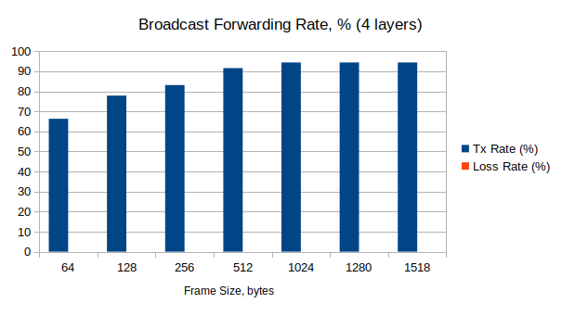

Frame Size, bytes | Tx Rate, % | Loss Rate, % | Loss Frames | Result
64 | 66,29 | 0 | 0 | Pass
128 | 77,85 | 0 | 0 | Pass
256 | 83,12 | 0 | 0 | Pass
512 | 91,56 | 0 | 0 | Pass
1024 | 94,37 | 0 | 0 | Pass
1280 | 94,37 | 0 | 0 | Pass
1518 | 94,37 | 0 | 0 | Pass

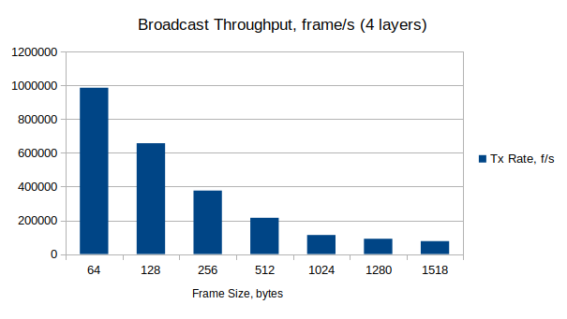

Frame Size, bytes | Tx Rate (Fps)
64 | 986346
128 | 657414
256 | 376442
512 | 215107
1024 | 112997
1280 | 90745
1518 | 76688

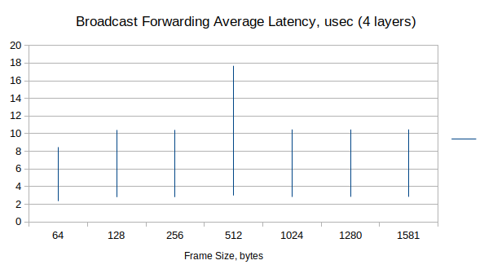

All layers

Frame Size,  bytes | Latency, usec |  |  | Jitter, usec
Frame Size,  bytes | Average | Min | Max | Average | Min | Max
64 | 2,3-8,5 | 2,24-8,26 | 5,92-13,33 | 0,003-0,04 | 0 | 2,45-2,77
128 | 2,8-10,4 | 2,70-10,17 | 6,14-13,87 | 0,002-0,03 | 0 | 2,17-2,33
256 | 2,8-10,4 | 2,69-10,16 | 4,86-12,52 | 0,005-0,01 | 0 | 2,00-2,21
512 | 2,9-17,7 | 2,70-10,16 | 8,24-36,70 | 0,002-0,01 | 0 | 2,10-2,31
1024 | 2,8-10,5 | 2,72-10,21 | 4,90-12,67 | 0,002-0,003 | 0 | 2,10-2,33
1280 | 2,8-10,5 | 2,70-10,20 | 4,72-12,50 | 0,002-0,003 | 0 | 1,88-2,10
1518 | 2,8-10,5 | 2,71-10,22 | 4,68-12,34 | 0,001-0,002 | 0 | 1,85-2,07

1st Layer

Frame Size,  bytes | Latency, usec |  |  | Jitter, usec
Frame Size,  bytes | Average | Min | Max | Average | Min | Max
64 | 2,35-2,39 | 2,24-2,29 | 5,92-6,18 | 0,003-0,04 | 0 | 2,4-2,77
128 | 2,80-2,86 | 2,70-2,73 | 6,14-7,22 | 0,002-0,03 | 0 | 2,11-2,33
256 | 2,80-2,82 | 2,70-2,72 | 4,86-5,00 | 0,005-0,01 | 0 | 2,02-2,12
512 | 2,98-17,69 | 2,70-2,73 | 8,24-36,69 | 0,002-0,01 | 0 | 2,07-2,37
1024 | 2,82-2,86 | 2,72-2,72 | 4,88-5,15 | 0,002-0,003 | 0 | 2,10-2,33
1280 | 2,83-2,86 | 2,70-2,73 | 4,72-4,96 | 0,002-0,003 | 0 | 1,88-2,10
1518 | 2,84-2,85 | 2,71-2,73 | 4,68-4,92 | 0,001-0,002 | 0 | 1,85-2,07

2nd Layer

Frame Size,  bytes | Latency, usec |  |  | Jitter, usec
Frame Size,  bytes | Average | Min | Max | Average | Min | Max
64 | 3,96-3,98 | 3,79-3,83 | 8,72-9,37 | 0,003-0,02 | 0 | 2,6-2,64
128 | 4,91-4,93 | 4,71-4,76 | 8,29-9,01 | 0,010-0,01 | 0 | 2,12-2,14
256 | 4,86-4,88 | 4,70-4,75 | 6,89-6,96 | 0,005-0,01 | 0 | 1,99-2,12
512 | 5,08-5,11 | 4,71-4,76 | 11,71-11,78 | 0,002-0,007 | 0 | 2,09-2,31
1024 | 4,89-4,92 | 4,72-4,77 | 6,96-7,11 | 0,002-0,003 | 0 | 2,09
1280 | 4,88-4,91 | 4,73-4,78 | 6,87-6,99 | 0,002-0,003 | 0 | 2,44
1518 | 4,89-4,93 | 4,74-4,79 | 6,76-6,88 | 0,002 | 0 | 1,88-1,9

3rd Layer

Frame Size,  bytes | Latency, usec |  |  | Jitter, usec
Frame Size,  bytes | Average | Min | Max | Average | Min | Max
64 | 6,20-6,25 | 6,00-6,04 | 10,98 | 0,016-0,022 | 0 | 2,61
128 | 7,57-7,65 | 7,39-7,50 | 10,99-11,06 | 0,002-0,01 | 0 | 2,14
256 | 7,54-7,64 | 7,37-7,49 | 9,65-9,75 | 0,01 | 0 | 2,09-2,17
512 | 7,78-7,88 | 7,39-7,50 | 14,42-14,52 | 0,005-0,007 | 0 | 2,21
1024 | 7,59-7,70 | 7,42-7,51 | 9,73-9,85 | 0,002-0,003 | 0 | 2,12
1280 | 7,58-7,69 | 7,40-7,52 | 9,61-9,73 | 0,003 | 0 | 2,44
1518 | 7,59-7,70 | 7,41-7,53 | 9,45-9,55 | 0,002 | 0 | 1,9

4th Layer

Frame Size,  bytes | Latency, usec |  |  | Jitter, usec
Frame Size,  bytes | Average | Min | Max | Average | Min | Max
64 | 8,43-8,46 | 8,19-8,26 | 13,26-13,33 | 0,016-0,022 | 0 | 2,61-2,64
128 | 10,37-10,41 | 10,10-10,17 | 13,80-13,87 | 0,002-0,01 | 0 | 2,14-2,24
256 | 10,39-10,42 | 10,06-10,16 | 12,44-12,52 | 0,01 | 0 | 2,04-2,12
512 | 10,63-10,66 | 10,07-10,17 | 17,26-17,31 | 0,005-0,007 | 0 | 2,12-2,21
1024 | 10,44-10,47 | 10,14-10,21 | 12,59-12,66 | 0,002-0,003 | 0 | 2,12
1280 | 10,43-10,47 | 10,10-10,19 | 12,45-12,50 | 0,003 | 0 | 2,04
1518 | 10,44-10,47 | 10,15-10,22 | 12,29-12,34 | 0,002 | 0 | 1,9

Source: xena2889-report-20231114-122401.pdf
Source: xena2889-report-20231113-173928.pdf

