Performance Evaluation of
the White Rabbit switch
(RFC 2889 Benchmarking)

Enkhbold Ochirsuren

GSI, TOS

10.04.2025

Table of Contents
1. Overview 3
1 WR switch 3
1.1. Full Mesh Test 5
Forwarding test 6
Throughput test 8
1.2. Partial 1:N Mesh Test 9
Forwarding test 10
Throughput test 12
1.3. Partial N:N Mesh Test 13
Forwarding test 14
Throughput test 16
1.4. Congestion Control Test 17
1.5. Forward Pressure Test 18
1.6. Maximum Forwarding Rate Test 19
1.7. Address Caching Capacity and Learning Rate Tests 20
1.8. Errored Frames Filtering Test 21
1.9. Broadcast Forwarding Test 22

1. Overview

The performance of the White Rabbit switch is evaluated by the methods defined in RFC 2889. This RFC deals with networking devices at the Medium Access Control (MAC) layer and provides a methodology for checking the capabilities given below:
- frame forwarding performance (forwarding rate and throughput)
- congestion control
- forward pressure and maximum forwarding rate
- broadcast forwarding and latency
- address handling

The testbed includes:
- chassis: XenaBay
- software: Xena2889 v1.46 (former Valkyrie2889), Windows 10 Enterprise LTSC 2021
- configuration: https://github.com/GSI-CS-CO/network_testing
- wr_RFC_2889/xena_cfg/RFC_2889_1_switch_Xena.x2889

As a device under test the WR switch from Creotech (model WRS-3/18) with the HW version v3.4 and SW version v8.0 is chosen.

Unlike to previous tests, RFC2889 benchmarking is done in one test setup:
- single WR switch

Similar to the all previous tests for SW versions v6.1 and v7.0, the test results are color coded to indicate if the WR switch passes or fails each test. The results that cannot be concluded are in orange.

Moreover, test results are compared with the results of previous test with v7.0 and comparison results are coded as follows: better than previous (+), worse than (-) and not much different (=).

1 WR switch

Test results in ‘wr_RFC_2889/xena_results/v8.0/xena2889-report_1_wrs_v80-20250408-091455.pdf’ are evaluated.

- Traffic test(-): for all predefined frame lengths (64-1518 bytes) and bandwidths (10-100%, 100M-1Gb/s) there are frame losses. Throughput cannot be determined for all frame lengths in a single test. Test results show that total throughput (-) is worsened and the forwarding rates (=) remain similar compared to the v7.0 results.
  - full mesh (-): maximum total throughput reached to 12,9Mb/s (5,85Kframe/s) for the frame size 256 bytes. For a single port it corresponds to 0,7Mb/s (325 frame/s) data rate. The throughput tests were passed for the frame sizes of 64 and 256 bytes.
  - partial 1:N mesh (-): maximum total throughput reached to 3,2Mb/s with losses for all specified frame sizes. The throughput tests were failed for all specified frame sizes.
  - partial N:N mesh (-): maximum total throughput reached to 1,6Mb/s with losses for all specified frame sizes. The throughput tests were failed for all specified frame sizes.
- Congestion control (-): no congestion control. Neither ‘head of line blocking’ (for uncongested port) nor back pressure (for congested port) is detected. Frame loss of 62,8% is detected for the frame size of 1518 bytes.
- Forward pressure (=): no ‘forward pressure’ is detected and switch can guarantee the interfame gap (IFG) of 96-bits.
- Maximum forwarding rate (=): maximum TX rates of 90% to 100% are achieved. Frame losses are detected for the frame sizes of 64 and 1280 bytes.
- Address caching capacity and learning rate (=): switch has inherently the slow address learning capability (< 1ms). Therefore, at the relative low frame rate (20f/s) the switch can learn up to 1074 MAC addresses (and it starts flooding with more MAC addresses). There is a problem in MAC aging: switch keeps MAC addresses beyond the aging time. This means that if ‘aging time’ (or ‘toggling sync state’) is selected for address reset condition, then test is failed. This behavior is observed in all previous software versions including v4.2, v5.0.1, v6.0, v6.1 and v7.0.
- Errored frames filtering (=): oversized and undersized frames cannot be filtered, but invalid FCS frames.
- Broadcast forwarding (=): forwarding rates of 66% (663 Mb/s) to 94,4% (943,7 Mb/s) are measured. The longer the frame size => better the broadcasting rate. For all frame sizes except 512 bytes, the average latencies stay below 7 us. Only for the frame size of 512 bytes, the average and maximum latencies reached up to 121 us and 240 us, respectively, which are significantly higher than all other measurement results.

One-line commands to extract test results from a given report file:
- extract specific test results from a given PDF file and store them in plain text (eg., full mesh):
  - pdftotext -f 8 -l 57 -layout <xena2889-report.pdf>
- extract ‘Rx Rate (Percent)’ values (eg., for frame size of 64 bytes) from the plain text file and sort them:
  - grep "Rx Rate (Percent)" <xena2889-report.txt> | sed 'n;d' | tr -s ' ' | cut -d " " -f 4
    - in case of if values for the frame size of 1518 is shown in separate lines:
      - sed ‘n;d’ – skip every second line, which has value for the frame size of 1518 bytes
      - sed ‘1~2d’ – skip every second line starting from line 1 (used to read the values for the frame size of 1518)
- replace “0%” with “0 %” in .txt file:
  - sed -i 's/\b0%/0 %/g' <xena2889-report.txt>
- extract the average, minimum and maximum latency values from the broadcast forwarding test results (eg., frame size = 64 bytes):
  - for str in Avg Min Max; do echo $str; grep "$str Latency" <xena2889-report.txt> | head -17 | tr -s ' ' | cut -d " " -f 5 | sort -g; done

1.1. Full Mesh Test
XenaBay
(Xena
2889 v1.46)
WRS
(nwt0297,
FW v8.0)
all 18 ports in TX and RX

Forwarding test

Frame  Size,  bytes > | 64 |  | 128 |  | 256 |  | 512 |  | 1024 |  | 1518
Tx, % | Rx, % | Loss, % | Rx, % | Loss, % | Rx, % | Loss, % | Rx, % | Loss, % | Rx, % | Loss, % | Rx, % | Loss, %
10 | 7,6 | 24 | 7,77 | 22,26 | 7,82 | 21,79 | 8,02 | 19,75 | 8,03 | 19,74 | 7,62 | 23,82
20 | 0,03 | 99,87 | 12,11 | 39,47 | 12,02 | 39,92 | 12,15 | 39,26 | 12,17 | 39,15 | 12,08 | 39,6
30 | 0,02 | 99,95 | 16,37 | 45,42 | 16,66 | 44,46 | 16,69 | 44,37 | 16,57 | 44,78 | 16,43 | 45,23
40 | 0,01 | 99,97 | 0,03 | 99,92 | 20,57 | 48,57 | 20,59 | 48,53 | 20,58 | 48,54 | 20,59 | 48,51
50 | 0,01 | 99,98 | 0,03 | 99,95 | 25,35 | 49,29 | 25,35 | 49,29 | 25,57 | 48,87 | 25,43 | 49,15
60 | 0,01 | 99,99 | 0,02 | 99,96 | 1,77 | 97,05 | 29,23 | 51,28 | 29,19 | 51,36 | 28,94 | 51,77
70 | 0,01 | 99,99 | 0,02 | 99,97 | 0,06 | 99,92 | 34,25 | 51,07 | 34,5 | 50,71 | 34,19 | 51,15
80 | 0,01 | 99,99 | 0,02 | 99,98 | 0,05 | 99,94 | 37,7 | 52,88 | 37,92 | 52,61 | 38 | 52,5
90 | 0,01 | 99,99 | 0,01 | 99,98 | 0,03 | 99,97 | 11,89 | 86,79 | 11,97 | 86,7 | 23,64 | 73,74
100 | 0 | 100 | 0,01 | 99,99 | 0,03 | 99,97 | 11,84 | 88,16 | 9,44 | 90,56 | 14,76 | 85,24

Table 1.1.a. Forwarding rate test results

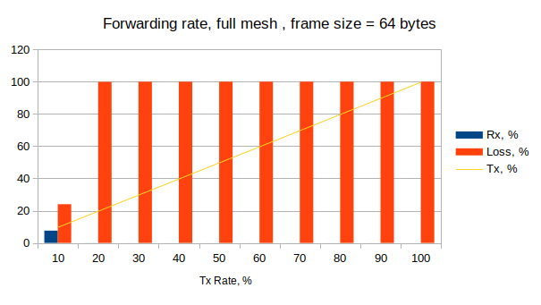

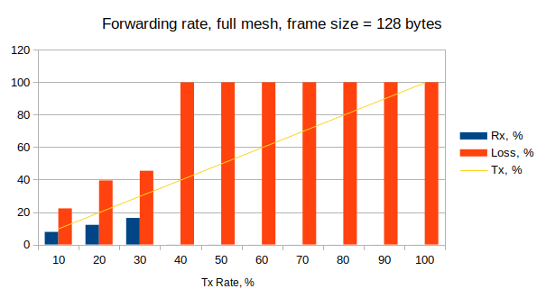

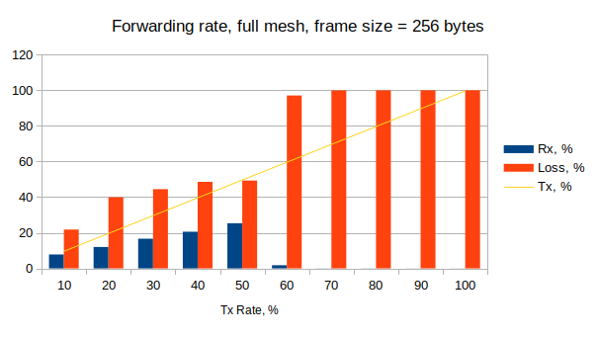

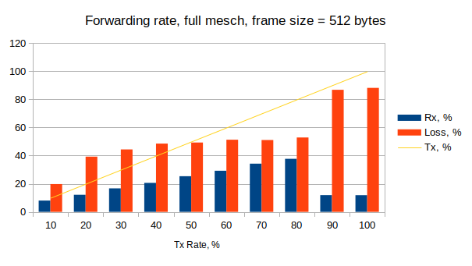

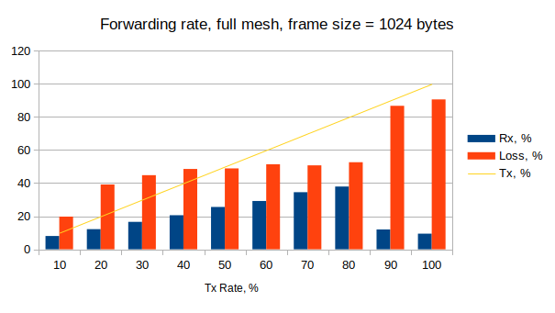

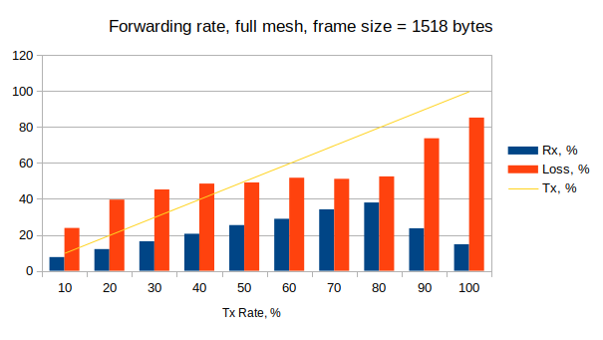

Throughput test

Frame Size, bytes | Tx Rate, % | Tx Rate, b/s | Tx Rate, f/s | Rx Rate, % | Loss Rate, % (frames) | Result
64 | 0,018 | 3,2M | 4743 | 0,02 | 0 (0) | Pass
128 | 0,018 | 3,2M | 2693 | 0,02 | 3,1 (2489) | Fail
256 | 0,072 | 12,9M | 5855 | 0,07 | 0 (0) | Pass
512 | 0,018 | 3,2M | 745 | 0,02 | 4 (884) | Fail
1024 | 0,018 | 3,2M | 377 | 0,02 | 2 (223) | Fail
1280 | 0,018 | 3,2M | 306 | 0,02 | 2,7 (250) | Fail
1518 | 0,018 | 3,1M | 255 | 0,02 | 3,1 (233) | Fail

Table 1.1.b. Throughput test results

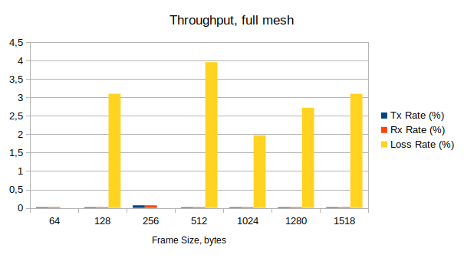

1.2. Partial 1:N Mesh Test

XenaBay
(Xena
2889 v1.46)
WRS
(nwt0297,
FW v8.0)
TX-to-RX: 1-to-17 or 17-to-1

Forwarding test

Frame  Size,  bytes > | 64 |  | 128 |  | 256 |  | 512 |  | 1024 |  | 1518
Tx, % | Rx, % | Loss, % | Rx, % | Loss, % | Rx, % | Loss, % | Rx, % | Loss, % | Rx, % | Loss, % | Rx, % | Loss, %
10 | 5,72 | 42,79 | 5,83 | 41,69 | 5,91 | 40,92 | 5,95 | 40,49 | 6,04 | 39,59 | 5,72 | 42,82
20 | 0,03 | 99,87 | 6,08 | 69,61 | 6,15 | 69,25 | 6,21 | 68,94 | 6,21 | 68,94 | 5,76 | 71,21
30 | 0,01 | 99,96 | 6,19 | 79,38 | 6,44 | 78,53 | 5,95 | 80,18 | 6,48 | 78,4 | 4,29 | 85,7
40 | 0,01 | 99,98 | 0,02 | 99,96 | 6,21 | 84,47 | 6,71 | 83,22 | 6,32 | 84,2 | 5,92 | 85,2
50 | 0,01 | 99,98 | 0,01 | 99,97 | 6,44 | 87,12 | 6,84 | 86,32 | 6,81 | 86,38 | 6,2 | 87,6
60 | 0,01 | 99,99 | 0,01 | 99,98 | 1,97 | 96,71 | 6,81 | 88,64 | 6,61 | 88,98 | 5,99 | 90,02
70 | 0,01 | 99,99 | 0 | 99,99 | 0,15 | 99,78 | 7,17 | 89,75 | 7,07 | 89,9 | 6,02 | 91,4
80 | 0,01 | 99,99 | 0,01 | 99,99 | 0,02 | 99,98 | 6,51 | 91,87 | 7,1 | 91,12 | 6,11 | 92,36
90 | 0 | 100 | 0,01 | 99,99 | 0 | 100 | 6,68 | 92,58 | 6,78 | 92,46 | 6,09 | 93,24
100 | 0 | 100 | 0,01 | 99,99 | 0,02 | 99,98 | 0 | 100 | 6,77 | 93,23 | 0 | 100

Table 1.2.a. Forwarding rate test results

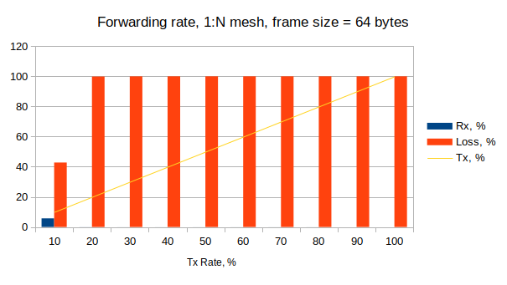

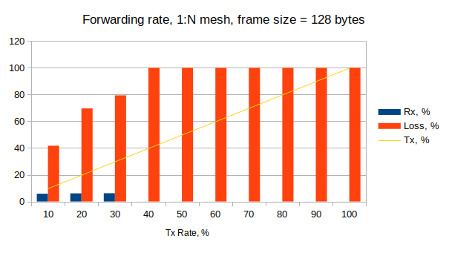

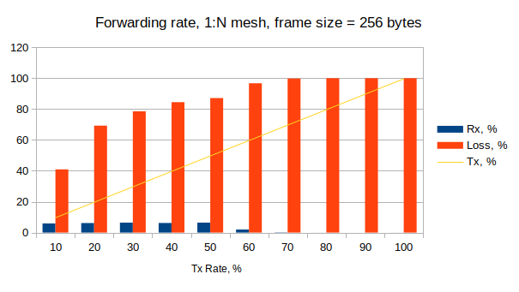

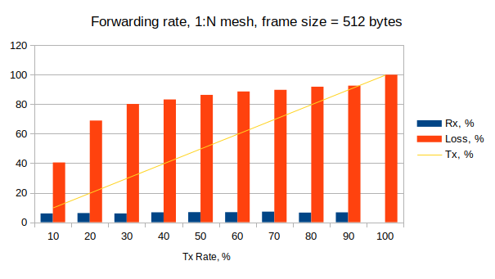

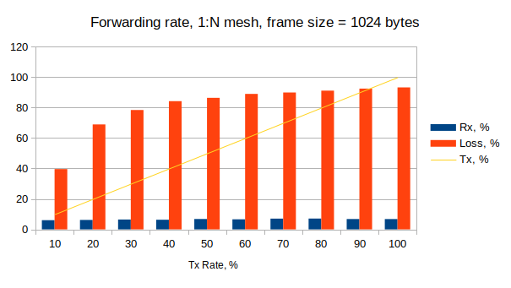

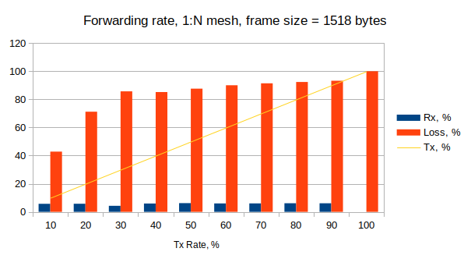

Throughput test

Frame Size, bytes | Tx Rate, % | Tx Rate, b/s | Tx Rate, f/s | Rx Rate, % | Loss Rate, % (frames) | Result
64 | 0,018 | 3,2M | 4750 | 0,02 | 2,6 (3712) | Fail
128 | 0,018 | 3,2M | 2696 | 0,02 | 1,7 (1383) | Fail
256 | 0,018 | 3,2M | 1445 | 0,02 | 0,7 (280) | Fail
512 | 0,018 | 3,2M | 750 | 0,02 | 1,3 (281) | Fail
1024 | 0,018 | 3,2M | 382 | 0,02 | 6,7 (764) | Fail
1280 | 0,018 | 3,2M | 307 | 0,02 | 1,6 (148) | Fail
1518 | 0,018 | 3,2M | 259 | 0,02 | 0,9 (73) | Fail

Table 1.2.b. Throughput test results

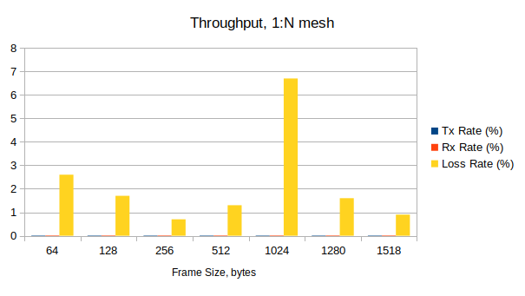

1.3. Partial N:N Mesh Test
XenaBay
(Xena
2889 v1.46)
WRS
(nwt0297,
FW v8.0)
TX-to-RX: 9-to-9

Forwarding test

Frame  Size,  bytes > | 64 |  | 128 |  | 256 |  | 512 |  | 1024 |  | 1518
Tx, % | Rx, % | Loss, % | Rx, % | Loss, % | Rx, % | Loss, % | Rx, % | Loss, % | Rx, % | Loss, % | Rx, % | Loss, %
10 | 9,38 | 6,21 | 9,92 | 0,76 | 9,69 | 3,06 | 9,43 | 5,68 | 9,78 | 2,23 | 9,38 | 6,24
20 | 10,62 | 46,91 | 10,83 | 45,86 | 10,95 | 45,23 | 11,03 | 44,83 | 11,01 | 44,93 | 11,09 | 44,57
30 | 10,61 | 64,65 | 10,81 | 63,97 | 10,96 | 63,45 | 11,04 | 63,21 | 11,07 | 63,1 | 10,94 | 63,52
40 | 0,02 | 99,95 | 10,83 | 72,92 | 10,96 | 72,6 | 10,8 | 72,99 | 11,04 | 72,4 | 11,09 | 72,27
50 | 0,01 | 99,97 | 10,83 | 78,34 | 10,92 | 78,15 | 10,9 | 78,19 | 11,07 | 77,85 | 10,99 | 78,02
60 | 0,01 | 99,98 | 10,74 | 82,1 | 10,46 | 82,56 | 11,04 | 81,61 | 11,05 | 81,58 | 11 | 81,66
70 | 0,01 | 99,98 | 0,85 | 98,79 | 10,96 | 84,34 | 11,04 | 84,23 | 11,08 | 84,17 | 11,01 | 84,27
80 | 0,01 | 99,99 | 0,02 | 99,98 | 10,97 | 86,29 | 10,91 | 86,37 | 11,07 | 86,16 | 10,89 | 86,38
90 | 0,01 | 99,99 | 0,02 | 99,98 | 10,87 | 87,93 | 10,94 | 87,84 | 11,08 | 87,69 | 11,09 | 87,67
100 | 0,01 | 99,99 | 0,02 | 99,98 | 10,96 | 89,04 | 11,04 | 88,96 | 11,05 | 88,95 | 11,05 | 88,95

Table 1.3.a. Forwarding rate test results

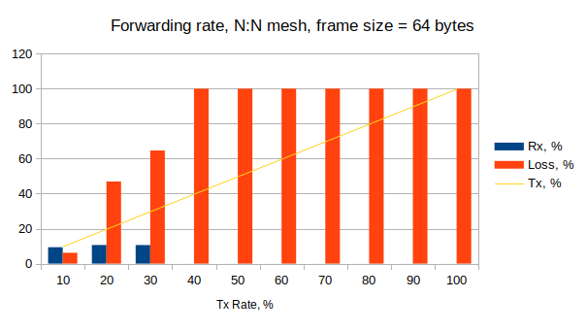

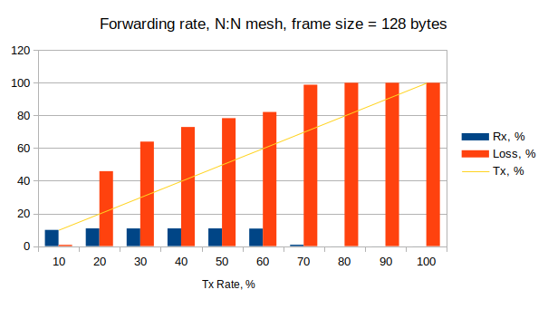

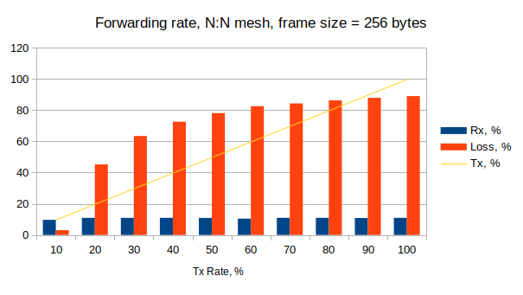

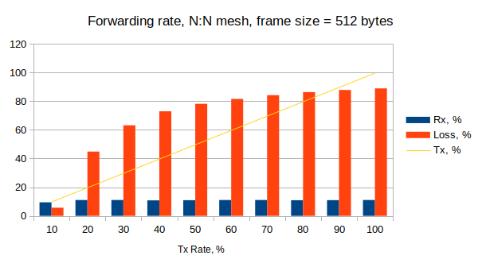

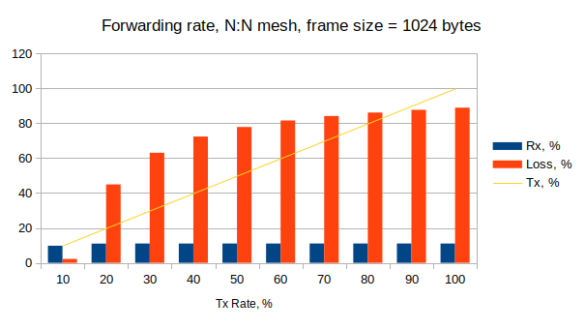

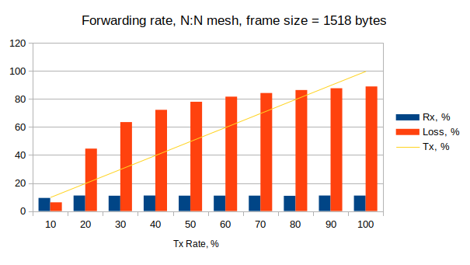

Throughput test

Frame Size, bytes | Tx Rate, % | Tx Rate, b/s | Tx Rate, f/s | Rx Rate, % | Loss Rate, % (frames) | Result
64 | 0,018 | 1,6M | 2373 | 0,02 | 1,6 (1146) | Fail
128 | 0,018 | 1,6M | 1347 | 0,02 | 0,8 (330) | Fail
256 | 0,018 | 1,6M | 721 | 0,02 | 1,4 (296) | Fail
512 | 0,018 | 1,6M | 373 | 0,02 | 1,7 (187) | Fail
1024 | 0,018 | 1,6M | 189 | 0,02 | 5 (284) | Fail
1280 | 0,018 | 1,6M | 151 | 0,02 | 0,04 (2) | Fail
1518 | 0,018 | 1,6M | 130 | 0,02 | 2,2 (84) | Fail

Table 1.3.b. Throughput test results

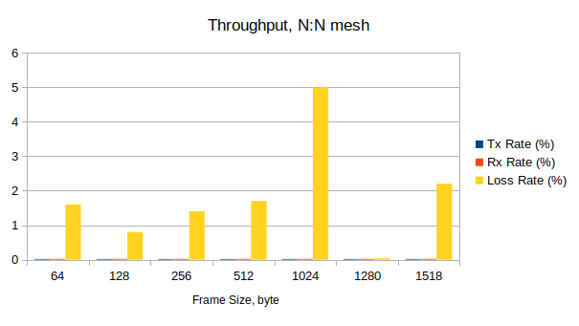

1.4. Congestion Control Test
2 ports in TX, 2 ports in RX

XenaBay
(Xena
2889 v1.46)
WRS
(nwt0297,
FW v8.0)

Frame Size | Tx Rate, % | Tx Frames | UC-Port:  Tx | UC-Port:  Rx | UC-Port:  Loss, % | C-Port:  Tx | C-Port:  Rx | C-Port:  Loss, % | Result
64 | 100 | 89285716 | 22321429 | 22321429 | 0 | 66964287 | 42621942 | 36,35 | Pass
128 | 100 | 50675677 | 12668920 | 12668920 | 0 | 38006757 | 24672541 | 35,08 | Pass
256 | 100 | 27173914 | 6793479 | 6793479 | 0 | 20380435 | 13393816 | 34,28 | Pass
512 | 100 | 14097746 | 3524437 | 3524437 | 0 | 10573309 | 6996695 | 33,83 | Pass
1024 | 100 | 7183910 | 1795978 | 1795978 | 0 | 5387932 | 3578526 | 33,58 | Pass
1280 | 100 | 5769232 | 1442308 | 1442308 | 0 | 4326924 | 2875992 | 33,53 | Pass
1518 | 100 | 4876464 | 1219116 | 453249 | 765867 | 3657348 | 2432092 | 33,50 | Fail

Table 1.4. Congestion control test results (C-Port: Congested Port, UC-Port: Uncongested Port)

1.5. Forward Pressure Test

XenaBay
(Xena
2889 v1.46)
WRS
(nwt0297,
FW v8.0)
1 TX port, 1 RX port

Frame Size,  bytes | Tx Frames | Tx max. util.,  % | Rx Frames | Rx max. util.,  % | Loss, % | Result
64 | 45180722 | 101,205 | 42613630 | 95,45 | 5,68 | Pass
128 | 25510204 | 100,68 | 24671078 | 97,368 | 3,29 | Pass
256 | 13636363 | 100,364 | 13392895 | 98,571 | 1,79 | Pass
512 | 7062146 | 100,188 | 6996318 | 99,254 | 0,93 | Pass
1024 | 3595397 | 100,096 | 3578299 | 99,618 | 0,48 | Pass
1280 | 2886836 | 100,077 | 2875824 | 99,693 | 0,38 | Pass
1518 | 2439817 | 100,065 | 2431962 | 99,74 | 0,32 | Pass

Table 1.5. Forward pressure test results

1.6. Maximum Forwarding Rate Test
XenaBay
(Xena
2889 v1.46)
WRS
(nwt0297,
FW v8.0)
1 port in TX, 1 port in RX

Frame Size, bytes | Tx Rate, % | Tx Rate, f/s | Tx Frames | Rx Frames | Loss, % (calculated) | Result
64 | 90 | 1339,5K | 40186488 | 40186488 | 0 | Pass
128 | 100 | 844,6K | 25337837 | 24602240 | 2,9 | Pass
256 | 100 | 452,9K | 13586956 | 13392925 | 1,4 | Pass
512 | 100 | 235K | 7048872 | 6996333 | 0,7 | Pass
1024 | 100 | 119,7K | 3591954 | 3578309 | 0,4 | Pass
1280 | 90 | 86,5K | 2596153 | 2596153 | 0 | Pass
1518 | 100 | 81,3K | 2438231 | 2431967 | 0,26 | Pass

Table 1.6. Maximum forwarding rate test results

1.7. Address Caching Capacity and Learning Rate Tests

XenaBay
(Xena
2889 v1.46)
WRS
(nwt0297,
FW v8.0)
3 ports (test, learning, monitor)

Address Caching Capacity (Learning Rate=20 Frames/s, DUT aging=310 seconds)

Frame Size, bytes | Address Count | Test Port  Tx Frames | Learn Port  Rx Frames | Monitor Port  Rx Frames | Result
64 | 1074 | 22 | 22 | 22 | Fail
128 | 100 | 22 | 22 | 22 | Fail
256 | 100 | 22 | 22 | 22 | Fail
512 | 100 | 22 | 22 | 22 | Fail
1024 | 100 | 22 | 22 | 22 | Fail
1280 | 100 | 22 | 22 | 22 | Fail
1518 | 100 | 22 | 22 | 22 | Fail

Table 1.7.a. MAC address caching capacity test results

Address Learning Rate (percent), frame/s (DUT aging=310 seconds)

Frame size, byte  Address count | 64 | 128 | 256 | 512 | 1024 | 1280 | 1518
100 | 20 | 20 | 20 | 20 | 20 | 20 | 20
300 | 20 | 20 | 20 | 20 | 20 | 20 | 20
500 | 20 | 20 | 20 | 20 | 20 | 20 | 20
700 | 20 | 20 | 20 | 20 | 20 | 20 | 20
900 | 20 | 20 | 20 | 20 | 20 | 20 | 20
1100 | 20 | 20 | 20 | 20 | 20 | 20 | 20
1300 | 20 | 20 | 20 | 20 | 20 | 20 | 20
2048 | 20 | 20 | 20 | 20 | 20 | 20 | 20

Table 1.7.b. MAC address learning rate test results

Issue: With the aging time of 310 seconds (300 seconds for WR switches by default) is chosen for the reset condition, the address caching capacity test is failed. Here, switch starts to forward test packets (100, 1074) properly, no flooding. At iteration with the critical number of packets (1561) it floods, and then it remains to flood in all further iterations with decreasing number of the test packets (1317, 1195, …, 1075, 1074). The test is failed because the switch floods even with the same number of packets (1074), with which no flooding was happened in previous iteration.

1.8. Errored Frames Filtering Test

XenaBay
(Xena
2889 v1.46)
WRS
(nwt0297,
FW v8.0)
1 port in TX, 1 port in RX

Tx Rate, % | Tx Valid | Rx Valid | Tx Over  size | Rx Over  size | Tx Under  size | Rx Under  size | Tx FCS Error | Rx FCS Error | Result
10 | 154130 | 154130 | 81221 | 81221 | 1506024 | 1505950 | 59 | 0 | Fail
20 | 308261 | 308261 | 162443 | 162443 | 3012048 | 3003506 | 58 | 0 | Fail
30 | 462392 | 462392 | 243664 | 243664 | 4518072 | 4445299 | 58 | 0 | Fail
40 | 616522 | 616522 | 324886 | 324886 | 6024096 | 5747243 | 58 | 0 | Fail
50 | 770653 | 770653 | 406107 | 406107 | 7530120 | 7100619 | 58 | 0 | Fail
60 | 924784 | 924784 | 487329 | 487329 | 9036144 | 8339676 | 58 | 0 | Fail
70 | 1078914 | 1078914 | 568551 | 568551 | 10542168 | 9458800 | 58 | 0 | Fail
80 | 1233045 | 1233045 | 649772 | 649772 | 12048192 | 10729227 | 58 | 0 | Fail
90 | 1387176 | 1387176 | 730994 | 730994 | 13554216 | 11944767 | 58 | 0 | Fail
100 | 1541307 | 1478061 | 812215 | 629321 | 15060240 | 11621558 | 58 | 0 | Fail

Table 1.8. Errored frames filtering test results

1.9. Broadcast Forwarding Test
XenaBay
(Xena
2889 v1.46)
WRS
(nwt0297,
FW v8.0)
1 port in TX and rest in RX

Frame Size, bytes | Tx Rate, % | Loss Rate, % | Loss Frames | Result
64 | 66,3 | 0 | 0 | Pass
128 | 77,9 | 0 | 0 | Pass
256 | 83,1 | 0 | 0 | Pass
512 | 91,6 | 0 | 0 | Pass
1024 | 94,4 | 0 | 0 | Pass
1280 | 94,4 | 0 | 0 | Pass
1518 | 94,4 | 0 | 0 | Pass

Table 1.9.a. Broadcast forwarding test results

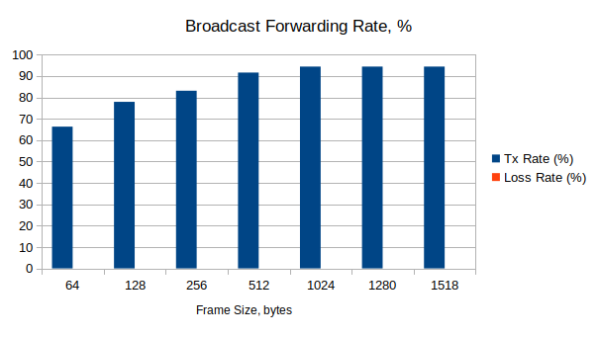

Frame Size, bytes | Tx Rate (Fps)
64 | 986517
128 | 657530
256 | 376472
512 | 215137
1024 | 112997
1280 | 90745
1518 | 76703

Table 1.9.b. Broadcast throughput test results

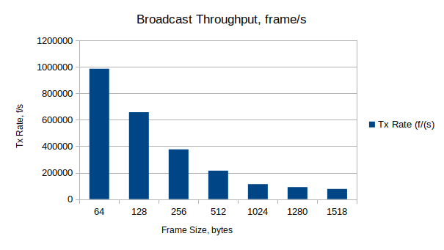

Frame Size,  bytes | Latency, usec |  |  | Jitter, usec
Frame Size,  bytes | Average | Min | Max | Average | Min | Max
64 | 2,5-4,9 | 1,6-2,3 | 6,2-10,6 | 0,003 | 0 | 2,1-2,8
128 | 2,9-6,7 | 2,1-2,8 | 6-12,7 | 0,002 | 0 | 2-2,3
256 | 2,3-3 | 2-2,7 | 4,7-6 | 0,008-0,01 | 0 | 2,2-2,5
512 | 3-121,6 | 2-2,8 | 6,4-240,1 | 0,002 | 0 | 2-2,2
1024 | 2,3-3 | 2,1-2,8 | 4,6-6,4 | 0,003-0,004 | 0 | 2,2-2,5
1280 | 2,3-3 | 2,1-2,8 | 4,4-5,3 | 0,004-0,006 | 0 | 2,2-2,6
1518 | 2,3-3 | 2-2,7 | 4,3-5,3 | 0,002-0,003 | 0 | 2,1-2,4

Table 1.9.c. Latency and jitter measurements in broadcast forwarding
