Performance Evaluation of
the White Rabbit switch
(RFC 2889 Benchmarking)

Enkhbold Ochirsuren

GSI, TOS

14.10.2024

Table of Contents
1. Overview 3
1 WR switch 4
4 layers of the WR switch 5
1.1. Full Mesh Results 6
Forwarding test 7
Throughput test 9
1.2. Partial 1:N Mesh Results 10
Forwarding test 11
Throughput test 13
1.3. Partial N:N Mesh Results 14
Forwarding test 15
Throughput test 17
1.4. Congestion Control Results 18
1.5. Forward Pressure Results 19
1.6. Maximum Forwarding Rate Results 20
1.7. Address Caching Capacity and Learning Rate Results 21
1.8. Errored Frames Filtering Results 23
1.9. Broadcast Forwarding Results 24
2.1. Full Mesh Results, 4 layers 26
Forwarding test 27
Throughput test 29
2.2. Partial 1:N Mesh Results, 4 layers 30
Forwarding test 31
Throughput test 33
2.3. Partial N:N Mesh Results, 4 layers 34
Forwarding test 35
Throughput test 37
2.4. Congestion Control Results 38
2.5. Forward Pressure Results 39
2.6. Maximum Forwarding Rate Results 40
2.7. Address Caching Capacity and Learning Rate Results 41
2.8. Errored Frames Filtering Results 42
2.9. Broadcast Forwarding Results 43

1. Overview

The performance of the White Rabbit switch is evaluated by the methods defined in RFC 2889. This RFC deals with networking devices at the Medium Access Control (MAC) layer and provides a methodology for checking the capabilities given below:
- frame forwarding performance (forwarding rate and throughput)
- congestion control
- forward pressure and maximum forwarding rate
- broadcast forwarding and latency
- address handling

The testbed includes:
- chassis: XenaBay (140.181.139.228)
- software: Xena2889 v1.46 (former Valkyrie2889), Windows 10 Enterprise LTSC 2021
- configuration: https://github.com/GSI-CS-CO/network_testing
- wr_RFC_2889/xena_cfg/RFC_2889_1_switch_Xena.v2889
- wr_RFC_2889/xena_cfg/RFC_2889_4_switches_Xena.v2889

As a device under test the WR switch from Creotech (model WRS-3/18) with the HW version v3.4 and SW version v7.0 is chosen.

In general, 2 test setups are built for benchmarking:
- single WR switch and
- 4 layers of the WR switch

Some sub-tests have been failed because of not optimal configuration and repeated again with suitable parameters. All test results are recorded into following files:
- xena2889-report_1_wrs_v70-20241003-055713.pdf (1 switch, complete test with tuned setups)

Similar to the previous test, which was done in 2023, the test results are color coded to indicate if the WR switch passes or fails each test. The results that cannot be concluded are in orange.

Moreover, test results are compared with the results of previous test with v6.1 and comparison results are coded as follows: better than previous (+), worse than (-) and not much different (=).

For previous test report of 2023 refer to: https://github.com/GSI-CS-CO/network_testing/blob/master/wr_RFC_2889/xena_results/report_valkyrie2889_v1.40_wrs_v6.1.pdf

1 WR switch

Test results in ‘xena2889-report_1_wrs_v70-20241003-055713.pdf’ are evaluated.

- Traffic test(=): for all predefined frame lengths (64-1518 bytes) and bandwidths (10-100%, 100M-1Gb/s) there are frame losses. RX rates never achieve corresponding TX rates. Throughput cannot be determined for all frame lengths by a single test.
  - full mesh: maximum total throughput (+) reached to 90,9Mb/s (41Kframe/s) for the frame size 256 bytes. For a single port it correspond to 5,05Mb/s (2287 frame/s) data rate. The throughput tests were passed for the frame sizes of 128, 256, 512 and 1518 bytes. No significant difference in the forwarding test results (=).
  - partial 1:N mesh: maximum total throughput (=) reached to 91,25Mb/s (41Kframe/s) for the frame size of 256 bytes. The throughput tests were passed for the frame sizes of 64 and 256 bytes. No significant difference in the forwarding test results (=).
  - partial N:N mesh: maximum total throughput (=) reached 12,04Mb/s (5451 frame/s) for the frame size of 256 bytes. The throughput tests were passed for the frame sizes of 64, 128, 256 and 1280 bytes. No significant difference in the forwarding test results (=).
- Congestion control (=): no congestion control. Neither ‘head of line blocking’ (for uncongested port) nor back pressure (for congested port) is detected.
- Forward pressure (=): no ‘forward pressure’ is detected and switch can guarantee the interfame gap (IFG) of 96-bits.
- Maximum forwarding rate (=): maximum TX rate is achieved with frame loss. For shorter frame sizes (128 bytes) the loss rates are higher (2,63%). The frame loss decreases when frame size gets larger (0,49% to 0,25%).
- Address caching capacity and learning rate (=): switch has inherently the slow address learning capability (< 1ms). Therefore, at the relative low frame rate (20f/s) the switch can learn up to 1074 MAC addresses (and it starts flooding with more MAC addresses). There is a problem in MAC aging: switch keeps MAC addresses beyond the aging time. This means that if ‘aging time’ (or ‘toggling sync state’) is selected for address reset condition, then test is failed. This behavior is observed in all previous software versions including v4.2, v5.0.1, v6.0 and v6.1.
- Errored frames filtering (=): oversized and undersized frames cannot be filtered, but invalid FCS frames. Ignore lost frames at the highest data rate (refer to maximum forwarding rate test).
- Broadcast forwarding (=): better broadcasting performance (over 91,5%, 915 Mb/s) for frames equal or larger than 512 bytes. The lowest forwarding rate is 66% (663 Mb/s) for 64 bytes frame length.

4 layers of the WR switch

Test results from following files and not evaluated in details, but depicted in graphs:
- xena2889-report_4_wrs_v70-20241010-062838.pdf (4 switches, tests except 1:N and N:N meshes)
- xena2889-report_4_wrs_v70-20241010-113027.pdf (4 switches, 1:N mesh)
- xena2889-report_4_wrs_v70-20241010-172320.pdf (4 switches, N:N mesh)

Next sections present the all test results (1 and 4 layers) in graphs.

1.1. Full Mesh Results
XenaBay
(Xena
2889 v1.46)
WRS
(nwt0297,
FW v7.0)
all 18 ports in TX and RX

Forwarding test

Frame Length | 64 bytes |  | 128 bytes |  | 256 bytes |  | 512 bytes |  | 1024 bytes |  | 1518 bytes
Tx Rate, % | Rx Rate, % | Loss Rate, % | Rx Rate, % | Loss Rate, % | Rx Rate, % | Loss Rate, % | Rx Rate, % | Loss Rate, % | Rx Rate, % | Loss Rate, % | Rx Rate, % | Loss Rate, %
10 | 7,47 | 25,27 | 7,73 | 22,65 | 7,88 | 21,22 | 8,04 | 19,58 | 7,77 | 22,35 | 7,55 | 24,45
20 | 0,03 | 99,87 | 12,26 | 38,71 | 12,1 | 39,66 | 12,26 | 38,72 | 12,1 | 39,74 | 11,96 | 40,18
30 | 0,02 | 99,94 | 16,21 | 45,95 | 16,4 | 45,33 | 16,53 | 44,89 | 16,2 | 46,01 | 16,67 | 44,44
40 | 0,01 | 99,97 | 0,03 | 99,92 | 20,5 | 48,73 | 21,14 | 47,14 | 21,08 | 47,31 | 20,88 | 47,79
50 | 0,01 | 99,98 | 0,03 | 99,95 | 25,1 | 49,84 | 24,92 | 50,16 | 24,71 | 50,57 | 24,91 | 50,18
60 | 0,01 | 99,98 | 0,02 | 99,96 | 0,16 | 99,73 | 28,55 | 52,41 | 29,65 | 50,59 | 29,82 | 50,3
70 | 0,01 | 99,99 | 0,02 | 99,97 | 0,06 | 99,91 | 33,83 | 51,66 | 33,46 | 52,21 | 33,62 | 51,97
80 | 0,01 | 99,99 | 0,02 | 99,98 | 0,05 | 99,94 | 37,29 | 53,39 | 38,84 | 51,44 | 35,56 | 55,56
90 | 0,01 | 99,99 | 0,01 | 99,99 | 0,05 | 99,94 | 23,56 | 73,82 | 22,83 | 74,63 | 22,25 | 75,27
100 | 0 | 100 | 0,01 | 99,99 | 0,04 | 99,96 | 45,51 | 54,49 | 15,81 | 84,19 | 11,72 | 88,28

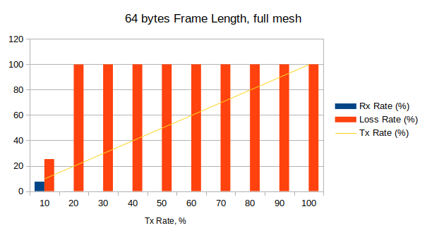

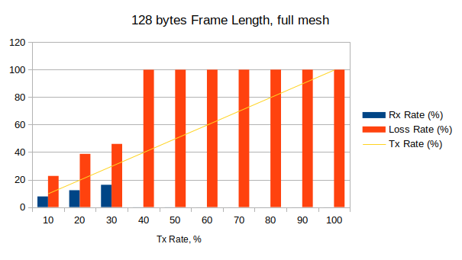

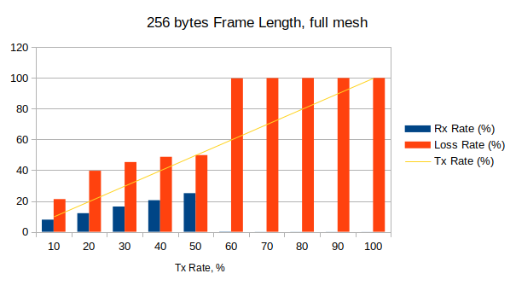

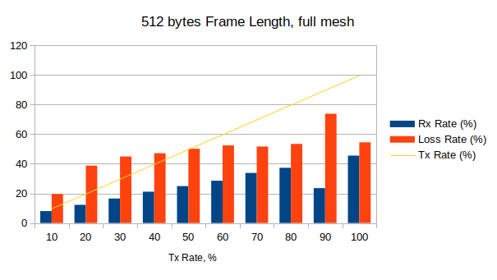

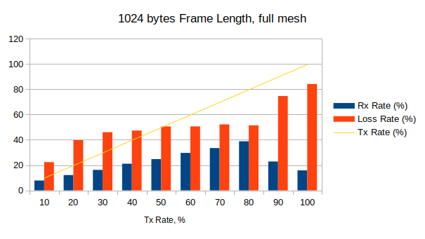

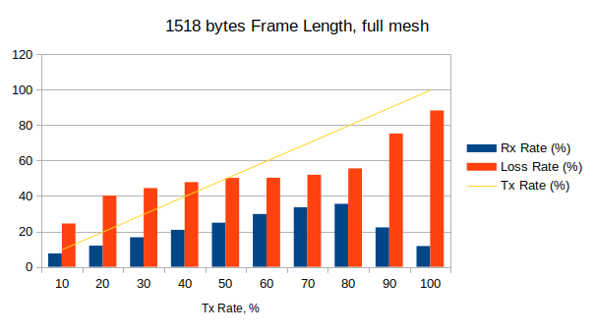

Throughput test

Frame Size, bytes | Tx Rate, % | Tx Rate, b/s | Tx Rate, f/s | Rx Rate, % | Loss Rate, % (frames) | Result
64 | 0,018 | 3,19M | 4743 | 0,02 | 0,34 (490) | Fail
128 | 0,258 | 46,34M | 39137 | 0 | 0 (0) | Pass
256 | 0,505 | 90,9M | 41167 | 0 | 0 (0) | Pass
512 | 0,018 | 3,17M | 745 | 0,02 | 0 (0) | Pass
1024 | 0,018 | 3,15M | 377 | 0,02 | 1,41 (160) | Fail
1280 | 0,018 | 3,18M | 306 | 0,02 | 1,05 (96) | Fail
1518 | 0,134 | 23,97M | 1948 | 0,13 | 0 (0) | Pass

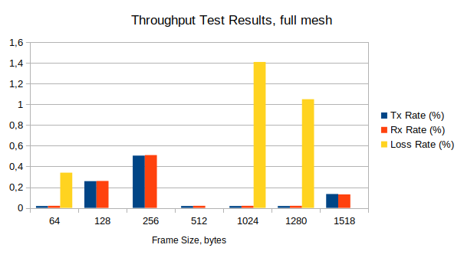

1.2. Partial 1:N Mesh Results

XenaBay
(Xena
2889 v1.46)
WRS
(nwt0297,
FW v7.0)
TX-to-RX: 1-to-17 or 17-to-1

Forwarding test

Frame Length | 64 bytes |  | 128 bytes |  | 256 bytes |  | 512 bytes |  | 1024 bytes |  | 1518 bytes
Tx Rate, % | Rx Rate, % | Loss Rate, % | Rx Rate, % | Loss Rate, % | Rx Rate, % | Loss Rate, % | Rx Rate, % | Loss Rate, % | Rx Rate, % | Loss Rate, % | Rx Rate, % | Loss Rate, %
10 | 5,74 | 42,63 | 5,84 | 41,64 | 5,9 | 40,99 | 5,94 | 40,63 | 5,95 | 40,46 | 5,7 | 42,87
20 | 0,02 | 99,92 | 6,09 | 69,5 | 6,16 | 69,21 | 6,2 | 69,02 | 6,2 | 68,87 | 5,78 | 71,1
30 | 0 | 99,98 | 6,24 | 79,21 | 6,4 | 78,69 | 6,47 | 78,43 | 6,46 | 78,48 | 5,83 | 80,56
40 | 0,01 | 99,97 | 0,02 | 99,96 | 6,48 | 83,79 | 6,27 | 84,31 | 6,7 | 83,26 | 5,9 | 85,24
50 | 0,01 | 99,98 | 0,01 | 99,97 | 6,53 | 86,93 | 6,83 | 86,35 | 6,85 | 86,29 | 5,99 | 88,03
60 | 0,01 | 99,99 | 0,01 | 99,98 | 0,71 | 98,81 | 7,03 | 88,29 | 6,6 | 89 | 6,04 | 89,93
70 | 0,01 | 99,99 | 0,01 | 99,98 | 0,02 | 99,97 | 7,06 | 89,91 | 7,04 | 89,94 | 6,05 | 91,36
80 | 0 | 100 | 0,01 | 99,99 | 0,01 | 99,98 | 6,63 | 91,72 | 6,92 | 91,35 | 6,1 | 92,37
90 | 0 | 99,99 | 0,01 | 99,99 | 0,02 | 99,98 | 6,66 | 92,6 | 6,84 | 92,4 | 6,02 | 93,31
100 | 0 | 100 | 0,01 | 99,99 | 0,02 | 99,99 | 6,64 | 93,36 | 6,95 | 93,05 | 6,23 | 93,77

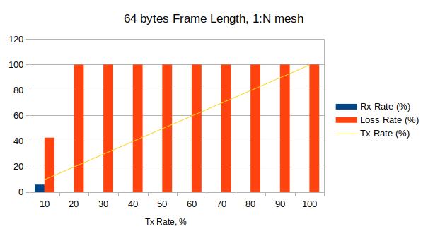

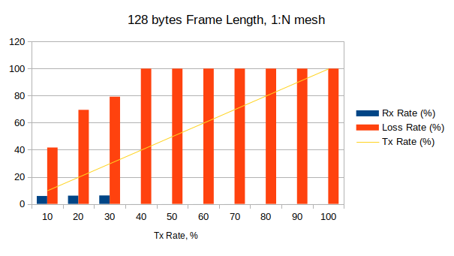

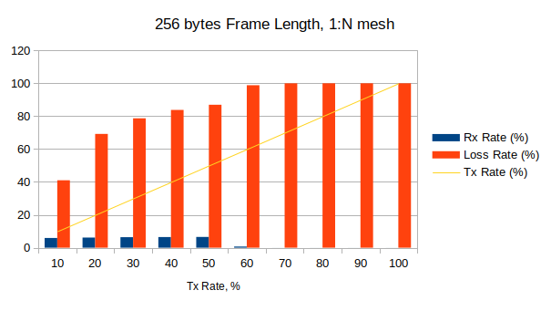

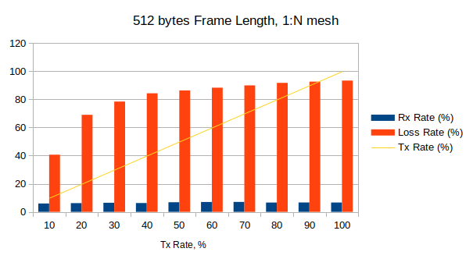

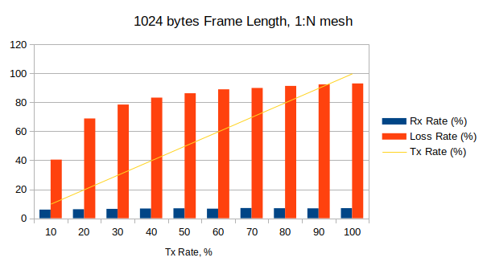

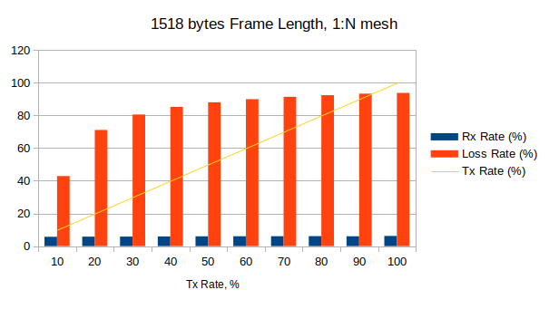

Throughput test

Frame Size, bytes | Tx Rate, % | Tx Rate, b/s | Tx Rate, f/s | Rx Rate, % | Loss Rate, % (frames) | Result
64 | 0,258 | 46,35M | 68973 | 0,26 | 0 (0) | Pass
128 | 0,018 | 3,19M | 2696 | 0,02 | 0,18 (142) | Fail
256 | 0,507 | 91,25M | 41325 | 0,51 | 0 (0) | Pass
512 | 0,018 | 3,19M | 750 | 0,02 | 1,41 (317) | Fail
1024 | 0,018 | 3,19M | 382 | 0,02 | 1,47 (168) | Fail
1280 | 0,018 | 3,19M | 307 | 0,02 | 1,05 (97) | Fail
1518 | 0,018 | 3,19M | 259 | 0,02 | 2,33 (181) | Fail

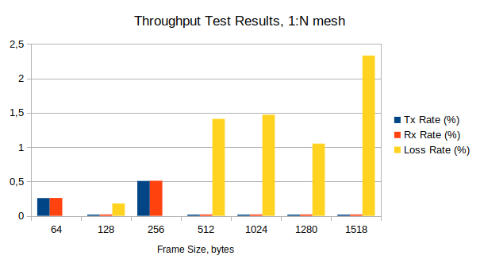

1.3. Partial N:N Mesh Results
XenaBay
(Xena
2889 v1.46)
WRS
(nwt0297,
FW v7.0)
TX-to-RX: 9-to-9

Forwarding test

 | Frame Length, bytes
 | 64 |  | 128 |  | 256 |  | 512 |  | 1024 |  | 1518
Tx Rate, % | Rx Rate, % | Loss Rate, % | Rx Rate, % | Loss Rate, % | Rx Rate, % | Loss Rate, % | Rx Rate, % | Loss Rate, % | Rx Rate, % | Loss Rate, % | Rx Rate, % | Loss Rate, %
10 | 9,85 | 1,51 | 9,67 | 3,3 | 9,49 | 5,11 | 9,78 | 2,23 | 9,73 | 2,7 | 10 | 0
20 | 10,62 | 46,9 | 10,83 | 45,86 | 10,79 | 46,06 | 11,03 | 44,84 | 10,88 | 45,6 | 10,71 | 46,46
30 | 10,52 | 64,95 | 10,73 | 64,22 | 10,96 | 63,46 | 10,88 | 63,74 | 11,08 | 63,08 | 10,96 | 63,46
40 | 0,21 | 99,47 | 10,83 | 72,93 | 10,85 | 72,87 | 11,04 | 72,41 | 11,08 | 72,31 | 11,09 | 72,27
50 | 0,02 | 99,97 | 10,83 | 78,35 | 10,95 | 78,1 | 10,81 | 78,37 | 11,08 | 77,84 | 11,09 | 77,81
60 | 0,01 | 99,98 | 10,62 | 82,3 | 10,9 | 81,83 | 11,04 | 81,6 | 11,08 | 81,53 | 10,88 | 81,86
70 | 0,01 | 99,98 | 0,02 | 99,97 | 10,96 | 84,34 | 10,93 | 84,38 | 11,03 | 84,25 | 11,09 | 84,16
80 | 0,01 | 99,99 | 0,1 | 99,87 | 10,8 | 86,5 | 10,93 | 86,34 | 11,08 | 86,15 | 11,09 | 86,14
90 | 0,01 | 99,99 | 0,02 | 99,98 | 10,96 | 87,82 | 11,03 | 87,75 | 11,08 | 87,69 | 11,09 | 87,68
100 | 0,01 | 99,99 | 0,02 | 99,98 | 10,83 | 89,17 | 10,72 | 89,28 | 11,07 | 88,93 | 10,92 | 89,08

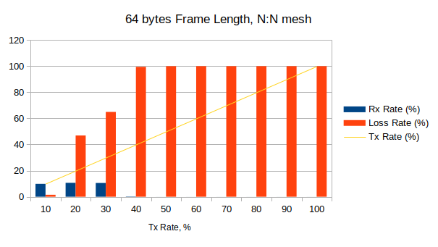

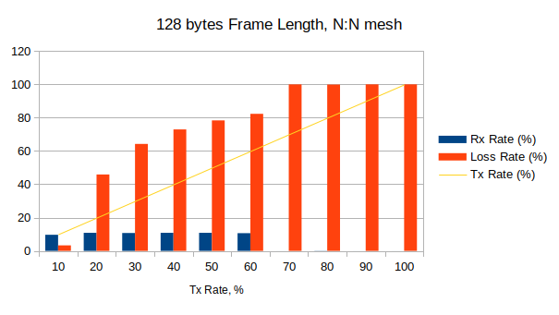

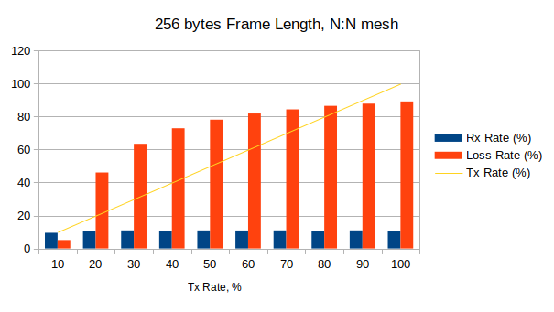

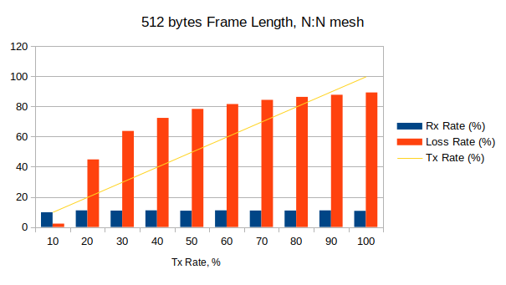

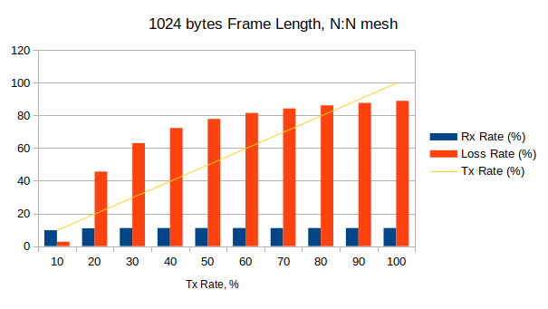

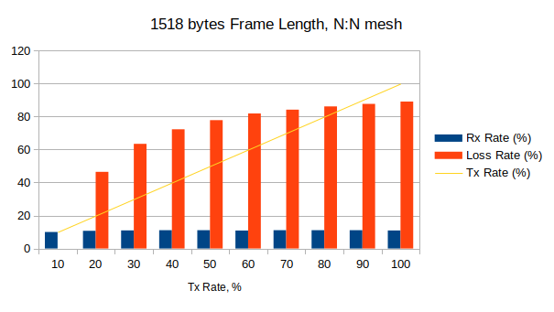

Throughput test

Frame Size, bytes | Tx Rate, % | Tx Rate, b/s | Tx Rate, f/s | Rx Rate, % | Loss Rate, % (frames) | Result
64 | 0,072 | 6,47M | 9626 | 0,07 | 0 (0) | Pass
128 | 0,018 | 1,6M | 1347 | 0,02 | 0 (0) | Pass
256 | 0,134 | 12,04M | 5451 | 0,13 | 0 (0) | Pass
512 | 0,018 | 1,59M | 373 | 0,02 | 3,78 (422) | Fail
1024 | 0,018 | 1,58M | 189 | 0,02 | 0,42 (24) | Fail
1280 | 0,134 | 12,02M | 1156 | 0,13 | 0 (0) | Pass
1518 | 0,018 | 1,59M | 130 | 0,02 | 2,65 (103) | Fail

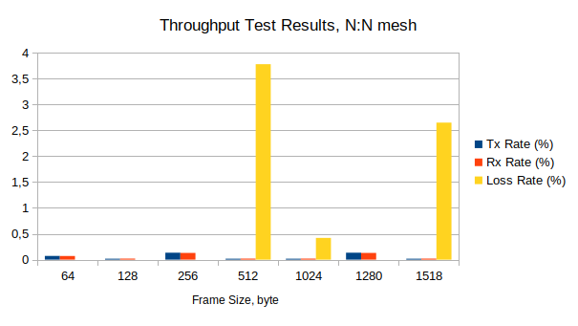

1.4. Congestion Control Results
2 ports in TX, 2 ports in RX

XenaBay
(Xena
2889 v1.46)
WRS
(nwt0297,
FW v7.0)

Frame Size | Tx Rate, % | Tx Frames | UC-Port:  Tx | UC-Port:  Rx | UC-Port:  Loss, % | C-Port:  Tx | C-Port:  Rx | C-Port:  Loss, % | Result
64 | 100 | 89285714 | 22321429 | 22321429 | 0 | 66964285 | 42621976 | 36,35 | Pass
128 | 100 | 50675676 | 12668919 | 12668919 | 0 | 38006757 | 24672475 | 35,08 | Pass
256 | 100 | 27173914 | 6793479 | 6793479 | 0 | 20380435 | 13393737 | 34,28 | Pass
512 | 100 | 14097746 | 3524437 | 3524437 | 0 | 10573309 | 6996709 | 33,83 | Pass
1024 | 100 | 7183909 | 1795977 | 1795977 | 0 | 5387932 | 3578522 | 33,58 | Pass
1280 | 100 | 5769232 | 1442308 | 1442308 | 0 | 4326924 | 2875979 | 33,53 | Pass
1518 | 100 | 4876464 | 1219116 | 1219116 | 0 | 3657348 | 2432099 | 33,50 | Pass

C-Port: Congested Port
UC-Port: Uncongested Port

1.5. Forward Pressure Results

XenaBay
(Xena
2889 v1.46)
WRS
(nwt0297,
FW v7.0)
1 TX port, 1 RX port

Frame Size,  bytes | Tx Frames | Tx max. util.,  % | Rx Frames | Rx max. util.,  % | Loss, % | Result
64 | 45180722 | 101,205 | 42613635 | 95,45 | 5,68 | Pass
128 | 25510204 | 100,68 | 24671080 | 97,368 | 3,29 | Pass
256 | 13636363 | 100,364 | 13392896 | 98,571 | 1,79 | Pass
512 | 7062146 | 100,188 | 6996319 | 99,253 | 0,93 | Pass
1024 | 3595397 | 100,096 | 3578299 | 99,618 | 0,48 | Pass
1280 | 2886836 | 100,077 | 2875824 | 99,693 | 0,38 | Pass
1518 | 2439817 | 100,065 | 2431962 | 99,74 | 0,32 | Pass

1.6. Maximum Forwarding Rate Results
XenaBay
(Xena
2889 v1.46)
WRS
(nwt0297,
FW v7.0)
1 port in TX, 1 port in RX

Frame Size, bytes | Tx Rate, % | Tx Rate, f/s | Tx Frames | Rx Frames | Loss, % (calculated) | Result
64 | 90 | 1339,3K | 40178571 | 40178571 | 0 | Pass
128 | 100 | 844,6K | 25337837 | 24671142 | 2,63 | Pass
256 | 90,51 | 409,9K | 12296875 | 12296875 | 0 | Pass
512 | 90,018 | 211,5K | 6345235 | 6345235 | 0 | Pass
1024 | 100 | 119,7K | 3591954 | 3574416 | 0,49 | Pass
1280 | 100 | 96,1K | 2884615 | 2875830 | 0,304 | Pass
1518 | 100 | 81,3K | 2438231 | 2431968 | 0,25 | Pass

1.7. Address Caching Capacity and Learning Rate Results

XenaBay
(Xena
2889 v1.46)
WRS
(nwt0297,
FW v7.0)
3 ports (test, learning, monitor)

Address Caching Capacity (Learning Rate=20 Frames/s, DUT aging=310 seconds)

Frame Size, bytes | Address Count | Test Port  Tx Frames | Learn Port  Rx Frames | Monitor Port  Rx Frames | Result
64 | 1074 | 22 | 22 | 22 | Fail
128 | 100 | 22 | 22 | 22 | Fail
256 | 100 | 22 | 22 | 22 | Fail
512 | 100 | 22 | 22 | 22 | Fail
1024 | 100 | 22 | 22 | 22 | Fail
1280 | 100 | 22 | 22 | 22 | Fail
1518 | 100 | 22 | 22 | 22 | Fail

Address Learning Rate, frame/s (DUT aging=310 seconds)

Frame size, byte  Address count | 64 | 128 | 256 | 512 | 1024 | 1280 | 1518
100 | 20 | 20 | 20 | 20 | 20 | 20 | 20
300 | 20 | 20 | 20 | 20 | 20 | 20 | 20
500 | 20 | 20 | 20 | 20 | 20 | 20 | 20
700 | 20 | 20 | 20 | 20 | 20 | 20 | 20
900 | 20 | 20 | 20 | 20 | 20 | 20 | 20
1100 | 20 | 20 | 20 | 20 | 20 | 20 | 20
1300 | 20 | 20 | 20 | 20 | 20 | 20 | 20
2048 | 20 | 20 | 20 | 20 | 20 | 20 | 20

Issue: With the aging time of 310 seconds (300 seconds for WR switches by default) is chosen for the reset condition, the address caching capacity test is failed. Here, switch starts to forward test packets (100, 1074) properly, no flooding. At iteration with the critical number of packets (1561) it floods, and then it remains to flood in all further iterations with decreasing number of the test packets (1317, 1195, …, 1075, 1074). The test is failed because the switch floods even with the same number of packets (1074), with which no flooding was happened in previous iteration.

1.8. Errored Frames Filtering Results

XenaBay
(Xena
2889 v1.46)
WRS
(nwt0297,
FW v7.0)
1 port in TX, 1 port in RX

Tx Rate, % | Tx Frames | Rx Frames | Tx Valid | Rx Valid | Tx Over  size | Rx Over  size | Tx Under  size | Rx Under  size | Tx FCS Error | Rx FCS Error | Result
10 | 1741375 | 1741294 | 154130 | 154130 | 81221 | 81221 | 1506024 | 1505943 | 58 | 0 | Fail
20 | 3482752 | 3474141 | 308261 | 308261 | 162443 | 162443 | 3012048 | 3003437 | 58 | 0 | Fail
30 | 5224128 | 5151028 | 462392 | 462392 | 243664 | 243664 | 4518072 | 4444972 | 58 | 0 | Fail
40 | 6965406 | 6688704 | 616522 | 616522 | 324788 | 324778 | 6024096 | 5747394 | 58 | 0 | Fail
50 | 8706880 | 8278244 | 770653 | 770653 | 406107 | 406107 | 7530120 | 7101484 | 58 | 0 | Fail
60 | 10448257 | 9751072 | 924784 | 924784 | 487329 | 487329 | 9036144 | 8338959 | 58 | 0 | Fail
70 | 12189633 | 11107208 | 1078914 | 1078914 | 568551 | 568551 | 10542168 | 9459743 | 58 | 0 | Fail
80 | 13931009 | 12613751 | 1233045 | 1233045 | 649772 | 649772 | 12048192 | 10730934 | 58 | 0 | Fail
90 | 15672386 | 14062292 | 1387176 | 1387176 | 730994 | 730994 | 13554216 | 11944122 | 58 | 0 | Fail
100 | 17413762 | 13728422 | 1541307 | 1477426 | 812215 | 629434 | 15060240 | 11621562 | 58 | 0 | Fail

1.9. Broadcast Forwarding Results
XenaBay
(Xena
2889 v1.46)
WRS
(nwt0297,
FW v7.0)
1 port in TX and rest in RX

Frame Size, bytes | Tx Rate, % | Loss Rate, % | Loss Frames | Result
64 | 66,29 | 0 | 0 | Pass
128 | 77,85 | 0 | 0 | Pass
256 | 83,12 | 0 | 0 | Pass
512 | 91,56 | 0 | 0 | Pass
1024 | 94,37 | 0 | 0 | Pass
1280 | 94,37 | 0 | 0 | Pass
1518 | 94,37 | 0 | 0 | Pass

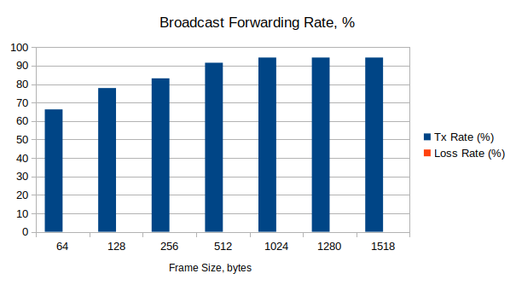

Frame Size, bytes | Tx Rate (Fps)
64 | 986517
128 | 657530
256 | 376472
512 | 215137
1024 | 112997
1280 | 90745
1518 | 76703

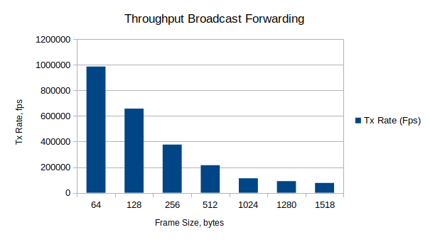

Frame Size,  bytes | Latency, usec |  |  | Jitter, usec
Frame Size,  bytes | Average | Min | Max | Average | Min | Max
64 | 2,58-5,57 | 1,67-2,29 | 5,97-11,52 | 0,003-0,003 | 0 | 2,04-2,84
128 | 2,98-4,91 | 2,13-2,73 | 6,31-9,72 | 0,002 | 0 | 2,04-2,3
256 | 2,4-2,98 | 2,13-2,74 | 4,83-6,21 | 0,008-0,01 | 0 | 2,12-2,5
512 | 3,32-143,2 | 2,13-2,75 | 10,91-262 | 0,002 | 0 | 2,07-2,24
1024 | 2,44-3,03 | 2,17-2,77 | 4,77-5,51 | 0,003-0,004 | 0 | 2,21-2,6
1280 | 2,37-2,97 | 2,13-2,75 | 4,21-5,37 | 0,004-0,006 | 0 | 2,24-2,65
1518 | 2,38-2,97 | 2,14-2,74 | 4,47-5,4 | 0,002-0,003 | 0 | 2,04-2,8

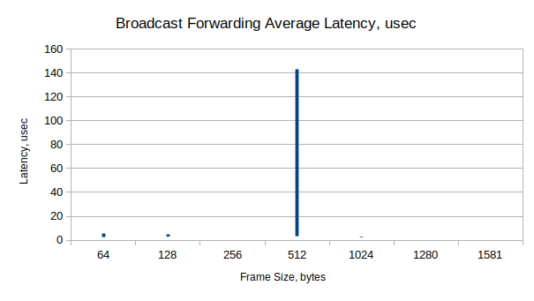

2.1. Full Mesh Results, 4 layers

XenaBay
(Xena
2889 v1.46)
WRS
(nwt0010,
FW v7.0)
all 18 ports in TX and RX
WRS
(nwt0016,
FW v7.0)
WRS
(nwt0296,
FW v7.0)
WRS
(nwt0297,
FW v7.0)

Forwarding test

Frame Length | 64 bytes |  | 128 bytes |  | 256 bytes |  | 512 bytes |  | 1024 bytes |  | 1518 bytes
Tx Rate, % | Rx Rate, % | Loss Rate, % | Rx Rate, % | Loss Rate, % | Rx Rate, % | Loss Rate, % | Rx Rate, % | Loss Rate, % | Rx Rate, % | Loss Rate, % | Rx Rate, % | Loss Rate, %
10 | 9,93 | 0,69 | 9,95 | 0,48 | 9,93 | 0,67 | 9,88 | 1,21 | 9,7 | 2,96 | 9,91 | 0,86
20 | 17,59 | 12,03 | 17,83 | 10,87 | 18,08 | 9,62 | 18,03 | 9,86 | 17,42 | 12,91 | 15,39 | 23,05
30 | 16,82 | 43,95 | 20,6 | 31,35 | 21,31 | 28,98 | 20,97 | 30,09 | 20,03 | 33,23 | 13,3 | 55,68
40 | 13,17 | 67,08 | 22,68 | 43,29 | 23,08 | 42,31 | 23,16 | 42,1 | 21,23 | 47 | 12,74 | 68,15
50 | 9,7 | 80,61 | 25,06 | 49,88 | 24,94 | 50,12 | 24,89 | 50,22 | 22,53 | 54,95 | 11,94 | 76,13
60 | 4,72 | 92,13 | 26,66 | 55,57 | 26,73 | 55,45 | 26,17 | 56,39 | 22,91 | 62 | 11,57 | 80,72
70 | 5,47 | 92,18 | 28,54 | 59,23 | 28,57 | 59,19 | 28,9 | 58,71 | 23,65 | 66,22 | 10,47 | 85,05
80 | 2,29 | 97,14 | 26,87 | 66,42 | 29,9 | 62,62 | 30,06 | 62,42 | 24,95 | 68,82 | 11,37 | 85,78
90 | 0,01 | 99,98 | 14,52 | 83,87 | 28,67 | 68,14 | 23,4 | 74 | 23,16 | 74,26 | 9,33 | 89,63
100 | 0,89 | 99,11 | 11,7 | 88,3 | 21,35 | 78,65 | 28,11 | 71,89 | 20,66 | 79,34 | 9,01 | 90,99

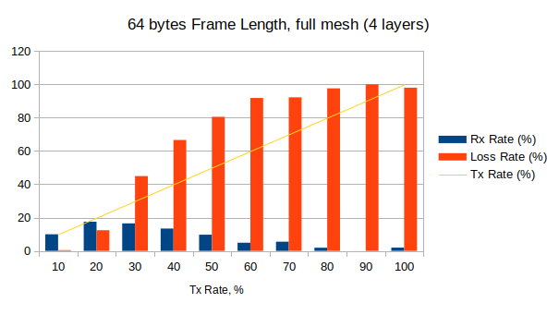

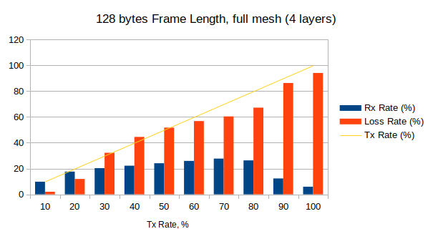

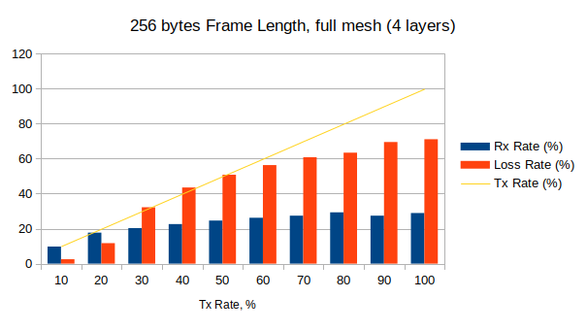

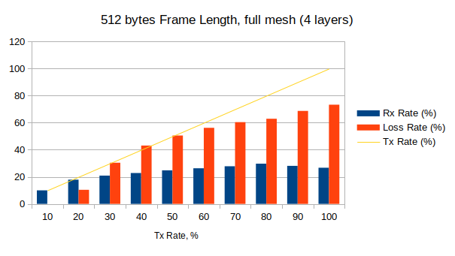

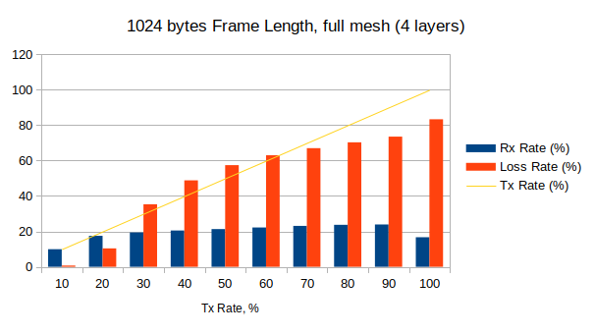

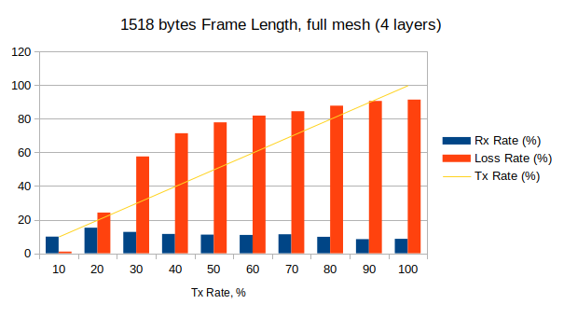

Throughput test

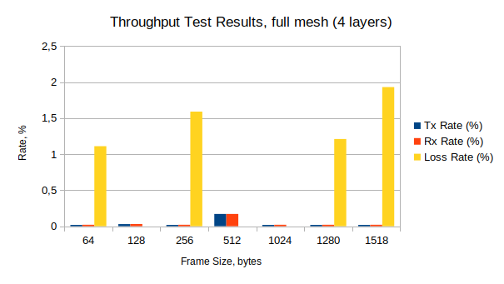

Frame Size, bytes | Tx Rate, % | Tx Rate, b/s | Tx Rate, f/s | Rx Rate, % | Loss Rate, % (frames) | Result
64 | 0,02 | 2,9M | 4,3K | 0,02 | 1,11 (1426) | Fail
128 | 0,03 | 4,75M | 4K | 0,03 | 0 (0) | Pass
256 | 0,02 | 2,9M | 1,3K | 0,02 | 1,6 (618) | Fail
512 | 0,17 | 26,8M | 6,3K | 0,17 | 0 (0) | Pass
1024 | 0,02 | 2,8M | 337 | 0,02 | 0 (0) | Pass
1280 | 0,02 | 2,9M | 275 | 0,02 | 1,21 (100) | Fail
1518 | 0,02 | 2,8M | 224 | 0,02 | 1,93 (130) | Fail

2.2. Partial 1:N Mesh Results, 4 layers

XenaBay
(Xena
2889 v1.46)
WRS
(nwt0010,
FW v7.0)
TX-to-RX: 1-to-17 or 17-to-1
WRS
(nwt0016,
FW v7.0)
WRS
(nwt0296,
FW v7.0)
WRS
(nwt0297,
FW v7.0)

Forwarding test

Frame Length | 64 bytes |  | 128 bytes |  | 256 bytes |  | 512 bytes |  | 1024 bytes |  | 1518 bytes
Tx Rate, % | Rx Rate, % | Loss Rate, % | Rx Rate, % | Loss Rate, % | Rx Rate, % | Loss Rate, % | Rx Rate, % | Loss Rate, % | Rx Rate, % | Loss Rate, % | Rx Rate, % | Loss Rate, %
10 | 5,9 | 41,4 | 5,4 | 46,5 | 6 | 39,7 | 6,1 | 39,3 | 6,1 | 39,2 | 5,9 | 41,5
20 | 0,01 | 99,9 | 6,5 | 67,4 | 6,4 | 68, | 6,6 | 66,9 | 6,6 | 66,8 | 5,9 | 70,2
30 | 0,01 | 99,9 | 6,9 | 77,2 | 7,1 | 76,2 | 7,2 | 76 | 7,2 | 76 | 5,8 | 80,7
40 | 0 | 100 | 0,01 | 99,9 | 7,3 | 81,6 | 6,7 | 83,3 | 7,8 | 80,6 | 6,1 | 84,8
50 | 0,01 | 99,9 | 0,02 | 99,9 | 7,4 | 85,2 | 8 | 84,1 | 7,7 | 84,6 | 6,2 | 87,6
60 | 0,01 | 99,9 | 0,01 | 99,9 | 1,4 | 97,6 | 8 | 86,7 | 7,8 | 87,1 | 6,3 | 89,5
70 | 0,01 | 99,9 | 0,01 | 99,9 | 0,02 | 99,9 | 8 | 88,5 | 8,7 | 87,6 | 6,3 | 91
80 | 0,01 | 99,9 | 0,01 | 99,9 | 0,01 | 99,9 | 7,6 | 90,5 | 7,9 | 90,1 | 6,5 | 92
90 | 0 | 100 | 0,01 | 99,9 | 0,02 | 99,9 | 7,6 | 91,5 | 8 | 91,1 | 6,5 | 93
100 | 0 | 100 | 0,01 | 99,9 | 0 | 100 | 7,7 | 92,3 | 8 | 92 | 6 | 94

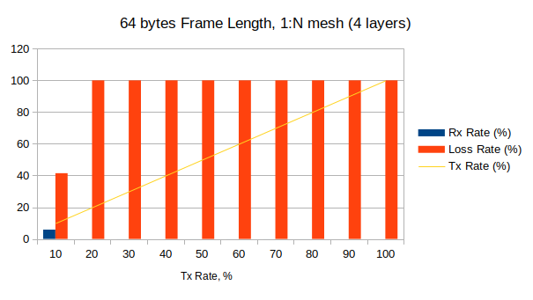

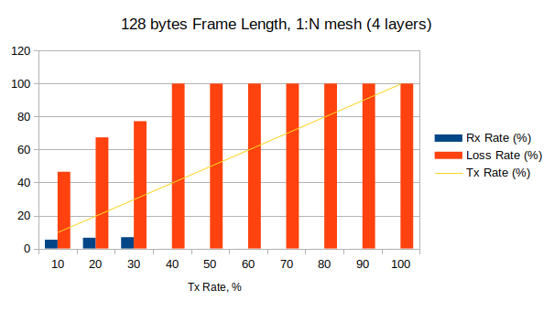

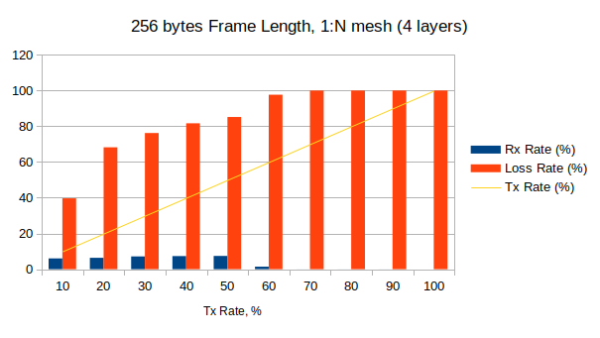

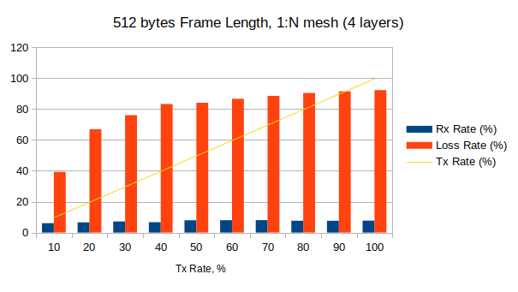

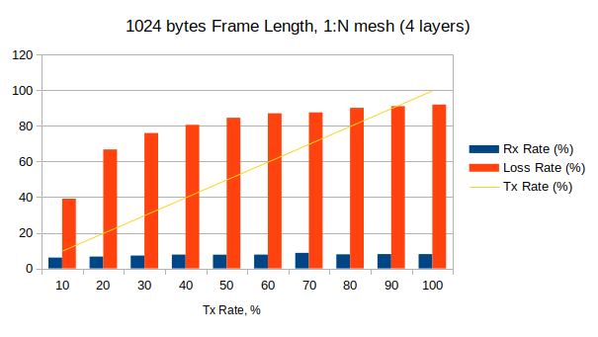

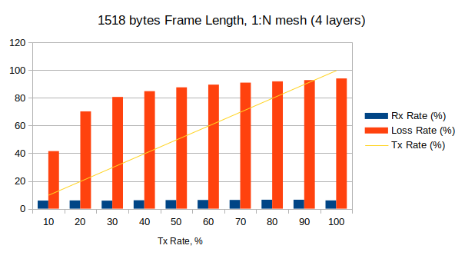

Throughput test

Frame Size, bytes | Tx Rate, % | Tx Rate, b/s | Tx Rate, f/s | Rx Rate, % | Loss Rate, % (frames) | Result
64 | 1 | 162M | 241K | 1 | 0 (0) | Pass
128 | 0,03 | 4,1M | 3,5K | 0,03 | 0 (0) | Pass
256 | 0,018 | 2,9M | 1,3K | 0,01 | 35,74 (14K) | Fail
512 | 0,02 | 2,9M | 675 | 0,02 | 1,04 (210) | Fail
1024 | 0,135 | 21,8M | 2,6K | 0,13 | 0 (0) | Pass
1280 | 0,02 | 2,9M | 276 | 0,02 | 0,56 (46) | Fail
1518 | 0,07 | 11,6M | 946 | 0,07 | 0 (0) | Pass

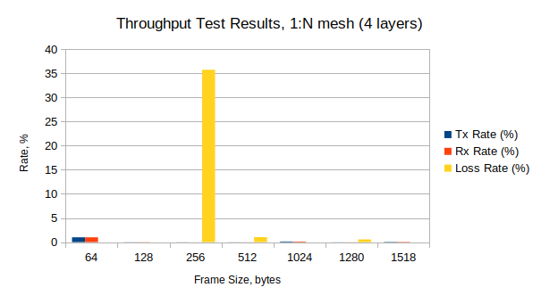

2.3. Partial N:N Mesh Results, 4 layers

XenaBay
(Xena
2889 v1.46)
WRS
(nwt0010,
FW v7.0)
TX-to-RX: 9-to-9
WRS
(nwt0016,
FW v7.0)
WRS
(nwt0296,
FW v7.0)
WRS
(nwt0297,
FW v7.0)

Forwarding test

 | Frame Length, bytes
 | 64 |  | 128 |  | 256 |  | 512 |  | 1024 |  | 1518
Tx Rate, % | Rx Rate, % | Loss Rate, % | Rx Rate, % | Loss Rate, % | Rx Rate, % | Loss Rate, % | Rx Rate, % | Loss Rate, % | Rx Rate, % | Loss Rate, % | Rx Rate, % | Loss Rate, %
10 | 9,9 | 1,1 | 9,9 | 0,8 | 9,9 | 1,3 | 9,8 | 1,8 | 9,8 | 1,6 | 9,97 | 0,27
20 | 10,6 | 47 | 10,7 | 46,6 | 10,8 | 46 | 11 | 45,5 | 10,9 | 45,7 | 11 | 45
30 | 10,6 | 64,6 | 10,8 | 64 | 11 | 63,5 | 10,8 | 64 | 11 | 63,2 | 10,6 | 65
40 | 0,03 | 99,9 | 10,8 | 73,1 | 10,8 | 73 | 10,9 | 72,8 | 10,9 | 72,8 | 11,1 | 72,3
50 | 0,02 | 99,9 | 10,8 | 78,5 | 11 | 78,1 | 11 | 78 | 11,1 | 77,8 | 11 | 78
60 | 0,02 | 99,9 | 10,8 | 82 | 11 | 81,7 | 11 | 81,6 | 11,1 | 81,5 | 11 | 81,7
70 | 0,01 | 99,9 | 0,6 | 99,2 | 11 | 84,3 | 11 | 84,2 | 11 | 84,3 | 10,7 | 84,8
80 | 0,01 | 99,9 | 0,02 | 99,9 | 11 | 86,3 | 11 | 86,2 | 11 | 86,2 | 11,1 | 86,2
90 | 0,01 | 99,9 | 0,02 | 99,9 | 10,8 | 88 | 11 | 87,8 | 11 | 87,8 | 11,1 | 87,7
100 | 0,01 | 99,9 | 0,03 | 99,9 | 10,8 | 89,2 | 11 | 89 | 11 | 89 | 10,8 | 89,2

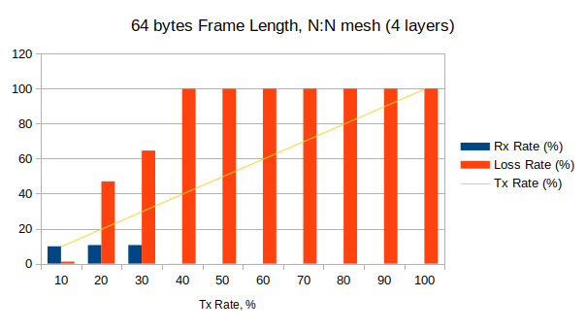

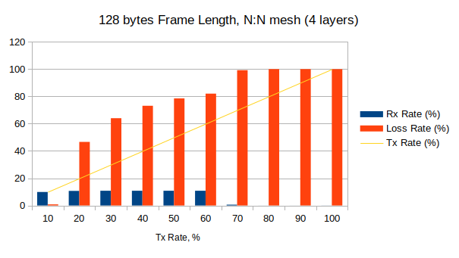

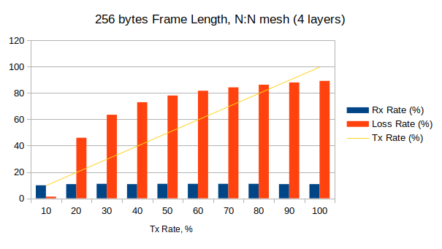

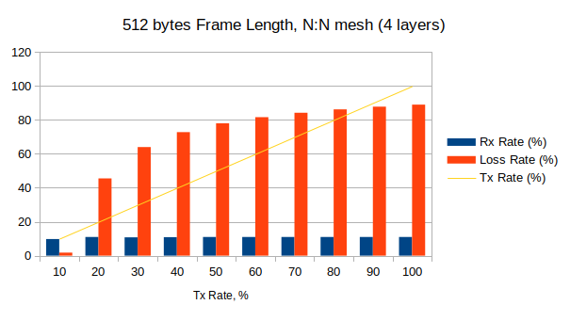

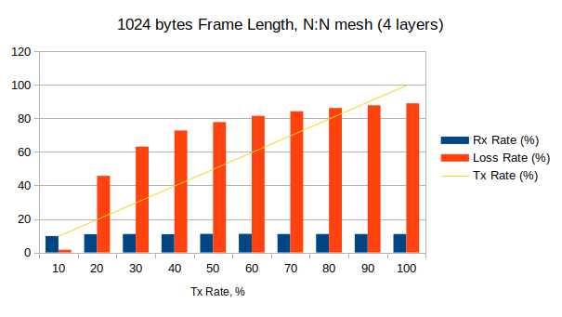

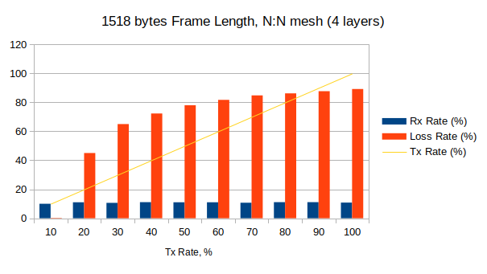

Throughput test

Frame Size, bytes | Tx Rate, % | Tx Rate, b/s | Tx Rate, f/s | Rx Rate, % | Loss Rate, % (frames) | Result
64 | 0,1 | 8,3M | 12,4K | 0,1 | 0 (0) | Pass
128 | 0,04 | 3,3M | 2,8K | 0,04 | 0 (0) | Pass
256 | 0,03 | 2,1M | 934 | 0,03 | 0 (0) | Pass
512 | 0,05 | 3,9M | 926 | 0,05 | 0 (0) | Pass
1024 | 0,26 | 20,9M | 2498 | 0,26 | 0 (0) | Pass
1280 | 0,02 | 1,4M | 138 | 0,02 | 3,58 (148) | Fail
1518 | 0,07 | 5,95M | 483 | 0,07 | 0 (0) | Pass

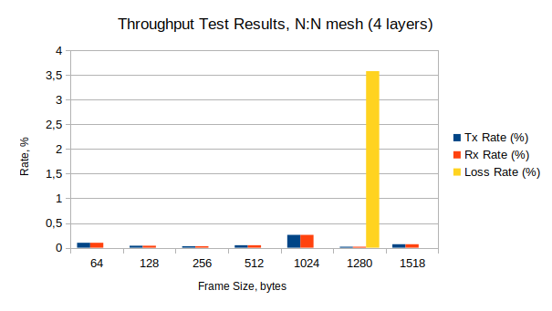

2.4. Congestion Control Results, 4 layers

XenaBay
(Xena
2889 v1.46)
WRS
(nwt0010,
FW v7.0)
RX: 1/1 congested/uncongested
WRS
(nwt0016,
FW v7.0)
WRS
(nwt0296,
FW v7.0)
WRS
(nwt0297,
FW v7.0)

Frame Size | Tx Rate, % | Tx Frames | UC-Port:  Tx | UC-Port:  Rx | UC-Port:  Loss, % | C-Port:  Tx | C-Port:  Rx | C-Port:  Loss, % | Result
64 | 100 | 89285715 | 22321429 | 9269359 | 58,47 | 66964286 | 33349067 | 50,2 | Fail
128 | 100 | 50675677 | 12668919 | 3686396 | 29,1 | 38006758 | 15691528 | 58,7 | Fail
256 | 100 | 27173914 | 6793479 | 3735599 | 45,01 | 20380435 | 9658785 | 52,6 | Fail
512 | 100 | 14097746 | 3524437 | 2300678 | 34,7 | 10573309 | 4696485 | 55,6 | Fail
1024 | 100 | 7183910 | 1795978 | 396592 | 77,9 | 5387932 | 3182163 | 40,9 | Fail
1280 | 100 | 5769232 | 1442308 | 939844 | 34,8 | 4326924 | 1936288 | 55,3 | Fail
1518 | 100 | 4876464 | 1219116 | 709159 | 41,8 | 3657348 | 1723077 | 52,9 | Fail

C-Port: Congested Port
UC-Port: Uncongested Port

2.5. Forward Pressure Results, 4 layers

XenaBay
(Xena
2889 v1.46)
WRS
(nwt0010,
FW v7.0)
1 TX port, 1 RX port
WRS
(nwt0016,
FW v7.0)
WRS
(nwt0296,
FW v7.0)
WRS
(nwt0297,
FW v7.0)

Frame Size,  bytes | Tx Frames | Tx max. util.,  % | Rx Frames | Rx max. util.,  % | Loss, % | Result
64 | 40662650 | 95,4 | 38352262 | 89,4 | 5,7 | Pass
128 | 22959183 | 94,5 | 22203966 | 90,7 | 3,3 | Pass
256 | 12272727 | 93,8 | 12053605 | 91,5 | 1,8 | Pass
512 | 6355932 | 93,2 | 6296690 | 93,5 | 0,9 | Pass
1024 | 3235858 | 94,6 | 3220475 | 93,4 | 0,5 | Pass
1280 | 2598152 | 94,2 | 2588246 | 93,2 | 0,4 | Pass
1518 | 2195836 | 93,9 | 2188771 | 92,9 | 0,3 | Pass

2.6. Maximum Forwarding Rate Results, 4 layers

XenaBay
(Xena
2889 v1.46)
WRS
(nwt0010,
FW v7.0)
1 TX port, 1 RX port
WRS
(nwt0016,
FW v7.0)
WRS
(nwt0296,
FW v7.0)
WRS
(nwt0297,
FW v7.0)

Frame Size, bytes | Tx Rate, % | Tx Rate, f/s | Tx Frames | Rx Frames | Loss, % (calculated) | Result
64 | 100 | 1339,3K | 40178571 | 38352284 | 4,54 | Pass
128 | 100 | 760,1K | 22804054 | 22203975 | 2,63 | Pass
256 | 100 | 407,6K | 12228260 | 12053609 | 1,43 | Pass
512 | 100 | 211,5K | 6343984 | 6296686 | 0,75 | Pass
1024 | 100 | 107,8K | 3232758 | 3220475 | 0,38 | Pass
1280 | 90 | 77,9K | 2336538 | 2336538 | 0 | Pass
1518 | 100 | 73,1K | 2194408 | 2188771 | 0,26 | Pass

2.7. Address Caching Capacity and Learning Rate Results, 4 layers

XenaBay
(Xena
2889 v1.46)
WRS
(nwt0010,
FW v7.0)
Test port
WRS
(nwt0016,
FW v7.0)
WRS
(nwt0296,
FW v7.0)
WRS
(nwt0297,
FW v7.0)
Learning port
Monitor port

Address Caching Capacity (Learning Rate=20 frames/s)

Frame Size, bytes | Address Count | Test Port  Tx Frames | Learn Port  Rx Frames | Monitor Port  Rx Frames | Result
64 | 1074 | 1074 | 1074 | 512 | Fail
128 | 100 | 100 | 100 | 100 | Fail
256 | 100 | 100 | 100 | 100 | Fail
512 | 100 | 100 | 100 | 100 | Fail
1024 | 100 | 100 | 100 | 100 | Fail
1280 | 100 | 100 | 100 | 100 | Fail
1518 | 100 | 100 | 100 | 100 | Fail

Address Learning Rate, frame/s (Base Learning Rate=20 frames/s)

Frame size, byte  Address count | 64 | 128 | 256 | 512 | 1024 | 1280 | 1518
100 | 4 | 4 | 4 | 4 | 4 | 4 | 4
300 | 4 | 4 | 4 | 4 | 4 | 4 | 4
600 | 4 | 4 | 4 | 4 | 4 | 4 | 4
900 | 4 | 4 | 4 | 4 | 4 | 4 | 4
1200 | 4 | 4 | 4 | 4 | 4 | 4 | 4
1600 | 4 | 4 | 4 | 4 | 4 | 4 | 4
2000 | 4 | 4 | 4 | 4 | 4 | 4 | 4

2.8. Errored Frames Filtering Results, 4 layers

XenaBay
(Xena
2889 v1.46)
WRS
(nwt0010,
FW v7.0)
1 TX port, 1 RX port
WRS
(nwt0016,
FW v7.0)
WRS
(nwt0296,
FW v7.0)
WRS
(nwt0297,
FW v7.0)

Tx Rate, % | Tx Frames | Rx Frames | Tx Valid | Rx Valid | Tx Over  size | Rx Over  size | Tx Under  size | Rx Under  size | Tx FCS Error | Rx FCS Error | Result
10 | 1567237 | 1566783 | 138717 | 138717 | 73099 | 73099 | 1355421 | 1354967 | 58 | 0 | Fail
20 | 3134476 | 3132488 | 277435 | 277435 | 146198 | 146198 | 2710843 | 2708855 | 58 | 0 | Fail
30 | 4701715 | 4699127 | 416152 | 416152 | 219298 | 219298 | 4066265 | 4063677 | 58 | 0 | Fail
40 | 6268953 | 6262702 | 554870 | 554870 | 292397 | 292397 | 5421686 | 5415435 | 58 | 0 | Fail
50 | 7836193 | 7830622 | 693588 | 693588 | 365497 | 365497 | 6777108 | 6771537 | 58 | 0 | Fail
60 | 9403431 | 9392578 | 832305 | 832305 | 438596 | 438596 | 8132530 | 8121677 | 58 | 0 | Fail
70 | 10970669 | 10958478 | 971023 | 971023 | 511695 | 511695 | 9487951 | 9475760 | 58 | 0 | Fail
80 | 12537909 | 12516467 | 1109741 | 1109741 | 584795 | 584795 | 10843373 | 10821931 | 58 | 0 | Fail
90 | 14105147 | 14089648 | 1248458 | 1248458 | 657894 | 657894 | 12198795 | 12183296 | 58 | 0 | Fail
100 | 15672386 | 12312732 | 1387176 | 1328986 | 730994 | 573276 | 13554216 | 10410470 | 58 | 0 | Fail

2.9. Broadcast Forwarding Results, 4 layers

XenaBay
(Xena
2889 v1.46)
WRS
(nwt0010,
FW v7.0)
1 TX port, 17 RX port
WRS
(nwt0016,
FW v7.0)
WRS
(nwt0296,
FW v7.0)
WRS
(nwt0297,
FW v7.0)

Frame Size, bytes | Tx Rate, % | Loss Rate, % | Loss Frames | Result
64 | 66,3 | 0 | 0 | Pass
128 | 77,8 | 0 | 0 | Pass
256 | 83,1 | 0 | 0 | Pass
512 | 91,6 | 0 | 0 | Pass
1024 | 94,4 | 0 | 0 | Pass
1280 | 94,4 | 0 | 0 | Pass
1518 | 94,4 | 0 | 0 | Pass

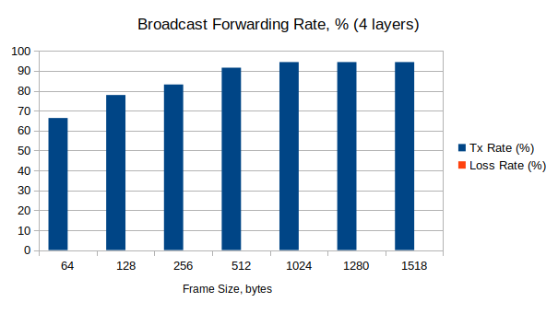

Frame Size, bytes | Tx Rate (Fps)
64 | 887865
128 | 591777
256 | 338825
512 | 193624
1024 | 101697
1280 | 81671
1518 | 69032

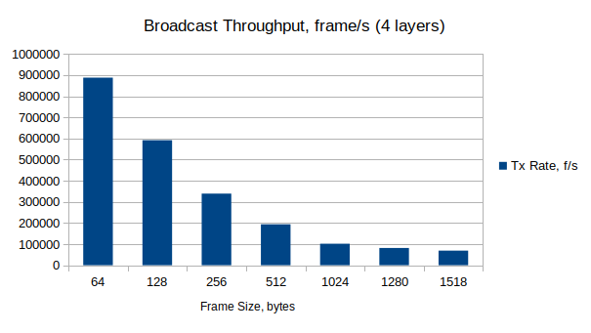

All layers

Frame Size,  bytes | Latency, usec |  |  | Jitter, usec
Frame Size,  bytes | Average | Min | Max | Average | Min | Max
64 | 2,3-8,5 | 2,2-8,3 | 6-13,7 | 0,002-0,03 | 0 | 2,6-2,8
128 | 2,8-10,3 | 2,7-10,3 | 6,1-14,7 | 0,001-0,001 | 0 | 2-2,2
256 | 2,8-10,3 | 2,7-10,2 | 4,9-12,5 | 0,003-0,08 | 0 | 2-2,3
512 | 3,1-10,4 | 2,7-10,2 | 7,6-16,6 | 0,001-0,004 | 0 | 2-2,2
1024 | 2,8-10,4 | 2,7-10,2 | 4,9-12,4 | 0,001-0,002 | 0 | 2-2,4
1280 | 2,8-10,4 | 2,7-10,2 | 4,8-12,5 | 0,001-0,002 | 0 | 1,9-2,1
1518 | 2,8-10,4 | 2,7-10,2 | 4,7-12,2 | 0,001 | 0 | 1,8-2

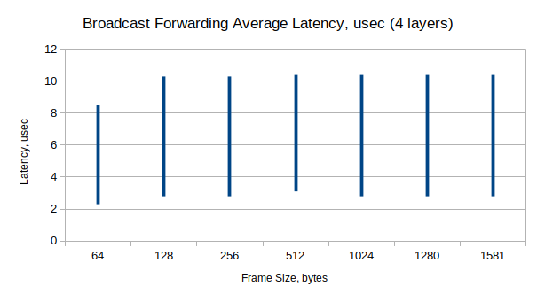

1st Layer

Frame Size,  bytes | Latency, usec |  |  | Jitter, usec
Frame Size,  bytes | Average | Min | Max | Average | Min | Max
64 | 2,3-2,4 | 2,2-2,3 | 6-6,1 | 0,002 | 0 | 2,6-2,8
128 | 2,8-3,4 | 2,7 | 6,1-7,5 | 0,001 | 0 | 2,1-2,2
256 | 2,8 | 2,7 | 4,9-5,1 | 0,003-0,004 | 0 | 2,1-2,3
512 | 3,1-7 | 2,7 | 7,6-16,6 | 0,001-0,002 | 0 | 2,2
1024 | 2,8 | 2,7 | 4,9-5,1 | 0,001 | 0 | 2,1-2,4
1280 | 2,8-2,9 | 2,7 | 4,8-5 | 0,001 | 0 | 1,9-2,1
1518 | 2,8-2,9 | 2,7 | 4,7-4,9 | 0,001 | 0 | 1,9-2

2nd Layer

Frame Size,  bytes | Latency, usec |  |  | Jitter, usec
Frame Size,  bytes | Average | Min | Max | Average | Min | Max
64 | 3,9 | 3,7 | 9 | 0,01 | 0 | 2,6
128 | 4,7-4,8 | 4,7 | 8,1-9 | 0,01 | 0 | 2-2,1
256 | 4,7-4,8 | 4,6-4,7 | 6,8-6,9 | 0,004-0,006 | 0 | 2-2,1
512 | 4,8-4,9 | 4,6-4,7 | 9-9,3 | 0,001-0,003 | 0 | 2,1
1024 | 4,8 | 4,6-4,7 | 6,8-7,4 | 0,001-0,002 | 0 | 2
1280 | 4,8 | 4,6-4,7 | 6,8-6,9 | 0,001-0,002 | 0 | 1,9-2,1
1518 | 4,8 | 4,7 | 6,6-6,7 | 0,001 | 0 | 1,9

3rd Layer

Frame Size,  bytes | Latency, usec |  |  | Jitter, usec
Frame Size,  bytes | Average | Min | Max | Average | Min | Max
64 | 6,1-6,2 | 5,8-6 | 11,3 | 0,01-0,02 | 0 | 2,6
128 | 7,5-7,6 | 7,3-7,5 | 10,8-10,9 | 0,001 | 0 | 2
256 | 7,4-7,6 | 7,3-7,5 | 9,5-9,7 | 0,004 | 0 | 2
512 | 7,5-7,7 | 7,3-7,5 | 11,6-11,9 | 0,001 | 0 | 2,1
1024 | 7,5-7,6 | 7,3-7,5 | 9,4-9,7 | 0,001-0,002 | 0 | 2
1280 | 7,5-7,6 | 7,3-7,5 | 9,5-9,6 | 0,001 | 0 | 1,9
1518 | 7,4-7,6 | 7,4-7,5 | 9,3-9,5 | 0,001 | 0 | 1,9

4th Layer

Frame Size,  bytes | Latency, usec |  |  | Jitter, usec
Frame Size,  bytes | Average | Min | Max | Average | Min | Max
64 | 8,5 | 8,3 | 13,6-13,7 | 0,01-0,02 | 0 | 2,6
128 | 10,3 | 10,1-10,2 | 13,7-14,7 | 0,001 | 0 | 2,1
256 | 10,3 | 10,1-10,2 | 12,4-12,5 | 0,005-0,08 | 0 | 2-2,1
512 | 10,4 | 10,1-10,2 | 14,4-14,8 | 0,001-0,004 | 0 | 2
1024 | 10,3-10,4 | 10,1-10,2 | 12,3-12,4 | 0,001-0,002 | 0 | 2
1280 | 10,3-10,4 | 10,1-10,2 | 12,4-12,5 | 0,001-0,002 | 0 | 2,1
1518 | 10,3-10,4 | 10,1-10,2 | 12,1-12,2 | 0,001 | 0 | 1,9

Source: xena2889-report_4_wrs_v70-20241010-113027.pdf
Source: xena2889_4_wrs_v70-report-20241010-172320.pdf

