Performance Evaluation of
the GSI timing network

Enkhbold Ochirsuren

GSI, TOS

10.12.2024

Table of Contents
1. Overview 3
2. Test setup 3
3. Test results 4
3.1. DM Broadcast Forwarding Results, 4 layers 5
Throughput 5
Latency and Jitter 6
3.2. B2B Traffic Forwarding Results, 4 layers 8
Throughput, 17 TX ports 8
Throughput, 7 TX ports 9
3.3. Mixed Traffic, 4 layers 10
DM Frame Loss 11
B2B Frame Loss 11
Service Frame Loss 12
Latency and Jitter 12

1. Overview

The objective of this study is to evaluate the performance of a timing network implemented on the White Rabbit switches (WRS). Beyond promising precise timing synchronization, the WR timing network ensures the reliable distribution of control data within a timing system. Therefore, it is essential to assess the timing network’s performance with respect to standard qualification factors such as throughput and latency. These factors are evaluated in typical network traffic scenarios:
- Data Master (DM) broadcast: this scenario involves broadcasting control data from a central DM node to all recipients within a network
- Bunch-2-Bucket (B2B) traffic (many-to-one): in this case, control data is unicast from multiple B2B nodes to a single DM node
- mixed traffic (1 DM, 6 B2B, 6 service): it combines all traffics of the previous scenarios.

Bandwidth is a measure of the data volume that can pass through a network at any given time. It’s not a measure of speed but rather a reflection of capacity, dependent on both throughput and latency.

Throughput represents the average amount of data that actually traverses a network within a certain time period.

Network latency is the amount of time that takes for data to move from its source to a destination across a network.

2. Test setup

The testbed consists of the following components:
- chassis: XenaBay
- software: Xena2889 v1.46, XenaManager v1.96.8942.2 (Xena software release 98)
- configuration: https://github.com/GSI-CS-CO/network_testing/
  - GSI_Use_Case_test/performance_analysis_2024_12/Configuration/Xena2889/*.x2889
  - GSI_Use_Case_test/performance_analysis_2024_12/Configuration/XenaManager/xenabay_gsi_use_case_4_layers.xmcfg

The complete test setup is constructed using four 4 layers of WRS, each configured with its corresponding layer role (localmaster, distribution and access).
Note: timing_localmaster_xenabay, timing_access_all_xenabay, timing_access_mixed_xenabay are special configurations for the localmaster and access WRSs (RADIUS is disabled).

All WRSs, model WRS-3/18, are programmed with software release v7.0. Hardware versions of v3.3 and v3.4 are mixed within the test setup.

The XenaBay chassis serves as both the traffic generator and analyzer. Two application software are used: Xena2889, XenaManager
Using the Xena2889 software, advanced network tests can be performed according to the RFC 2889 specification. The provided throughput and forwarding rate tests are performed for individual traffic types (DM and B2B), and the maximum throughput is measured.

Besides that the XenaManager software is employed to generate a mix of different traffic types and measure their their frame loss statistics.

Note: in case of trouble reboot the XenaBay chassis and restart the Xena software. Rebooting the chassis can be done by XenaManager (Available Resources:reserve chassis -> Resource Properties: reboot chassis).

For DM broadcast and B2B unicast traffics, the test frames simulate the timing messages, ranging from 1 to 16 messages per frame. The layer 2 frame length of 90 bytes corresponds to 1 timing message per frame (preamble (7 octets), start frame delimiter (SFD, 1 octet) and interpacket gap (IPG, 12 octets) are not considered).

The service traffic represents any network traffic with all possible frame lengths, ranging from 64 to 1518 bytes.

3. Test results

All test results are stored in separate files:

- DM broadcast, 1-to-17:
  - xena2889-report_gsi_dm_broadcast_4_layers_v7-20241209-105640.pdf
- B2B traffic, 17-to-1:
  - xena2889-report_gsi_b2b_traffic_4_layers_v7-20241205-144745.pdf
- B2B traffic, 7-to-1:
  - xena2889-report_gsi_b2b_traffic_4_layers_v7-20241206-172612.pdf
- mixed traffic:
  - *.csv

One-line commands to extract measurement values from a given report file:
- convert PDF to plain text: $ pdftotext -f 3 -l 6 -layout <xena2889-report.pdf>
- extract ‘Latency’ values and sort (e.g., get values in the 5th column for frame length of 90 bytes): $ for str in Avg Min Max; do echo $str; grep "$str Latency" <xena2889-report.txt> | tr -s ' ' | cut -d " " -f 5 | sort -g; done

3.1. DM Broadcast Forwarding Results, 4 layers
XenaBay
(Xena2889
v1.46)
WRS v7.0
(nwt0010,
localmaster_
xenabay)
1 TX port,
17 RX ports
WRS v7.0
(nwt0016,
distribution)
WRS v7.0
(nwt0296,
distribution)
WRS v7.0
(nwt0297,
access_all_
xenabay)
wri15 - P020
wri2 - P021, wri9 - P022
wri3 - P023, wri4 - P024, wri5 – P025
wri13 - P043, wri14 - P044, wri15 - P045
wri6 - P000, wri7 - P001, wri8 - P002
wri10 - P040, wri11 - P041, wri12 - P042
wri16 - P003, wri17 - P004, wri18 - P005

Throughput and latency were measured using the RFC 2889 broadcast forwarding test (fraction=100%, duration=30 seconds, iteration=3, TX rate: initial=0,1%, max=100%, min=0,01%, resolution=1%).

Throughput

Timing message broadcast (frame length = 90-750 bytes) was generated from 1 source port (wri15/16 is reserved for DM) and received at 17 destination ports. The measurements show that a single timing message could be broadcast up to 89,8% (corresponds to 808,7 Mb/s or 919 Kframe/s) of the total data rate of the WR switch. Additionally, the throughput slightly increased to 98,4% (886,2 Mb/s or 144 Kframe/s) when multiple timing messages (eg., 16 messages) were sent per frame.
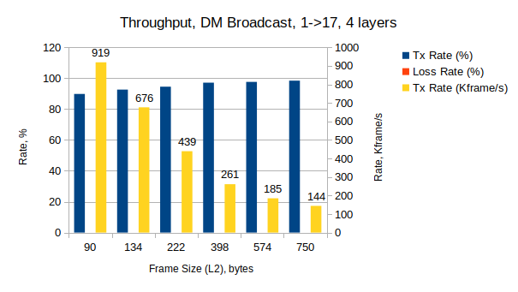

Timing messages | 1 | 2 | 4 | 8 | 12 | 16
Frame size (L2), bytes | 90 | 134 | 222 | 398 | 574 | 750
TX rate, % | 89,8 | 92,6 | 94,5 | 97,1 | 97,6 | 98,4
TX rate, Kframe/s | 919 | 676 | 439 | 261 | 185 | 144
Loss, frames | 0 | 0 | 0 | 0 | 0 | 0

Latency and Jitter

The average latency was reported to be around 10,2 to 13,2 us. Here, low and high values are boundary values from all ports. The difference of around 1-2 us was measured between broadcasting of a single timing message and (a few) multiple timing messages in a frame. The minimum and maximum latencies ranged from 9,8 to 11,7 us, and from 13,2 to 22,8 us, respectively.
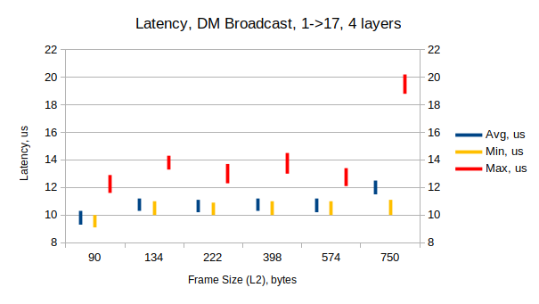

Timing messages | 1 | 2 | 4 | 8 | 12 | 16
Frame size (L2), bytes | 90 | 134 | 222 | 398 | 574 | 750
Avg (low), us | 10,2 | 11,2 | 11 | 11,2 | 11,1 | 12,5
Avg (high), us | 10,9 | 11,9 | 11,8 | 11,9 | 11,8 | 13,2
Min (low), us | 9,8 | 10,8 | 10,8 | 10,9 | 10,9 | 10,9
Min (high), us | 10,7 | 11,6 | 11,6 | 11,7 | 11,6 | 11,7
Max (low), us | 13,3 | 14,5 | 13,2 | 14,9 | 14,2 | 21,8
Max (high), us | 14,3 | 15,4 | 15 | 15,6 | 15 | 22,8

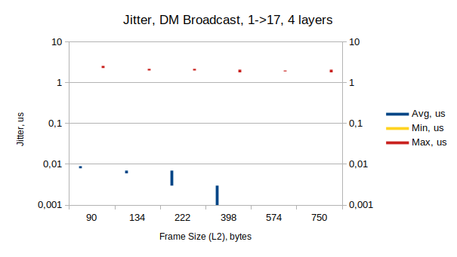

Timing messages | 1 | 2 | 4 | 8 | 12 | 16
Frame size (L2), bytes | 90 | 134 | 222 | 398 | 574 | 750
Avg (low), us | 0,008 | 0,006 | 0,003 | 0,001 | 0,001 | 0,001
Avg (high), us | 0,009 | 0,007 | 0,007 | 0,003 | 0,001 | 0,001
Min (low, high), us | 0 | 0 | 0 | 0 | 0 | 0
Max (low), us | 2,3 | 2 | 2 | 1,8 | 1,9 | 1,8
Max (high), us | 2,6 | 2,2 | 2,2 | 2,1 | 2 | 2,1

3.2. B2B Traffic Forwarding Results, 4 layers

XenaBay
(Xena2889
v1.46)
WRS v7.0
(nwt0010,
localmaster_
xenabay)
1 RX port,
n TX ports
n=17..7
WRS v7.0
(nwt0016,
distribution)
WRS v7.0
(nwt0296,
distribution)
WRS v7.0
(nwt0297,
access_all_
xenabay)
wri15 - P020
wri2 - P021, wri9 - P022
wri3 - P023, wri4 - P024, wri5 – P025
wri13 - P043, wri14 - P044, wri15 - P045
wri6 - P000, wri7 - P001, wri8 - P002
wri10 - P040, wri11 - P041, wri12 - P042
wri16 - P003, wri17 - P004, wri18 - P005
Throughput was measured using the RFC 2889 1:n partial mesh test (overall test port rate=1% (L1 9Mb/s), duration=30 seconds, iteration=3, topology=blocks, direction=west-to-east, TX rate: initial=1%, min=0,01%, max=100%, res=0,1%). In general, traffic from 17 west ports (B2B) was generated and forwarded to 1 east port (DM). Network throughput was measured depending on number of timing messages in a frame (frame length = 90-750 bytes), and number of west ports (n).

Throughput, 17 TX ports

The first test series was done with all west ports (n = 17) and varying B2B frame lengths (90-750 bytes). There are frame losses for all frame B2B frame lengths.
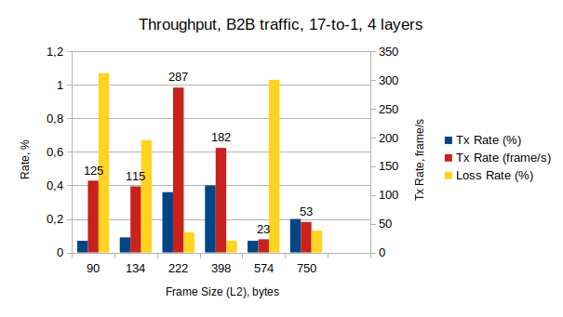

Timing messages | 1 | 2 | 4 | 8 | 12 | 16
Frame size (L2), bytes | 90 | 134 | 222 | 398 | 574 | 750
TX rate, % | 0,07 | 0,09 | 0,36 | 0,4 | 0,07 | 0,2
TX rate, frame/s | 125 | 115 | 287 | 182 | 23 | 53
TX rate, Kb/s | 109,7 | 142,2 | 555,5 | 607,6 | 107,7 | 329,3
Loss rate, % | 1,07 | 0,67 | 0,12 | 0,07 | 1,03 | 0,13
Loss, frames | 40 | 23 | 10 | 4 | 7 | 2

Throughput, 7 TX ports

The second test series was dedicated to find out the trade-off between maximum number of west ports and maximum network throughput. B2B traffic without loss was measured with 7 west ports and maximum throughput ranges 85,8% (54 Mb/s, 16,2 Kframe/s, 8 timing message per frame).
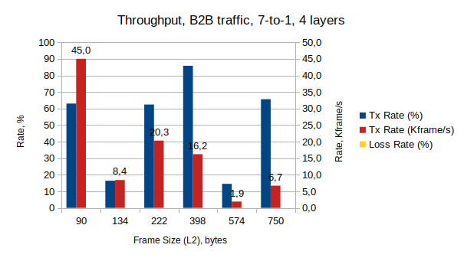

Timing messages | 1 | 2 | 4 | 8 | 12 | 16
Frame size (L2), bytes | 90 | 134 | 222 | 398 | 574 | 750
TX rate, % | 63 | 16,4 | 62,4 | 85,8 | 14,5 | 65,6
TX rate, Kframe/s | 45 | 8,4 | 20,3 | 16,2 | 1,9 | 6,7
TX rate, Mb/s | 39,7 | 10,34 | 39,3 | 54,1 | 9,1 | 41,2
Loss rate, % | 0 | 0 | 0 | 0 | 0 | 0
Loss, frames | 0 | 0 | 0 | 0 | 0 | 0

3.3. Mixed Traffic, 4 layers

DM broadcast
Service broadcast
Snoop

XenaBay
(Xena
Manager
V1.96)

B2B unicast

Service broadcast

WRS v7.0
(nwt0010,
localmaster_
xenabay)
wri15 - P020
WRS v7.0
(nwt0016,
distribution)
WRS v7.0
(nwt0296,
distribution)
WRS v7.0
(nwt0297,
access_mixed
_xenabay)
wri17 - P021
wri18 - P022
wri3 - P023, wri4 - P024, wri5 – P025
wri13 - P043, wri14 - P044, wri15 - P045
wri6 - P000, wri7 - P001, wri8 - P002
wri10 - P040, wri11 - P041, wri12 - P042
wri16 - P003, wri17 - P004, wri18 - P005

Traffic types of DM broadcast, B2B unicast, and service broadcast were generated with different data rate and frame length according to table below. The frame rate and length of the DM and B2B frames were used as iteration parameters for each measurement. Each run takes 5 minutes. The service broadcast traffic was generated with data rate of 142 Kb/s and frame length of 64-1518 bytes for all measurements.
Note: all measurements are done by using XenaManager software. Load ‘xenabay_gsi_use_case_4_layers.xmcfg’. Reserve all test ports (incl. P022 for snooping) and load corresponding port configurations.

Layer | WRS port | XenaBay port | Data rate, Mb/s | Frame size, bytes  (Frame rate, Kframe/s) | Traffic
1 | LM:wri15 | P020 | 10, 20, 50, 100 | 90, 134 (113,64, 81,17) | DM
 | LM:wri17 | P021 | 0,14 | 64-1518 (21) | Service trunk
 | LM:wri18 | P022 |  |  | (snooping)
4 | A:wri3 | P023 | 2, 4, 8, 16, 32 | 90, 134 (4,54, 3,25) | B2B
 | A:wri4 | P024 | 2, 4, 8, 16, 32 | 90, 134 | B2B
 | A:wri5 | P025 | 2, 4, 8, 16, 32 | 90, 134 | B2B
 | A:wri6 | P000 | 0,14 | 64-1518 | Service
 | A:wri7 | P001 | 0,14 | 64-1518 | Service
 | A:wri8 | P002 | 0,14 | 64-1518 | Service
 | A:wri10 | P040 | 0,14 | 64-1518 | Service
 | A:wri11 | P041 | 0,14 | 64-1518 | Service
 | A:wri12 | P042 | 0,14 | 64-1518 | Service
 | A:wri13 | P043 | 2, 4, 8, 16, 32 | 90, 134 | B2B
 | A:wri14 | P044 | 2, 4, 8, 16, 32 | 90, 134 | B2B
 | A:wri15 | P045 | 2, 4, 8, 16, 32 | 90, 134 | B2B
 | A:wri16 | P003 | 0,14 | 64-1518 | Service
 | A:wri17 | P004 | 0,14 | 64-1518 | Service
 | A:wri18 | P005 | 0,14 | 64-1518 | Service

DM Frame Loss

No frame loss in the DM broadcast was detected within probed data rates up to 100 Mb/s, and frame length of 90 and 134 bytes.

B2B Frame Loss

Frame loss in the B2B traffic was detected in higher data rates of the DM and B2B traffic:

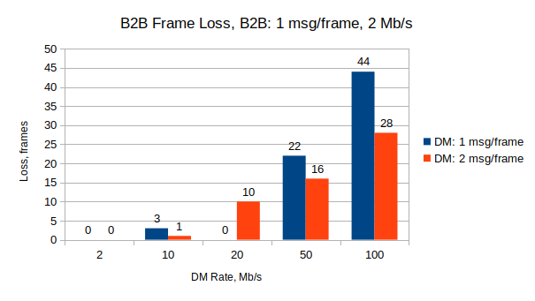

DM rate, Mb/s |  | 10 | 20 | 50 | 100
DM rate, frame/s |  | 11636 | 22727 | 56818 | 113636
DM msg/frame = 1  (frame = 90 bytes) | B2B frame loss, frames | 3 | 0 | 22 | 44
DM msg/frame = 1  (frame = 90 bytes) | B2B frame loss rate | 4,4*10⁻⁶ | 0 | 3,2*10⁻⁵ | 6,4*10⁻⁵
DM msg/frame = 2  (frame = 134 bytes) | B2B frame loss, frames | 1 | 10 | 16 | 28
DM msg/frame = 2  (frame = 134 bytes) | B2B frame loss rate | 1,5*10⁻⁶ | 1,5*10⁻⁵ | 2,3*10⁻⁵ | 4,1*10⁻⁵

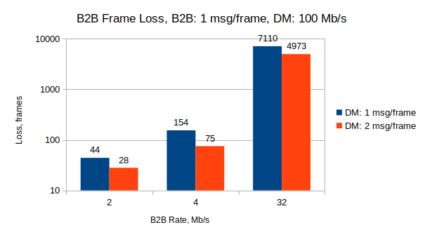

B2B rate, Mb/s |  | 2 | 4 | 32
B2B rate, frame/s |  | 2272 | 4545 | 36363
DM msg/frame = 1  (frame = 90 bytes) | B2B frame loss, frames | 44 | 154 | 7110
DM msg/frame = 1  (frame = 90 bytes) | B2B frame loss rate | 6,4*10⁻⁵ | 1,1*10⁻⁴ | 6,5*10⁻⁴
DM msg/frame = 2  (frame = 134 bytes) | B2B frame loss, frames | 28 | 75 | 4973
DM msg/frame = 2  (frame = 134 bytes) | B2B frame loss rate | 4,1*10⁻⁵ | 5,5*10⁻⁵ | 6,5*10⁻⁴

In addition, the frame loss was detected only with B2B frames that has the length of 1 timing message. For other frame lengths (2/4/8 timing messages) no frame loss was detected (DM rate=100Mb/s, 1 msg/frame).

B2B frame loss | B2B frame | B2B frame length, bytes
Detected | 1 message/frame | 90
Not detected | 2, 4, 8 messages/frame | 134, 222, 398

Service Frame Loss

According the network configuration there are two uni-directional service traffic is enabled: upstream (layer 4 to layer 1) and downstream (layer 1 to layer 4). Frame loss occurred in the downstream traffic at rate of 1,85*10⁻³ (e.g., 204 lost frames out of 110160 TX frames).

Latency and Jitter

Latency were not evaluated, but one corner case measurement shows that it takes 9,7-10,9 us in average for all traffic types. The maximum latency around 23 us was measured for the DM broadcast and B2B traffics.

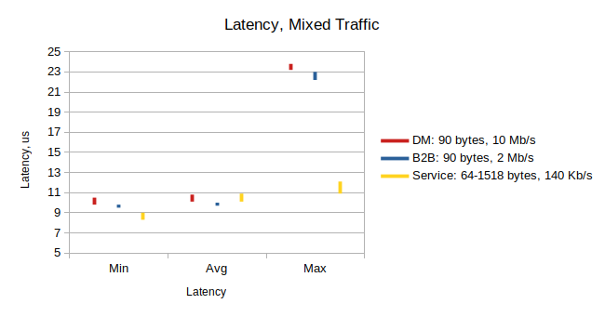

Traffic types | Min latency, us | Avg latency, us | Max latency, us
DM: 90 bytes, 10 Mb/s | 9,8-10,5 | 10,1-10,8 | 23,2-23,8
B2B: 90 bytes, 2 Mb/s | 9,5-9,8 | 9,7-10 | 22,2-23
Service: 64-1518 bytes, 140 Kb/S | 8,3-9 | 10,1-10,9 | 10,9-12,1

xena2889-report_gsi_dm_broadcast_4_layers_v7-20241209-105640.pdf
xena2889-report_gsi_b2b_traffic_4_layers_v7-20241205-144745.pdf
xena2889-report_gsi_b2b_traffic_4_layers_v7-20241206-172612.pdf

