**Features Comparison 页**

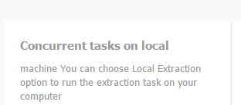

粗体Concurrent tasks on local machine

下面的小字：

You can choose Local Extraction option to run the extraction task on your computer.

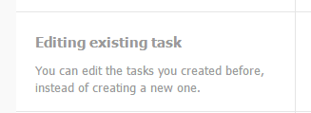

下面的小字：

You can edit the existing tasks, instead of creating a new one.

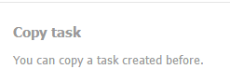

下面的小字：

You can copy an existing task.



下面的小字：

You can view your data after you back up your data or when you run the task in the cloud.

这个红色的X号要变成勾。

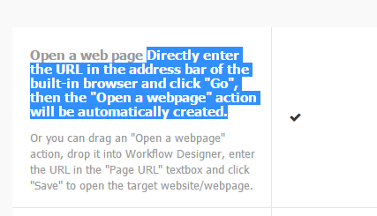

选中的字是要变成下面的小字的。

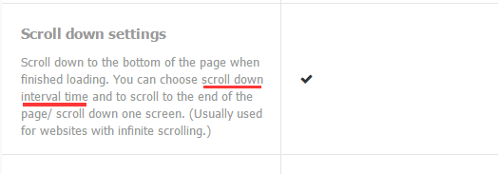

改成the scroll-down interval time

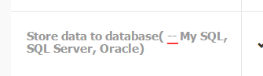

-- 去掉



. 去掉