1. 申请试用增加一句话：（已经发QQ给你了）

Each Octoparse Account can only use a free trial once.

标红

1. 默认字体为 font-family:Maax-Standard,Helvetica,Arial,sans-serif; 默认字号为17px

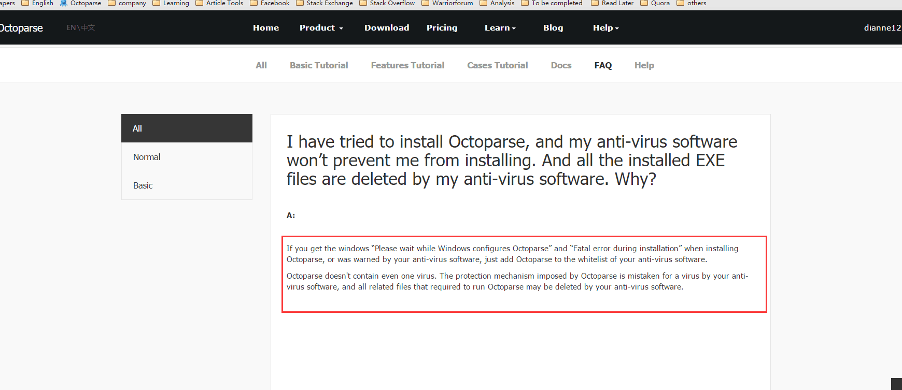

3、

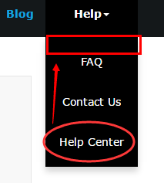

把 help center 调整到第一行。

4、

**About Us 页**

Octoparse is a free web scraper for collecting data from the web. Based on the popularity in China market, where Octoparse already has more than 180,000 users, we decided to break into an international market.

Since our founding in 2014, Our mission is to offer you the very best web scraping service. However, we constantly strive to make improvements wherever we can and that is why we would greatly appreciate any help you can give us. Please let us know what you would ideally look for from us for help and support.

The world has been changed for ever by data revolution. There’ re more and more companies with critical reliance on data. Data’ s influences have spilled over into everyday life. And the data revolution is set to become even more personal. The fastest growing dataset of all is the one being created by you. Every time we call, text, search, travel, buy, we add to the data mountain.

Data is just there and it’s valuable. But it’s not always easy to get the right data from the web because all websites have their own design. Publicly available data could be turned into valuable business intelligence.If you are one of those who are looking for data to support your analysis, you just found the right solution.

Octoparse makes it easier and faster for you to get data from the web without having you to code. It will automatically extract content from almost any website and allows you to save it as clean structured data in a format of your choice. You can also turn any data into custom APIs. Now you don’t have to hire tons of interns to copy and paste manually. You just need to make the rule for collecting data and Octoparse will do the rest.

“No matter who you are, no matter what you look like, no matter where you come from, here in Octoparse, you can make it if you try”

Are you prepared to be surprised by Octoparse?

**Contact Us**

Octopus Data Inc.

721 Brea Canyon Road, Suite 1, Walnut, CA 91789

support@octoparse.com（加链接）

地图

5、

**代理页**

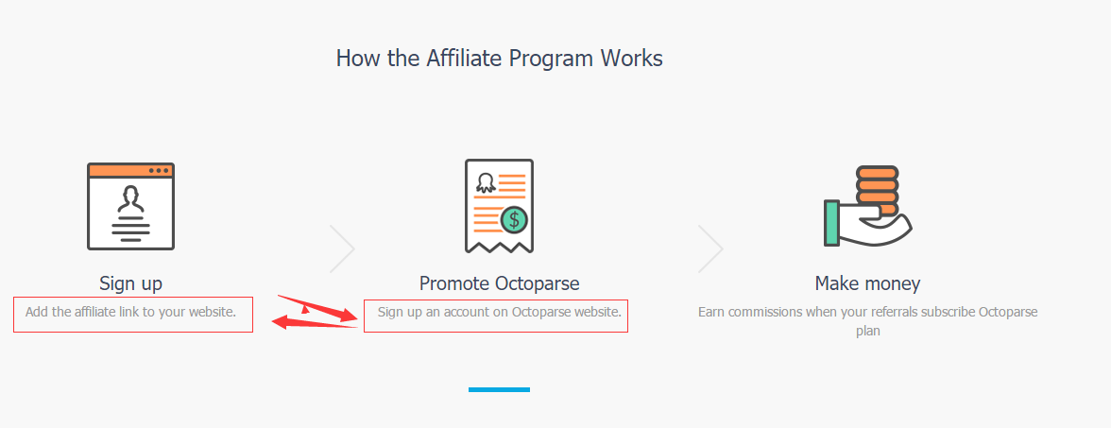

这2句话相互换位置。记得句末不要加句号。

左边 Sign up an account on Octoparse website

右边 Add the affiliate link to your website

6、

**Features Comparison 页**

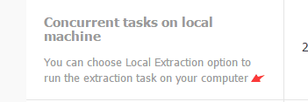

下面的小字加句号：

You can choose Local Extraction option to run the extraction task on your computer.

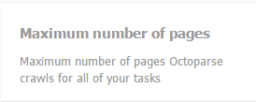

下面的小字加句号：

Maximum number of pages Octoparse crawls for all of your tasks.

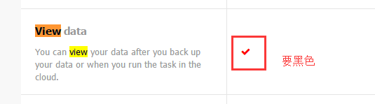

打钩 要黑色不要红色

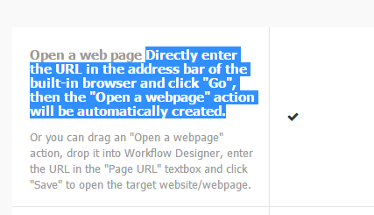

选中的字是要变成下面的小字的。

粗体：Open a web page

小字：

Directly enter the URL in the address bar of the built-in browser and click "Go", then the "Open a webpage" action will be automatically created.

Or you can drag an "Open a webpage" action, drop it into Workflow Designer, enter the URL in the "Page URL" textbox and click "Save" to open the target website/webpage.

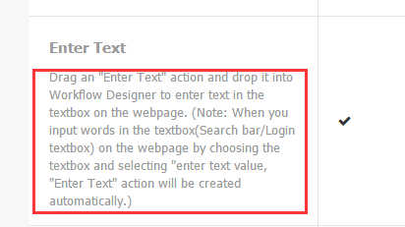

下面小字改成：

Drag an "Enter Text" action and drop it into Workflow Designer to enter text in the textbox on the webpage. (Note: When you input words in the textbox (Search bar/Login textbox) on the webpage by choosing the textbox and selecting "Enter text value”, "Enter Text" action will be created automatically.)

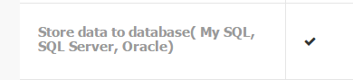

Store data to database (My SQL, SQL Server, Oracle)

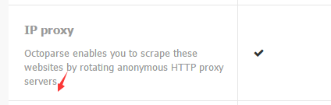

句末加句号.

7、

**Home 首页**

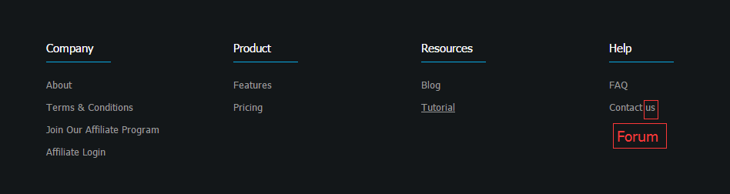

改成Contact Us

**Pricing 页**

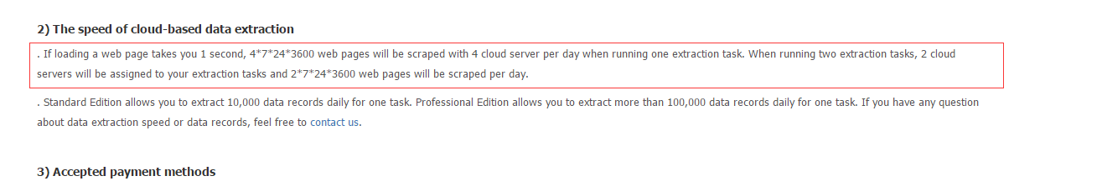

改成（主要是改了这个蓝色句子）

. If it takes around 1 second to load a web page, 4*7*24*3600 web pages will be scraped with 4 cloud server per day when running one extraction task. When running two extraction tasks, 2 cloud servers will be assigned to your extraction tasks and 2*7*24*3600 web pages will be scraped per day.

8、

**Blog 页**

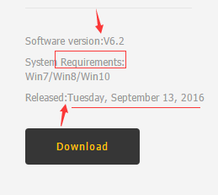

2个空色箭头要加空格，requirements首字母小写。

改成：

Software version: V 6.2

System requirements:

Win7/Win8/Win10

Released: September 13, 2016

9、

Product

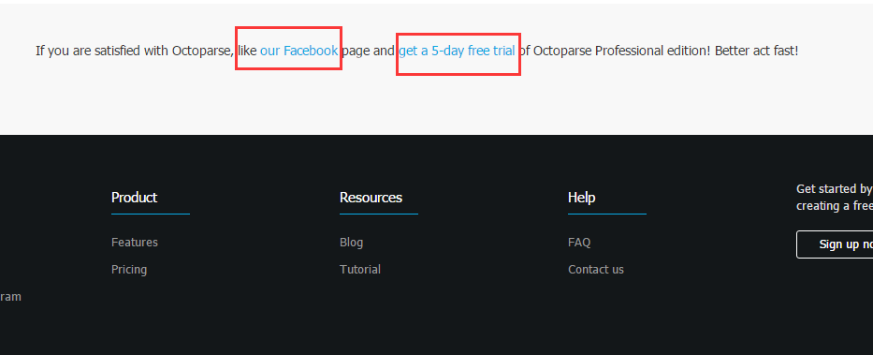

like our page加链接https://www.facebook.com/Octoparse/

get a 5-day free trial 不用加链接了。