2/1/2022

Danielle sherman

CTO, Blackwell Electronics

Overview:

As per your request, I performed a market basket analysis on the Electrondex provided csv. I inspected and cleaned the dataset. I found redundant rules that were removed in order to provide a more accurate analysis. However, a larger dataset with more product purchase history would produce better insight.

The vast majority of rules identified were either irrelevant or unclear. Those that were insightful pose their own set of questions. The data suggest that 95% of the time a customer purchases a Dell KM117 Wireless Keyboard & Mouse and an iPhone Charger Cable, they also purchase an Apple MacBook Air. Out of thousands of transactions, this occurred 20 times. The data suggests that this is not just a coincidence. No other rules meet these criteria as strongly as this aforementioned product association rule. This is visualized in the graph below.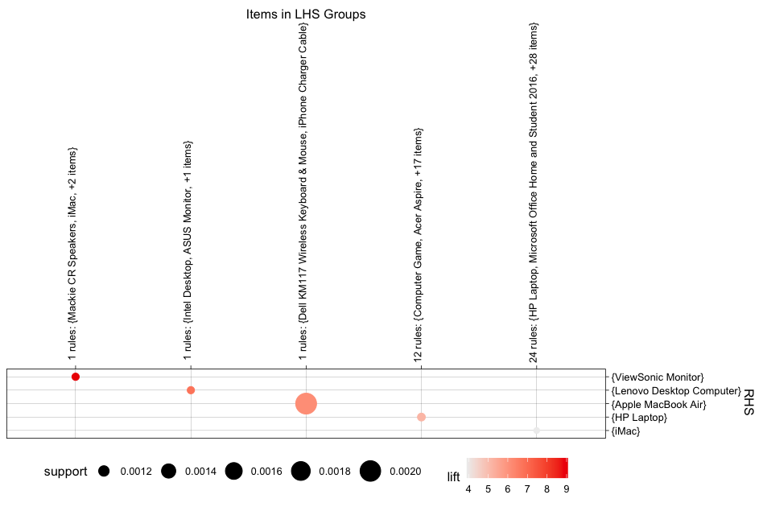

It is worth noting a few other rules that are significant, but have low sales. Customers who bought a Dell Desktop, an iMac, a Lenovo Desktop Computer, and a Mackie CR Speakers always purchased a ViewSonic Monitor. This is most likely not a coincidence, but this exact sale only occurred 11 times. Also, customers who purchased an ASUS Monitor, and Intel Desktop, and a ViewSonic Monitor always purchased a Lenovo Desktop Computer, again, it would be more significant if more than 11 transactions occurred. The analysis indicated that this is most likely not a coincidence. These rules are visualized in the graph below.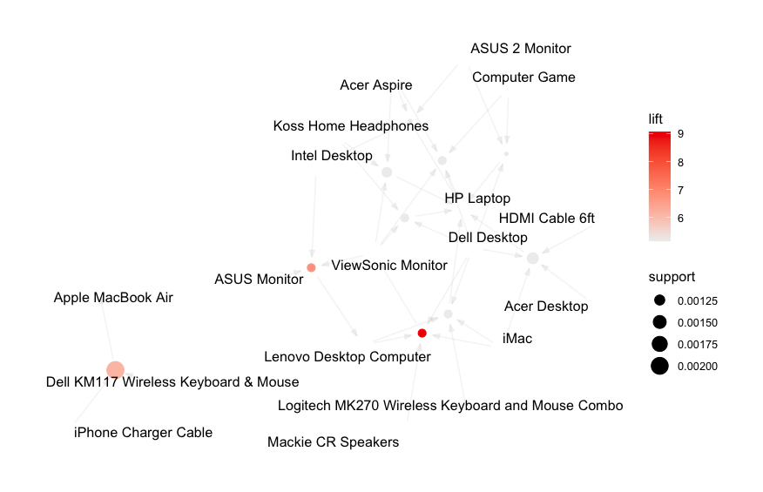

**OBSERVATIONS:**

Out of thousands of transactions the strongest rules only had sales as high as 20 times. The products purchased almost always work together would not need much advertising apart from creating bundles designating products for cross-selling. It would be best to sell a customer a cable to charge their new iPhone as oppose to the customer purchasing it elsewhere. If Electronidex is already employing sales promotions and cross-selling, then I would advise Blackwell Electronics not to acquire. However, if they are not, Blackwell could increase those purchases for a larger profit.

GRANT JOHNSON