Figure 1: Figure using IRIS Data Set
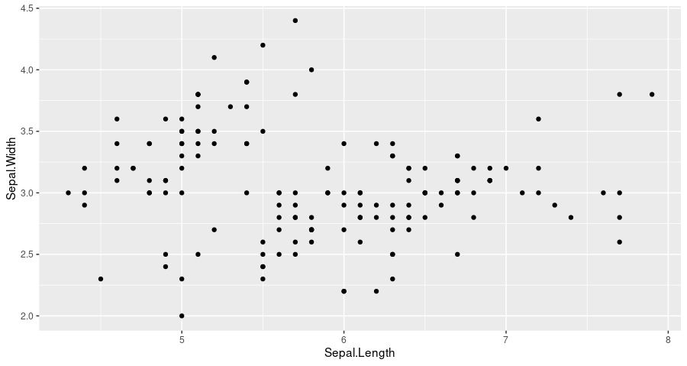

1.) Footnote #1 for sample figure 1.
2.) Footnote #2 for sample figure 1.
3.) Footnote #3 for sample figure 1.

