Figure 2: Figure using IRIS Data Set
Gender: Male
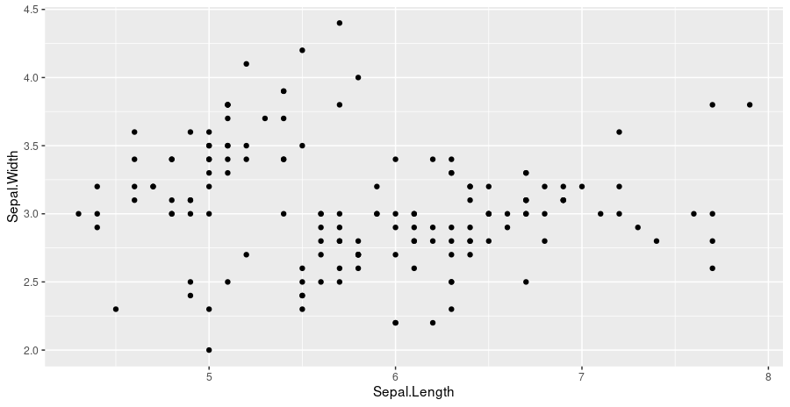

1.) Footnote #1 for sample figure 2.
2.) Footnote #2 for sample figure 2.
3.) Footnote #3 for sample figure 2.

Figure 2: Figure using IRIS Data Set
Gender: Female
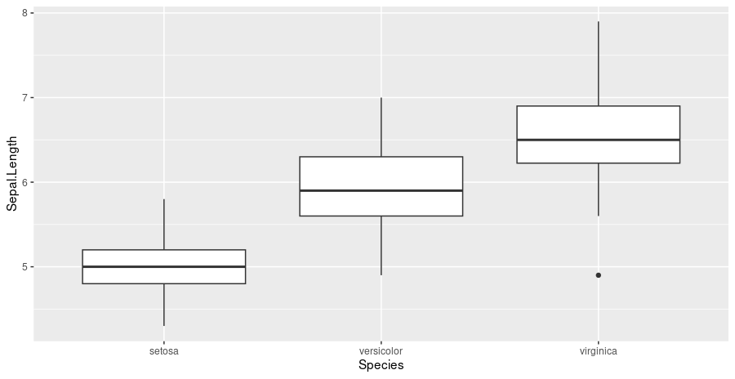

1.) Footnote #1 for sample figure 2.
2.) Footnote #2 for sample figure 2.
3.) Footnote #3 for sample figure 2.

