GSK Assignment 3

GS Kumbhare

03/08/2020

**Objective**

Objective is to find best classification model that can fit air quality data set. We also took relationship between error rates and model complexity. We also investigate relationship between several predictor and response variable.

**Data description**

The data set we have is obtained from R directory of datasets. We obtained the Airquality data for a period of 5 month. In total we have 153 instances in the dataset. In this the class is months number.

**Attributes of data**

1. Ozone level
2. Solar radiation
3. Windspeed
4. Temperature
5. Month
6. Day

**Libraries**

Libraries needed for classification model

library(ggthemes)  
library(ggplot2)  
library(caret)

## Loading required package: lattice

library(ggiraphExtra)

##   
## Attaching package: 'ggiraphExtra'

## The following object is masked from 'package:ggthemes':  
##   
## theme_clean

library(ggplot2)  
library(broom)  
library(readr)  
library(MASS)  
library(e1071)  
library(nnet)  
library(corrplot)

## corrplot 0.84 loaded

library(tidyverse)

## -- Attaching packages ---------------------------------------------------- tidyverse 1.3.0 --

## v tibble 3.0.2 v dplyr 1.0.0  
## v tidyr 1.1.0 v stringr 1.4.0  
## v purrr 0.3.4 v forcats 0.5.0

## -- Conflicts ------------------------------------------------------- tidyverse_conflicts() --  
## x dplyr::filter() masks stats::filter()  
## x dplyr::lag() masks stats::lag()  
## x purrr::lift() masks caret::lift()  
## x dplyr::select() masks MASS::select()

library(car)

## Loading required package: carData

##   
## Attaching package: 'car'

## The following object is masked from 'package:dplyr':  
##   
## recode

## The following object is masked from 'package:purrr':  
##   
## some

**Dataset**

We load our dataset in the console

str(airquality)

## 'data.frame': 153 obs. of 6 variables:  
## $ Ozone : int 41 36 12 18 NA 28 23 19 8 NA ...  
## $ Solar.R: int 190 118 149 313 NA NA 299 99 19 194 ...  
## $ Wind : num 7.4 8 12.6 11.5 14.3 14.9 8.6 13.8 20.1 8.6 ...  
## $ Temp : int 67 72 74 62 56 66 65 59 61 69 ...  
## $ Month : int 5 5 5 5 5 5 5 5 5 5 ...  
## $ Day : int 1 2 3 4 5 6 7 8 9 10 ...

From the dataset we loaded we can see that there are NA values in our data set Next we remove na values so that our model works good.

na<- na.omit(airquality)  
str(na)

## 'data.frame': 111 obs. of 6 variables:  
## $ Ozone : int 41 36 12 18 23 19 8 16 11 14 ...  
## $ Solar.R: int 190 118 149 313 299 99 19 256 290 274 ...  
## $ Wind : num 7.4 8 12.6 11.5 8.6 13.8 20.1 9.7 9.2 10.9 ...  
## $ Temp : int 67 72 74 62 65 59 61 69 66 68 ...  
## $ Month : int 5 5 5 5 5 5 5 5 5 5 ...  
## $ Day : int 1 2 3 4 7 8 9 12 13 14 ...  
## - attr(*, "na.action")= 'omit' Named int [1:42] 5 6 10 11 25 26 27 32 33 34 ...  
## ..- attr(*, "names")= chr [1:42] "5" "6" "10" "11" ...

Now we summarise the clean dataset

summary(na)

## Ozone Solar.R Wind Temp   
## Min. : 1.0 Min. : 7.0 Min. : 2.30 Min. :57.00   
## 1st Qu.: 18.0 1st Qu.:113.5 1st Qu.: 7.40 1st Qu.:71.00   
## Median : 31.0 Median :207.0 Median : 9.70 Median :79.00   
## Mean : 42.1 Mean :184.8 Mean : 9.94 Mean :77.79   
## 3rd Qu.: 62.0 3rd Qu.:255.5 3rd Qu.:11.50 3rd Qu.:84.50   
## Max. :168.0 Max. :334.0 Max. :20.70 Max. :97.00   
## Month Day   
## Min. :5.000 Min. : 1.00   
## 1st Qu.:6.000 1st Qu.: 9.00   
## Median :7.000 Median :16.00   
## Mean :7.216 Mean :15.95   
## 3rd Qu.:9.000 3rd Qu.:22.50   
## Max. :9.000 Max. :31.00

First we find correlation between all the variables

cor(na)

## Ozone Solar.R Wind Temp Month  
## Ozone 1.000000000 0.34834169 -0.61249658 0.6985414 0.142885168  
## Solar.R 0.348341693 1.00000000 -0.12718345 0.2940876 -0.074066683  
## Wind -0.612496576 -0.12718345 1.00000000 -0.4971897 -0.194495804  
## Temp 0.698541410 0.29408764 -0.49718972 1.0000000 0.403971709  
## Month 0.142885168 -0.07406668 -0.19449580 0.4039717 1.000000000  
## Day -0.005189769 -0.05775380 0.04987102 -0.0965458 -0.009001079  
## Day  
## Ozone -0.005189769  
## Solar.R -0.057753801  
## Wind 0.049871017  
## Temp -0.096545800  
## Month -0.009001079  
## Day 1.000000000

We make our correlation plot for our data set

correlations <- cor(na[,1:4])  
corrplot(correlations, method = "square")

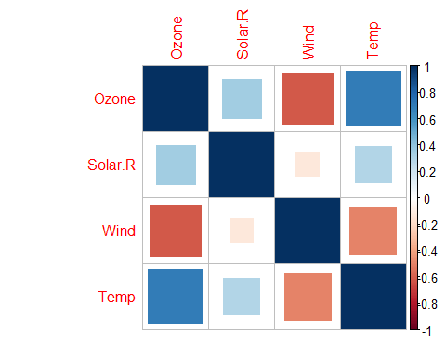

**Modelling**

We will be using forward selection method for our modeling. In this method we will start with 1 predictor and increase to 3 predictor for each model

Our First model will be linear regression model

**Linear regression Model**

1. Model1 of linear regression

modellr1<- lm(Ozone~Solar.R, data = na)  
modellr1

##   
## Call:  
## lm(formula = Ozone ~ Solar.R, data = na)  
##   
## Coefficients:  
## (Intercept) Solar.R   
## 18.5987 0.1272

AIC(modellr1)

## [1] 1083.714

BIC(modellr1)

## [1] 1091.843

summary(modellr1)

##   
## Call:  
## lm(formula = Ozone ~ Solar.R, data = na)  
##   
## Residuals:  
## Min 1Q Median 3Q Max   
## -48.292 -21.361 -8.864 16.373 119.136   
##   
## Coefficients:  
## Estimate Std. Error t value Pr(>|t|)   
## (Intercept) 18.59873 6.74790 2.756 0.006856 **   
## Solar.R 0.12717 0.03278 3.880 0.000179 ***  
## ---  
## Signif. codes: 0 '***' 0.001 '**' 0.01 '*' 0.05 '.' 0.1 ' ' 1  
##   
## Residual standard error: 31.33 on 109 degrees of freedom  
## Multiple R-squared: 0.1213, Adjusted R-squared: 0.1133   
## F-statistic: 15.05 on 1 and 109 DF, p-value: 0.0001793

From the above analysis of Ozone according to Solar radiation the value of residual standard error and multiple R-squared values are 31.33 and 12.13% respectively.

1. **Model 2 of linear regression**

modellr2<- lm(Ozone~Solar.R+ Wind, data = na)  
modellr2

##   
## Call:  
## lm(formula = Ozone ~ Solar.R + Wind, data = na)  
##   
## Coefficients:  
## (Intercept) Solar.R Wind   
## 77.2460 0.1004 -5.4018

AIC(modellr2)

## [1] 1033.816

BIC(modellr2)

## [1] 1044.654

summary(modellr2)

##   
## Call:  
## lm(formula = Ozone ~ Solar.R + Wind, data = na)  
##   
## Residuals:  
## Min 1Q Median 3Q Max   
## -45.651 -18.164 -5.959 18.514 85.237   
##   
## Coefficients:  
## Estimate Std. Error t value Pr(>|t|)   
## (Intercept) 77.24604 9.06751 8.519 1.05e-13 ***  
## Solar.R 0.10035 0.02628 3.819 0.000224 ***  
## Wind -5.40180 0.67324 -8.024 1.34e-12 ***  
## ---  
## Signif. codes: 0 '***' 0.001 '**' 0.01 '*' 0.05 '.' 0.1 ' ' 1  
##   
## Residual standard error: 24.92 on 108 degrees of freedom  
## Multiple R-squared: 0.4495, Adjusted R-squared: 0.4393   
## F-statistic: 44.09 on 2 and 108 DF, p-value: 1.003e-14

Our Residual standar error is 24.92 and multiple R-squared value is 44.95%.

1. **Model3 of linear regression**

modellr3<- lm(Ozone~Solar.R + Wind + Temp, data = na)  
modellr3

##   
## Call:  
## lm(formula = Ozone ~ Solar.R + Wind + Temp, data = na)  
##   
## Coefficients:  
## (Intercept) Solar.R Wind Temp   
## -64.34208 0.05982 -3.33359 1.65209

AIC(modellr3)

## [1] 998.7171

BIC(modellr3)

## [1] 1012.265

summary(modellr3)

##   
## Call:  
## lm(formula = Ozone ~ Solar.R + Wind + Temp, data = na)  
##   
## Residuals:  
## Min 1Q Median 3Q Max   
## -40.485 -14.219 -3.551 10.097 95.619   
##   
## Coefficients:  
## Estimate Std. Error t value Pr(>|t|)   
## (Intercept) -64.34208 23.05472 -2.791 0.00623 **   
## Solar.R 0.05982 0.02319 2.580 0.01124 *   
## Wind -3.33359 0.65441 -5.094 1.52e-06 ***  
## Temp 1.65209 0.25353 6.516 2.42e-09 ***  
## ---  
## Signif. codes: 0 '***' 0.001 '**' 0.01 '*' 0.05 '.' 0.1 ' ' 1  
##   
## Residual standard error: 21.18 on 107 degrees of freedom  
## Multiple R-squared: 0.6059, Adjusted R-squared: 0.5948   
## F-statistic: 54.83 on 3 and 107 DF, p-value: < 2.2e-16

Our residual standard error and Multple R-Squared value is 21.18 and 60.59% respectively.

**Summary Linear regression**

With our analysis of linear regression models we see that as we increase number of predictors our value of residual standard error decreases and multiple R-Squared value increases. This shows that increase in predictor variables in reduces our error rate and increases accuracy.

**Logistic regression**

We will be using Logistic regression for our analysis further.

1. **Model 1 of logistic regression**

#We use logistic regression with one predictor  
#1.first predictors is Solar radiation   
log_fit1=glm(Ozone~Solar.R, data=na)  
print(log_fit1)

##   
## Call: glm(formula = Ozone ~ Solar.R, data = na)  
##   
## Coefficients:  
## (Intercept) Solar.R   
## 18.5987 0.1272   
##   
## Degrees of Freedom: 110 Total (i.e. Null); 109 Residual  
## Null Deviance: 121800   
## Residual Deviance: 107000 AIC: 1084

glance(log_fit1)

## Warning: `...` is not empty.  
##   
## We detected these problematic arguments:  
## * `needs_dots`  
##   
## These dots only exist to allow future extensions and should be empty.  
## Did you misspecify an argument?

## # A tibble: 1 x 8  
## null.deviance df.null logLik AIC BIC deviance df.residual nobs  
## <dbl> <int> <dbl> <dbl> <dbl> <dbl> <int> <int>  
## 1 121802. 110 -539. 1084. 1092. 107022. 109 111

Our AIC value for model 1 of logistic regression is 1083.7

1. **Model2 of logistic regression**

#We use logistic regression with one predictor  
#1.first predictors is Solar radiation   
log_fit2=glm(Ozone~Solar.R + Wind, data=na)  
print(log_fit2)

##   
## Call: glm(formula = Ozone ~ Solar.R + Wind, data = na)  
##   
## Coefficients:  
## (Intercept) Solar.R Wind   
## 77.2460 0.1004 -5.4018   
##   
## Degrees of Freedom: 110 Total (i.e. Null); 108 Residual  
## Null Deviance: 121800   
## Residual Deviance: 67050 AIC: 1034

glance(log_fit2)

## Warning: `...` is not empty.  
##   
## We detected these problematic arguments:  
## * `needs_dots`  
##   
## These dots only exist to allow future extensions and should be empty.  
## Did you misspecify an argument?

## # A tibble: 1 x 8  
## null.deviance df.null logLik AIC BIC deviance df.residual nobs  
## <dbl> <int> <dbl> <dbl> <dbl> <dbl> <int> <int>  
## 1 121802. 110 -513. 1034. 1045. 67053. 108 111

In our model 2 AIC value is 1033.81. And our BIC value is 1044.65.

1. **Model3 of logistic regression**

#We use logistic regression with one predictor  
#1.first predictors is Solar radiation   
log_fit3=glm(Ozone~Solar.R+ Wind + Temp, data=na)  
print(log_fit3)

##   
## Call: glm(formula = Ozone ~ Solar.R + Wind + Temp, data = na)  
##   
## Coefficients:  
## (Intercept) Solar.R Wind Temp   
## -64.34208 0.05982 -3.33359 1.65209   
##   
## Degrees of Freedom: 110 Total (i.e. Null); 107 Residual  
## Null Deviance: 121800   
## Residual Deviance: 48000 AIC: 998.7

glance(log_fit3)

## Warning: `...` is not empty.  
##   
## We detected these problematic arguments:  
## * `needs_dots`  
##   
## These dots only exist to allow future extensions and should be empty.  
## Did you misspecify an argument?

## # A tibble: 1 x 8  
## null.deviance df.null logLik AIC BIC deviance df.residual nobs  
## <dbl> <int> <dbl> <dbl> <dbl> <dbl> <int> <int>  
## 1 121802. 110 -494. 999. 1012. 48003. 107 111

Lower AIc value tells that the model is closer to the truth. And lower BIC mean the model is considered to be true model.

Lets plot this in a graph.

dat1 <- data.frame(No_of_Predictors =c(1,2,3), AIC = c(1083.7, 1033.8, 998.7171))  
  
dat1

## No_of_Predictors AIC  
## 1 1 1083.7000  
## 2 2 1033.8000  
## 3 3 998.7171

ggplot(dat1, aes(x=No_of_Predictors, y=AIC)) +  
 geom_point() +  
 geom_line() +  
 labs(x="Model Complexity (No. of Predictors)", y="AIC", title="AIC changes with increase of variable/ change in ")

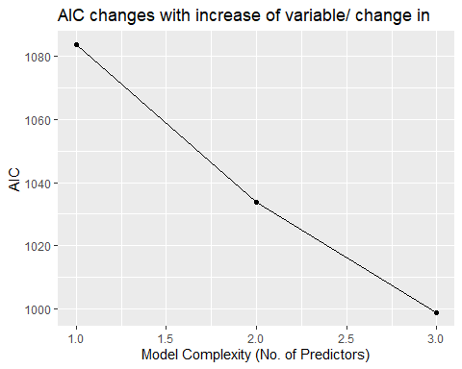

**Summary of Logistic Regeression**

1. We can see that as the number of variables increases the model truthfulness increases.
2. It implies that the performance of model improves as we increase the number of predictors.

**KFold cross validation linear mean regression**

In K-fold Cross validation the idea is to radomly divide the data into K equal sized parts.We leave out one part and fit the model to other remaining parts combined. At last we obtain prediction for teh left out part.

First we make our linear mean regression model.

1. **Kfold LM**

#kfold With linear mean regression method  
  
set.seed(1)  
train.control <- trainControl(method = "cv", number = 10)  
# Train the model1  
modelkfold1 <- train(Ozone ~ Solar.R , data = na , method = "lm",  
 trControl = train.control)  
# Summarize the results of model 1  
print(modelkfold1)

## Linear Regression   
##   
## 111 samples  
## 1 predictor  
##   
## No pre-processing  
## Resampling: Cross-Validated (10 fold)   
## Summary of sample sizes: 100, 101, 100, 98, 100, 101, ...   
## Resampling results:  
##   
## RMSE Rsquared MAE   
## 30.63197 0.1748174 24.57872  
##   
## Tuning parameter 'intercept' was held constant at a value of TRUE

Our RMSE value is 30.63.

**Kfold lm model 2**

#kfold With linear mean regression method  
  
set.seed(1)  
train.control <- trainControl(method = "cv", number = 10)  
# Train the model1  
modelkfold2 <- train(Ozone ~ Solar.R + Wind , data = na , method = "lm",  
 trControl = train.control)  
# Summarize the results of model 2  
print(modelkfold2)

## Linear Regression   
##   
## 111 samples  
## 2 predictor  
##   
## No pre-processing  
## Resampling: Cross-Validated (10 fold)   
## Summary of sample sizes: 100, 101, 100, 98, 100, 101, ...   
## Resampling results:  
##   
## RMSE Rsquared MAE   
## 24.70793 0.4835431 20.59158  
##   
## Tuning parameter 'intercept' was held constant at a value of TRUE

Out RMSE value is 24.70

**Kfold LM Model 3**

#kfold With linear mean regression method  
  
set.seed(1)  
train.control <- trainControl(method = "cv", number = 10)  
# Train the model3  
modelkfold3 <- train(Ozone ~ Solar.R+ Wind + Temp , data = na , method = "lm",  
 trControl = train.control)  
# Summarize the results of model 3  
print(modelkfold3)

## Linear Regression   
##   
## 111 samples  
## 3 predictor  
##   
## No pre-processing  
## Resampling: Cross-Validated (10 fold)   
## Summary of sample sizes: 100, 101, 100, 98, 100, 101, ...   
## Resampling results:  
##   
## RMSE Rsquared MAE   
## 20.75562 0.6568537 16.04515  
##   
## Tuning parameter 'intercept' was held constant at a value of TRUE

Value of RMSE has reduced to 20.75. We plot all the RMSE values.

dat2 <- data.frame(No_of_Predictors =c(1,2,3), RMSE= c(30.63, 24.75, 20.75))  
  
dat2

## No_of_Predictors RMSE  
## 1 1 30.63  
## 2 2 24.75  
## 3 3 20.75

ggplot(dat2, aes(x=No_of_Predictors, y=RMSE)) +  
 geom_point() +  
 geom_line() +  
 labs(x="Model Complexity (No. of Predictors)", y="RMSE", title="RMSE changes with increase of variable/ change in Models ")

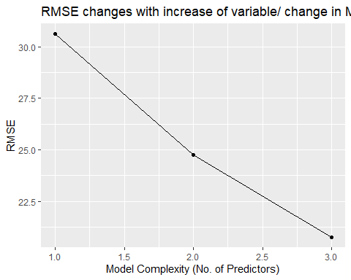

**Summary of Kfold LM**

With lower RMSE of a model the model has better predictions. The last model with 3 predictors has lowest root mean square error. That means model with 3 prediction is better than model with lower predictors.

**KNN Model**

K nearest neighbour is an instance based learnign, where the function is only approximated locally and all the other computation is deferred untill function evaluation. Since this algorithm relies on distance for teh classifiation, the training dataset is normalized to increase accuracy.

1. **Model1 With 1 predictor**

#knn model 1  
trControl <- trainControl(method = "cv",  
 number = 3)  
Modelknn1 <- train(Ozone ~ Solar.R,  
 method = "knn",  
 tuneGrid = expand.grid(k = 10),  
 trControl = trControl,  
 data = na)  
Modelknn1

## k-Nearest Neighbors   
##   
## 111 samples  
## 1 predictor  
##   
## No pre-processing  
## Resampling: Cross-Validated (3 fold)   
## Summary of sample sizes: 74, 74, 74   
## Resampling results:  
##   
## RMSE Rsquared MAE   
## 31.86325 0.1611655 25.75232  
##   
## Tuning parameter 'k' was held constant at a value of 10

Root mean square error value for model 1 of KNN is 30.289.

1. **Model 2**

#knn model 1  
trControl <- trainControl(method = "cv",  
 number = 3)  
Modelknn2 <- train(Ozone ~ Solar.R + Wind,  
 method = "knn",  
 tuneGrid = expand.grid(k = 10),  
 trControl = trControl,  
 data = na)  
Modelknn2

## k-Nearest Neighbors   
##   
## 111 samples  
## 2 predictor  
##   
## No pre-processing  
## Resampling: Cross-Validated (3 fold)   
## Summary of sample sizes: 74, 74, 74   
## Resampling results:  
##   
## RMSE Rsquared MAE   
## 30.54655 0.1708377 23.12547  
##   
## Tuning parameter 'k' was held constant at a value of 10

The RMSE value of model 2 of knn is 28.57. It seems like with increase in predictors the value of RMSE is drecreasing.

1. **Model 3**

#knn model 1  
trControl <- trainControl(method = "cv",  
 number = 3)  
Modelknn3 <- train(Ozone ~ Solar.R + Wind + Temp,  
 method = "knn",  
 tuneGrid = expand.grid(k = 10),  
 trControl = trControl,  
 data = na)  
Modelknn3

## k-Nearest Neighbors   
##   
## 111 samples  
## 3 predictor  
##   
## No pre-processing  
## Resampling: Cross-Validated (3 fold)   
## Summary of sample sizes: 73, 74, 75   
## Resampling results:  
##   
## RMSE Rsquared MAE   
## 25.728 0.413587 19.90318  
##   
## Tuning parameter 'k' was held constant at a value of 10

Our model 3 RMSE value is 25.010.

dat3 <- data.frame(No_of_Predictors =c(1,2,3), RMSE= c(30.28, 28.57, 25.010))  
  
dat3

## No_of_Predictors RMSE  
## 1 1 30.28  
## 2 2 28.57  
## 3 3 25.01

ggplot(dat3, aes(x=No_of_Predictors, y=RMSE)) +  
 geom_point() +  
 geom_line() +  
 labs(x="Model Complexity (No. of Predictors)", y="RMSE", title="RMSE changes with increase of variable/ change in KNN Models ")

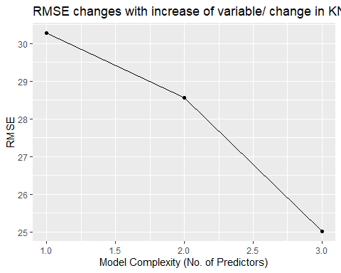

**LOOCV Models**

In LOOCV model we leave one data point and build model on the rest of dataset. Then we test the model against the data point that was left out in step one and record the test error associated with it.

**Model1 LOOCV**

#LOOCV for one predictor   
train.control.loocv <- trainControl(method = "LOOCV")  
# Train the model  
modelloocv1 <- train(Ozone ~Solar.R, data = na, method = "lm",  
 trControl = train.control.loocv)  
# Summarize the results  
print(modelloocv1)

## Linear Regression   
##   
## 111 samples  
## 1 predictor  
##   
## No pre-processing  
## Resampling: Leave-One-Out Cross-Validation   
## Summary of sample sizes: 110, 110, 110, 110, 110, 110, ...   
## Resampling results:  
##   
## RMSE Rsquared MAE   
## 31.51877 0.09617832 24.59652  
##   
## Tuning parameter 'intercept' was held constant at a value of TRUE

In LOOCV model 1 our RMSE value is 31.51877 with one predictor.

1. **Model 2 KNN**

#LOOCV for one predictor   
train.control.loocv <- trainControl(method = "LOOCV")  
# Train the model  
modelloocv2 <- train(Ozone ~Solar.R +Wind, data = na, method = "lm",  
 trControl = train.control.loocv)  
# Summarize the results  
print(modelloocv2)

## Linear Regression   
##   
## 111 samples  
## 2 predictor  
##   
## No pre-processing  
## Resampling: Leave-One-Out Cross-Validation   
## Summary of sample sizes: 110, 110, 110, 110, 110, 110, ...   
## Resampling results:  
##   
## RMSE Rsquared MAE   
## 25.3448 0.415619 20.64459  
##   
## Tuning parameter 'intercept' was held constant at a value of TRUE

In our second model RMSE is 25.34.

1. **Model 3 LOOCV**

#LOOCV for one predictor   
train.control.loocv <- trainControl(method = "LOOCV")  
# Train the model  
modelloocv3 <- train(Ozone ~Solar.R + Wind + Temp, data = na, method = "lm",  
 trControl = train.control.loocv)  
# Summarize the results  
print(modelloocv3)

## Linear Regression   
##   
## 111 samples  
## 3 predictor  
##   
## No pre-processing  
## Resampling: Leave-One-Out Cross-Validation   
## Summary of sample sizes: 110, 110, 110, 110, 110, 110, ...   
## Resampling results:  
##   
## RMSE Rsquared MAE   
## 21.65222 0.5734888 16.06211  
##   
## Tuning parameter 'intercept' was held constant at a value of TRUE

With our 3rd model our RMSE drastically reduces to 21.6.

**Summary**

With all 3 models from LOOCV model 3 has lowest RMSE value. It shows that with increase in predictors the error rate reduces.

**Conclusion**

We conclude this experiment by analysis of RMSE from all the CV models we built.

Dat5 <- data.frame(models = c("Kfold", "KNN", "LOOCV"), RMSE= c(20.75, 25.010, 21.655))  
Dat5

## models RMSE  
## 1 Kfold 20.750  
## 2 KNN 25.010  
## 3 LOOCV 21.655

dat4 <- data.frame(Models =c(1,2,3), RMSE= c(20.75, 25.010, 21.655))  
  
dat4

## Models RMSE  
## 1 1 20.750  
## 2 2 25.010  
## 3 3 21.655

ggplot(dat4, aes(x=Models, y=RMSE)) +  
 geom_point() +  
 geom_line() +  
 labs(x="Models", y="RMSE", title="RMSE changes in different CV models")

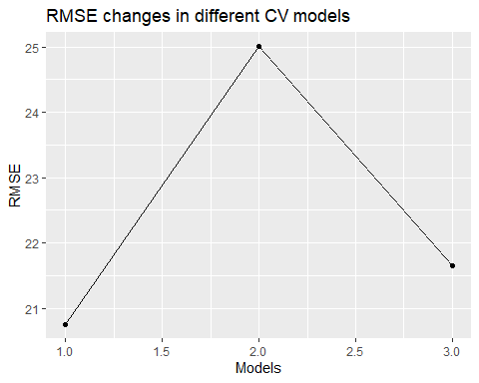

From all the CV models we built we see that K-fold analysis has lowest Error rate among all the CV models. Hence K-Fold is best Model for our dataset.