***Step 1:*** Extract the folder **(Cell_Test_Plan_Generator.7z)**

***Step 2:*** Run the application **(Cell_Test_Plan_Generator_[For_Testing].exe)**

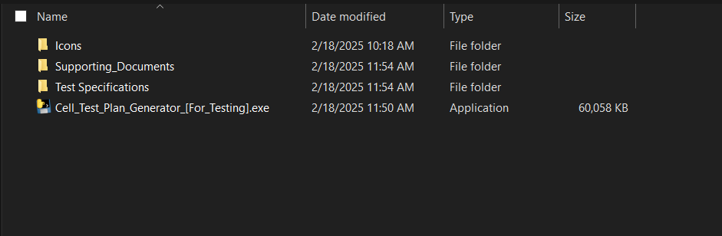

***Step 3:*** Click on **Browse Files** and select the **Test specification** and **Operating window** document

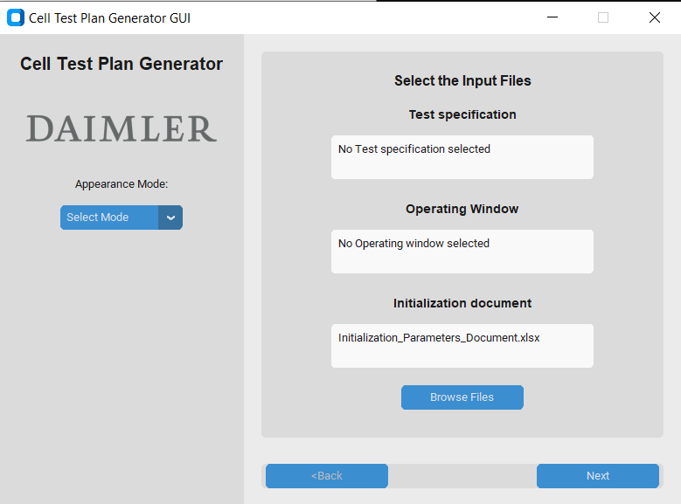

***Step 4.a:*** Select the **test procedure** from the drop-down menu

***Step 4.b:*** Select the **cell type** from the drop-down menu

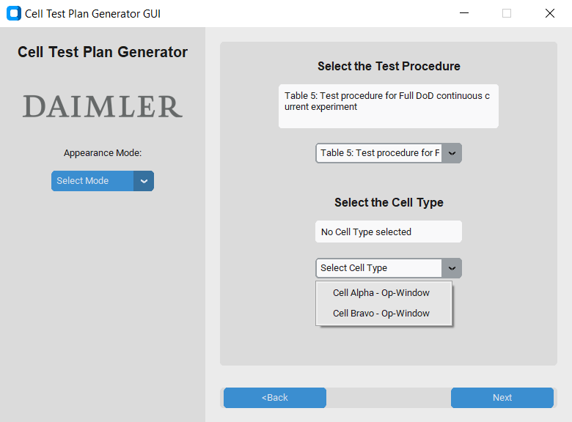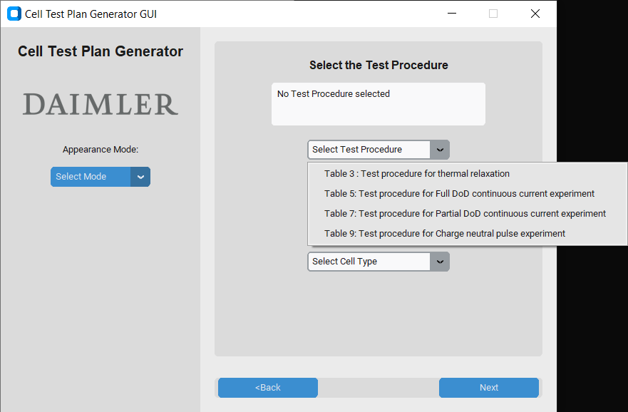

***Step 5.a:*** Select the **cell cycler** from the drop-down menu

***Step 5.b:*** Check mark the **add** **termination box** (if termination condition is required at last)

***Step 6:*** Select the **Registration parameters** from the available list and click **Add->** to add the selected parameters. Click **Confirm** once all the parameters are selected

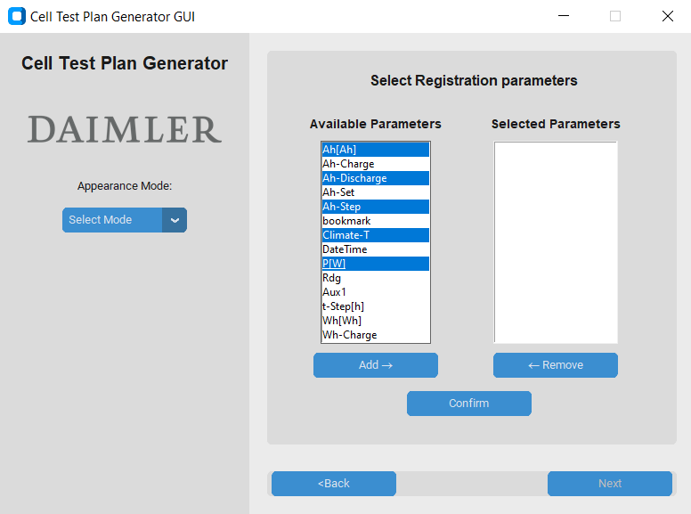

***Step 7:*** Click **Generate** and the test plan (.pln) will be generated in the **Output** folder

