

Quick Start Guide

Georg-Simon-Ohm Renderfarm (GSORF)

Table of contents
Introduction 3
System Requirements 3
Minimum hardware 3
Recommended hardware 3
Operating System 3
Preparation 4
Installation 4
GSORF 4
Blender 4
Operation 5
1. Overview 5
2. Starting the Server 5
3. Starting the Client 7
4. Rendering a .blend file 8
5. Monitoring the rendering progress 9
6. Collecting the finished renderings 10

Introduction

The Georg-Simon-Ohm Renderfarm (in short GSORF) allows you to connect several computers to distribute the rendering of three-dimensional Blender scenes (.blend) onto those machines.

System Requirements

Minimum hardware
- 32-bit dual core 2Ghz CPU with SSE2 support.
- 2 GB RAM
- 24 bits 1280×768 display
- Mouse or trackpad
- OpenGL-compatible graphics card with 256 MB RAM

Recommended hardware
- 64-bit quad core CPU
- 8 GB RAM
- Full HD display with 24 bit color
- Three button mouse
- OpenGL-compatible graphics card with 1 GB RAM

Operating System

GSORF has been developed with the cross-platform framework Qt, thus it can be run on Windows, Mac OS, Linux and similar operating systems.

Preparation

Before using GSORF you need to do a few preparations. Since the rendering is done with Blender, you need to have it installed on every computer that will be rendering later on.

Installation

GSORF

You don't need to install GSORF. Just download, unzip and run it on every computer in your network.

Blender

Blender can be downloaded directly from the Blender Foundation website:
http://www.blender.org/download/

To check if Blender has been installed properly, open a Terminal Window and type in „blender“, like this:

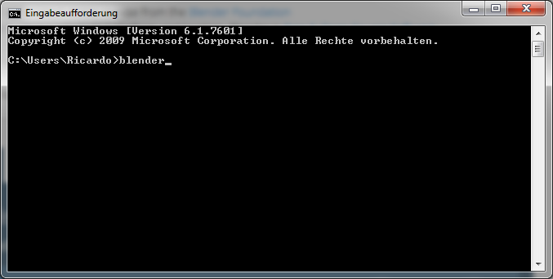
If this command opens Blender you are ready to use GSORF.

Operation

1. Overview

GSORF consists of two program components: The server and the client.
As it's the brain of your renderfarm the server controls data transmission and allows you to start a new rendering. This in turn is then sent to all other computers which are running the client. Clients will render the scene and send back the finished image to the server. You can then collect the image files for video editing and compositing.

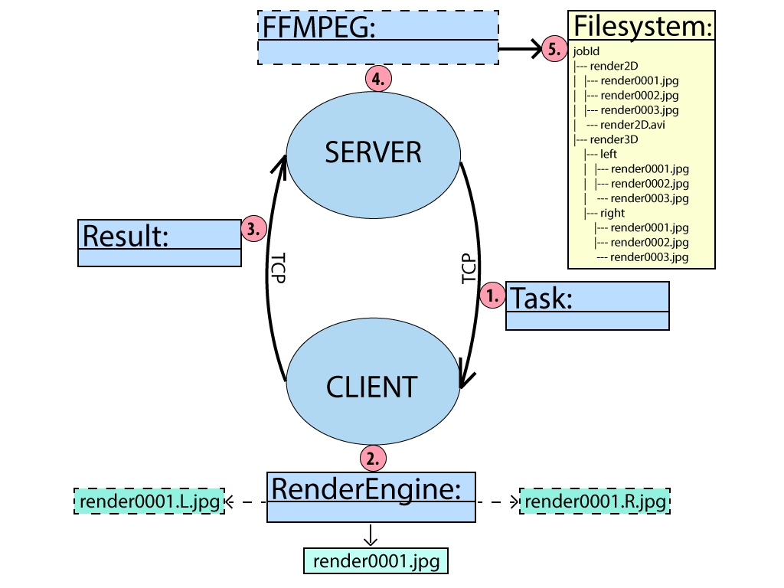

2. Starting the Server

Start GSORF on a machine where you want to store all your finished renderings. It will automatically search for a server in the network. This should fail since there are no servers on your network right now.

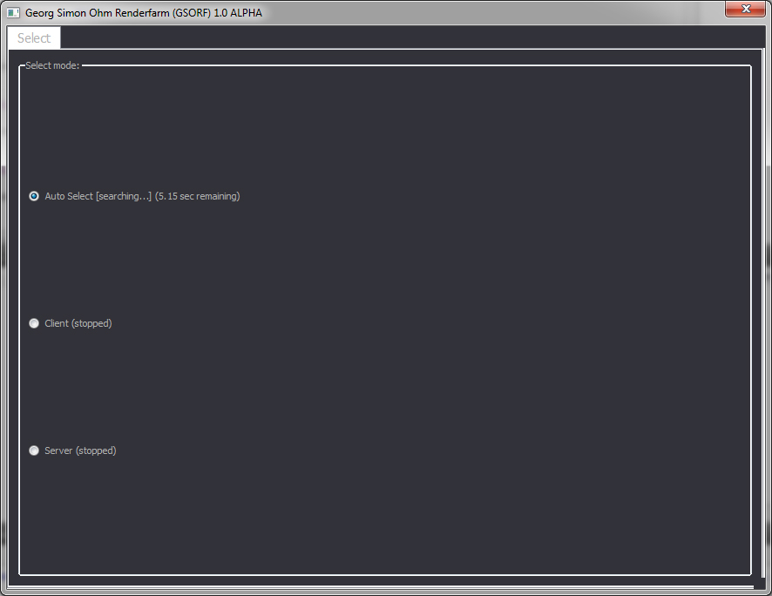
Select „Server“ from this list. You are now presented with the server perspective.

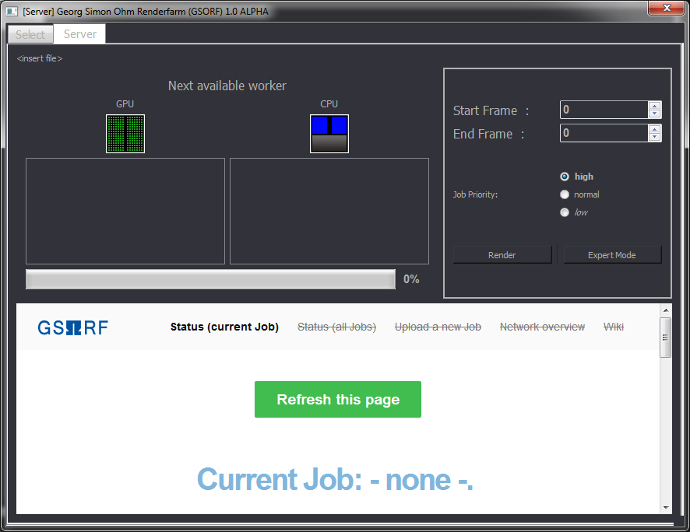
For now we will leave the server open and return here again as soon as some clients are running.

3. Starting the Client

Start GSORF on the remaining machines as well.

It should now automatically recognize the server on the network and switch to the client perspective.

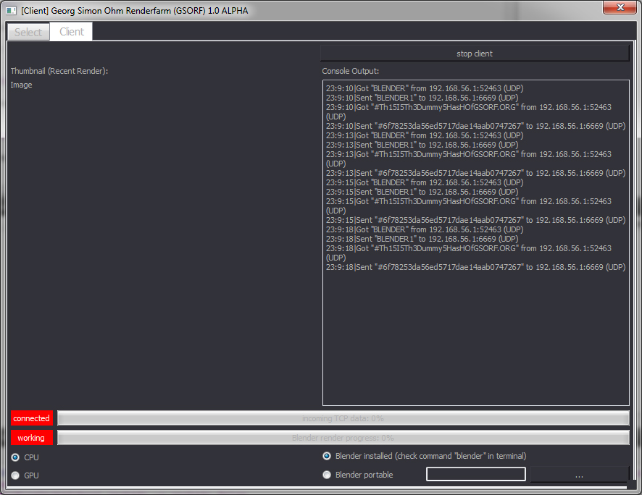
Repeat this step on every machine you want to use for rendering.

4. Rendering a .blend file

You have now set up everything to start rendering your .blend file on the network. Take a look at the server. It should now display all available render clients.

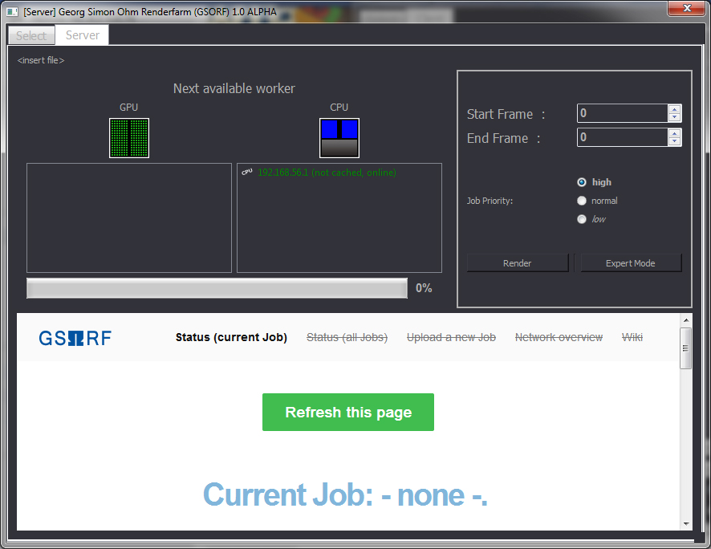
To define a new render job, drag and drop your .blend file in the server. The name of your file is now displayed in the window top. Next, set the start and end frame. You can now press „render“ to send the job on the network.

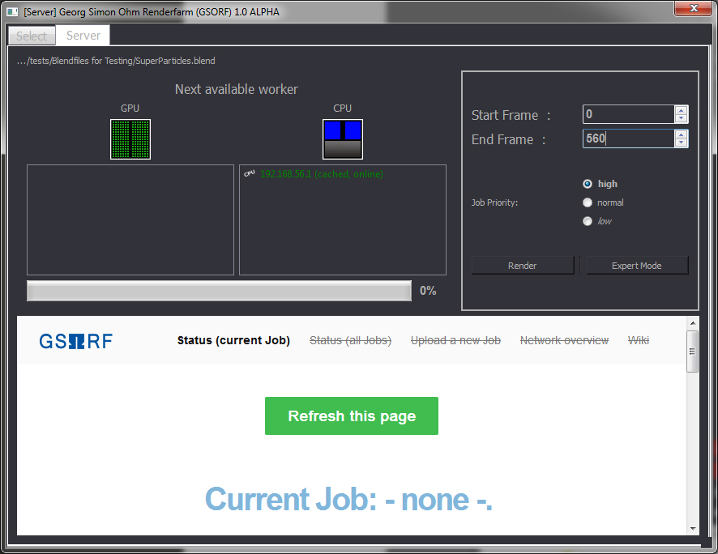
Depending on the complexity of your scene this may take a while, please keep the server running while the rendering is in progress.

5. Monitoring the rendering progress

You can monitor the rendering progress in a web browser. Navigate to the url „http://localhost:8080“ to open the GSORF web interface:

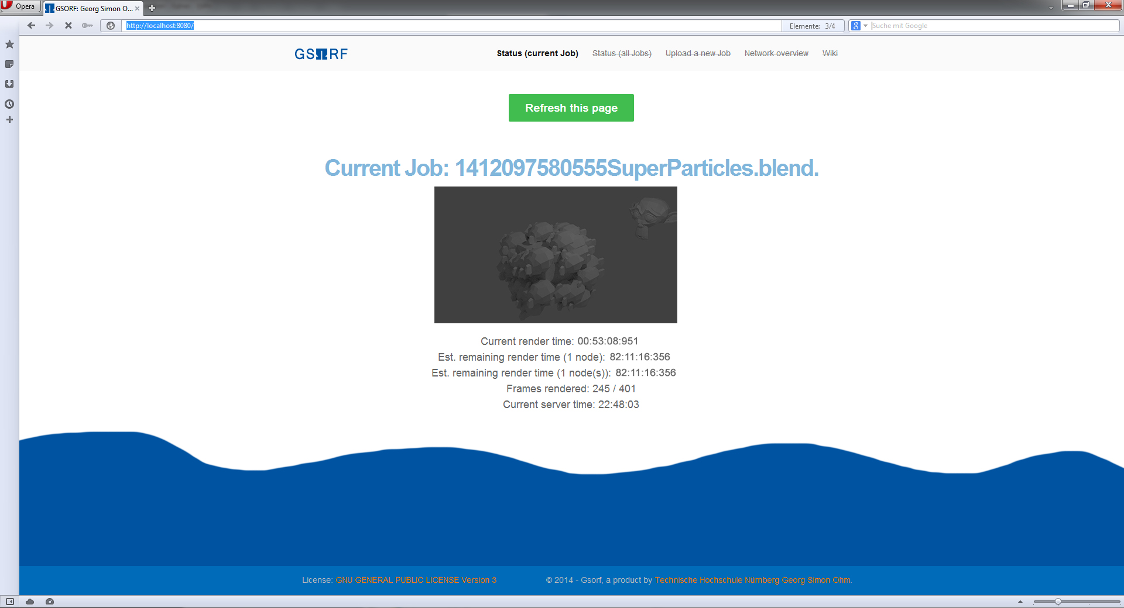
As soon as the rendering is complete, you can collect the images.

6. Collecting the finished renderings

The animation frames are stored in a separate directory on the server, which is called according to your .blend file.

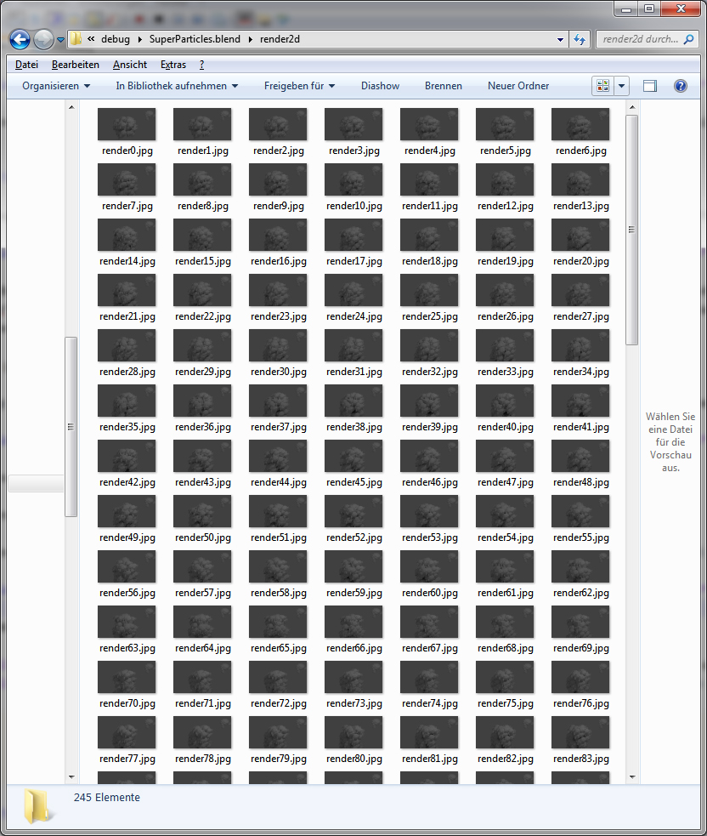

Developer contact  Adam Kalisz:  Tel: +49 (0)175 7034443  Email: gsorf@lwtv.de | Developer contact  Dominik Rusiecki:  Tel: +49 (0)172 9614 69  Email: rusieckido46966@th-nuernberg.de | Product owner  Prof. Dr. Stefan Röttger
Nuremberg, Germany
© Copyright 2014. Georg-Simon-Ohm Technische Hochschule Nürnberg. All rights reserved.
All trademarks are the property of their respective owners.

GSORF Quick Start Guide 1.0v1.AK

