Car game recipe

Contents

Setup a simple car 1

Make the track 1

Make the lights and ‘start race’ conditions 5

Make the checkpoints 8

Win game 9

# Setup a simple car

1. Use the SimpleCar2.docx, and create a car of your liking.
2. Gamer must be able to jump into Car, left shift+E to go to first gear and use ‘wasd’ to drive.
3. Shift+q for gear down and reverse.

# Make the track

1. Use this link - <https://create.roblox.com/store/asset/11345810767/roblox-race-track-kit> - and GetModel, this is Roblox race track kit. Drag drop it into 3d view. See image below.
2. A screenshot of a computer

   Description automatically generated
3. Rename the Models below and move it to folders as shown in images below
4. Note – zoom to 350% to clearly see the name/text in mages below.
5. 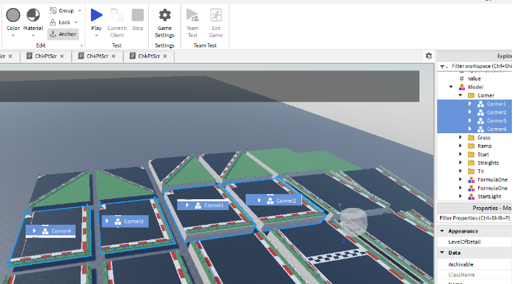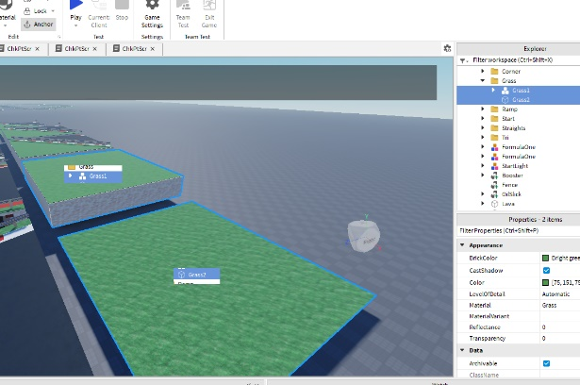
6. 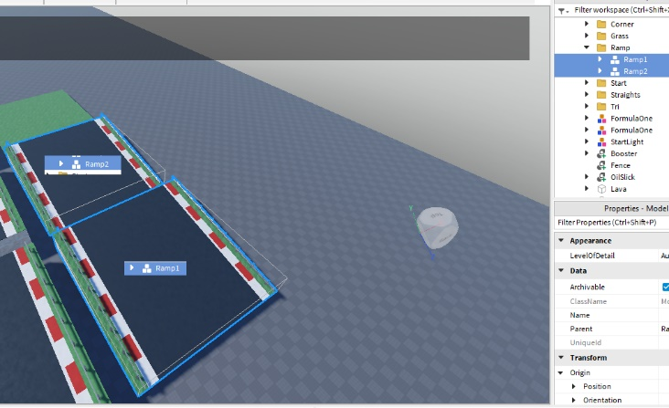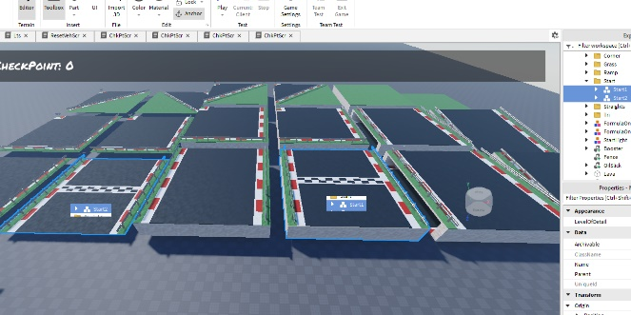
7. 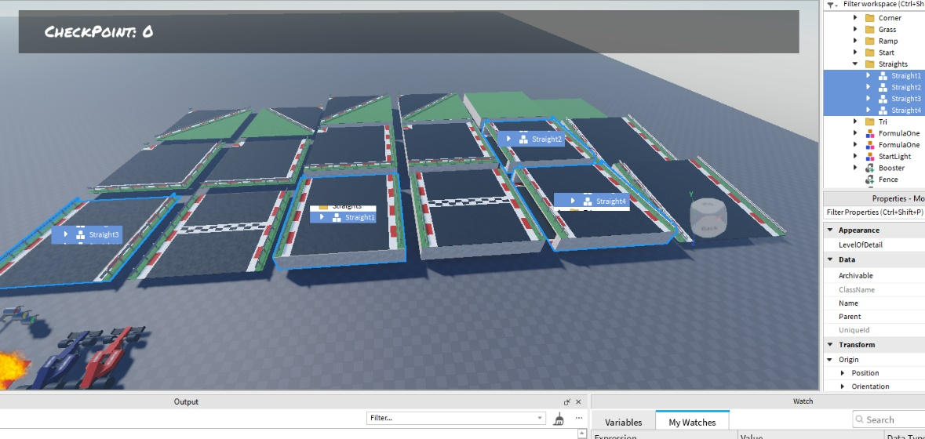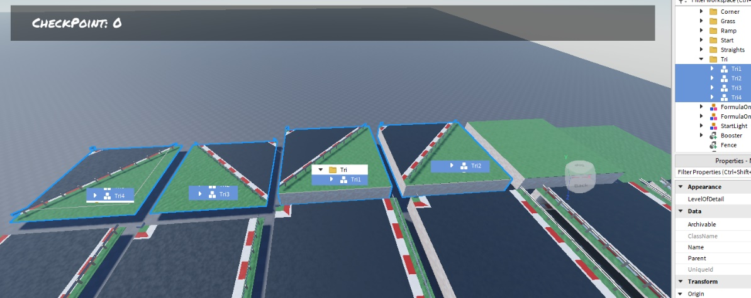
8. Now, duplicate part by part and set the position and orientation as given below to make the track. Move all the duplicated track parts into a folder called ‘Track’ in workspace.
9. This is just an example, can play around with available parts and make track of any shape.
10. Duplicate start2 and pos = (7, 0, -88)
11. Duplicate ramp1 pos = (37, 4.87, -151.8) and orientation = (0, -180, -0)
12. Duplicate straight2 pos = (37, -0.05, -215.9), orient = (-0, -90, -0) and scale = 1.003
13. Duplicate ramp1 pos = (37, 4.87, -280)
14. Duplicate straight3 p = (37, 0, -343.891) and scale = 1.003
15. Duplicate tri4 p=( 33, 0, -404) and orient = (0, 90, 0)
16. Duplicate tri4 p=( -23, 0, -412) and orient=( -0, -90, 0)
17. Duplicate tri4 p=( -31, 0, -468) and orient=( 0, 90, 0)
18. Duplicate straight3 p=( -91, -0, -472) and orient=( 0, 90, -0)
19. Duplicate tri4 p=( -151, -0, -468) and orient=(0, 180, 0)
20. Duplicate tri4 p=( -159, -0, -412)
21. Duplicate straight3 p=( -219, 0, -408) orient = (0,90,0)
22. Duplicate tri4 p=( -279, 0, -404) , orient = (0, 180, 0)
23. Duplicate straight3 p=( -283, 0, -344)
24. Duplicate straight3 p=( -283, 0, -280)
25. Duplicate straight3 p=( -283, 0, -216)
26. Duplicate straight3 p=( -283, 0, -152)
27. Duplicate straight3 p=( -283, 0, -88)
28. Duplicate tri4 p=( -279, 0, -28) and orient=( 0, -90, 0)
29. Duplicate tri4 p=( -223, 0, -28)
30. Duplicate straight3 p=( -219, -0, -88)
31. Duplicate tri4 p=( -215, -0, -148) and orient=( 0, -180, 0)
32. Duplicate straight3 p=( -155, 0, -152) and orient=( 0, 90, -0)
33. Duplicate tri4 p=( -95, -0, -148), and orient = (0, 90, 0)
34. Duplicate straight3 p=( -91, -0, -88)
35. Duplicate tri4 p=( -87, -0, -28) and orient =( 0, -90, 0)
36. Duplicate tri4 p=( -31, 0, -20) and orient=( 0, 90, -0)
37. Duplicate tri4 p=( -23, -0, 36) and orient = (0, -90, 0)
38. Duplicate tri4 p=( 33, -0, 36)
39. Duplicate straight3 p=( 37, -0, -24)
40. A video game of a race track

    Description automatically generated
41. Position the car near the start line, play and see.

# Make the lights and ‘start race’ conditions

1. Rename A-Chassis 6.81T by Novena to Car1. Drag drop Car1 to ServerStorage.
2. Add a part. Size = (4, 0.3, 3). Pos = (1.2, 0.15, -63.9). Rename to ResetVeh. Color to blue. Material to diamond plate. Anchor it.
3. Under ResetVeh add a ResetVehScr. In script add below code.

local resetBlk = script.Parent

local resetDone = false

function ResetCars()

if resetDone then

return

end

resetDone = true

print('deleting current cars')

for _,obj in pairs(game.Workspace:GetChildren()) do

if obj.Name:match("Car") then

print(obj.Name)

obj:Destroy()

end

end

print('cloning new cars')

for _,obj in pairs(game.ServerStorage:GetChildren()) do

print(obj.Name)

local carCopy = obj:Clone()

carCopy.Parent = game.Workspace

carCopy:MakeJoints()

end

wait(20)

resetDone = false

end

resetBlk.Touched:Connect(ResetCars)

1. When we start the game, only after we step on the plate, car will be spawned and game will begin.
2. Duplicate StartLight and move it to ‘Track’ folder. Pos = (7.6, 9.1, -110.6) , or=(0,90,0)
3. Create a part, rename to Gate, anchor it. Set size = (57.6, 19, 6), pos = (38, 9.7, -88.1) and transparency = 0.7. Color to white, material to Asphalt.
4. In ServerScriptService add script and rename to Lts
5. In script add below code.

local redLt = workspace.Track.StartLight.RedModel.LightBulb.PointLight

local yelLt = workspace.Track.StartLight.YellowModel.LightBulb.PointLight

local grnLt = workspace.Track.StartLight.GreenModel.LightBulb.PointLight

local gate = workspace.Gate

local wtTm = 4

local function StLts()

wait(wtTm)

print('red on')

redLt.Enabled = true

wait(wtTm)

print('red off, yellow on')

redLt.Enabled = false

yelLt.Enabled = true

wait(wtTm)

print('yellow off, green on')

yelLt.Enabled = false

grnLt.Enabled = true

gate.Transparency = 1

gate.CanCollide = false

wait(wtTm*4)

print('Green off')

grnLt.Enabled = false

end

StLts()

1. Play and see. First red, then yellow, then green light turns on and when green is on, the ‘Gate’ will disappear and car can start the race!

# Make the checkpoints

1. Add Gui as shown in image below. Note the ‘ChkPtLbl’ and ‘WonGame’. The text for ‘WonGame’ must be ‘You have won the game!’ , and uncheck ‘Visible’.
2. A video game screen capture

   Description automatically generated
3. A screenshot of a video game

   Description automatically generated
4. Create folder called ‘ChkPts’ under workspace.
5. Under ChkPts, add a intValue and rename to ‘lastChkpt’
6. Under ChkPts, add a part, rename to ‘1’. Size = (56.1, 7.1, 2), pos = (37.05, 3.65, -362.2). Color to light white, material to Asphalt, transparency to 0.8. Anchor it. Cancollide unchecked.
7. Under 1, add a script, rename to ChkPtScr and add the code below.

local chkptPart = script.Parent

local lPt = game.Workspace.ChkPts.lastChkPt

local Players = game:GetService('Players')

local lplyr = nil

local function ChkPtHit(otherPart)

if otherPart.Parent.Parent.Parent.Name:match("Car") then

if chkptPart.Name == tostring(lPt.Value + 1) then

lPt.Value = lPt.Value + 1

lplyr.PlayerGui.ScreenGui.Frame.ChkPtLbl.Text = "CheckPoint: "..tostring(lPt.Value)

end

end

end

local function PlayerAdded(Player)

lplyr = Player

end

chkptPart.Touched:Connect(ChkPtHit)

Players.PlayerAdded:Connect(PlayerAdded)

1. Play and see. When car crosses the check point ‘1’ see that information updated in UI.
2. Duplicate 1 to 2, set pos=( -283.35, 3.65, -145.2)
3. Duplicate 2 to 3, set pos=( -47.25, 3.65, -13) or=(0,45,0)
4. Duplicate 3 to 4, set pos=( 37.05, 3.65, -53)
5. Play and see, after hitting each checkpoint, the information must be updated.

# Win game

1. Open the script under checkpoint ‘4’.
2. Update the code to below.

local chkptPart = script.Parent

local lPt = game.Workspace.ChkPts.lastChkPt

local Players = game:GetService('Players')

local lplyr = nil

local function PauseGame()

for i,v in pairs(game:GetDescendants()) do

if v == game:GetService("StreamingService") then

print("StreamingService")

elseif v:IsA("BasePart") then

v.Anchored = true

elseif v:IsA("Script") or v:IsA("LocalScript") then

v.Disabled = true

elseif v:IsA("Sound") then

v:Stop()

end

end

end

local function ChkPtHit(otherPart)

if otherPart.Parent.Parent.Parent.Name:match("Car") then

if chkptPart.Name == tostring(lPt.Value + 1) then

lPt.Value = lPt.Value + 1

lplyr.PlayerGui.ScreenGui.Frame.ChkPtLbl.Text = "CheckPoint: "..tostring(lPt.Value)

lplyr.PlayerGui.ScreenGui.Frame.WonGame.Visible = true

wait(2)

PauseGame()

end

end

end

local function PlayerAdded(Player)

lplyr = Player

end

chkptPart.Touched:Connect(ChkPtHit)

Players.PlayerAdded:Connect(PlayerAdded)

1. Play and see – after completing one round, game’s car wins!