# Trial and intro to Roblox

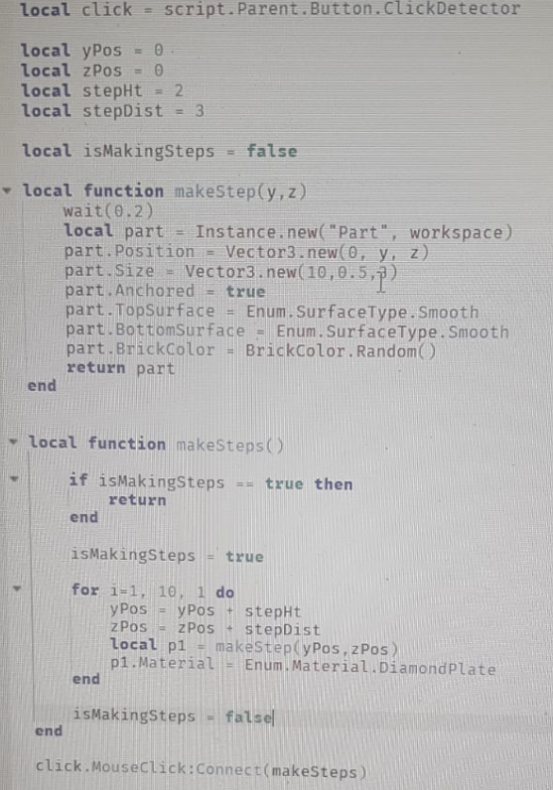

# Basic coding

# Lava obstacle

function onTouch(part)

if script.Parent.BrickColor == BrickColor.new("Really red") then

local humanoid = part.Parent:FindFirstChild("Humanoid")

if humanoid ~= nil then

humanoid.Health =0

else

wait(2)

end

end

end

script.Parent.Touched:Connect(onTouch)

# UI in Roblox

<https://drive.google.com/file/d/1k2iGBpz2lszWq7V4BHeqe1KXXLrXJB-_/view?usp=sharing>

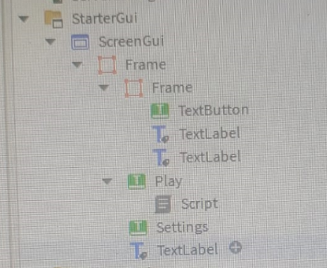

# Model solid geometry Union

# MiniGame in Roblox

Minigame file

<https://drive.google.com/file/d/1ZoEXhZNnkOhYTBfcZYcP2QWRtZxM7Il8/view?usp=sharing>

Jumpy away.png

<https://drive.google.com/file/d/1vCJr6RjA2MH9jN78RDXt-m512N4Yx5i1/view?usp=sharing>

# Shop

Roblox shop 3d model

<https://create.roblox.com/store/asset/2310029676/Shop>

Shop ui sample

<https://drive.google.com/file/d/1JPtxIZ_YjjlV55U3HYw4MTzmUwnG-VJ-/view?usp=sharing>

local open = game.Workspace.openShop

local close = game.Workspace.closeShop

local frame = script.Parent

local closeBtn = frame.closebutton

frame.Visible = false

local function shopMenu(otherPart)

local player = game.Players:FindFirstChild(otherPart.Parent.Name)

if player then

player.PlayerGui.ScreenGui.Shop.Visible = true

end

end

local function closeShopMenu(otherPart)

local player = game.Players:FindFirstChild(otherPart.Parent.Name)

if player then

player.PlayerGui.ScreenGui.Shop.Visible = false

end

end

local function menuClose()

frame.Visible = false

end

open.Touched:Connect(shopMenu)

close.Touched:Connect(closeShopMenu)

closeBtn.MouseButton1Click:Connect(menuClose)

# Hinge and new blocks

1. Just add two blocks. Bottom one anchored, top one free.
2. A white rectangular object on a tiled floor

   Description automatically generated
3. Move the top block a bit up and add hinge
4. A screenshot of a computer

   Description automatically generated 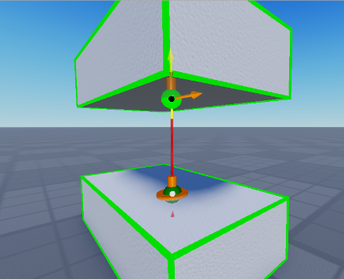 A screenshot of a computer

   Description automatically generated
5. To make it ‘motor’ see above settings
6. A screenshot of a computer

   Description automatically generated
7. To make It servo see above
8. SeeSaw
9. A screenshot of a computer

   Description automatically generated
10. b

# ab

# Horror game

Horror game Roblox file below

<https://drive.google.com/file/d/1njvB_y7Jr7ZMw8R8ZjIRY0SPLlOor7oQ/view?usp=sharing>

recipe below

<https://drive.google.com/file/d/17sWkF5DJFBFVtB00H9Evu6aYrsexWdAh/view?usp=sharing>

# A

# B

# c