8/30/2016

|  |
| --- |
| [Type the document subtitle] | CBIT-CDS-C001 |

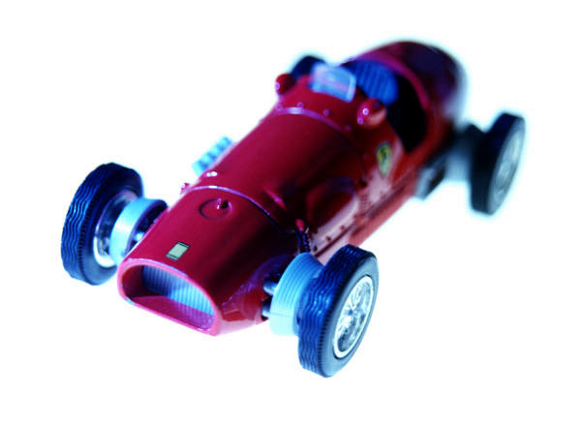

|  |  |
| --- | --- |
| [Type the company name] | [Type the document title] |

1. ***Creation of Document:***

* To open Microsoft word first click on start button next click on all programs you will probably need to scroll to find the Ms office.
* Programs from the menu from the ms office click the ms word the a new page will be opened with the ms word.